Australian Capital Territory

Nature Conservation (Closed Reserves) Declaration 2025 (No 4)

Notifiable instrument NI2025–293
made under the
Nature Conservation Act 2014, s 259 (Conservator may close reserve)

1 Name of instrument
This instrument is the Nature Conservation (Closed Reserves) Declaration 2025 (No 4).

2 Commencement
This instrument commences at 6:00 pm on 10 June 2025.

3 Declaration
I declare that public access to:
- the reserves mentioned in schedule 1; and
- those parts of Red Hill Nature Reserve and Farrer Ridge Nature Reserve indicated in the maps at schedule 2,
is prohibited during the closure times mentioned in schedule 3.

4 Exceptions
Section 3 does not apply to:
- a person accompanied by a conservation officer exercising a function under the Act; or
- a person who is:
  - implementing the Nature Conservation (Eastern Grey Kangaroo) Controlled Native Species Management Plan 2017 (DI2017-37) within the areas declared under section 3 (closed reserves); or
  - controlling a pest animal species in the closed reserves; and
  - contracted by the Territory to conduct the activity mentioned in paragraph (i) or (ii); or
  - authorised in writing by the custodian of the closed reserve accessed by the person, to conduct the activity mentioned in paragraph (i) or (ii); or
- an employee of Icon Water exercising a function of their position within the defined area.

5 Definitions
the defined area means:
- the fenced compound containing the Icon Water service reservoir in Farrer Ridge Nature Reserve; and
- the road and management trail connecting Athllon Drive and the south-eastern corner of the compound mentioned in paragraph (a).

6 Expiry
This instrument expires on 31 July 2025.

Bren Burkevics
Conservator of Flora and Fauna

6 June 2025
Schedule 1 Reserves fully closed
(see s 3)

Reserves

Aranda Bushland Nature Reserve

Aranda Bushland Nature Reserve
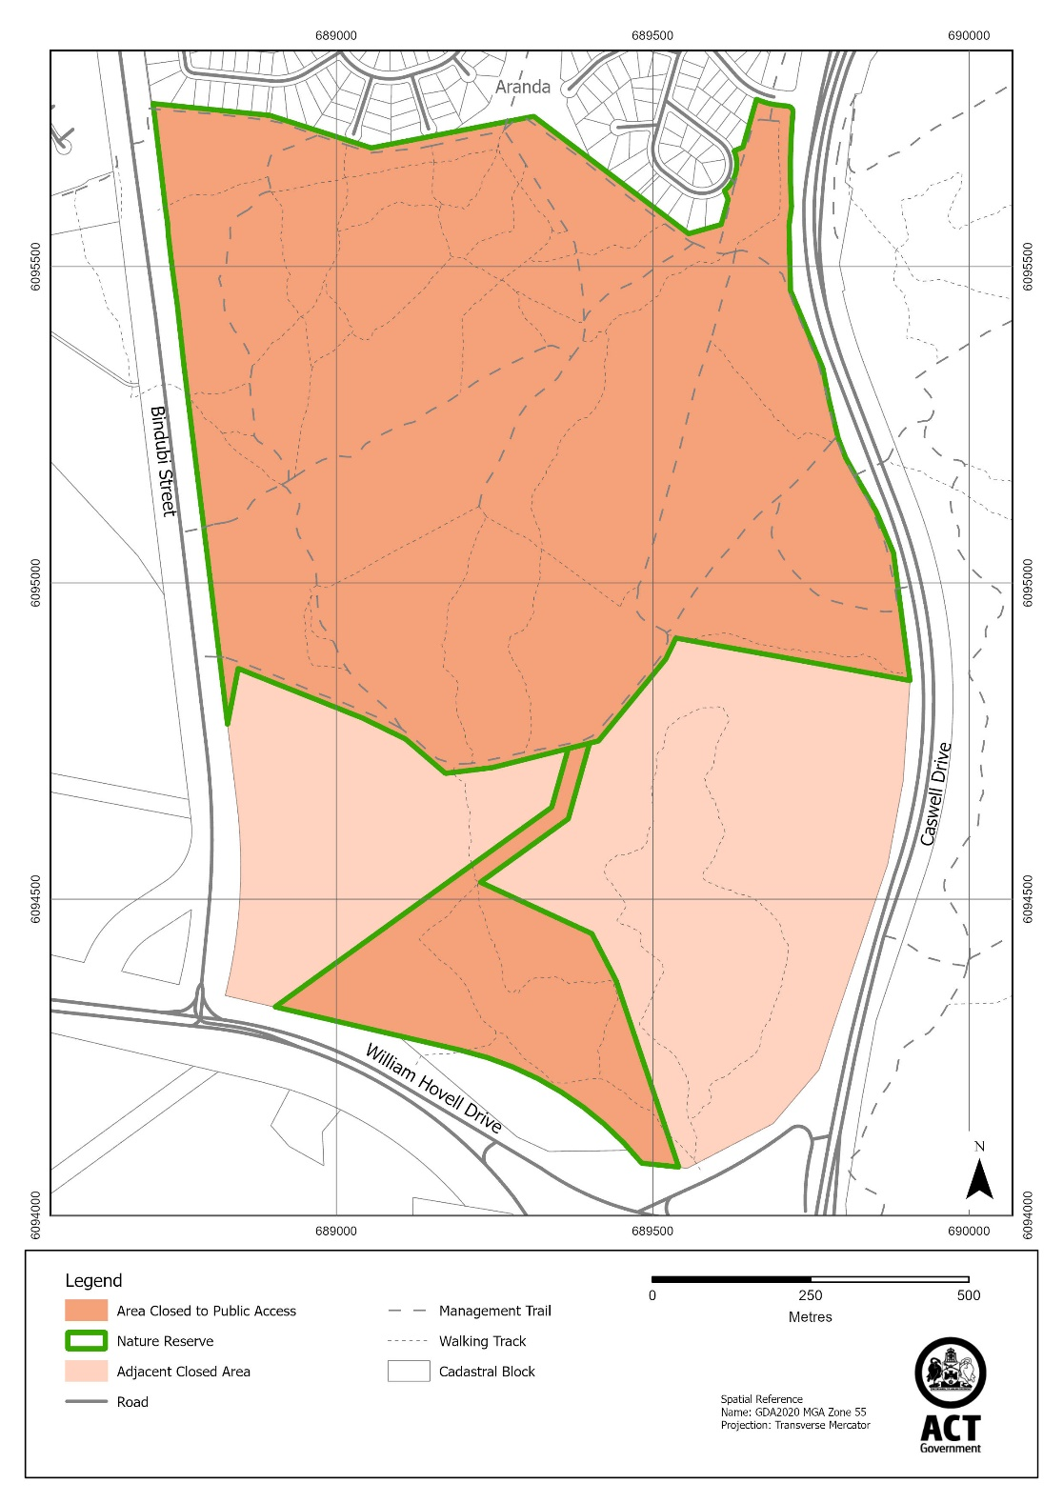
Schedule 2 Reserves partially closed
(see s 3)

Red Hill Nature Reserve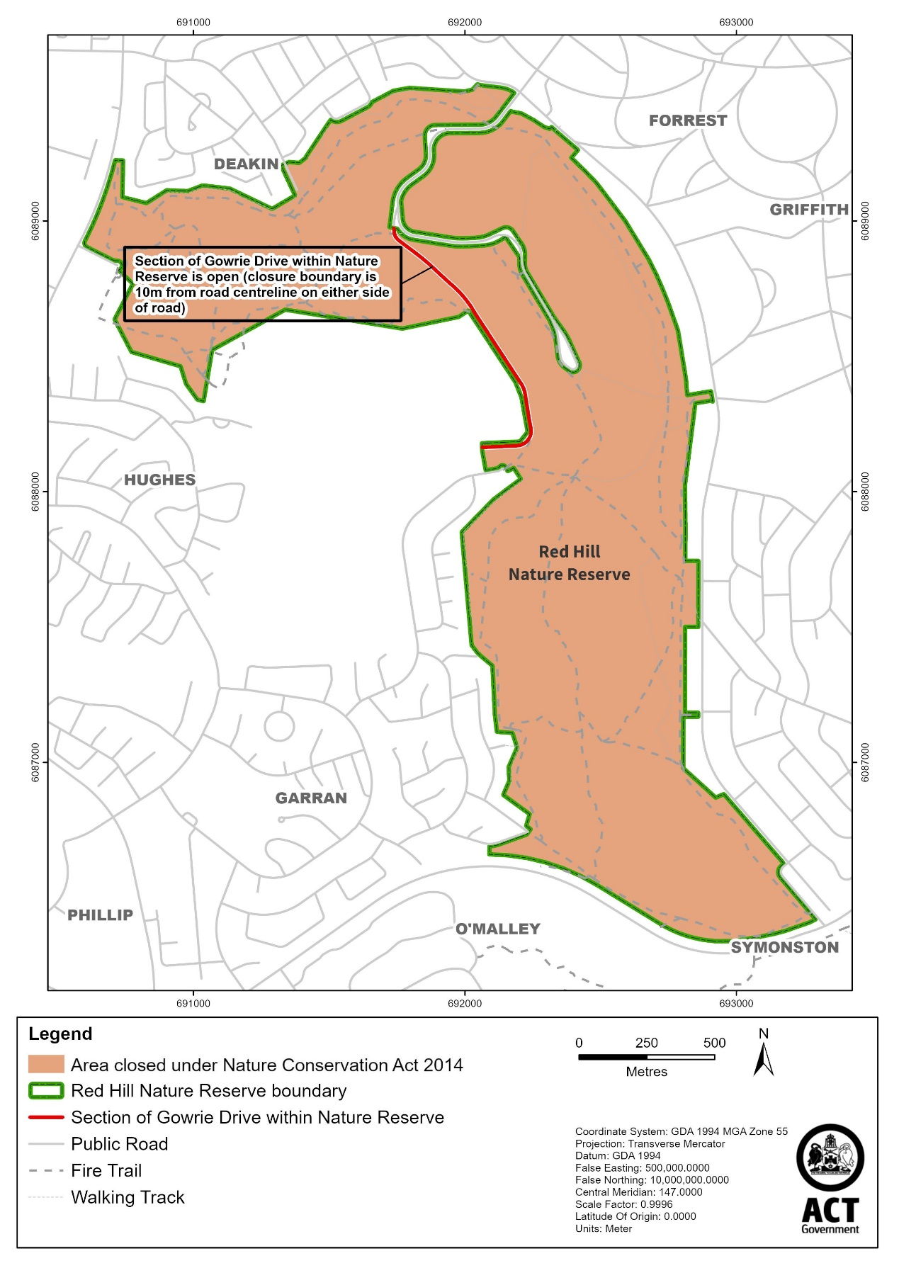
Farrer Ridge Nature Reserve

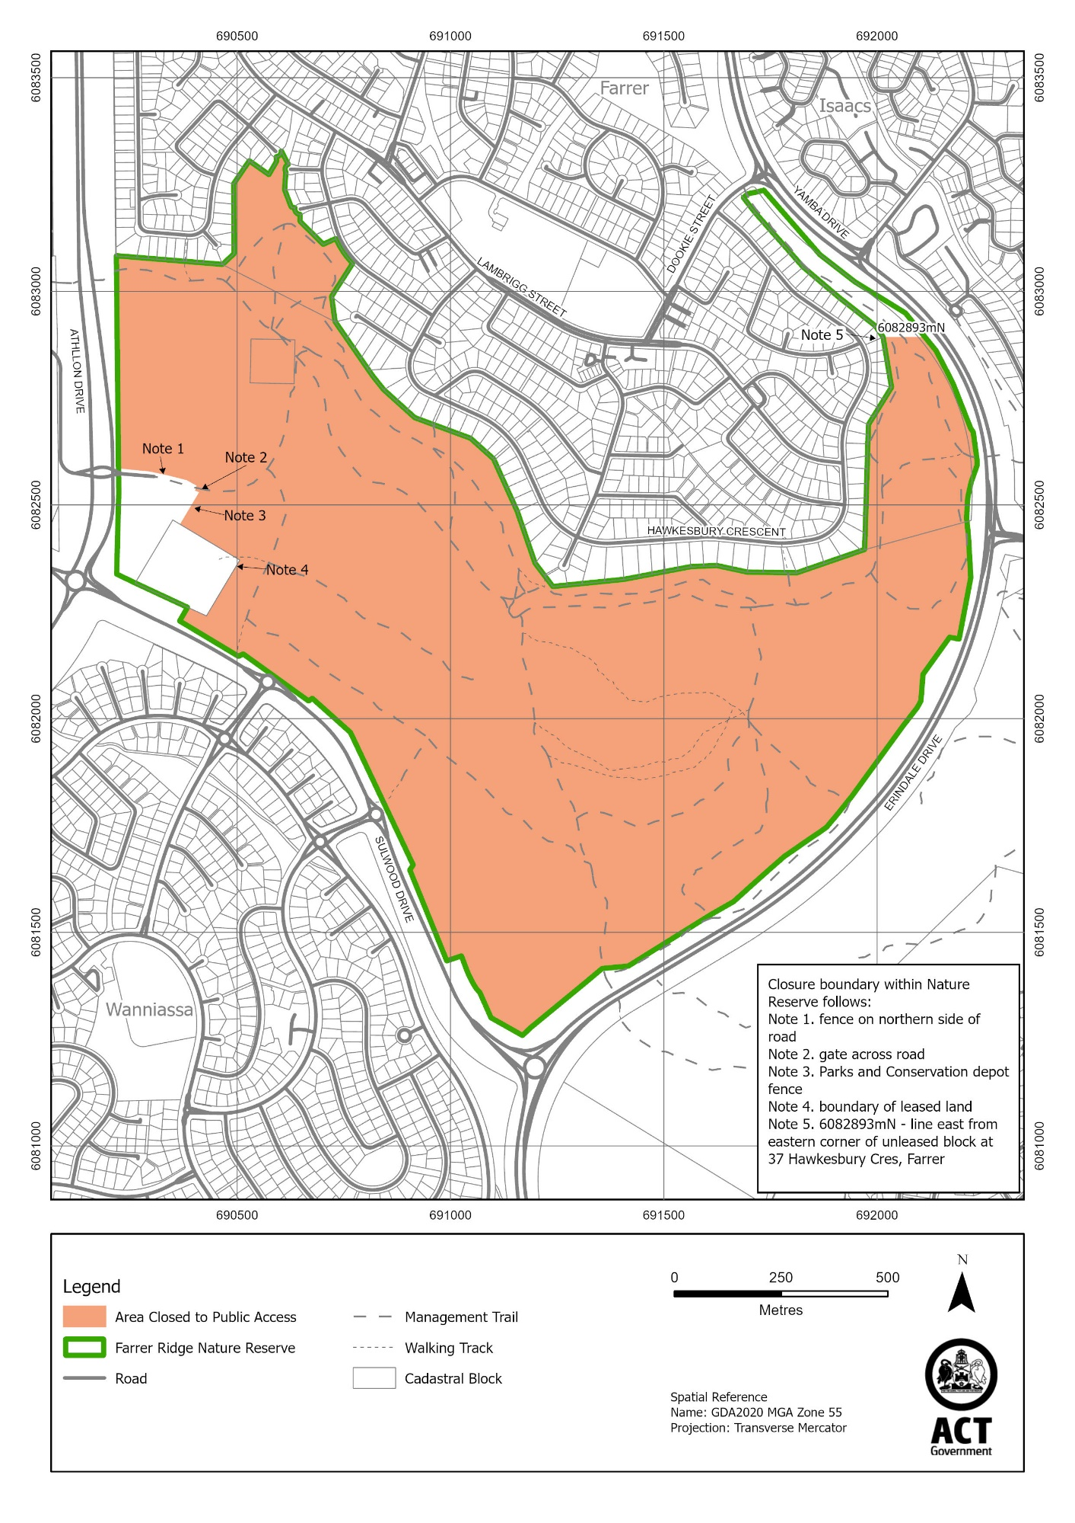

Schedule 3 Closure times
(see s 3)

Times when public access is prohibited

Beginning at 6:00 pm every Monday, Tuesday, Wednesday and Thursday and ending on the following day at 6:00 am.

Note The closure beginning on Thursday 31 July 2025 will end at midnight on 1 August 2025.

