Australian Capital Territory

Nature Conservation (Closed Reserves) Declaration 2025 (No 5)

Notifiable instrument NI2025–294
made under the
Nature Conservation Act 2014, s 259 (Conservator may close reserve)

1 Name of instrument
This instrument is the Nature Conservation (Closed Reserves) Declaration 2025 (No 5).

2 Commencement
This instrument commences at 6:00 pm on 10 June 2025.

3 Declaration
I declare that public access to:
- the reserves mentioned in schedule 1; and
- those parts of Mount Ainslie Nature Reserve, Molonglo River Reserve, Gungaderra Grasslands Nature Reserve and Crace Grasslands Nature Reserve indicated in the maps at schedule 2,
is prohibited during the closure times mentioned in schedule 3.

4 Exceptions
Section 3 does not apply to:
- a person accompanied by a conservation officer exercising a function under the Act; or
- a person who is:
  - implementing the Nature Conservation (Eastern Grey Kangaroo) Controlled Native Species Management Plan 2017 (DI2017-37) within the areas declared under section 3 (closed reserves); or
  - controlling a pest animal species in the closed reserves; and
  - contracted by the Territory to conduct the activity mentioned in paragraph (i) or (ii); or
  - authorised in writing by the custodian of the closed reserve accessed by the person, to conduct the activity mentioned in paragraph (i) or (ii).

5 Expiry
This instrument expires on 31 July 2025.

Bren Burkevics
Conservator of Flora and Fauna

6 June 2025
Schedule 1 Reserves fully closed
(see s 3)

Reserves

Mulanggari Grasslands Nature Reserve
Mount Majura Nature Reserve

Mulanggari Grasslands Nature Reserve
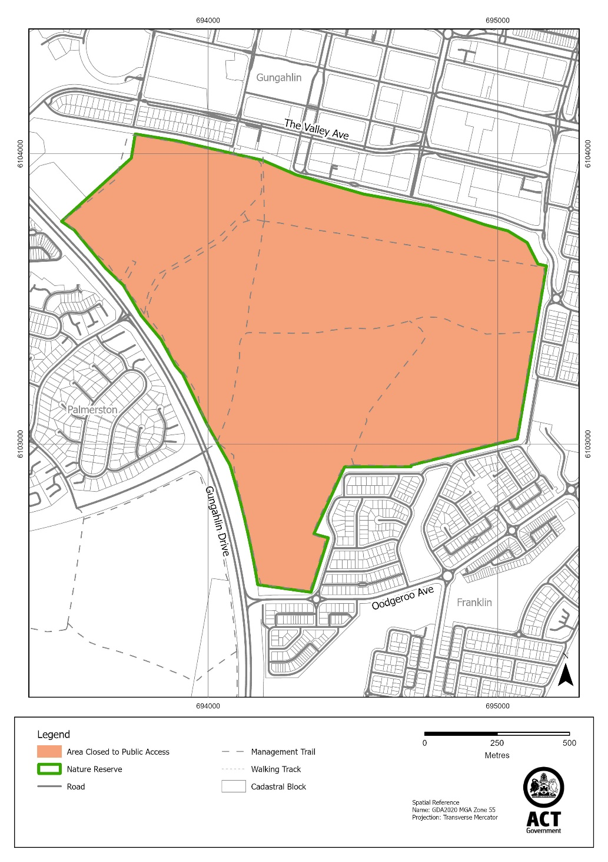

Mount Majura Nature Reserve
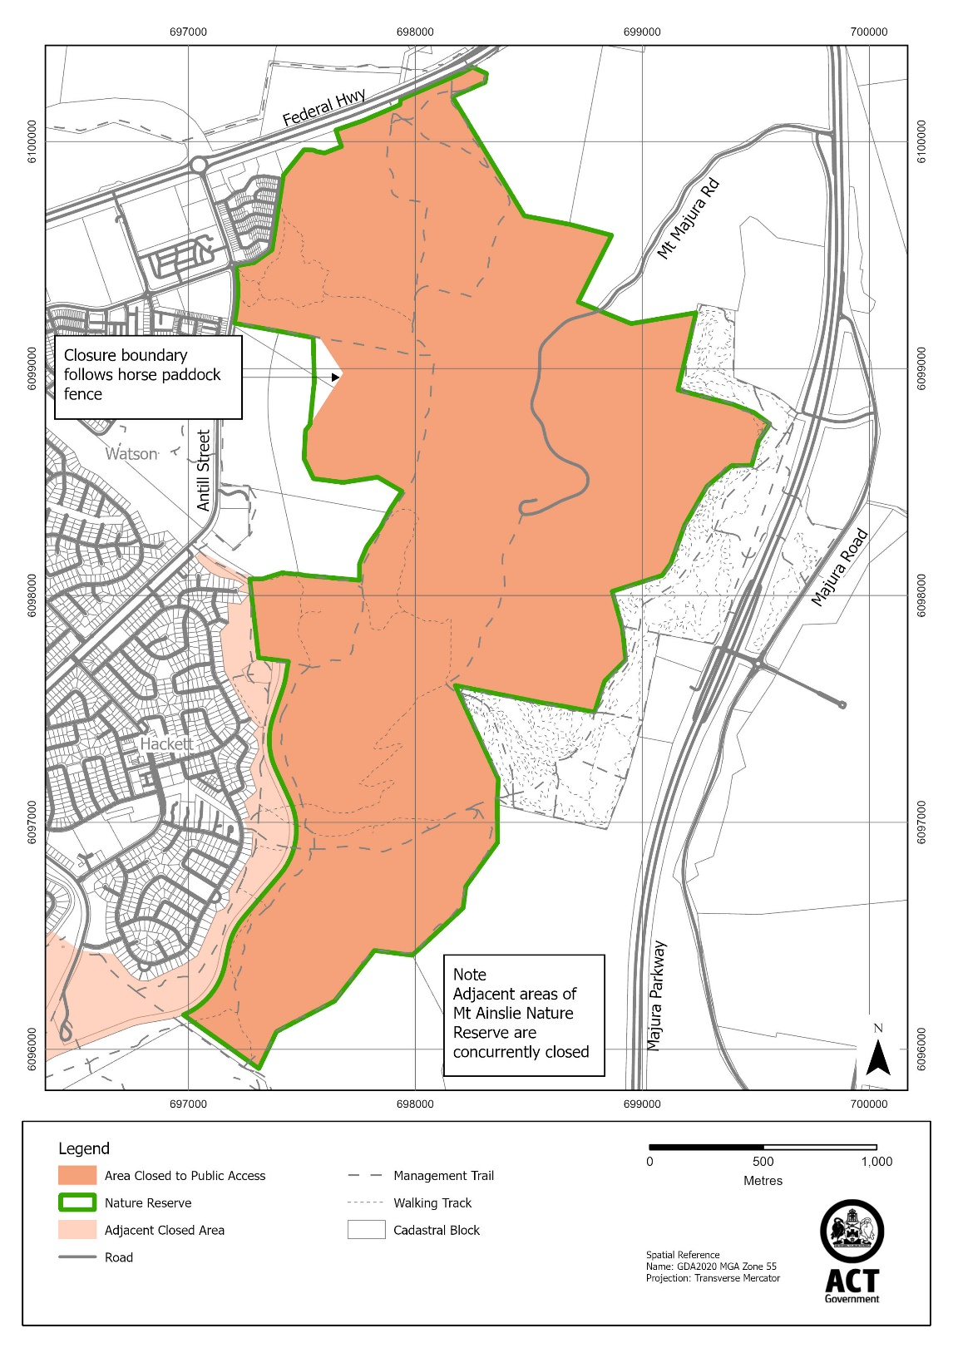
Schedule 2 Reserves partially closed
(see s 3)

Mount Ainslie Nature Reserve

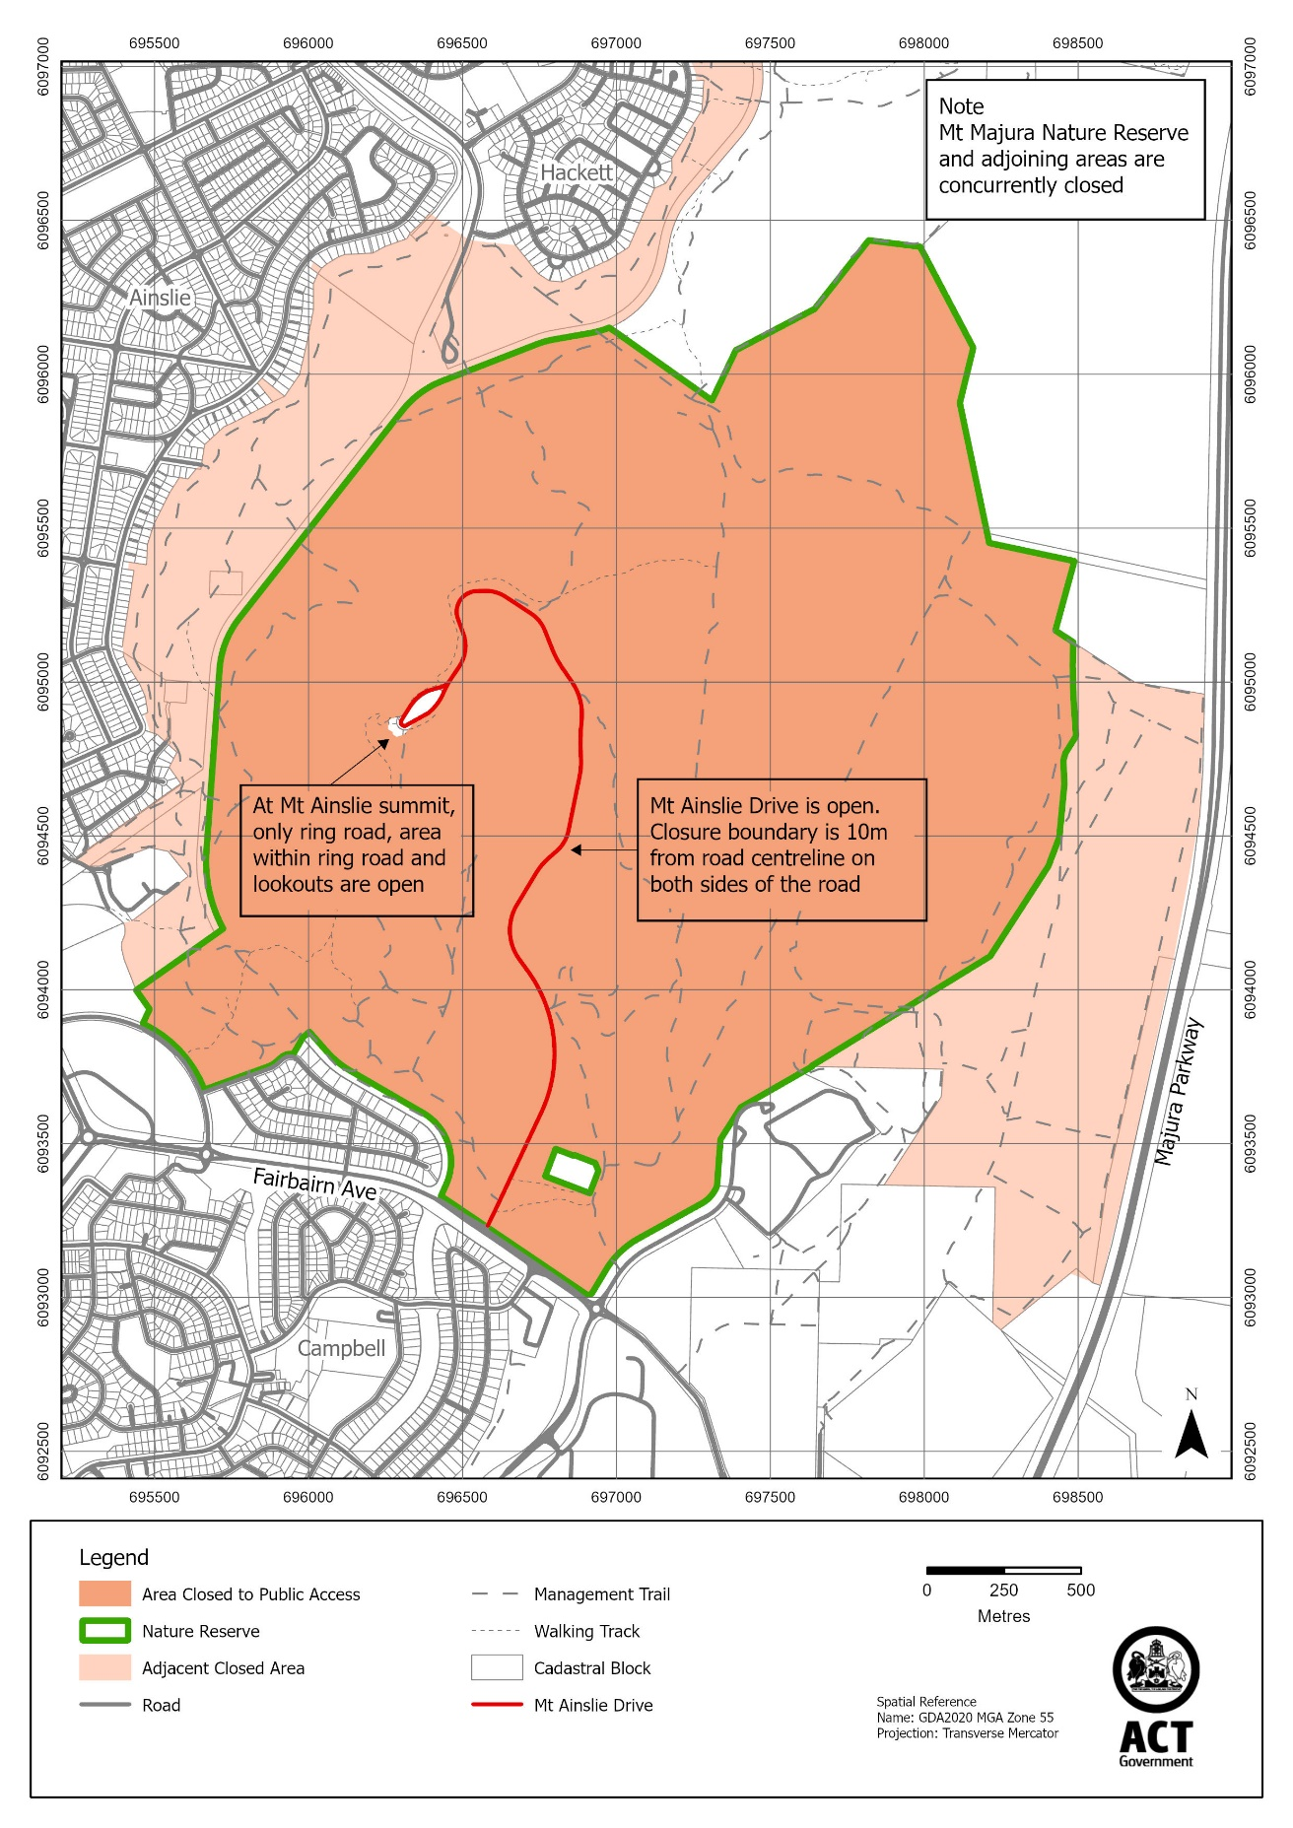
Molonglo River Reserve (“Kama” section)

Note – The area closed is wholly within the former Kama Nature Reserve

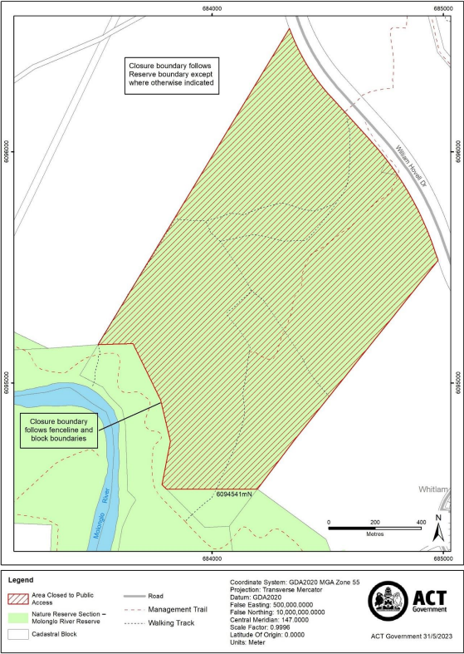
Gungaderra Grasslands Nature Reserve

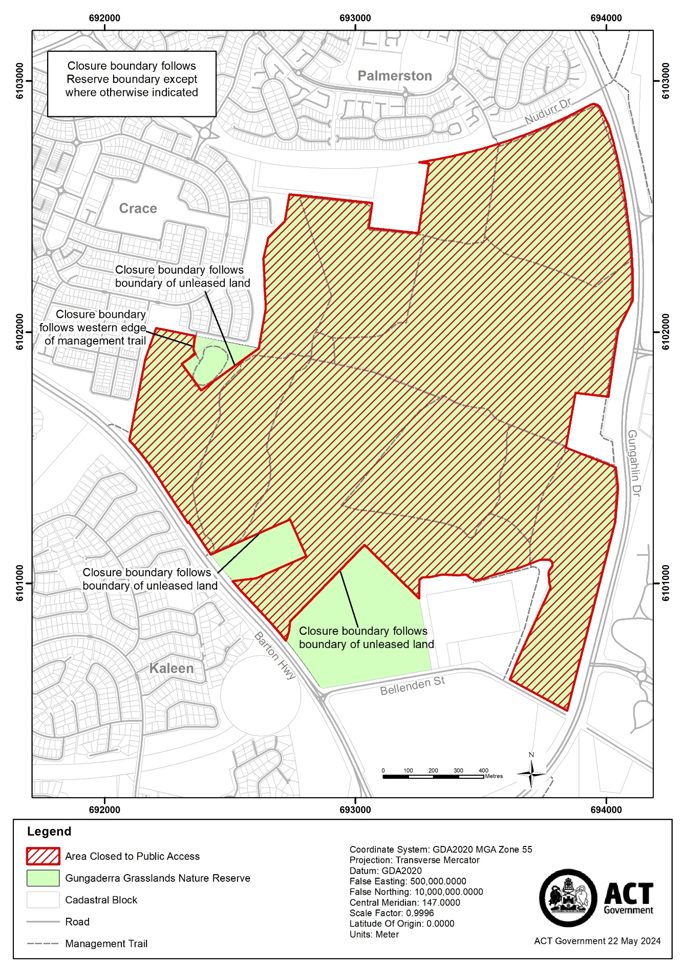

Crace Grasslands Nature Reserve

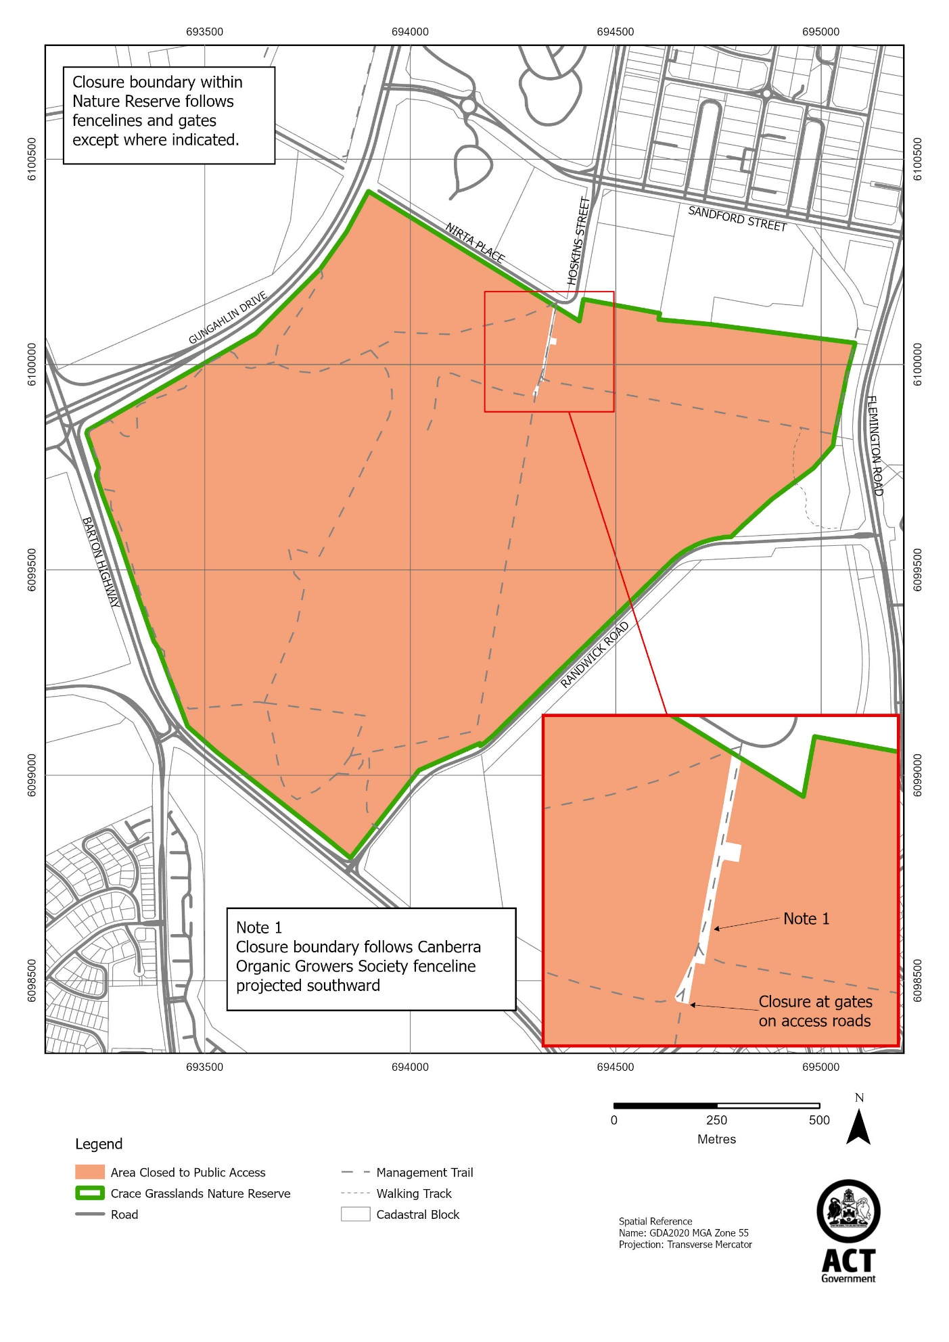
Schedule 3 Closure times
(see s 3)

Times when public access is prohibited

Beginning at 6:00 pm every Monday, Tuesday, Wednesday and Thursday and ending on the following day at 6:00 am.

Note The closure beginning on Thursday 31 July 2025 will end at midnight 1 August 2025.

