Australian Capital Territory

Nature Conservation (Closed Reserves—Mulligans Flat and Goorooyarroo Nature Reserves) Declaration 2025 (No 1)

Notifiable instrument NI2025–295
made under the
Nature Conservation Act 2014, s 259 (Conservator may close reserve)

1 Name of instrument
This instrument is the Nature Conservation (Closed Reserves—Mulligans Flat and Goorooyarroo Nature Reserves) Declaration 2025 (No 1).

2 Commencement
This instrument commences at 6:00 pm on 10 June 2025.

3 Declaration
I declare that public access to those parts of Mulligans Flat Nature Reserve and Goorooyarroo Nature Reserve (the closed reserves) indicated in the maps at schedule 1 is prohibited during the closure times mentioned in schedule 2.

4 Exceptions
- Section 3 does not apply to:
- a person accompanied by a conservation officer exercising a function under the Act; or
- a person who is:
  - contracted by the Territory; or
  - authorised in writing by the custodian of the closed reserves, to:
    - implement the Nature Conservation (Eastern Grey Kangaroo) Controlled Native Species Management Plan 2017 (DI2017-37); or
    - control a pest animal species in the closed reserves; or
- a person participating in a tour of the closed reserves run by the Capital Woodland and Wetland Association with written permission from the custodian of the closed reserves to do so during the closure times mentioned in schedule 2; or
- a scientific researcher who is conducting research in the closed reserves with written permission from the custodian of the closed reserves to do so during the closure times mentioned in schedule 2.

5 Expiry
This instrument expires on 31 July 2025.

Bren Burkevics
Conservator of Flora and Fauna

10 June 2025

Schedule 1 Reserves partially closed
(see s 3)

Mulligans Flat Nature Reserve and Goorooyarroo Nature Reserve
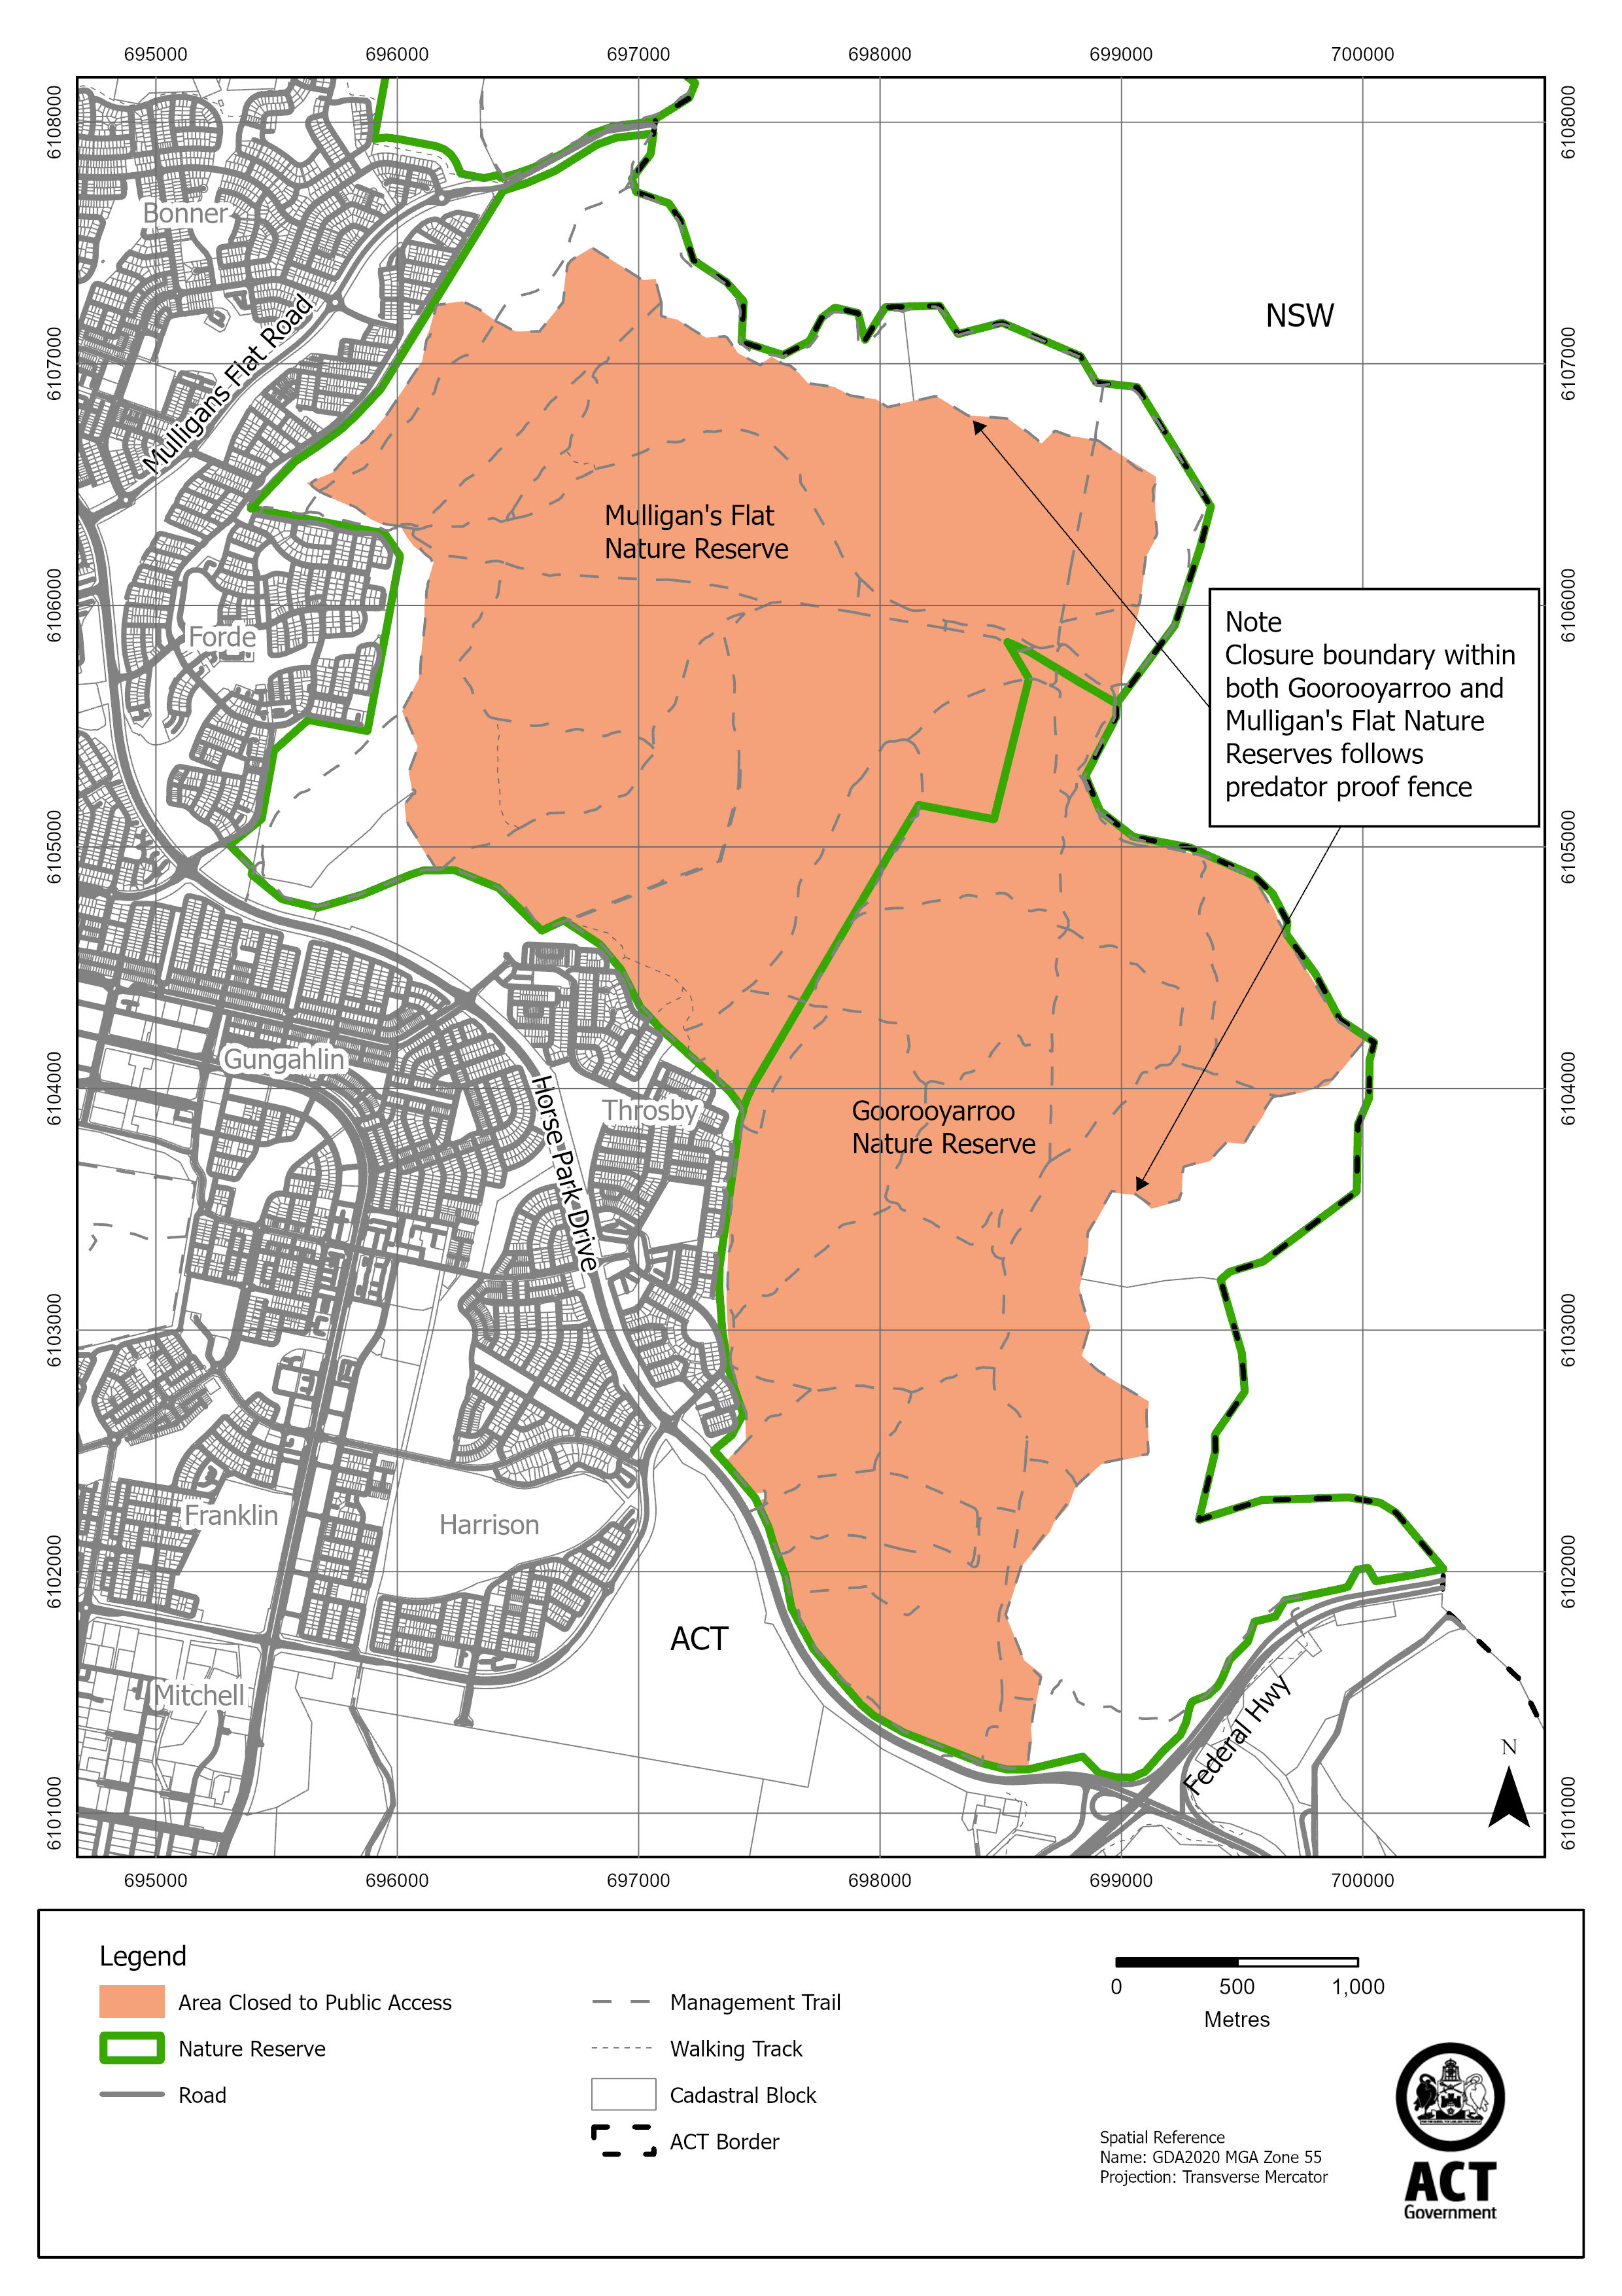

Schedule 2 Closure times
(see s 3)

Times when public access is prohibited

Beginning at 6:00 pm every Monday, Tuesday, Wednesday and Thursday and ending on the following day at 6:00 am.

Note The closure beginning on Thursday 31 July 2025 will end at midnight on 1 August 2025.

