Australian Capital Territory

Nature Conservation (Common Greenshank) Conservation Advice 2025

Notifiable instrument NI2025–301
made under the
Nature Conservation Act 2014, s 90C (Conservation advice)

1 Name of instrument
This instrument is the Nature Conservation (Common Greenshank) Conservation Advice 2025.

2 Commencement
This instrument commences on the day after its notification day.

3 Conservation advice for Common Greenshank
Schedule 1 sets out the conservation advice for Common Greenshank (Tringa ferruginea).

Linda Neaves
Chair, Scientific Committee
21 May 2025
Schedule 1
(see s 3)

Conservation Advice
Common Greenshank – Tringa nebularia

Conservation Status
The Common Greenshank – Tringa nebularia (Gunnerus, 1767) – is recognised as threatened in the following jurisdictions:
National Endangered, Environment Protection and Biodiversity Conservation Act 1999
Marine, Environment Protection and Biodiversity Conservation Act 1999
Migratory, Environment Protection and Biodiversity Conservation Act 1999
Vulnerable, Action Plan for Australian Birds
ACT Endangered, Nature Conservation Act 2014
NSW Endangered, Biodiversity Conservation Act 2016
VIC Endangered, Flora and Fauna Guarantee Act 1988
QLD Endangered, Nature Conservation Act 1992
NT Not Listed, Territory Parks and Wildlife Conservation Act 1976
WA Not Listed, Biodiversity Conservation Act 2016
SA Not Listed, National Parks and Wildlife Act 1972
TAS Endangered, Threatened Species Protection Act 1995

ELIGIBILITY
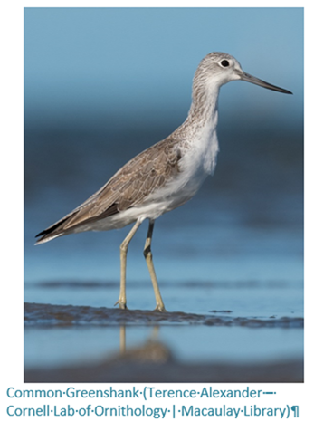
The Common Greenshank is listed as Endangered in the ACT Threatened Native Species List under IUCN Criterion A – A2bce+3ce+4bce. It is eligible for listing under this category as species numbers have reduced by more than 50 % over three generations, and the cause of decline has not ceased. It is thought that changes to coastal stopover locations, particularly along the coast of the Yellow Sea have contributed to the species’ decline (DCCEEW 2024; Attachment 1).

DESCRIPTION AND ECOLOGY
The Common Greenshank is a large heavily built wading bird, typically 30–35 cm long, has a wingspan of 55–65 cm, and weighs 170 grams. It has a long, slightly upturned bill with a finely pointed tip and has longish pale greyish-green, sometimes greenish-yellow legs and feet. The sexes are similar, but there is some seasonal variation in plumage (DCCEEW 2024). In its non-breeding plumage, while in Australia, the wings and back are pale grey-brown with fine white feather margins with the grey extending to the sides of the upper-breast. The lower breast and underparts are white (DCCEEW 2024).
The Common Greenshank is carnivorous. In Australia, it has been recorded eating molluscs, crustaceans, insects and, occasionally, fish and frogs (del Hoyo et al. 1996). The Common Greenshank generally feeds alone but roosts in small groups. It is nervous, wary, noisy and excitable, dashing about while feeding, bobbing its head. When flushed from vegetation, its ringing alarm call alerts other shorebirds. Its flight is fast and zigzagging with clipped wingbeats, and its toes protrude beyond its tail (Pizzey and Knight 2012; Higgins and Davies 1996).

DISTRIBUTION AND HABITAT

Common Greenshanks breed between late April and June (del Hoyo et al. 1996) across an extensive area from the British Isles through Scandinavia to eastern Russia. They migrate through Asia and Europe to Africa, South and south‐east Asia and Australasia, arriving in Australia from August usually via Western Australia (Lane 1987). Although considered an uncommon non-breeding migrant, Common Greenshanks are widespread in many coastal areas. They are also found throughout most of eastern Australia with 36% of the Australian population occurring on inland wetlands (Hansen et al 2016; Clemens 2017). In New South Wales, the species is widespread west of the Great Dividing Range, especially between the Lachlan and Murray Rivers and the Darling-Baaka River drainage basin, including the Macquarie Marshes, and north-west regions (Higgins and Davies 1996; DCCEEW 2024) (Map 1). Common Greenshanks usually depart the non-breeding grounds in Australia from March, however there are some sites where they overwinter in Australia.
Map 1. Modelled distribution of Common Greenshank.
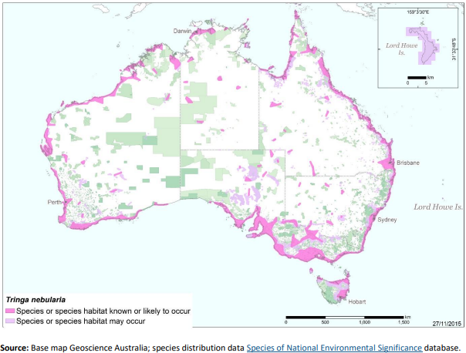
Common Greenshanks are infrequently recorded in the ACT, having been recorded here in 22% of years (1974 –2014) (ACT Government 2018). In the ACT, most sightings have been recorded at Kellys Swamp (1982, 1984, 2009 (COG 1984, 1987, 2011)), in Jerrabomberra Wetlands Nature Reserve (JWNR) (1994, 2006, 2019 (COG 1998, 2007, 2020)) or at the Fyshwick Sewage Ponds (1968, 2014 (COG 1969, 2016)). Other sightings have been recorded at Mulligans Flat (in 1995, 1996, 2013 (COG 1998, 1999, 2014)), Lake Burley Griffin (1979 (COG 1981) and Tuggeranong Weir (in 1986 (COG 1988). The Common Greenshank is recorded at a higher overall frequency nearby in NSW at Lake Bathurst and to a lesser extent at Lake George (ACT Government 2018). Records of the species in the ACT are between late October and late January with one anomaly in late June (eBird 2024) and in May in 2019 (COG 2020).
Common Greenshanks are known to use a variety of habitats. Freshwater habitats include open muddy or rocky shores of lakes or rivers, (del Hoyo et al. 1996), ponds (Snow and Perrins 1998) and flooded grasslands (Hockey et al. 2005). In coastal or marine habitats, the species is known to frequent swamps (del Hoyo et al. 1996), saltmarshes, sandy or muddy coastal flats, mangroves, estuaries (del Hoyo et al. 1996), lagoons, pools on tidal reefs (Snow and Perrins 1998), and areas of exposed coral (Urban et al. 1986). Common Greenshanks are even known to use artificial habitats, such as sewage farms, commercial saltfields, inundated rice-fields (del Hoyo et al. 1996) and reservoirs (Snow and Perrins 1998).
Figure 1: Distribution of Common Greenshank records in the ACT region – 1982–2017
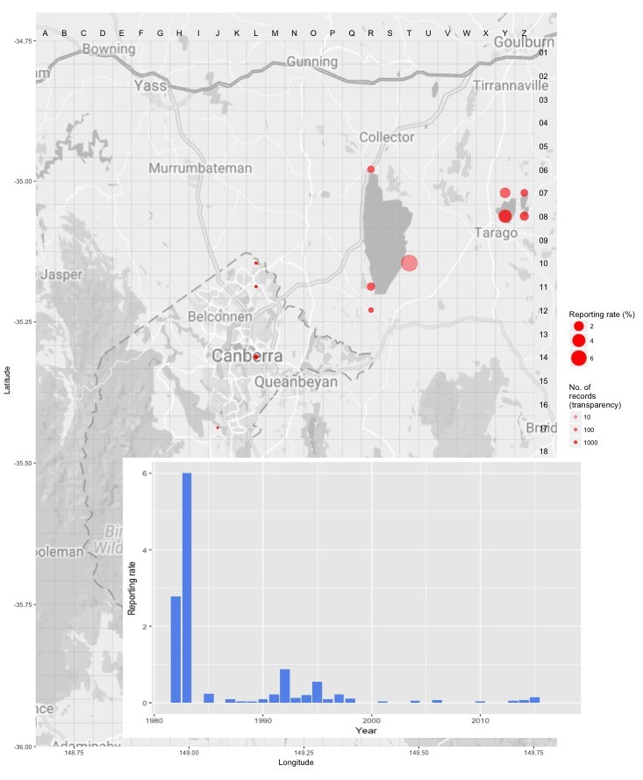
Source: Canberrabirds.org.au. (2018). Note: Reporting rate (%) is the proportion of all surveys in which the species was present. These data were collected by volunteer birdwatchers using various survey methods and, on some occasions, more than one person may have recorded bird sightings on the same day, which may skew the data.

Threats
Outside Australia, the main areas under threat are coastal stopover locations, particularly along the coast of the Yellow Sea. Threats in these areas include degradation and loss of the species’ preferred wetland habitats through, for example, environmental pollution, reduced river flows and human disturbance (Kelin and Qiang 2006).
In Australia, Common Greenshanks are potentially vulnerable to habitat loss due to climate change or water extraction for irrigation. Australia has lost and degraded many of its wetlands due to land use changes (e.g., development, farming practices) and undervaluing wetlands as important habitat (Geoscience Australia 2021). As they are notoriously wary, Common Greenshanks may also be more sensitive to disturbance than most other shorebird species (Clemens et al. 2021), which may affect foraging success in Australia and elsewhere.

Within the ACT, the Common Greenshank is primarily threatened by loss and degradation of suitable ephemeral habitat and disturbance to fitness-related behaviours (ACT Government 2018), mostly due to:
- anthropogenic climate change-related loss of wetland habitats, due to, for example, reduced rainfall and run-off, increased temperature and evaporation, and increasing incidence and severity of drought
- habitat degradation through unfavourable changes to or management of vegetation surrounding wetland sites, resulting in altered hydrology, poor water quality or water contamination
- anthropogenic disturbance, including visitors to publicly accessible wetlands for recreation (e.g., JWNR), leashed or roaming dogs and impacts of residential/industrial development including noise and light pollution.

Major Conservation Objective
The priority management objective should be to maintain viable, wild populations of the species in the long term, as a component of the indigenous biological resources of the ACT and as a contribution to regional and national conservation of the species. This includes the need to maintain natural evolutionary processes.

Conservation Priorities
Conservation actions specific to the Common Greenshank are detailed in the Commonwealth Conservation Advice (DCCEEW 2024). The ACT Action Plan for Listed Migratory Species outlines conservation actions relevant to migratory birds more generally and aims to Improve knowledge about the occurrence and management of listed migratory species in the ACT (ACT Government 2018). Conservation and management priorities for Common Greenshank in the ACT should be to:
- protect habitat, especially important feeding and roosting habitat, through improving legal site protection and managing other threats identified in the ACT Action Plan for Listed Migratory Species
- monitor population trends (as provided by citizen science) and condition of current and potential areas of habitat
- model the effects of climate change on the distribution and quality of the species’ habitat (see Climate Change section below)
- actively seek opportunities to involve members of local indigenous communities in on ground conservation activities for this species
- encourage and support the continuation and further development of community conservation activities, e.g., the Jerrabomberra Wetlands programs
- continue to support the engagement with other jurisdictions to support the international recovery of the species

Conservation Issues
It is recommended that quantitative targets and resourcing requirements are clearly identified in any Action Plan or other related projects/programs relevant to this species. Broader conservation issues need to be considered in developing and implementing actions arising from this advice.

Critical Habitat
Under the EPBC Act, ‘important habitat’ is a key concept for migratory species, as identified in EPBC Act Policy Statement 1.1 Significant Impact Guidelines - Matters of National Environmental Significance 2009. Important habitats in Australia for migratory shorebirds under the EPBC Act include those recognised as nationally or internationally important. JWNR and the Horse Park Wetlands (separate to Horse Park Drive Wetlands) are nationally important wetlands in the Australian Directory of Important Wetlands in Australia (DCCEEW 2023).
The Commonwealth Conservation Advice (DCCEEW 2024) identifies ‘habitat critical to the survival’ or important habitats of a species refers to areas that are necessary:
- for activities such as foraging, breeding, roosting, or dispersal
- for the long-term maintenance of the species (including the maintenance of species essential to the survival of the species, such as macrobenthos (sediment-dwelling invertebrate prey)
- to maintain genetic diversity and long-term evolutionary development, or
- for the reintroduction of populations or recovery of the species.
Habitat critical to the survival of the species, should not be destroyed or modified. Actions that have indirect impacts on habitat critical to the survival of the species should also be minimised (i.e., human disturbance or light pollution impacting habitat). Actions that compromise survival, such as the introduction of new diseases, weeds, or predators, should also be avoided. Actions that remove habitat critical to the survival of the Common Greenshank would interfere with recovery and reduce the area of occupancy of the species. It is important to retain as much foraging and roosting habitat as possible (DCCEEW 2024).
No Critical Habitat as defined under section 207A of the EPBC Act has been identified or included in the Register of Critical Habitat under the EPBC Act.

Climate Change
Climate change impacts are inevitable and will affect the likelihood of persistence, within the ACT, of many species. Capacity should be developed to model the impact on Common Greenshank and its habitat under likely climate change scenarios if we are to anticipate and manage the impacts of climate change. This will require a combination of research and the development of in-house capacity for the collection of relevant data and its application in climate change modelling.

Jurisdictional Collaboration
As Common Greenshank is a migratory species, the development of any policies and action/recovery plans should be discussed between relevant jurisdictional entities.

Ngunnawal Community Engagement
The ACT Government should actively facilitate, the inclusion of the Ngunnawal people in the conservation of this species and its habitat as part of Ngunnawal Country. Reference to the draft Cultural Resource Management Plan (ACT Government in prep.) would be useful to inform culturally appropriate resource management including of native species that aligns with achieving conservation outcomes for the species.

Other Relevant Advice, plans or Prescriptions
- Commonwealth Conservation Advice – Common Greenshank (DCCEEW 2024)
- ACT Action Plan – Listed Migratory Species Action Plan (ACT Government 2018)

Listing Background
Common Greenshank is a listed Marine Species and Migratory Species under the Environment Protection and Biodiversity Conservation Act 1999 (EPBC Act) and is also listed as an Endangered species under the EPBC Act, effective 5 January 2024. It was found eligible for listing as Endangered under Criterion 1 (A2bce+3ce+4bce) of the EPBC Act. In 2025, under the Nature Conservation Act 2014, the ACT Scientific Committee recommended the Common Greenshank be listed in the Endangered category in the ACT Threatened Native Species List to align with the EPBC Act listing.

Action Plan Decision
The ACT Scientific Committee does not recommend that the Minister for the Environment should make the decision to have an action plan for the species in the ACT under the Nature Conservation Act 2014 at this time provided the provisions of the ACT Action Plan for Listed Migratory Species (ACT Government 2018) are strengthened to protect important habitat with an adaptive management and monitoring approach. Actions for shore birds, including the Common Greenshank are included in that plan, but need to be strengthened for threatened species and their habitats, especially relating to dealing with the impacts from urban development.
A National Recovery Plan is not required to be prepared for the species (DCCEEW 2024) as the approved Commonwealth Conservation Advice is deemed to be an effective, efficient and responsive document to guide the implementation of priority management actions, mitigate key threats and support the recovery of the species. It is considered to support the species recovery by identifying priority actions, stakeholders for engagement, and the survey and research priorities to facilitate a better understanding of key threats as well as biological and ecological knowledge gaps (DSSEEW 2024).

References
ACT Government 2018. Action Plan for Listed Migratory Species. Environment, Planning and Sustainable Development Directorate, ACT Government, Canberra.
ACT Government in prep. Draft Cultural Resource Management Plan. Environment, Planning and Sustainable Development Directorate, ACT Government, Canberra.
Birdlife International 2024. Species factsheet: Tringa nebularia.
https://datazone.birdlife.org/species/factsheet/common-greenshank-tringa-nebularia
Canberra Birds 2018. Common Greenshank Tringa nebularia data sheet. Canberra Ornithologists Group (COG), Canberra. http://canberrabirds.org.au/birds/common-greenshank/
COG 1969. Canberra Bird Notes 4(1): 11.
COG 1981. Annual Bird Report: 1 July 1979 to 30 June 1980. Canberra Bird Notes 6(1): 3–42.
COG 1984. Observations of Birds at Jerrabomberra Wetlands and Eastern Lake Burley Griffin: July 1982-June 1983. Canberra Bird Notes 9(1): 2–22.
COG 1987. Annual Bird Report: 1 July 1985 to 30 June 1986. Canberra Bird Notes 12(2): 30–83.
COG 1988. Annual Bird Report: 1 July 1986 to 30 June 1987. Canberra Bird Notes 13(3): 54–102.
COG 1998. Annual Bird Report: 1 July 1993 to 30 June 1994 and 1 July 1994 to 30 June 1995. Canberra Bird Notes 23(3): 1–96.
COG 1999. Annual Bird Report: 1 July 1995 to 30 June 1996 and 1 July 1996 to 30 June 1997. Canberra Bird Notes 24(2): 49–140.
COG 2007. Annual Bird Report: 1 July 2005 to 30 June 2006. Canberra Bird Notes 32(1): 1–68.
COG 2011. Annual Bird Report: 1 July 2009 to 30 June 2010. Canberra Bird Notes 36(1): 1–80.
COG 2014. Annual Bird Report: 1 July 2012 to 30 June 2013. Canberra Bird Notes 39(1): 1–106.
COG 2016. Annual Bird Report: 1 July 2014 to 30 June 2015. Canberra Bird Notes 41(1): 1–112.
COG 2020. Annual Bird Report: 1 July 2018 to 30 June 2019. Canberra Bird Notes 45(1): 1–106.
Clemens RS 2017. Ecology and Conservation of Australia's Shorebirds. PhD thesis. University of Queensland, Brisbane.
Clemens R, Rogers D, Carey M and Garnett ST 2021. Common Greenshank Tringa nebularia. In The Action Plan for Australian Birds 2020. (Eds Garnett ST and Baker GB) pp. 305–308. CSIRO Publishing, Melbourne.
Department of Climate Change, Energy, the Environment and Water (DCCEEW) 2023. Directory of Important Wetlands in Australia. Australian Wetlands Database. https://www.dcceew.gov.au/water/wetlands/australian-wetlands-database/directory-important-wetlands
Department of Climate Change, Energy, the Environment and Water (DCCEEW) 2024. Conservation Advice for Tringa nebularia (Common Greenshank). Department of Climate Change, Energy, the Environment and Water (Commonwealth), Canberra.
del Hoyo J, Elliott A and Sargatal J (Eds) 1996. Handbook of the Birds of the World. Volume 3, Hoatzin to Auks. Lynx Edicions, Barcelona.
eBird 2024. Explore - Common Greenshank Tringa nebularia. https://ebird.org/species/comgre/AU-ACT
Gunnerus JE 1767. in Knud Leem's, Beskrivelse over Finmarken's Lapper. Copenhagen Vol. 1. [251].
Higgins PJ and Davies SJJF (Eds.) 1996. Handbook of Australian, New Zealand and Antarctic Birds. Volume Three – Snipe to Pigeons. Melbourne, Victoria: Oxford University Press
Hockey PAR, Dean WRJ and Ryan PG 2005. Roberts Birds of Southern Africa. Trustees of the John Voelcker Bird Book Fund, Cape Town
Kelin C, Qiang X 2006. Conserving migratory shorebirds in the Yellow Sea region. In: Boere G, Galbraith C Stroud D (Eds.), Waterbirds Around the World pp. 319. The Stationery Office, Edinburgh.
Lane BA 1987. Shorebirds in Australia. Reed, Sydney.
Melville DS 1997. Threats to waders along the East Asian-Australasian Flyway. In: Straw P (Ed.) Shorebird Conservation in the Asia-Pacific Region pp. 15–34. Birds Australia, Melbourne.
Pizzey G and F. Knight F 1997. The Graham Pizzey and Frank Knight Field Guide to the Birds of Australia. Sydney: Angus and Robertson.
Snow DW and Perrins CM 1998. The Birds of the Western Palearctic, Volume 1: Non-Passerines. Oxford University Press, Oxford.
Urban EK, Fry CH and Keith S 1986. The Birds of Africa, Volume II. Academic Press, London.
Weller D, Kidd L, Lee C, Klose S, Jaensch R and Driessen J 2020. Directory of Important Habitat for Migratory Shorebirds in Australia. Report prepared for the Australian Government Department of Agriculture, Water and the Environment. BirdLife Australia, Melbourne.

Further Information
Further information on the related Action Plan or other threatened species and ecological communities can be obtained from: Environment, Planning and Sustainable Development Directorate (EPSDD).
Phone: (02) 132281, EPSDD–Environment website: https://www.act.gov.au/environment

Attachment A: Listing Assessment (DCCEEW 2024)

