Australian Capital Territory

Nature Conservation (Curlew Sandpiper) Conservation Advice 2025

Notifiable instrument NI2025–302
made under the
Nature Conservation Act 2014, s 90C (Conservation advice)

1 Name of instrument
This instrument is the Nature Conservation (Curlew Sandpiper) Conservation Advice 2025.

2 Commencement
This instrument commences on the day after its notification day.

3 Conservation advice for Curlew Sandpiper
Schedule 1 sets out the conservation advice for Curlew Sandpiper (Calidris ferruginea).

Linda Neaves
Chair, Scientific Committee
21 May 2025

Schedule 1
(see s 3)

Conservation Advice
Curlew Sandpiper – Calidris ferruginea

Conservation Status
The Curlew Sandpiper – Calidris ferruginea (Pontoppidan, 1763) – is recognised as threatened in the following jurisdictions:
International Vulnerable, International Union for Conservation of Nature (IUCN) Red List
National Critically Endangered, Environment Protection and Biodiversity Conservation Act 1999
Marine, Environment Protection and Biodiversity Conservation Act 1999
Migratory, Environment Protection and Biodiversity Conservation Act 1999
Endangered, Action Plan for Australian Birds 2020
ACT Critically Endangered, Nature Conservation Act 2014
NSW Critically Endangered, Biodiversity Conservation Act 2016
VIC Critically Endangered, Flora and Fauna Guarantee Act 1988
QLD Critically Endangered, Nature Conservation Act 1992
NT Critically Endangered, Territory Parks and Wildlife Conservation Act 1976
WA Critically Endangered, Biodiversity Conservation Act 2016
SA Endangered, National Parks and Wildlife Act 1972
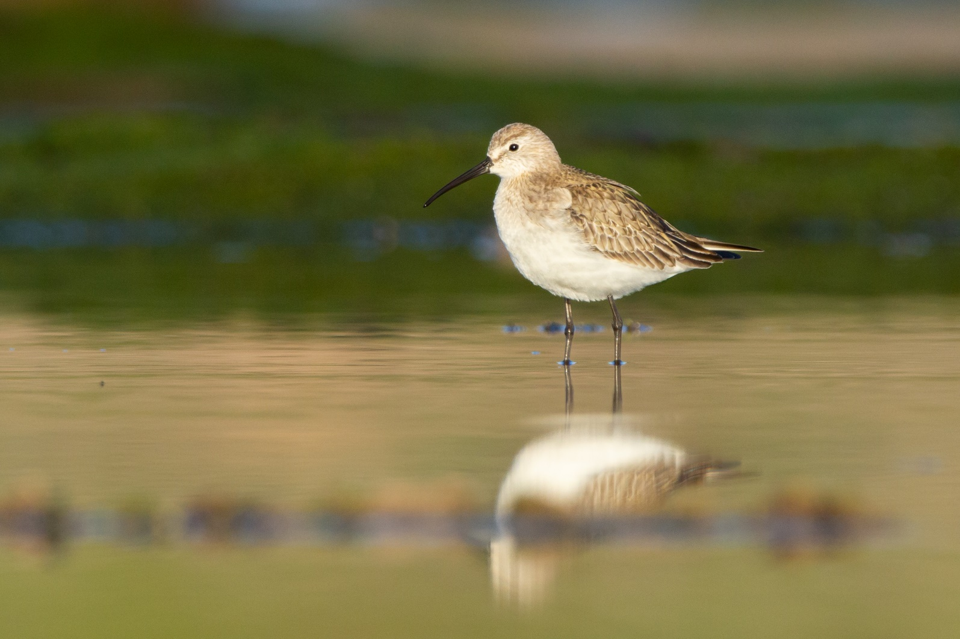
TAS Not Listed, Threatened Species Protection Act 1995
Curlew Sandpiper (Joel Poyitt – Cornell Lab of Ornithology|Macaulay Library)

ELIGIBILITY
The Curlew Sandpiper is listed as Critically Endangered in the ACT Threatened Native Species List under IUCN Criterion A – A2bce+3ce+4bce as the species has undergone a reduction in numbers of over 80 percent over three generations, and the cause of decline has not ceased. While not fully understood, the reduction in numbers is thought to be due, in part, to the increasing frequency and length of droughts, particularly in south-eastern Australia (Clemens 2017). Elsewhere, the main threats are changes to coastal staging locations, particularly along the coast of the Yellow Sea, pollution, and hunting or drowning from fishing nets. (DCCEEW 2024; Attachment 1).

DESCRIPTION AND ECOLOGY
The Curlew Sandpiper is a small-medium-sized wader bird, typically 18–23 cm long, has a wingspan of 38–41 cm, and weighs 57 grams. It has a long, black decurved bill with a finely pointed tip and has longish black legs and feet. The sexes appear similar, however, females are slightly larger and have a longer bill and there is marked seasonal variation in plumage (DCCEEW 2024). In its non-breeding plumage, it is grey-brown above, and white below, with a white wing-bar and rump visible in flight. In breeding plumage, it is bright reddish-brown below and the wings are barred black (Birdlife Australia 2024). The Curlew Sandpiper feeds on insects and their larvae when breeding and when in Australia on small marine invertebrates. Curlew Sandpiper often feed in mixed flocks with other species of shorebirds, pecking at invertebrates on the surface of the mud or making shallow probes below its surface (Higgins and Davies 1996; Dann 1999).

DISTRIBUTION AND HABITAT

Curlew Sandpipers breed in June and July in the Arctic of northern Siberia. They migrate through Europe and the Middle East to Africa, and through South Asia and South‐east Asia and Australasia (Weller et al. 2020). They arrive in Australia in September and are most common in the far south-east and north-west of Australia where they are widespread in many coastal sites and to a lesser extent in suitable inland wetland habitats. For example, they occur along the entire coast of New South Wales, particularly in the Hunter Estuary and sometimes in freshwater wetlands in the Murray-Darling Basin (DCCEEW 2024) (Map 1). The Curlew Sandpiper departs the non-breeding grounds in Australia in April, however many juveniles may over winter in Australia.
Map 1. Modelled distribution of the Curlew Sandpiper
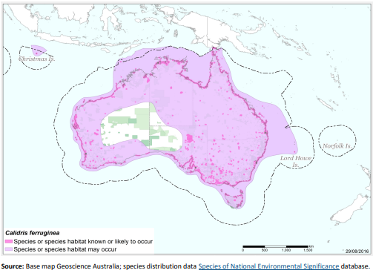
In Australia, habitat critical to the survival of Curlew Sandpipers includes a mosaic of feeding and roosting habitat (DCCEEW 2024). The species may be highly selective about foraging environments because of its specialised feeding techniques. Feeding habitat includes exposed sandy or soft mud substrates on intertidal flats and beaches. Curlew Sandpipers also occur at inland wetlands when conditions are suitable, particularly on the muddy edges of marshes, large rivers and lakes (both saline and freshwater), irrigated land, flooded areas (del Hoyo et al. 1996), dams (Urban et al. 1986), and saltpans. Curlew Sandpipers also roost in mixed-species flocks, usually in sheltered mudflats or inland water bodies.
The Curlew Sandpiper is mainly a coastal species and is rarely recorded in the ACT. The species has been recorded in the ACT between late August and early November (ebird 2024), and only in 10% of years (1974–2014) (ACT Government 2018). It appears to coincide to the times when there is widespread and severe drought across South-eastern Australia, and it is possible that they are appearing in the ACT region when there is limited freshwater habitats available elsewhere. The published records are mostly of single birds seen within Jerrabomberra Wetlands Nature Reserve (JWNR) at Kellys Swamp and Jerrabomberra Creek, and at Fyshwick Sewage Ponds. However, eight birds were seen together in JWNR in September 1972 (COG 1972). Single birds in this area were also recorded in early September and November in 1982 and early January 1983 (COG 1984 CBN 9(1)), in January 2002, late August 2004 (COG 2006), mid-September 2009 (COG 2011), early November 2013 (COG 2015) and one at the end of September 2018 (COG 2020).
Figure 1: Distribution of Curlew Sandpiper records in the ACT region – 1982–2017
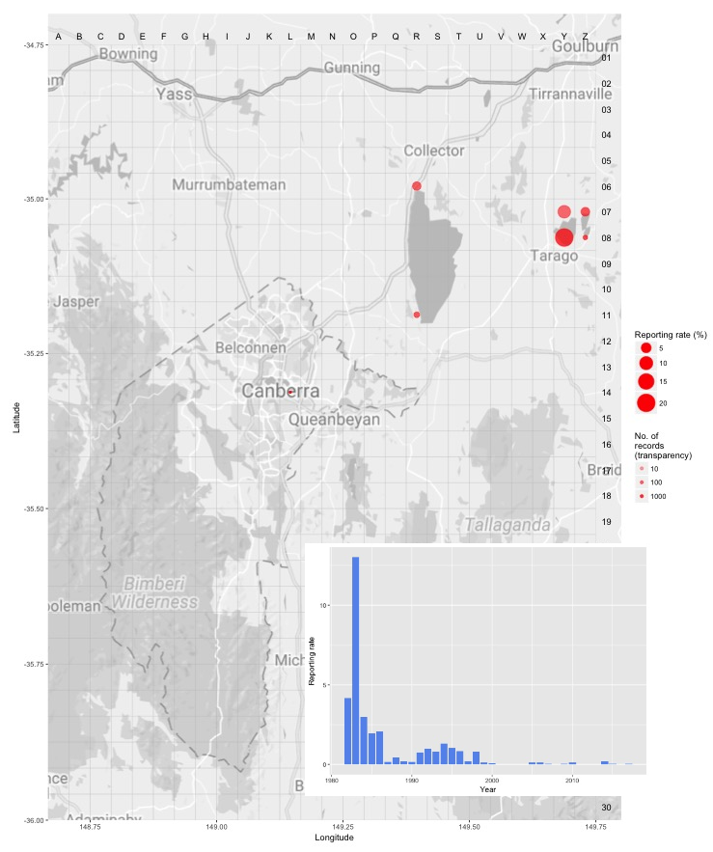
Source: Canberrabirds.org.au. (2018). Note: Reporting rate (%) is the proportion of all surveys in which the species was present. These data were collected by volunteer birdwatchers using various survey methods and, on some occasions, more than one person may have recorded bird sightings on the same day, which may skew the data.

Threats
In Australia, the major threat to this species is an increase in the frequency and length of droughts (Clemens 2017). The ongoing loss and degradation of habitat, including coastal habitat affected by rising sea levels, is also likely to threaten Curlew Sandpiper populations in Australia.
Within the ACT, the Curlew Sandpiper is primarily threatened by loss and degradation of suitable ephemeral habitat and disturbance to fitness-related behaviours (ACT Government 2018), mostly due to:
- anthropogenic climate change-related loss of wetland habitats, due to, for example, reduced rainfall and run-off, increased temperature and evaporation, and increasing incidence and severity of drought
- habitat degradation through unfavourable changes to or management of vegetation surrounding wetland sites, resulting in altered hydrology, poor water quality or water contamination
- anthropogenic disturbance, including visitors to publicly accessible wetlands for recreation (e.g., JWNR); leashed or roaming dogs; potentially cats and foxes; and impacts of residential/industrial development including noise, light and chemical pollution, as well as redirected excessive run-off from nearby urban development that can adversely impact the pedoderm and corresponding ecosystem function.

Major Conservation Objective
The priority management objective should be to maintain viable, wild populations of the species in the long term, as a component of the indigenous biological resources of the ACT and as a contribution to regional and national conservation of the species. This includes the need to maintain natural evolutionary processes.

Conservation Priorities
Conservation actions specific to the Curlew Sandpiper are detailed in the Commonwealth Conservation Advice (DCCEEW 2024). The ACT Action Plan for Listed Migratory Species outlines conservation actions relevant to migratory birds,and aims to improve knowledge about the occurrence and management of listed migratory species in the ACT (ACT Government 2018). Conservation and management priorities for Curlew Sandpiper in the ACT should be to:
- protect habitat, especially important feeding and roosting habitat through improving legal site protection and managing other threats identified in the ACT Action Plan for Listed Migratory Species
- monitor population trends and condition as provided by citizen science
- model the effects of climate change on the distribution and quality of the species’ habitat (see below)
- actively seek opportunities to involve members of local indigenous communities in on ground conservation activities for this species
- encourage and support the continuation and further development of community conservation activities, e.g., the Jerrabomberra Wetlands programs
- continue to support the engagement with other jurisdictions to support the international recovery of the species

Conservation Issues
It is recommended that quantitative targets and resourcing requirements are clearly identified in any Action Plan or other related projects/programs relevant to this species. Broader conservation issues need to be considered in developing and implementing actions arising from this advice.

Critical Habitat
Under the EPBC Act, ‘important habitat’ is a key concept for migratory species, as identified in EPBC Act Policy Statement 1.1 Significant Impact Guidelines - Matters of National Environmental Significance 2009. Important habitats in Australia for migratory shorebirds under the EPBC Act include those recognised as nationally or internationally important. JWNR and the Horse Park Wetlands (separate to Horse Park Drive Wetlands) are nationally important wetlands in the Australian Directory of Important Wetlands in Australia (DCCEEW 2023).
The Commonwealth Conservation Advice (DCCEEW 2024) identifies ‘habitat critical to the survival’ or important habitats of a species refers to areas that are necessary:
- for activities such as foraging, breeding, roosting, or dispersal
- for the long-term maintenance of the species (including the maintenance of species essential to the survival of the species, such as macrobenthos (sediment-dwelling invertebrate prey)
- to maintain genetic diversity and long-term evolutionary development, or
- for the reintroduction of populations or recovery of the species.
Habitat critical to the survival of the species, should not be destroyed or modified. Actions that have indirect impacts on habitat critical to the survival of the species should also be minimised (i.e., human disturbance or light pollution impacting habitat). Actions that compromise survival, such as the introduction of new diseases, weeds, or predators, should also be avoided. Actions that remove habitat critical to the survival of the Curlew Sandpiper would interfere with recovery and reduce the area of occupancy of the species. It is important to retain as much foraging and roosting habitat as possible (DCCEEW 2024).
No Critical Habitat as defined under section 207A of the EPBC Act has been identified or included in the Register of Critical Habitat under the EPBC Act.

Climate Change
Climate change impacts are inevitable and will affect the likelihood of persistence, within the ACT, of many species. The Curlew Sandpiper is only using habitat in the ACT intermittently but if this increases then capacity should be developed to model the impact on the species and its habitat under likely climate change scenarios if we are to anticipate and manage the impacts of climate change. This will require a combination of research and the development of in-house capacity for the collection of relevant data and its application in climate change modelling.

Jurisdictional Collaboration
As Curlew Sandpiper is a migratory species, the development of any policies and action/recovery plans should be discussed between relevant jurisdictional entities.

Ngunnawal Community Engagement
The ACT Government should actively facilitate, the inclusion of the Ngunnawal people in the conservation of this species and its habitat as part of Ngunnawal Country. Reference to the draft Cultural Resource Management Plan (ACT Government in prep.) would be useful to inform culturally appropriate resource management including of native species that aligns with achieving conservation outcomes for the species.

Other Relevant Advice, plans or Prescriptions
- Commonwealth Conservation Advice – Curlew Sandpiper (DCCEEW 2024)
- ACT Action Plan – Migratory Species Action Plan (ACT Government 2018)

Listing Background
Curlew Sandpiper is a listed Marine Species and Migratory Species under the Environment Protection and Biodiversity Conservation Act 1999 (EPBC Act) and is also listed as a Critically Endangered species under the EPBC Act, effective 26 May 2015. It was reassessed under the EPBC and on 5 January 2024 is retained as Critically Endangered under Criterion 1 (A2bce+3ce+4bce) of the EPBC Act. In 2025, under the Nature Conservation Act 2014, the ACT Scientific Committee recommended the Curlew Sandpiper be listed in the Critically Endangered category in the ACT Threatened Native Species List to align with the EPBC Act listing.

Action Plan Decision
The ACT Scientific Committee does not recommend that the Minister for the Environment should make the decision to have an action plan for the species in the ACT under the Nature Conservation Act 2014 at this time provided the provisions of the ACT Action Plan for Listed Migratory Species (ACT Government 2018) are strengthened to protect important habitat with an adaptive management and monitoring approach. Actions for shore birds, including the Curlew Sandpiper are included in that plan, but need to be strengthened to include guidance for the conservation of threatened species and their habitats, especially relating to dealing with the impacts from urban development.
A National Recovery Plan is not required to be prepared for the species (DCCEEW 2024) as the approved Commonwealth Conservation Advice is deemed to be an effective, efficient and responsive document to guide the implementation of priority management actions, mitigate key threats and support the recovery for the species. It is considered to support the species recovery by identifying priority actions, stakeholders for engagement, and the survey and research priorities to facilitate a better understanding of key threats as well as biological and ecological knowledge gaps (DSSEEW 2024).

References
ACT Government 2018. Action Plan for Listed Migratory Species. Environment, Planning and Sustainable Development Directorate, ACT Government, Canberra. https://www.legislation.act.gov.au/di/2018-27/
ACT Government in prep. Draft Cultural Resource Management Plan. Environment, Planning and Sustainable Development Directorate, ACT Government, Canberra.
Birdlife Australia 2024. Profile - Curlew Sandpiper Calidris ferruginea. https://birdlife.org.au/bird-profiles/curlew-sandpiper/
BirdLife International 2017. Calidris ferruginea (amended version of 2016 assessment). The IUCN Red List of Threatened Species 2017: e.T22693431A110631069. https://www.iucnredlist.org/species/22693431/110631069
Birdlife International 2024. Species factsheet: Calidris ferruginea. https://datazone.birdlife.org/species/factsheet/Curlew-sandpiper-calidris-ferruginea
Canberra Birds 2018. Curlew Sandpiper Calidris ferruginea data sheet. Canberra Ornithologists Group (COG), Canberra. http://canberrabirds.org.au/birds/Curlew-sandpiper/
COG 2002. Waders in plenty. Canberra Bird Notes 2(4): 10.
COG 2006. Annual Bird Report: 1 July 2004 to 30 June 2005. Canberra Bird Notes 31(1): 1–80.
COG 2011. Annual Bird Report: 1 July 2009 to 30 June 2010. Canberra Bird Notes 36(1): 1–80.
COG 2015. Annual Bird Report: 1 July 2013 to 30 June 2014. Canberra Bird Notes 40(1): 1–114.
COG 2020. Annual Bird Report: 1 July 2018 to 30 June 2019. Canberra Bird Notes 45(1): 1–106.
Clemens RS 2017. Ecology and Conservation of Australia's Shorebirds. PhD thesis. University of Queensland, Brisbane.
Clemens R, Rogers D, Carey M and Garnett ST 2021. Curlew Sandpiper Calidris ferruginea. In The Action Plan for Australian Birds 2020. (Eds Garnett ST and Baker GB) pp. 287–290. CSIRO Publishing, Melbourne.
Dann P 1999. Foraging behaviour and diets of Red-necked Stints and Curlew Sandpipers in southeastern Australia. Wildlife Research 27:61–68.
Department of Climate Change, Energy, the Environment and Water (DCCEEW) 2023. Directory of Important Wetlands in Australia. Australian Wetlands Database. https://www.dcceew.gov.au/water/wetlands/australian-wetlands-database/directory-important-wetlands
Department of Climate Change, Energy, the Environment and Water (DCCEEW) 2024. Conservation Advice for Calidris ferruginea (Curlew Sandpiper). Department of Climate Change, Energy, the Environment and Water (Commonwealth), Canberra.
del Hoyo J, Elliott A and Sargatal J (Eds) 1996. Handbook of the Birds of the World. Volume 3, Hoatzin to Auks. Lynx Edicions, Barcelona.
eBird 2024. Explore - Curlew Sandpiper Calidris ferruginea. https://ebird.org/species/cursan/AU-ACT
eBird 2016. eBird: An online database of bird distribution and abundance [web application]. eBird, Cornell Lab of Ornithology, Ithaca, New York. ACT data portal at: https://ebird.org/region/AU-ACT?yr=all
Higgins PJ and Davies SJJF (Eds.) 1996. Handbook of Australian, New Zealand and Antarctic Birds. Volume Three – Snipe to Pigeons. Melbourne, Victoria: Oxford University Press
Melville DS 1997. Threats to waders along the East Asian-Australasian Flyway. In: Straw P (Ed.) Shorebird Conservation in the Asia-Pacific Region pp. 15–34. Birds Australia, Melbourne.
Pontoppidan EL 1763. Den Danske Atlas eller Konge-Riget Dannemark. Kisbenhavn: Trykt hos Kongelig Iniversiteta Bogtrykker A.H. Godiche Vol. 1 724 [624].
Urban EK, Fry CH and Keith S 1986. The Birds of Africa, Volume II. Academic Press, London.
Weller D, Kidd L, Lee C, Klose S, Jaensch R and Driessen J 2020. Directory of Important Habitat for Migratory Shorebirds in Australia. Report prepared for the Australian Government Department of Agriculture, Water and the Environment. BirdLife Australia, Melbourne.

Further Information
Further information on the related Action Plan or other threatened species and ecological communities can be obtained from: Environment, Planning and Sustainable Development Directorate (EPSDD).
Phone: (02) 132281, EPSDD–Environment website: https://www.act.gov.au/environment

Attachment A: Listing Assessment (DCCEEW 2024)

