Australian Capital Territory

Nature Conservation (Sharp-tailed Sandpiper) Conservation Advice 2025

Notifiable instrument NI2025-303
made under the
Nature Conservation Act 2014, s 90C (Conservation advice)

1 Name of instrument
This instrument is the Nature Conservation (Sharp-tailed Sandpiper) Conservation Advice 2025.

2 Commencement
This instrument commences on the day after its notification day.

3 Conservation advice for Sharp-tailed Sandpiper
Schedule 1 sets out the conservation advice for Sharp-tailed Sandpiper (Calidris acuminata).

Linda Neaves
Chair, Scientific Committee
21 May 2025

Schedule 1
(see s 3)

Conservation Advice
Sharp-tailed Sandpiper – Calidris acuminata

Conservation Status
The Sharp-tailed Sandpiper – Calidris acuminata (Horsfield 1821) – is recognised as threatened in the following jurisdictions:
International Vulnerable, International Union for Conservation of Nature (IUCN) Red List
National Vulnerable, Environment Protection and Biodiversity Conservation Act 1999
Marine, Environment Protection and Biodiversity Conservation Act 1999
Migratory, Environment Protection and Biodiversity Conservation Act 1999
Vulnerable, Action Plan for Australian Birds
ACT Vulnerable, Nature Conservation Act 2014
NSW Not listed, Biodiversity Conservation Act 2016
VIC Not listed, The Flora and Fauna Guarantee Act 1988
QLD Not listed, Nature Conservation Act 1992
SA Not listed, National Parks and Wildlife Act 1972
TAS Not Listed, Threatened Species Protection Act 1995

ELIGIBILITY
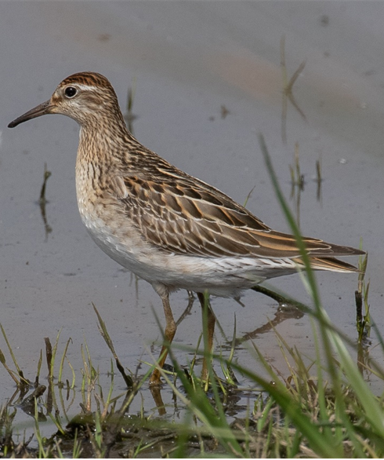The Sharp-tailed Sandpiper is listed as Vulnerable in the ACT Threatened Native Species List under IUCN Criterion A – A2bce+3ce+4bce as the species has undergone a substantial reduction in numbers over three generations, with increasing frequency and severity of drought in Australia contributing to the species’ decline (Clemens 2017) it is predicted these effects will continue and be amplified by climate change (Evans et al. 2017). Elsewhere, the main threats are changes to coastal stopover locations, particularly along the coast of the Yellow Sea (DCCEEW 2024; Attachment 1).
Sharp-tailed Sandpiper (Rawshorty – NatureMapr)

DESCRIPTION AND ECOLOGY
The Sharp-tailed Sandpiper is a small-medium-sized wading bird, typically 17–22 cm long, has a wingspan of 36–43 cm, and weighs 65 grams. It has a flat back, pot belly and somewhat drawn-out rear end. It has a small flat head on a short neck with a short and slightly decurved bill. The species has medium length legs. The sexes are similar and there is marked seasonal variation in plumage (Higgins and Davies 1996). Breeding adults are heavily marked with chevrons and spots on the underparts and have a rich chestnut cap and white eyeing. Non-breeding adults are duller grey-brown with a drab brown cap. Juveniles are brightest, with a plain buffy breast, bright cap, and contrasting white eyeline (eBird 2024).
The Sharp-tailed Sandpiper is omnivorous and forages on seeds, worms, molluscs, crustaceans and insects (Higgins and Davies 1996, Weller et al. 2020).

Distribution and Habitat

The Sharp-tailed Sandpiper breeds in northern Siberia from June to August. It departs on its southern migration journey from late June, with most birds leaving in July. Adult males leave before females, which depart before the juveniles. The species is a passage migrant through eastern Mongolia, China, Korea, Japan, Micronesia, the Philippines, and Southeast Asia.

During the non-breeding season, approximately 91 percent of the East Asian - Australasian population occurs in Australia and New Zealand (Bamford et al. 2008). Sharp-tailed Sandpipers normally arrive in northern Australia in early September and occur within all states and territories (Map 1). They are found mostly in the south-east and are widespread in both inland wetlands and coastal locations. The species is widespread in most regions of New South Wales and Victoria as well as occurring in Canberra (Figure 1). Being one of the first shorebirds to leave Australia, the Sharp-tailed Sandpiper typically departs the non-breeding grounds by April. Overwintering individuals in Australia are extremely rare.
Map 1. Modelled distribution of Sharp-tailed Sandpiper.
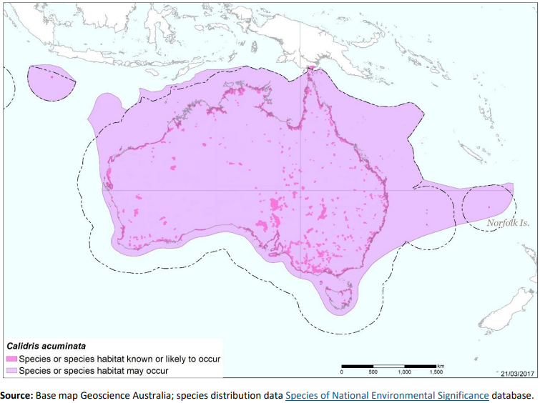

Sharp-tailed Sandpipers are more flexible in their habitat choice and more tolerant of grassy vegetation than most shorebird species. The highest density groups are usually found around grassy edges of shallow inland freshwater wetlands (DCCEEW 2024) up to 800 m asl. (Quintero and Jetz 2018). They are also found around sewage ponds, flooded fields, mudflats, mangroves, rocky shores, and beaches (DCCEEW 2024)). After rainfall events, the species may also feed on areas of agricultural pasture (Higgins and Davies 1996; Weller et al. 2020).
Figure 1: Distribution of Sharp-tailed Sandpiper records in the ACT region – 1982–2017
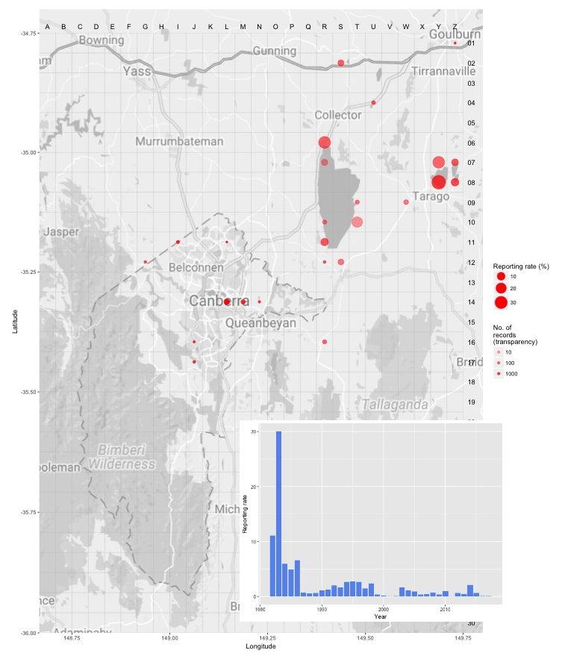
Source: Canberrabirds.org.au. (2018). Note: Reporting rate (%) is the proportion of all surveys in which the species was present. These data were collected by volunteer birdwatchers using various survey methods and, on some occasions, more than one person may have recorded bird sightings on the same day, which may skew the data.
The Sharp-tailed Sandpiper is the second most regularly occurring shorebird in the ACT (after Latham’s Snipe) with records showing it has been recorded here in 78% of years over the previous 40 years (Australian Wildlife Services 2016 in ACT Government 2018). In the ACT, most individuals have been recorded between September and January (eBird 2024) but birds can arrive in the ACT as early as August and stay until April. Around 78% of observations of this species in the ACT are from Jerrabomberra Wetlands Nature Reserve (JWNR), with another 14% at the Fyshwick Sewage Ponds (COG 2015). The largest flock size recorded in the ACT in 2018 was just 18 birds (in October at JWNR), a vast difference to the 300 birds recorded in 2017 and 800 in 2016 (COG 2019, 2020). Comparable analysis is not available since 2018, but numbers have likely remained at or below 2018 levels (ebird 2025; NatureMapr 2025). The species may occasionally be seen at other locations including Lake Burley Griffin East Basin, Norgrove Park Wetland, Mulligans Flat Dam, Ginninderra Creek, Canturf turf farm (Fyshwick) and West Belconnen Pond (eBird and COG in ACT Government 2018).
Larger groups tend to be seen at Fyshwick Sewage Pond compared to elsewhere in the ACT (e.g., 28 birds were seen on 26 October 2014, 61 observations of this species in 2014, 32 in 2013 (eBird 2015)). The most important habitat in the region for the Sharp-tailed Sandpiper occurs in NSW at Lake Bathurst (e.g., 3000 birds recorded in November 2014, (COG 2016)) and to a lesser extent Lake George (ACT Government 2018).

Threats
In Australia, the major threat to this species is from an increased frequency and severity of drought (Clemens 2017), which is predicted to occur as the climate changes (Evans et al. 2017). Other threats to the species include the ongoing loss and degradation of wetland habitat.
Within the ACT, the Sharp-tailed Sandpiper is primarily threatened by loss and degradation of suitable ephemeral habitat and disturbance to fitness-related behaviours (ACT Government 2018), mostly due to:
- anthropogenic climate change-related loss of wetland habitats, due to, for example, reduced rainfall and run-off, increased temperature and evaporation, and increasing incidence and severity of drought
- habitat degradation through unfavourable changes to or management of vegetation surrounding wetland sites, resulting in altered hydrology, poor water quality or water contamination
- anthropogenic disturbance, including visitors to publicly accessible wetlands for recreation (e.g., JWNR), leashed or roaming dogs and impacts of residential/industrial development including noise and light pollution.

Major Conservation Objective
The priority management objective should be to maintain viable, wild populations of the species in the long term, as a component of the indigenous biological resources of the ACT and as a contribution to regional and national conservation of the species. This includes the need to maintain natural evolutionary processes.

Conservation Priorities
Conservation actions specific to the Sharp-tailed Sandpiper are detailed in the Commonwealth Conservation Advice (DCCEEW 2024). The ACT Action Plan for Listed Migratory Species outlines conservation actions relevant to migratory birds more generally, aiming to improve knowledge about the occurrence and management of listed migratory species in the ACT (ACT Government 2018). Conservation and management priorities for Sharp-tailed Sandpiper in the ACT should be to:
- protect habitat, especially important feeding and roosting habitat through improving legal site protection and managing other threats outlined in the ACT Action Plan for Listed Migratory Species
- monitor population trends (as provided by citizen science) and condition of current and potential areas of habitat
- model the effects of climate change on the distribution and quality of the species’ habitat (see Climate Change section in Conservation Issues below)
- actively seek opportunities to involve members of local indigenous communities in on ground conservation activities for this species
- encourage and support the continuation and further development of community conservation activities, e.g., the Jerrabomberra Wetlands programs
- continue to support the engagement with other jurisdictions to support the international recovery of the species.

Conservation Issues
It is recommended that quantitative targets and resourcing requirements are clearly identified in any Action Plan or other related projects/programs relevant to this species. Broader conservation issues need to be considered in developing and implementing actions arising from this advice.

Critical Habitat and Nationally Important Habitat
Under the EPBC Act, ‘important habitat’ is a key concept for migratory species, as identified in EPBC Act Policy Statement 1.1 Significant Impact Guidelines - Matters of National Environmental Significance 2009. Important habitats in Australia for migratory shorebirds under the EPBC Act include those recognised as nationally or internationally important. JWNR and the Horse Park Wetlands (separate to Horse Park Drive Wetlands) are nationally important wetlands in the Australian Directory of Important Wetlands in Australia (DCCEEW 2023).
An Internationally Important site is determined for Sharp-tailed Sandpiper if it regularly supports more than 1 percent of the species’ total population (1 per cent flyway of the population = 850 individuals, Hansen et al. 2016).
A Nationally Important site is determined for Sharp-tailed Sandpiper if it regularly supports more than 0.1 percent of the bird’s Flyway population (0.1 per cent of the flyway population = 85 individuals, Hansen et al. 2016). All internationally or nationally important habitat that exceeds the above thresholds is considered habitat critical to the survival of the species. The degradation or loss of designated important habitat will have disproportionately detrimental impacts on the species’ populations and must be avoided (DCCEEW 2024).
The Commonwealth Conservation Advice (DCCEEW 2024) identifies ‘habitat critical to the survival’ or important habitats of a species refers to areas that are necessary:
- for activities such as foraging, breeding, roosting, or dispersal
- for the long-term maintenance of the species (including the maintenance of species essential to the survival of the species, such as macrobenthos (sediment-dwelling invertebrate prey)
- to maintain genetic diversity and long-term evolutionary development, or
- for the reintroduction of populations or recovery of the species.
Habitat critical to the survival of the species, should not be destroyed or modified. Actions that have indirect impacts on habitat critical to the survival of the species should also be minimised (i.e., human disturbance or light pollution impacting habitat). Actions that compromise survival, such as the introduction of new diseases, weeds, or predators, should also be avoided. Actions that remove habitat critical to the survival of Sharp-tailed Sandpiper would interfere with recovery and reduce the area of occupancy of the species. It is important to retain as much foraging and roosting habitat as possible (DCCEEW 2024).
No Critical Habitat as defined under section 207A of the EPBC Act has been identified or included in the Register of Critical Habitat under the EPBC Act.

Climate Change
Climate change impacts are inevitable and will affect the likelihood of persistence, within the ACT, of many species. Capacity should be developed to model the impact on Sharp-tailed Sandpiper and its habitat under likely climate change scenarios if we are to anticipate and manage the impacts of climate change. This will require a combination of research and the development of in-house capacity for the collection of relevant data and its application in climate change modelling.

Jurisdictional Collaboration
As Sharp-tailed Sandpiper is a migratory species, the development of any policies and action/recovery plans should be discussed between relevant jurisdictional entities.

Ngunnawal Community Engagement
The ACT Government should actively facilitate, the inclusion of the Ngunnawal people in the conservation of this species and its habitat as part of Ngunnawal Country. Reference to the draft Cultural Resource Management Plan (ACT Government in prep.) would be useful to inform culturally appropriate resource management including of native species that aligns with achieving conservation outcomes for the species.

Other Relevant Advice, plans or Prescriptions
- Commonwealth Conservation Advice – Sharp-tailed Sandpiper (DCCEEW 2024)
- ACT Action Plan – Migratory Species Action Plan (ACT Government 2018)

Listing Background
Sharp-tailed Sandpiper is a listed Marine Species and Migratory Species under the Environment Protection and Biodiversity Conservation Act 1999 (EPBC Act) and is also listed as a Vulnerable species under the EPBC Act, effective 5 January 2024. It is assessed as Vulnerable under Criterion 1 (A2bce+3ce+4bce) of the EPBC Act. In 2025, under the Nature Conservation Act 2014, the ACT Scientific Committee recommended the Sharp-tailed Sandpiper be listed in the Vulnerable category in the ACT Threatened Native Species List to align with the EPBC Act listing.

Action Plan Decision
The ACT Scientific Committee does not recommend that the Minister for the Environment should make the decision to have an action plan for the species in the ACT under the Nature Conservation Act 2014 at this time. Actions for shore birds, including the Sharp-tailed Sandpiper are included in the ACT Action Plan for Listed Migratory Species (ACT Government 2018), however management actions should be strengthened in this plan for threatened migratory species and their habitats in the ACT, including for the Sharp-tailed Sandpiper.
A National Recovery Plan is not required to be prepared for the species (DCCEEW 2024) as the approved Commonwealth Conservation Advice is deemed to be an effective, efficient and responsive document to guide the implementation of priority management actions, mitigate key threats and support the recovery of the species. It is considered to support the species recovery by identifying priority actions, stakeholders for engagement, and the survey and research priorities to facilitate a better understanding of key threats as well as biological and ecological knowledge gaps (DSSEEW 2024).

References
ACT Government 2018. Action Plan for Listed Migratory Species. Environment, Planning and Sustainable Development Directorate, ACT Government, Canberra. https://www.legislation.act.gov.au/di/2018-27/
ACT Government in prep. Draft Cultural Resource Management Plan. Environment, Planning and Sustainable Development Directorate, ACT Government, Canberra.
Australian Wildlife Services 2016 unpubl. Spatial Mapping of EPBC Listed Migratory Species in the ACT. Notes on methods. Notes prepared by Jennifer Smits, March 2016.
BirdLife International 2022. Calidris acuminata. The IUCN Red List of Threatened Species 2022: e.T22693414A152588591.
https://dx.doi.org/10.2305/IUCN.UK.2022-1.RLTS.T22693414A152588591.en.
Birdlife International 2024. Species factsheet: Calidris acuminata. https://datazone.birdlife.org/species/factsheet/sharp-tailed-sandpiper-calidris-acuminata
Canberra Birds 2018. Sharp-tailed Sandpiper Calidris acuminata data sheet. Canberra Ornithologists Group (COG), Canberra. http://canberrabirds.org.au/birds/sharp-tailed-sandpiper/
COG 2015. Annual Bird Report: 1 July 2013 to 30 June 2014. Canberra Bird Notes 40(1): 1–114.
COG 2016. Annual Bird Report: 1 July 2014 to 30 June 2015. Canberra Bird Notes 41(1): 1–112.
COG 2019. Annual Bird Report: 1 July 2017 to 30 June 2018. Canberra Bird Notes 44(1): 1–108.
COG 2020. Annual Bird Report: 1 July 2018 to 30 June 2019. Canberra Bird Notes 45(1): 1–106.
Clemens RS 2017. Ecology and Conservation of Australia's Shorebirds. PhD thesis. University of Queensland, Brisbane.
Clemens R, Rogers D, Garnett ST and Carey M 2021. Sharp‐tailed Sandpiper Calidris acuminata. In The Action Plan for Australian Birds 2020. (Eds Garnett ST and Baker GB) pp. 284–287. CSIRO Publishing, Melbourne.
Department of Climate Change, Energy, the Environment and Water (DCCEEW) 2023. Directory of Important Wetlands in Australia. Australian Wetlands Database. https://www.dcceew.gov.au/water/wetlands/australian-wetlands-database/directory-important-wetlands
Department of Climate Change, Energy, the Environment and Water (DCCEEW) 2024. Conservation Advice for Calidris acuminata (Sharp-tailed Sandpiper). Department of Climate Change, Energy, the Environment and Water (Commonwealth), Canberra.
eBird 2015. eBird: An online database of bird distribution and abundance [web application]. eBird, Cornell Lab of Ornithology, Ithaca, New York. ACT data portal at: https://ebird.org/region/AU-ACT?yr=all
eBird 2024. Explore – Sharp-tailed Sandpiper Calidris acuminata. https://ebird.org/species/shtsan/AU-ACT
ebird 2025. Explore – Sharp-tailed Sandpiper Calidris acuminata in the Australian Capital Territory.
https://media.ebird.org/catalog?birdOnly=true&taxonCode=shtsan&mediaType=photo&regionCode=AU-ACT&view=list
Evans JP, Argueso D, Olson R & Di Luca A 2017. Bias‐corrected regional climate projections of extreme rainfall in south‐east Australia. Theoretical and Applied Climatology 130: 1085–1098.
Hansen BD, Fuller RA, Watkins D, Rogers DI, Clemens RS, Newman M, Woehler EJ & Weller DR 2016. Revision of the East Asian-Australasian Flyway Population Estimates for 37 listed Migratory Shorebird Species. Report prepared for the Australian Government Department of the Environment. BirdLife Australia, Melbourne. https://www.agriculture.gov.au/sites/default/files/documents/revision-east-asian-australasian-flyway-population-sept-2016.pdf
Higgins PJ and Davies SJJF (Eds.) 1996. Handbook of Australian, New Zealand and Antarctic Birds. Volume Three – Snipe to Pigeons. Melbourne, Victoria: Oxford University Press
Melville DS 1997. Threats to waders along the East Asian-Australasian Flyway. In: Straw P (Ed.) Shorebird Conservation in the Asia-Pacific Region pp. 15–34. Birds Australia, Melbourne.
NatureMapr 2025. Canberra Nature Map – Calidris acuminata (Sharp-tailed Sandpiper) Canberra & Southern Tablelands. https://canberra.naturemapr.org/species/2138
Pizzey G and F. Knight F 1997. The Graham Pizzey and Frank Knight Field Guide to the Birds of Australia. Sydney: Angus and Robertson.
Quintero I and Jetz W 2018. Global elevational diversity and diversification of birds. Nature 555(7695): 246–250.
Weller D, Kidd L, Lee C, Klose S, Jaensch R & Driessen J 2020. Directory of Important Habitat for
Migratory Shorebirds in Australia. Prepared for Australian Government Department of
Agriculture, Water and the Environment by BirdLife Australia, Melbourne.

Further Information
Further information on the related Action Plan or other threatened species and ecological communities can be obtained from: Environment, Planning and Sustainable Development Directorate (EPSDD).
Phone: (02) 132281, EPSDD – Environment Website: https://www.act.gov.au/environment

Attachment A: Listing Assessment (DCCEEW 2024)
