Australian Capital Territory

Nature Conservation (Latham’s Snipe) Conservation Advice 2025

Notifiable instrument NI2025-304
made under the
Nature Conservation Act 2014, s 90C (Conservation advice)

- Name of instrument
This instrument is the Nature Conservation (Latham’s Snipe) Conservation Advice 2025.
- Commencement
This instrument commences on the day after its notification day.
- Conservation advice for Latham’s Snipe
Schedule 1 sets out the conservation advice for Latham’s Snipe (Gallinago hardwickii).

Linda Neaves
Chair, Scientific Committee
21 May 2025

Schedule 1
(see s 3)

Conservation Advice
lATHAM’S SNIPE – Gallinago hardwickii

Conservation Status
The Latham’s Snipe – Gallinago hardwickii (J.E. Gray, 1831) – is recognised as threatened in the following jurisdictions:
International Near Threatened, International Union for Conservation of Nature (IUCN) Red List
National Vulnerable, Environment Protection and Biodiversity Conservation Act 1999
Vulnerable, The Action Plan for Australian Birds 2020
ACT Vulnerable, Nature Conservation Act 2014
NSW Vulnerable, Biodiversity Conservation Act 2016
VIC Not listed, Flora and Fauna Guarantee Act 1988
QLD Vulnerable, Nature Conservation Act 1992
SA Rare, National Parks and Wildlife Act 1972
TAS Vulnerable, Threatened Species Protection Act 1995

ELIGIBILITY
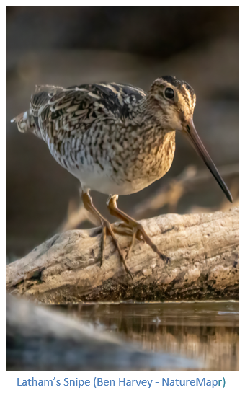
Latham’s Snipe is listed as Vulnerable in the ACT Threatened Native Species List under IUCN Criterion A – A2b as the species has likely undergone a decline of over 30 % over three generations, due to drought and fire and loss of wetlands in Australia and illegal or unregulated hunting in some overseas habitats (Hansen et al. 2021; Attachment 1).

DESCRIPTION AND ECOLOGY
Latham’s Snipe (also known as Japanese Snipe) is a medium-sized wading bird, typically 29–33 cm long, has a wingspan of 50–54 cm, and weighs 150–230 grams. The plumage is intricately marked with rufous, black and buff, with bold brown stripes and cream streaks; the flanks are barred, the belly and underparts are whitish. The long bill and conspicuous white belly are key characteristics for field sightings (Higgins and Davies 1996; Pizzey and Knight 1997). The sexes are similar in appearance, and there is no seasonal variation in adult plumage. Adults and juveniles are indistinguishable after early November (Higgins and Davies 1996).
Latham's Snipe usually occurs singly or in small, loose groups of less than a dozen birds (Naarding 1983; Driscoll 1993; Higgins and Davies 1996). The species is occasionally observed in larger groups of several dozen birds (Naarding 1983; Higgins and Davies 1996) or more, e.g., when migrating, flocks may contain up to 200 birds when they arrive in Australia (Frith et al. 1977; Naarding 1981, 1982). In non-breeding areas, snipe that are flushed from cover flee with a distinctive and rapid 'zig-zagging' flight (Weston 2006, pers. comm.) and the main call is a quick, explosive ‘chak!’, or ‘zhak!’, like the sudden tearing of sandpaper (ACT Government 2018).
Latham's Snipe is an omnivorous species that feeds on seeds and other plant material (mainly from species in families such as Cyperaceae, Poaceae, Juncaceae, Polygonaceae, Ranunculaceae and Fabaceae), and on invertebrates including insects (mainly flies and beetles), earthworms and spiders and occasionally molluscs, isopods and centipedes. They use their bills to jab and probe into mud that may be exposed or covered by very shallow water (Frith et al. 1977; Todd 2000).

Distribution and Habitat
Latham's Snipe only breed in northern Japan, and some islands off far-eastern Russia (Narding 1986; Higgins and Davies 1996). After breeding, they migrate to south-eastern Australia, passing through New Guinea and northern Australia (Higgins and Davies 1996). Most birds spend the non-breeding period at sites located south of the Richmond River in New South Wales (NSW) (Frith et al. 1977 – Map 1).
Map 1. Modelled distribution of Latham’s Snipe.
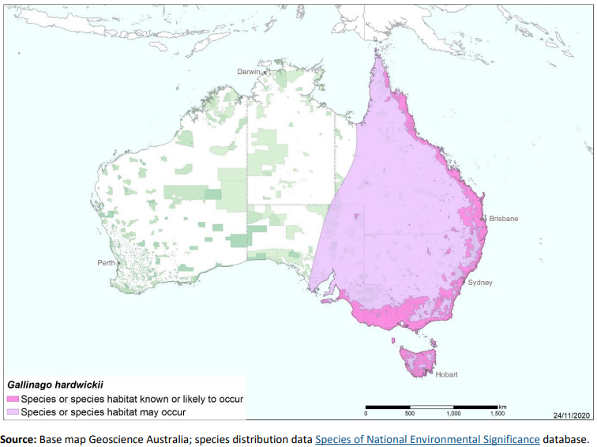
Latham Snipe usually inhabit open, freshwater wetlands with low, dense vegetation. However, they can also occur in habitat with saline or brackish water, in modified or artificial wetlands, and in areas located close to humans or human activity (Frith et al. 1977; Naarding 1983). Smaller numbers inhabit drier habitat, including open woodlands and high-altitude grasslands or herblands, usually those being in proximity to surface water. The snipe roost on the ground near (or sometimes in) their foraging areas, usually in sites that provide some degree of shelter, e.g., beside or under clumps of vegetation, among dense tea-tree, in forests, in drainage ditches or plough marks, among boulders, or in shallow water if cover is unavailable (Frith et al. 1977; Naarding 1982, 1983). Latham's Snipe can occur coincidentally with the Painted Snipe (Rostratula australis).
In the ACT and local region, there are two broad habitat types determined by altitude. The highland swamps, such as Ginini Flats and Nursery Swamp, and the lowland areas that can be separated into three types of wetland: small ephemeral wetlands such as soaks and farm dams; larger ephemeral wetlands which hold enough water to develop appropriate roosting and feeding habitat; and larger urban lakes that do not vary much in water depth but contain suitable roosting habitat and may also, on occasion, provide suitable feeding habitat (Davey and Gould 2017).
Latham’s Snipe was monitored at Jerrabomberra Wetlands Nature Reserve (JWNR) annually for 19 years (1984–2003) and other sites (Mulligans Flat dam, Horse Park Wetland and Bonshaw) for shorter periods by the ACT Government (Lintermans 1987; Lintermans 1993). In the 2016–17 season, the Woodlands and Wetlands Trust, in partnership with the Canberra Ornithologists Group (COG), undertook surveys at a variety of 30 lowland ACT and surrounding NSW wetlands where the Latham’s Snipe was known to occur (Davey and Gould 2017). The survey was part of the broader Latham’s Snipe Project, which continues to expand an understanding of the movements and habitat use of these birds both locally and worldwide. Sites where high numbers of Latham’s Snipe were regularly recorded included JWNR, Horse Park Drive Wetland, and West Belconnen Pond, and to a lesser extent, the Mulligans Flat dams (Davey and Gould 2017).
They regularly visit JWNR where 30 were recorded on 16 December 2018 (27 in 2017, 49 in 2016, 29 in 2015) (COG 2017, 2018, 2019, 2020). The number of records is variable from year to year (Figure 1 inset) from around 26–34 sites (COG 2018, 2019, 2020). The Latham’s Snipe Project reported 146 Latham’s Snipe at JWNR in September 2022 (Hansen 2023).
Other locations include Acacia Inlet on Lake Burley Griffin, Lake Tuggeranong, the upper reaches of the NAAS River and at altitude, e.g., at Ginini Flats (1600 m). They may also be found at various other urban wetlands, e.g., Horse Park, Dunlop Pond, at Giralang and more widely at wetter sites wherever there is suitable habitat, e.g., in other areas within Canberra Nature Park.
Figure 1: Distribution of Latham’s Snipe records in the ACT region – 1982–2017
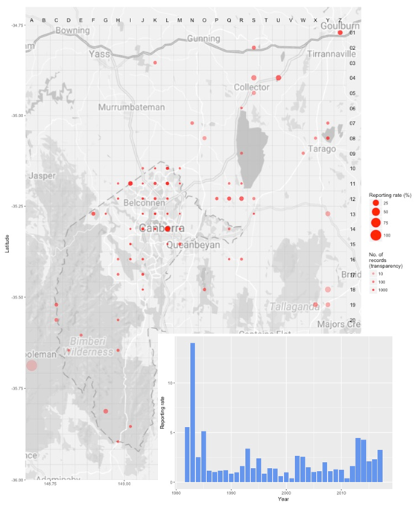
Source: Canberrabirds.org.au. (2018). Note: Reporting rate (%) is the proportion of all surveys in which the species was present. These data were collected by volunteer birdwatchers using various survey methods and, on some occasions, more than one person may have recorded bird sightings on the same day, which may skew the data.

Threats
Within Australia, the current major threat to the species appears to be the ongoing loss of habitat. The wetland habitats occupied by Latham’s Snipe are threatened by a variety of processes, including, drainage; diversion of water for storage or agriculture; development of land for urban or other purposes; and land management practices such as mowing of habitat during summer, which can render it unsuitable for several months (Frith et al. 1977; Garnett and Crowley 2000). The birds are easily disturbed by the intrusion of humans or cattle into their habitats, especially those near industrial complexes, roads or railways, airfields and within school grounds (Higgins and Davies 1996). The pollution of wetlands (through nutrient enrichment, industrial discharge or inappropriate land management practices) and the salinisation of wetlands are potential threats to snipe (Melville 1997), but no information is available on the impact of pollution or salinisation upon snipe populations.
Sudden recent declines in the Latham’s Snipe are attributed to extreme drought and large‐scale fires during 2010 and 2019–20 (Ura and Tajiri 2020). Over the longer‐term, extreme drought conditions caused by climate change is likely to be a strong driving factor for further population declines. Additional threats within Australia include the drainage and diversion of water from wetlands, as well as urban development within potential Latham’s Snipe habitat (Higgins and Davies 1996; Hansen et al. 2021).
Within the ACT, the major threat to Latham’s Snipe is likely urban development, with other significant threats including:
- anthropogenic climate change causing reduction and loss of wetland habitats due to reduced rainfall and run-off, increased temperature and evaporation, and increasing incidence and severity of drought
- human disturbance, including visitors to publicly accessible wetlands for recreation (e.g., JWNR and Mulligans Flat NR)
- disturbance by roaming dogs
- disturbance and predation by cats and foxes
- unfavourable changes to vegetation surrounding wetland sites
- poor water quality or water contamination of wetland sites
- impacts of residential/industrial development including noise, lighting and run-off.

Major Conservation Objective
The priority management objective should be to maintain viable, wild populations of the species in the long term, as a component of the indigenous biological resources of the ACT and as a contribution to regional and national conservation of the species. This includes the need to maintain natural evolutionary processes.

Conservation Priorities
Conservation actions are detailed in the Commonwealth Conservation Advice (DCCEEW 2024). An important goal in the ACT Action Plan for Migratory Species is to Improve knowledge about the occurrence and management of listed migratory species in the ACT with particular focus on Latham’s Snipe (ACT Government 2018). Conservation and management priorities for Latham’s Snipe in the ACT should be to:
- protect habitat, especially important feeding and roosting habitat through improving legal site protection and managing other threats above and as highlighted in the ACT Action Plan for Migratory Species
- monitor population trends and condition of current and potential areas of habitat
- model climate change (see below)
- actively seek opportunities to involve members of local indigenous communities in on ground conservation activities for this species
- encourage and support the continuation and further development of community conservation activities, e.g., the Jerrabomberra Wetlands programs and the Latham’s Snipe Project
- follow the Guidelines for restoring and managing wetland habitat for Latham’s Snipe (Hansen et al. 2024) as applicable to the ACT
- continue to support the engagement with other jurisdictions to support the international recovery of the species, e.g., Latham’s Snipe Japan-Australia Foundation through the Latham’s Snipe Project.

Conservation Issues
It is recommended that quantitative targets and resourcing requirements are clearly identified in any Action Plan or other related projects/programs relevant to this species. Broader conservation issues need to be considered in developing and implementing actions arising from this advice.

Critical Habitat and Nationally Important Habitat
Under the EPBC Act, ‘important habitat’ is a key concept for migratory species, as identified in EPBC Act Policy Statement 1.1 Significant Impact Guidelines - Matters of National Environmental Significance 2009. Important habitats in Australia for migratory shorebirds under the EPBC Act include those recognised as nationally or internationally important. JWNR and the Horse Park Wetlands (separate to Horse Park Drive Wetlands) are nationally important wetlands in the Australian Directory of Important Wetlands in Australia (DCCEEW 2023).
For the purposes of identifying nationally important habitat, important habitat for Latham’s Snipe is described as areas that have previously been identified as internationally important for the species, or areas that support at least 18 individuals of the species (DCCEEW 2024). All internationally or nationally important habitat that exceeds the above thresholds is considered habitat critical to the survival of the species. The degradation or loss of designated important habitat will have disproportionately detrimental impacts on the species’ populations and must be avoided (DCCEEW 2024).
An additional ‘important’ site to keep a watch on is Bonshaw (next to HMS Harman), where at least 18 Latham’s Snipe were recorded in surveys in 1997 and 1999 (M. Lintermans pers. Comm 2024).
The Commonwealth Conservation Advice (DCCEEW 2024) identifies ‘habitat critical to the survival’ or important habitats of a species refers to areas that are necessary:
- for activities such as foraging, breeding, roosting, or dispersal
- for the long-term maintenance of the species (including the maintenance of species essential to the survival of the species, such as macrobenthos (sediment-dwelling invertebrate prey)
- to maintain genetic diversity and long-term evolutionary development, or
- for the reintroduction of populations or recovery of the species.
Habitat critical to the survival of the species, should not be destroyed or modified. Actions that have indirect impacts on habitat critical to the survival of the species should also be minimised (i.e., human disturbance or light pollution impacting habitat). Actions that compromise survival, such as the introduction of new diseases, weeds, or predators, should also be avoided. Actions that remove habitat critical to the survival of Latham’s Snipe would interfere with recovery and reduce the area of occupancy of the species. It is important to retain as much foraging and roosting habitat as possible (DCCEEW 2024).
No Critical Habitat as defined under section 207A of the EPBC Act has been identified or included in the Register of Critical Habitat under the EPBC Act.

Urban Development
Urban wetland habitat used by Latham’s Snipe is at the greatest risk of loss due to increasing pressure from residential and industrial developments (Hansen et al. 2024). A significant issue is the impact of urban development on important habitat sites for the Latham’s Snipe. For example, urban development can increase runoff to wetlands and change the hydrology of the area which impacts water levels and vegetation, therefore, the habitat structure of these important wetlands that are close to urban development need to be protected from these increased flows and considered early in any development of nearby areas. Proactive targeted action will be required to minimise the impact of urban development.
Also, conservation actions need to protect both roosting and foraging sites for Latham’s Snipe. In the case of Jerrabomberra Wetlands NR, foraging sites occur outside the protected area of the reserve, some of which are in areas earmarked for future development (Gould in ACT Government 2024).

Climate Change
Climate change impacts are inevitable and will affect the likelihood of persistence, within the ACT, of many species. Capacity must be developed to model the impact on Latham’s Snipe and its habitat under likely climate change scenarios if we are to anticipate and manage the impacts of climate change. This will require a combination of research and the development of in-house capacity for the collection of relevant data and its application in climate change modelling.

Jurisdictional Collaboration
As Latham’s Snipe is a migratory species, the development of any policies and action/recovery plans should be discussed between relevant jurisdictional entities. The Guidelines for restoring and managing wetland habitat for Latham’s Snipe (Hansen et al. 2024) are a collaboration across jurisdiction and are intended to provide science-based advice for land managers, practitioners and decision makers including land developers, local governments, farmers, extension officers, government researchers and environmental consultants.

Ngunnawal Community Engagement
The ACT Government should actively facilitate, the inclusion of the Ngunnawal people in the conservation of this species and its habitat as part of Ngunnawal Country. Reference to the draft Cultural Resource Management Plan (ACT Government in prep.) would be useful to inform culturally appropriate resource management including of native species that aligns with achieving conservation outcomes for the species.

Other Relevant Advice, plans or Prescriptions
- Commonwealth Conservation Advice – Latham’s Snipe (DCCEEW 2024)
- ACT Action Plan – Migratory Species Action Plan (ACT Government 2018)
- Jerrabomberra Wetlands Nature Reserve Plan of Management (ACT Government 2010)
- Review of the Jerrabomberra Wetlands NR POM (ACT Government 2025)
- Guidelines for restoring and managing wetland habitat for Latham’s Snipe (Hansen et al. 2024)

Listing Background
Latham’s Snipe is a listed Marine Species and Migratory Species under the Environment Protection and Biodiversity Conservation Act 1999 (EPBC Act) and is also listed as a Vulnerable species under the EPBC Act, effective 5 January 2024. It is assessed as Vulnerable under Criterion 1 (A2b) of the EPBC Act. In 2025, under the Nature Conservation Act 2014, the ACT Scientific Committee recommended the Latham’s Snipe be listed in the Vulnerable category in the ACT Threatened Native Species List to align with the EPBC Act listing.

Action Plan Decision
The ACT Scientific Committee does not recommend that the Minister for the Environment should make the decision to have an action plan for the species in the ACT under the Nature Conservation Act 2014 provided the provisions of the Migratory Species Action Plan are strengthened to protect important habitat with an adaptive management and monitoring approach. Actions for shore birds, including the Latham’s Snipe are included in the ACT Action Plan for Listed Migratory Species (ACT Government 2018) but this needs to be strengthened to include guidance for the conservation of threatened species, especially relating to dealing with the impacts from urban development.
A National Recovery Plan is not required to be prepared for the species (DCCEEW 2024) as the approved Commonwealth Conservation Advice is deemed to be an effective, efficient and responsive document to guide the implementation of priority management actions, mitigate key threats and support the recovery for the species. It is considered to support the species recovery by identifying priority actions, stakeholders for engagement, and the survey and research priorities to facilitate a better understanding of key threats as well as biological and ecological knowledge gaps (DSSEEW 2024).

References
ACT Government 2010. Jerrabomberra Wetlands Nature Reserve Plan of Management 2010. Department
of Territory and Municipal Services, ACT Government, Canberra.
ACT Government 2018. Action Plan for Listed Migratory Species. Environment, Planning and Sustainable Development Directorate, ACT Government, Canberra. https://www.legislation.act.gov.au/di/2018-27/
ACT Government 2024. Review of the Jerrabomberra Wetlands Nature Reserve Plan of Management 2010. ACT Parks and Conservation Service, Environment, Planning and Sustainable Development Directorate. ACT Government, Canberra. https://www.legislation.act.gov.au/ni/2025-152/
ACT Government in prep. Draft Cultural Resource Management Plan. Environment, Planning and Sustainable Development Directorate, ACT Government, Canberra.
Canberra Birds 2018. Latham’s Snipe Gallinago hardwickii data sheet. Canberra Ornithologists Group, Canberra. http://canberrabirds.org.au/birds/lathams-snipe/
COG 2017. Annual Bird Report: 1 July 2015 to 30 June 2016. Canberra Bird Notes 42(1): 1–116.
COG 2018. Annual Bird Report: 1 July 2016 to 30 June 2017. Canberra Bird Notes 43(1): 1–112.
COG 2019. Annual Bird Report: 1 July 2017 to 30 June 2018. Canberra Bird Notes 44(1): 1–108.
COG 2020. Annual Bird Report: 1 July 2018 to 30 June 2019. Canberra Bird Notes 45(1): 1–106.
Davey C and Gould L 2017. Surveying Latham Snipe in the ACT and surrounding areas August 2016 – March 2017. Canberra Bird Notes 42(3): 229–238.
Department of Climate Change, Energy, the Environment and Water (DCCEEW) 2023. Directory of Important Wetlands in Australia. Australian Wetlands Database. https://www.dcceew.gov.au/water/wetlands/australian-wetlands-database/directory-important-wetlands
Department of Climate Change, Energy, the Environment and Water (DCCEEW) 2024. Conservation Advice for Gallinago hardwickii (Latham’s Snipe). Department of Climate Change, Energy, the Environment and Water (Commonwealth), Canberra.
Frith HJ, Crome FHJ and Brown BK 1977. Aspects of the Biology of the Japanese Snipe Gallinago hardwickii. Australian Journal of Ecology 2(3): 341–368. https://doi.org/10.1111/j.1442-9993.1977.tb01150.x
Garnett S and Crowley GM 2000. The Action Plan for Australian Birds 2000. Environment Australia, Canberra.
Gray JE 1831. Description of a new species of Snipe (Scolopax Hardwickii) discovered by Charles Hardwicke, Esq. in Van Diemen's Land. Zoological Miscellany 1(4): 16. https://archive.org/details/zoologicalmisce01graygoog
Hansen B 2023. 2022–2023 Snipe survey results and other news. Latham’s Snipe Project. https://lathamssnipeproject.wordpress.com/2023/10/11/2022-2023-snipe-survey-results-and-other-news/
Hansen B, Ura T, Tajiri H, Dutson G and Garnett ST 2021. Latham's Snipe Gallinago hardwickii. In ST Garnett and GB Baker (Eds.) The Action Plan for Australian Birds 2020. pp. 297–300. CSIRO Publishing, Melbourne. https://cdu.primo.exlibrisgroup.com/permalink/61CDU_INST/j6pesm/alma991002199119803446
Hansen B, Walters J and Akers R. (2024) Guidelines for restoring and managing wetland habitat for Latham’s Snipe. Unpublished report produced by the Latham’s Snipe Project.
DOI: 10.25955/28139495
https://federation.figshare.com/articles/report/Guidelines_for_restoring_and_managing_wetland_habitat_for_Latham_s_Snipe/28139495/1?file=51816146
Higgins PJ and Davies SJJF (Eds.) 1996. Handbook of Australian, New Zealand and Antarctic Birds. Volume Three – Snipe to Pigeons. Melbourne, Victoria: Oxford University Press
Lintermans M 1987. Summary of Latham’s Snipe Surveys at Jerrabomberra Wetlands. Internal Report. ACT Parks and Conservation Service, Canberra.
Lintermans M 1993. Latham’s Snipe Gallinago hardwickii at Horse Park Wetland: A preliminary survey. Unpublished Internal Report 93/4. ACT Parks and Conservation Service.
Melville DS 1997. Threats to waders along the East Asian-Australasian Flyway. In: Straw P (Ed.) Shorebird conservation in the Asia-Pacific region. Pp. 15–34. Birds Australia, Melbourne.
Naarding JA 1981. Latham's Snipe (Gallinago hardwickii) in Tasmania. Wildlife Division Technical Report. 81/2. Tasmania: National Parks and Wildlife Service.
Naarding JA 1982. Latham's Snipe (Gallinago hardwickii) in Tasmania. Wildlife Division Technical Report. 82/1. Tasmania: National Parks and Wildlife Service.
Naarding JA 1983. Latham's Snipe (Gallinago hardwickii) in Southern Australia. Wildlife Division Technical Report. 83/01. Tasmania: National Parks and Wildlife Service.
Pizzey G and F. Knight F 1997. The Graham Pizzey and Frank Knight Field Guide to the Birds of Australia. Sydney: Angus and Robertson.
Ura T and Tajiri H 2020. Extreme weather brought about a large forest fire in Australia. Decrease in population of the Latham's Snipe in Hokkaido. Survey report. Wild Bird Society of Japan, Tokyo.
Weston 2006, pers. comm. Cited in ‘Gallinago hardwickii – Latham’s Snipe’. Species Profile and Threats (SPRAT) database. Australian Government Department of Climate Change, Energy, the Environment and Water (DCCEEW). Available at: https://www.environment.gov.au/cgi-bin/sprat/public/publicspecies.pl?taxon_id=863

Further Information
Further information on the related Action Plan or other threatened species and ecological communities can be obtained from: Environment, Planning and Sustainable Development Directorate (EPSDD).
Phone: (02) 132281, EPSDD–Environment website: https://www.act.gov.au/environment

Attachment A: Listing Assessment (DCCEEW 2024)
