Australian Capital Territory
Corrections Management (Capturing and Recording Information about Decision Makers for Clients with Disability) Operating Procedure 2025
Notifiable instrument NI2025–358
made under the
Corrections Management Act 2007, s14 (Corrections policies and operating procedures)

1 Name of instrument
This instrument is the Corrections Management (Capturing and Recording Information about Decision Makers for Clients with Disability) Operating Procedure 2025.
2 Commencement
This instrument commences on the day after notification.
3 Operating procedure
I make this operating procedure to facilitate the effective and efficient management of correctional services.

Leanne Close ^{APM}
Commissioner
ACT Corrective Services
24 June 2025

OPERATING PROCEDURE | Capturing and Recording Information about Decision Makers for Clients with Disability
OPERATING PROCEDURE NO. | 6.2
SCOPE | Court Transport Unit/Alexander Maconochie Centre/Community Operations
PURPOSE
To provide instructions to the Court Transport Unit (CTU), Admissions and Induction teams at the Alexander Maconochie Centre (AMC), and Community Operations staff, on the requirement to ask all individuals whether they have any of the following and record appropriately:
- a Legally Appointed Decision Maker also known as either a:
- Guardian
- Financial Manager/Trustee or
- Power of Attorney.
- National Disability Insurance Scheme (NDIS) funding
- NDIS support coordinator
- NDIS plan nominee
- NDIS correspondence nominee.
DEFINITIONS
Protected Person | A person that the ACT Civil and Administrative Tribunal (ACAT), or other relevant decision-making body, has determined has impaired decision-making ability. ACAT, or other relevant decision-making body, will appoint another person to make decisions on their behalf.
Legally Appointed Decision Maker | A person appointed by ACAT, or other relevant decision-making body, as either a:  - Guardian, for health, welfare and lifestyle matters or  - Financial Manager, for matters relating to financial and/or property  - both a Financial Manager and a Guardian.  ACAT, or other relevant decision-making body, will decide who a Guardian and/or Financial Manager will be and the type of decisions they can make on behalf of the protected person.  ACAT, or other relevant decision-making body, may appoint a Public Guardian and/or Public Trustee, or a family member or friend, generally referred to as a private guardian.
General Power of Attorney | A legal authority that gives a trusted person (“the attorney”) the ability to make decisions for another person (“the principal”) in legal or financial matters. It is only valid while “the principal” has the legal capacity to make decisions.
Enduring Power of Attorney | An enduring legal authority that allows an “attorney” to make decisions on behalf of “the principal” in relation to financial, property, personal care and/or health care matters. It may take effect immediately, from a particular date or when the principal becomes a person with impaired decision-making capacity. It continues to be valid even though “the principal” may become a person with impaired decision-making capacity.
National Disability Insurance Scheme (NDIS) | A scheme of the Australian Government that provides funding to eligible people based on their individual support needs and may include:  - daily personal activities  - transport to enable participation in community, social, economic, and daily life activities  - therapeutic supports including behaviour support  - mobility equipment.
NDIS support coordinator | A support coordinator helps people find and connect with service providers that meet their needs and assists them in putting their support plans into action.
NDIS plan nominee | A plan nominee can make decisions preparing, managing, or changing a person’s plan, including receiving and managing the person’s funding.
NDIS correspondence nominee | A correspondence nominee can make decisions about a person’s business with the NDIS but cannot change a person’s plan or manage funding for the plan. They can write to NDIS and receive mail from NDIS on the person’s behalf.
PROCEDURES
- General
  - A person may have permanent or temporary impaired decision-making ability for a variety of reasons including an intellectual, neurological, or psychological condition.
  - Intellectual, neurological, or psychological conditions may not necessarily be evident and may not be diagnosed, or some people may not identify as having a disability or other condition.
  - People may also choose not to share information about conditions affecting their decision-making ability, consistent with their right to privacy. Everyone has the right:
    - not to have their privacy, family, home or correspondence interfered with unlawfully or arbitrarily, and
    - not to have their reputation unlawfully attacked.
  - ACAT, or other relevant decision-making body, may appoint a guardian by order. These orders state what kind of decisions a guardian can make for a person and they will outline the areas where a guardian may act/or have decision making powers, such as:
    - accommodation
    - education or training
    - employment
    - consent for medical procedure and/or treatment
    - matters relating to legal proceedings.
  - A Financial Manager/Trustee will have an ACAT order, or order from other relevant decision-making body, for the person’s financial and property matters.
  - An Appointed Decision Maker shows that the person needs help making decisions. They might also have useful ideas about other support options to improve the persons experience with ACTCS.
  - NDIS funding may indicate an individual may need additional support or reasonable adjustments to ensure inclusive and equitable access to ACTCS information and services.
  - NDIS participants have an individual plan that lists their goals and the funding they have received.
  - A NDIS participant may have a NDIS support coordinator who may assist the individual to:
- understand their plan
- coordinate supports
- build capacity and resilience
- connect them with NDIS providers.
  - A NDIS participant may have a NDIS plan nominee who is responsible for making NDIS-related decisions or act on a participant’s behalf.

- CTU Reception
Appointed Decision Maker
  - CTU Reception staff must check the detainee’s electronic record to determine whether the person has an Appointed Decision Maker.
This information will be flagged in red on the top left of the individual’s home page:

Or under the following heading: Offender pages – Alert concern – Other – Appointed Decision Maker – Financial Manager, Guardian or Power of Attorney 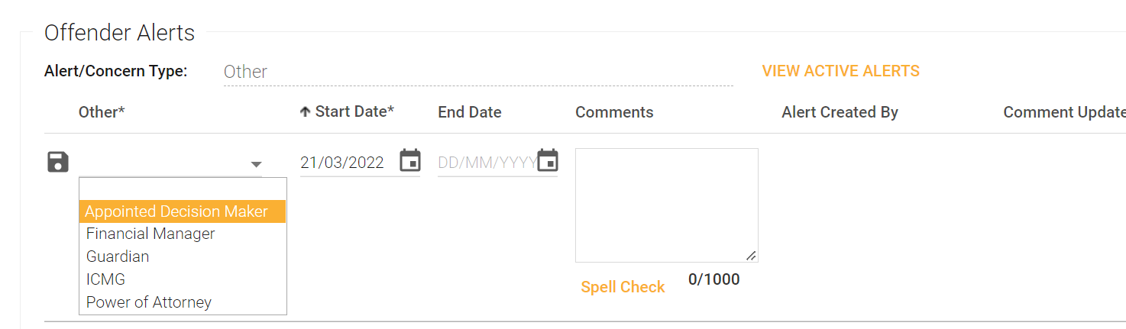
  - If it is indicated that the person has an Appointed Decision Maker, CTU Reception staff must ensure this information is communicated to Admissions staff during handover of the detainee.
NDIS
  - CTU Reception staff must also check the individual’s electronic record to determine whether the person is a NDIS participant. This information will be flagged in red on the top left of the individual’s home page:

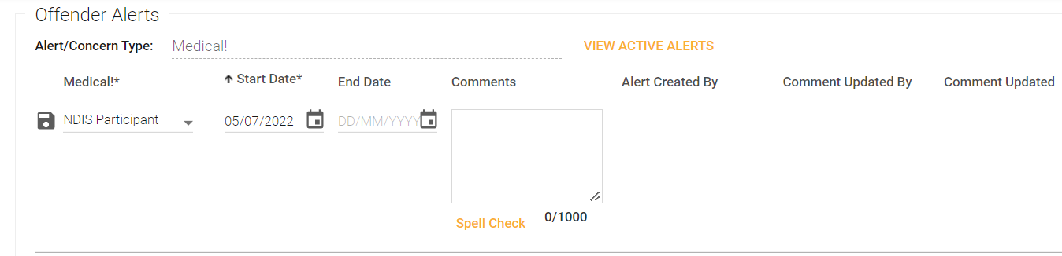
Or under the following heading: Offender pages – Alert concern – Medical – NDIS participant
  - If it is indicated that the person is a NDIS participant, CTU Reception staff must ensure this information is communicated to the Admissions staff.

- CTU Reception initial screening for Appointed Decision Makers and NDIS supports
  - CTU Reception staff must ask the detainee if they have an Appointed Decision Maker, such as a Guardian, Financial Manager/Trustee or Power of Attorney and whether they are a NDIS participant, have NDIS funding and/or have a NDIS support coordinator, regardless of whether this information is recorded on CORIS.
  - Any disclosed information regarding an Appointed Decision Maker and/or NDIS supports must be communicated to AMC Admissions staff.

- AMC Admissions staff
  - Upon receiving information from CTU Reception staff that an individual has an Appointed Decision Maker, and where these contact details are known, Admissions staff must phone the guardian to advise the individual is in custody and to obtain details about the guardianship order.
  - Admissions staff must advise the individual that contact has been made with the guardian. If contact has been attempted unsuccessfully, the detainee and Induction Services Unit must be advised that contact has not yet occurred to ensure it is followed up.
  - Admissions staff must inform Induction Services Unit staff when contact has been made with the guardian.

- Community Operations and Induction Services Unit (ISU) – Prior to initial contact
Appointed Decision Maker
  - Prior to initial contact with a detainee or upon allocation of an offender, staff must check the individual’s electronic record in accordance with section 2.1.
  - If the individual is not yet known to ACTCS and no record exists, appropriate checks should be made during first contact with the individual in accordance with section 6.
  - If the individual has an Appointed Decision Maker, staff must read the relevant order and ensure that ACTCS complies with the order.
  - If there is an alert but a copy of the order is not available in the individual’s electronic record, Community Operations or Induction staff must request a copy. Refer to section 7 Identifying and Contacting Appointed Decision Maker for how to obtain a copy.
  - Once a copy of the order has been received, the staff member must upload it to the individual’s electronic record and email their relevant Disability Liaison Officer to advise them.
  - ISU staff must try to contact the Appointed Decision Maker as soon as practicable to inform them that the individual is in custody. The Appointed Decision Maker may suggest any needed adjustments or extra support for the individual.
  - Community Operations staff must try to contact the Appointed Decision Maker as soon as practicable, particularly when it is critical for release or case planning.
  - Staff must inform the individual as soon as practicable that they have contacted their Appointed Decision Maker.
  - If staff would like support to interpret the order, they may contact their relevant Disability Liaison Officer.

NDIS
  - Prior to initial contact with a detainee or upon allocation of an offender, staff must check the individual’s electronic record to determine whether the person is a NDIS participant.
This information will be flagged in red on the top left of the individual’s home page:
Or under the following heading: Offender pages – Alert concern – Medical – NDIS participant

- Identification of Appointed Decision Makers and NDIS status
Community Operations
  - At any point of contact, staff must ask the individual if they have an Appointed Decision Maker, such as a Guardian, Financial Manager/Trustee or Power of Attorney, as early as possible. This applies to all staff interacting with the individual, including Court Duty Officers.
  - Staff must ask the individual if they are a NDIS participant, have NDIS funding and/or have a NDIS support coordinator.

- Recording and contacting Appointed Decision Maker – Community Operations and Induction Services Unit staff
  - If an individual indicates that they have an Appointed Decision Maker or there is an alert on their electronic record staff must:
    - create an alert under the Offender Alert concerns field in the individual’s electronic record, and select the relevant item (Appointed Decision Maker, Guardian or Power of Attorney – use Power of Attorney for General or Enduring).
    - seek the contact details of the Guardian, Financial Manager and/or Power of Attorney from the person. Enter these details in the comments field in the new alert created.
  - Where a copy of the order is not on the individual’s electronic record, staff must obtain a copy of the order, which can be obtained from either:
    - the individual
    - the Appointed Decision Maker, by contacting them directly
    - ACAT by emailing: ACATGuardianship@act.gov.au
    - the nominated Power of Attorney or their Legal Representative, or
    - other identified relevant decision-making body.
  - If the individual does not know the contact details of their Appointed Decision Maker, staff must contact ACAT by emailing: ACATGuardianship@act.gov.au.
  - The Disability Liaison Officer in Community Operations or Offender Reintegration may be able to assist in making these enquiries.

- Recording NDIS Participant Information and Support Coordinator Contact
  - If the individual indicates that they are a NDIS participant, have NDIS funding and/or a NDIS support coordinator, Community Operations or Induction Services Unit staff must:
    - create an alert under the Offender Alert concerns field in the individual’s electronic record and select the relevant item (Medical - NDIS Participant); and
    - seek the contact details of the NDIS support coordinator (if relevant) and enter these details in the comments field in the new alert created.
  - If the individual does not know the contact details of their NDIS support coordinator, staff must contact the relevant Disability Liaison Officer who may be able to assist in making these enquiries.

- Notifying about Appointed Decision Makers and NDIS support information
  - If at any time, an ACTCS staff member learns that an individual has an Appointed Decision Maker or receives NDIS supports and there is no alert recorded, they must inform the individual’s case manager or allocated Community Operations staff member. The relevant staff member will then follow the procedures outlined in sections 7 and 8.

- Communicating with Appointed Decision Makers and NDIS Support Coordinator
  - While it is preferable to obtain the individual’s consent before contacting the Appointed Decision Maker, ACTCS are not required to do so.
  - Staff must ensure the individual is informed of the intention to contact and any communication with the Appointed Decision Maker.
  - Contact must be made with the Appointed Decision Maker as soon as practicable.
  - If an individual has a NDIS support coordinator, staff must obtain the individual’s consent before making any contact.

- Involvement of Appointed Decision Makers in case planning and assessments
  - If an order specifies that the Appointed Decision Maker is responsible for decisions about where the individual lives, they must be included in release case planning and any accommodation assessments, including those for the Justice Housing Program.
  - If the order states that the Appointed Decision Maker is responsible for decisions about parole, community service work, or referrals to support services and interventions, they must be included in these assessments.

- Further information
  - For further information, please contact either the Disability Liaison Officer in Community Operations or Offender Reintegration.

RELATED DOCUMENTS
- Footprint Survey
- Reception, Admission and Induction Operating Procedure
- Reception, Admission and Induction Policy
- Support for Detainees and Offenders with Additional Support Needs Policy

Leanne Close APM
Commissioner
ACT Corrective Services

24 June 2025

Document details
Criteria | Details
Document title: | Corrections Management (Capturing and Recording Information about Decision Makers for Clients with Disability) Operating Procedure 2025
Document owner/approver: | Assistant Commissioner, Offender Reintegration, ACT Corrective Services
Date effective: | The day after the notification date
Review date: | Five (5) years after the notification date
Responsible Officer: | Senior Director, Offender Reintegration
Compliance: | This Operating Procedure reflects the requirements of the Corrections Management (Policy Framework) Policy 2024

Version Control
Version no. | Date | Description | Author
V1 | June 2025 | First Issued | Y Jansen and M McKenzie

