Australian Capital Territory
Urban Forest (Tree Management Plans) Guidelines 2025 (No 1)
Notifiable Instrument NI2025-364
made under the
Urban Forest Act 2023, section 88 (Tree management plans—guidelines)

1 Name of instrument
This instrument is the Urban Forest (Tree Management Plans) Guidelines 2025 (No 1).
2 Commencement
This instrument commences the day after it is notified.
3 Approval
I approve the guidelines for tree management plans in the attached schedule 1.
4 Revocation
This instrument revokes the Urban Forest (Tree Management Plans) Guidelines 2023 (No 1) NI2023-823.

Bren Burkevics
Conservator of Flora and Fauna

30 June 2025

specifications FOR THE submission OF
TREE MANAGEMENT PLANS

Table 1. Required Sections in a Tree Management Plan
Key:  ✔ Required  ○ Required if relevant or requested  ◊ Required if trees are proposed for removal | Regulated Trees (leased land) |  | Public Trees (unleased land) |  |  |  |  | Registered or Remnant (leased and unleased land)
 | Construction  related activities | All other activities  requiring a TMP | Complex infill and  Infrastructure  Projects | Public Realm  Projects | Simple Infill and Infrastructure Projects | Driveway application only | Events
Tree Management Plan Drawing | ✔ | ✔ | ✔ | ✔ | ✔ | ✔ | ○ | ✔
Site/Event and Assessment Details | ✔ | ✔ | ✔ | ✔ | ✔ | ✔ | ○ | ✔
Canopy Contribution Table | ◊ | ◊ | ◊ | ◊ | ◊ | ◊ | ◊ | ◊
Tree Protection Notes | ✔ | ✔ | ✔ | ✔ | ✔ | ○ | ○ | ✔
Development Stages | ✔ |  | ○ | ○ | ○
Tree Assessment Schedule (TAS) | ✔ | ✔ | ✔ | ✔ | ✔ | ✔ | ○ | ✔
Protection status | ✔ | ✔ | ✔ | ✔ | ✔ |  | ✔ | ✔
Height* | ✔ | ✔ | ✔ | ✔ | ○ |  |  | ✔
Canopy width* | ✔ | ✔ | ✔ | ✔ | ○ |  |  | ✔
Structural Root Zone (SRZ) | ○ | ○ | ○ | ○ | ○ | ✔
Circumference or Diameter | ✔ | ✔ |  | ○ | ○ |  |  | ✔
Species* | ✔ | ✔ | ✔ | ✔ | ✔ |  |  | ✔
Hollows | ○ | ○ | ✔ | ✔ |  |  |  | ✔
Tree Quality Classification* | ○ | ○ | ✔ | ✔ | ○ |  |  | ✔
Photograph/s | ○ |  | ✔ | ○ | ○ |  | ○ | ✔
* trees of similar qualities, species and size may be grouped together, without detailed measurements for each, unless intended for removal or otherwise specified by the Decision-Maker.
Examples of work/project types for public trees
The list of examples set out below does not limit the circumstances that the Decision-Maker may request a Tree Management Plan.
Complex infrastructure and infill projects: road duplications, large scale utility upgrades, multi-residential, commercial or other infill projects.
Public realm projects: shopping centre upgrades, urban open space, active travel, recreation.
Simple infill and infrastructure projects: single dwelling knockdown rebuild Building Applications (BA) or Development Applications (DA) or dual occupancy with potential public tree impacts; path upgrades, outdoor dining permits, utility maintenance with potential public tree impacts.

General Notes
Legislation
A Tree Management Plan is required in response to managing a protected tree from potential damage, see division 5.1 of the Urban Forest Act 2023. A Tree Management Plan may be required as part of a Development Application or other works permit, or at the request of the decision-maker. A Tree Management Plan can also be proposed by an applicant wanting to seek approval to undertake works on or around a protected tree.
An approved Tree Management Plan is not an approval to remove a protected tree.. Approval to remove a protected tree must be explicitly provided by the Decision-Maker in response to an application.
Further Information
These specifications provide instruction for the requirements of a Tree Management Plan (TMP). Mandatory specifications are referred to as must, all other specifications may be included but are not mandatory.
These specifications apply to activities that have potential to impact protected trees on public, private and neighbouring land.
These guidelines are intended to assist applicants to provide TMPs that meet the requirements of the Act, enabling adequate protection measures and an efficient assessment process.
This list is not a comprehensive list of all details required in a Tree Management Plan. The Decision-Maker reserves the right to request further information if deemed necessary for the assessment of the TMP and any associated tree damaging activities. This may include information not marked as required in this document.

Preparing a TMP
A TMP may be prepared by the applicant when no or low impact to the Tree Protection Zone (TPZ) is expected.
In all other cases, a TMP may be prepared by a certified project arborist (minimum Australian Qualification Framework (AQF) Level 5 in Arboriculture) or person with equivalent experience.
Draft documents will not be accepted. Arboricultural Impact Assessments (AIA) are not required as part of the TMP and will not be accepted as an alternative to a TMP, but may be provided as an appendix. The potential impacts of a proposal are to be identified prior to the TMP being prepared.
Tree Management Plans must clearly contain the applicable sections within the document (see Table 1. Required Sections in a Tree Management Plan):
Clear and definitive language must be used throughout the report. Critical tree protection specifications containing language such as ‘should’ or ‘may’ will not be accepted.
Note: for example: the tree protection zone (TPZ) fencing may be erected prior to any works commencing, including demolition of existing structures or vegetation.
The use of the word ‘may’ in place of ‘will’ is not acceptable, as it implies the fencing is optional.

A Tree Management Plan may also contain
- reference to or a copy of an existing reports for the site or tree
- example images or detail of TPZ fencing, signage, root protection etc
- additional plans
- any other supporting document that the applicant deems relevant to the Tree Management Plan.

General requirements for all Tree Management Plan Drawings
All drawings submitted with a TMP must:
- be drawn to scale (generally 1:100, 1:200, or 1:500) and include a scale bar;
- have dimensions;
- indicate north;
- include a key, where visual references are used;
- have a title block that includes at a minimum, the block, section and suburb, date the plan was produced and a version number (if more than one version exists);
- be presented and scalable in A3;
- include all relevant information, if required, in the Section Details below; and
- explicitly state that the drawing is a TMP (e.g. in the drawing title).

Part 1
Documentation Requirements for
Tree Management Plans Relating to Works

General Information
These specifications provide specifications for Tree Management Plans (TMPs) submitted to the Decision-Maker through Development Applications or in response to works being undertaken in proximity to a protected tree.
Such works may include, but are not limited to:
- site access and paths;
- demolition;
- installation of hoarding and scaffold;
- building and construction (including driveway replacements);
- utility installation, relocation, or access;
- traffic management and loading zones;
- other activities associated with construction such as storage, scaffolding, plant and equipment use, nature strip or footpath reinstatement; and
- pruning.
The location of the protected tree(s) is not limited to the site on which works are occurring. If the works will encroach on the tree protection zone (TPZ) of a protected tree on a neighbouring lease, or public land (such as a nature strip), protection measures for these neighbouring trees must be considered and included in the TMP where applicable.

General Details

Compliance
The applicant and/or lessee is responsible for taking reasonable steps to tell each person carrying out works adjacent to the protected tree(s) that a TMP is in place.
A copy of the TMP must be available on site (ideally laminated and attached to tree protection fencing) and form part of site induction or be directly provided to any contractor carrying out works.
Compliance measures that may be incorporated in a TMP on complex or multi-staged projects include:
- A schedule of inspections to be conducted at project stages by qualified project arborist (or equivalent person).
- Records kept of each inspection, including date, attendees, any notes and/or photos taken by the project arborist (or equivalent person).

Tree Removals associated with a TMP
Where applicable, the TMP must be consistent with approved (or applied for) tree activities under Section 21 of the Urban Forest Act 2023 (the Act) or other mechanism (i.e.. via a Development Application).
Tree removals cannot be approved via a TMP, but can be applied for within a TMP that includes a completed TAS and is supported by a Canopy Contribution Table.
If a tree removal is approved, as reflected on a TMP, a separate Notice of Decision will be provided pursuant to Section 28 of the Act, referencing the applicable criterion the approval is provided under.
An approved TMP, showing proposed tree removals, does not constitute approval to remove trees.

Section Details
Details of what each section in Table 1 must contain, when required, are listed below.

Tree Management Plan Drawing
Please note that a TMP developed for public land is not the same as a Landscape Management and Protection Plan (LMPPs are required for works on or adjacent to public unleased land and use of public unleased land, irrespective of trees, and may be combined with a TMP where appropriate). The TMP must be prepared in accordance with these Specifications.
All notations on the TMP drawing must correspond with the TAS, be site specific (not generic) and:
- Include a site plan showing the location of all trees, using identifiers from the TAS, showing the Tree Protection Zone/s (TPZ) and the SRZ as required.
- Where a site plan includes more than one (1) tree, clear sequential tree identifiers must be used to correspond to the TAS.
- Show (where applicable) all tree protection measures to be implemented, including (but not limited to):
  - Fencing
  - Surface protection/anti-compaction devices
  - Cleaning bins (for contaminated wastewater disposal)
  - Hydro excavation
  - Identify any proposed tree pruning (pruning plan to be provided as an attachment);
  - Tree protection signage (see Appendix A for example)
- Show all encroachments into the TPZ. Distance must be clearly shown on the site plan between proposed incursion and tree. Consideration must also be made to the proposed location of temporary encroachments such as site sheds, scaffolding, crane and concrete truck set up locations, material storage, waste and spoil, portable toilets, cleaning areas, and vehicle movements.
- Show all existing and proposed services within the TPZ and SRZ of a protected tree.
- Show existing and proposed building footprint, driveways and any structures that are or will be within the TPZ of a protected tree. Additional Plans can be provided to demonstrate changes at each stage.
Site and Assessment Details
The TMP must include:
- Site address (including Block and Section where applicable), client details and lessee details* (for leased land). *this information may be provided separately, such as part of an online application form or associated Development Application.
- Contact details and qualifications (if applicable) of person preparing the TMP.
- Brief – provide purpose of TMP, including what works are being undertaken on the site. Limited to 200 words. e.g. Deck demolition and construction of new deck and pergola.
- Site attendance date^, and what inspection methods or diagnostics (if any) were carried out. ^Tree assessments are valid for a maximum of 2 years. The Decision-Maker may request an updated TAS if the assessment is more than 6 months old.
- Completed canopy contribution table (if applicable*)
- Completed prior approvals list (if applicable**)

Table 2. Canopy Contribution Table
 | Regulated | Public | Total
 | TAS identifier | TAS identifier | Total
Number of protected tree removals proposed
Number of retained protected trees
Proposed number of replants, assuming all removals are approved
Type of replant proposed (for non-homeowners^) | Identifier on landscape plans | Identifier on landscape plans
Conifer
Introduced under 10m
Introduced 10-15m
Introduced 15m+
Native under 10m
Native 10-15m
Native 15m+
* this table is only required if there are proposed protected tree removals.
^ Not required for homeowners. See the Tree Calculator for further information.

Table 3. Prior Approvals List

TAS Identifier | Approval Notice Identifier | CCA Signed (Yes or No)
** This table is required if you have been granted approval to remove a protected tree referenced in this TMP, via an alternate pathway, such as a Tree Activity Application.

Tree Protection Notes
Describe all tree protection and tree care measures (that have not been detailed on the TMP Drawing) to be implemented, including (but not limited to):
- fencing;
- surface protection/anti-compaction devices;
- mulch or wet hessian fabric applications;
- irrigation;
- trunk guard;
- set up of plant and equipment, and installation of site facilities;
- tree sensitive construction techniques (e.g. pier footings, waffle slab, etc);
- hydro excavation method;
- cleaning bins (for contaminated wastewater disposal);
- tree protection signage (see Appendix A for example); and
- conditions, including for root severance and pruning.

Note: Tree Protection Notes need not duplicate information already provided on the TMP drawing. For example, if the drawing indicates the location of the tree protection fencing, with an annotation of ‘1800mm high chain wire fence’, this does not need to be re-written again in the tree protection notes.

Development Stages
If any progressive stage of a development requires a change in protection measures, detail of the tree protection and management provisions at each stage must be broken down. These stages usually include (but are not limited to);
- demolition and earthworks;
- construction
- landscape phase; and
- consolidation of landscape.
Each stage can involve different contractors and potential impacts, and, for this reason, it may be necessary to separate the TMP into stages. Applicants must:
- Indicate changes to the Tree Management Plan Drawing or Tree Protection Notes, as applicable throughout the stages of development; and
- Provide additional drawings, if necessary to demonstrate staged changes.

Note: Tree Assessment Schedule (TAS) Sections
All required sections of the TAS must include trees on neighbouring land or leases that may be impacted as part of the proposed activities. i.e. All potentially impacted protected trees must be included in the TAS.
Tree Assessment Schedule
Not all activities require a full TAS. The required sections, based on activity type, are indicated in Table 1.

Protection Status
Identify the protection status of any impacted trees, including:
- Public
- Regulated
- Registered
- Remnant; or
- not protected under the Urban Forest Act 2023*
Note: include all applicable statuses, if more than one applies.
*Whilst some trees are not protected under the Urban Forest Act 2023, other regulatory protections may apply (e.g. the Public Unleased Land Act 2013, Nature Conservation Act 2014 and ACT Planning and Land Management Act 1988)

Height
Height of the tree (in metres) to the nearest 0.5m.

Canopy Width
Measured in metres, to the nearest 0.5m. To be taken using a measuring tape along the ground, across the widest point of the canopy. If the widest point is not accessible, a recent ACTMapi aerial measurement may be used.

Structural Root Zone (SRZ)
Pursuant to the Australian Standards 4970-2009 Protection of Trees on Development Sites, the SRZ can be calculated as follows:
SRZ radius = (D x 50) 0.42 x 0.64
Where
D = trunk diameter, in metres, measured above the root buttress.
NOTE: The SRZ for trees with trunk diameters less than 0.15 m will be 1.5 m
The SRZ should be included on the Tree Management Plan Drawing, where possible.

Circumference or Diameter
Include either the circumference or the diameter of the tree’s trunk, taken at 1.4m from natural ground level.
For multi-trunk measurements, each trunk should be measured 1.4m above ground level to calculate the average circumference.

Species
Botanical name or, if not known, common name.

Hollows
Confirmation of any present, habitable hollows. If the habitable status of hollows is unknown, note the location of the hollow/s.

Tree Quality Classification
Assign a tree quality classification for each protected tree, such as: Exceptional, High, Medium, Low.
Include both arboricultural value and ecological and/or amenity value.
Provide definitions of terms.

An optional classification matrix is provided at Appendix B.

Photographs
Photographs are to aid in the identification and location of trees and should be clear and labelled where necessary. For sites with multiple trees in close plantings, group photos will be accepted.

Part 2

Tree Management Plans for Events or Land Use

General Information
These specifications provide specifications for Tree Management Plans (TMPs) submitted to the Decision-Maker through Public Unleased Land Permits (PULP), license applications or other public land use pathways.
Circumstances may include, but are not limited to:
- events on public land
- public land use licenses or permits
- ongoing land use for other activities.
Uses or activities that may cause damage include, but are not limited to:
- Vehicle access
- tents/yurts/teepees
- food vans
- lighting
- fixtures on trees
- signage
- digging
- trenching
- pre-existing irrigation
- pegs
- stays
- ropes
- straps
- swings
- wet weather plans; and
- soil compaction.
The location of the protected tree(s) is not limited to the site on which works are occurring. If the works will encroach on the tree protection zone (TPZ) of a protected tree on a neighbouring lease, or public land (such as a nature strip), protection measures for these neighbouring trees must be considered and included in the TMP where applicable.
Section Details
Details of what each section in Table 1 must contain, when required, are listed below.

Tree Management Plan Drawing and Tree Protection Notes
All notations on the TMP Drawing must be site specific (not generic) and:
- Site plan using aerial image (ACTMapi), identifying location of equipment, hardstand, entry and exit points etc (where applicable).
Show, where applicable, all tree protection to be implemented, including (but not limited to):
- fencing;
- surface protection/anti-compaction devices;
- trunk guard;
- tree protection signage (see Appendix A for example);
- vehicle access routes; and
- tree Protection measures throughout stages of land use, if differing. E.g. Event bump in, during event, event bump out.

Event and Assessment Details
The TMP must include, if requested:
- Site address and event host contact details*(i.e. person who will be on site for the duration of the activity).
- Brief – Purpose of TMP including event/activity detail such as date, duration, number of attendees. Limited to 200 words*.
- Contact details and qualifications (if applicable) of person preparing the TMP.
- Summary of protected trees, e.g. the event will take place in an area within the TPZ of 3 trees, see TMP Drawing.
Note: Protected trees under the Act include all public trees.
*this information may be provided separately, such as part of an online application form for a Public Unleased Land Permit.

Restricted Activity Acknowledgement – PULP Terms and Conditions
Agreement to the PULP Terms and Conditions for Tree Management, confirming that the applicant (land user) understands the responsibilities associated with the Tree Management Plan.

Definitions

“the Act” means the Urban Forest Act 2023

“Conservator” means the Conservator of Flora and Fauna.

“damage” includes to kill, destroy, poison, ringbark, fell, remove, remove a hollow or anything else done to or in relation to a protected tree that is likely to cause it to die, significantly reduce its life expectancy or significantly and adversely affect its health, stability or general appearance. The meaning of ‘damage’ is consistent with the meaning of damage as defined in s 14 of the Urban Forest Act 2023

“decision-maker” means the delegate responsible for making decisions about impacts on protected trees.

“guidelines” mean specifications, and this legislative instrument being Urban Forest Act (Tree Management Plans) Guidelines 2025 (No. 1).

“homeowner” means the person is the lessee of the land and the person provides written evidence that they have been living on the land for at least two years, or they intend to live on the land for at least two years.

“impact” means damage or the potential to damage

“must” means a mandatory element of a Tree Management Plan under this instrument. If a mandatory element is not included, a Tree Management Plan may be rejected and require resubmission.

“may” means elements that can be included in a Tree Management Plan but are not mandatory in all. These are usually situation specific.

“non-homeowner” means all other leaseholders that are not homeowners. e.g. investors, developers, businesses.

“project arborist” means the person responsible for carrying out the tree assessment, report preparation, specification of tree protection measures and monitoring of the tree throughout the project. Usually someone with qualifications of AQF5 or above in arboriculture, or equivalent experience.

“responsible authority” means the delegate as appointed by the Conservator of Flora and Fauna or the delegate as appointed by the responsible directorate’s decision-maker.

“responsible person” means the person accepting liability for the activities being undertaken on the land and for the protection and / or damage of the protected tree/s.

“restricted activities” means activities that could lead to damage of a protected tree.

“specifications” means guidelines and this legislative instrument being Urban Forest Act (Tree Management Plans) Guidelines 2025 (No 1).

“SRZ” means structural root zone and refers to the area around the base of a tree required for the tree’s stability in the ground. Defined by AS4970-2009,0 the SRZ calculation is as follows:
SRZ radius = (DRC x 50) 0.42 x 0.64, where DRC = trunk diameter, in metres, measured above root crown (DRC = Diameter Above Root Crown).

“TAA” means a Tree Activity Application and refers to the application used when proposing or requesting to damage a protected tree.

“TMP” means tree management plan and refers to a plan developed in accordance with section 88 of the Urban Forest Act 2023.

“TMP Drawing” means tree management plan drawing and refers to a map or drawing that depicts the site and the protected trees and includes tree protection zones and strategies.

“TPZ” means tree protection zone and refers to the area of ground surrounding the trunk of a tree that must be protected and where certain activities are prohibited. See Part 2 Section 13 of the Act.

“tree quality classification” means a rating assigned to a tree by the TMP author based on varying factors including the health, vigour, form, ecological and landscape value of a tree. A tree rating provided in a TMP may not be accepted by the decision-maker.

“use” means carrying out an activity on the public land that excludes some or all members of the public from the place, as defined by s 41 (1) of the Public Unleased Land Act 2013.

“work/s” means construction, building, landscaping or any other works that may be associated with a building application or development application.

Appendix A – Tree Protection Signage
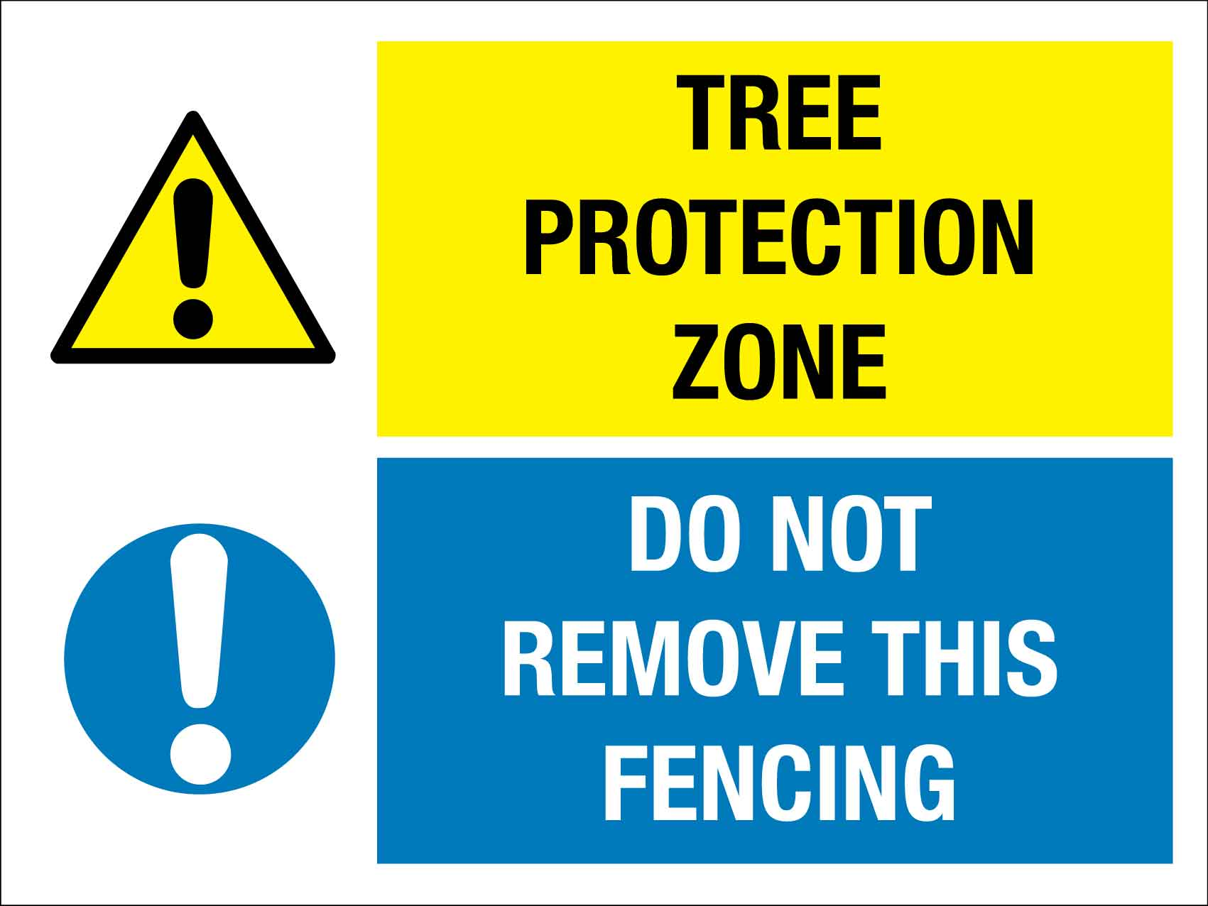

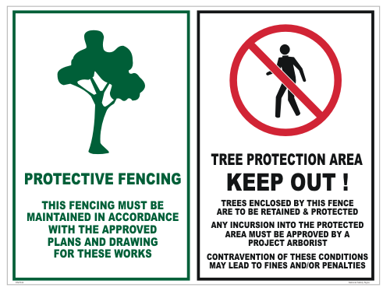

Appendix B – Tree Quality Classification

Professional knowledge and discretion is assumed to be applied when assigning values to trees, with the below methodology to be used as a guideline for arborists who do not utilise their own (or an adopted) rating system.
Tree Quality Classification Matrix
Environmental/Arboricultural and/or Amenity Value
 | 7 | 6 | 5 | 4 |  | 3 | 2 |  | 1
Dead Native Tree* | High |  | Medium |  |  | Low
VALID Assessment (all other trees)^
Acceptable | High |  |  |  | Medium |  |  | Low
Tolerable | High |  | Medium |  |  | Low
Not Tolerable** | Medium |  | Low
*Dead non-native trees, or trees with a Not Acceptable VALID risk rating are not factored into this assessment, as they would meet the criteria for removal under the Act.
** Where risk mitigation is possible, tree retention may be argued for medium value trees
^ for arborists adopting this methodology who have not undertaken VALID training, you may consider substituting alternative risk assessment terminology from your chosen methodology to apply this matrix.

Determining Environmental, Arboricultural and Amenity Values
Example factors to consider when determining the environmental, arboricultural and/or amenity value assigned to the tree. To assign a value, the tree should meet 3 or more criteria in a rating range.
For Dead Native Trees, a minimum of one criteria should be met to assign a rating. If a Dead Native Tree does not meet any criteria, a rating of ‘not.
If a tree meets more than 3 criteria in the ‘very high’ category, it should be considered as exceptional, with consideration given for all other assessment categories.
 | Very High (6-7) | High (5) | Medium (3-4) | Low (1-2)
Crown Size | Very Large (>200m² or >14m wide Canopy) | Large (100-200m², 10-14m wide canopy) | Medium  (50-100m² 7-10m wide canopy) | Small  (<40m², less than 7m wide canopy)
Canopy Density (in full leaf) | Dense – 90-100% foliage cover. | Normal – 70-90% foliage cover. | Thinning – 50-70% foliage cover | Sparse – less than 50% foliage cover
Health | High vigour, no sign of decay, pest activity or discoloration. | Normal to high vigour, no sign of active decay or pests, little to no visual discolouration. | Normal vigour, signs of decay and/or pests or some visual discolouration. | Low vigour. Notable leaf discolouration, epicormic growth, signs of active decay or pests.
Visual Prominence or Impact  | Located in a visually prominent position in the landscape. A landmark or visible from a considerable distance. | Visible from surrounding properties, the street or other thoroughfares. | Visible from surrounding properties. | Not visible from surrounding properties (obscured by other trees or built forms).
Form and habit | Very good form and branching habit, excellent specimen, aesthetically distinctive and/or an excellent representation of the species. | Good form and habit, minor distortion or suppression, a good. representation of the species. | Fair form and habit, a fair representation of the species. | Poor form and habit and/or an atypical or poor representation of the species.
Environmental Significance | Listed on Schedule 2, threatened or key species in the community; or is a Remnant tree. | Endemic species & representative of the original vegetation of the area. | Planted or self-sown exotic or non-local native tree. | -
Botanical importance | Rare or few in the region. The only example of its type, a species endemic to ACT. | Uncommon in cultivation. | Common in cultivation. | Very common in cultivation, widely represented in the area.
Habitat Value | Provides important habitat (nesting/foraging/food source/shelter) for threatened fauna species. | Provides habitat for native wildlife. Located within a wildlife corridor. Evidence of nesting hollows, known food sources, and/or other visible evidence of wildlife (markings, nests etc) | Beneficial for native wildlife. | Little or no value to native wildlife
Amenity, Arboricultural and Ecological Value assignment guidance table
Values may be assigned outside of the above guidance table, in conjunction with the application of arboricultural expertise. Values assigned outside of the above may include, but are not limited to:
- Retention priority – where removal or retention may result in disproportionate impact to the surrounding area.
- Professional opinion – where something (positive or negative) is observed that is not directly accounted for in the guidance table.

