Australian Capital Territory
Gaming Machine (Peripheral Equipment) Approval 2025 (No 6)
Notifiable instrument NI2025-378
made under the
Gaming Machine Act 2004, section 69 (Approval of gaming machines and peripheral equipment)

1 Name of instrument
This instrument is the Gaming Machine (Peripheral Equipment) Approval 2025 (No 6)

2 Commencement
This instrument commences the day after the date of notification.

- Approval
I approve the peripheral equipment described in the attached Schedule to this instrument.
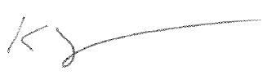
Karl Somers
Delegate
ACT Gambling and Racing Commission
20 May 2025

For further information please contact the approved supplier.

Aristocrat Technologies Australia Pty Ltd
Subject: Alternative Touchscreen Controller Firmware
Platform: | Gen 10 The Baron Upright
Description: | VBD Assembly OMRON Dual Bash Button No Wireless Charger 19.5”
Part: | 160180, issue B
Application Reference Number: | 01-A2605/S01

