Australian Capital Territory
Planning (Various) Minor Plan Amendment 2025 (No 1)
Notifiable instrument NI2025–441
made under the
Planning Act 2023, s 85 (Making minor plan amendments)

1 Name of instrument
This instrument is the Planning (Various) Minor Plan Amendment 2025 (No 1).
2 Commencement
This instrument commences on the day after its notification day.
3 Minor plan amendment
I am satisfied under the Planning Act 2023, section 85 (1) that Minor Plan Amendment 2025-08 is a minor plan amendment to the Territory Plan.
4 Dictionary
In this section:
Minor Plan Amendment 2025-08 means the minor plan amendment to the Territory Plan in schedule 1.

Freya O’Brien
Delegate of the territory planning authority
13 August 2025

Schedule 1

MINOR AMENDMENT
TO THE TERRITORY PLAN
2025-08
Amendments to the Territory Plan Map, Inner South District Policy, Molonglo Valley District Policy, and Woden District Policy

This minor plan amendment was prepared
under part 5.3 of the Planning Act 2023
Contents
1.0 INTRODUCTION 1
1.1 Outline of the process 1
1.2 Summary of the amendments 1
2.0 CONSULTATION WITH THE PUBLIC 2
2.1 Consultation period 2
2.2 Comments from the public 2
2.3 Changes made following public consultation 2
3.0 TERRITORY PLAN CHANGES 3
3.1 Territory Plan Map 3
3.2 Inner South District Policy 7
3.3 Molonglo Valley District Policy 8
3.4 Woden District Policy 10
4.0 TERRITORY PLAN AMENDMENT INSTRUCTIONS 13
4.1 Territory Plan Map 13
4.2 Part D: D04 – Inner South District Policy 14
4.3 Part D: D05 – Molonglo Valley District Policy 16
4.4 Part D: D07 – Woden District Policy 17
INTERPRETATION SERVICE 20

- INTRODUCTION
  - Outline of the process
Minor plan amendment 2025-08 (MA2025-08) to the Territory Plan is a minor plan amendment (MA) prepared under section 84 (2) (a), section 88 and section 84 (2) (d) of the Planning Act 2023 (the Act).

Section 84 of the Act outlines the different types of MAs, some which require limited consultation to be undertaken and some which require no consultation to be undertaken.

Under Section 85 of the Act a MA can only be made where:
- any required limited consultation has taken place and the authority is satisfied that the content of the MA meets the requirements of the Act
- if the MA is not inconsistent with the planning strategy or any relevant district strategy
- any comments received during the consultation period and from the National Capital Authority have been considered.

This MA required limited consultation to be undertaken and was released for public consultation in accordance with the Act.

The MA is not inconsistent with the planning strategy or any relevant district strategy.

The National Capital Authority has received a copy of this MA.

For more information on the content of the Territory Plan and minor plan amendment processes please refer to the Environment, Planning and Sustainable Development (EPSDD) website The Territory Plan - Environment, Planning and Sustainable Development Directorate - Planning (act.gov.au).
  - Summary of the amendments
MA2025–08 makes the following changes to:

The Territory Plan Map for Block 10 Section 51 Lyneham:

- Rezone land where development is encroaching on adjoining land consistent with a declaration made by the Territory Planning Authority.

The Inner South District Policy:

- Include additional prohibited uses in the development table to limit uses of a new lease to a retirement village and other minor uses.
- Amend assessment requirement 79 to enable separate development applications to be lodged for the following:
  - Creation of an additional lease retaining the golf course use.
  - Removal of the concessional lease status and payment of the market value of the crown lease.
  - Adding the use of retirement village, requiring the payment of a lease variation charge.

The Molonglo Valley District Policy:
- Amend assessment requirements 43, 44, 45 and 64 to clarify:
  - the requirement for a town oval and its size to be located within the school site in the Molonglo East precinct (or in a location agreed by the Education Directorate)
  - the requirement for a multi-purpose indoor recreation facility and its size
  - that the town oval and multi-purpose indoor centre are to be accessible by the public, including by clubs and other sporting groups
  - that car parking associated with sport and recreation facilities on the school site is to remain available to the public outside of school hours

The Woden District Policy:

- Amend assessment requirement 43 for Block 4 Section 7 Phillip in the Woden Town Centre to enable greater building heights to recognise that part of the block will be developed for commercial uses which requires greater ceiling heights (with the number of stories to remain the same).
- Amend assessment requirement 38 to clarify the provisions for permitted and prohibited development.
- CONSULTATION WITH THE PUBLIC
  - Consultation period
Under section 84 (2) of the Planning Act 2023, this minor amendment was subject to limited public consultation of at least 20 working days. Written comments on MA2025-08 were invited from the public from 6 June 2025 to 7 July 2025.
  - Comments from the public
One formal written comment was received during consultation. The comment was in relation to allowing greater flexibility for the location of the proposed Molonglo Town Centre school site.
  - Changes made following public consultation
The Authority made minor revisions to Assessment Requirements 44 b) and 45 e) in the Molonglo District Policy to allow flexibility around the specific location of the school site within the Molonglo Town Centre, provided this is agreed to by the Education Directorate.

A minor correction was made to Assessment Requirement 43 in the Woden District Policy to include ‘c1’ in the note. A minor correction was also made to align both area C1 in Figure 10 and PD5 in Figure 15 with block 4 section 7 Phillip.
- TERRITORY PLAN CHANGES
  - Territory Plan Map
A multi-unit development at Lyneham Part Block 10 (formerly Block 3) Section 51 Lyneham has a minor encroachment of architectural features into the adjoining PRZ1 Urban Open Space zone and residential use is prohibited in that zone. In the development process there can be instances where it is appropriate for a development to encroach into adjoining Territory land; however, due to the zoning of the land, the use (of the encroachment) is prohibited.
Section 158 of the Act enables an applicant to seek declaration from the Territory Planning Authority (Authority) that such an encroachment is considered to be minor and can therefore be the subject of a development application. This then triggers the requirement for a minor amendment under section 88 of the Act for a rezoning where a development encroaches onto adjoining Territory land. Section 88 of the Act permits changing the boundary of a zone where development is deemed to be encroaching onto adjoining Territory land, provided that the change is consistent with a development proposal under section 158 of the Act.
Section 158 of the Act requires the Authority to make a declaration for development encroaching on adjoining Territory land if development is prohibited, provided that the proposal satisfies the criteria in section 158 (2).
The proposal was assessed by the Authority and deemed to comply with the requirements of section 158 of the Act. The declaration was approved by a delegate of the Authority on 7 February 2025 and has been published on the Planning website: www.planning.act.gov.au/professionals/our-planning-system/planning-act-2023/encroachment-declarations
Location map
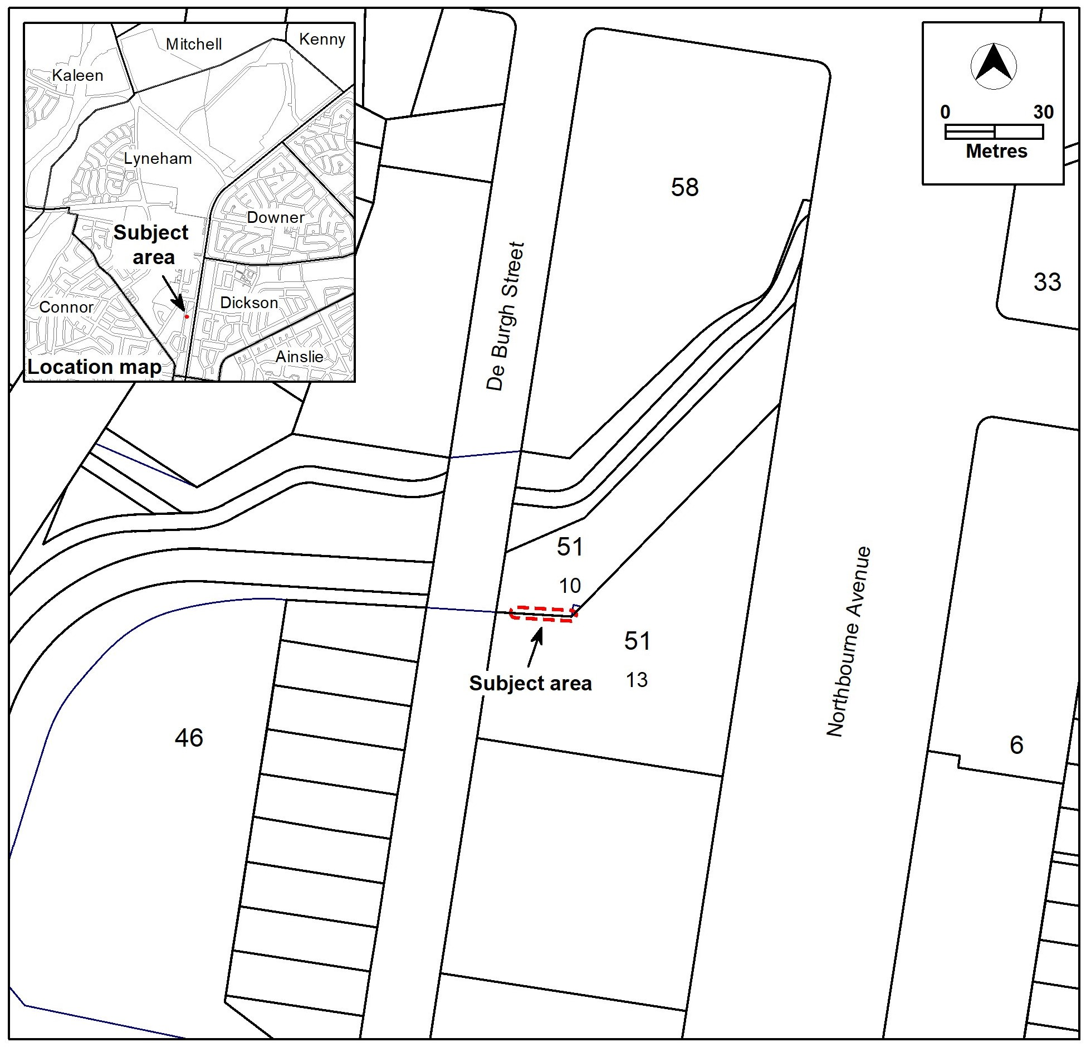

Existing Territory Plan Map
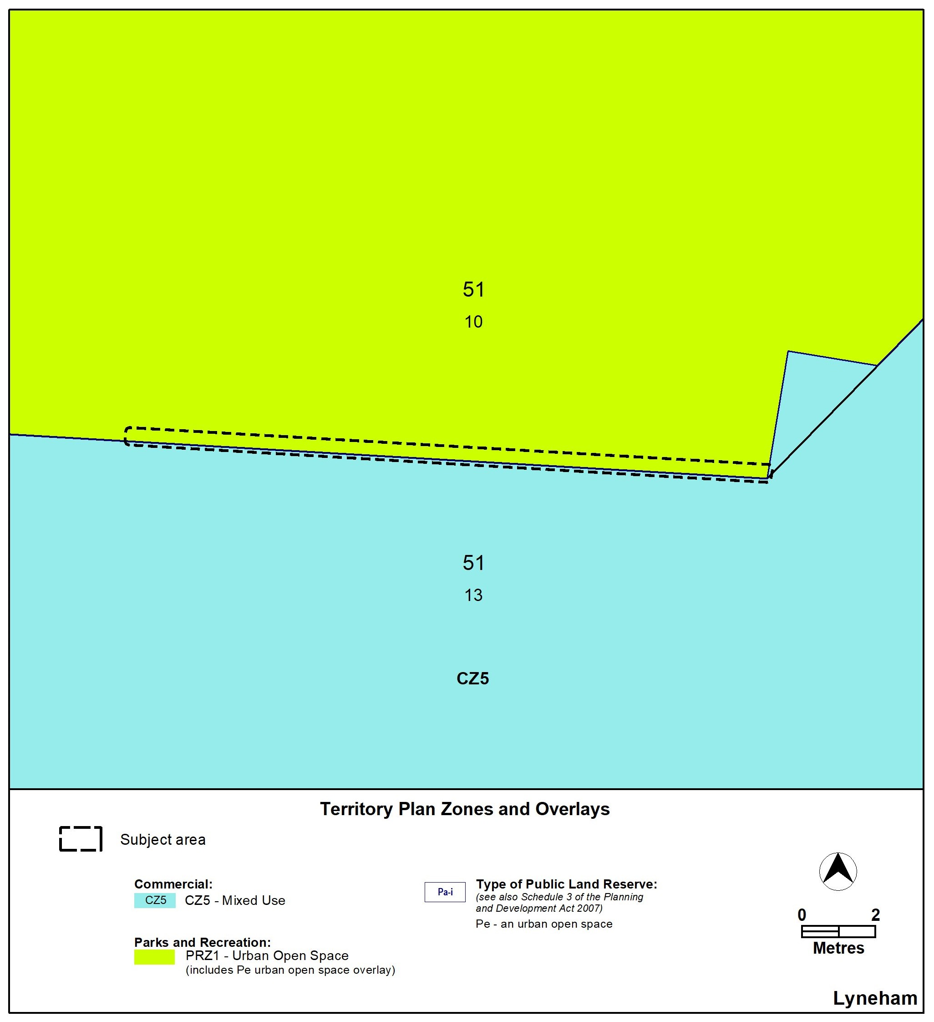

Proposed Territory Plan Map
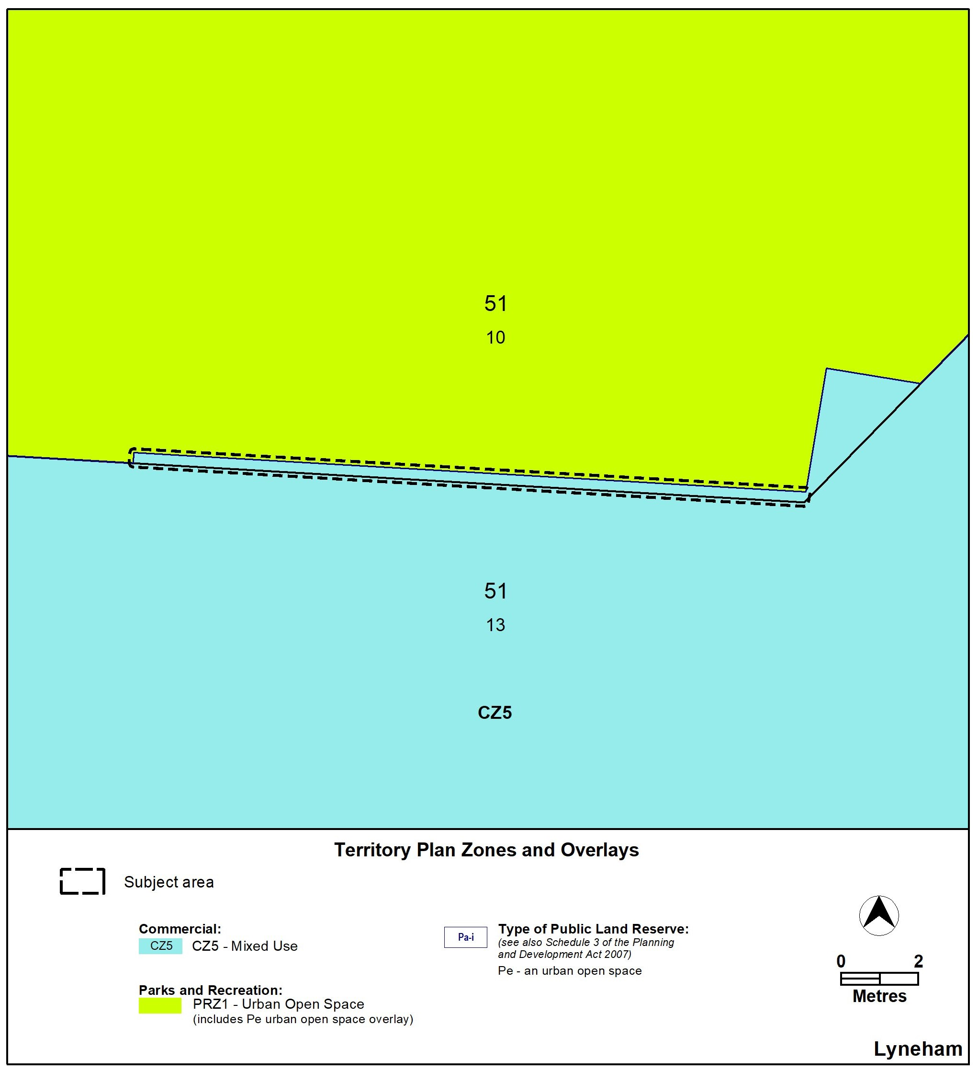

  - Inner South District Policy
Changes are made to assessment requirement 79 to enable the creation of a lease for a retirement village on the Federal Golf course. The previous wording required the retirement village to exist prior to subdivision occurring. The changes would the revocation of the concessional lease status process to occur and, if approved, would require the payment of a lease variation charge (the market value of the crown lease).

The creation of the new lease will allow the remainder of the site to be retained as an 18-hole golf course and to retain its concessional lease status while the retirement village is contained within an approved subdivided parcel.

To guarantee the new lease is limited to a retirement village, changes to the land use table are made to prohibit uses that would otherwise be permitted in the PRZ2 Restricted Access Recreation zone apart from minor uses (such as minor or ancillary development).

The changes are consistent with the original policy intent contained in the Red Hill and Surrounds Integrated Plan 2021 and Variation 384 Federal Golf Course to the Territory Plan which commenced in 2023.

The following land uses are added to the Land Use Table in the ‘Additional prohibited development’ column for Red Hill, PRZ2, retirement village:

aquatic recreation facility, carpark, club, communications facility, community activity centre, consolidation, distribution reservoir, guest house, hotel, indoor recreation facility, major electricity storage facility, major electricity sub-station, major gross pollutant trap, major pump station, major road, major service conduits, motel, playing field, power generation station, public agency, treatment plant, utility hydrogen production facility, water storage dam.

The following changes are made to assessment requirement 79:
Land use – 79. Development of a retirement village is focused primarily within the investigation area identified
retirement in Figure 13 and must comply with all of the following:
village a) Retirement village is restricted to a maximum of 125 units.
- Maximum number of storeys is 3.
- Subdivision is only permitted to create one additional lease for a retirement village. No further subdivision of either Crown lease is permitted, including subdivision under the Unit Titles Act 2001, of the:.
- Lease for the retirement village.
- Lease containing the golf course.
e) d) Vehicular access to the retirement village is provided from Kitchener Street
f) e) No public vehicular access is provided to the retirement village from Gowrie Drive through the golf course.
g) f) No public vehicular access is provided to the golf course, club house and associated facilities from the retirement village.
h) g) Buildings and structures are setback a minimum of 50 metres from residential and PRZ1 zoned blocks as indicated on Figure 13.
i) h) Development of a retirement village does not diminish or inhibit the opportunity for an 18 hole golf course and associated facilities to operate on the balance of the site.
  - Molonglo Valley District Policy
Changes are made to the Molonglo Valley District Policy. These changes are outlined below.
Changes to assessment requirements 43, 44, 45 and 64 are proposed to clarify:
- the requirement for a town oval and its size to be located within the school site in the Molonglo East precinct
- the requirement for a multi-purpose indoor recreation facility and its size
- that the town oval and multi-purpose indoor centre are to be accessible by the public, including by clubs and other sporting groups
- that car parking associated with sport and recreation facilities on the school site is to remain available to the public outside of school hours

These requirements are generally in accordance with the intent of the concept plan that was prepared by EPSDD and incorporated into the Territory Plan in 2022.

Amend assessment requirements 43, 44, 45 and 64 as below:
Locality | Assessment requirement

Molonglo –Town Centre and Surrounds - Future Urban Areas (Figure 5)
Land use – school sites | 43. Two school sites are provided, and are generally located in accordance with Figure 7 and contained within a Community Facility zone:  a) In Denman Prospect precinct of 4.3 hectares or as agreed by the Education Directorate.  b) In Molonglo East precinct of 9.3 hectares or as agreed by the Education Directorate.  44. Where feasible, sSchool sites provide the following facilities that are accessible to the public, including sporting clubs and groups outside of school hours:  a) In the Denman Prospect precinct school site (Figure 6) – a playing field of at least one hectare in area.  b) In the Molonglo East precinct school site (or location agreed by the Education Directorate):  : Multi-purpose indoor courts for use by clubs and other sporting groups.  i) a multi-purpose indoor centre with a gross floor area of at least 5,300m² ii) a town oval of at least 1.9 hectares in area.
Land use – community and recreation facilities | 45. Recreation and community facilities:  a) The provision of community facilities is to generally align with the outcomes of the community and recreation facilities assessment, generally in the locations indicated in Figure 7 and be accessible from the ground floor.  b) Include spaces that can be used for activities, passive recreation, gatherings and performances, such as a town square.  c) Where possible, are co-located in highly accessible locations to active travel routes and public transport stops.  d) Include a town plaza adjoining the main street designed with sufficient area to provide spaces for people to meet, relax and spend time and to allow for temporary uses including markets, stalls and community.  e) Include a town oval within close proximity to the school site in the suburb of Molonglo East precinct (or in a location agreed by the Education Directorate):  .  f) In the suburb of Molonglo, a site for a place of worship is provided on land zoned for Community Facility, either as a standalone site or co-located with other community facilities, to the satisfaction of the relevant government agency.

Car parking | 63. In the CZ1 core zone podium parking and ground level car parking is prohibited at ground and first floor levels except where:  a) Surface carparking is minimised and used only as a temporary measure, unless screened by buildings.  b) Parking areas, including ground level parking, multi-level car parks and podium parking are concealed and screened by buildings with active development frontages or residential uses where permitted.  c) Opportunities for on-street parking are provided and integrated with street trees and landscaping.  d) Natural topography of the land is utilised to promote multi-level car parking in basements and under croft development.  64. Car parking associated with sport and recreation facilities on school sites is to remain available to the public outside school hours.

  - Woden District Policy
Changes are made to assessment requirement 43 of the Woden District Policy for Block 4 Section 7 Phillip in the Woden Town Centre. This is to facilitate commercial development (as required for the site) which requires greater building heights in metres due to larger ceiling height requirements while retaining the same number of storeys.

The changes clarify where residential development is not permitted on the site:
- by removing the part of assessment requirement 38 which states that residential development is only allowed within 36 metres of Callum Street for Block 4; and
- adding residential development to the prohibited list in the development table and identifying the relevant part of the block (i.e. outside of 36 metres from Callum Street).
This approach is consistent with the way prohibited development is usually identified in the Territory Plan.
Amend the Land Use Table to add the following:
Locality | Zone | Additional assessable development | Additional prohibited development | Relevant parcel or Figure
Phillip | CZ2 | Nil | residential use, commercial accommodation use | PD5 Figure 15

Amend assessment requirement 38 by omitting the second sentence:
Control | Assessment requirement

Phillip
Land and site use | 38. An additional 3m in height may be allowed for the building containing the pool facility to accommodate the increased floor to ceiling height required on the ground floor. Development of dwellings and commercial accommodation on Section 7 is only permitted within 36m of Callam Street.

Amend assessment requirement 43 to insert Area ‘c1’ and renumber:
Control | Assessment requirement
Height of building | 43. Maximum height of buildings indicated in Figure 10:  a) Area ‘a’ – 78m (approx. 24 storeys).  b) Area ‘b’ – 53m (approx. 16 storeys).  c) Area ‘c’ – 41m (approx. 12 storeys) – see also part Block 4 Section 79 Phillip provisions.  d) Area ‘c1’ – 12 storeys.  d)e) Area ‘d’ – 22m (approx. 6 storeys).  e)f) Area ‘e’ and ‘f’ – 16m (approx. 4 storeys).  f)g) One tower element per block (prior to any subdivision), in areas ‘a’, ‘b’ and ‘c’ (except for part Block 4 Section 79 Phillip) may be increased by 15m provided the proposal is recognised as being of high-quality architectural merit, the proposal demonstrates a positive contribution to the streetscape, the proposal does not unreasonably impact through overshadowing, and the visual bulk of the building is minimised.  g)h) Buildings in area ‘e’ can be a maximum of 19m where fronting Townsend St, Colbee Court or Dundas Court and the upper level is setback 3m. Buildings facing Altree Court can be a maximum of 22m.  Note: for areas ‘a’, ‘b’, ’c’, ‘c1’ and ‘d’ roof top plant that are screened and setback 3 metres from the building façade of the floor immediately below are not included in the number of storeys or the height of building in metres.
Amend Figure 10 Phillip (Town Centre) – Building Heights, land and site use and building design, to insert area c1.

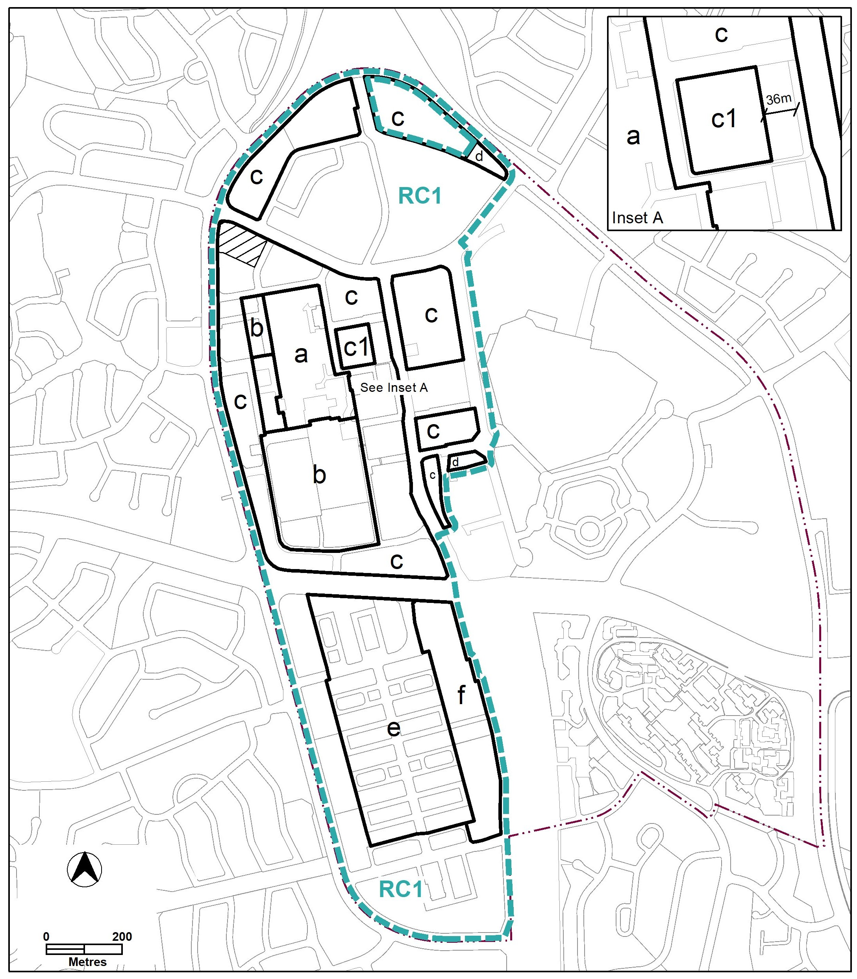

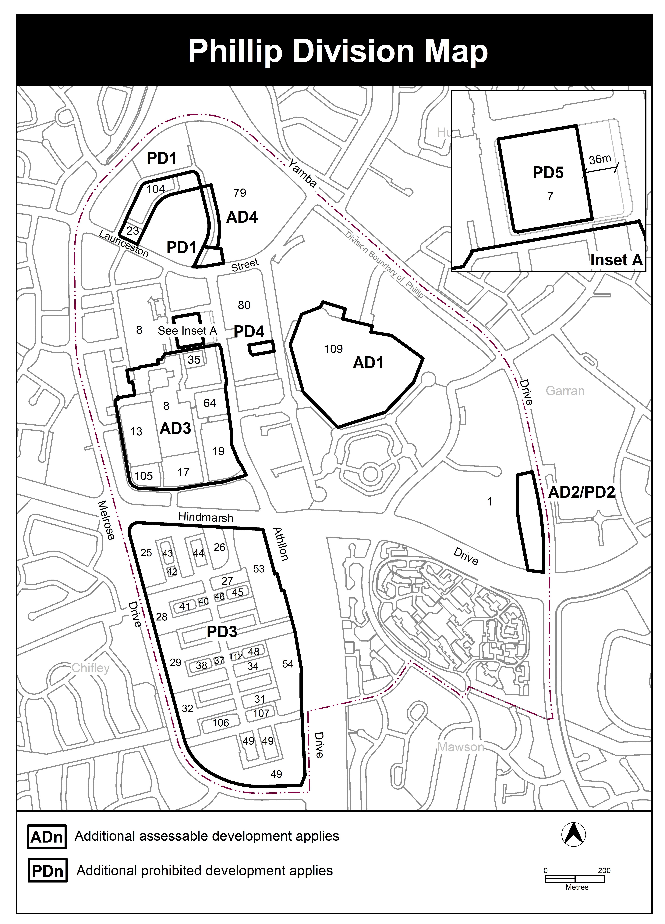
Amend Figure 15 Phillip Division Map to insert the PD5 area.
- TERRITORY PLAN AMENDMENT INSTRUCTIONS
  - Territory Plan Map

The Territory Plan map is varied as indicated below.

  - Part D: D04 – Inner South District Policy

Land Use Table, Red Hill, PRZ2, retirement village

Omit

Red Hill PRZ2 retirement village Nil AD2 Figure 20

Insert

Red Hill | PRZ2 | retirement village | aquatic recreation facility, carpark, club, communications facility, community activity centre, consolidation, distribution reservoir, guest house, hotel, indoor recreation facility, major electricity storage facility, major electricity sub-station, major gross pollutant trap, major pump station, major road, major service conduits, motel, playing field, power generation station, public agency, treatment plant, utility hydrogen production facility, water storage dam. | AD2 Figure 20

Hyperlink Figure 20 in the text with the corresponding figure

Assessment Requirements

Red Hill – Federal Golf Course

Substitute

Land use – 79. Development of a retirement village is focused primarily within the investigation area identified
retirement in Figure 13 and must comply with all of the following:
village a) Retirement village is restricted to a maximum of 125 units.
- Maximum number of storeys is 3.
- Subdivision is only permitted to create one additional lease. No further subdivision of either Crown lease is permitted, including subdivision under the Unit Titles Act 2001.
- Vehicular access to the retirement village is provided from Kitchener Street
- No public vehicular access is provided to the retirement village from Gowrie Drive through the golf course.
- No public vehicular access is provided to the golf course, club house and associated facilities from the retirement village.
- Buildings and structures are setback a minimum of 50 metres from residential and PRZ1 zoned blocks as indicated on Figure 13.
- Development of a retirement village does not diminish or inhibit the opportunity for an 18 hole golf course and associated facilities to operate on the balance of the site.

Hyperlink Figure 13 in the text with the corresponding figure

  - Part D: D05 – Molonglo Valley District Policy

Assessment requirements 43, 44 and 45

Substitute

Locality | Assessment requirement

Molonglo –Town Centre and Surrounds - Future Urban Areas (Figure 5)
Land use – school sites | 43. Two school sites are provided, and are generally located in accordance with Figure 7 and contained within a Community Facility zone:  a) In Denman Prospect precinct of 4.3 hectares or as agreed by the Education Directorate.  b) In Molonglo East precinct of 9.3 hectares which includes a town oval or as agreed by the Education Directorate.  44. School sites provide the following facilities that are accessible to the public, including sporting clubs and groups outside of school hours:  a) In the Denman Prospect precinct school site (Figure 6) – a playing field of at least one hectare in area.  b) In the Molonglo East precinct school site (or location agreed by the Education Directorate):  i) a multi-purpose indoor centre with a gross floor area of at least 5,300m²  ii) a town oval of at least 1.9 hectares in area.
Land use – community and recreation facilities | 45. Recreation and community facilities:  a) The provision of community facilities is to generally align with the outcomes of the community and recreation facilities assessment, generally in the locations indicated in Figure 7 and be accessible from the ground floor.  b) Include spaces that can be used for activities, passive recreation, gatherings and performances, such as a town square.  c) Where possible, are co-located in highly accessible locations to active travel routes and public transport stops.  d) Include a town plaza adjoining the main street designed with sufficient area to provide spaces for people to meet, relax and spend time and to allow for temporary uses including markets, stalls and community.  e) Include a town oval within the school site in the Molonglo East precinct (or in a location agreed by the Education Directorate).  f) In the suburb of Molonglo, a site for a place of worship is provided on land zoned for Community Facility, either as a standalone site or co-located with other community facilities, to the satisfaction of the relevant government agency.

Hyperlink Figure 6 and Figure 7 in the text with the corresponding figures

Assessment requirement 64

Substitute

Car parking associated with sport and recreation facilities on school sites is to remain available to the public outside school hours.

  - Part D: D07 – Woden District Policy

Land use table

Insert
Locality | Zone | Additional assessable development | Additional prohibited development | Relevant parcel or Figure
Phillip | CZ2 | Nil | residential use, commercial accommodation use | PD5 Figure 15
Hyperlink Figure 15 in the text with the corresponding figure

Assessment requirement 38

Omit

Development of dwellings and commercial accommodation on Section 7 is only permitted within 36m of Callam Street.

Assessment requirement 43

Substitute

Control | Assessment requirement
Height of building | 43. Maximum height of buildings indicated in Figure 10:  a) Area ‘a’ – 78m (approx. 24 storeys).  b) Area ‘b’ – 53m (approx. 16 storeys).  c) Area ‘c’ – 41m (approx. 12 storeys) – see also part Block 4 Section 79 Phillip provisions.  d) Area ‘c1’ – 12 storeys.  e) Area ‘d’ – 22m (approx. 6 storeys).  f) Area ‘e’ and ‘f’ – 16m (approx. 4 storeys).  g) One tower element per block (prior to any subdivision), in areas ‘a’, ‘b’ and ‘c’ (except for part Block 4 Section 79 Phillip) may be increased by 15m provided the proposal is recognised as being of high-quality architectural merit, the proposal demonstrates a positive contribution to the streetscape, the proposal does not unreasonably impact through overshadowing, and the visual bulk of the building is minimised.  h) Buildings in area ‘e’ can be a maximum of 19m where fronting Townsend St, Colbee Court or Dundas Court and the upper level is setback 3m. Buildings facing Altree Court can be a maximum of 22m.  Note: for areas ‘a’, ‘b’, ’c’, c1 and ‘d’ roof top plant that are screened and setback 3 metres from the building façade of the floor immediately below are not included in the number of storeys or the height of building in metres.
Hyperlink Figure 10 in the text with the corresponding figure

Figure 10 Phillip (Town Centre) – Building heights, land and site use and building design

Substitute

Figure 15 Phillip

Substitute

INTERPRETATION SERVICE
To speak to someone in a language other than English please telephone the Telephone Interpreter Service (TIS) 13 14 50
LANGUAGE | DETAILS
English | If you need an interpreter please call: 13 14 50
Mandarin (Simplified Chinese) / 简体中文 | 如果您需要翻译，请致电：13 14 50
Arabic / العربية | إذا كنت بحاجة إلى مترجم شفهي اتصل بالرقم: 50 14 13
Cantonese (Traditional Chinese) / 繁體中文 | 如果你需要傳譯員，請致電：13 14 50
Vietnamese /  Tiếng Việt | Nếu bạn cần thông dịch viên, xin gọi: 13 14 50
Korean / 한국어 | 통역사가 필요할 경우 다음 번호로 전화하시기 바랍니다: 13 14 50
Spanish / Español | Si necesita un intérprete, llame al 13 14 50
Persian (Farsi) / فارسی | اگر به مترجم نیاز دارید، لطفاً به این شماره تلفن کنید: 50 14 13
Dari / دری | اگر به یک ترجمان شفاهی نیاز دارید لطفاً به شمارۀ 131450 زنگ بزنید.
Punjabi / ਪੰਜਾਬੀ | ਜੇਕਰ ਤੁਹਾਨੂੰ ਕਿਸੇ ਦੁਭਾਸ਼ੀਏ ਦੀ ਲੋੜ ਹੈ ਤਾਂ ਕਿਰਪਾ ਕਰਕੇ ਫੋਨ ਕਰੋ: 13 14 50
Tamil / தமிழ் | உங்களுக்கு மொழிபெயர்த்துரைப்பாளர் ஒருவர் தேவைப்பட்டால் 13 14 50 என்ற எண்ணை அழைக்கவும்
Greek / Ελληνικά | Αν χρειάζεστε διερμηνέα, τηλεφωνήστε: 13 14 50
Italian / Italiano | Se hai bisogno di un interprete, chiama: 13 14 50
Hazaragi / هزاره گی | اگه ده ترجمان ضرورت ده رید، لطفاً ده شماره 50 14 13 تماس بگیرید.
Thai / ภาษาไทย | หากคุณต้องการล่าม กรุณาโทรไปที่ 13 14 50
Karen / ကညီကျိၥ် | ဖဲနမ့ၢ်လိၣ်ဘၣ်ပှၤကတိၤကျိးထံတၢ်တဂၤအခါ၀ံသးစူၤကိးဘၣ်-၁၃၁ ၄၅၀ တက့ၢ်.

Telephone and Interpreter Service 13 14 50 - Canberra and District - 24 hours a day, seven days a week

