Australian Capital Territory
Planning (Ainslie) Major Plan Amendment 2025

Notifiable instrument NI2025-482
made under the
Planning Act 2023, s 75 (Minister’s powers in relation to draft plan amendments)

1 Name of instrument
This instrument is the Planning (Ainslie) Major Plan Amendment 2025.
2 Major plan amendment
(1) I approve Major Plan Amendment 02 to the Territory Plan.
(2) The major plan amendment must be presented to the Legislative Assembly and may only commence by commencement notice under section 80 (2).
3 Dictionary
In this instrument:
Major Plan Amendment 02 to the Territory Plan means the Major Plan Amendment in schedule 1.

Chris Steel MLA
Minister for Planning and Sustainable Development
21 August 2025

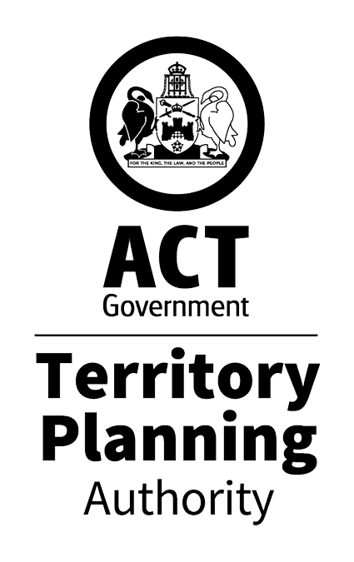

MAJOR PLAN AMENDMENT 02

Ainslie Football and Social Club
Blocks 11,16, 20, 21 and 22 Section 26 Ainslie

September 2025
This major plan amendment to the Territory Plan was prepared
under division 5.2.7 of the Planning Act 2023
Contents
1.0 INTRODUCTION 1
1.1 Purpose 1
1.2 Outline of process 1
2.0 SUMMARY OF MPA-02 2
2.1 Site description 2
2.2 Summary of amendments to the Territory Plan 4
2.3 Summary of consequential amendments to other documents 6
3.0 NEED FOR THE MAJOR PLAN AMENDMENT 7
3.1 Application 20XX-XX 8
4.0 CONSULTATION 9
4.1 Consultation with agencies 9
4.2 Consultation with the public 9
5.0 MAJOR PLAN AMENDMENT 02 10
5.1 Amendments to the Territory Plan Map 10
5.2 Amendments to the Inner North and City District Policy – Land Use 11
5.3 Amendments to the Inner North and City District Policy – Assessment Outcomes 11
5.4 Amendments to the Inner North and City District Policy – Assessment Requirements 12
INTERPRETATION SERVICE 13

- INTRODUCTION
  - Purpose
This document is major plan amendment 02 – Ainslie Football and Social Club (MPA-02) to the Territory Plan.

Key parts of this document are:
- section 2 – summarises the MPA, including amendments to the Territory Plan and associated documents
- section 3 – why this MPA was undertaken
- section 5 – detailed amendment instructions to the Territory plan proposed by this MPA.
  - Outline of process
A major plan amendment (MPA) is statutory process under the Planning Act 2023 (the Act) that enables the Territory Plan to be amended. The three types of MPAs are:
- Proponent-initiated
- Authority-initiated
- Minister-initiated

MPA-02 is a proponent-initiated MPA.

After public consultation concluded the Territory Planning Authority (the Authority) gave MPA-02 to the Minister for Planning and Sustainable Development (the Minister) for referral to the relevant Legislative Assembly Standing committee (the Standing Committee).

As the Standing Committee decided to not report on MPA-02, under section 75 (2) (a) of the Act, the Minister approved MPA-02.

Under section 77 of the Act, the Minister must present MPA-02 to the Legislative Assembly which may reject it completely or partly. If not rejected by the Legislative Assembly, the Minister may commence MPA-02 and become part of the Territory Plan.

For more information about the content of the Territory Plan and the major plan amendment processes please refer to the Environment, Planning and Sustainable Development (EPSDD) website.
- SUMMARY OF MPA-02
This section summarises:
- the amendments MPA-02 made to the Territory Plan and supporting documents
- outlines the relevant subject area

Amendments to the Territory Plan by this MPA are summarised in section 2.2 and shown in detail at section 5 of this document. The consequential amendments made to the Territory Plan’s related documents are summarised in section 2.3 of this document.
  - Site description
MPA-02 relates to the subject area shown in Figure 1 and consists of blocks 11, 16, 20, 21 and 22 section 26 Ainslie. The subject area is currently occupied by the Ainslie Football and Social Club and Alan Ray Oval. The custodian of the subject area is a private lessee.

Prior to the approval of MPA-02, block 11 was zoned Commercial CZ6 Leisure and Accommodation zone while the remainder of the blocks were zoned Parks and Recreation PRZ2 Restricted Access zone. Prior to MPA-02 the Territory Plan zoning for the subject area can be seen in Figure 2.
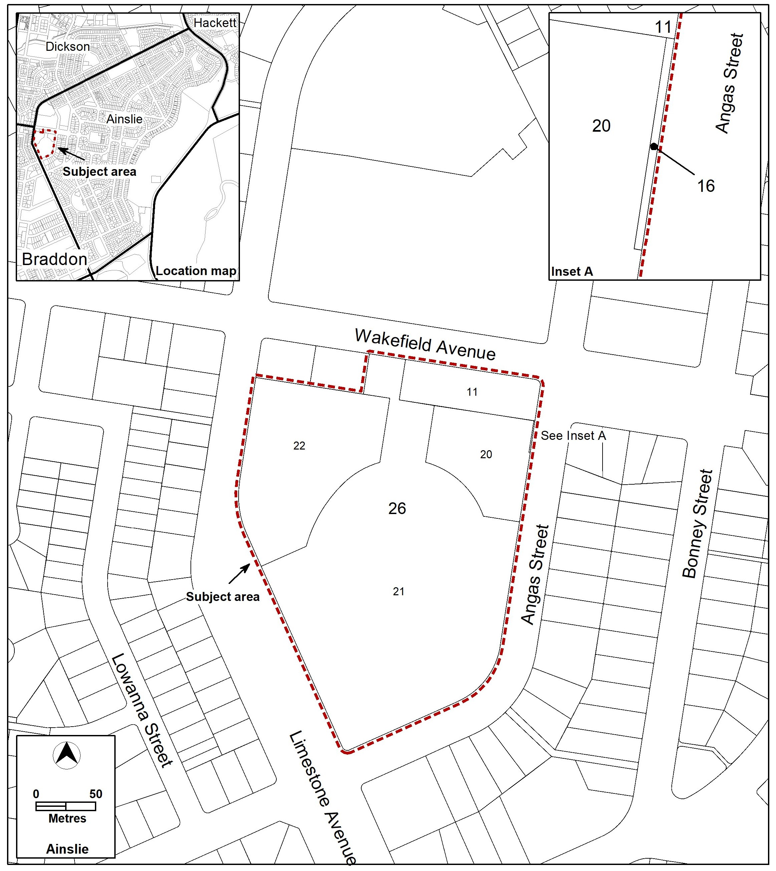
Figure 1 – Locality Map

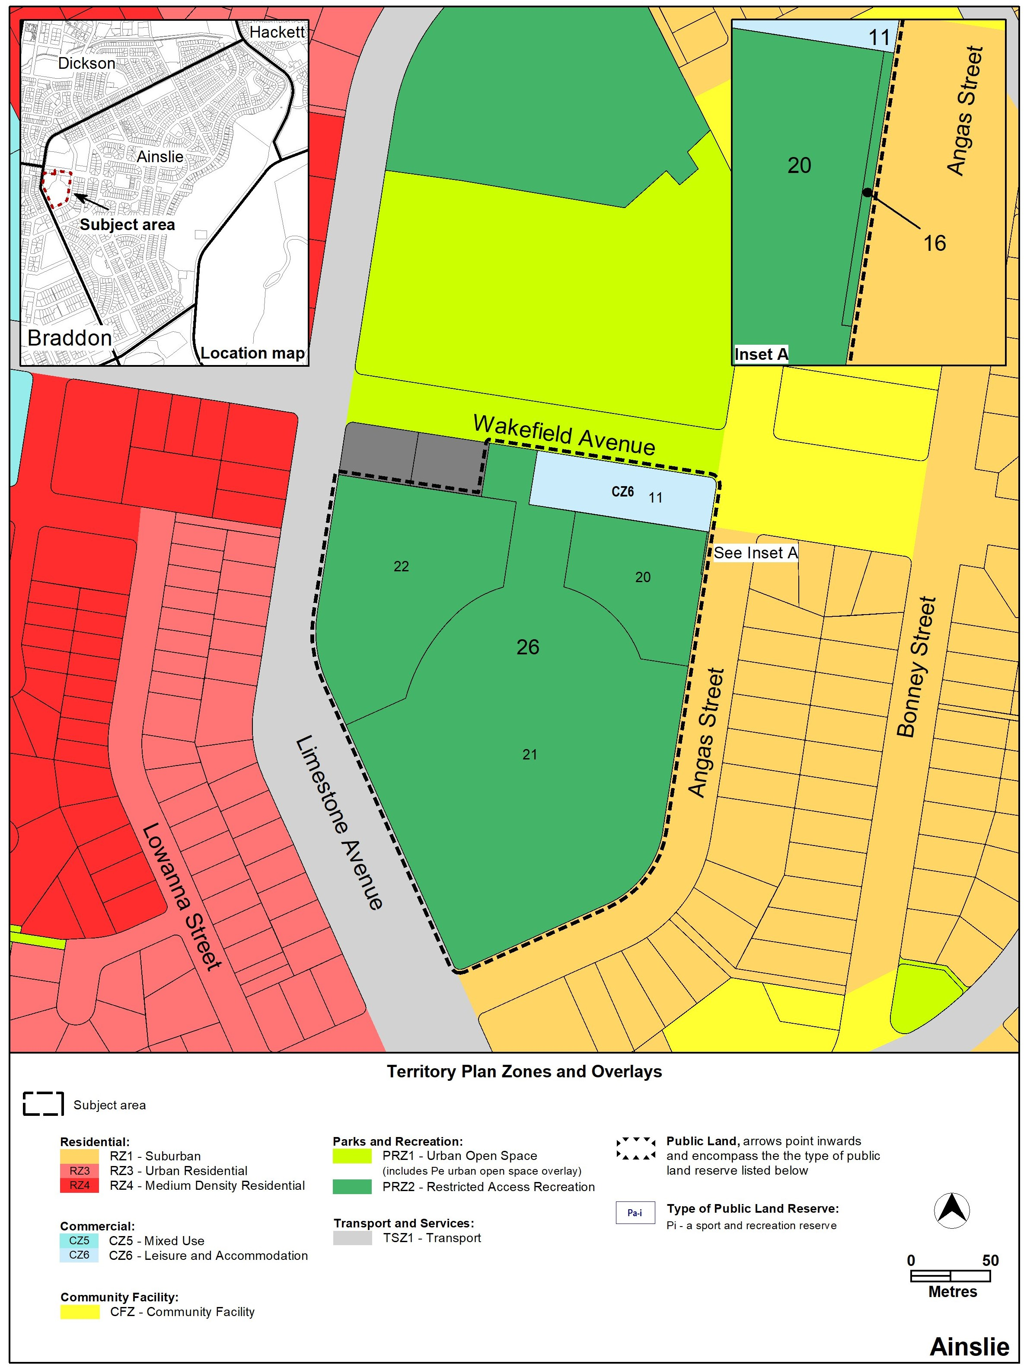
Figure 2 – Territory Plan zoning prior to MPA-02
  - Summary of amendments to the Territory Plan
MPA-02 amends the Territory Plan as follows:
- Territory Plan Map
- amend the map, as shown in Figure 3, to facilitate residential and commercial development on the northern part of the site.
- Inner North and City District Policy
- amend the land use table to:
  - permit hotel and club in the propose CZ5 area to allow the relocation of the club
  - prohibit bulky goods retailing, business agency, communications facility, financial establishment and public agency to maintain the commercial hierarchy and remove unsuitable uses.
- introduce assessment outcomes for the subject area which:
  - restricts commercial development to a scale and nature that maintains the commercial hierarchy.
  - encourages denser forms of residential development of the site in line with the Inner North and City District Strategy
  - for the proposed residential development, reduce vehicular parking in recognition of the subject area’s proximity to light rail, active travel routes and employment centres and the capacity and quality of active travel facilities in the area.
- introduce assessment requirements that limit building heights to 12.5m when within 15m from Angas Street and 21.5m in all other cases. This will reduce the impact on surrounding, lower density residential development.

Further detail of the amendments being made to the Territory Plan by this MPA can be found in section 5 of this document.

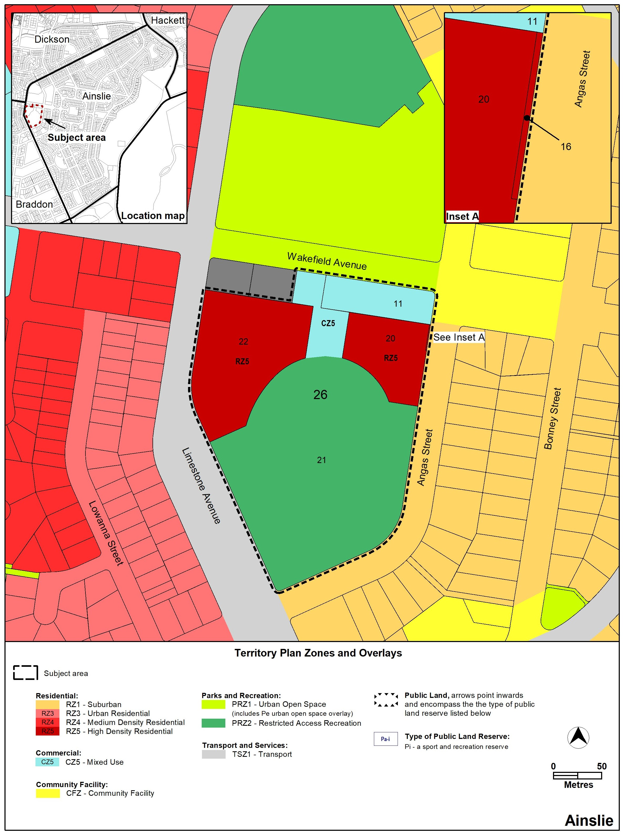
Figure 3 –Territory Plan zoning as amended by MPA-02
  - Summary of consequential amendments to other documents
Technical Specifications may be used as guidance in how to meet the assessment outcomes in the Territory Plan policies. These can guide the preparation and assessment of a development application.

The Technical Specifications are not part of the Territory Plan. Therefore, they will be amended separately when/if MPA-02 commences.
MPA-02 proposes the following consequential amendments to the Inner North and City Technical Specifications:
- a maximum gross floor area of 250m² for supermarkets and shops selling food, to protect the retail hierarchy of surrounding centres.
- a minimum dwelling limit of 200 dwellings and maximum of 400 dwellings across the site to provide guidance for the proposed assessment outcome.
- maximum storey limit of 3 storeys for development within 15 metres of Angas Street and 6 storeys in all other cases. This will provide guidance about how many storeys are generally expected within the 12.5m and 21.5m requirements set in the Territory Plan.
- reduction in vehicular parking provision rates for residential development, shown in Table 1, in recognition of the subject area’s proximity to public transport along Northbourne Avenue.
Residential Zone Technical Specifications provisions  Prior to the commencement of MPA-02 | Residential Zone Technical Specifications provisions  After the commencement of MPA-02
single bedroom dwelling – 1 space | studio or one-bedroom dwelling – 1 space maximum
two-bedroom dwelling – minimum of 1.5 spaces | two-bedroom dwelling – minimum 1 space maximum of 1.3 spaces
three or more-bedroom dwelling – minimum of 2 spaces | three or more-bedroom dwelling – minimum 1.5 spaces and a maximum of 2 spaces
visitor – one space per four dwellings where a complex comprises four or more dwellings. | visitor – one space per every eight dwellings.
Table 1 – Proposed amendment to parking provisions in the Technical Specifications

For general information about other documents, such as the Technical Specifications or Development Controls, see the EPSDD website.
- NEED FOR THE MAJOR PLAN AMENDMENT
The Inner North and City District Strategy (the District Strategy) builds upon the ACT Planning Strategy’s desire for a compact, efficient and liveable city. The District Strategy does this by outlining considerations for future planning changes as well as identifying key sites and change areas within the district that can contribute to the current and future development demands for the ACT’s growing population. The District Strategy shows the subject area as a ‘Category 3’ change area.

Notably, the District Strategy outlines:
- the district as having the largest proportion of jobs of any district
- a potential future demand of up to 24 000 additional dwellings in the Inner North and City District by 2050.
- the subject area and other key sites and change areas in the district must contribute 1,500 to 11,000 dwellings to this demand the abovementioned potential demand.
- That planning changes can assist clubs diversify their income streams away from gaming revenue. This includes development of available land for various forms of housing.

The District Strategies were introduced as part of the ACT Planning System Review and Reform Project. The District Strategy mentions that further investigation is required to support planning changes for the Ainslie Football and Social club change. This MPA and associated background papers are these further investigations.

The Minister’s Statement of Planning Priorities (the Statement) also mentions a desire to have more allow for more well-located housing that is close to amenities and within the existing urban areas. In addition, the Statement also argues for increasing housing choice. For a well-connected suburb, there is limited housing choice and housing density in Ainslie which is predominately detached single dwellings.

MPA-02 is consistent with these key strategic planning documents by providing more housing and increased housing choice within the existing urban areas that are near amenities such as retail, employment and public transport. This will also assist the club diversify their income streams away from gaming revenue.

To mitigate the impact of new development, MPA-02 limits building heights, restricts land uses and provides guidance about the dwelling numbers. With the approval and commencement of MPA-02, development applications can be determined by the Authority against all relevant provisions of the Territory Plan, including the Residential Zones Policy and Commercial Zones Policy.
  - Application 2023-03
Prior to the preparation of a proponent-initiated MPA the proponent must lodge an application to be considered and accepted by the Authority. The application must be accompanied by a supporting report.

The supporting report must include how the proposal gives effect to the following ‘key documents’:
- the Planning Strategy
- the relevant District Strategy
- any current or proposed amendments to the Territory Plan
- the Statement of Planning Priorities
- anything else the Authority considers relevant.

In accordance with section 59 of the Act, the Authority accepted application 2023-03 on 4 September 2024 as it was satisfied the intended development outlined in the supporting report gave effect to the ‘key documents’.

The Authority’s reasoning for this MPA can be found in section 3 of this document
- CONSULTATION
  - Consultation with agencies
In accordance with section 62 of the Act the Authority consulted with the following in relation to this MPA:
- the National Capital Authority
- the Conservator of Flora and Fauna
- the Environment Protection Authority
- the Heritage Council
- each referral entity
- if unleased or leased public land, each custodian of the land likely to be affected.

Comments received from these and other entities were considered in the preparation of and by the Minister in approving this MPA.
  - Consultation with the public
Public consultation on this MPA occurred between 2 December 2024 and 3 February 2025. Written comments were invited from the public during the public consultation period.

One hundred and twenty-five comments were received during the public consultation period and a further 21 submissions were received after 3 February 2025. The main matters raised were:
- Unsuitability of the proposed RZ5 and CZ5 zoning
- excessive building heights
- opposition to proposed reduction in vehicular parking provisions
- loss of recreation areas and environmental impacts
- increased noise from proposed commercial uses
- concern about loss of heritage
- increased demand on facilities, including educational uses

About 17% of the submissions supported the MPA.

After the conclusion of public consultation the Authority made amendments to MPA-02 because of the above comments.

Comments received from the public during the consultation period and amendments made to MPA-02 by the Authority were considered by the Minister in approving this MPA.
- MAJOR PLAN AMENDMENT 02
This section details how MPA-02 proposes to amend the Territory Plan.

Consequential amendments which are a part of MPA-02 to the Technical Specifications have not been included as they do not form part of the Territory Plan. The Technical Specifications will be amended separately when MPA-02 commences. Consequential amendments to the Technical Specifications proposed with MPA-02 can be found in part 2.3 of this document.
  - Amendments to the Territory Plan Map
The relevant part of the Territory Plan map is varied in accordance with Figure 4.

Figure 4 –Territory Plan Map as amended by MPA-02
  - Amendments to the Inner North and City District Policy – Land Use
Insert the following into the Land Use Table of the Inner North and City District with a hyperlink to Figure 9a.
Locality | Zone | Additional assessable development | Additional prohibited development | Relevant parcel or Figure
Ainslie | CZ5 | club, commercial accommodation use | bulky goods retailing, business agency, communications facility, financial establishment, public agency | Figure 9a

  - Amendments to the Inner North and City District Policy – Assessment Outcomes
Substitute the text under the ‘area specific assessment outcomes’ heading in the Assessment Outcomes of the Inner North and City District for the following, including a hyperlink to Figure 9a:
The assessment outcomes for proposed development in specific locations are listed below. Localities that are not listed do not have any area specific assessment outcomes to consider.

Locality |  | Assessment Outcomes
Ainslie Football and Social Club (Figure 9a) | - The scale and nature of commercial development does not adversely affect the existing retail hierarchy or surrounding establish local, group and town centre.  - The subject area achieves a mix of medium and high-density residential development consistent with subject area’s proximity to public transport, employment areas and local amenities.  - The amount of parking provided for residential development considers the capacity and quality of proposed and existing active travel facilities within in the subject area as well as the proximity to employment, retail and other amenities.
  - Amendments to the Inner North and City District Policy – Assessment Requirements
Insert the following under Assessment Require 17 of the Assessment Requirements in the Inner North and City District Policy.
Control | Assessment requirement
Ainslie
Building heights | 17a. The maximum height of buildings in CZ5 and RZ5 for the subject area shown in Figure 9a is:  - for development (or part thereof) within 15 metres of Angas Street – 12.5 metres  - for all other development – 21.5 metres

Insert Figure 9a, shown below, before Figure 10 in the Inner North and District Policy.
Figure 9a – Ainslie Football and Social Club site
INTERPRETATION SERVICE
To speak to someone in a language other than English please telephone the Telephone Interpreter Service (TIS) 13 14 50

LANGUAGE | DETAILS
English | If you need an interpreter please call: 13 14 50
Mandarin (Simplified Chinese) / 简体中文 | 如果您需要翻译，请致电：13 14 50
Arabic / العربية | إذا كنت بحاجة إلى مترجم شفهي اتصل بالرقم: 50 14 13
Cantonese (Traditional Chinese) / 繁體中文 | 如果你需要傳譯員，請致電：13 14 50
Vietnamese /  Tiếng Việt | Nếu bạn cần thông dịch viên, xin gọi: 13 14 50
Korean / 한국어 | 통역사가 필요할 경우 다음 번호로 전화하시기 바랍니다: 13 14 50
Spanish / Español | Si necesita un intérprete, llame al 13 14 50
Persian (Farsi) / فارسی | اگر به مترجم نیاز دارید، لطفاً به این شماره تلفن کنید: 50 14 13
Dari / دری | اگر به یک ترجمان شفاهی نیاز دارید لطفاً به شمارۀ 131450 زنگ بزنید.
Punjabi / ਪੰਜਾਬੀ | ਜੇਕਰ ਤੁਹਾਨੂੰ ਕਿਸੇ ਦੁਭਾਸ਼ੀਏ ਦੀ ਲੋੜ ਹੈ ਤਾਂ ਕਿਰਪਾ ਕਰਕੇ ਫੋਨ ਕਰੋ: 13 14 50
Tamil / தமிழ் | உங்களுக்கு மொழிபெயர்த்துரைப்பாளர் ஒருவர் தேவைப்பட்டால் 13 14 50 என்ற எண்ணை அழைக்கவும்
Greek / Ελληνικά | Αν χρειάζεστε διερμηνέα, τηλεφωνήστε: 13 14 50
Italian / Italiano | Se hai bisogno di un interprete, chiama: 13 14 50
Hazaragi / هزاره گی | اگه ده ترجمان ضرورت ده رید، لطفاً ده شماره 50 14 13 تماس بگیرید.
Thai / ภาษาไทย | หากคุณต้องการล่าม กรุณาโทรไปที่ 13 14 50
Karen / ကညီကျိၥ် | ဖဲနမ့ၢ်လိၣ်ဘၣ်ပှၤကတိၤကျိးထံတၢ်တဂၤအခါ၀ံသးစူၤကိးဘၣ်-၁၃၁ ၄၅၀ တက့ၢ်.

Telephone and Interpreter Service 13 14 50 - Canberra and District - 24 hours a day, seven days a week

