Australian Capital Territory
Planning (Whitlam FUA Uplift) Minor Plan Amendment 2025
Notifiable instrument NI2025-542
made under the
Planning Act 2023, s 85 (Making minor plan amendments)

1 Name of instrument
This instrument is the Planning (Whitlam FUA Uplift) Minor Plan Amendment 2025.
2 Commencement
This instrument commences on the day after notification.
3 Minor plan amendment
I am satisfied under the Planning Act 2023, section 85 (1) (a) that Minor Plan Amendment 2025-11 is a minor plan amendment to the Territory Plan.
4 Dictionary
In this instrument:
Minor Plan Amendment 2025-11 means the minor plan amendment in schedule 1.
Freya O’Brien
Delegate of the territory planning authority
29 September 2025

Schedule 1


MINOR PLAN AMENDMENT
TO THE TERRITORY PLAN
2025–11
Whitlam FUA uplift

This minor plan amendment was prepared
under part 5.3 of the Planning Act 2023
Contents
1.0 INTRODUCTION 1
1.1 Outline of the process 1
1.2 Summary of the proposal 1
2.0 TERRITORY PLAN CHANGES 2
2.1 Part B – Territory Plan Map 2
2.2 Part D – District Policies 5
3.0 TERRITORY PLAN AMENDMENT 7
3.1 Amendment to the Territory Plan Maps (Part B) 7
3.2 Amendment to the Molonglo Valley District Policy (D05) 8
INTERPRETATION SERVICE 11

- INTRODUCTION
  - Outline of the process
Minor plan amendment 2025-11 (MA2025-11) to the Territory Plan is a minor plan amendment (MA) prepared under section 84 (1) (c) of the Planning Act 2023 (the Act).

Section 84 of the Planning Act outlines the different types of MAs, some which require limited consultation to be undertaken and some which do not require consultation to be undertaken. This MA is consistent with the provisions under section 84 (1) (c) of the Act and therefore no consultation is needed.

Under Section 85 of the Act a MA can only be made if the MA is not inconsistent with the planning strategy or any relevant district strategy.

The MA is not inconsistent with the planning strategy or the Molonglo Valley district strategy.

The National Capital Authority will be advised of this MA.

For more information on the content of the Territory Plan and minor plan amendment processes please refer to the planning website www.planning.act.gov.au/professionals/our-planning-system/the-territory-plan/amendments-to-the-territory-plan.

  - Summary of the proposal
MA2025-11 proposes to:
- remove part of the future urban area overlay from land in the division of Whitlam and add ongoing provisions consistent with the approved estate development plan.

- TERRITORY PLAN CHANGES
MA2025-11 makes changes to parts of the following Territory Plan documents:
- Part B – Territory Plan Map
- Part D – District Policies
  - D05 – Molonglo Valley District Policy

  - Part B – Territory Plan Map
The Territory Plan map is varied to identify the zones and overlays that apply to land ceasing to be in a future urban area.

Whitlam - Location map

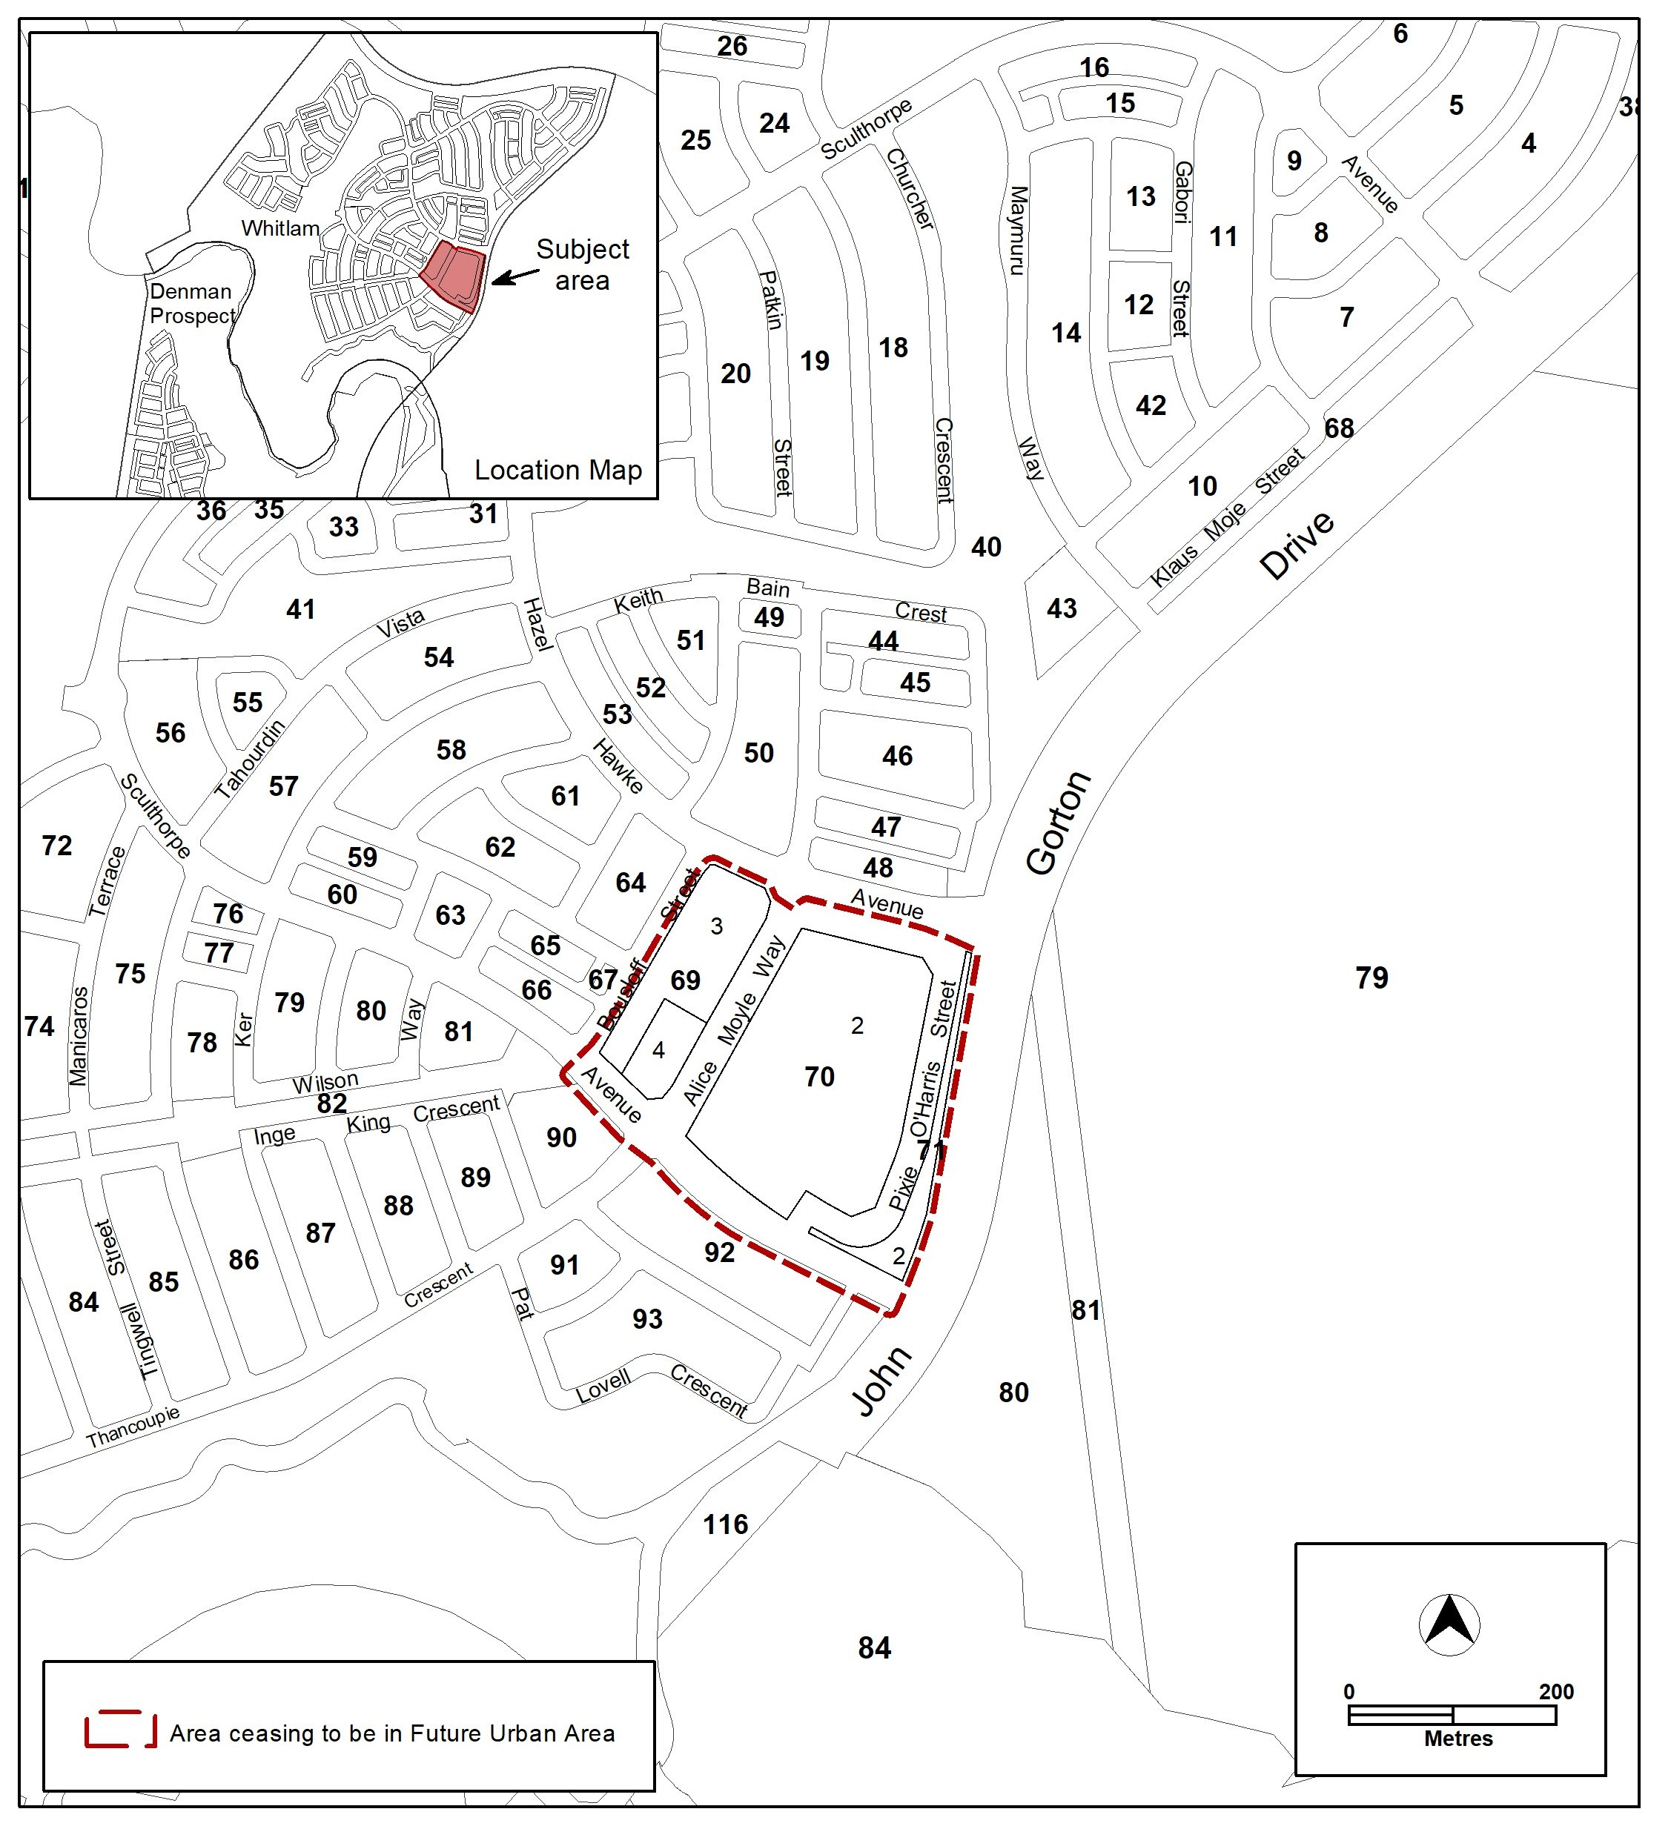

Whitlam – Existing Territory Plan map

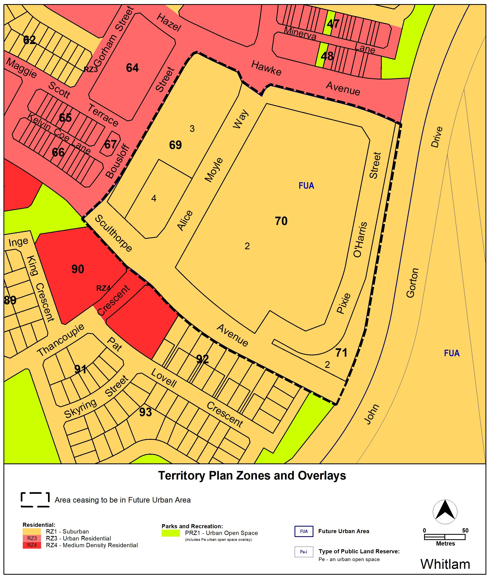

Whitlam – updated Territory Plan map

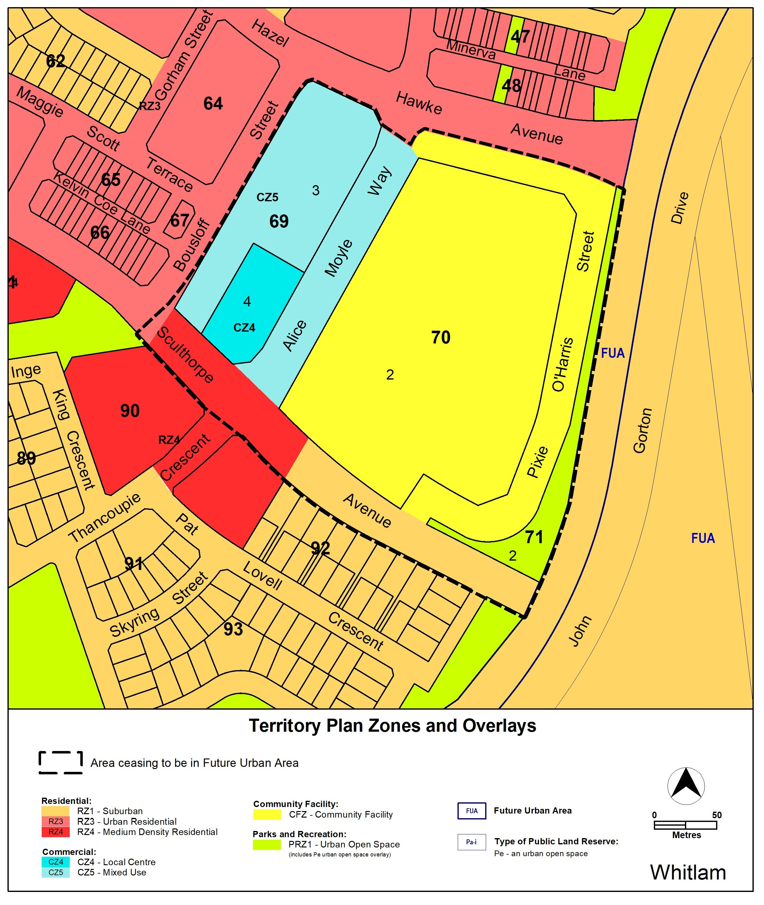

  - Part D – District Policies
The Molonglo Valley District Policy will be varied to identify new provisions that apply to land ceasing to be in a future urban area.
Substituted Assessment Requirement 69:
69. Development complies with the requirements specified in Figures 13, 14, 15, 16, 17, 18, 19, 20, 21 and 21A.
New Assessment Requirement 70A:
Active frontage |  | 70A. Active frontages are provided in accordance with Figure 21A.  a) Only the following uses are provided at ground floor level on nominated active frontages:  a) Business agency.  b) Community activity centre.  c) Financial establishment.  d) Indoor entertainment facility.  e) Indoor recreation facility.  f) Public agency.  g) Restaurant.  h) Shop  b) Residential use is not permitted at ground floor level where active frontages are nominated, with the exception of apartment lobbies, foyers and lifts.  c) The use of built form elements such as balconies, projections, awnings and hoods is required along nominated active frontages to provide shelter and ameliorate wind and downdraft in public areas.
New Assessment Requirement 70B:
Building height |  | 70B. The maximum number of storeys is nominated in Figure 21A.
New Assessment Requirement 70C:
Vehicle access |  | 70C. No vehicle access is provided from frontages as indicated in Figure 21A.
New Assessment Requirement 70D:
Setbacks |  | 70D. For blocks identified in Figure 21A the minimum boundary setbacks to all floor levels are nominated.  a) Street facades must be articulated with elements such as awnings, balconies, emphasised entrances, verandahs, colonnades and the like.

Proposed new Figure 21A:
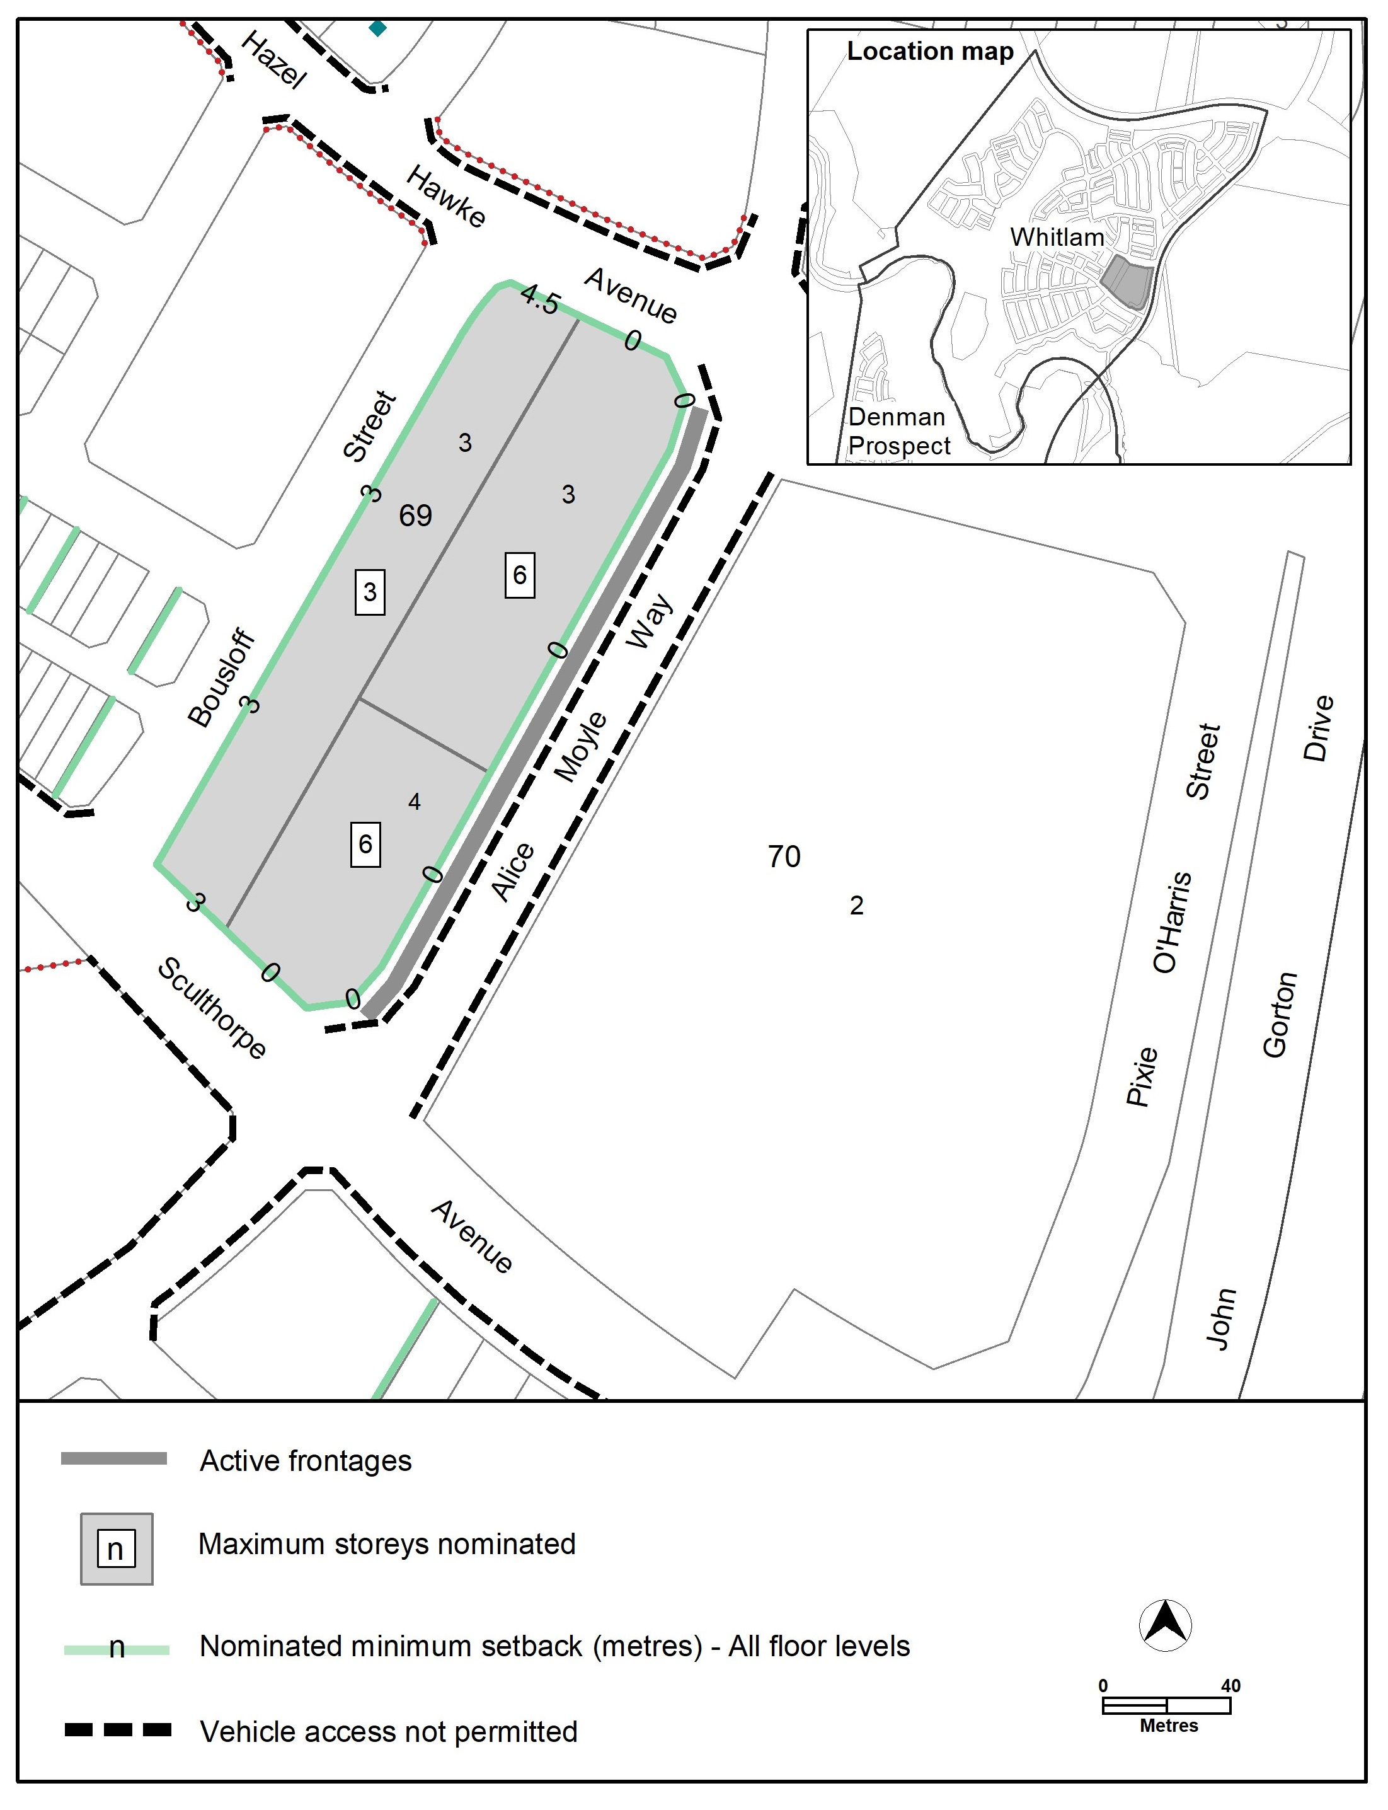

- TERRITORY PLAN AMENDMENT
  - Amendment to the Territory Plan Maps (Part B)
- Territory Plan map

The relevant part of the Territory Plan map is varied as indicated below.

  - Amendment to the Molonglo Valley District Policy (D05)
- Assessment Requirements; Whitlam

Assessment Requirement: 69
Substitute Assessment Requirement 69 with the following
69. Development complies with the requirements specified in Figures 13, 14, 15, 16, 17, 18, 19, 20, 21 and 21A.

Assessment Requirement: 70A
Insert new controls after existing Assessment Requirement 70
Active frontage |  | 70A. Active frontages are provided in accordance with Figure 21A.  a) Only the following uses are provided at ground floor level on nominated active frontages:  a) Business agency.  b) Community activity centre.  c) Financial establishment.  d) Indoor entertainment facility.  e) Indoor recreation facility.  f) Public agency.  g) Restaurant.  h) Shop  b) Residential use is not permitted at ground floor level where active frontages are nominated, with the exception of apartment lobbies, foyers and lifts.  c) The use of built form elements such as balconies, projections, awnings and hoods is required along nominated active frontages to provide shelter and ameliorate wind and downdraft in public areas.

Building height |  | 70B. The maximum number of storeys is nominated in Figure 21A.

Vehicle access |  | 70C. No vehicle access is provided from frontages as indicated in Figure 21A.

Setbacks |  | 70D. For blocks identified in Figure 21A the minimum boundary setbacks to all floor levels are nominated.  Facades on the nominated frontage with the minimum boundary setback must be articulated with elements such as awnings, balconies, emphasised entrances, verandahs, colonnades and the like.

Insert
Figure 21A Whitlam – Ongoing Provisions
INTERPRETATION SERVICE

