Australian Capital Territory
Planning (Holt) Major Plan Amendment 2025
Notifiable instrument NI2025–567
made under the
Planning Act 2023, s 75 (Minister’s powers in relation to draft plan amendments)

1 Name of instrument
This instrument is the Planning (Holt) Major Plan Amendment 2025.
2 Major plan amendment
(1) I approve under section 75 (2) (a) of the Planning Act 2023 (the Act) the Major Plan Amendment 03 to the Territory Plan.
(2) In accordance with the Act, section 75 (5) (c), a major plan amendment must be presented to the Legislative Assembly and may only commence by commencement notice under section 80 (2).
3 Dictionary
In this instrument:
Major Plan Amendment 03 to the Territory Plan means the Major Plan Amendment in schedule 1.
Chris Steel MLA
Minister for Planning and Sustainable Development
14 October 2025

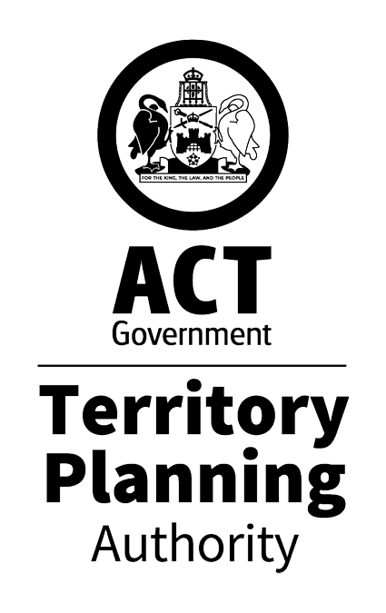

MAJOR PLAN AMENDMENT
to the
TERRITORY PLAN 03

Change of zoning from RZ2 to CFZ
for
Blocks 2, 7 and 8 Section 74 Holt

October 2025
This draft major plan amendment was prepared
under division 5.2.7 of the Planning Act 2023
Contents
1.0 Introduction 1
1.1 Purpose 1
1.2 Outline of process 1
2.0 Summary of MPA-03 2
2.1 Site description 2
2.2 Summary of amendments to the Territory Plan 4
3.0 REASONS FOR THE MAJOR PLAN AMENDMENT 5
4.0 CONSULTATION 6
4.1 Consultation with entities 6
4.2 Consultation with the public 6
5.0 MAJOR PLAN AMENDMENT 03 7
5.1 Amendment to the Territory Plan Map 7
INTERPRETATION SERVICE 8

- Introduction
  - Purpose
This document is major plan amendment 03 – Holt (MPA-03) to the Territory Plan.

Key parts of this document are:
- section 2 – summarises the MPA, including amendments to the Territory Plan and associated documents
- section 3 – why this MPA was undertaken
- section 5 – detailed amendment instructions to the Territory plan proposed by this MPA.
  - Outline of process
A major plan amendment (MPA) is a statutory process under the Planning Act that enables the Territory Plan to be amended. The three types of MPAs are:
- Proponent-initiated
- Authority-initiated
- Minister-initiated

MPA-03 was a proponent-initiated MPA.

Under section 63 of the Planning Act, the Authority made MPA-03 available for public comment from 11 April 2025 to 30 May 2025. Following consultation, the Authority considered whether to revise or withdraw the DPA.

After consultation concluded, the Authority considered the comments and gave DPA-03 to the Minister for referral to the relevant Legislative Assembly Standing committee (the Standing Committee). The Standing Committee did not prepare a report in relation to DPA-03.

With the above complete, and in considering the background papers, the ACT Planning Strategy 2018 and the Belconnen District Policy, the Minister for Planning and Sustainable Development approved MPA-03.

The Minister must now present MPA-03 to the Legislative Assembly who may reject it completely or partly. If passed by the Legislative Assembly, the MPA may commence and become part of the Territory Plan.

A commencement notice or rejection notice will be published on the major plan amendment webpage.

For more information about the content of the Territory Plan and the major plan amendment processes please refer to the City and Environment (CED) website.

- Summary of MPA-03
This section summarises:
- the amendments MPA-03 made to the Territory Plan and supporting documents
- outlines the relevant subject area

Amendments to the Territory Plan by this MPA are summarised in section 2.2 and shown in detail at section 5 of this document.
  - Site description
The subject site is located at Blocks 2, 7 and 8 Section 74 Holt in the Belconnen District (figure 1) and is located between Hardwick Crescent and Powell Street. The site is currently zoned RZ2 Suburban Core.

Land adjacent to the northwest and southeast of the site is zoned Community Facility, with residential RZ2 Suburban Core to the west. The Kippax Group Centre is located to the east of the site and provides shopping and services and facilities to meet the needs of the community, and is zoned Commercial CZ1 Core, CZ2 Business, and CFZ Community Facility.

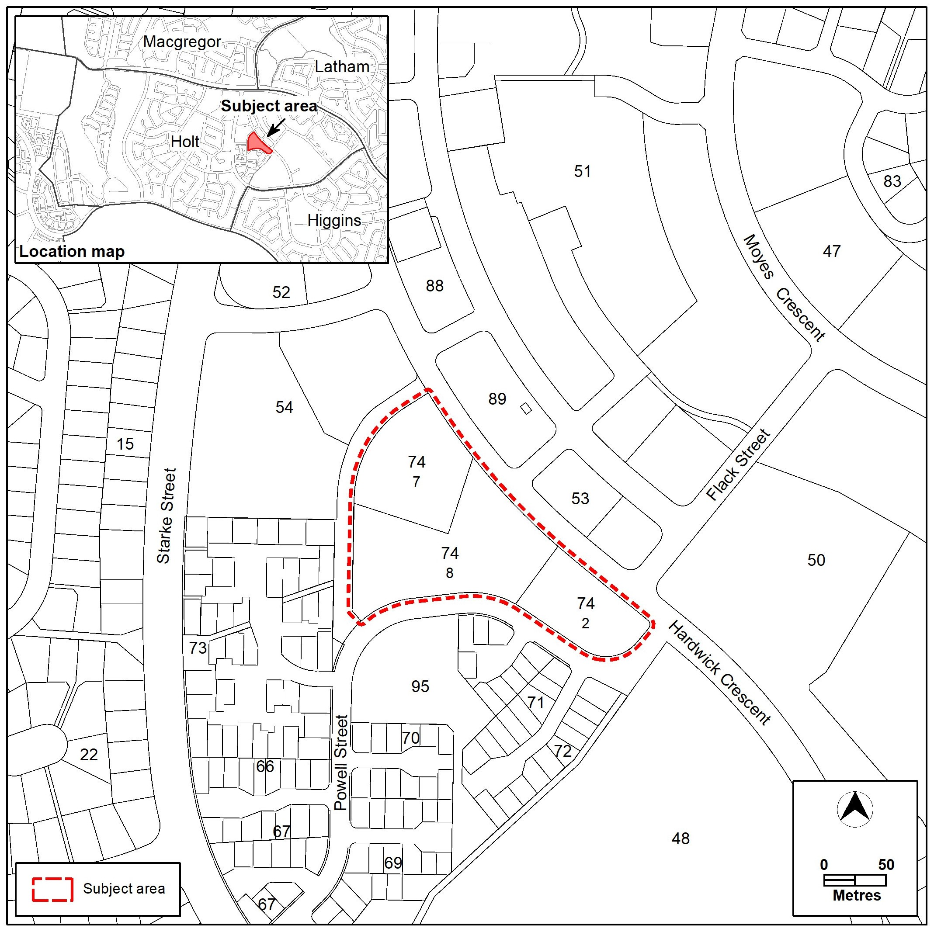

Figure 1 – Location Map
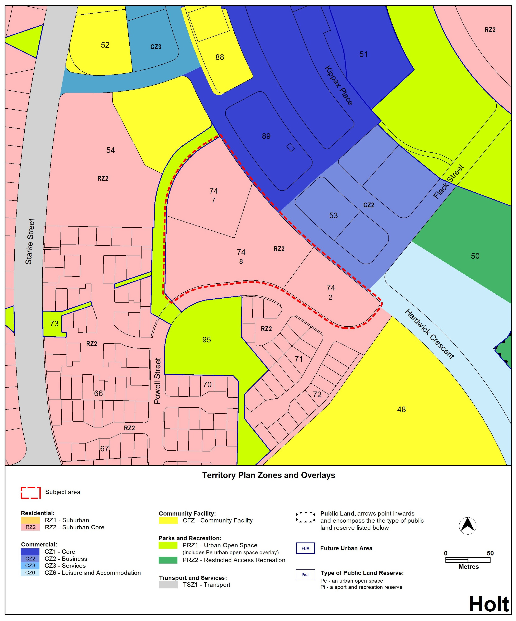
Figure 2 – Existing Territory Plan Zoning

  - Summary of amendments to the Territory Plan
MPA-03 amends the Territory Plan by rezoning Blocks 2, 7 and 8 Section 74 Holt from Residential RZ2 Suburban Core to CFZ Community Facility (see figure 3 below). This will enable redevelopment of the existing retirement village to provide additional aged care accommodation that will help meet the growing demand for such facilities in the community.

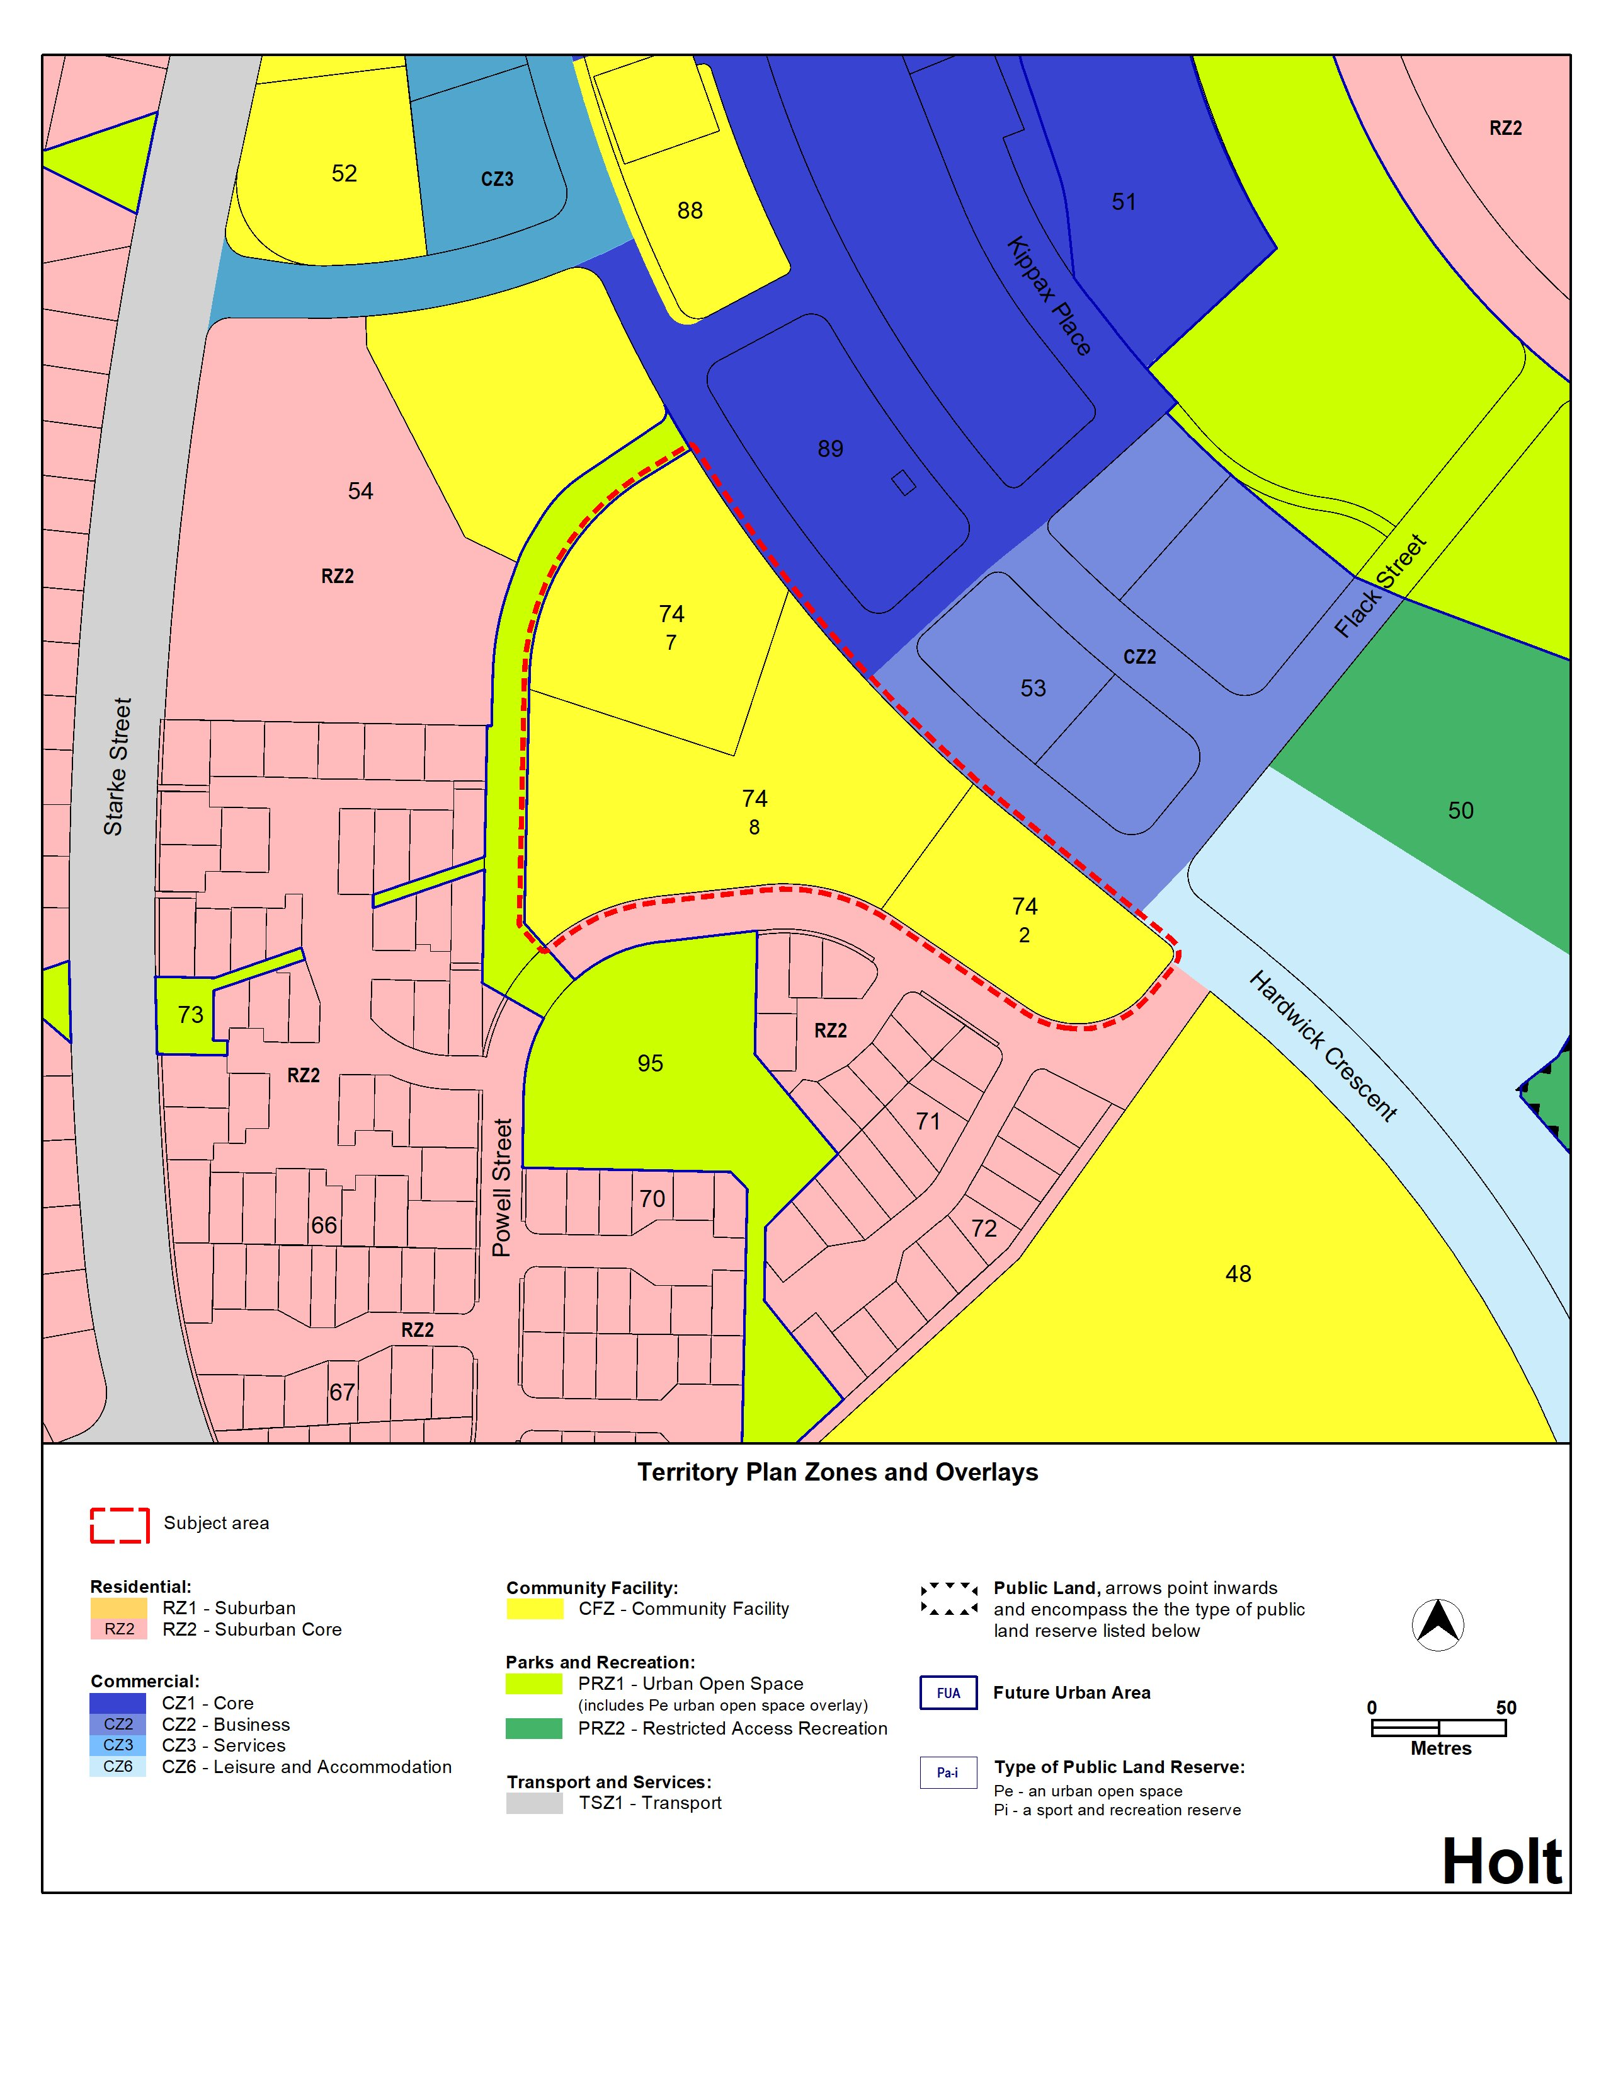
Figure 3 – Proposed Territory Plan zoning
- REASONS FOR THE MAJOR PLAN AMENDMENT
The site comprises Blocks 2, 7 and 8 Section 74 Holt and is currently occupied by low rise, low density aged care accommodation. Rezoning the site to CFZ Community Facility will reinforce the current uses of the site and limit the site to permissible land uses in Community Facility zone. The CFZ only allows residential uses which are limited to community housing (where in conjunction with other uses), residential care accommodation and retirement village.

The CFZ may enable increased building heights if assessment outcome 11 of the Community Facility Zone Policy is met - which requires the height, bulk and scale of the development to be appropriate noting the zone policy outcomes. The Community Facility Zone Specifications provide a benchmark for this outcomes, which outlines 4-storeys and 15 metres in height (with some additional limitations where development is within 30 metres of a residential block).

The zoning change will facilitate the redevelopment of the existing retirement village to provide:

- a greater number of dwellings as part of a staged redevelopment of the existing retirement village
- increased housing to meet the specific needs of older people, which represent an increasing demographic
- enable residents of the district to downsize and age in place.

The site is in a suitable location to facilitate rezoning as it is close to shops, services and facilities provided by the adjacent Kippax Group Centre. It is also close to a transport hub at the group centre and commercial and community facilities which may encourage active travel.

- CONSULTATION
  - Consultation with entities
In accordance with section 62 of the Planning Act the Authority must consult with each of the following in relation to this MPA:
- the National Capital Authority
- the Conservator of Flora and Fauna
- the Environment Protection Authority
- the Heritage Council
- each referral entity
- if unleased or leased public land, each custodian of the land likely to be affected.
  - Consultation with the public
Written comments were invited from the public on this MPA from 11 April 2025 to 30 May 2025.

Two comments were received during the public consultation period.

Comments received from the public during the consultation period were considered by the Minister in approving this MPA.

- MAJOR PLAN AMENDMENT 03
This section details how MPA-03 amends the Territory Plan.
  - Amendment to the Territory Plan Map
The relevant part of the Territory Plan map is varied in accordance with Figure 3.

Figure 3 –Territory Plan Map
INTERPRETATION SERVICE
To speak to someone in a language other than English please telephone the Telephone Interpreter Service (TIS) 13 14 50
LANGUAGE | DETAILS
English | If you need an interpreter please call: 13 14 50
Mandarin (Simplified Chinese) / 简体中文 | 如果您需要翻译，请致电：13 14 50
Arabic / العربية | إذا كنت بحاجة إلى مترجم شفهي اتصل بالرقم: 50 14 13
Cantonese (Traditional Chinese) / 繁體中文 | 如果你需要傳譯員，請致電：13 14 50
Vietnamese /  Tiếng Việt | Nếu bạn cần thông dịch viên, xin gọi: 13 14 50
Korean / 한국어 | 통역사가 필요할 경우 다음 번호로 전화하시기 바랍니다: 13 14 50
Spanish / Español | Si necesita un intérprete, llame al 13 14 50
Persian (Farsi) / فارسی | اگر به مترجم نیاز دارید، لطفاً به این شماره تلفن کنید: 50 14 13
Dari / دری | اگر به یک ترجمان شفاهی نیاز دارید لطفاً به شمارۀ 131450 زنگ بزنید.
Punjabi / ਪੰਜਾਬੀ | ਜੇਕਰ ਤੁਹਾਨੂੰ ਕਿਸੇ ਦੁਭਾਸ਼ੀਏ ਦੀ ਲੋੜ ਹੈ ਤਾਂ ਕਿਰਪਾ ਕਰਕੇ ਫੋਨ ਕਰੋ: 13 14 50
Tamil / தமிழ் | உங்களுக்கு மொழிபெயர்த்துரைப்பாளர் ஒருவர் தேவைப்பட்டால் 13 14 50 என்ற எண்ணை அழைக்கவும்
Greek / Ελληνικά | Αν χρειάζεστε διερμηνέα, τηλεφωνήστε: 13 14 50
Italian / Italiano | Se hai bisogno di un interprete, chiama: 13 14 50
Hazaragi / هزاره گی | اگه ده ترجمان ضرورت ده رید، لطفاً ده شماره 50 14 13 تماس بگیرید.
Thai / ภาษาไทย | หากคุณต้องการล่าม กรุณาโทรไปที่ 13 14 50
Karen / ကညီကျိၥ် | ဖဲနမ့ၢ်လိၣ်ဘၣ်ပှၤကတိၤကျိးထံတၢ်တဂၤအခါ၀ံသးစူၤကိးဘၣ်-၁၃၁ ၄၅၀ တက့ၢ်.

Telephone and Interpreter Service 13 14 50 - Canberra and District - 24 hours a day, seven days a week

