Australian Capital Territory
Planning (Various) Minor Plan Amendment 2025 (No 2)
Notifiable instrument NI2025–620
made under the
Planning Act 2023, s 85 (Making minor plan amendments)

1 Name of instrument
This instrument is the Planning (Various) Minor Plan Amendment 2025 (No 2).
2 Commencement
This instrument commences on the day after its notification day.
3 Minor plan amendment
I am satisfied under the Planning Act 2023, section 85 (1) that Minor Plan Amendment 2025-10 is a minor plan amendment to the Territory Plan.
4 Dictionary
In this section:
Minor Plan Amendment 2025-10 means the minor plan amendment to the Territory Plan in schedule 1.

Freya O’Brien
Delegate of the territory planning authority
17 November 2025

Schedule 1


MINOR AMENDMENT
TO THE TERRITORY PLAN
2025-10
Clarification and miscellaneous amendments to various district and zone policies

This minor plan amendment was prepared
under part 5.3 of the Planning Act 2023
Contents
1.0 INTRODUCTION 1
1.1 Outline of the process 1
1.2 Summary of the proposed amendments 2
2.0 CONSULTATION WITH THE PUBLIC 3
2.1 Consultation period 3
2.2 Comments from the public 3
2.3 Changes made following consultation 3
3.0 TERRITORY PLAN CHANGES 4
3.1 Belconnen District Policy 4
3.2 Inner North and City District Policy 4
3.3 Molonglo Valley District Policy 5
3.4 Weston Creek District Policy 5
3.5 Tuggeranong District Policy 5
3.6 Transport and Services Zone Policy 6
4.0 TERRITORY PLAN AMENDMENT INSTRUCTIONS 7
4.1 Part D: D02 – Belconnen District Policy 7
4.2 Part D: D03 – Inner North and City District Policy 7
4.3 Part D: D05 – Molonglo Valley District Policy 9
4.4 Part D: D06 – Weston Creek District Policy 9
4.5 Part D: D08 – Tuggeranong District Policy 9
4.6 Part E: E06 – Transport and Services Zones Policy 10
INTERPRETATION SERVICE 11

- INTRODUCTION
  - Outline of the process
Minor plan amendment 2025-10 (MA2025-10) to the Territory Plan is a minor plan amendment (MA) prepared under section 84 (1) (a) and 84 (2) (d) of the Planning Act 2023 (the Act).

Section 84 of the Act outlines the different types of MAs, some which require limited consultation to be undertaken and some which require no consultation to be undertaken.

Under Section 85 of the Act a MA can only be made where:
- any required limited consultation has taken place and the authority is satisfied that the content of the MA meets the requirements of the Act
- if the MA is not inconsistent with the planning strategy or any relevant district strategy
- any comments received during the consultation period and from the National Capital Authority have been considered.

This MA required limited consultation to be undertaken and was released for public consultation in accordance with the Act.

The MA is not inconsistent with the planning strategy or any relevant district strategies.

The National Capital Authority has received a copy of this MA.

For more information on the content of the Territory Plan and minor plan amendment processes please refer to the Planning website: The Territory Plan - City and Environment Directorate - Planning

  - Summary of the amendments

MA2025–10 makes the following changes:

Belconnen District Policy

- Clarify that future development is required to improve the public realm along Luxton Street to enhance pedestrian movement in relation to area ‘j’. This is to align the provision to its original intent.

- Clarify that the requirements in Assessment Requirement 14 only apply to the subject area identified in Figure 4. This is to clarify a drafting error when implementing the Territory Plan 2023.

Inner North and City District Policy

- Clarify that the assessment requirements for development in the Residential RZ3 and RZ4 zones only apply to multi-unit housing in these locations.

- Clarify that Assessment Requirement 1 is intended to apply only to the areas identified in Figure 1.

- Clarify that the RL617 height limit in Assessment Requirement 21 only applies to the commercial centre in Braddon shown as RC1 in Figure 10.

- Amend Assessment Requirement 29 to refer to the correct Figure 15.

Molonglo Valley District Policy

- Clarify that the Molonglo town centre and surrounds is excluded from the height controls in Assessment Requirement 36, noting they’re captured by Assessment Outcomes 3-6.

Weston Creek District Policy

- Rectify road names in Assessment Requirement 35.

Tuggeranong District Policy:

- Revise Assessment Requirement 25 to clarify the requirement to make a substantial contribution to replacement carparking in the town centre.

- Update Figure 4 Greenway – Building Heights to remove redundant dashed line on figure

Transport and Services Zone Policy

- Change spelling of ‘Carpark’ in the Land Use Table to the correct spelling of ‘car park’ as defined in the Territory Plan.
- CONSULTATION WITH THE PUBLIC
  - Consultation period
Under section 84 (2) of the Planning Act 2023, this minor amendment was subject to limited public consultation of at least 20 working days. Written comments on MA2025-10 were invited from the public from 30 September 2025 and closed on 29 October 2025.
  - Comments from the public
Two written public comments were received during consultation.

Belconnen District Policy – height and pedestrian requirements
The first comment was in relation to Assessment Requirement 7 of the Belconnen District Policy regarding improvements to the public realm along Luxton Street to enhance pedestrian movement. The comment raised concerns about the revised wording not representing the intent of the Belconnen Town Centre Masterplan and the findings of later Belconnen place planning community and stakeholder co-design workshops conducted by the Suburban Land Agency (SLA) regarding the sites.

The previous provision that ‘A clear public pedestrian connection linking Lathlain Street to the lower end of Luxton Street or Emu Bank’ was introduced into the Belconnen Precinct Code in the previous Territory Plan through Variation 342 to the Territory Plan for the Belconnen Town Centre that commenced in 2019, to implement elements of the Belconnen Town Centre Master Plan that was completed in 2016.

There is no specific mention of a direct connection to navigate the grade change from Lathlain Street to the lower portion of the Belconnen Town Centre. Rather, the master plan envisaged improvements to Luxton Street.

It’s also worth noting that the previous provision provided that additional building height could be achieved for development on Block 38 Section 52, Block 2 Section 151 , Block 22 Section 21 and Block 23 Section 21 Belconnen where pedestrian connection is provided. Direct pedestrian connection that navigates the grade change would need to be delivered on an independent site, Block 39 Section 52 Belconnen (which contains the bicycle path and is completely surrounded by roads). Noting this, a direct pedestrian connection would be more effectively delivered and integrated in any future development on Block 39 Section 52 Belconnen rather than delivered by a combination of future lessees of other sites.

Noting all of the above, no changes have been made to the wording of the assessment requirement.

Molonglo Valley District Policy – Height requirements
The second comment related to the wording of Assessment Requirement 36 in the Molonglo Valley District Policy. Concerns were raised about allowing increased height and density in the Molonglo Town Centre, that the changes were inconsistent with the Planning Strategy 2018 and the Molonglo Valley District Strategy and that the changes via minor amendment did not meet the criteria for a minor amendment under Section 85 of the Planning Act 2023.
The district strategies were introduced as a part of the new planning system that commenced on 27 November 2023. District strategies provide additional strategic planning guidance for Canberra’s urban districts in addition to the overarching Planning Strategy of 2018. The Molonglo Valley District Strategy identified the main commercial centre as a Category 1 change area where change could happen within 0-5 years. The district strategy states that “the role and function of the Molonglo group centre may evolve over time, becoming more like a town centre servicing a wider catchment” and also indicates that it will be the primary commercial hub for the district with an expectation of transition to a town centre. Planning for the town centre and appropriate infrastructure provision in the context of the western edge is ongoing.
The National Capital Authority (NCA) through Amendment 99 introduced a change to the National Capital Plan to upgrade the status of the Molonglo Group Centre to a town centre. The change to the National Capital Plan took effect on 16 September 2024.
The change in status of the Molonglo Group Centre to the Molonglo Town Centre have also already been made in the Territory Plan 2023 that was approved and commenced on 27 September 2024 (NI2024-510 and CN2024-06 on the ACT Legislation Register) to make it consistent with the National Capital Plan. These changes have already been made and were found to not be inconsistent with the district strategy or planning strategy.
A change was also subsequently made to the Planning Act 2023 (Act) to recognise the main commercial centre for the Molonglo Valley as a town centre via the Planning (Molonglo Town Centre) Amendment Act 2025, which commenced on 12 September 2025.
Importantly, the change to a town centre will enable the provision of a centre which reflects the scale and status of the Molonglo Valley district and will be capable of delivering facilities and services to the surrounding population. The change reflects the projected increase in ACT population estimates for the Molonglo Valley which anticipates a population of 70,000 by 2050, an increase from previous estimates of 55,000, when the main commercial centre was originally proposed to be developed as a large group centre.
Under sections 84 (2) (e) and 89 of the Act, a minor amendment can be made for land within a future urban area, provided any required limited consultation has taken place. As the area is within the FUA and the change has undergone the required consultation, the amendments are a minor plan amendment.
  - Changes made following consultation

Changes have been made to Assessment Requirement 36 of the Molonglo Valley District Strategy to further clarify that the provision does not apply to the town centre. The note has been removed as it is not required.

- TERRITORY PLAN CHANGES
  - Belconnen District Policy
Assessment Requirement 7:

Part of this assessment requirement currently contains a provision that taller buildings can be considered for area ‘j’ shown on Figure 3 to a maximum height of building of 12 storeys or 42m, measured from the Emu Bank frontage, where development achieves among other requirements, a clear public pedestrian connection linking Lathlain Street to the lower end of Luxton Street or Emu Bank”

Sub-paragraph i) has been reworded to clarify that future development is required improve the public realm along Luxton Street to enhance pedestrian movement. This change to the text better captures the intent of the Belconnen Master Plan.

Assessment Requirement 14:

Part of this assessment requirement has been reworded to clarify that a 6m wide public pedestrian easement containing a new shared use path or pedestrian link linking Emu Band to Lake Ginninderra is provided only for the subject area shown in Figure 4.
  - Inner North and City District Policy
Assessment Requirements

In the explanatory section for assessment requirements in the district policy, the wording has been adjusted to clarify that the assessment requirements for development in the Residential RZ3 and RZ4 zones only apply to multi-unit housing in these locations.

Assessment Requirement 1

Assessment Requirement 1 has been reworded to clarify that it is intended to apply only to the areas identified in Figure 1. This issue was identified as having potential for misinterpretation.

Assessment Requirement 21

The wording has been adjusted to clarify that the RL617 height limit only applies to the commercial centre in Braddon (shown as RC1 in Figure 10). This issue was identified as having potential for misinterpretation.

Assessment Requirement 29

The incorrect figure reference has been rectified in this assessment requirement by replacing Figure 14 with the correct reference to Figure 15.
  - Molonglo Valley District Policy

Assessment Requirement 36

The wording has been revised to clarify that this assessment requirement does not apply to the area within the Molonglo Town Centre and surrounds.

  - Weston Creek District Policy
Assessment Requirement 35

The road name has been rectified in this requirement to clarify that it applies to Unwin Street (not Unwin Place). This is a legacy road name error that was transferred from the previous Territory Plan.

  - Tuggeranong District Policy
Assessment Requirement 25
The wording has been revised to clarify that the requirement for replacement carparking where development is proposed on an existing public carpark. This is to provide further guidance on demonstrating what would be considered to constitute a substantial contribution to the long-term parking supply for public use at all times for the town centre.
Figure 4 – Greenway Building Heights
The dashed line has been removed from Figure 4 – Greenway Building Heights as this parcel (Sections 75-79 Greenway) has been fully developed and the area subject to this demarcation on the figure is no longer referenced in the policy.

Revised Figure 4
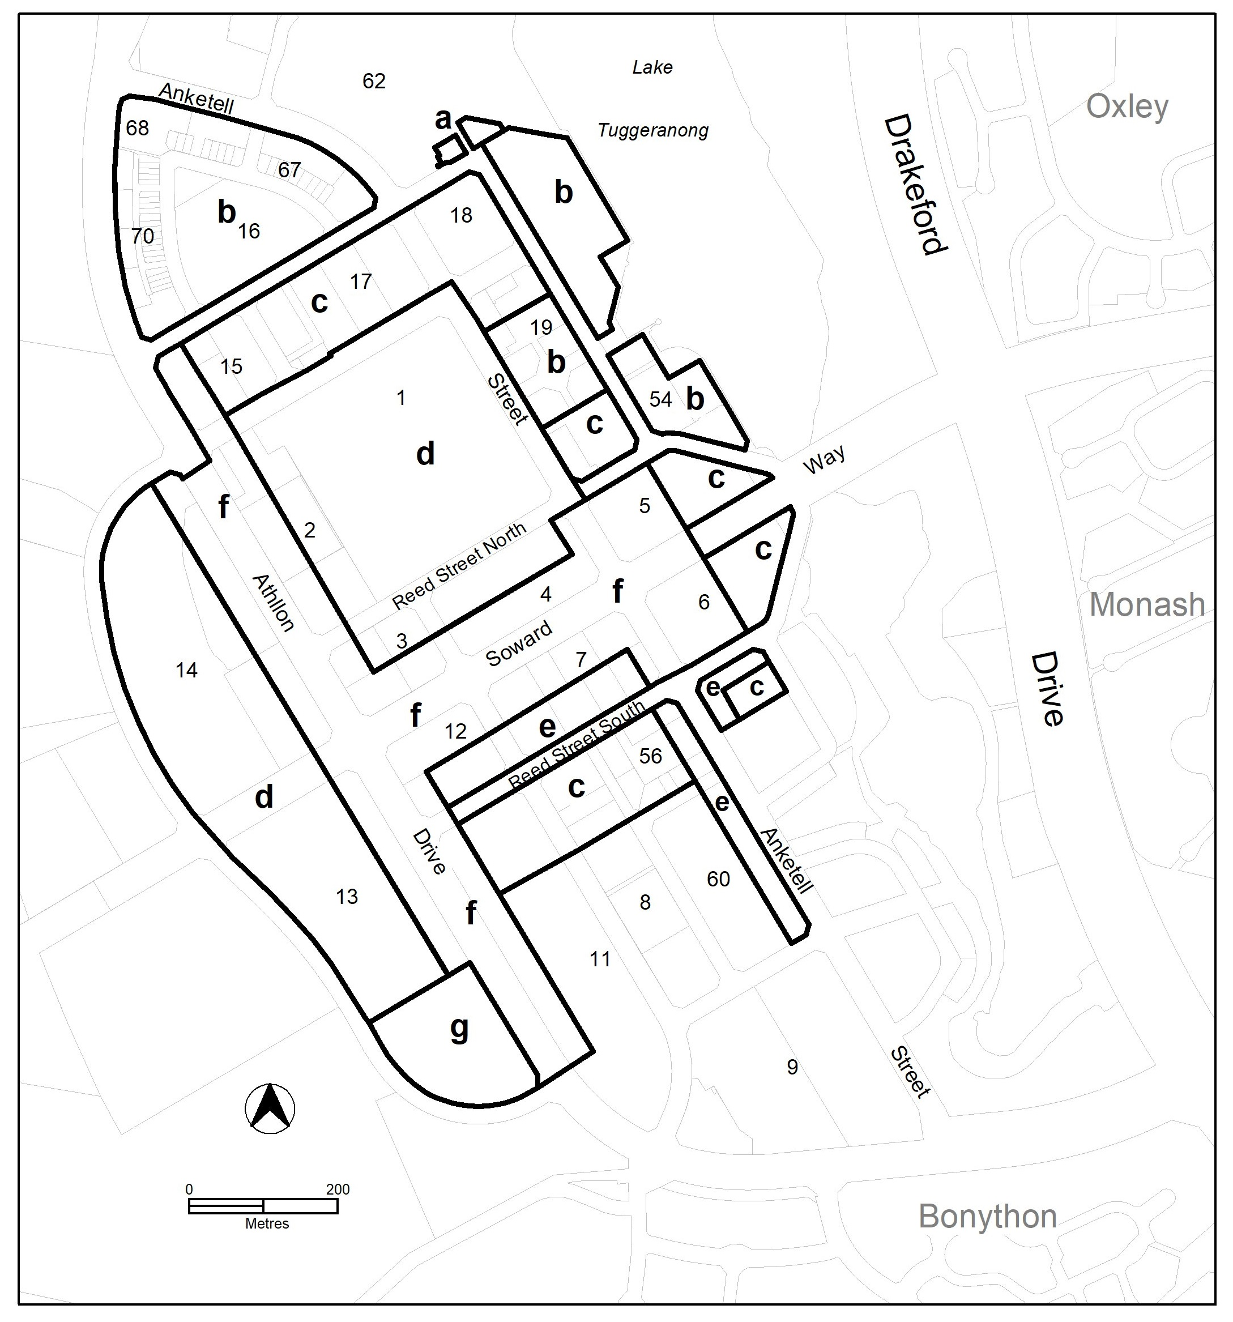

  - Transport and Services Zone Policy

The spelling of ‘Carpark’ in the Land Use Table has been rectified to align with the correct spelling of ‘Car park’ as defined in the Dictionary in Part G of the Territory Plan.

- TERRITORY PLAN AMENDMENT INSTRUCTIONS
  - Part D: D02 – Belconnen District Policy

Assessment Requirement 7

Substitute sub-paragraph i) under the paragraph relating to “Taller buildings can be considered for area ‘j’ shown on Figure 3…” with:

- Improvements to the public realm along Luxton Street to enhance pedestrian movement.

Assessment Requirement 14

Substitute

14. On Section 65:
- For the subject area shown in Figure 4, the minimum setback between buildings and the boundary to Lake Ginninderra is 10m to facilitate outdoor dining.
- A 6m wide public pedestrian easement is provided as identified in the subject area in Figure 4 as containing a proposed new shared-use path or pedestrian link linking Emu Bank to Lake Ginninderra.
- Office and residential use are not permitted at ground level in CZ6.

Hyperlink: ‘Figure 4’ in Assessment Requirement 1 to the respective figure
  - Part D: D03 – Inner North and City District Policy

Assessment Requirements

Omit

Development proposals in the Inner North and City District must meet the following requirements. Localities that are not listed do not have assessment requirements.

Replace with

Development proposals in the Inner North and City District must meet the following requirements. Localities that are not listed do not have assessment requirements. The assessment requirements for development in the Residential RZ3 and RZ4 zones only apply to multi-unit housing in these locations.

Assessment requirement 1

Substitute

- In areas identified in Figure 1, maximum site coverage of up to 100% in the Primary Building Zone may be permitted subject to the agreement of adjoining lessees and lodging a plan for integrated development. This requirement applies to all built-to-boundary proposals less than 100% site coverage in the Primary Building Zone.

Hyperlink: ‘Figure 1’ in Assessment Requirement 1 to the respective figure

Assessment Requirement 21

Substitute

21. For the commercial area in Braddon shown as RC1 in Figure 10, building heights do not exceed RL617m.

Hyperlink: ‘Figure 10’ in Assessment Requirement 21 to the respective figure

Assessment Requirement 29

Substitute

29. Development on existing car parks (Figure 15) retains or improves the existing level of car parking, accommodates onsite any additional car parking required by the development, ensures that car parking remains available for public access. However, alternative proposals may be considered where it is demonstrated there is enough car parking for the needs of the centre as a whole and the development does not adversely affect the overall function of the centre in terms of economic, social, traffic and parking and urban design impacts.

Hyperlink: ‘Figure 15’ in Assessment Requirement 29 to the respective figure

  - Part D: D05 – Molonglo Valley District Policy

Assessment requirement 36

Substitute

36. Residential development to a maximum of 6 storeys is permitted at group and local centres. This does not apply to the Molonglo Town Centre and surrounds (figure 5) as building heights in this area are controlled by Assessment Outcomes 3-9.

  - Part D: D06 – Weston Creek District Policy

Assessment requirement 35

Substitute

35. Medium density housing between Unwin Street and Heysen Street is to be a maximum of 3 storeys and be provided adjacent to open space.
  - Part D: D08 – Tuggeranong District Policy

Assessment requirement 25

Substitute

25. Development of public car parking areas provides for car parking that is generated by the development and makes a substantial contribution to the long term parking supply for public use at all times for the town centre as endorsed by the Territory.

Note: to satisfy the requirement for the substantial contribution to, and provision of publicly accessible car parking, a site-specific parking assessment must be undertaken and provided to identify the appropriate rate of replacement car parking provision for public use.

Figure 4 – Greenway - Building Heights

Substitute

  - Part E: E06 – Transport and Services Zones Policy

Land Use Table

Omit

Carpark

Replace with

Car park
INTERPRETATION SERVICE
To speak to someone in a language other than English please telephone the Telephone Interpreter Service (TIS) 13 14 50
LANGUAGE | DETAILS
English | If you need an interpreter please call: 13 14 50
Mandarin (Simplified Chinese) / 简体中文 | 如果您需要翻译，请致电：13 14 50
Arabic / العربية | إذا كنت بحاجة إلى مترجم شفهي اتصل بالرقم: 50 14 13
Cantonese (Traditional Chinese) / 繁體中文 | 如果你需要傳譯員，請致電：13 14 50
Vietnamese /  Tiếng Việt | Nếu bạn cần thông dịch viên, xin gọi: 13 14 50
Korean / 한국어 | 통역사가 필요할 경우 다음 번호로 전화하시기 바랍니다: 13 14 50
Spanish / Español | Si necesita un intérprete, llame al 13 14 50
Persian (Farsi) / فارسی | اگر به مترجم نیاز دارید، لطفاً به این شماره تلفن کنید: 50 14 13
Dari / دری | اگر به یک ترجمان شفاهی نیاز دارید لطفاً به شمارۀ 131450 زنگ بزنید.
Punjabi / ਪੰਜਾਬੀ | ਜੇਕਰ ਤੁਹਾਨੂੰ ਕਿਸੇ ਦੁਭਾਸ਼ੀਏ ਦੀ ਲੋੜ ਹੈ ਤਾਂ ਕਿਰਪਾ ਕਰਕੇ ਫੋਨ ਕਰੋ: 13 14 50
Tamil / தமிழ் | உங்களுக்கு மொழிபெயர்த்துரைப்பாளர் ஒருவர் தேவைப்பட்டால் 13 14 50 என்ற எண்ணை அழைக்கவும்
Greek / Ελληνικά | Αν χρειάζεστε διερμηνέα, τηλεφωνήστε: 13 14 50
Italian / Italiano | Se hai bisogno di un interprete, chiama: 13 14 50
Hazaragi / هزاره گی | اگه ده ترجمان ضرورت ده رید، لطفاً ده شماره 50 14 13 تماس بگیرید.
Thai / ภาษาไทย | หากคุณต้องการล่าม กรุณาโทรไปที่ 13 14 50
Karen / ကညီကျိၥ် | ဖဲနမ့ၢ်လိၣ်ဘၣ်ပှၤကတိၤကျိးထံတၢ်တဂၤအခါ၀ံသးစူၤကိးဘၣ်-၁၃၁ ၄၅၀ တက့ၢ်.

Telephone and Interpreter Service 13 14 50 - Canberra and District - 24 hours a day, seven days a week

