Australian Capital Territory
Heritage (Decision about Partial Cancellation of the Trees of the Former Commonwealth Scientific & Industrial Research (CS&IR) Dickson Experiment Station, Downer) Notice 2025
Notifiable instrument NI2025–632
made under the
Heritage Act 2004, s 49 (Decision about cancellation proposal)

1 Name of instrument
This instrument is the Heritage (Decision about Partial Cancellation of the Trees of the Former Commonwealth Scientific & Industrial Research (CS&IR) Dickson Experiment Station, Downer) Notice 2025.
2 Commencement
This instrument commences on the day after its notification day.
3 Particulars of the place and its registration
The particulars of the place and its registration, including the registration details of the place are in the schedule.
4 Reasons for the partial cancellation decision
The ACT Heritage Council (the council) is satisfied on reasonable grounds that specifying pine tree species for the windbreak in the place no longer has heritage significance. The reasons for the partial cancellation in the place are specified in the schedule.
Note Partial cancellation—see the Act, s 50.
5 Date the decision takes effect
The council’s decision takes effect on 19 December 2025.

Mary Clare Swete Kelly
Secretary (as delegate for)
ACT Heritage Council
19 November 2025

THIS PAGE IS LEFT INTENTIONALLY BLANK

Schedule

(See sections 3 and 4)

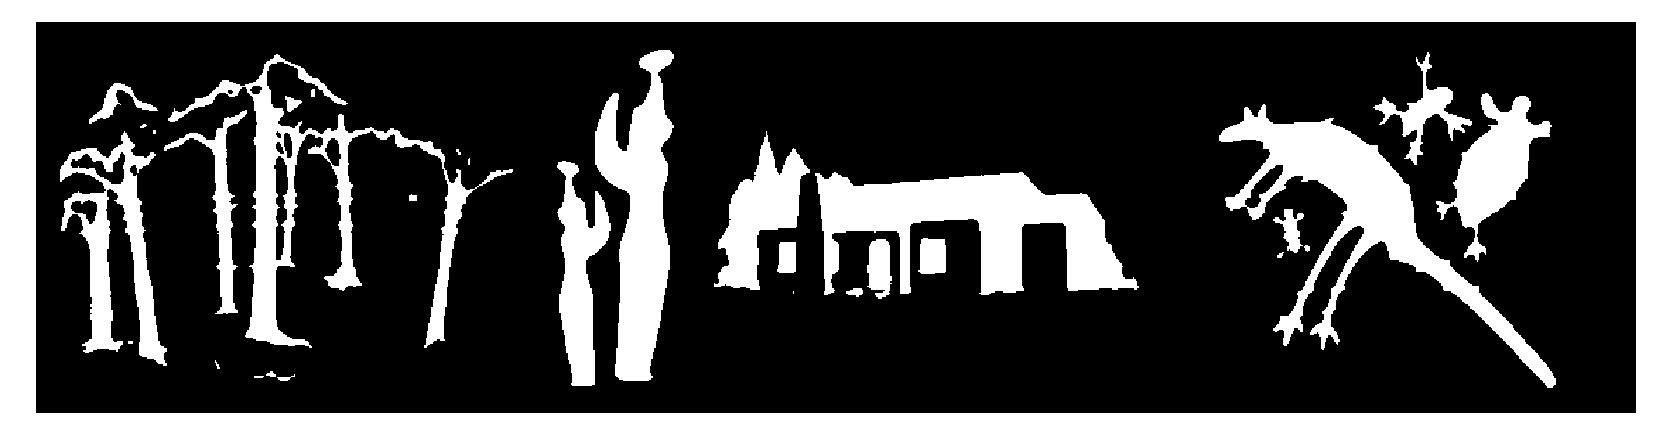
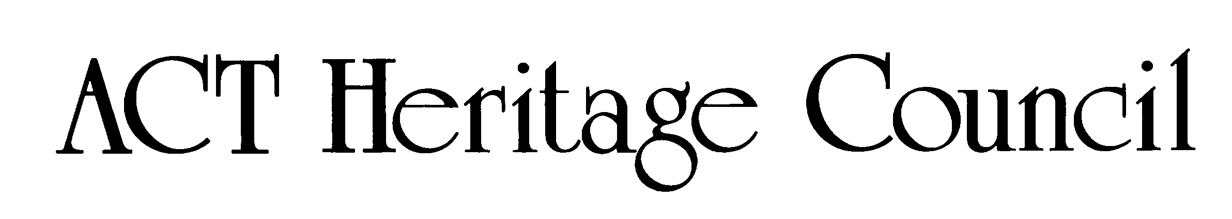
AUSTRALIAN CAPITAL TERRITORY
HERITAGE REGISTER
Registration
For the purposes of s40 and s49 of the Heritage Act 2004, an entry to the heritage register has been prepared by the ACT Heritage Council for the following place:

TREES OF THE FORMER COMMONWEALTH SCIENTIFIC & INDUSTRIAL RESEARCH (CS & IR) DICKSON EXPERIMENT STATION, DOWNER.
The street verges along both sides of Swinden Street, Downer; the street verge along the western side of Frencham Street; Blocks 1-2, Section 73; and Blocks 13, 22, 23, 25, 27, Section 61, Downer.
Date of Decision
19 November 2025
Date of Registration
19 December 2025* Notifiable Instrument: NI2025-632
*the date the partial cancellation takes effect must be after the period an interested person may apply to the ACAT for a review of the decision.
Copies of the Register Entry are available for inspection online at https://www.environment.act.gov.au/heritage and at ACT Heritage. For further information please contact:

The Secretary
ACT Heritage Council

Email
heritage@act.gov.au
Post
GPO Box 158
CANBERRA ACT 2601
Telephone
13 22 81

Preamble
The Trees of the Former Commonwealth Scientific & Industrial Research (CS & IR) Dickson Experiment Station, Downer, was first added to the Interim Heritage Places Register on 26 June 1998 under the Land (Planning and Environment) Act 1991. It was then transferred to the current ACT Heritage Register when the Heritage Act 2004 was enacted.
In 2024, a partial cancellation proposal was made to remove references to pine trees species on the Bradfield Street side of the boundary as a significant feature of the place while retaining the heritage significance of the windbreak formation purpose of those trees. The proposal was made on the basis of loss of heritage values, as the original plantings had been removed and replaced with a different species.
The Council opened public consultation on this matter to inform its decision. On 19 November 2025, the Council decided that specifying a pine species no longer had heritage significance.
In making the partial cancellation decision that the pine species no longer has heritage significance, the Council has remade the decision. This includes making all necessary changes to remake decision under the current Heritage Act. It is made by updating the previous decision to the new significance criteria and format while remaining as close as possible to the original.
The Council has considered all public consultation submissions made during the partial cancellation proposal process. It was noted that several submissions made arguments that a key feature of the windbreak plantings was its consistency beyond just the Bradfield Street section that was the focus of the proposal. The Council agreed with this and considered it a pragmatic and reasonable decision to remove the requirement of a specific species for the whole of the windbreak planting in the registration entry.
Necessary changes include the omission of the previous “specific requirements” as they do not form part of the current Act. It was not considered necessary to remake them into guidelines as the requirements simply protected the existing character. This protection is already covered by it being registered and does not serve the purpose of the current guidelines section of the Act.
The original 1996 Interim Heritage Places Register decision is included for reference as an appendix to the background document.

Statement of heritage significance
The Swinden Street verges and Sections 61 and 73, Downer are significant as the approach and hub of the former CS&IR Dickson Experiment Farm which occupied 670 acres of northern Canberra for 25 years from 1940 to 1965. During this time a wide range of agricultural research of Territory and National significance was carried out including research related to wartime and immediate post-war needs.
Swinden Street is characterised by large eucalypt trees which were planted in about 1943 to line the driveway to the Farm. These trees, which are over 50 years old, whilst approaching the end of their effective and safe lives as street trees, continue to contribute through their size and overall form to the streetscape qualities.
The windbreak and other mature tree plantings particularly the Yellow box and Apple box, which lined former roads and the two specimens of Californian big tree, on Sections 61 and 73 date from the early 1940s and are significant landscape elements.
Windbreaks in a suburb are unusual. In landscape terms the windbreak encloses and protects the playing fields and community facilities and provides a delineation between the suburban housing component and the central open space.
The treelined driveway and the administrative and laboratory facilities for the farm determined the urban plan for the suburb of Downer in the late 1950s.
In social terms the maturity of the shopping centre, which was 'recycled' from the Experiment Farm buildings, provides a feeling of maturity in a suburb where all the houses were brand new and the gardens non-existent.
This statement refers to the heritage significance of the place as required in s12(d) of the Heritage Act 2004.

Location of the place
The Trees of the Former Commonwealth Scientific & Industrial Research (CS & IR) Dickson Experiment Station are located:
Swinden Street verges, being the street verges along both sides of Swinden Street, Downer, and
Section 61 and Section 73, Downer, being the street verge along the western side of Frencham Street; part Blocks 1-2, Section 73; and Blocks 13, 22, 23, 25, 27, Section 61, Downer.
This statement refers to the name and location of the place as required in s12(a) and s12(b) of the Heritage Act 2004.

Description of the place
Swinden Street, Downer
Swinden Street is flanked by established Eucalyptus macarthurii (Camden woollybutt), one Eucalyptus elata, and younger Grey box as replacements for the Camden woollybutt.
Sections 61 and 73 Downer
This area can be divided into nine areas with distinct and identifiable plantings.
Area A on the western boundary of Sections 61 and 73, adjacent to Melba Street, consists of a two row shelterbelt planting, with two inner rows of Pin oak (Quercus palustris). The windbreak trees are planted about 6m apart within the rows and 5m between rows. The street trees on the eastern side of Melba Street are Flowering plum, (Prunus sp.).
Area B on the northern side of Section 61, adjacent to Bradfield Street, is a two row windbreak.
Area C on the southern side of Section 73 adjacent to Bonython Street is a two row windbreak.
Area D on the eastern side of Section 61 adjacent to Frencham Street is a line of Apple box (Eucalyptus bridgesiana). There are some single specimens and small groups of Apple box remaining and the species has been used in group plantings beside and between suburbs.
Area E is the two Californian Big Trees near the northeast corner of the oval carpark on Block 1 Section 73.
Area F is along the eastern side of Section 73 adjacent to Frencham Street. The tree species is Argyle apple (Eucalyptus cinerea). There is a double row of Flowering plum on the edge of the oval beside the Argyle apple trees.
This area also contains the remnants of screen and garden planting around the former Farm Foreman's cottage on the western side of Section 73. There are two fine specimens of Californian big tree (Sequoiadendron giganteum). Other trees in this area include Arizona cypress (originally classified as Cupressus arizonica, now taken to be Hesperocyparis arizonica) planted as a screen, Desert ash (Fraxinus oxycarpa), Turkey oak (Quercus cerris) and Hawthorn (Crataegus sp.).
Nearby there is a hedge of Japanese photinia (Photinia glabra 'rubens') which provides an effective screen and windbreak for the adjacent sportsfield.
Area G includes the surrounds to the shopping area and football oval. Species include Southern nettle tree (Celtis australis) Plane (Platanus sp.), Flowering plum, Hawthorns, Chinese elm (Ulmus parvifolia), Bottlebrush (Callistemon sp.) and Gossamer wattle (Acacia floribunda). The Flowering plum are in a double row similar to those in Area E. There is also an informal hedge of Japanese photinia of similar age to the one in Area F.
Area H contains the remnants of plantings which surrounded and screened the Manager's Cottage. Trees remaining include White poplar (Populus alba) Service tree (Sorbus domestica), Chinese pistacia (Pistacia chinensis, platanus sp.) and Arizona cypress (Cupressus arizonica). There are also Plane and Golden osier (Salix alba 'Vitellina').
Area I borders the concrete footpath which links Frencham and Melba streets. The trees are Yellow box (Eucalyptus melliodora). Yellow box of similar age and size also form the street trees in the short road leading to Frencham Place. Other eucalypts near the Yellow box include White brittle gum (Eucalyptus mannifera ssp maculosa), Camden woollybutt (Eucalyptus macarthurii) and Willow-leafed peppermint (Eucalyptus nicholii).

Trees of the Former Commonwealth Scientific & Industrial Research (CS & IR) Dickson Experiment Station has the following attributes of significance:
Swinden Street verges with avenue plantings of eucalypts.
Sections 61 and 73: the original pattern, alignment and orientation of dense windbreak plantings and various specimen trees marking out original features of the experiment farm; and extant trees including Yellow box, (Eucalyptus melliodora), Apple box (Eucalyptus bridgesiana) and Californian big tree (Sequoiadendron giganteum).
This statement refers to the description of the place as required in s12(c) of the Heritage Act 2004. The attributes described in this section form part of the heritage significance of the place. For the purposes of s12(c) of the Heritage Act 2004, the registration boundary of the place is at Figures 1-3.

Conservation objective
The guiding conservation objective is that Trees of the Former Commonwealth Scientific & Industrial Research (CS & IR) Dickson Experiment Station shall be conserved and appropriately managed in a manner respecting its heritage significance.
The ACT Heritage Council may adopt heritage guidelines applicable to the place under s25 of the Heritage Act 2004.
For further information on guidelines applicable to the place, or for advice on proposed works or development, please contact ACT Heritage via email at heritage@act.gov.auor via 13 22 81.

Reason for registration
The Council has assessed the Trees of the Former Commonwealth Scientific & Industrial Research (CS & IR) Dickson Experiment Station against the heritage significance criteria and is satisfied that the place has heritage significance when assessed against criteria (a), (f) and (g) under s10 of the Heritage Act 2004. A place is considered to have heritage significance if it meets one or more of the criteria.
Table 1 Criteria that the Council consider have been met.
Criterion | (a) | (b) | (c) | (d) | (e) | (f) | (g) | (h)
Met | YES | No | No | No | No | YES | YES | No
This statement refers to the heritage significance of the place as required in s12(d) of the Heritage Act 2004.

Assessment against the heritage significance criteria
This section refers to the heritage significance of the place as required in s12(d) of the Heritage Act 2004.
The Council’s assessment against the criteria specified in s10 of the Heritage Act 2004 is as follows.
In assessing the heritage significance of Trees of the Former Commonwealth Scientific & Industrial Research (CS & IR) Dickson Experiment Station, the Council considered:
- the original 1998 Interim Heritage Places Register entry for the Trees of the Former Commonwealth Scientific & Industrial Research (CS & IR) Dickson Experiment Station that considered the original nomination and documentary evidence supplied by the nominator and public consultation conducted at the time;
- The partial cancellation proposal and public consultation submissions report, Trees of the Former CS&IR Experimental Station – partial cancellation end of consultation report 2025; and
- the report by ACT Heritage titled, Background Information Trees of the Former Commonwealth Scientific & Industrial Research (CS & IR) Dickson Experiment Station, November 2025, containing photographs and information on history, description, condition and integrity.
Pursuant to s10 of the Heritage Act 2004, a place or object has heritage significance if it satisfies one or more of the following criteria. Future research may alter the findings of this assessment. The Council’s assessment against the criteria specified in s10 of the Heritage Act 2004 is as follows.

(a) importance to the course or pattern of the ACT’s cultural or natural history
MEETS CRITERION.
The Council has assessed Trees of the Former Commonwealth Scientific & Industrial Research (CS & IR) Dickson Experiment Station against criterion (a) and is satisfied that the place meets this criterion.
The extent to which the design and components of the Farm determined later urban planning to accommodate houses, shops, a school, sportsfields and streetscape and street tree planting are relevant to this criterion. Its former access road (now Swinden Street) with avenue planting, and extant trees evidence the former experimental farm site, they are: the windbreak plantings; Yellow box; Apple box; and Californian big tree. Replacement plantings have conserved the heritage significance of original plantings through their character and location.

(b) has uncommon, rare or endangered aspects of the ACT’s cultural or natural history;
The Council has not assessed Trees of the Former Commonwealth Scientific & Industrial Research (CS & IR) Dickson Experiment Station against criterion (b) and cannot determine that the place meets this criterion.
Details of the assessment against this criterion, or equivalent, did not form part of the original decision and cannot be made or updated without a further heritage decision under s24 of the Act to introduce a new assessment of heritage significance.

(c) potential to yield important information that will contribute to an understanding of the ACT’s cultural or natural history
The Council has not assessed Trees of the Former Commonwealth Scientific & Industrial Research (CS & IR) Dickson Experiment Station against criterion (c) and cannot determine that the place meets this criterion.
Details of the assessment against this criterion, or equivalent, did not form part of the original decision and cannot be made or updated without a further heritage decision under s24 of the Act to introduce a new assessment of heritage significance.

(d) importance in demonstrating the principal characteristics of a class of cultural or natural places or objects
The Council has not assessed Trees of the Former Commonwealth Scientific & Industrial Research (CS & IR) Dickson Experiment Station against criterion (d) and cannot determine that the place meets this criterion.
Details of the assessment against this criterion, or equivalent, did not form part of the original decision and cannot be made or updated without a further heritage decision under s24 of the Act to introduce a new assessment of heritage significance.

(e) importance in exhibiting particular aesthetic characteristics valued by the ACT community or a cultural group in the ACT
The Council has not assessed Trees of the Former Commonwealth Scientific & Industrial Research (CS & IR) Dickson Experiment Station against criterion (e) and cannot determine that the place meets this criterion.
Details of the assessment against this criterion, or equivalent, did not form part of the original decision and cannot be made or updated without a further heritage decision under s24 of the Act to introduce a new assessment of heritage significance.

(f) importance in demonstrating a high degree of creative or technical achievement for a particular period
MEETS CRITERION.
The Council has assessed Trees of the Former Commonwealth Scientific & Industrial Research (CS & IR) Dickson Experiment Station against criterion (f) and is satisfied that the place meets this criterion.
The decision to incorporate the former experimental farm landscape into the new suburb was innovative. It helped also to establish a community spirit in an entirely new suburb virtually treeless and lacking any natural focus. The community spirit was reflected in the operation of weekend community markets well before they became a feature of other centres.

(g) has a strong or special association with the ACT community, or a cultural group in the ACT for social, cultural or spiritual reasons
MEETS CRITERION.
The Council has assessed Trees of the Former Commonwealth Scientific & Industrial Research (CS & IR) Dickson Experiment Station against criterion (g) and is satisfied that the place meets this criterion.
Swinden Street and Sections 61 and 73 have a special association with Canberra's role as a centre for national research and the base for the Commonwealth Scientific and Industrial Research Organization, CSIRO.
The area was the hub of the Division of Plant Industry's field studies for 25 years and the two buildings and mature tree plantings are 'living' evidence of this significant period in Australian agricultural research. This period included World War II when the research effort was directed into fields of national defence significance.
Its former access road (now Swinden Street) with avenue planting, and extant trees evidence the former experimental farm site, they are: the windbreak plantings; Yellow box; Apple box; and Californian big tree. Replacement plantings have conserved the heritage significance of original plantings through their character and location.

(h) has a special association with the life or work of a person, or people, important to the history of the ACT
The Council has not assessed Trees of the Former Commonwealth Scientific & Industrial Research (CS & IR) Dickson Experiment Station against criterion (h) and cannot determine that the place meets this criterion.
Details of the assessment against this criterion, or equivalent, did not form part of the original decision and cannot be made or updated without a further heritage decision under s24 of the Act to introduce a new assessment of heritage significance.

Registration Boundary
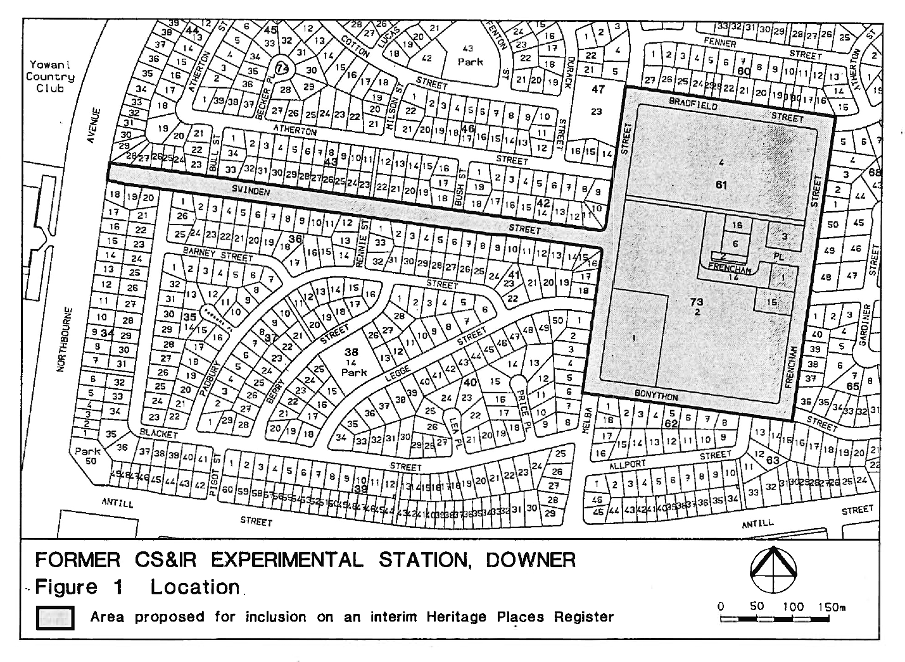
Figure 1 – 1998 IHPR entry boundary – the curtilage covers all of the verges up to the front boundaries of adjacent blocks of Swinden Street, Frencham Street, as well as portions of Bonython Street, Melba Street and Bradfield Street surrounding Sections 61 and 73.
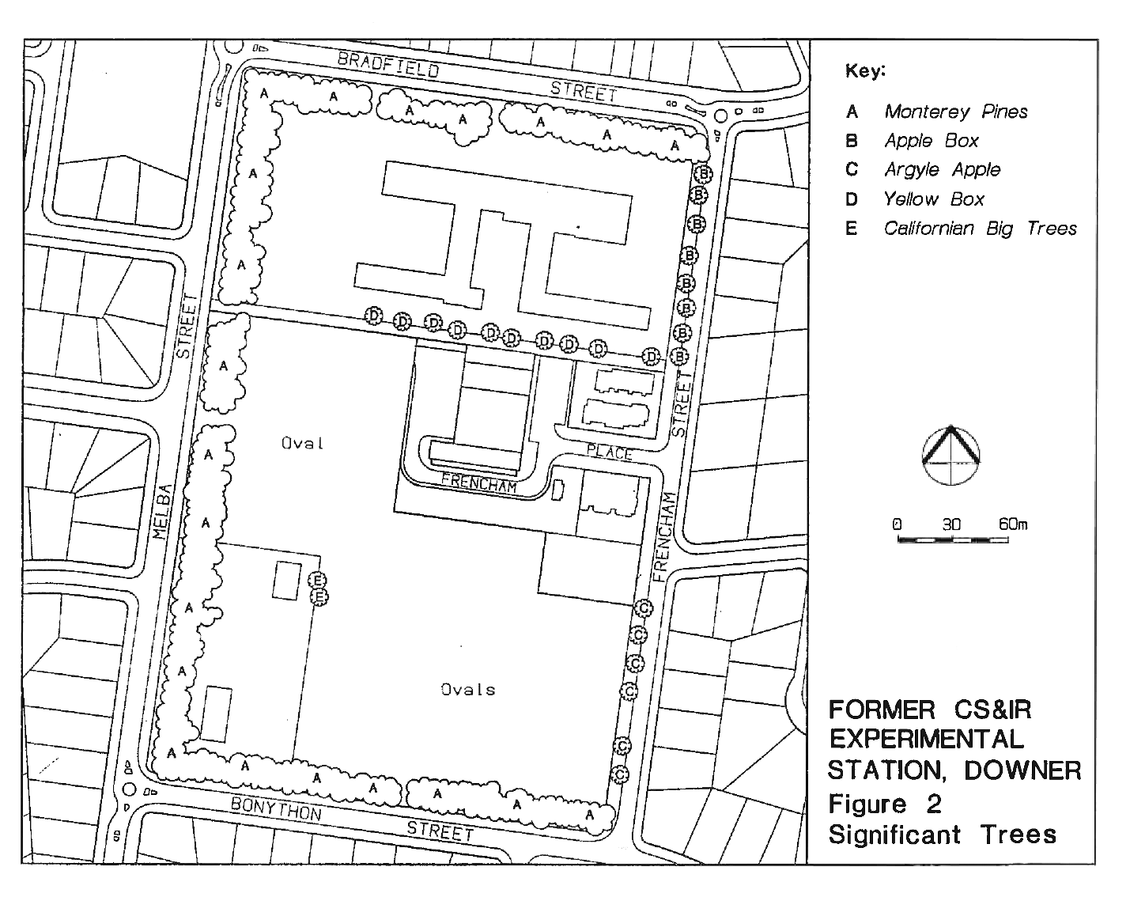
Figure 2 – 1998 IHPR entry mapping of original trees into Areas A-E surrounding Section 61 and 73.
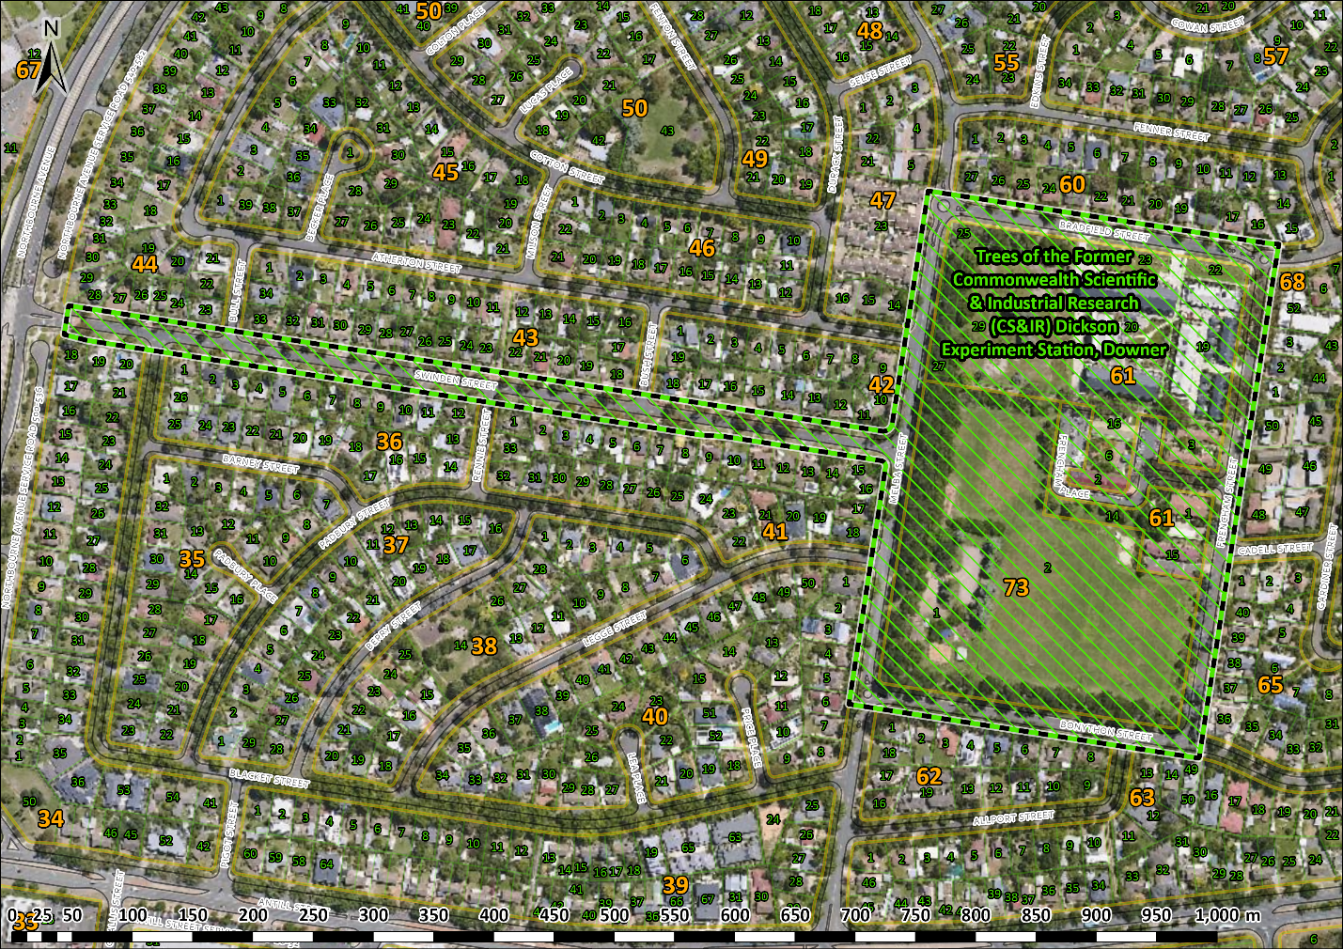
Figure 3 The registration boundary overlain on modern aerial imagery and current cadastre.

