Australian Capital Territory
Planning (Miscellaneous) Minor Plan Amendment 2025 (No 6)
Notifiable instrument NI2025–642
made under the
Planning Act 2023, s 85 (Making minor plan amendments)

1 Name of instrument
This instrument is the Planning (Miscellaneous) Minor Plan Amendment 2025 (No 6).
2 Commencement
This instrument commences on the day after its notification day.
3 Minor plan amendment
I am satisfied under the Planning Act 2023, section 85 (1) (a) that Minor Plan Amendment 2025-12 is a minor plan amendment to the Territory Plan.
4 Dictionary
In this section:
Minor Plan Amendment 2025-12 means the minor plan amendment to the Territory Plan in schedule 1.

Freya O’Brien
Delegate of the Territory Planning Authority
25 November 2025

Schedule 1


MINOR PLAN AMENDMENT TO THE TERRITORY PLAN
2025–12

Miscellaneous amendments to the Belconnen District Policy, Inner South District Policy and the Non-Urban District Policy

This minor plan amendment was prepared
under part 5.3 of the Planning Act 2023
Contents
1.0 INTRODUCTION 1
1.1 Outline of the process 1
1.2 Summary of the amendments 2
2.0 Territory Plan changes 3
2.1 Belconnen District Policy 3
2.2 Inner South District Policy 3
2.3 Non-Urban District Policy 3
3.0 TERRITORY PLAN AMENDMENT INSTRUCTIONS 4
3.1 Part D: D02 – Belconnen District Policy 4
3.2 Part D: D04 – Inner South District Policy 5
3.3 Part D: D10 – Non-Urban District Policy 5
INTERPRETATION SERVICE 7

- INTRODUCTION
  - Outline of the process
Minor plan amendment 2025-12 (MA 2025-12) to the Territory Plan is a minor plan amendment (MA) prepared under section 84 (1) (a) of the Planning Act 2023 (the Act).

Section 84 of the Act outlines the different types of MAs, some which require limited consultation to be undertaken and some which do not require consultation. This MA is consistent with the provisions under section 84 (1) (a) of the Act and therefore no consultation is needed.

Under Section 85 of the Act this type of MA can only be made if the MA is not inconsistent with the planning strategy or any relevant district strategy.

The MA is not inconsistent with the Planning Strategy and the relevant district strategies.

For more information on the content of the Territory Plan and minor plan amendment processes please refer to the planning website: www.planning.act.gov.au/professionals/our-planning-system/the-territory-plan/amendments-to-the-territory-plan

  - Summary of the amendments

This MA makes the following changes:

Belconnen District Policy

- Rectify Assessment Requirement 50 to correspond to new Figure 13a to clearly show where height limits apply in the Division of Lawson.

Inner South District Policy

- Rectify the wording in Assessment Requirement 3 to make it clear that the Gross Floor Area provisions apply only to the use of Office.

Non-Urban District Policy

- Rectify the wording in Assessment Requirement 11 and 12 to make it clear that the provisions are only meant to apply to the areas indicated by AD2 and AD3 in Figure 16 and not the whole of Paddys River District.

- Update Figure 16 to amend incorrect map labels.

- Territory Plan changes
This section contains details of the changes to be made to the Territory Plan.
  - Belconnen District Policy

When introducing the Territory Plan 2023, the previous Figure 2 from the Lawson Precinct Map and Code which showed building heights in the Territory Plan 2008 was inadvertently omitted. This minor amendment rectifies this omission by including the omitted figure as Figure 13a to clarify the location of building heights for part of the division of Lawson. It also amends Assessment Requirement 50 to correspond to Figure 13a.
  - Inner South District Policy

When introducing the Territory Plan 2023, the word ‘office’ was not translated from the Territory Plan 2008 to the current Assessment Requirement 3. This currently results in gross floor area requirements inadvertently applying to additional land uses beyond office.

This minor amendment rectifies the wording in Assessment Requirement 3 to make it clear that the gross floor area provisions apply only to the use of office.
  - Non-Urban District Policy

When introducing the Territory Plan 2023, the areas shown on the Paddys River Precinct Map in the Territory Plan 2008 were not translated into the Assessment Requirements. This inadvertently results in agricultural uses being limited to livestock grazing in the entire district, rather than a specified area.

This minor amendment rectifies the wording in Assessment Requirements 11 and 12 to make it clear that the provisions are only meant to apply to the areas indicated by AD2 and AD3 in Figure 16 and not the whole of Paddys River District.

Figure 16 Paddys River has been updated to rectify incorrect map labels from MT2 to AD2.

- TERRITORY PLAN AMENDMENT INSTRUCTIONS
  - Part D: D02 – Belconnen District Policy

Assessment Requirement 50

Substitute:

In a residential zone, no part of any building is to extend above RL620 except in the area between east of the historic windbreak and south east of Reservoir Hill where no part of the dwelling may extend beyond RL625 in accordance with Figure 13a.

Hyperlink: ‘Figure 13a’ in Assessment Requirement 50 to the respective figure

New Figure 13a

Insert after existing Figure 13

Figure 13a Lawson – Building Heights
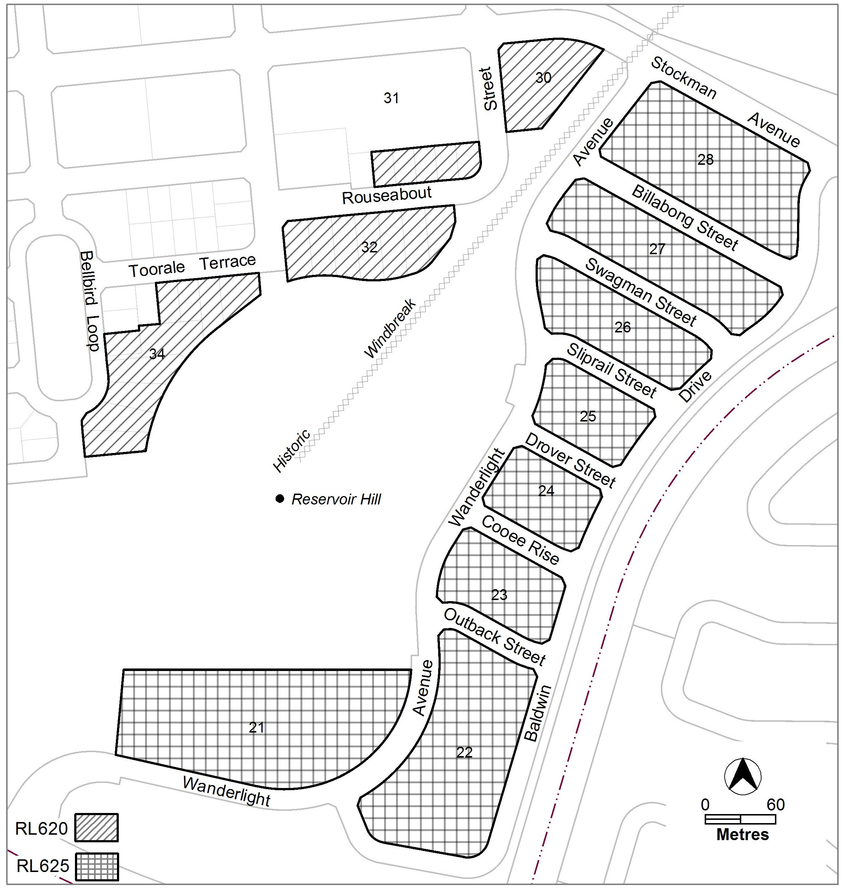
  - Part D: D04 – Inner South District Policy

Assessment Requirement 3

Substitute:

In accordance with Figure 1, in area ‘c’ the maximum gross floor area for office use is 500m².

Hyperlink: ‘Figure 1’ in Assessment Requirement 3 to the respective figure

  - Part D: D10 – Non-Urban District Policy

Assessment Requirement 11 and 12

Substitute:

11. In accordance with Figure 16 AD2 and AD3, Agriculture (where permitted) is limited to livestock grazing excluding horse agistment where appropriate.

12. In accordance with Figure 16 AD2 and AD3, Tourist facility buildings are low rise and comprise lodge style, self-contained cabins.

Hyperlink: ‘Figure 16’ in Assessment Requirement 11 and 12 to the respective figure

Figure 16

Substitute:

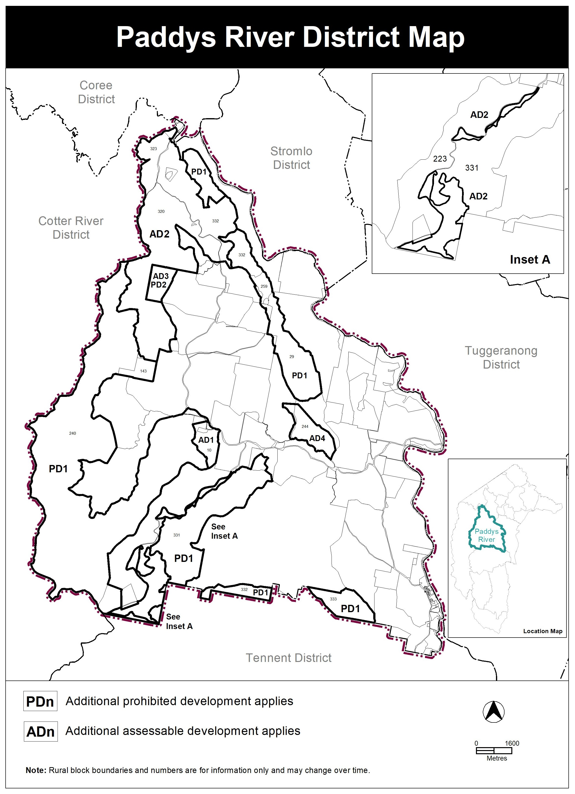

INTERPRETATION SERVICE
To speak to someone in a language other than English please telephone the Telephone Interpreter Service (TIS) 13 14 50
LANGUAGE | DETAILS
English | If you need an interpreter please call: 13 14 50
Mandarin (Simplified Chinese) / 简体中文 | 如果您需要翻译，请致电：13 14 50
Arabic / العربية | إذا كنت بحاجة إلى مترجم شفهي اتصل بالرقم: 50 14 13
Cantonese (Traditional Chinese) / 繁體中文 | 如果你需要傳譯員，請致電：13 14 50
Vietnamese /  Tiếng Việt | Nếu bạn cần thông dịch viên, xin gọi: 13 14 50
Korean / 한국어 | 통역사가 필요할 경우 다음 번호로 전화하시기 바랍니다: 13 14 50
Spanish / Español | Si necesita un intérprete, llame al 13 14 50
Persian (Farsi) / فارسی | اگر به مترجم نیاز دارید، لطفاً به این شماره تلفن کنید: 50 14 13
Dari / دری | اگر به یک ترجمان شفاهی نیاز دارید لطفاً به شمارۀ 131450 زنگ بزنید.
Punjabi / ਪੰਜਾਬੀ | ਜੇਕਰ ਤੁਹਾਨੂੰ ਕਿਸੇ ਦੁਭਾਸ਼ੀਏ ਦੀ ਲੋੜ ਹੈ ਤਾਂ ਕਿਰਪਾ ਕਰਕੇ ਫੋਨ ਕਰੋ: 13 14 50
Tamil / தமிழ் | உங்களுக்கு மொழிபெயர்த்துரைப்பாளர் ஒருவர் தேவைப்பட்டால் 13 14 50 என்ற எண்ணை அழைக்கவும்
Greek / Ελληνικά | Αν χρειάζεστε διερμηνέα, τηλεφωνήστε: 13 14 50
Italian / Italiano | Se hai bisogno di un interprete, chiama: 13 14 50
Hazaragi / هزاره گی | اگه ده ترجمان ضرورت ده رید، لطفاً ده شماره 50 14 13 تماس بگیرید.
Thai / ภาษาไทย | หากคุณต้องการล่าม กรุณาโทรไปที่ 13 14 50
Karen / ကညီကျိၥ် | ဖဲနမ့ၢ်လိၣ်ဘၣ်ပှၤကတိၤကျိးထံတၢ်တဂၤအခါ၀ံသးစူၤကိးဘၣ်-၁၃၁ ၄၅၀ တက့ၢ်.

Telephone and Interpreter Service 13 14 50 - Canberra and District - 24 hours a day, seven days a week

