Australian Capital Territory
Heritage (Decision about Provisional Registration of Barton Conference Centre, Barton) Notice 2026
Notifiable instrument NI2026–168
made under the
Heritage Act 2004, s 34 (Notice of decision about provisional registration)

1 Name of instrument
This instrument is the Heritage (Decision about Provisional Registration of Barton Conference Centre, Barton) Notice 2026.
2 Commencement
This instrument commences on the day after its notification day.
3 Decision about provisional registration
On 1 April 2026, the ACT Heritage Council (the council) decided not to provisionally register Barton Conference Centre, Block 1, Section 13, Barton (the place).
4 Description of the place
The description of the place is in the schedule.
5 Reasons for the decision
The council is not satisfied on reasonable grounds that the place is likely to have heritage significance as defined by section 10 of the Heritage Act 2004. A detailed statement of reasons, including an assessment against the heritage significance criteria, is provided in the schedule.
6 Date decision takes effect
The decision not to provisionally register the place takes effect on the day after the council made its decision.

Dr Mary Clare Swete Kelly
Secretary (as delegate for)
ACT Heritage Council
1 April 2026

Schedule
(See sections 4 and 5)


Statement of Reasons
Decision Not to Provisionally Register
Barton Conference Centre
Block 1, Section 13, Barton
on the ACT Heritage Register
In accordance with s 32 of the Heritage Act 2004, the ACT Heritage Council has decided not to provisionally register the Barton Conference Centre. This Statement of Reasons provides an assessment of the Barton Conference Centre and finds that the place does not meet any of the criteria under s 10 of the Heritage Act 2004.

Reasons for decision
The Council is not satisfied on reasonable grounds that the place is likely to have heritage significance as defined by s 10 of the Heritage Act 2004.
This statement refers to the Council’s reasons for its decision as required by s 34(5)(b)(iv) of the Heritage Act 2004.

Location of the place
This statement refers to the location of the place as required by s 34(5)(b)(ii) of the Heritage Act 2004.
Barton Conference Centre, also known as ACMA Conference Centre, Industry House, CA House, Block 1, Section 13, 28 Brisbane Avenue/10 National Cct, Barton.

Description of the place
This statement refers to the description of the place as required by s 34(5)(b)(iii) of the Heritage Act 2004. The boundary of the place and extent of features listed below is illustrated at Figure 1.
The Barton Conference Centre is a low‑scale, modernist building set into its site between 2 taller buildings along Brisbane Avenue. Designed by Enrico Taglietti and completed in 1967, the place is characterised by a single‑storey above‑ground lobby and catering area, now a café, with the original conference chamber constructed sunken below ground level, which has since been gutted and is now a gym.
The building was sunken to reduce its visual impact and to integrate it with the surrounding landscaped setting. In its original form, the roof of the underground chamber supported a shallow reflecting pond and fountain that formed part of an integrated climatic control system, while strong horizontal roof lines and sculptural curved walls expressed the building’s organic architectural intent.
Externally, the building originally featured raw off‑form concrete surfaces, white Tyrolean render to brickwork, and prominent splayed timber fascias. Many of these elements have since been removed, replaced or altered.
The pond and fountain have been removed and replaced with paving, original finishes have been rendered over, and additional structures, stairs, services and drainage elements have been added in a manner that interrupts the clarity of the original form.
Internally, the conference chamber and associated spaces have been gutted, with the removal of architect‑designed interiors, fittings and furniture. As a result, while the basic massing, geometry of main features in the structure and partially underground configuration remain legible, much of the material expression and spatial character that once defined the place has been lost.

Assessment against the heritage significance criteria
This statement refers to the Council’s assessment of the place against the heritage significance criteria as a part of its reasons for its decision as required by s 34(5)(b)(iv) of the Heritage Act 2004.
In assessing the heritage significance of Barton Conference Centre, the Council considered:
- the original nomination and documentary evidence supplied by the nominator
- the Council’s Heritage Assessment Policy (March 2018)
- information provided by site inspections on 10 and 13 September 2013, 7 January 2026, and 10 March 2026 by ACT Heritage and members of the Heritage Council
- the report by ACT Heritage titled, Background Information Barton Conference Centre, March 2026, containing photographs and information on history, description, condition and integrity.
According to s 10 of the Heritage Act 2004, a place or object has heritage significance if it satisfies one or more of the following criteria. Future research may alter the findings of this assessment.

(a) importance to the course or pattern of the ACT’s cultural or natural history
Does not meet criterion.
The Council is not satisfied on reasonable grounds that the place meets this criterion.
The Barton Conference Centre was a purpose‑built conference facility developed during the National Capital Development Commission (NCDC) period. The design reflected contemporary planning priorities for the Parliamentary Zone, including minimising visual impact, responding to climate, and integrating architecture with landscape.
The building illustrated mid‑20th century experimentation in institutional architecture in the ACT, particularly in relation to environmental control to local conditions, the internal articulation of movement into and through the space as well as internal design integrating elements from the states and territories with a focus on private and secure shared spaces.
Taglietti’s effect on the landscape of the ACT has been recognised in several of the Register entries for his buildings. The Center Cinema, Giralang School, and McKeown House are among many examples that highlight the importance of these places to the ACT through the application of Taglietti’s key design principles. The original Barton Conference Centre structure showcased many of these key elements in a holistic design, unusually including full interior fit out. Over time, however, changes to the surrounding landscape and the removal of distinctive characteristics have left only the main structural core intact. This remaining section includes what was once the pool area with cantilevered edges, splayed fascias, and select internal volumes with compromised spatial relationships. Although the building retains Taglietti's signature horizontal elements and sculptural geometry of forms and could potentially be partially restored to appeal to the public appreciation of his legacy; the loss of original materials and alterations to both internal spaces and external planning mean it can no longer effectively represent what it was intended to be in the history of the ACT.
As originally built, the place may have been an interesting addition to the ACT during the rapid expansion under the NCDC, but it is unclear how much of a contribution it had made to the course and pattern of the ACT’s cultural history.
Extensive alterations have significantly reduced the building’s ability to demonstrate these historical patterns. The loss of the pond and fountain, removal of original interiors, alteration of finishes and substantial change to the surrounding context have weakened the clarity with which the place could express its original purpose and design intent.
Given its loss of condition and integrity it is unlikely that what remains would be considered important in demonstrating these contributions to the history of the ACT.

(b) has uncommon, rare or endangered aspects of the ACT’s cultural or natural history
Does not meet criterion.
The Council is not satisfied on reasonable grounds that the place meets this criterion.
While sometimes described as an “underground” building, the Barton Conference Centre was more accurately a sunken structure, with substantial portions remaining above ground. In this respect it differs materially from Enrico Taglietti’s fully underground cinema designs, most notably the Center Cinema added to the Register in 2021, which represent a more resolved and extreme exploration of subterranean architecture and related engineering challenges.
The most distinctive aspect of the place was the integration of the roof pond and fountain as part of the building’s climatic control system. This approach was unusual in Canberra at the time and reflected broader experimentation with water‑based cooling systems during the period.
Similar systems were used in other places, such as Civic Square and the former Parliament House, and the evidence shows they did not always work well. The unusual aspect here was the attempt to combine water features with the building’s structure and services, not the building’s design itself. However, as the system did not work reliably and was later removed, it does not meet the level of rarity required under this criterion.
The pond and fountain have been removed—and the technical system that made them work no longer exists—the place no longer demonstrates anything uncommon or rare.

(c) potential to yield important information that will contribute to an understanding of the ACT’s cultural or natural history
Does not meet criterion.
The Council is not satisfied on reasonable grounds that the place meets this criterion.
Although the place embodied particular design ideas and technical approaches, these were fully documented through drawings, photographs and contemporary publications, and were readily observable in the building as constructed. The fabric does not have the capacity to reveal information that could not already be understood through direct inspection or documentary sources.
Consistent with the Council’s Heritage Assessment Policy (March 2018) - where a place does not contain buried, obscured or otherwise unrecoverable information - this criterion is not met.

(d) importance in demonstrating the principal characteristics of a class of cultural or natural places or objects
Does not meet criterion.
The Council is not satisfied on reasonable grounds that the place meets this criterion.
In its original form, the Barton Conference Centre demonstrated several characteristics associated with Taglietti’s organic approach, including attention to spatial volume, integration with landscape, and expressive use of form.
However, within Taglietti’s career, the building represents an early and transitional work, rather than a definitive or highly resolved example of his organic architecture. Later projects more clearly and consistently demonstrate the principal characteristics of this architectural approach and there is not enough of the original design remaining to be able to demonstrate if any of it was important to later designs and developing his signature style.
The place contributed to, but did not clearly exemplify, the principal characteristics of its class when considered within the broader body of comparable places. Loss of interiors, internal articulation, alteration of finishes and changes to the landscape setting mean that the remaining fabric no longer demonstrates the defining characteristics of Taglietti’s style. Only the basic form of the building remains legible, which is not enough to meet the thresholds required to meet the criterion.

(e) importance in exhibiting particular aesthetic characteristics valued by the ACT community or a cultural group in the ACT
Does not meet criterion.
The Council is not satisfied on reasonable grounds that the place meets this criterion.
While the building has been generally described as liked or admired, there is no evidence demonstrating that the Barton Conference Centre has been valued by the wider ACT community for particular aesthetic characteristics as required by the Act. General appreciation or professional interest does not meet the threshold for community‑held aesthetic value.

(f) importance in demonstrating a high degree of creative or technical achievement for a particular period
Does not meet criterion.
The Council is not satisfied on reasonable grounds that the place meets this criterion.
The integration of the roof pond and fountain into the sunken building’s environmental control system represented a creative response to climate and site conditions. However, the system was not demonstrably successful in practice, and similar approaches were trialled elsewhere with mixed results.
The design represents experimentation rather than exceptional technical achievement. Additionally, with the removal of the technical systems, the place is unable to demonstrate the potential technical innovation noted in the nomination.

(g) has a strong or special association with the ACT community, or a cultural group in the ACT for social, cultural or spiritual reasons
Does not meet criterion.
The Council is not satisfied on reasonable grounds that the place meets this criterion.
There is no evidence that the place has had a strong or special association with the ACT community or any cultural group for social, cultural or spiritual reasons.
As with the assessment against aesthetic values, while the building has been generally described as liked or admired, there is no evidence demonstrating that the Barton Conference Centre has a strong or special association with the ACT community for social, cultural or spiritual reasons as required by the Act. General appreciation or professional interest does not meet the threshold for strong or special association with the community.

(h) has a special association with the life or work of a person, or people, important to the history of the ACT
Does not meet criterion.
The Council is not satisfied on reasonable grounds that the place meets this criterion.
The Barton Conference Centre is associated with Enrico Taglietti, an architect important to the history of the ACT. However, to satisfy this criterion, the association must go beyond an individual’s standard professional practice, such as evidence of exceptional personal involvement, innovation that clearly prefigures later work, or a building that represents a turning point in their career.
While Taglietti was involved in the design and later expressed concern about alterations, this level of engagement is consistent with his approach to many projects. There is insufficient evidence that this place represents a unique antecedent to his later philosophy or that his involvement exceeded his usual practice, such as the intensive on‑site engagement documented for other projects. The loss of integrity, particularly the custom designed furniture and fittings, further weakens the ability of the place to demonstrate any special association with Taglietti.

Place boundary
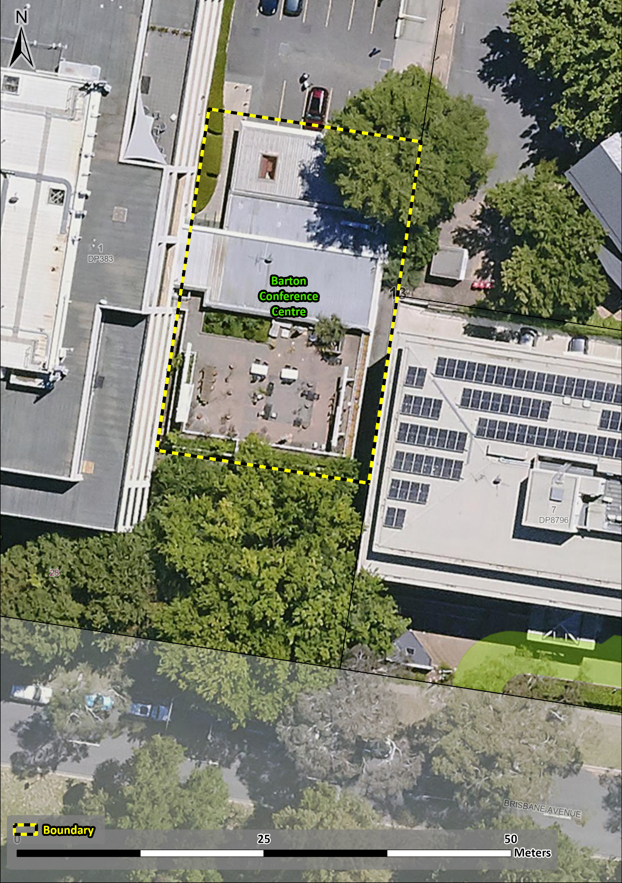
Figure 1 - Place boundary.

