Australian Capital Territory
Heritage (Decision about Provisional Registration of Urambi Co-operative Housing Precinct, Kambah) Notice 2026
Notifiable instrument NI2026—170
made under the
Heritage Act 2004, s 34 (Notice of decision about provisional registration)

1 Name of instrument
This instrument is the Heritage (Decision about Provisional Registration of the Urambi Co-operative Housing Precinct, Kambah) Notice 2026.
2 Commencement
This instrument commences on the day after its notification day.
3 Decision about provisional registration
On 1 April 2026, the ACT Heritage Council (the council) decided to provisionally register the Urambi Co-operative Housing Precinct, Block 1, Section 149, Kambah (the place).
4 Registration details of the place
The registration details of the place are in the schedule.
5 Reasons for the decision
The council decided to provisionally register the place because it is satisfied on reasonable grounds that it is likely to have heritage significance as it is likely to meet one or more of the heritage significance criteria in section 10 of the Heritage Act 2004. A detailed statement of reasons, including an assessment against the heritage significance criteria, is provided in the schedule.
6 Date provisional registration takes effect
The provisional registration of the place takes effect on 2 April 2026 (being the day after the council entered into the heritage register the registration details for the place together with an indication that the registration is provisional).
7 Indication of the Heritage Council’s intention
The council intends to decide whether to register the place under the Act, division 6.2 during the period of provisional registration.
8 Invitation to make written comments during public consultation period
(1) The council invites written comments about the registration of the place. Any written comments must be made within 4 weeks after the day this notice is notified.
(2) Written comments can be provided to the council by the following methods:
(a) mail to
The Secretary
ACT Heritage Council
480 Northbourne Avenue
DICKSON ACT 2602
(b) email to heritage.registrations@act.gov.au

Dr Mary Clare Swete Kelly
Secretary (as delegate for)
ACT Heritage Council
1 April 2026

Schedule
(See sections 4 and 5)

AUSTRALIAN CAPITAL TERRITORY
HERITAGE REGISTER
Provisional Registration
For the purposes of s33 of the Heritage Act 2004, a provisional entry to the heritage register has been prepared by the ACT Heritage Council for the following place:

Urambi Co-operative Housing Precinct
BLOCK 1 SECTION 149, KAMBAH
DATE OF DECISION
1 April 2026
DATE OF PROVISIONAL REGISTRATION
2 April 2026 (being the day after the council entered into the heritage register the registration details for the place together with an indication that the registration is provisional)
Notifiable Instrument: 2026–
PERIOD OF EFFECT OF PROVISIONAL REGISTRATION
Nine months commencing on 2 April 2026 being until 1 January 2027.
Extended Period (if applicable) Start Date ________ End Date ________
Copies of the Register Entry are available for inspection at ACT Heritage. For further information please contact:
The Secretary
ACT Heritage Council
GPO Box 158
CANBERRA ACT 2601
Telephone 13 22 81

Statement of heritage significance
This statement refers to the heritage significance of the place as required in s12(d) of the Heritage Act 2004.
The Urambi Co-operative Housing Precinct (Urambi Village) is of heritage significance for its strong association with the post-war co-operative housing movement as the first of only 2 successfully completed 20th century co-operative housing projects in the ACT and for its distinctive application of the Sydney Regional Style of modernist architecture.
Developed by the Urambi Co-operative Community Advancement Society between 1974-1976, the project is illustrative of the ‘golden age’ of the co-operative movement in Australia and the post-war interest in alternative housing models in the ACT. The successful completion of the project is also closely tied to changes in Territory planning legislation and a wider climate of social reform under the Whitlam government.
The design of Urambi Village exhibits the aspirations of the co-operative and co-housing housing movements. It encourages social connection whilst maintaining individual home ownership and provides an alternative to life on the suburban ‘quarter acre block’. Design elements of the co-operative and co-housing movements are evident in the precinct layout and its built fabric. It was designed by Michael Dysart in the Sydney Regional Style of modernist architecture.
Significant design features include clusters of self-contained private dwellings, a network of pedestrian pathways, minimal vehicle intrusion, and common spaces and facilities, including a community centre which acts as a social hub for the village. The application of a dark brown colour palette and natural materials, integration with the sloping terrain, and extensive landscaping contribute to an overall sense of community living within a natural environment whilst maintaining individual privacy.
Urambi Village is in excellent physical condition and alterations have been undertaken by residents in keeping with the original design intent, resulting in a high degree of integrity. The enduring success of the project is reflected in the strong sense of community maintained by past and present residents over half a century.

Location of the place
This statement refers to the name and location of the place as required in s12(a) and s12(b) of the Heritage Act 2004.
Urambi Co-operative Housing Precinct, also known as Urambi Village, Block 1, Section 149, Crozier Circuit, Kambah. The precinct incorporates the entire block, including street addresses 79-87 Crozier Circuit, Kambah.

Description of the place
This statement refers to the description of the place as required in s12(c) of the Heritage Act 2004. The attributes described in this section form part of the heritage significance of the place. For the purposes of s12(c) of the Heritage Act 2004, the registration boundary of the place is at Figure 1.
The Urambi Co-operative Housing Precinct (Urambi Village) is a housing complex located in Kambah, developed in 1974 by the Urambi Co-operative Community Advancement Society as an alternative housing model centred on community living. Designed by Michael Dysart & Associates, the village comprises 72 houses, including 43 split-level houses and 29 courtyard houses in the Sydney Regional Style of modernist architecture.
The 4.4-hectare precinct curves around the crest of a low hill, forming an inverted ‘L’ shape around Crozier Circuit to the east. The layout of Urambi Village prioritises co-housing design principles, whereby residents live in clustered private homes around shared spaces to generate a sense of community whilst maintaining individual privacy. Houses are grouped into 15 clusters, comprised of 3 to 7 houses forming parallel rows of terraces. Irregular offsets within each row and the use of wing walls create privacy between houses and form enclosed or partially enclosed outdoor courtyard spaces. Split level houses are positioned along Crozier Circuit, whilst courtyard houses are placed along the northern and western edges of the site.
The topography of the site slopes downwards to the north and west, providing views across the Murrumbidgee Country Club golf course and towards the Brindabella Mountains. Houses have been sited around remnant eucalyptus trees and additional planting of both native and exotic species by Urambi Village residents reinforces a sense of living within the natural environment. The overall design emphasises integration with the landscape, including the use of split-level dwellings along the sloping hillside, clustering of houses, landscape corridors, and a uniform dark brown colour palette.
The layout of Urambi Village prioritises pedestrian movement and homes are accessed via footpaths, including a central ‘spine path,’ to encourage opportunities for social interaction. Vehicle access is intentionally limited, with six shared car parks comprising a mix of carports and open spaces located off Crozier Circuit. Houses do not necessarily present a formal front façade and residents operate under a ‘sphere of influence’ approach by contributing to the upkeep of communal areas adjoining their homes. Together with the network of pedestrian pathways and landscaped corridors woven throughout the complex, this arrangement creates natural transition zones between private residences and shared community spaces. Communal facilities include a community centre, swimming pool, barbeque area, ball court, seating areas, and shared service points such as letterboxes and waste collection areas.
The complex is designed in the Sydney Regional Style of modernist architecture. Buildings share a unified palette of dark brown tiled roofs, brickwork, and dark stained timber to blend with the natural environment. Other elements include the use of clerestory windows, timber framing, and timber panelled doors. The sloping topography of the site is complemented by the use of split-level dwellings and skillion roofs. Houses range from 2 to 5 bedrooms, supporting diverse households whilst maintaining visual harmony through colour palette and style.
The Urambi Co-operative Housing Precinct has the following attributes of significance:
- Arrangement of split-level and courtyard dwellings in parallel terrace clusters with irregular offsets
- Common facilities and spaces, such as a community centre, swimming pool, and ball court
- Network of pedestrian pathways, open spaces, transition zones and nature corridors
- General alignment and positioning of roads and shared car parks to encourage social interaction and minimise vehicle intrusion
- Integration of structures within a natural environment, including a mixture of both Australian native and exotic flora
- Skillion roofs in alignment with triangular wing walls
- Siting of houses within the sloping topography providing views to the west and north
- Use of a cohesive dark colour palette and natural materials, or substitutions consistent with the original design intent
- Dark stained timber awning sash windows and clerestory windows
- Community governance structure, governance systems and processes as set out in Urambi Village guidelines and policy documents

Conservation objective
The guiding conservation objective is that Urambi Co-operative Housing Precinct shall be conserved and appropriately managed in a manner respecting its heritage significance.
The ACT Heritage Council may make heritage guidelines applicable to the place under s25 of the Heritage Act 2004.
For further information on managing the place, or for advice on proposed works or development, please contact ACT Heritage via email at heritage@act.gov.au or via 13 22 81.

Reason for provisional registration
This statement refers to the heritage significance of the place as required in s12(d) of the Heritage Act 2004.
The Council has assessed the Urambi Co-operative Housing Precinct against the heritage significance criteria and is satisfied on reasonable grounds that the place is likely to have heritage significance when assessed against criteria/criterion (a), (b) and (d) under s10 of the Heritage Act 2004. A place is considered to have heritage significance if it meets one or more of the criteria.
Table 1 Criteria that the Council consider have been met.
Criterion | (a) | (b) | (c) | (d) | (e) | (f) | (g) | (h)
Met | Yes | Yes | No | Yes | No | No | No | No

Assessment against the heritage significance criteria
This statement refers to the heritage significance of the place as required in s12(d) of the Heritage Act 2004.
In assessing the heritage significance of Urambi Co-operative Housing Precinct, the Council considered:
- the original nomination and documentary evidence supplied by the nominator
- the Council’s Heritage Assessment Policy (March 2018)
- information provided by a site inspection on 9 December 2025 by ACT Heritage
- the report by ACT Heritage titled, Background Information Urambi Co-operative Housing Precinct, January 2026, containing photographs and information on history, description, condition and integrity
According to s10 of the Heritage Act 2004, a place or object has heritage significance if it meets one or more of the following criteria. Future research may alter the findings of this assessment.

(a) importance to the course or pattern of the ACT’s cultural or natural history
MEETS CRITERION.
The Council is satisfied on reasonable grounds that the place is likely to meet this criterion.
Urambi Village is important for its association with the post-war period and co-operative housing movement in the ACT.
Urambi Village represents the first of only 2 successfully completed co-operative housing projects during the post-war period, which was characterised by rapid population growth and experimentation with alternative housing models.
The project was undertaken between 1974 and 1976 by the Urambi Co-operative Community Advancement Society during a peak period of interest in co-operative housing and the broader ‘golden age’ of the co-operative movement in Australia. The formation of the co-operative is also closely tied to changes in Territory planning legislation and the wider climate of social reform associated with the Whitlam government. Urambi Village reflects the progressive ethos and aspirations of co-operative housing movements for affordable community living in harmony with the natural environment. In particular, it reflects an attempt to generate a sense of community during a period of change and growth for the capital.
The design of the precinct by Michael Dysart demonstrates key features of the co-operative and co-housing movement, incorporating self-contained dwellings within shared community spaces to foster social networks whilst maintaining individual privacy. Key design elements include clustered housing, common spaces and facilities such as a community centre, a network of pedestrian paths, and minimal vehicle intrusion. The precinct also illustrates the Sydney Regional Style of modernist architecture, including a cohesive dark brown colour scheme, siting of houses within sloping terrain, and a natural environment.
These features have been maintained to a high standard by residents, and the precinct has a high degree of integrity. The success of the project and design is evidenced by the strong sense of community that has endured in the village over the past 50 years, embraced by both past and present residents. This includes a governance structure that supports community decision-making regarding development, alterations and repairs at the complex.
Urambi Village meets the threshold indicator of rarity and representativeness as evidence of the golden age of the co-operative housing movement in the ACT.

(b) has uncommon, rare or endangered aspects of the ACT’s cultural or natural history
MEETS CRITERION.
The Council is satisfied on reasonable grounds that the place is likely to meet this criterion.
Urambi Village is the first of only 2 20th century co-operative housing projects in the ACT, the other being Wybalena Grove in Cook.
The success of Urambi Village is closely tied to the political, economic, and social climate of the ACT in early 1970s, during the peak of the co-operative housing movement in Australia. At this time, at least 14 housing co-operatives were registered in the ACT, although only Urambi Village and Wybalena Grove in Cook resulted in completed projects.
Following this peak of activity housing co-operatives significantly declined and the movement did not materialise into a strong housing alternative in Australia due to financial, legislative and cultural shifts. Whilst there is contemporary interest in alternative and co-operative housing models as an affordable and sustainable housing solution, there are no other known successfully completed co-operative housing projects in the ACT from the 20th century.
Urambi Village meets the threshold indicator of rarity and intactness as evidence of the golden age of the co-operative housing movement in the ACT.

(c) potential to yield important information that will contribute to an understanding of the ACT’s cultural or natural history
Does not meet criterion.
The Council is not satisfied on reasonable grounds that the place is likely to meet this criterion.
There is no evidence to suggest that Urambi Village will yield substantial new information about the ACT’s cultural or natural history than what is currently known through historical documentation, or visible in the built fabric of the place.

(d) importance in demonstrating the principal characteristics of a class of cultural or natural places or objects
MEETS CRITERION.
The Council is satisfied on reasonable grounds that the place is likely to meet this criterion.
Urambi Village is a distinctive example of the modernist Sydney Regional Style in the ACT, being the first of 2 examples where this was applied to a co-operative housing venture (the other being Wybalena Grove in Cook).
Design elements of the Sydney Regional Style are evident in the layout, materials, and landscaping of Urambi Village, designed by architect Michael Dysart.
The overall design emphasises integration with the natural environment, including the consistent application of dark, natural materials, and siting of houses within the sloping terrain. Visual cohesion across the village is achieved through the use of a unified palette of dark brown tiled roofs, brickwork, and dark stained timber. Where substitutions of original fabric have been required, material has been chosen that is consistent with the original design intent. Other elements of the Sydney Regional Style include the use of dark stained timber awning sash windows and clerestory windows.
Integration with the sloping landscape is expressed through the arrangement of houses in clustered parallel terrace rows with irregular offsets curved along the sloping topography of the site. The sloping topography of the site is similarly complemented by the use of split-level dwellings along Crozier Circuit and angular lines formed by skillion roofs and wing walls.
Visual harmony with the natural environment is also achieved through meandering pedestrian paths, open spaces, transition zones and nature corridors. Extensive planting efforts undertaken by Urambi Village residents since its construction have contributed to an overall sense of residential living within a natural environment.
Urambi Village is notable as an unusual example of the Sydney Regional Style when compared to other examples in the ACT due to the application of this design to a large community focussed housing project. Elements of co-housing design have been applied to encourage a sense of community, while balancing individual privacy.
The use of clustered housing, common spaces and facilities, a network of pedestrian paths, and the general alignment and positioning of roads and shared carparks encourages interaction between community members when moving throughout the village.
Meanwhile, irregular offsets within each row and the use of wing walls creates privacy between houses as well as forming enclosed or partially enclosed outdoor courtyard spaces. Whilst houses range from 2 to 5 bedrooms in order to support a diversity of household needs, visual harmony is maintained across the village through colour palette and style.
The layout of Urambi Village has remained largely unchanged since its construction in the 1970s. Additions and alterations have been carried out in keeping with the original design principles, maintaining a visual cohesion of dark, natural materials and angular forms across the site.
The success of the design has been recognised with several awards from the Australian Institute of Architects including the CS Daley Medal for Housing in 1977, the ACT Chapter 25-year award in 2002, and recognition on the Register of Nationally Significant 20th Century Architecture.
Urambi Village meets the threshold indicator of distinctiveness through the application of the Sydney Regional Style of architecture to a co-operative housing project.

(e) importance in exhibiting particular aesthetic characteristics valued by the ACT community or a cultural group in the ACT
Does not meet criterion.
The Council is not satisfied on reasonable grounds that the place is likely to meet this criterion.
There are no known distinctive aesthetic characteristics at Urambi Village that are valued by a specific cultural group in the ACT or by the ACT community more broadly.
The threshold indicator of ‘valued by the ACT community’ must be objectively tested and/or clearly demonstrated. While Urambi Village is valued among architects and those passionate about architecture, this does not qualify as the broader ACT community nor a cultural group.

(f) importance in demonstrating a high degree of creative or technical achievement for a particular period
Does not meet criterion.
The Council is not satisfied on reasonable grounds that the place is likely to meet this criterion.
Whilst Urambi Village displays a considered use of the Sydney Regional Style, this reflects broader trends in the creative and technical innovations of modernist architectural design, including the wider practice of architect Michael Dysart and other Sydney Regional Style designers. The level of creative and technical achievement displayed at Urambi Village is not of an unusually high degree for its time.

(g) has a strong or special association with the ACT community, or a cultural group in the ACT for social, cultural or spiritual reasons
Does not meet criterion.
The Council is not satisfied on reasonable grounds that the place is likely to meet this criterion.
Whilst the precinct is highly valued by both past and present residents, there are no known special or strong associations that are demonstrable, enduring, and out of the ordinary between Urambi Village and a specific cultural group in the ACT for social, cultural, or spiritual reasons.

(h) has a special association with the life or work of a person, or people, important to the history of the ACT
Does not meet criterion.
The Council is not satisfied on reasonable grounds that the place is likely to meet this criterion.
There are no known special associations between Urambi Village and the life or work of a specific person important to the history of the ACT.
Sydney architect Michael Dysart is an accomplished and celebrated modernist architect of the Sydney Regional Style, who also designed Wybalena Grove in Cook. In particular, Dysart played an important role in designing educational buildings and public housing in New South Wales as a NSW Government Architect. In this role Dysart was responsible for the design of at least 43 schools across NSW. Dysart also designed the Lowline home, the first architect designed project home for Pettit & Sevitt displayed in 1963 at the Rocks in Sydney. There are many examples of the Pettit and Sevitt Lowline home in Canberra, as well as other project homes designed by Dysart with the company Aspect and Habitat in Aranda, Kambah and Weston.
In order to meet this criterion, the association between the person and the place must be enduring, beyond the ordinary, and differentiated from other similar places associated with the person. The life or work of that person must also be important to the history of the ACT.
Although the association of Urambi Village with Dysart is a close one, Dysart is best recognised for his work in New South Wales. There is no known special association between Dysart and Urambi Village beyond the commissioning of the design, or broader significance of this association to shaping the history of the ACT.

Registration boundary
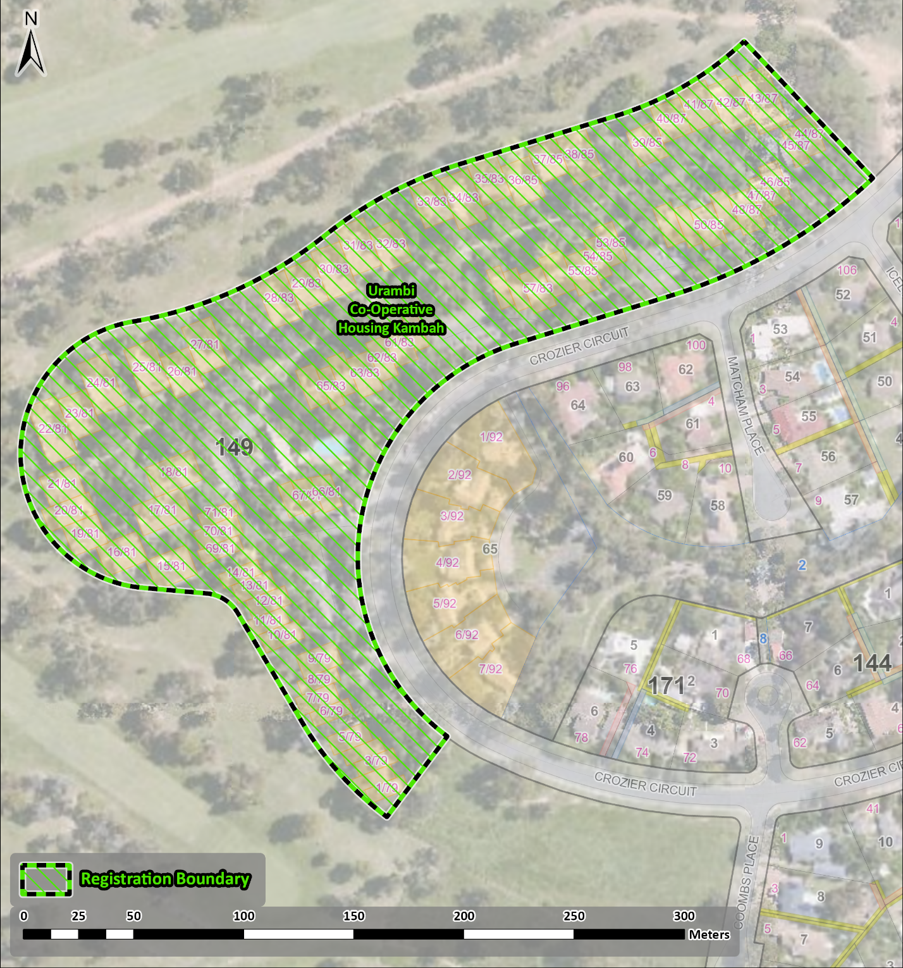
Figure 1 - Registration boundary for the Urambi Co-operative Housing Precinct

