Australian Capital Territory
Heritage (Decision about Provisional Registration of Wybalena Grove Precinct, Cook) Notice 2026
Notifiable instrument NI2026—171
made under the
Heritage Act 2004, s 34 (Notice of decision about provisional registration)

1 Name of instrument
This instrument is the Heritage (Decision about Provisional Registration of the Wybalena Grove Precinct, Cook) Notice 2026.
2 Commencement
This instrument commences on the day after its notification day.
3 Decision about provisional registration
On 1 April 2026, the ACT Heritage Council (the council) decided to provisionally register the Wybalena Grove Precinct, Block 1, Section 37, Cook (the place).
4 Registration details of the place
The registration details of the place are in the schedule.
5 Reasons for the decision
The council decided to provisionally register the place because it is satisfied on reasonable grounds that it is likely to have heritage significance as it is likely to meet one or more of the heritage significance criteria in section 10 of the Heritage Act 2004. A detailed statement of reasons, including an assessment against the heritage significance criteria, is provided in the schedule.
6 Date provisional registration takes effect
The provisional registration of the place takes effect on 2 April 2026 (being the day after the council entered into the heritage register the registration details for the place together with an indication that the registration is provisional).
7 Indication of the Heritage Council’s intention
The council intends to decide whether to register the place under the Act, division 6.2 during the period of provisional registration.
8 Invitation to make written comments during public consultation period
(1) The council invites written comments about the registration of the place. Any written comments must be made within 4 weeks after the day this notice is notified.
(2) Written comments can be provided to the council by the following methods:
(a) mail to
The Secretary
ACT Heritage Council
480 Northbourne Avenue
DICKSON ACT 2602
(b) email to heritage.registrations@act.gov.au

Dr Mary Clare Swete Kelly
Secretary (as delegate for)
ACT Heritage Council
1 April 2026

Schedule

(See sections 4 and 5)

AUSTRALIAN CAPITAL TERRITORY
HERITAGE REGISTER
Provisional Registration
For the purposes of s33 of the Heritage Act 2004, a provisional entry to the heritage register has been prepared by the ACT Heritage Council for the following place:

Wybalena Grove Precinct
BLOCK 1 SECTION 37, COOK
DATE OF DECISION
1 April 2026
DATE OF PROVISIONAL REGISTRATION
2 April 2026 (being the day after the council entered into the heritage register the registration details for the place together with an indication that the registration is provisional)
Notifiable Instrument: 2026–
PERIOD OF EFFECT OF PROVISIONAL REGISTRATION
Nine months commencing on 2 April 2026 being until 1 January 2027.
Extended Period (if applicable) Start Date ________ End Date ________
Copies of the Register Entry are available for inspection at ACT Heritage. For further information please contact:
The Secretary
ACT Heritage Council
GPO Box 158
CANBERRA ACT 2601
Telephone 13 22 81

Statement of heritage significance
This statement refers to the heritage significance of the place as required in s12(d) of the Heritage Act 2004.
The Wybalena Grove Precinct (Wybalena Grove) is of heritage significance for its strong association with the post-war co-operative housing movement as 1 of only 2 successfully completed 20th century co-operative housing projects in the ACT, and for its distinctive application of the Sydney Regional Style of modernist architecture.
Wybalena Grove is an experimental co-operative housing venture which was undertaken by the Cook Aranda Co-operative Housing Society (CACHS) in the 1970s. CACHS was formed during a period of rapid population growth and intensive residential building by the National Capital Development Authority in the post-war period. Wybalena Grove is the larger of 2 co-operative housing ventures that emerged from this period in the ACT, the other being Urambi Village in Kambah. The project is illustrative of the ‘golden age’ of the co-operative movement in Australia and the post-war interest in alternative housing models in the ACT. The successful completion of the project is also closely tied to changes in Territory planning legislation and a wider climate of social reform under the Whitlam government.
The design of Wybalena Grove exhibits the aspirations of the co-operative and co-housing housing movements, encouraging social connection whilst maintaining individual home ownership, providing an alternative to life on the suburban ‘quarter acre block’. Design elements of the co-operative and co-housing movement and Sydney Regional Style of architecture are evident in the layout, materials, and landscaping of Wybalena Grove, designed by architect Michael Dysart.
This includes self-contained private dwellings with single, split level, and tri-level variations arranged in parallel terrace clusters with irregular offsets, a network of pedestrian pathways, minimal intrusion by vehicles, and common facilities and spaces. The application of dark, natural materials, steeply pitched gabled roofs, triangular wingwalls, and stained timber awning sash windows and clerestory windows presents a cohesive design profile across the site. Siting within the sloping terrain with a northwestern aspect and extensive landscaping including nature corridors, open spaces, and transition zones, contribute to an overall sense of community residential living within a natural setting.
The layout of Wybalena Grove has remained largely unchanged since its construction in the 1970s. Since then, there has been a long history of various additions and alterations to residences and communal spaces, largely carried out in keeping with the original design aesthetic. The success of the design as a co-operative housing project is evident in the strong sense of community retained by both past and present Wybalena Grove residents.

Location of the place
This statement refers to the name and location of the place as required in s12(a) and s12(b) of the Heritage Act 2004.
The Wybalena Grove Precinct, also known as Wybalena Grove, Block 1, Section 37, Cook. The precinct incorporates the entire block, including street addresses 1 to 105 Wybalena Grove, accessed via Lyttleton Crescent, Cook.

Description of the place
This statement refers to the description of the place as required in s12(c) of the Heritage Act 2004. The attributes described in this section form part of the heritage significance of the place. For the purposes of s12(c) of the Heritage Act 2004, the registration boundary of the place is at Figure 1.
Wybalena Grove is a housing complex comprised of 105 residential houses situated across 13 hectares of landscaped bushland in Cook. It is bounded by Lyttleton Crescent to the north, Bindubi Street to the east, and a nature reserve to the south. Houses are predominantly semi-detached in groups of 2 or 3, with some detached examples. They are grouped in 5 clusters. Within each cluster, houses are arranged in rows with irregular offsets, producing a ‘staggered’ terracing effect along a southwest-northeast alignment.
These rows of staggered terracing houses ascend a heavily vegetated hillside, providing a northwestern aspect and solar access from the rear of each residence. Clusters are accessed via a central, curved road that terminates in three cul-de-sacs. Vehicle access is limited throughout the complex, with several shared car parks and a limited number of residences with individual car ports. Movement throughout the complex is facilitated by pedestrian paths, encouraging encounters between community members and enhancing the sense of living among the natural environment. Communal areas include seating areas, a tennis court, playground, barbeques, community garden, and grassed village green.
Wybalena Grove houses are stylistically uniform and characteristic of the late 20th century modernist Sydney Regional Style, designed by Sydney architect Michael Dysart. The houses have steeply pitched tiled and gabled roofs, with triangular wingwalls, comprised of dark stained or painted timber beams and dark bricks. Dark stained timber awning sash windows and clerestory windows are also present throughout the complex.
The original floorplan designs were highly customisable, including 2 to 5 bedrooms across single, split level, and tri-level variations. Houses can be accessed via the front door to the southeast, where there is a small courtyard and, in some residences, a carport. The main aspect is from the rear of the houses, where there is a larger private outdoor space and views to the northwest towards landscaped communal spaces, bushland or, in some instances, the surrounding hills. The houses were designed to sit within the sloping landscape and remnant native vegetation. Substantial planting carried out by the community since its establishment has resulted in Wybalena Grove’s characteristic bushland setting, including nature corridors, open spaces, and transition zones.
The layout of Wybalena Grove has remained largely unchanged since its construction in the 1970s. Various additions and alterations to residences and communal spaces have been carried out over the decades. These have been guided by the Wybalena Grove Development Framework, adopted by the Owners Corporation in 1984. In several cases, extensions have been carried out within the existing roof space, adding roof windows for solar access.
Other additions and alterations include the installation of timber decking, courtyard fencing, balconies, additional windows, and solar panels. Many houses have undergone internal renovations. While some houses retain more original features than others, overall, the exteriors present a visual cohesion of dark, natural materials and triangular form, maintaining the design connection across the site and blending in with the surrounding bushland.
Private dwellings and communal spaces in Wybalena Grove have been closely managed by Wybalena Grove residents since construction. Consequently, the complex is in excellent physical condition.
The Wybalena Grove Precinct has the following attributes of significance:
- Arrangement of single, split level, and tri level houses in parallel terrace clusters with irregular offsets
- Communal facilities and common areas
- Network of pedestrian pathways, open spaces, transition zones and nature corridors
- General alignment and positioning of roads and shared car parks to encourage social interaction and minimise vehicle intrusion
- Integration of structures within a natural bushland environment, including a mixture of both Australian native and exotic flora
- Steeply pitched gabled roofs in alignment with triangular wingwalls
- Siting of houses within the sloping topography, with a northwestern aspect
- Use of a cohesive dark colour palette and natural materials, or substitutions consistent with the original design intent
- Dark stained timber awning sash windows and clerestory windows
- Community governance structure, governance systems and processes as set out in Wybalena Grove guidelines and policy documents

Conservation objective
The guiding conservation objective is that the Wybalena Grove Precinct shall be conserved and appropriately managed in a manner respecting its heritage significance.
The ACT Heritage Council may make heritage guidelines applicable to the place under s25 of the Heritage Act 2004.
For further information on managing the place, or for advice on proposed works or development, please contact ACT Heritage via email at heritage@act.gov.au or via 13 22 81.

Reason for provisional registration
This statement refers to the heritage significance of the place as required in s12(d) of the Heritage Act 2004.
The Council has assessed the Wybalena Grove Precinct against the heritage significance criteria and is satisfied on reasonable grounds that the place is likely to have heritage significance when assessed against criteria (a), (b), and (d) under s10 of the Heritage Act 2004. A place is considered to have heritage significance if it meets one or more of the criteria.
Table 1 Criteria that the Council consider have been met.
Criterion | (a) | (b) | (c) | (d) | (e) | (f) | (g) | (h)
Met | Yes | Yes | No | Yes | No | No | No | No

Assessment against the heritage significance criteria
This statement refers to the heritage significance of the place as required in s12(d) of the Heritage Act 2004.
In assessing the heritage significance of the Wybalena Grove Precinct, the Council considered:
- the original nomination and documentary evidence supplied by the nominator
- the Council’s Heritage Assessment Policy (March 2018)
- information provided by a site inspection on 7 October 2025 by ACT Heritage
- the report by ACT Heritage titled, Background Information Wybalena Grove Precinct, 2026, containing photographs and information on history, description, condition and integrity
According to s10 of the Heritage Act 2004, a place or object has heritage significance if it meets one or more of the following criteria. Future research may alter the findings of this assessment.

(a) importance to the course or pattern of the ACT’s cultural or natural history
MEETS CRITERION.
The Council is satisfied on reasonable grounds that the place is likely to meet this criterion.
Wybalena Grove, established by the Cook Aranda Co-operative Housing Society (CACHS) in the 1970s and designed in the Sydney Regional Style by architect Michael Dysart, is important for its association with the post-war period and co-operative housing movement in the ACT. This movement emerged during a period of intensified building efforts by the National Capital Development Commission (NCDC) to meet the residential housing needs of a dramatically increasing population during the post-war period. Although the NCDC was initially resistant to the idea of co-operative housing, the concept was ultimately supported as a housing solution for Canberra’s growing population.
Housing demand and rising construction costs presented an opportunity for innovation in residential architecture. This period saw the proliferation of modernist and experimental residential housing in the ACT, including the peak period of interest in co-operative housing and the broader ‘golden age’ of the co-operative movement in Australia. Wybalena Grove has a distinctive association with this period of development. It is the larger of 2 co-operative housing ventures that emerged in the 1970s in the ACT, the other being Urambi Village in Kambah, also designed by Michael Dysart. The completion of Wybalena Grove is also closely tied to changes in Territory planning legislation and the wider climate of social reform associated with the Whitlam government.
Wybalena Grove reflects the progressive ethos and aspirations of the co-operative housing movement for affordable community living in harmony with the natural environment. In particular, it reflects an attempt to generate a sense of community during a period of change and growth for the capital. Community focussed living balanced with the need for privacy is evident in the design of Wybalena Grove. Key design features include clustered parallel terraces with irregular offsets, communal facilities and common areas, a network of pedestrian pathways, and the general alignment and positioning of roads and car parks to encourage social interaction. The use of a cohesive dark colour palette and natural materials, siting of dwellings within the sloping topography, nature corridors, open spaces and transition zones, and extensive landscaping all contribute to the overall sense of community living within a natural environment.
Historical documents demonstrate that Wybalena Grove has been highly successful at fostering a sense of community for its residents, and it remains a popular cooperatively managed residential complex today. This includes a governance structure that supports community decision-making regarding development, alterations and repairs at the complex.
Wybalena Grove meets the threshold indicators of rarity and representativeness. It is evidence of the golden age of the co-operative housing movement in the ACT.

(b) has uncommon, rare or endangered aspects of the ACT’s cultural or natural history
MEETS CRITERION.
The Council is satisfied on reasonable grounds that the place is likely to meet this criterion.
Wybalena Grove is 1 of only 2 20th century co-operative housing projects in the ACT, the other being Urambi Village in Kambah, also designed by Michael Dysart.
The success of Wybalena Grove is closely tied to the political, economic, and social climate of the ACT in the early 1970s, during the peak of the co-operative housing movement in Australia. At this time, at least 14 housing co-operatives were registered in the ACT, however only Wybalena Grove and Urambi Village resulted in completed projects.
Following this peak of activity housing co-operatives significantly declined, and the movement did not materialise into a strong housing alternative in Australia due to financial, legislative and cultural shifts. While there is contemporary interest in alternative and co-operative housing models as an affordable and sustainable housing solution, there are no other known successfully completed co-operative housing projects in the ACT from the 20th century.
The ambitions of the co-operative movement are captured in the original design intent for Wybalena Grove and remain evident in the layout and built fabric of the place. This includes elements of co-housing design, such as clustered housing, minimal vehicle intrusion, communal spaces, and a network of pedestrian pathways.
Wybalena Grove meets the threshold indicator of rarity and intactness as evidence of the golden age of the co-operative housing movement.

(c) potential to yield important information that will contribute to an understanding of the ACT’s cultural or natural history
Does not meet criterion.
The Council is not satisfied on reasonable grounds that the place is likely to meet this criterion.
There is no evidence to suggest that Wybalena Grove will yield substantial new information about the ACT’s cultural or natural history beyond what is currently known through historical documentation, or visible in the built fabric of the place.

(d) importance in demonstrating the principal characteristics of a class of cultural or natural places or objects
MEETS CRITERION.
The Council is satisfied on reasonable grounds that the place is likely to meet this criterion.
Wybalena Grove is a distinctive example of the modernist Sydney Regional architectural design style in the ACT, being 1 of only 2 examples where this was applied to a co-operative housing venture (the other being Urambi Village in Kambah).
Design elements of the Sydney Regional Style are evident in the layout, materials, and landscaping of Wybalena Grove, designed by architect Michael Dysart. This is expressed through the sympathetic arrangement of houses in parallel terrace clusters along the sloping topography of the site and consistent application of dark, natural materials to match the colour palette of a bushland setting. Houses were originally positioned around patches of remnant native vegetation, and extensive planting efforts undertaken by Wybalena Grove residents since its construction have contributed to an overall sense of residential living within a natural bushland environment.
Visual harmony with the natural environment and the sloped topography is similarly expressed with split level designs and the use of dark toned natural materials. Rather than the typical Sydney Regional Style skillion roof, steeply pitched gabled roofs connect with wingwalls between houses, extending triangular lines to the ground. The overall visual effect is complementary to the sloping topography. The use of natural, textured materials includes dark brick, dark stained exposed timber, and dark tiles. Dark stained timber awning sash windows and clerestory windows are also features of the Sydney Regional Style incorporated at Wybalena Grove.
Wybalena Grove is notable as an unusual example of the Sydney Regional Style when compared to other examples in the ACT due to the application of this design to a large community focussed housing project. Several distinctive design elements have been applied to encourage a sense of community, while balancing individual privacy. This includes the arrangement of houses in 5 clusters, integrated with communal facilities such as a playground, village green, tennis court, community garden, and barbeque spaces. The general alignment and positioning of roads, shared car parks, and pedestrian pathways also encourages interaction between community members when moving throughout the complex. At the same time, privacy is provided by the irregular offsets of houses within a terrace row, as well as by large triangular wingwalls between houses.
The layout of Wybalena Grove has remained largely unchanged since its construction in the 1970s. Additions and alterations, while common throughout the precinct, have predominantly been carried out in keeping with the original design principles, maintaining a visual cohesion of dark, natural materials and triangular forms across the site.
Wybalena Grove has been recognised and celebrated for its modernist design, receiving the Sir Roy Grounds Award for Enduring Architecture in 2019 from the Australian Institute of Architects. Wybalena Grove has also featured in art and design print, digital, and televised media for its modernist features, bushland setting, and community living.
Wybalena Grove meets the threshold indicator of distinctiveness through the application of the Sydney Regional Style of architecture to a co-operative housing project.

(e) importance in exhibiting particular aesthetic characteristics valued by the ACT community or a cultural group in the ACT
Does not meet criterion.
The Council is not satisfied on reasonable grounds that the place is likely to meet this criterion.
There are no known distinctive aesthetic characteristics at Wybalena Grove that are valued by a specific cultural group in the ACT or by the ACT community more broadly.
The threshold indicator of ‘valued by the ACT community’ must be objectively tested and/or clearly demonstrated. While Wybalena Grove is valued among architects and those passionate about architecture, this does not qualify as the broader ACT community nor a cultural group.

(f) importance in demonstrating a high degree of creative or technical achievement for a particular period
Does not meet criterion.
The Council is not satisfied on reasonable grounds that the place is likely to meet this criterion.
While Wybalena Grove displays a considered use of materials to complement the natural topography and foster community living, this reflects broader trends in the creative and technical innovations of modernist architectural design, including the wider practice of architect Michael Dysart and other Sydney Regional Style designers. The level of creative and technical achievement displayed at Wybalena Grove is neither exceptionally important nor of an unusually high degree for its time.

(g) has a strong or special association with the ACT community, or a cultural group in the ACT for social, cultural or spiritual reasons
Does not meet criterion.
The Council is not satisfied on reasonable grounds that the place is likely to meet this criterion.
There are no known special or strong associations between Wybalena Grove and a specific cultural group in the ACT.

(h) has a special association with the life or work of a person, or people, important to the history of the ACT
Does not meet criterion.
The Council is not satisfied on reasonable grounds that the place is likely to meet this criterion.
There are no known special associations between Wybalena Grove and the life or work of a specific person important to the history of the ACT.
Sydney architect Michael Dysart is an accomplished and celebrated modernist architect of the Sydney Regional Style, who also designed Urambi Village in Kambah. Dysart played an important role in designing educational buildings and public housing in New South Wales as a NSW Government Architect. In this role Dysart was responsible for the design of at least 43 schools across NSW. Dysart also designed the Lowline home, the first architect-designed project home for Pettit & Sevitt displayed in 1963 at the Rocks in Sydney. There are many examples of the Pettit and Sevitt Lowline home in Canberra, as well as other project homes designed by Dysart with the company Aspect and Habitat in Aranda, Kambah and Weston.
To meet this criterion, the association between the person and the place must be enduring, beyond the ordinary, and differentiated from other similar places associated with the person. The life or work of that person must also be important to the history of the ACT.
Although the association of Wybalena Grove with Dysart is a close one, Dysart is best recognised for his work in New South Wales. There is no known special association between Dysart and Wybalena Grove beyond the commissioning of the design.

Registration boundary
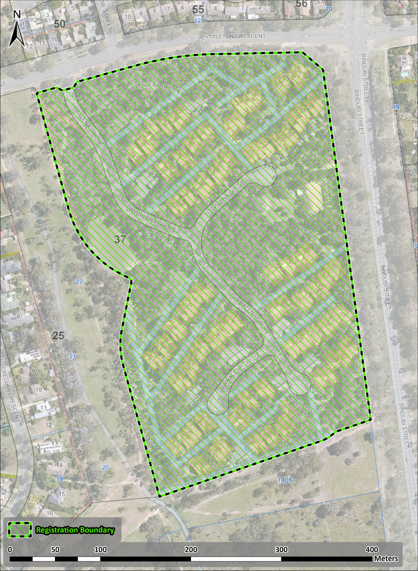
Figure 1 - Registration boundary for the Wybalena Grove Precinct

