Australian Capital Territory
Planning (Gungahlin FUA Uplift) Minor Plan Amendment 2026 (No 1)
Notifiable instrument NI2026–223
made under the
Planning Act 2023, s 85 (Making minor plan amendments)

1 Name of instrument
This instrument is the Planning (Gungahlin FUA Uplift) Minor Plan Amendment 2026 (No 1).
2 Commencement
This instrument commences on the day after its notification day.
3 Minor plan amendment
I am satisfied under the Planning Act 2023, section 85 (1) (a) that Minor Plan Amendment 2026-05 is a minor plan amendment to the territory plan.
4 Dictionary
In this instrument:
Minor Plan Amendment 2026-05 means the minor plan amendment to the territory plan in schedule 1.
James Bennett
Delegate of the territory planning authority
05 May 2026

Schedule 1


MINOR PLAN AMENDMENT
TO THE TERRITORY PLAN
2026-05
Gungahlin FUA uplift

This minor plan amendment was prepared
under part 5.3 of the Planning Act 2023
Contents
1.0 INTRODUCTION 1
1.1 Outline of the process 1
1.2 Summary of the proposal 1
2.0 TERRITORY PLAN CHANGES 2
2.1 Part B – Territory Plan Map 2
2.2 Part D – District Policies 5
3.0 TERRITORY PLAN AMENDMENT 6
3.1 Amendment to the Territory Plan Maps (Part B) 6
3.2 Amendment to the Gungahlin District Policy (D01) 7
INTERPRETATION SERVICE 8

- INTRODUCTION
  - Outline of the process
Minor plan amendment 2026-05 (MA2026-05) to the Territory Plan is a minor plan amendment (MA) prepared under section 84 (1) (c) of the Planning Act 2023 (the Act).

Section 84 of the Act outlines the different types of MAs, some which require limited consultation to be undertaken and some which do not require consultation to be undertaken. This MA is consistent with the provisions under section 84 (1) (c) of the Act and therefore no consultation is needed.

Under Section 85 of the Act a MA can only be made if the MA is not inconsistent with the planning strategy or any relevant district strategy.

The MA is not inconsistent with the planning strategy or the Gungahlin district strategy.

The National Capital Authority will be advised of this MA.

For more information on the content of the Territory Plan and minor plan amendment processes please refer to the planning website www.planning.act.gov.au/professionals/our-planning-system/the-territory-plan/amendments-to-the-territory-plan.

  - Summary of the proposal
MA2026-05 proposes to:
- remove part of the future urban area overlay from land in the division of Gungahlin and add ongoing provisions consistent with the approved estate development plan.

- TERRITORY PLAN CHANGES
MA2026-05 makes changes to parts of the following Territory Plan documents:
- Part B – Territory Plan Map
- Part D – District Policies
  - D01 – Gungahlin District Policy

  - Part B – Territory Plan Map
The Territory Plan map is varied to identify the zones and overlays that apply to land ceasing to be in a future urban area.

Gungahlin - Location map

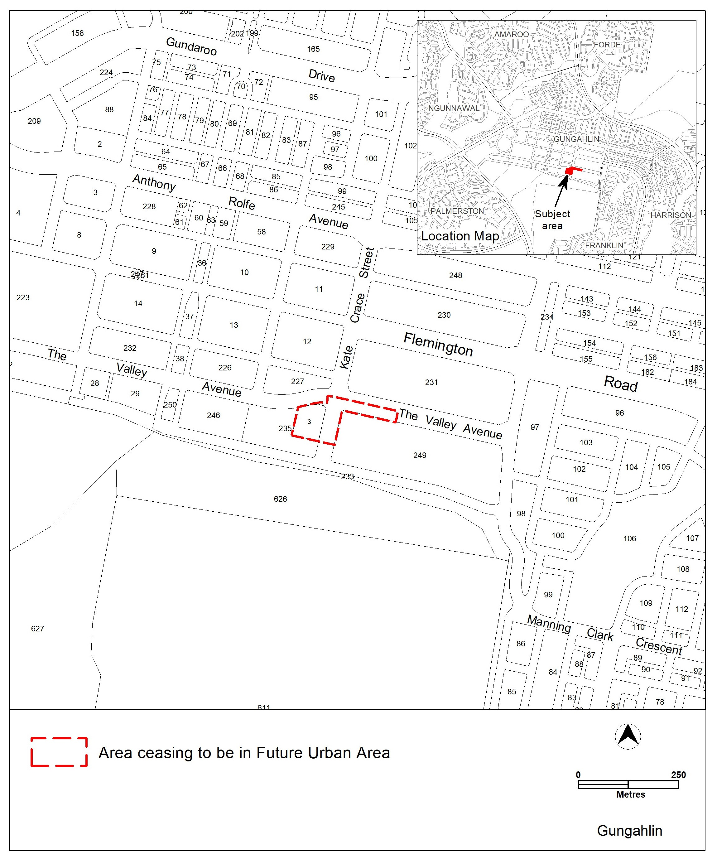

Gungahlin – Existing Territory Plan map

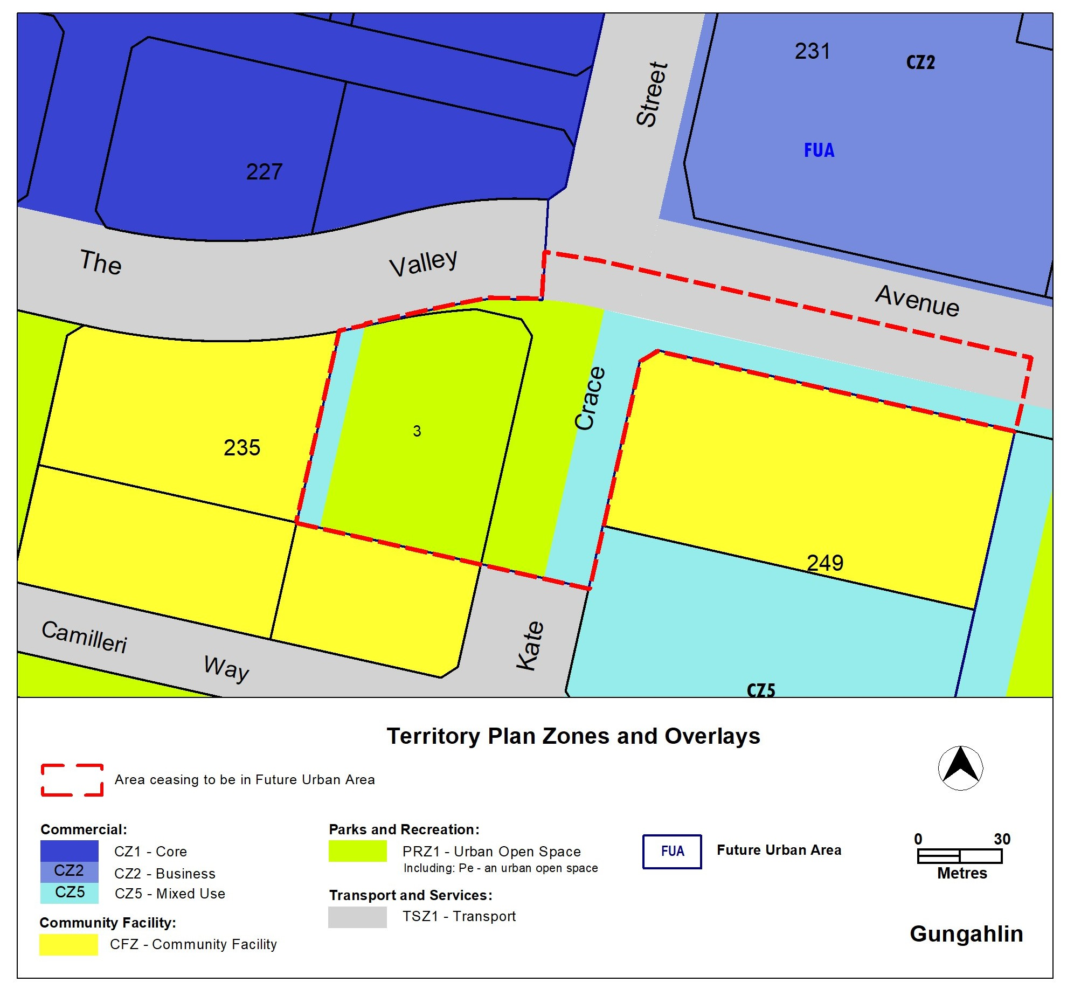

Gungahlin – updated Territory Plan map

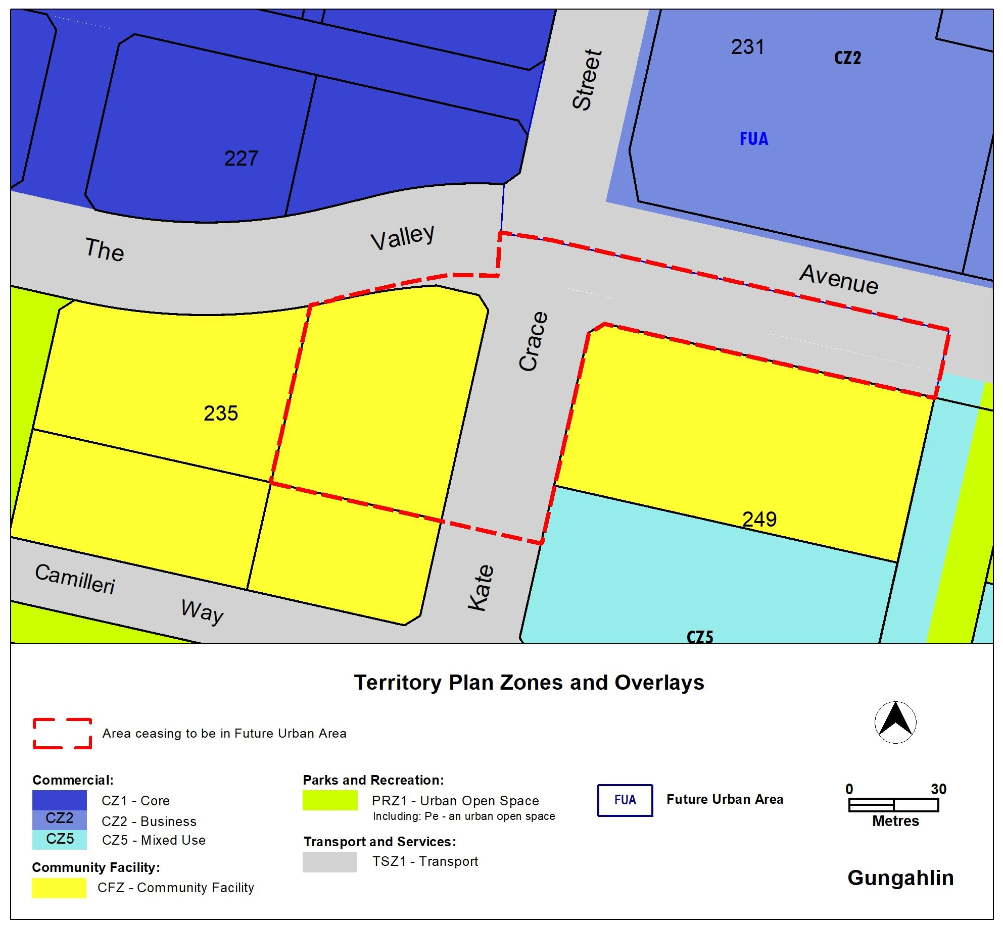

  - Part D – District Policies
The Gungahlin District Policy will be varied to update Figure 5A to include new provisions that apply to land ceasing to be in a future urban area.

Updated Figure 5A:
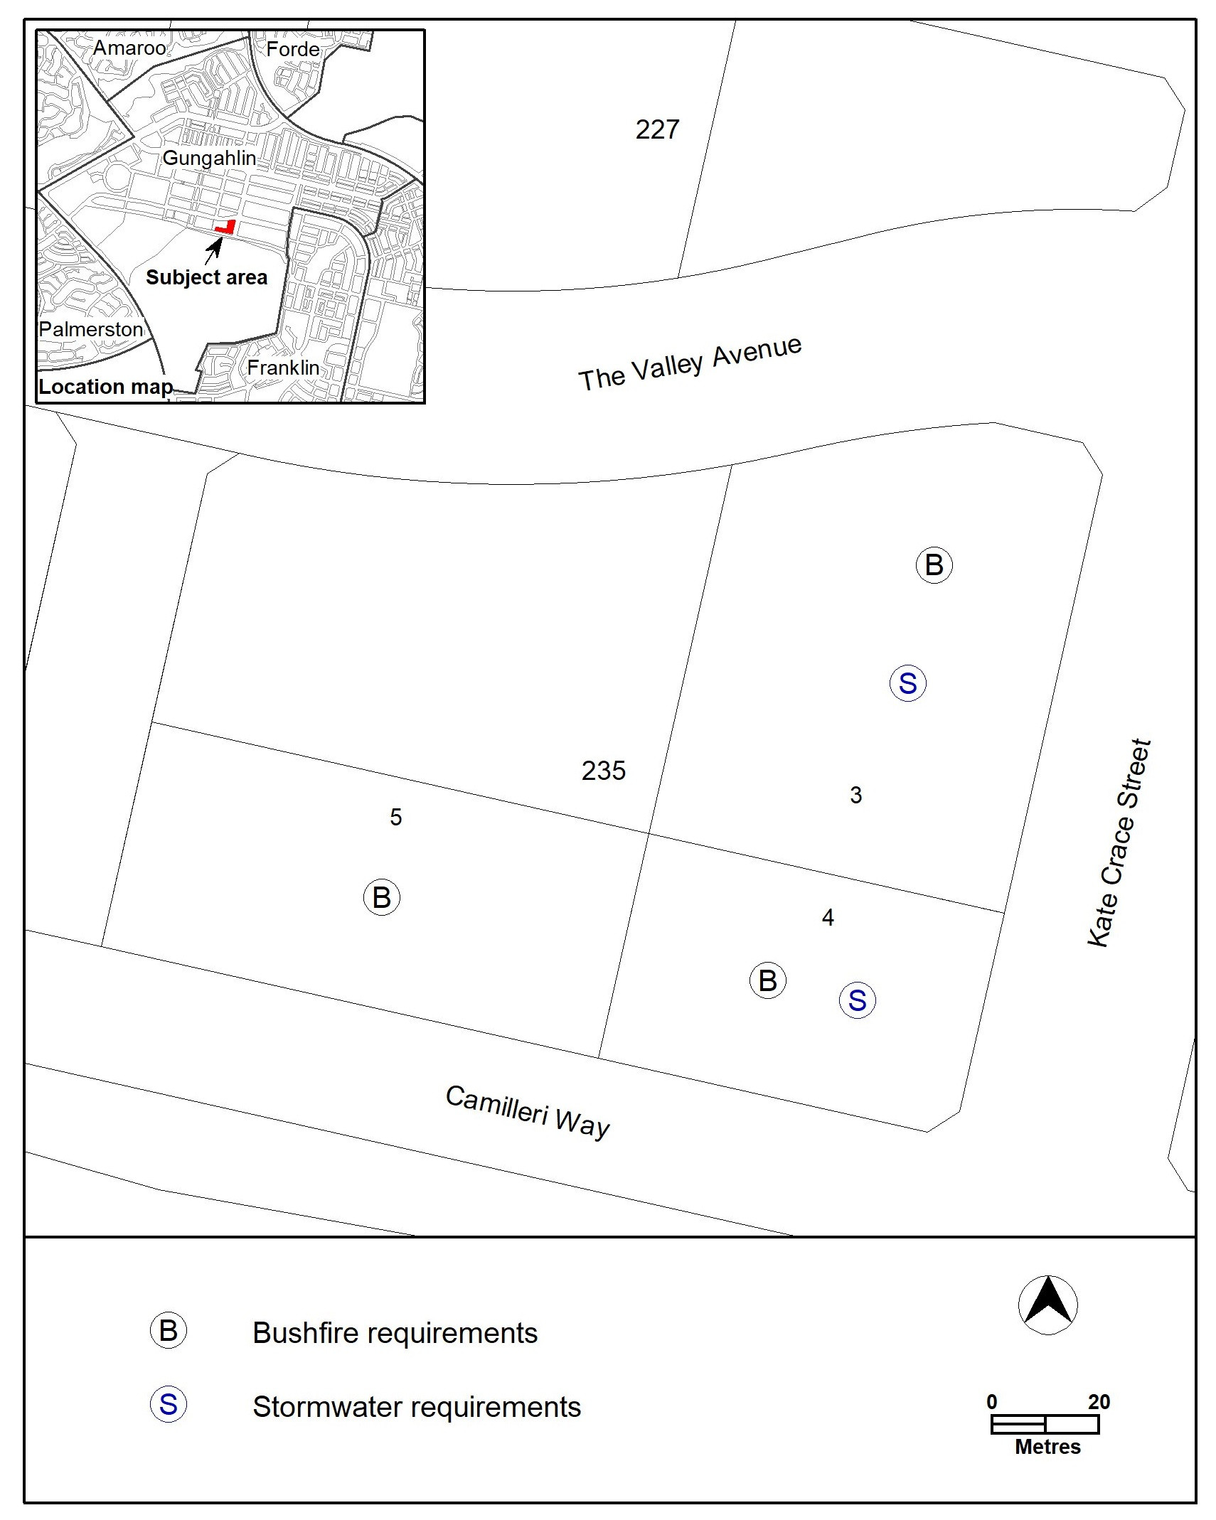

- TERRITORY PLAN AMENDMENT
  - Amendment to the Territory Plan Maps (Part B)
1. Territory Plan map

The relevant part of the Territory Plan map is varied as indicated below.

  - Amendment to the Gungahlin District Policy (D01)
2. Assessment Requirements; Gungahlin
Substitute
Figure 5A Gungahlin – Bushfire and stormwater

INTERPRETATION SERVICE
To speak to someone in a language other than English please telephone the Telephone Interpreter Service (TIS) 13 14 50
LANGUAGE | DETAILS
English | If you need an interpreter please call: 13 14 50
Mandarin (Simplified Chinese) / 简体中文 | 如果您需要翻译，请致电：13 14 50
Arabic / العربية | إذا كنت بحاجة إلى مترجم شفهي اتصل بالرقم: 50 14 13
Cantonese (Traditional Chinese) / 繁體中文 | 如果你需要傳譯員，請致電：13 14 50
Vietnamese /  Tiếng Việt | Nếu bạn cần thông dịch viên, xin gọi: 13 14 50
Korean / 한국어 | 통역사가 필요할 경우 다음 번호로 전화하시기 바랍니다: 13 14 50
Spanish / Español | Si necesita un intérprete, llame al 13 14 50
Persian (Farsi) / فارسی | اگر به مترجم نیاز دارید، لطفاً به این شماره تلفن کنید: 50 14 13
Dari / دری | اگر به یک ترجمان شفاهی نیاز دارید لطفاً به شمارۀ 131450 زنگ بزنید.
Punjabi / ਪੰਜਾਬੀ | ਜੇਕਰ ਤੁਹਾਨੂੰ ਕਿਸੇ ਦੁਭਾਸ਼ੀਏ ਦੀ ਲੋੜ ਹੈ ਤਾਂ ਕਿਰਪਾ ਕਰਕੇ ਫੋਨ ਕਰੋ: 13 14 50
Tamil / தமிழ் | உங்களுக்கு மொழிபெயர்த்துரைப்பாளர் ஒருவர் தேவைப்பட்டால் 13 14 50 என்ற எண்ணை அழைக்கவும்
Greek / Ελληνικά | Αν χρειάζεστε διερμηνέα, τηλεφωνήστε: 13 14 50
Italian / Italiano | Se hai bisogno di un interprete, chiama: 13 14 50
Hazaragi / هزاره گی | اگه ده ترجمان ضرورت ده رید، لطفاً ده شماره 50 14 13 تماس بگیرید.
Thai / ภาษาไทย | หากคุณต้องการล่าม กรุณาโทรไปที่ 13 14 50
Karen / ကညီကျိၥ် | ဖဲနမ့ၢ်လိၣ်ဘၣ်ပှၤကတိၤကျိးထံတၢ်တဂၤအခါ၀ံသးစူၤကိးဘၣ်-၁၃၁ ၄၅၀ တက့ၢ်.

Telephone and Interpreter Service 13 14 50 - Canberra and District - 24 hours a day, seven days a week

