Australian Capital Territory
Planning (Missing Middle Housing Reform) Major Plan Amendment 2026

Notifiable instrument NI2026–246
made under the
Planning Act 2023, s 75 (Minister’s powers in relation to draft plan amendments)

1 Name of instrument
This instrument is the Planning (Missing Middle Housing Reform) Major Plan Amendment 2026.
2 Major plan amendment
(1) I approve under section 75 (2) (a) of the Planning Act 2023 (the Act) the Major Plan Amendment 04 to the Territory Plan.
(2) In accordance with the Act, section 75 (5) (c), a major plan amendment must be presented to the Legislative Assembly and may only commence by commencement notice under section 80 (2).
3 Dictionary
In this instrument:
Major Plan Amendment 04 to the Territory Plan means the Major Plan Amendment in schedule 1.
Chris Steel MLA
Minister for Planning and Sustainable Development
22 May 2026

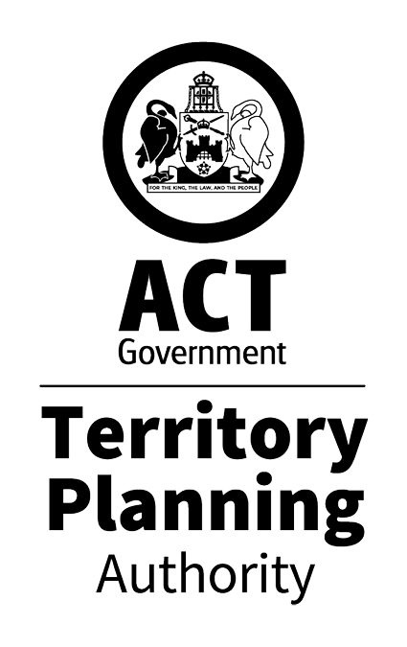
MAJOR PLAN AMENDMENT to the
TERRITORY PLAN 04

Missing Middle Housing Reform
Changes to Part A, Residential Zones Policy, Subdivision Policy and Dictionary

May 2026
This major plan amendment was prepared
under division 5.2.7 of the Planning Act 2023
Contents
1.0 INTRODUCTION 1
1.1 Purpose 1
1.2 Outline of process 1
2.0 APPLICABLE LAND 2
3.0 NEED FOR THE MAJOR PLAN AMENDMENT 4
4.0 CONSULTATION 5
4.1 Consultation with entities 5
4.2 Consultation with the public 5
5.0 MAJOR PLAN AMENDMENT 04 6
5.1 Amendments to Part A – Administration and Governance 8
5.2 Amendments to D01 to D10 - District Policies 8
5.3 Amendments to the E01 – Residential Zones Policy 8
5.4 Amendments to E02 to E07 – Zone Policies 9
5.5 Amendments to the F01 – Subdivision Policy 9
5.6 Amendments to F02 – Leasing Policy 9
5.7 Amendments to Part G – Dictionary 9
6.0 CONSEQUENTIAL AMENDMENTS TO OTHER DOCUMENTS 10
6.1 Design Guide 10
6.2 Technical Specifications 10
INTERPRETATION SERVICE 13

- INTRODUCTION
  - Purpose
This document is major plan amendment 04 – Missing Middle Housing Reform (MPA-04) to the Territory Plan.

Key parts of this document are:
- section 2 – summarises the MPA, including amendments to the Territory Plan and associated documents
- section 3 – why this MPA was undertaken
- section 5 – detailed amendment instructions to the Territory plan proposed by this MPA.

This document relies on various background papers including a supporting report. These background papers will be available on the Territory Planning Authority’s (the Authority) website at least until MPA-04 commences or is rejected by the Legislative Assembly (the Assembly).
  - Outline of process
A major plan amendment (MPA) is statutory process under the Planning Act that enables the Territory Plan to be amended. The three types of MPAs are:
- Proponent-initiated
- Authority-initiated
- Minister-initiated

MPA-04 is an authority initiated MPA.

After public consultation concluded the Authority gave MPA-04 to the Minister for referral to the relevant Legislative Assembly Standing committee (the Standing Committee).

The Standing Committee decided to report on MPA-04 and finalised their report on 30 April 2026. The Minister for Planning and Sustainable Development (the Minister) directed the Authority to revise MPA-04 to consider the recommendations of the Standing Committee report. The Minister presented the government response to the Standing Committee’s report to the Assembly on 26 May 2026.

Under section 75 (2) (a) of the Planning Act 2023 (the Planning Act) the Minister has now approved MPA-04.

Once presented to the Assembly, assuming no motion to reject MPA-04 is moved, MPA-04 may commence and become part of the Territory Plan.

For more information about the content of the Territory Plan and the major plan amendment processes please refer to the Authority’s website.
- APPLICABLE LAND
The subject area for MPA-04 is residential zoned land currently zoned RZ1 Suburban and RZ2 Suburban Core. Some consequential amendments are also proposed to land zoned RZ3 Urban Residential, RZ4 Medium Density Residential and RZ5 High Density Residential as a result of the changes made in RZ1 and RZ2.

The extent and distribution of RZ1 is outlined in Figure 1 and RZ2 in Figure 2.

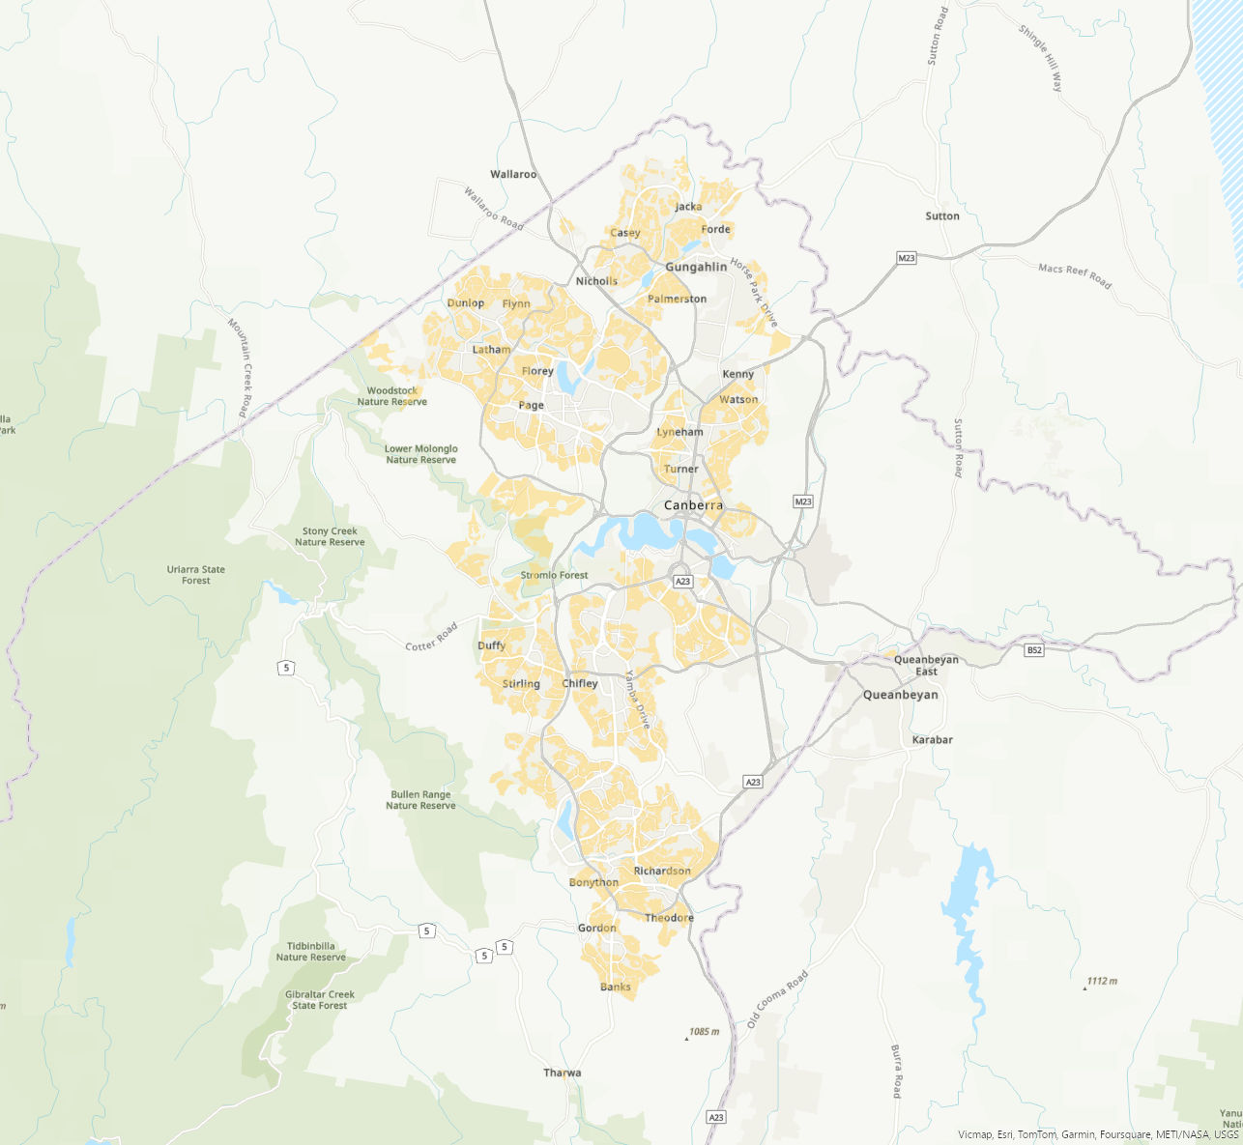
Figure 1 – Current distribution of RZ1 land
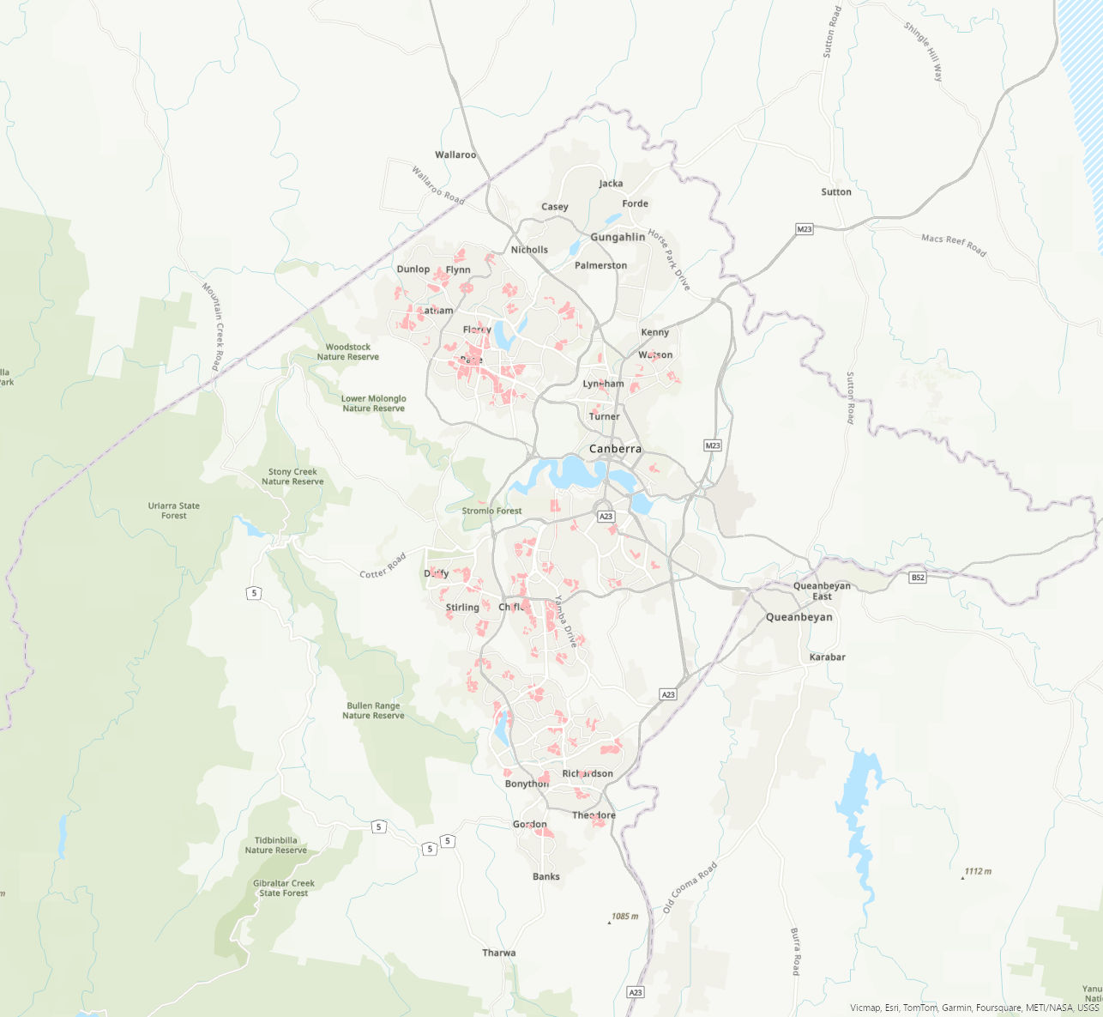
Figure 2 – Current distribution of RZ2 land

For a more detailed site description of the zones, please refer to the relevant supporting report.
- NEED FOR THE MAJOR PLAN AMENDMENT
The ACT’s population is currently around 470,000 people and by 2050, the population is expected to reach almost 700,000 people. To support this anticipated growth in population, the ACT will need to provide 30,000 new homes by 2030 and up to 100,000 new homes by 2050.

The ACT Planning Strategy 2018, which sets the high-level and long-term goals for planning in the ACT, aims to accommodate this population growth by delivering 70 per cent of new housing within the existing urban footprint. Ultimately, the Planning Strategy aims to deliver a compact and efficient city. These reforms will directly facilitate achievement of this aim by permitting more ‘missing middle’ housing within existing RZ1 and RZ2 zoned land.

Introduced in 2023, the District Strategies consider the broad policy aims of the Planning Strategy along with each district’s unique character and values, and outlines where and how change is expected to occur in the next 15 years. Relevant to these amendments, the District Strategies note the importance of delivering missing middle housing across all districts (excluding East Canberra) to provide greater housing choice, including in districts with lower growth projections.

Most recently, the Minister for Planning’s Statement of Planning Priorities directly notes a priority to enable diverse housing choice by delivering missing middle housing in existing residential areas. The Statement of Planning Priorities highlights that the Missing Middle Housing Design Guide (the Design Guide), along with amendments to the planning framework (this MPA), as key mechanisms in which this will be delivered.

The Design Guide provides best practice design guidance for targeted ‘missing middle’ residential typologies. For the purpose of these reforms, ‘missing middle’ is defined as multi-occupancy (dual and tri-occupancy), townhouses, terrace homes and low-rise apartments (up to three storeys). Prior to MPA-04, the planning framework did not widely facilitate the delivery of missing middle housing and often presented barriers to this type of housing. MPA-04 was informed by the best practice design guidance contained in the Design Guide. Together, these amendments and the Design Guide will enable for high-quality missing middle housing to be delivered in our existing residential areas.

Further detail about how this MPA meets the key strategic policy documents is set out in the background papers, specifically the supporting report.
- CONSULTATION
  - Consultation with entities
In accordance with section 62 of the Planning Act the Authority consulted with the following entities in relation to this MPA:
- the National Capital Authority
- the Conservator of Flora and Fauna
- the Environment Protection Authority
- the Heritage Council
- each referral entity
- if unleased or leased public land, each custodian of the land likely to be affected.

Comments received from these and other agencies were considered in the preparation of and by the Minister in approving this MPA.

Copies of comments received from the abovementioned entities are provided with the consultation report (background paper) prepared for MPA-04.
  - Consultation with the public
Public consultation on MPA-04 occurred between 20 May 2025 to 22 July 2025, with written submissions accepted until 5 August 2025. This was concurrent with consultation on the Design Guide.

During the consultation period:
- 539 people were engaged across 18 events held across Canberra, including pop-ups and community and industry workshops.
- Over 16,000 unique visitors came to the YourSay webpage.
- A total of 689 written submissions were received, including:
  - 74 long format submissions
  - 68 written comments at events
  - 398 survey responses, and
  - 149 quick comments.

Feedback received during public consultation suggests there is strong support for diverse housing types that suit different life stages, improve affordability, and promote vibrant communities, support for alternatives to urban sprawl, and a strong desire for subdivision resulting in separately titled dwellings, rather than unit titled dwellings.

Changes that were made in response to consultation are outlined in the consultation report, part of the background papers to MPA-04.
- MAJOR PLAN AMENDMENT 04
This section details how MPA-04 amends the Territory Plan.

MPA-04 proposes amendments to Part A, Subdivision Policy, Residential Zones Policy and the Dictionary of the Territory Plan. These amendments are required to give effect to the proposal set out in the supporting report. The amendments to the Territory Plan are summarised below and detailed in 5.1 to 5.7 below.

Part A - Administration and Governance
- creation of the Design Guide, its applicability, and consequential amendments to the applicability of the Housing Design Guide.
- the Housing Design Guide has been renamed to the Apartment Design Guide and its triggers have been refined to better reflect its focus.
- the role of the policy outcomes was confirmed as high-level objectives rather than specific assessment items.

Part D - District Policies
- the role of the policy outcomes was confirmed as high-level objectives rather than specific assessment items.

Part E - Residential Zones Policy
- the role of the policy outcomes was confirmed as high-level objectives rather than specific assessment items.
- the naming and policy outcomes for all residential zones were redefined to differentiate the zones and better target suitable development and redevelopment outcomes within the zones.
- Assessment Outcome 5 was revised to require consideration of desired zone policy outcomes and streetscape character during the development assessment process.
- Assessment Outcome 6 was revised to ensure that potential public domain impacts for vehicular parking are appropriate considered during the development application process.
- co-housing was permitted to support increased population density
- suitably designed apartments were permitted in RZ1 to increase housing choice.
- assessment requirements that limit secondary residence to a block greater than 500m² were removed to provide greater housing choice.
- An assessment requirement that limits co-housing to blocks greater than 1050m² was removed to facilitate more innovative missing middle development.
- assessment requirements for heights in metres and storeys were adjusted across all zones. Height in storeys were moved to the Territory Plan will instead be located in the technical specifications. This change allowed height to be controlled while reducing pressure on floor-to ceiling heights of developments and supports the appropriate scaling of height across zones.
- site coverage assessment requirements for single dwellings have been standardised.
- site coverage assessment requirements for multi-unit redevelopment have been increased in RZ1 and RZ2 to 45%, and RZ3, RZ4 and RZ5 to 50%. This allows a wider variety of development on blocks whilst still maintaining adequate space to meet living infrastructure/canopy cover, permeability and private open space requirements.
- block density assessment requirements that limit the number of dwellings and minimum block sizes for redevelopment have been removed. This allows a proposal to instead meet the relevant design provisions of the Territory Plan and design guides supported by the dwelling density targets outlined in the Residential Zones Technical Specification.

Part F - Subdivision Policy
- the role of the policy outcomes was confirmed as high-level objectives rather than specific assessment items.
- subdivision of RZ1 blocks has been permitted without the need to first construct a dwelling. This is supported by a mandatory 350m² minimum block size requirement.
- the assessment outcomes and requirements to ensure blocks which subdivide are suitable for additional development have been changed. This includes specific consideration of impacts related to battle-axe blocks.
- assessment requirements that create barriers to consolidation for co-housing development were removed.
- assessment requirements which create barriers to subdivision and consolidation in RZ1, particularly removing the restriction on subdivision and allowing unit-titling on blocks greater than 600m² have been removed.

Part F – Leasing Policy
- the role of the policy outcomes was confirmed as high-level objectives rather than specific assessment items.

Part G – Dictionary
- the roof pitch of what is defined as an attic was amended from more than 36 degrees to more than 45 degrees
- townhouse development was included in the definition of detached house
- a definition for ‘end of section block’ was created to support the Design Guide
- the definition of private open space was amended to confirm that private open space should incorporate planning area.

The supporting report, part of the background papers for MPA-04 provides further detail about the amendments and why they are needed.

For consequential amendments to the other documents, such as the technical specifications because of this MPA, see section 6 of this document.
  - Amendments to Part A – Administration and Governance
Substitute Part A- Administration and Governance with the document at Appendix 1.
  - Amendments to D01 to D10 - District Policies
This applies to each of the following district policies:
- D01 – Gungahlin District Policy
- D02 – Belconnen District Policy
- D03 – Inner North and City District Policy
- D04 – Inner South District Policy
- D05 – Molonglo Valley District Policy
- D06 – Weston Creek District Policy
- D07 – Woden District Policy
- D08 – Tuggeranong District Policy
- D09 – East Canberra District Policy
- D10 – Non-Urban District Policy

Substitute the introductory text under ‘Policy Outcomes’ with the following:

These policy outcomes describe the high-level objectives for the district. District policy outcomes are derived from the relevant district strategy, which sets the strategic planning vision and directions for the district.

Policy outcomes inform assessment outcomes and assessment requirements. Where a development is consistent with the assessment outcomes and assessment requirements, it is considered to be consistent with the policy outcomes.
  - Amendments to the E01 – Residential Zones Policy
Substitute Part E01 – Residential Zones Policy with the document at Appendix 2.
  - Amendments to E02 to E07 – Zone Policies
This applies to each of the following zones policies:
- E02 – Commercial Zones Policy
- E03 - Industrial Zones Policy
- E04 – Commercial Facility Zones Policy
- E05 – Parks and Recreation Zones Policy
- E06 – Transport and Services Zones Policy
- E07 – Non-Urban Zones Policy

Substitute the introductory text under ‘Policy Outcomes’ with the following:

These policy outcomes describe the high-level objectives for each zone.

Policy outcomes inform assessment outcomes and assessment requirements. Where a development is consistent with the assessment outcomes and assessment requirements, it is considered to be consistent with the policy outcomes.
  - Amendments to the F01 – Subdivision Policy
Substitute Part F01 – Subdivision Policy with the document at Appendix 3.
  - Amendments to F02 – Leasing Policy
Substitute the introductory text under ‘Policy Outcomes’ with the following:

These policy outcomes describe the high-level objectives when varying a Crown lease. These are in conjunction with the policy outcomes in the relevant district policy and zone policy.
  - Amendments to Part G – Dictionary
Substitute Part G – Dictionary with the document at Appendix 4
- CONSEQUENTIAL AMENDMENTS TO OTHER DOCUMENTS
Documents, such as the technical specifications and development controls, are not part of the Territory Plan and were not amended as part of this MPA. The amendments in this section will be undertaken to the relevant documents when/if MPA-04 commences.
  - Design Guide
The Authority prepared the Design Guide to support the provisions introduced by MPA-04. The Design Guide was released for public consultation along with MPA-04.

Revisions were made to the Design Guide in response to public consultation and the Standing Committee’s report on MPA-04.

Approval and introduction of the Design Guide and changes to existing Design Guides will be undertaken separately from MPA-04.
  - Technical Specifications
The Chief Planner will amend the Subdivision Technical Specifications and Residential Zones Technical Specifications to support MPA-04 as summarised below.

Subdivision Technical Specifications
- reduce minimum block sizes for RZ1 to RZ4.
- set controls around subdivided RZ1 blocks, particularly to discourage battle-axe block arrangements and to limit the impact of driveways to the streetscape.
- limit the location and size of consolidated RZ1 blocks based on location.
- adjust minimum block size specifications across residential zones.
- introduce a range of heritage specifications.
- other wording changes to clarify specifications that are intended to only apply to estate subdivisions.

Residential Zones Technical Specifications
- set maximum dwelling densities for different types of multi-unit housing in RZ1
- remove minimum dimensions of private open space of single dwelling developments.
- reduce the minimum private open space specifications for multiunit developments in RZ1 and RZ2.
- for multi-unit development in the RZ1 and RZ2, confirm that private open space can contribute along with principal-private open space and communal open space where it has a dimension of at least four metres.
- align principal private open space requirements for multi-unit housing developments across all residential zones.
- alter building height limitations (in metres) across all residential zones to reflect changes in the Residential Zones Policy and a transition of height across zones.
- remove height transition requirements for RZ5 blocks, noting these are appropriately captured by other assessment outcomes and general considerations made through the DA assessment process.
- alter building envelopes by slightly increasing the starting point where measurements are taken.
- standardise upper floor level front setbacks with lower floor level front setbacks for single dwelling and multi-unit housing.
- reduce side setbacks and increasing rear setbacks for multi-unit housing in RZ1 and RZ2.
- increase the angle in which solar building envelopes are calculated for multi-unit housing from 31 degrees to 45 degrees.
- clarify the application of solar access specifications in missing middle housing developments and larger-scale multi-unit housing.
- introduce new specifications that consider overshadowing to a neighbour’s daytime living area, principal private open space and rooftop solar systems.
- amend building separation and privacy specifications for multi-unit housing across all residential zones to be more prescriptive on separation between walls with windows and to principal private open spaces.
- reduce the minimum dwelling floor area of studios and 3+ bedroom dwellings.
- remove maximum building depth specifications to provide greater flexibility in design outcomes.
- clarify that the minimum floor to floor heights apply to larger-scale multi-unit housing developments. The existing ceiling height specifications continue to apply to missing middle housing developments.
- consolidate storage requirements for multi-unit housing.
- amend the front fence specification to allow fencing or walls forward of the building line for multi-unit housing in select scenarios.
- increase minimum planting area requirements for single dwelling housing in compact blocks.
- decrease minimum planting area requirements from multi-unit housing in RZ1 and RZ2.
- increase minimum tree planting requirements on compact and midsized blocks.
- increase minimum tree canopy coverage requirements that applies to multi-unit housing developments in RZ1 and RZ2.
- introduce a specification to discourage artificial turf.
- introduce a range of heritage specifications.
- remove specification for a minimum of one car space per dwelling to be roofed.
- adjust parking rates for multi-unit housing across all residential zones.

Separate documents have been prepared as part of the background papers for MPA-04 showing how the above amendments will be presented in the Residential Zones Technical Specifications and Subdivision Technical Specifications.

Further discussion on the consequential amendments proposed by MPA-04 to the technical specifications are outlined in the supporting report (background paper)

General information about these other documents, such as how the technical specifications will be used by the proponent and Authority in determining a development application, can be found on the Authority’s website.
INTERPRETATION SERVICE
To speak to someone in a language other than English please telephone the Telephone Interpreter Service (TIS) 13 14 50
LANGUAGE | DETAILS
English | If you need an interpreter please call: 13 14 50
Mandarin (Simplified Chinese) / 简体中文 | 如果您需要翻译，请致电：13 14 50
Arabic / العربية | إذا كنت بحاجة إلى مترجم شفهي اتصل بالرقم: 50 14 13
Cantonese (Traditional Chinese) / 繁體中文 | 如果你需要傳譯員，請致電：13 14 50
Vietnamese /  Tiếng Việt | Nếu bạn cần thông dịch viên, xin gọi: 13 14 50
Korean / 한국어 | 통역사가 필요할 경우 다음 번호로 전화하시기 바랍니다: 13 14 50
Spanish / Español | Si necesita un intérprete, llame al 13 14 50
Persian (Farsi) / فارسی | اگر به مترجم نیاز دارید، لطفاً به این شماره تلفن کنید: 50 14 13
Dari / دری | اگر به یک ترجمان شفاهی نیاز دارید لطفاً به شمارۀ 131450 زنگ بزنید.
Punjabi / ਪੰਜਾਬੀ | ਜੇਕਰ ਤੁਹਾਨੂੰ ਕਿਸੇ ਦੁਭਾਸ਼ੀਏ ਦੀ ਲੋੜ ਹੈ ਤਾਂ ਕਿਰਪਾ ਕਰਕੇ ਫੋਨ ਕਰੋ: 13 14 50
Tamil / தமிழ் | உங்களுக்கு மொழிபெயர்த்துரைப்பாளர் ஒருவர் தேவைப்பட்டால் 13 14 50 என்ற எண்ணை அழைக்கவும்
Greek / Ελληνικά | Αν χρειάζεστε διερμηνέα, τηλεφωνήστε: 13 14 50
Italian / Italiano | Se hai bisogno di un interprete, chiama: 13 14 50
Hazaragi / هزاره گی | اگه ده ترجمان ضرورت ده رید، لطفاً ده شماره 50 14 13 تماس بگیرید.
Thai / ภาษาไทย | หากคุณต้องการล่าม กรุณาโทรไปที่ 13 14 50
Karen / ကညီကျိၥ် | ဖဲနမ့ၢ်လိၣ်ဘၣ်ပှၤကတိၤကျိးထံတၢ်တဂၤအခါ၀ံသးစူၤကိးဘၣ်-၁၃၁ ၄၅၀ တက့ၢ်.

Telephone and Interpreter Service 13 14 50 - Canberra and District - 24 hours a day, seven days a week

APPENDIX 1

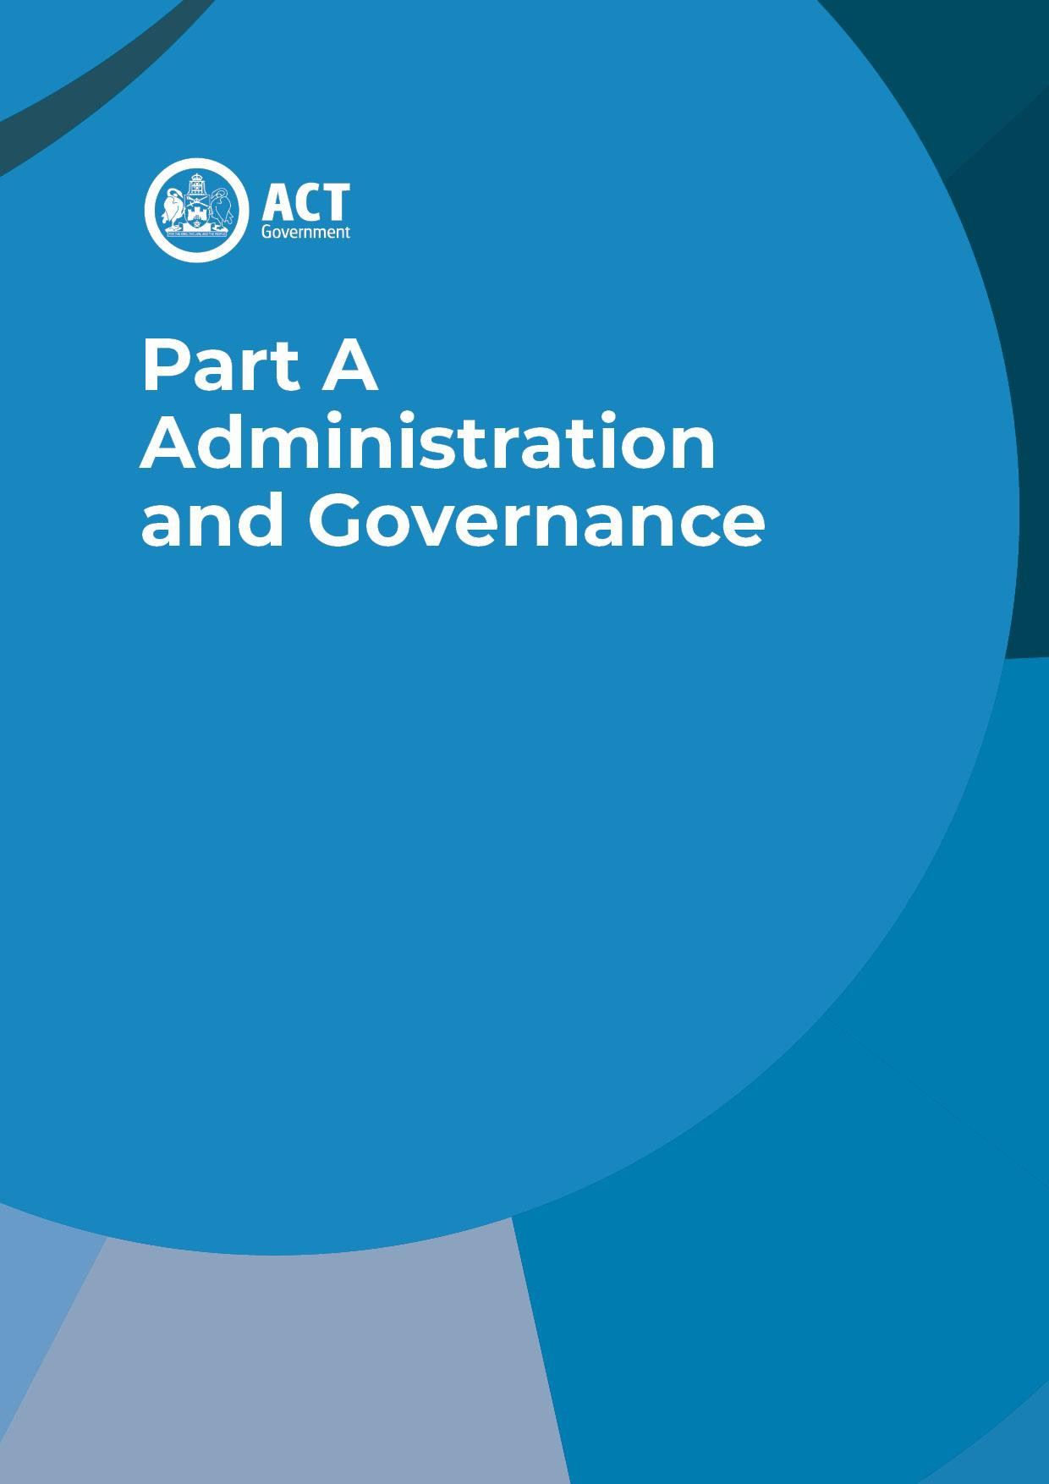

Table of Contents
A.1. What is the Territory Plan? 1
A.2. Land to which the Plan applies 1
A.3. Structure of the Territory Plan 1
3.1. Territory Plan 1
3.2. Supporting documents 5
A.4. How to use the Territory Plan 7

  - What is the Territory Plan?
This plan is the Territory Plan 2023.
The Territory Plan 2023 (the Plan) is prepared and administered by the Territory Planning Authority as a notifiable instrument as required by Section 45 of the Planning Act 2023 (the Act) and in accordance with Chapter 5.
The object of the Plan is to ensure, in a manner not inconsistent with the National Capital Plan, that the planning and development of the Australian Capital Territory (the ACT) provides the people of the ACT with an attractive, safe and efficient environment in which to live, work and have their recreation (Section 46 of the Act).
The Territory Plan sets out a statutory framework for the future development and conservation of land in the ACT. In effect, the Territory Plan is a policy about how land can be used and what can be built where.
The Territory Plan is primarily used to decide development applications and to make other planning related decisions, such as decisions about the zoning and the use of land. An outcome-based approach to the assessment of development proposals is a distinctive feature of this Territory Plan.
The Territory Plan may also shape public and private infrastructure investment decisions, government and community efforts towards ecological or cultural restoration, and guide the future pattern of urban development in the ACT.
  - Land to which the Plan applies
The Plan applies to land within the ACT as shown on the maps in Part B of the Plan.

The Plan does not apply to land identified as Designated Land under the National Capital Plan, or to land declared to be National Land. An area may be declared to be National Land if it is, or is intended to be, used by or on behalf of the Commonwealth.
  - Structure of the Territory Plan
  - Territory Plan

The Territory Plan consists of seven parts:

Part A – The Territory Plan (Governance)
This part contains key statutory information necessary for the administration and operation of the Territory Plan, including where the Territory Plan applies. This part contains an explanation of the components of the Territory Plan and how they are used in the development assessment process.

Part B – Territory Plan Map

This part contains the maps that form part of the Plan, identifying all land covered by the Plan. Maps graphically depict the spatial elements of the Plan, as shown on the legend, and support the written policy.
Each parcel of land is coded for the zone that applies and any overlays that are applicable. The maps also include the district in which a parcel of land is located. The cadastral database over which the maps are normally printed does not form part of the Plan. It is to aid interpretation of the map and shown for information only.
ACTMAPi is a mapping tool available on the Territory Planning Authority’s website to make it easier to identify a parcel of land and determine the zone that applies. ACTMAPi is not a statutory map and does not replace the Territory Plan Map.
Overlays identify land that has additional considerations applying to it. Commonwealth Requirements
Some parcels of land in the ACT are required to consider nominated Commonwealth requirements. This land is enclosed by a blue border and identified by the following letter:
S – Special Requirements of the National Capital Plan – land where special requirements apply under the National Capital Plan
U – National Land proposed for urban development – land that is zoned non-urban in the Territory Plan but identified for urban development in the National Capital Plan
A – National Land subject to a master plan under applicable Commonwealth legislation –
land that is used for airport (not included in the National Capital Plan or Territory Plan)
Note: The areas subject to special requirement provisions in the National Capital Plan are shown for information purposes only and do not form part of the Territory Plan.
Future Urban Areas
Land indicated on the map enclosed by a blue border within which the code ‘FUA’ appears is future urban land. Identification of a FUA means that area of land has been earmarked for future development.
The development of FUAs can be guided by the principles and policies in the District Strategies and are required to comply with the relevant area specific assessment outcomes and assessment requirements provided in the District Policies. The Subdivision Policy also sets the assessment outcomes and requirements that development in FUAs is typically subject to.
Public Land
The purposes for which public land is reserved is indicated on the Map by a houndstooth border and by a map code as indicated below, (except for land zoned Urban Open Space – see note below):

Pa - a wilderness area Pb - a national park Pc - a nature reserve
Pd - a special purpose reserve Pe - an urban open space*
Pf - a cemetery or burial ground Pg - a water supply catchment Ph - a lake
Pi - a sport and recreation reserve
* Due to the number and small size of many of the land parcels, the urban open space public land category is not defined by enclosing symbols on the Map in the same manner as the other categories. All Territory land shown zoned Urban Open Space on the Map is reserved as public land in the Pe category unless specifically excluded or covered by another public land category.

Part C – Planning principles and strategic links
This part provides more information on important principles and the strategic planning framework for land use and development in the ACT. Some of the important principles include a statement of principles of good planning and the interaction with the Planning Strategy and district strategies.

Part D – District policies
District policies are an important and distinctive feature of this Plan. The use of district policies is underpinned by strategic planning work undertaken at a district level that builds on detailed analysis and research undertaken for each district (district strategies). Development considerations identified in the district strategies are then implemented through the relevant district policy, making it a required consideration in the development assessment process.
District policies are key to shaping places and communities in the ACT, implementing strategic planning objectives, protecting and minimising the impacts on our environment, and establishing future urban form and development patterns.
There are nine urban districts and one non-urban district, each with its own unique characteristics and themes. District policies contain the considerations and requirements that are specific to a district or part of a district. These considerations and requirements override any relevant requirements in the zone or other policies.
District policies specify uses that are permissible or prohibited on specific blocks in addition to those specified by a zone. The policies outline desired policy outcomes that are important to each district and include assessment outcomes and key assessment requirements relevant to each district. Development applications must demonstrate that they are consistent with all the relevant assessment outcomes and assessment requirements.
The districts included in the Territory Plan are illustrated in Figure 1 below.

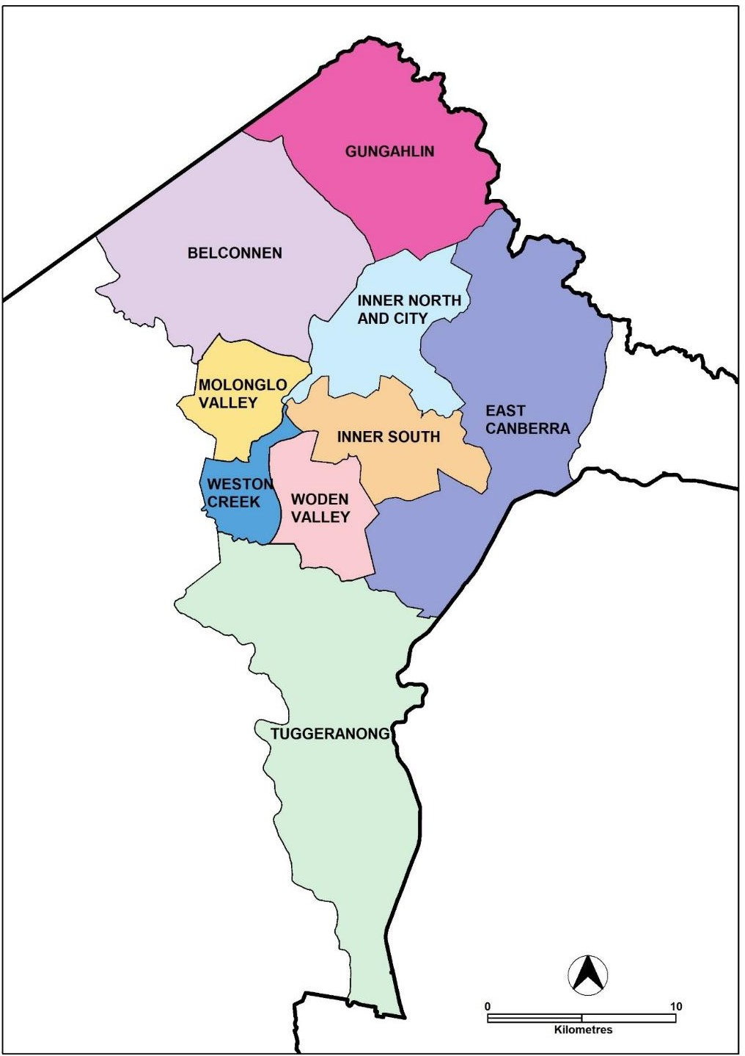
Figure 1: Districts included in the Territory Plan

Part E – Zone policies
Zone policies allocate land uses and development opportunities to land in the ACT based on the zoning of the land.
There are seven zone policies that incorporate the 23 land use zones to apply zone specific considerations and requirements to land in the ACT.
Zone policies specify uses that are permissible (subject to a development application) or prohibited in specific zones. The policies outline desired policy outcomes that are important in differentiating each zone and include assessment outcomes and key assessment requirements relevant to each zone.

Part F – Other policies
Other policies are necessary to guide the orderly development of land in the ACT.
One such policy is for the subdivision of land, including the development of greenfield land for future estates and smaller block subdivisions to make better use of existing underdeveloped land. This policy also includes the assessment outcomes and key assessment requirements that apply to future urban areas (as identified in the Territory Plan Map with the future urban area overlay).
Another policy is required for the unique leasehold system found in the ACT, specifically to assess applications that propose new or additional uses in the Crown lease.
These policies apply to relevant development types across all districts and zones.

Part G – Dictionary
Part G comprises a dictionary that contains key definitions and terms used in the Territory Plan. Definitions describe, clarify and provide meaning to key concepts and uses that are essential to the application of the Territory Plan and necessary for the assessment of development proposals.
  - Supporting documents

The Territory Plan provides for a more outcomes focused planning system. It is accompanied by supporting documents such as design guides and planning technical specifications that provide important guidance and clarification to deliver a more efficient development assessment process that focuses on developing high-quality built outcomes for Canberra.
Other supporting documents can include factsheets, advisory notes, templates and training material.
Supporting materials do not form part of the Territory Plan but may be ‘called up’ by policies within the Territory Plan. Design guides are a required consideration in the development assessment process and both design guides and planning technical specifications are notifiable instruments.

Design guides
Though the Territory Plan contains provisions that will deliver the desired planning outcomes for the ACT, there is a need for these to be supported by clear methods and examples for how they can be met.
Under the Planning Act 2023, the Minister may prepare design guidance for development proposals (design guides) to support the Territory Plan. A design guide is a notifiable instrument published on the ACT Legislation Register and must also be published on the Territory Planning Authority website.
The guides provide clear and easy to understand qualitative guidance that identify design possibilities and encourage innovation. Design guides also identify where flexibility in design can be considered and matters that must be addressed. Overall, the guides are critical in the design and assessment process, particularly when planning provisions are less prescriptive and leave room for interpretation and innovation.

Design guides made by the Minister include:
- Urban Design Guide - provides guidance for larger developments to support the delivery of high quality public realm and built form outcomes.
- Apartment Design Guide – provides guidance for residential and mixed-use residential housing to support the amenity and wellbeing of the residents and their visitors.
- Missing Middle Housing Design Guide – provides guidance for low to mid sized residential development to support high-quality housing and amenity outcomes.
- Biodiversity Sensitive Urban Design Guide – provides guidance on protecting natural values, including biodiversity and ecological connectivity.
- City Centre Urban Design Guide – provides area specific design guidance for the city centre.
Other place-specific or theme-based design guides may be prepared and made by the Minister.

Planning technical specifications
Under the Planning Act 2023, the Chief Planner may make technical specifications to support design guides and the Territory Plan. Technical specifications are a notifiable instrument published on the ACT Legislation Register and must also be published on the Territory Planning Authority website.
Planning technical specifications are used as a possible solution or to provide guidance for identified aspects of a development proposal. The specifications may also be used as a reference or benchmark in the preparation and assessment of development proposals to demonstrate compliance with the assessment outcomes, and the Territory Plan.
The Territory Plan makes reference to district specifications (providing possible solutions to district policies), zone specifications (providing possible solutions to zone policies) and other specifications (providing possible solutions to other policies).
Figure 2 below illustrates the Territory Plan structure and the relationship with the supporting material.
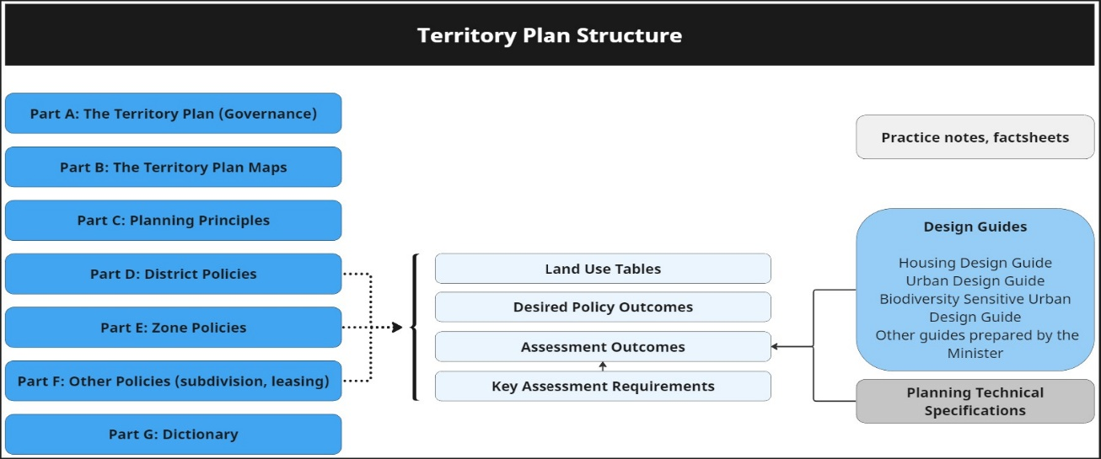
Figure 2: Territory Plan structure and supporting material

  - How to use the Territory Plan

Uses
After identifying the zoning of a parcel of land, the relevant Zone Policy indicates uses that are permissible (marked as a ‘Y’ in the land use table) or prohibited. The relevant district policy may specify that other uses are permissible on a nominated site, or that a use normally permitted in a zone is prohibited on a site.

Policy outcomes
The policy outcomes within the district, zone and other policies describe the high-level objectives to be achieved in a specific district or zone, or to be achieved through a subdivision or lease variation. For zones and districts, these outcomes identify how one zone is different to another or features that are of particular importance in a district (or part of a district).

The policy outcomes inform the assessment outcomes and assessment requirements for a zone, district, subdivision or lease variation. Where a development is consistent with the assessment outcomes and assessment requirements, it is considered to be consistent with the policy outcomes. Policy outcomes are considered in the assessment process to help outline the intent of the assessment outcomes.

Assessment outcomes
The primary assessment consideration for a development application is the assessment outcomes in the district, zone and other policies. Assessment outcomes are consistent with the policy outcomes in the Territory Plan policies and specify the desired outcomes to be achieved by a development proposal.
Recognising the importance when planning a development of first considering the broader urban context and then moving to the detailed design considerations, the assessment outcomes in the zone and other policies are grouped into the following themes:
- Country and Place
- Urban Structure and Natural Systems
- Site and Land Use
- Access and Movement
- Public Space and Amenity
- Built Form and Building Design
- Sustainability and Environment
- Parking, Services and Utilities
Not all themes are relevant in each policy therefore all eight themes may not be included in a policy document.
In demonstrating compliance with the assessment outcomes, consideration is to be given to the relevant design guides and may be given to planning technical specifications which may serve as a benchmark. While all assessment outcomes are to be met, not all outcomes are covered by design guidance and/or planning technical specification. Assessment of a zone assessment outcome can take into consideration the relevant zone specification or an applicable district specification, noting that the district specification takes precedence over the zone specification. However, a district assessment outcome only takes into consideration a corresponding district specification.
Where a proposed development complies with a relevant provision in the design guide and/or planning technical specification and the development comprehensively addresses the assessment outcome, further assessment regarding those assessment outcomes will not be required.
Where a design guide applies to a development, the proposal must demonstrate that it is consistent with the guidance provided for assessment outcomes in relation to the design elements listed below. Given the nature of the design guides, different design responses are possible to meet the same assessment outcomes.
The Territory Planning Authority may consider endorsement or written support from an entity or utility service provider to demonstrate compliance with an outcome that relates to a relevant assessment outcome.

Assessment requirements
Assessment requirements set the mandatory development controls within specific zones or for specific development types.
District policies also contain assessment requirements. Assessment requirements in district policies will prevail where inconsistencies occur.

Applicability of design guides
The developments specified below are required to respond to all parts of the applicable design guide(s).
Urban Design Guide
Development is required to consider and provide a design response to the Urban Design Guide where:
- it is precinct scale with a site area greater than one hectare;
- the combined development gross floor area exceeds 10,000m²;
- comprises more than 1,000m² of public or common space; or
- required to seek advice from the Design Review Panel.
In demonstrating consistency with the assessment outcomes, proposed development must demonstrate consideration of the design guidance provided in the Urban Design Guide for the following themes:
- Country and place;
- Urban structure and natural systems
- Site and Land Use
- Access and Movement
- Public Space and Amenity
- Built Form and Building Design
- Sustainability and Environment
Apartment Design Guide
Residential and mixed-use residential development is required to consider and provide a design response to the Apartment Design Guide where the development meets all the following:
- provides more than one residential dwelling
- is not for missing middle housing as defined by the Missing Middle Housing Design Guide.
Each of the following developments are excluded:
- secondary residences
- extensions and alterations to multi-unit housing (of no more than 50% increase in floor area).
Missing Middle Housing Design Guide
Development of missing middle housing (as defined in the Missing Middle Housing Design Guide) is required to consider and provide a design response to the Missing Middle Housing Design Guide where the development is residential only and meets at least one of the following:
- is three storeys or less and provides more than one residential dwelling.
- is for subdivision or consolidation of currently leased RZ1 and RZ2 blocks.
Note: A design response and assessment only needs to be undertaken against either the Apartment Design Guide or the Missing Middle Housing Design Guide, not both.
Biodiversity Sensitive Urban Design Guide
The Biodiversity Sensitive Urban Design Guide applies to the planning, design, and approval processes for the development and redevelopment of sites:
- in future urban areas;
- in non-urban zones (NUZ1-5);
- in PRZ1 Urban Open Space; and
- with an area greater than one hectare in all zones.
The Biodiversity Sensitive Urban Design Guide does not apply to single dwelling housing, secondary residences, or development where the increase in impermeable surfaces is 500m² or less.
In demonstrating consistency with the assessment outcomes, proposed development must demonstrate consideration of the design guidance provided in the Biodiversity Sensitive Design Guide for the following themes:
- maintain and enhance nature;
- connect and extend nature;
- minimise threats to protect nature; and
- connect people to nature.
City Centre Urban Design Guide
The City Centre Urban Design Guide is a place-specific design guide. Development is required to consider and provide a design response to the City Centre Urban Design Guide where a development requires a development application within the boundaries of the City Centre as defined in the CCUDG.
Place-specific or theme-based Design Guides
Additional Design Guides may be made from time to time under the Planning Act 2023. These design guides will set out their application to particular development types.
All design guides are published on the ACT Legislation Register and the Territory Planning Authority website.

Hierarchy of Territory Plan components
In the event of any inconsistency between Territory Plan considerations, the order of precedence is as follows:
- District Policy;
- Zone Policy;
- Other Policy;
- Design Guides;
- District Specifications;
- Zone Specifications; and
- Other Specifications.

Other development requirements
Though the Territory Plan specifies the requirements to be met by a development proposal, other legislation and development requirements must be complied with where they apply (for example the Heritage Act 2004, ACT Nature Conservation Act 2014 and Environment Protection and Biodiversity Conservation Act 1999, and/or relevant Municipal Infrastructure Standards).
Where a development is subject to special requirements under the National Capital Plan, or any relevant development control plan prepared under the National Capital Plan, the development must not be inconsistent with the special requirements or development control plan. Where any provision of the Territory Plan is inconsistent with the National Capital Plan, that provision has no effect.

APPENDIX 2

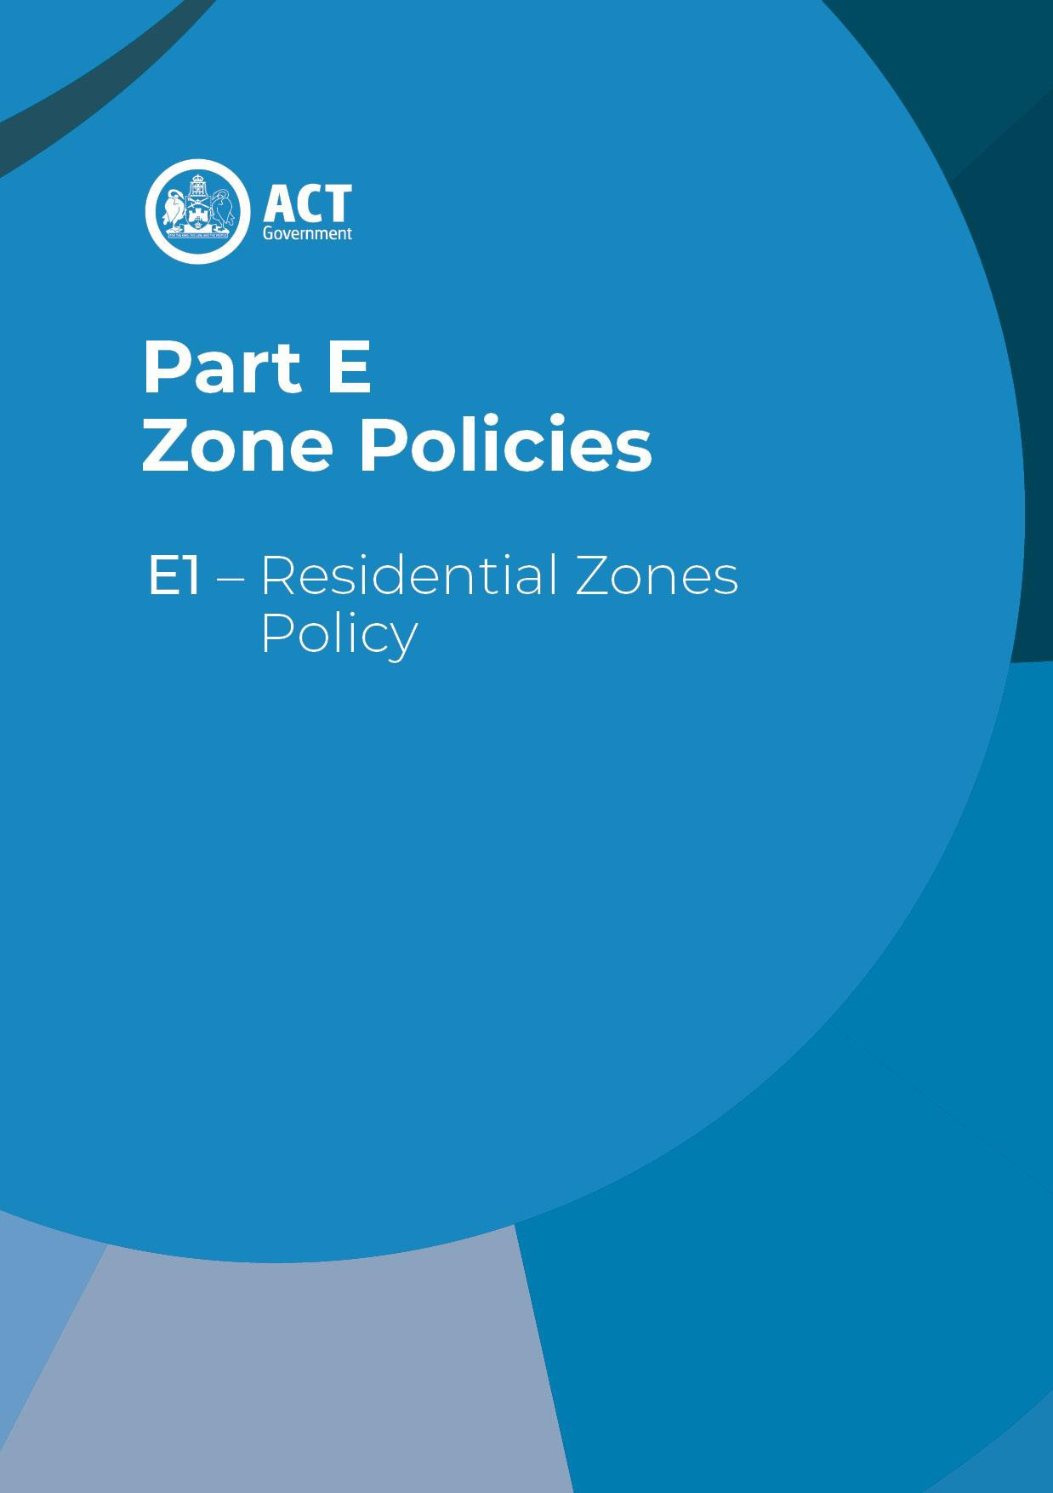

Table of Contents

Application 1
Land Use Table 1
Policy Outcomes 2
Assessment Outcomes 4
Urban Structure and Natural Systems 4
Site and Land Use 4
Access and Movement 4
Public Space and Amenity 5
Built Form and Building Design 5
Sustainability and Environment 5
Parking, Services and Utilities 5
Assessment Requirements 7
Secondary residences 7
Home business 7
Number of storeys 7
Site coverage – single dwellings 8
Site coverage – multi- unit housing 8
Redevelopment 8
Gas connections 8

Application

The Residential Zones Policy applies to all development in a residential zone (RZ1 to RZ5 inclusive).

Land Use Table

The following table identifies permissible land uses and development types (marked ‘Y’) in residential zones.
The uses listed require development approval unless they meet the ‘exempt development’ definition of the Planning Act 2023. Development and land use types listed are defined in the Territory Plan Dictionary.
Uses not listed in the table are prohibited. Development of prohibited uses may be considered under certain limited circumstances as outlined under Part 7.3 of the Planning Act 2023.
District policies specify additional types of development and land uses that are permissible or prohibited in specific locations.

Land Use / Development Type | RZ1 | RZ2 | RZ3 | RZ4 | RZ5
Ancillary use | Y | Y | Y | Y | Y
Boarding house | Y | Y | Y | Y | Y
Co-housing | Y | Y | Y | Y | Y
Community activity centre | Y | Y | Y | Y | Y
Community garden | Y | Y | Y | Y | Y
Community housing | Y | Y | Y | Y | Y
Consolidation | Y | Y | Y | Y | Y
Demolition | Y | Y | Y | Y | Y
Early childhood education and care | Y | Y | Y | Y | Y
Guest house | Y | Y | Y | Y | Y
Health facility | Y | Y | Y | Y | Y
Home business | Y | Y | Y | Y | Y
Home occupation | Y | Y | Y | Y | Y
Minor road | Y | Y | Y | Y | Y
Minor use | Y | Y | Y | Y | Y
Multi-unit housing | Y | Y | Y | Y | Y
Parkland | Y | Y | Y | Y | Y

Land Use / Development Type | RZ1 | RZ2 | RZ3 | RZ4 | RZ5
Residential care accommodation | Y | Y | Y | Y | Y
Retirement village | Y | Y | Y | Y | Y
Secondary residence | Y | Y | Y | Y | Y
Service reticulation | Y | Y | Y | Y | Y
Sign | Y | Y | Y | Y | Y
Single dwelling housing | Y | Y | Y | Y | Y
Social enterprise | - | - | - | Y | Y
Subdivision | Y | Y | Y | Y | Y
Supportive housing | Y | Y | Y | Y | Y
Temporary use | Y | Y | Y | Y | Y
Varying a lease | Y | Y | Y | Y | Y
Veterinary clinic | Y | Y | Y | Y | Y

Policy Outcomes

These policy outcomes describe the high-level objectives for each zone.
Policy outcomes inform assessment outcomes and assessment requirements. Where a development is consistent with the assessment outcomes and assessment requirements, it is considered to be consistent with the policy outcomes.

All residential zones
- Residential zones are primarily for residential developments but permit other development that complements residential uses and streetscapes.
- Development should be of a scale and nature that recognises and responds to the zone hierarchy.
- Facilitate development that is resilient to climate change, is sensitive to biodiversity, has reasonable solar access, is energy efficient and promotes sustainable water use and water sensitive urban design, as well as encouraging active living and active travel.
RZ1 – Suburban Zone
- Provide for a range of housing choices in a suburban setting which is primarily low density and low rise.
- Housing development meets changing household and community needs and demonstrates good design outcomes.
- Provide opportunities for redevelopment by enabling some change to residential density and subdivision pattern.
- Development respects valued features of the neighbourhood and landscape character of the area and does not have unreasonable negative impacts on neighbouring properties.

RZ2 – Suburban Density Zone
- Facilitate development or redevelopment of sites that are generally in reasonable proximity to local services and amenities.
- Achieve a mix of low and medium density housing in a manner that demonstrates good design outcomes.
- Provide for a range of housing choice that is primarily low rise multi-unit housing or more compact single dwelling housing.
- Provide opportunities for redevelopment by enabling change, including to residential density and subdivision pattern.

RZ3 – Residential Transition Zone
- Facilitate urban development or redevelopment to achieve primarily medium density, low-mid rise housing within close proximity to local services and amenities in a manner that demonstrates good design outcomes.
- Provide for a range of housing choices, which are predominately multi-unit housing of various dwelling types or more compact single dwelling housing.
- Provide opportunities for redevelopment by enabling change, including to the residential density and the original pattern of subdivision.

RZ4 – Urban Residential Zone
- Facilitate urban development or redevelopment of sites to achieve medium to high density, midrise housing in a manner that demonstrates good design outcomes.
- Provide for a range of housing choices, which are predominately medium to high density multi-unit housing of various dwelling types.
- Provide opportunities for redevelopment by enabling change, including to residential density and the original pattern of subdivision.
RZ5 – Urban Density Zone
- Facilitate urban development or redevelopment of sites to achieve higher density, mid and medium rise housing in a manner that demonstrates good design outcomes.
- Provide opportunities for the establishment and maintenance of residential housing that is generally high density.
- Provide housing in areas with very good access to facilities and services and/or frequent public transport services.
- Provide for a range of high density and larger scale housing choices of various dwellings types.
- Provide opportunities for redevelopment by enabling changes, including to the original pattern of subdivision

Assessment Outcomes

Consistent with the zone policy outcomes, development proposals in residential zones must demonstrate that they are consistent with the assessment outcomes stated below.
In demonstrating compliance with the assessment outcomes, consideration is to be given to the relevant design guides and may be given to planning technical specifications which may serve as a benchmark. While all assessment outcomes are to be met, not all outcomes are covered by design guidance and/or planning technical specifications.
Where a proposed development complies with relevant provisions in the design guide and/or planning technical specification and the development comprehensively addresses the assessment outcome, further assessment regarding that assessment outcome will not be required.
Where a design guide applies to a development, the proposal must demonstrate that it is consistent with the relevant guidance. More information is available in the design guide. Given the nature of the design guides, different design responses are possible to meet the same assessment outcomes.
The Territory Planning Authority may consider advice or written support from a referral entity to demonstrate compliance with a relevant assessment outcome. Where endorsement from an entity is noted as a planning technical specification, entity referral may be required.

The assessment outcomes for proposed development in residential zones are:

Assessment outcomes – Residential Zones
Urban Structure and Natural Systems |  | - Biodiversity connectivity is maintained across the landscape.  - Loss of native habitat and biodiversity is avoided and/or minimised.  - The health and functionality of waterways and catchments is maintained, including through application of water sensitive urban design principles
Site and Land Use |  | - The functionality and usability of the development is appropriate for its intended purpose/use.  - The proposed use and scale of development are appropriate to the site and zone, noting the desired zone policy outcomes and the streetscape character.  - Adverse impacts of development on surrounding uses (within a site, on adjoining sites or to the public domain) is minimised and residential amenity protected. This includes between residential uses and between non-residential and residential uses.
Access and Movement |  | - The functionality and layout of the development is accessible and adaptable, while achieving good connections with the surrounding area. This includes consideration of traffic flow and passive surveillance.  - The development encourages active travel through safe and convenient access to the active travel network.  - Access to, from and within the site permits safe and legible movement while catering for all users (including pedestrians). This includes consideration of vehicle maneuverability and access routes.
Public Space and Amenity |  | - The development (including the design of outdoor spaces) achieves reasonable solar access and microclimate conditions to public areas and streets to support their use by the community.  - Private open space and communal open space provides sufficient space and facilities for residents and visitors to recreate and relax, as well as providing area for service functions. Spaces are readily accessible for a range of activities.  - Reasonable levels of active ground floor interface and passive surveillance to public spaces and streets is achieved.  - Any advertising or signs are suitable for their context and do not have a detrimental impact on the surrounding area (for instance due to size or light emission).
 | Built Form and Building Design |  | - The height, bulk and scale of the development is appropriate, noting the desired zone policy outcomes and the streetscape. This includes consideration of building envelope and setbacks.  - Reasonable solar access to dwellings and private open space within a block and on adjoining residential blocks is achieved. This includes solar access into main living spaces within a dwelling and existing rooftop solar collectors and solar hot water services.  - Reasonable levels of privacy to dwellings and private open space within a block and on adjoining residential blocks is achieved.  - The dwelling mix and the internal size, scale and layout of dwellings in multi-unit housing provide for a comfortable living environment that meets the changing needs of residents. This includes consideration of cross-ventilation and energy efficiency.  - Courtyard walls and fences do not have an adverse impact on the streetscape.
 | Sustainability and Environment |  | - Sufficient planting area, canopy trees, deep soil zones and water sensitive urban design measures are provided to enhance living infrastructure, support healthy tree growth and minimise stormwater runoff.  - Urban heat island effects are reduced through limiting impervious surfaces and provision of canopy trees and plants.  - Threats to biodiversity such as noise, light pollution, invasive species incursion or establishment, chemical pollution, or site disturbance are avoided or minimised through good design.  - Minimise cut and fill to protect natural hydrological function and limit soil erosion and site disturbance.  - The development considers and addresses site characteristics, including heritage, natural features, topography, infrastructure and utilities.  - Environmental risks, including noise, bushfire, flooding, contamination, air quality or hazardous materials are appropriately considered for the development on the site.
 | Parking, Services and Utilities |  | - The development provides electric vehicle parking and access to charging locations in multi-unit housing.  - The development provides appropriate end-of-trip facilities in multi-unit housing which includes secure bicycle parking.  - Vehicle and bicycle parking sufficiently caters for the development while minimising visual impacts from the street or public space. This includes consideration of parking location, dimensions and number of spaces provided.  - Waste is appropriately managed on site without having a detrimental impact on residents and the surrounding area.  - The site is appropriately serviced in terms of infrastructure and utility services and  any associated amenity impacts are minimised.

Assessment Requirements

Assessment requirements set the mandatory development controls within specific zones or for specific development types.
District policies also contain assessment requirements. Assessment requirements in district policies will prevail where inconsistencies occur.
Development proposals in residential zones must meet the following requirements:
Control | Assessment requirement
Secondary residences | - A secondary residence is developed only in association with single dwelling housing.  - The maximum dwelling size* of a secondary residence is 90m².  *For the purpose of this requirement, dwelling size is the floor area measured to the outside face of external walls (including internal walls between the living areas and garage) but excludes the garage.  - Maximum of one secondary residence per block.
Home business | - At least 1 worker who genuinely lives on the lease is employed at any one time by the home business operating from the lease.  - A home business does not, or is unlikely to, cause pollution, create a health hazard or present danger which is prohibited under any relevant Territory legislation and/or Code of Practice (as may vary from time to time).
Number of storeys | - Maximum number of storeys is:  - RZ1 – 2 storeys  - RZ2 –  i) for single dwelling housing and secondary residence – 2 storeys  ii) for multi-unit housing – 3 storeys  - RZ3 –  i) for secondary residence – 2 storeys  ii) for single dwelling housing– 3 storeys  iii) for multi-unit housing – 4 storeys  - RZ4 –  i) for secondary residence – 2 storeys  ii) for single dwelling housing– 3 storeys  iii) for multi-unit housing – 6 storeys  - RZ5 –  i) for secondary residence – 2 storeys  ii) for single dwelling housing– 3 storeys  iii) for multi-unit housing – 7 storeys
Site coverage – single dwellings | - Site coverage for single dwellings is a maximum of:  - For large blocks: 40% of the block area.  - For mid-sized blocks*: 60% of the block area.  - For compact blocks: 70% of the block area.  * Includes blocks identified in a district technical specification as being subject to mid-size block provisions.  For single dwellings on blocks created through the subdivision of an original residential block, site coverage is a maximum of:  - In RZ1 and RZ2: 45% of the block area.  - In RZ3, RZ4 and RZ5: 50% of the block area.  Note: Single dwelling includes all secondary residences and associated roofed Class 10 buildings.
Site coverage – multi- unit housing | - Site coverage for multi-unit housing is a maximum of:  - RZ1 and RZ2 – 45% of the original block area.  - RZ3, RZ4 and RZ5 – 50% of the original block area.
Redevelopment | - Where a lawfully constructed building already exceeds the maximum set by an assessment requirement (such as site coverage, building height or number of storeys), a new building or additions / alterations may be permitted to the same maximum as the existing building provided there are no additional adverse impacts on adjoining properties including, but not limited to, solar access.
Gas connections | - No new gas network connections are allowed to all new or existing developments including redevelopments.

APPENDIX 3

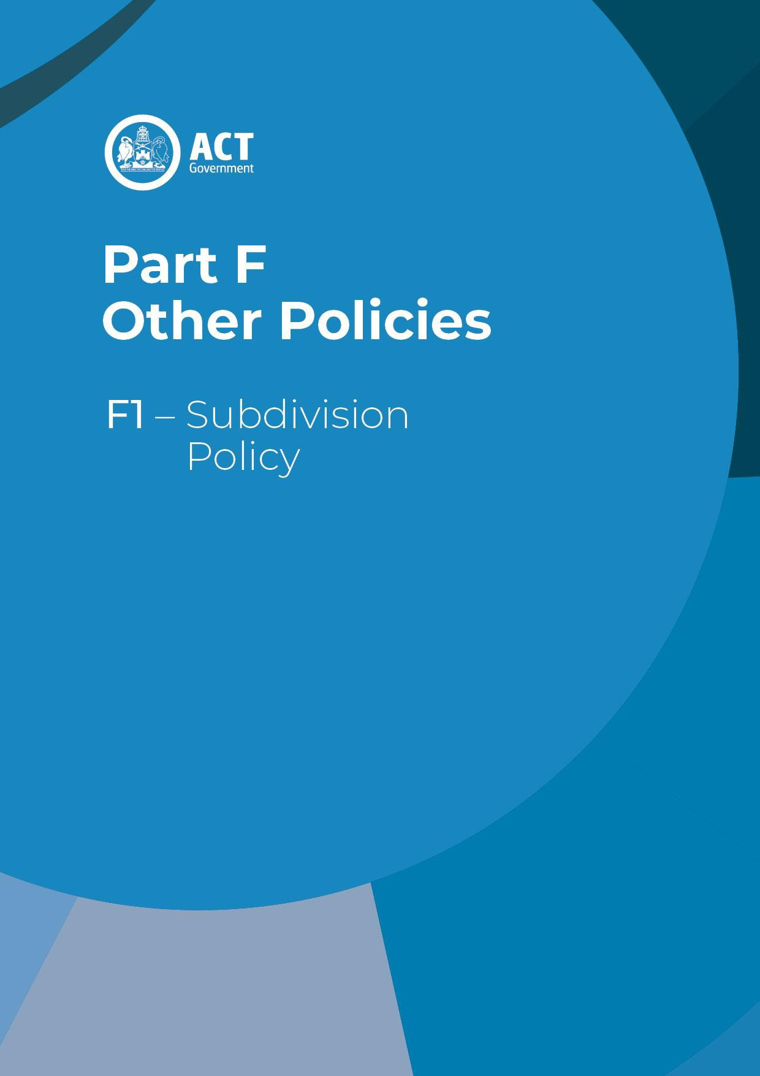

Table of Contents
Application 1
Policy Outcomes 1
Assessment Outcomes 1
Country and Place 2
Urban Structure and Natural Systems 2
Site and Land Use 2
Access and Movement 2
Public Space and Amenity 2
Sustainability and Environment 2
Parking, Services and Utilities 3
Assessment Requirements 3
Subdivision – Community Facilities Zone 3
Subdivision – All zones except Residential Zones 3
Block size – IZ1 Zone 3
Subdivision of certain development types 3
Subdivision and consolidation of residential blocks, except in RZ1 4
Consolidation of blocks – RZ1 4
Residential subdivision generally 4
Bushfire – All zones 5
Gas connections – All zones 5

Application

The Subdivision Policy applies to development proposing subdivision, including unit title subdivision, boundary adjustments, consolidations and the creation of new blocks. The policy applies to all Territory land across all zones including future urban areas and is to be read in conjunction with the relevant district policy and zone policy.

Policy Outcomes

These policy outcomes describe the high-level objectives for subdivision proposals. These are in conjunction with the policy outcomes in the relevant district policy and zone policy.
Policy outcomes inform assessment outcomes and assessment requirements. Where a development is consistent with the assessment outcomes and assessment requirements, it is considered to be consistent with the policy outcomes.

All zones
- An orderly pattern of subdivision which responds to its surrounds, zone outcomes and environmental features.
- Functional and useable parcels of land that are well connected and serviced to relevant utilities, infrastructure and public spaces.
- High quality social, planning and environmental outcomes.
- Land that offers excellent future development opportunities suitable for the existing or proposed zone.

Assessment Outcomes

Consistent with the subdivision policy outcomes and the relevant district and zone policy outcomes, development proposals must demonstrate that they are consistent with the assessment outcomes stated below. Development proposals must also demonstrate that they are consistent with the relevant district and zone assessment outcomes.
In demonstrating compliance with the assessment outcomes, consideration is to be given to the relevant design guides and may be given to planning technical specifications which may serve as a benchmark. While all assessment outcomes are to be met, not all outcomes are covered by design guidance and/or planning technical specifications.
Where a proposed development complies with relevant provisions in the design guide and/or planning technical specification and the development comprehensively addresses the assessment outcome, further assessment regarding that assessment outcome will not be required.
Where a design guide applies to a development, the proposal must demonstrate that it is consistent with the relevant guidance. More information is available in the design guide. Given the nature of the design guides, different design responses are possible to meet the same assessment outcomes.
The Territory Planning Authority may approve an application that does not satisfy the relevant planning technical specifications where satisfied the development proposal meets all relevant assessment outcomes.

The assessment outcomes for proposed subdivisions are:

Assessment outcomes – Subdivision
Country and Place | 1. The subdivision design considers and responds appropriately to cultural significance and history or heritage.
Urban Structure and Natural Systems | - New blocks are appropriately located and are of a size and configuration that can accommodate the intended use for the site (for example an appropriately sized and configured site for single dwelling use).  - The proposed scale and range of uses in the subdivision are appropriate to the context and consistent with the Territory Plan Map, where applicable. This includes consideration of a range of block sizes to promote housing diversity and choice, and to meet a range of housing needs.  - Biodiversity connectivity is maintained across the landscape.  - Loss of native habitat and biodiversity is avoided and/or minimised.  - The health and functionality of waterways and catchments is maintained, including through application of water sensitive urban design principles.  - The subdivision is designed in a way to minimise the need for ongoing site-specific  provisions (such as front or side boundary setbacks) to apply to blocks.
Site and Land Use | 8. The functionality and usability of the subdivision is appropriate for its intended purpose/use. This includes limiting future adverse impacts between permissible land uses and on surrounding areas.
Access and Movement | - Road hierarchy, layout and design (including entry and egress points) enables the distribution of traffic in a legible, convenient and safe manner. This includes providing a high level of internal accessibility for pedestrians, cyclists and public transport.  - Clear and high quality movement corridors enable effective external connections for local vehicle, pedestrian and cycle movements, while minimising through traffic from external areas (other than for pedestrians, cyclists and public transport) and ‘rat runs’.  - The use of rear lane accessways, cul-de-sac roadways and battle-axe blocks in estates are minimised.  - The streetscape impacts associated with battle-axe blocks in existing urban areas are minimised.
Public Space and Amenity | - The subdivision design achieves reasonable solar access and microclimate conditions for individual blocks to enable the design of sustainable buildings, and to public areas and streets to support their use by the community.  - Public space provided within a subdivision accommodates a range of uses, users and activities. This includes consideration of recreational opportunities, including facilities for pedestrians and cyclists.  - Public space provides opportunities to link existing or proposed areas of open space and/or providing for shared use of public facilities by adjoining communities.
Sustainability and Environment | - Urban heat island effects are reduced, stormwater run-off is minimised and ecosystem services are maintained through provision of planting area and canopy trees, limiting impervious surfaces, selection of building materials and design of outdoor spaces. This includes consideration of water sensitive urban design measures. Urban heat island effects are reduced through limiting impervious surfaces, selection of building materials and design of outdoor spaces.  - Deep soil zones are provided on site to support healthy tree growth and provide adequate room for canopy trees.  - Threats to biodiversity such as noise, light pollution, invasive species incursion or establishment, chemical pollution, or site disturbance are avoided or minimised through good design.  - Minimise cut and fill to protect natural hydrological function and limit soil erosion and site disturbance.  - The subdivision design considers and addresses site constraints, including natural features and topography  - Environmental risks including bushfire, flooding, contamination, air quality or hazardous materials are appropriately considered in the design of the subdivision.  - Existing and significant vegetation is preserved where reasonable, and new landscaping responds to and integrates with preserved features where possible.  - Residents are provided a reasonable level of protection from known sources of noise, odour and light pollution.
Parking, Services and Utilities | - Appropriate vehicle and bicycle parking is provided to meet the needs of users that is safe and convenient for users and pedestrians.  - Waste is appropriately managed within the subdivision without having a detrimental impact on the surrounding area.  - The site is appropriately serviced in terms of infrastructure and utility services and the noise and visual amenity impact of these are minimised.

Assessment Requirements

Assessment requirements set the mandatory development controls within specific zones or for specific development types.
District policies also contain assessment requirements. Assessment requirements in district policies will prevail where inconsistencies occur.
Development proposals involving the subdivision of land (including stratum subdivision) must meet the following requirements:

Control | Assessment requirement
Subdivision – Community Facilities Zone | 1. Subdivision of a lease developed for Supportive Housing, Community Housing, Retirement Village, including subdivision under the Unit Titles Act 2001, is not permitted.
Subdivision – All zones except Residential Zones | 2. Subdivision is only permitted where it is demonstrated that any residual block can accommodate another assessable development designed in accordance with the relevant provisions of this Policy and any district or zone policy.
Block size – IZ1 Zone | - The minimum block size for blocks subdivided from existing leases is 2000m² (unless stated otherwise in the lease).  - The average of all blocks to be created via subdivision of the original lease is to be not less than 5000m² (unless stated otherwise in the lease).
Subdivision of certain development types | - Subdivision is not permitted to provide separate title, including subdivision under the Unit Titles Act 2001, to:  - A secondary residence in all zones.  - An individual boarding room in all zones.  - Community housing in RZ1 and CFZ.
Subdivision and consolidation – residential blocks generally | - Subdivision or consolidation is only permitted where each of the subdivided blocks have utilities infrastructure.  - For blocks that are registered or provisionally registered under the Heritage Act 2004, subdivision and consolidation is only permitted where all of the following apply:  - The subdivision or consolidation is not specifically prohibited by a guideline, order or agreement made under the Heritage Act 2004, and would not otherwise diminish the heritage significance of the place.  - It complies with the relevant requirements relating to community uses.  Note: For this requirement, subdivision does not include a minor boundary adjustment, where no additional blocks are created.  - Subdivision or consolidation is only permitted in residential zones where one or more of the following apply:  - A new dwelling is capable of being accommodated on the block in accordance with the relevant parts of the Territory Plan.  - If one dwelling on the land is lawfully constructed, the proposed development demonstrates that any building on a consequent lease is, or can be designed, in accordance with the relevant parts of the Territory Plan.
Consolidation of blocks  – RZ1 | - This requirement applies to consolidation of blocks in RZ1 which proposes consolidation of:  - A standard block with unleased land.  - One or more standard blocks registered or provisionally registered under the  Heritage Act 2004.  Consolidation complies with all of the following:  - Not more than 2 blocks are consolidated.  - All blocks proposed to be consolidated have adjoining street frontages.  - None of the blocks proposed to be consolidated has been previously consolidated.  - In all other cases, block consolidation in RZ1 is permitted, unless one of the following apply:  - One or more block has been previously consolidated.  - The consolidated block is proposed to contain, or will contain, less than or equal the amount of dwellings on the unconsolidated blocks.  Example for 10. b) – It is proposed to consolidate three blocks into one. All three original blocks contain one dwelling each. Consolidation of these three blocks would only be permitted if, as part of the consolidation proposal or in the future, four or more dwellings would be contained on the site.
Subdivision – RZ1 | - In RZ1, subdivision under the Planning Act 2023 to create one or more additional blocks is permitted where:  - each subdivided block contains a lawfully constructed dwelling, or  - each subdivided block is a minimum of 350m²  12. In RZ1, subdivision of multi-unit housing under the Unit Titles Act 2001 is permitted where all dwellings have been lawfully constructed, and one of the following applies:  a) On a standard block a minimum of 600m².  b) On a non-standard block.  Note 1: staged development under the Unit Titles Act 2001 is not permitted for less than five units.  Note 2: For this provision, subdivision does not include a minor boundary adjustment, where no additional blocks are created.
Bushfire – All zones | - Blocks within a bushfire prone area are not developed where the bushfire attack level is greater than BAL 29 for subsequent buildings.
Gas connections – All zones | - No gas mains connections are to be provided to new residential blocks.

APPENDIX 4

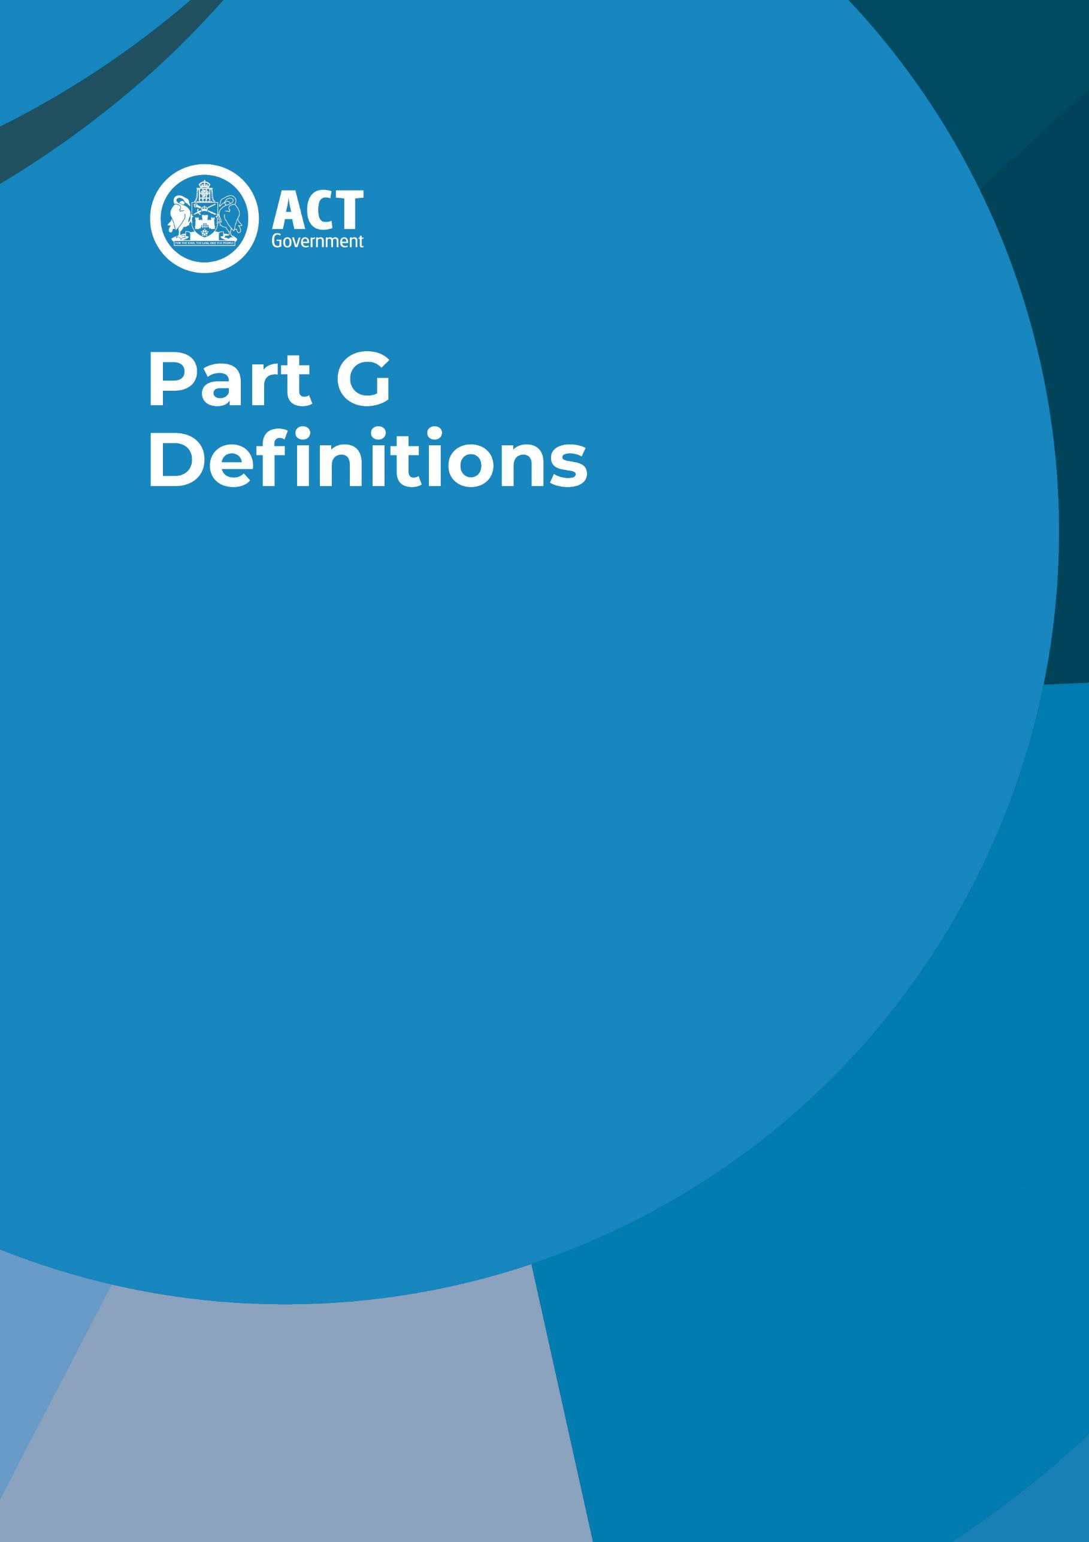

Table of Contents
Definitions – uses of land 1
Table 1 – land use definitions 2
Definitions – terms and concepts 19
Table 2 – terms and concept definitions 19

A definition in this dictionary applies to the entire Territory Plan unless a provision in the plan provides for a more limited application.

Note 1 The Legislation Act contains definitions relevant to this instrument. For example:
- definition;
- in relation to;
- instrument;
- person;
- territory land; and
- the Territory.

Note 2 A definition in the Planning Act 2023 or any regulation under the Act applies to the plan unless the plan provides a specific definition. For example, the following terms are defined in the Act’s dictionary:
- application;
- approval; and
- Territory Planning Authority.

Definitions – uses of land

Table 1 defines land uses that are specified in the Territory Plan and directly relate to the range of land uses permitted or prohibited on a parcel of land. A use listed in a district policy or zone policy is a use defined in the table below.

The example uses mentioned in the second column for a definition do not form part of the definition of the use but are intended to provide a range of activities commonly referred to that can be taken to be a use to which the definition applies.

The list of land uses may not directly correlate with land uses and definitions provided in Crown leases. Where there is uncertainty as to whether a land use listed as permissible in a Crown lease aligns with a land use definition provided in Table 1, the Territory Planning Authority will consider the appropriate definition of the land use that applied at the time the Crown lease was granted. The definition of the term as it applied at the time of granting of the lease will then be considered in the context of current definitions to determine whether the proposal must be considered as a

‘Prohibited Use’ under Part 7.3 of the Planning Act 2023 as well as the extent of applicability of the provisions of the relevant policy, design guide or planning technical specification.

Table 1 – land use definitions

Definition | Example uses
agriculture means broadacre animal farming, crop and pasture production, and horticulture for commercial wholesale production, but does not include intensive animal farming or any cultivation or animal farming carried out primarily for the personal enjoyment of, or consumption by, the owner or occupant of land. | horse agistment livestock grazing broadacre farming
airport means the use of land for the landing or departure of aircraft, housing, servicing, maintenance and repair of aircraft and the assembly of passengers and goods transported on the aircraft. | air cargo facilities air terminals  general aviation facilities landing fields  military aviation facilities
ancillary use means the use of land for a purpose that is incidental and subordinate or secondary to the primary use of the land.
animal care facility means a facility the purpose of caring, boarding, breeding, or raising of predominantly domestic or household animals. | catteries kennels
aquatic recreation facility means the use of land for a sporting, exercise, pastime, or leisure activity, whether or not operated for gain, which is based on the recreational use of an adjacent water feature but does not include a swimming pool or an aquarium. | boat landing facilities boat sheds  marinas  wharves
boarding house means the use of land to provide the residents with a principal place of residence for 3 months or more where meals, laundry or other services are provided only to those residents of the boarding house, and/or may also include shared facilities, such as communal living area, bathroom, kitchen, or laundry facilities. A boarding house is not licensed to sell liquor under the Liquor Act 2010. | lodging house private hotel serviced room  student accommodation
bulk landscape supplies mean the use of land for the bulk sale of sand, soil, screenings, and other such garden materials.
bulky goods retailing means the use of land where the goods or materials sold or displayed are predominantly of such a size, shape, or weight as to require:  - a large area for handling, storage, or display; and/or  - direct vehicular access to the site by members of the public, for the purpose of loading goods or materials from the loading dock into their vehicles after purchase, but does not include any shop used primarily for the sale of food or clothing. | auction rooms  camping equipment sales carpet sales  do-it-yourself home improvement centres furniture sales hardware stores  showroom for bulky goods
business agency means the use of land for the purpose of providing a commercial service directly and regularly to the public. | computer service health insurance agency real estate agency travel agency

Definition | Example uses
café means the use of land the principal purpose of which is the preparation and serving, on a retail basis, of food and drink to people for consumption on the premises, take away meals and drinks or entertainment are also provided.
car park means the use of land specifically allocated for the parking of motor vehicles including any manoeuvring space and access thereto.
caravan park/camping ground means the use of land for the placement of caravans or tents for the purpose of temporary accommodation and may include cabins for overnight and holiday accommodation, amenity buildings, recreational and entertainment facilities, manager's office and residence and shops which cater for the occupants of the caravan park/camping ground. | cabins holiday park
caretaker’s residence means one dwelling used for the residence of a caretaker, in connection with another land use, including industry and commercial activity.
cemetery means the use of land for the interment or the cremation of the dead including any funeral parlour or chapel erected on such land and used in connection with the cemetery. | burial ground cemetery (public land reserve) crematorium  graveyard
civic administration means the use of land for the purpose of carrying out the legislative and judicial functions of government. | ACT Legislative Assembly archive  civic centre Court of Law Tribunal
club means the use of land as a meeting place for persons associated, or for a body incorporated, for a social, sporting, athletic, literary, political, or other like purpose, and which is a licensed premise under the Liquor Act 2010. | ethnic clubs football club Labor club Leagues club RSL club
co-housing means a development with separate dwellings or private living areas, with some common/shared indoor components such as kitchens, living areas, bedrooms, and laundries. Private living areas must each contain a bedroom and a bathroom as a minimum and may contain a kitchenette.
The common/shared indoor components may be provided in a separate building.
commercial accommodation use means the use of a building or part of a building for one or more commercial accommodation units. It does not include a caravan park/camping ground or a group or organised camp. | serviced apartment Short-term rental accommodation  homestay

Definition | Example uses
communications facility means the use of land for the provision of facilities for postal, telecommunications and other communication purposes including facilities used for receiving and transmitting radiated signals using radio masts, towers, and antennae systems but does not include cabling or ducting used for the carrying of electromagnetic signals. | mobile phone antenna satellite or microwave dish radar equipment  aviation navigation communication space tracking facility  telecommunication facility, depot  television/radio broadcasting facility Australia Post exchange telephone exchange
community activity centre means the use of land by a public authority, or a body of persons associated for the purpose of providing for the social wellbeing of the community. | community centre community hall meeting rooms  Men’s Shed neighbourhood centre public health, welfare, or information services Scout and/or Guide hall  space for community groups
community garden means the use of land for the cultivation of produce primarily for personal use by those people undertaking the gardening, including demonstration gardening or other environmental activities which encourage the involvement of schools, youth groups and citizens in gardening activities.
community housing means the use of land for affordable residential rental which is managed by a community housing provider.
community theatre means the use of land for a theatre, cinema, concert hall, auditorium or theatrette run by non-profit organisations.
community use includes community activity centre, community theatre, cultural facility, educational establishment, early childhood education and care, health facility, hospital, place of worship, religious associated use and veterinary clinic.
complementary use means the use of land for a purpose that is not otherwise defined in the Territory Plan but does not have a greater impact on the land than a use permitted in that zone.
consolidation has the same meaning as in Section 256 of the Planning Act 2023.

Definition | Example uses
corrections facility means the use of land for the confinement or safe custody of persons so confined as the result of legal process and includes attendance centres established for persons sentenced to serve periods of community service. | corrections centre prison  remand centre  youth remand centre
craft workshop means the use of land for the manufacture, primarily by manual methods, of craft articles such as leatherwork, pottery, woodwork, hand woven goods and the like, but excludes the manufacture of food and beverages for human consumption.
cultural facility means the use of land for the purpose of cultural activities to which the public normally has access, but does not include a shop for art, craft, or sculpture dealer. | art gallery library museum
data centre means the use of land for the co-location of groups of networked computer servers for the remote storage, processing and/or distribution of large amounts of data.
defence installation means the use of land operated by the Department of Defence or the armed forces of Australia and includes Department of Defence offices, offices associated with national security and defence communications facilities, but does not include facilities associated with military aviation.
demolition means to wholly or partly dismantle or damage a building or structure to the extent that it no longer can function as it’s approved purpose.
diplomatic residence means a dwelling specifically for the residential use of diplomatic staff of an embassy, a high commission, a legation, or a consulate.
distribution reservoir means a storage tank associated with the maintenance of pressure and supply in the reticulated water supply system.
drink establishment means the use of land for the sale of alcoholic beverages and spirits to members of the public primarily for consumption on the premises, and which is a licensed premise under the Liquor Act 2010. | bar tavern
drive-in cinema means the use of land as an open-air cinema that makes provision for the audience or spectators to view that entertainment while seated in motor vehicles.
drone facility means the use of land for the landing or departure of drones and the housing, servicing, maintenance, and repair of drones. It does not include facilities where drones are used solely for the collection and delivery of goods or drones used for personal use.

Definition | Example uses
ecotourism means the use of land for tourism related facilities and activities that take place in the natural environment, the primary aim being to support the conservation of the native flora and fauna in those locations.
educational establishment means the use of land for the purpose of tuition, training or research directed towards the discovery or application of knowledge, whether or not for the purposes of gain, and may include associated residential accommodation. | adult education centre high school kindergarten  pre-school primary school road safety centre secondary college  sheltered workshop sports institute institute of technology university
early childhood education and care means a service approved under the Education and Care Services National Law or a licenced service under the Children and Young People Act 2008. | long day care services pre-school  play school  out of school hours services
emergency services facility means the use of land for the purpose of providing emergency services and protection for the community. | ambulance station civil defence  fire station police station
end-of-trip facilities means places where amenities are provided for bicycle riders and other active travel users at either end of a trip (either origin or destination). The end-of-trip facilities can include amenities such as bicycle parking, shower and change facilities, lockers, and drying areas.
farm tourism means operating a craft workshop, shop, guesthouse, outdoor recreation facility, overnight camping area or other activity for tourists that is secondary to the primary use of the land for agriculture and authorised by the lease.
financial establishment means the use of land for the primary purpose of providing finance, investment opportunities and providing services to lenders, borrowers, and investors on a direct and regular basis. | bank  co-operative society credit union  finance companies
freight transport facility means the use of land for the principal purpose of bulk handling and storage of goods or materials whether or not facilities are included for the parking, servicing and repair of vehicles used to transport the goods or materials on site, but does not include any retail sales or wholesaling from the site. | freight depot/warehouse motor freight forwarding service  motor freight packing, crating service  motor freight terminals and depots

Definition | Example uses
funeral parlour means the use of land by an undertaker in the carrying out of that profession. The term includes all ancillary uses such as a funeral chapel and office.
general industry means an industry, not being a light, hazardous, offensive, or mining industry, in which the processes carried on, the transportation involved, or the machinery or materials used have the potential to interfere with the amenity of the locality by reason of noise, vibration, smell, fumes, smoke, vapour, steam, soot, ash, dust, waste water, waste products, grit, oil or otherwise.
group or organised camp means the use of land for the purpose of providing short term share accommodation and recreation facilities by a body of persons associated together for the physical, cultural, spiritual, or intellectual welfare of the community. | church camp Outward Bound camp religious retreat school camp  Scout, Guide camp YMCA camp  youth camp
guest house means the use of land for one or more commercial accommodation units and where common or shared facilities are provided for the provision of services such as meals and laundry to occupants of the premises but not to non-occupant members of the public. | chalet  farmstead accommodation tourist lodge  youth hostel
hazardous industry means an industry, not being a general, light, offensive or mining industry, which by reason of the process involved, or the method of manufacture of the materials used or produced represents a significant source of hazard to human health or life or property, for any reason. | chemical factory gas works  liquid fuel depot petroleum refining
hazardous waste facility means the use of land for the collection, storage, treatment, or disposal of hazardous waste.
health facility means the use of land for providing health care services (including diagnosis, preventative care, or counselling) or medical or surgical treatment to out-patients only. | baby health clinic consulting room dental clinic dental surgery doctor's surgery  family planning clinic first aid station health centre medical centre/clinic optician  X-ray centre
helicopter landing facility means the use of land authorised by the Civil Aviation Safety Authority for use by helicopters whether or not terminal facilities or hangar storage are included.

Definition | Example uses
home business means the use of a residential dwelling on residential or commercial zoned land for a profession, trade or other occupation carried on by a resident of a building or other structure on the land
Home occupation means an occupation that is carried on in a dwelling by one or more permanent residents of the dwelling and that does not involve:
- the employment of persons other than residents; or
- interference with the amenity of the neighbourhood; or
- the sale or display of goods; or
- any signage.
horticulture means the use of land for intensive plant production such as fruit, vegetable, or flower production (including berries and vines). | hydroponics market garden orchard  plant nursery (excluding  retail plant nursery)
hospital means the use of land for the medical care (including diagnosis, preventative care, and counselling) of in-patients, whether or not out- patients are also provided with care or treatment and may include associated residential accommodation.
hotel means the use of land for one or more commercial accommodation units and where the premise is licensed under the Liquor Act 2010. It may also include associated facilities such as a restaurant, bar, or functions room, which may be used by the occupants of the premises but, which are also available for use by non-occupant members of the public.
incineration facility means the use of land for the disposal of waste by burning.
indoor entertainment facility means the use of land for entertainment where such use is primarily indoors. | amusement arcade casino  cinema  commercial theatre concert hall  night club
indoor recreation facility means the use of land for sporting and recreation activities where such use is primarily indoors. | fitness centre gymnasium  indoor sports stadium indoor swimming pool squash court

Definition | Example uses
industrial trades means the use of land for the selling, hiring, inspection or servicing of goods or materials for industrial, agricultural, construction, transport or like purposes where:  - a large area for handling, storage or display is required; and/or  - the activity carried out has the potential to have an impact similar to industry in terms of traffic and parking generation, noise and air pollution, and visual impact. | agricultural supplier agricultural machinery sales and service  builders' supplies  display of building materials industrial machinery sales and service  timber yard vehicle repair and maintenance  plant and equipment hire
industry means the use of land for the principal purpose of manufacturing, assembling, altering, repairing, renovating, ornamenting, finishing, cleaning, washing, winning of minerals, dismantling, processing, or adapting of any goods or any articles.
intensive animal farming means any form of animal production that takes place within a building or a building where animals are reared in confined areas. | feedlots fish farming  poultry establishments shedded wool production
landfill site means the use of land for the permanent depositing of waste within the ground.
land management facility means the use of land for land management or the storage of any plant, machinery or materials used in the course of land management, whether or not facilities are included for the parking, servicing, fuelling, charging and repair of plant or machinery. Fuelling includes the production and storage of hydrogen for on-site fuelling purposes. | bushfire fighting facility forest depot  land management depot ranger station  visitor information centre
light industry means an industry, not being a general, offensive, hazardous, or mining industry, in which the processes carried on, the transportation involved, or the machinery or materials used do not interfere with the amenity of the locality by reason of noise, vibration, smell, fumes, smoke, vapour, steam, soot, ash, dust, wastewater, waste products, grit, oil or otherwise. The use includes a craft workshop.
light rail means a system for the provision of light rail public transport services, including tracks, catenaries, supports for tracks and catenaries, stops, access to stops, signalling and other control facilities and other facilities and equipment associated with the provision of those services.
The term excludes light rail depot and electrical substation facilities.

Definition | Example uses
liquid fuel depot means the use of land for:
- the bulk storage or wholesale distribution of petrol, oil, petroleum products or other inflammable liquids;
- the retail distribution of drums containing petrol, oil, petroleum products or other inflammable liquids; or
- the bulk storage or wholesale distribution of hydrogen fuel as a liquid or gas, including the production of hydrogen fuel for these purposes.
major electrical sub-station means switching and transformer equipment handling voltages greater than 66kV.
major electricity storage facility means equipment and associated buildings for the storage of electricity with a capacity of 5MW or greater, or a grid connection of 66kV or greater.
major gross pollutant trap means an open trap constructed on main drains to intercept sediment and trash transported in stormwater.
major pump station means a pump station having a capacity greater than 500 litres per second in the case of water supply; 50 litres per second in the case of sewage; or a gas compression station operating at greater than 1000 kPa pressure.
major road means a road that is an arterial road, parkway, highway, or the like and any road identified within the transport services zone. | arterial road distributor road freeway highway parkway
major service conduits means the major bulk water supply and reticulation mains having a diameter equal to or greater than 675mm, trunk sewers having a diameter equal to or greater than 750mm, stormwater main drains having a diameter equal to or greater than 900mm or comprising open drains or waterways, transmission lines having a voltage greater than 66kV, gas mains having a diameter greater than 100mm, and major telecommunication cable ducts having a width equal to or greater than 1000mm.
mental health facility has the same meaning as in the Mental Health Act 2015.
mining industry means an industry, not being a light, general, hazardous or offensive industry, which extracts minerals, coal, oil, gas or construction materials by such processes as underground or open-cut mining, quarrying, dredging, the operation of wells or evaporation pans, or by recovery from ore dumps or tailings, and includes primary processing operations carried out at or near mine sites as an integral part of the mining operation and works to rehabilitate the site. | quarry
minor road means a road other than a major road.

Definition | Example uses
minor use means the use of land for a purpose that is incidental to the use and development of land in the zone and includes but is not limited to open space; public car parking; community path systems; shared circulation spaces (such as lift wells, stair wells); minor service reticulation; electricity storage devices and other utility services that do not exclude other uses from the land; street furniture and the like.
mobile home has the same meaning as in the Planning Act 2023.
mobile home park has the same meaning as in the Planning Act 2023.
motel means the use of land for one or more commercial accommodation units and where the units are provided with convenient space for parking of motor vehicles. It may also include associated facilities such as a restaurant, bar, or functions room, which may be used by the occupants of the premises but, which are also available for use by non occupant members of the public. A motel may be licensed under the Liquor Act 2010.
multi-unit housing means the use of land for more than one dwelling. | build-to-rent development
municipal depot means the use of land for the storage of any plant, machinery, vehicles, light rail vehicles or materials used in the course of a municipal undertaking, whether or not facilities are included for the parking, servicing, fuelling, charging and repair of plant, machinery or vehicles.
Fuelling includes the production and storage of hydrogen for on-site fuelling purposes.
nature conservation area means an area set aside for the purpose of the conservation or preservation of natural and/or cultural values
offensive industry means an industry, not being a general, hazardous, light, or mining industry, which by reason of the process involved or the method of manufacture or the nature of the materials or goods used, produced, or stored requires to be isolated from other buildings, when all measures to reduce or minimise impact have been employed. | abattoir factory
office means the use of land for the purpose of administration, clerical, technical, professional or like business activities, including a government office, which does not include dealing with members of the public on a direct and regular basis except where this is ancillary to the main purpose of the office. | chancellery departmental offices private sector offices professional suite  statutory authority offices
outdoor education establishment means the use of land for an education centre for children or adults where the primary focus is on the natural and/or cultural resources of the area.

Definition | Example uses
outdoor recreation facility means the use of land for a recreation facility serving the sporting or recreational needs of people where the activities are undertaken predominantly outdoors. | archery bowling green BMX track  community garden croquet green enclosed oval equestrian facility golf course  grass, snow ski run model aviation/aero modelling  motor bike, mini-bike track motor racing track mountain bike tracks netball court  racecourse, trotting track showground  skate board park sporting rifle range sportsground stadium, arena  swimming pool (outdoor) tennis court  velodrome
overnight camping area means the use of land for holiday and recreational purposes which involves primarily the setting up and use of tents for overnight accommodation which is open to public use.
parkland means the use of land for recreation, conservation or amenity purposes and includes facilities for the enjoyment and convenience of the public, such as kiosks, car parks, shelters, pavilions, public toilets and the like. The term also includes the use of the land for the management of stormwater drainage, for community path systems and landscape buffers, and for other minor utility purposes where such uses can be integrated into the open space system. It has unrestricted public access. | botanic gardens and public arboretum  hilltop reserve  lake, rivershore reserve picnic area  playground public park public lookout  recreational reserve regional park  town park
pedestrian plaza means an open or sheltered area other than part of a building, used principally for free pedestrian movement in which vehicular traffic is forbidden or limited.

Definition | Example uses
personal service means a shop used primarily for selling services and in which the sale of goods is ancillary to the service provided. | dry cleaner hairdresser massage parlour photographer shoe repairer skin care  nail salon  pet grooming salon
place of assembly means the use of land for gatherings of people to attend functions, whether or not for the purposes of gain. | auditorium convention centre exhibition hall reception rooms  trade fair
place of worship means the use of land for the primary purposes of religious worship and associated activities by a congregation, religious group, or members of the public whether or not the premises are also used for religious instruction, tuition, meetings, training and other community activities. | chapel church mosque shrine synagogue temple
plantation forestry means the growing of trees in plantation form for the production of fibres, pulp, timber and logs, and including roads, tracks and break construction, cultivation, planting, fertilising, tending, harvesting and regeneration and associated facilities such as depots for storage of equipment, plants, materials and fuel, vehicle workshops and garaging, fire fighting facilities and accommodation for administration and support staff. | hardwood plantation forestry  pine plantation
playing field means the use of land for the conduct of sports, athletics and games and includes facilities with such land for the enjoyment or convenience of the public such as kiosks, car parks, changing facilities, pavilions and the like. It has unrestricted public access. | unfenced oval oval  sports field
power generation station means equipment and associated buildings constructed for the generation of electricity utilising gas, coal, renewable energy technology or other fuel sources.
produce market means the use of land for the sale, from market buildings or stalls, of fruit and vegetables and other primary produce and may include the sale of other products, which complement this primary purpose. | fruit and vegetable stall farmers market
public agency means the use of land for the purpose of providing a public service directly and regularly to the public and includes a government agency, which provides a commercial service to the public. | community and health services  departmental shopfront legal aid office  motor registry post office

Definition | Example uses
railway use means any of the following uses:
- a railway line for passenger and/or freight movement;
- a railway station;
- a railway freight terminal; and/or
- a railway equipment maintenance depot;
- and includes land and reservations of land set aside for railway purposes.
The term excludes light rail.
recyclable materials collection means the use of land for depositing and temporarily storing discarded materials that are suitable for recycling, such as paper, glass, clothing, garden waste and plastics, which are to be transported elsewhere for recycling.
recycling facility means the use of land for depositing, storing, separating, dismantling, salvaging, treating, renovating, or redistributing discarded materials and scrap goods for use as recycled materials, such as paper, glass, plastics, timber, garden and food waste, metals, manufacturing off-cuts, household goods and oils. | composting facility motor vehicle wrecker's yard  scrap metal dealer second-hand building materials yard recycling sorting
religious associated use means the use of land for the activities conducted by religious organisations other than for worship and may include residential accommodation by ministers of religion. | church meeting hall convent  monastery  presbytery, manse, rectory priory
residential care accommodation means the use of land by an agency or organisation that exists for the purposes of providing accommodation and services such as the provision of meals, domestic services and personal care for persons requiring support. Although services must be delivered on site, management and preparation may be carried out on site or elsewhere. | nursing home hospice  supported dwelling convalescent home rehabilitation facility
residential use includes caretaker’s residence, co-housing, community housing, diplomatic residence, multi-unit housing, residential care accommodation, retirement village, secondary residence, single dwelling housing and supportive housing.
restaurant means the use of land for the primary purpose of providing food for consumption on the premises whether or not the premises are licensed premises under the Liquor Act 2010 and whether or not entertainment is provided. | eatery bistro
retail plant nursery means a shop used for the propagation and sale of plants, shrubs, trees, and garden supplies.
retail use includes bulky goods retailing, café, personal service, retail plant nursery, shop, supermarket, take-away food shop,

Definition | Example uses
retirement village means premises where older members of the community or retired people live, or will live, in independent living units or serviced units, under a retirement village scheme.
road means any way or street (so called), whether in existence or under reserve, open to the public which is provided and maintained for the passage of vehicles, persons, and animals and which may include footpaths, community paths, bus lay-bys, light rail tracks, turning areas, or traffic controls.
sand and gravel extraction means the extraction of sand and gravel deposited in the bed of a stream or flood plain, or of deposits associated with deposition in a previous geological period.
scientific research establishment means the use of land for the purpose of scientific research including the development of electronic technology, biotechnology, or other scientific disciplines for application to commerce, industry, or government. | agricultural research facility CSIRO facility meteorological use observatory  plant and animal quarantine facilities  rural research field stations scientific laboratory
secondary residence means a second dwelling on a block which is subordinate to the principal dwelling on the block.
service reticulation means the water supply, sewerage, stormwater and gas pipe reticulation, electricity lines and telecommunication cables which are normally located in road verges and the like, or easements within leases.
service station means the use of land for the fuelling, charging and/or servicing of motor vehicles, whether or not the land is also used for any one or more of the following purposes:
- the sale by retail of spare parts and accessories for motor vehicles;
- washing and greasing of motor vehicles;
- installation of accessories;
- the retail sale of other goods, within an ancillary retail area not greater than 150m² in area;
- providing toilet facilities, amenities, and service for motorists;
- repairing of motor vehicles (other than body building, panel beating or spray painting);
- the hiring of trailers; and
- production and storage of hydrogen for on-site fuelling purposes.

Definition | Example uses
shop means the use of land for the purpose of selling, exposing, or offering the sale by retail or hire, goods, and personal services. | antique dealer  art, craft, or sculpture dealer  auction room boutique butcher  camping supplies store chemist  convenience store delicatessen department store florist  gift shop  household appliances liquor store  mobile phone store newsagent  pet shop  sports goods store toy store
sign means any device or representation openly visible to the general public, when viewed from a public place or from unleased Territory Land, for the purpose of direction or control or information, or displaying an advertisement.
single dwelling housing means the use of land for residential purposes for a single dwelling only.
social enterprise means a commercial organisation that exists to create social benefit as its primary purpose and may or may not be for profit and which may include employment and skills development for on-site residents.
stock/sale yard means the use of land for the purpose of a market for the sale of animals and the holding of livestock pending their sale.
storage facility means the use of land for the storage, whether permanent or temporary, of goods (not including obsolete motor vehicles or obsolete machinery) within or upon which no trade (whether retail or wholesale) or industry is carried on. | self-storage archives
subdivision has the same meaning as in Section 7 of the Planning Act 2023.
supermarket means a shop predominantly selling food and other household items where the selection of goods is organised on a self-service basis.

Definition | Example uses
supportive housing means the use of land for residential accommodation for persons in need of support, that provides a range of support services such as counselling, domestic assistance and personal care for residents as required. Although such services must be able to be delivered on site, management and preparation may be carried out on site or elsewhere. Housing may be provided in the form of self-contained dwellings. The term does not include a retirement village or student accommodation. | aged persons units older persons units public housing rooming house social housing special dwelling
take-away food shop means a shop, which is predominantly for the preparation of food and refreshments for consumption elsewhere.
temporary use means the use of land for a purpose that is temporary in nature and for which a time limit is applied (for a maximum of three years) such as through a development condition or licence and which may be extended or renewed.
tourist facility means the use of land for providing entertainment, recreation, cultural or similar facilities for use mainly by holidaying visitors and may include a restaurant, cafe, bar, tourist accommodation and the retail sale of arts and crafts, souvenirs, antiques and the like. | amusement park theme park
tourist resort means the use of land for one or more commercial accommodation units together with a wide range of recreational and/or cultural facilities in a resort style setting. It may also include associated facilities such as a restaurant, bar, or functions room, which may be used by the occupants of the premises but, which are also available for use by non- occupant members of the public. A tourist resort may be licensed under the Liquor Act 2010.
transport facility means the use of land for the assembly, transport or dispersal of passengers travelling by any form of public transport, whether or not such public transport is provided by a public or private agency. It includes facilities for the parking, manoeuvring, temporary layover and storage of public transport vehicles, and vehicles used in connection with a commercial or industrial transport undertaking and driver amenities. | bus interchange bus layover  bus terminal (interstate) driver rest facility  Inter-town public transport route  transport ticket services
treatment plant means a facility constructed for the purposes of physical, chemical, or biological treatment of water supply, sewage, or stormwater.
urban lake, pond and/or retardation basin means a dam constructed for the impoundment of urban and rural runoff for the purposes of landscape, recreation, pollution control, or retardation of peak stormflows.
utility hydrogen production facility means equipment and associated buildings for the production and associated storage of hydrogen for subsequent reticulation or distribution.

Definition | Example uses
vehicle sales means the use of land for the sale, hire, display or offering for sale or hire of new or used motor vehicles, caravans, motor cycles, boats, trailers or other vehicles. This may include the ancillary use of such premises for the sale of spare parts or accessories and the storage, cleaning, and maintenance of such vehicles, but does not include a service station. | boat, caravan dealer car, truck dealer motorcycle dealer
veterinary clinic means the use of land as a facility for the diagnosis, surgical or medical treatment of animals, especially domestic animals, where the activities carried on do not interfere with the amenity of the locality. The animals may be kept on the premises overnight for the purposes of observation and treatment, but only if there is a caretaker dwelling on the same block. It does not include an animal care facility.
veterinary hospital means the use of land for diagnosis, surgical or medical treatment of animals, particularly larger animals, where services are available at all times. The animals may be kept on the premises overnight for
the purposes of observation and treatment.
warehouse means the use of land for the purposes of the bulk sale of goods to be retailed by others or the bulk storage of goods, merchandise or materials pending their sale and distribution to persons engaged in the retail trade but does not include premises used for the purpose of bulk storage of calcium carbide, flammable liquid, solid fuel, gas, hide, skins, tallow, bones, or motor vehicles for recovery of spare parts or accessories. | cold storage food storage
waste transfer station means the use of land for the collection of waste into bulk containers for the further transport to a landfill site, recycling facility or other waste disposal facility.
water storage dam means a dam constructed for the purposes of impounding water for water supply purposes. | distribution reservoir stock water supply
woodlot means disaggregated plots and clumps of trees grown for production and/or landcare shelter belt and landscape purposes.
zoological facility means the use of land for the containment of animals for viewing by members of the public. | aquarium  wildlife sanctuary zoo

Definitions – terms and concepts

Table 2 defines terms and concepts that are specified in the Territory Plan. The definitions in Table 2 override any common terminology.

The list of terms and concepts may not directly correlate with terms and concepts provided in Crown leases. Where there is uncertainty between the terminology in Table 2 and in a Crown lease, the Territory Planning Authority will consider the appropriate definition that applied at the time the Crown lease was granted. The definition as it applied at the time of granting of the lease will then be considered in the context of current definitions to determine whether the proposal is consistent with the lease.

Table 2 – terms and concept definitions

Definition
active living means a way of life that integrates physical activity into a person’s daily routines.
active travel means physical activity undertaken as a means of transport and not purely as a form of recreation. Active travel can include walking, cycling, and scooting – as well as skating, skateboarding, and the use of mobility aids. Active travel also includes using any of these forms as incidental activity associated with the use of public transport.
adjacent, to an area, means either contiguous with the area, or, if the area is separated from another area only by a road, the adjacent front boundary of each area faces the road.
adjunct means something associated with another thing but not necessarily part of it.
advertisement means any device or representation visible to the general public which is used for the purpose of directly or indirectly promoting sales or drawing attention to an enterprise or undertaking, and includes any hoarding or similar structure, a bunting, flag, streamer or balloon used or adapted for use for that purpose.
AEP (annual exceedance probability) means the probability in any one year of a storm event exceeding a stated stream flow level.
AHD means Australian height datum.
apartment means a dwelling located within a building containing two or more dwellings where another dwelling is either located above or below the dwelling. An apartment is not an attached house.
Note: Apartment is a type of multi-unit housing. See the definition of that term in the Uses of Land section of this Dictionary.
articulation zone means a specified area on a block within which the design of the façade of buildings is required to be articulated in order to provide visual interest to the streetscape.

Definition
attached house means any dwelling, within a building containing two or more dwellings, which has within its curtilage open space at ground level and separate private access for each dwelling for the exclusive use of the occupants of the dwelling. Attached houses may incorporate communal basement car parking. Attached house includes row house, semi-detached house, terrace house, townhouse.
Note: Apartment is a type of multi-unit housing. See the definition of that term in the Uses of Land section of this Dictionary.
attic means any habitable space, but not a separate dwelling, contained wholly within a roof pitched at not more than 45 degrees above the ceiling line of the storey immediately below, except for minor elements such as dormer windows and the like.
backlighting, in relation to a sign, means the internal illumination of a sign box and the internal illumination of individual letters or characters comprising a sign, provided that the sign box, letter or character is constructed of translucent and not transparent materials.
balcony means a small outdoor area, raised above the ground, directly accessible from within the building and open except for a balustrade on at least one side.
basement means a space within a building where the floor level of the space is predominantly below datum ground level and where the finished floor level of the level immediately above the space is less than 1.0 metre above datum ground level.
bicycle parking device means a product constructed of high security material designed to provide stability to a bicycle parked in or against the device. For example, bicycle rails or hanging racks.
blank wall means any wall, which has no openings such as windows or doors.
block means a parcel of land, whether or not the subject of a lease, that has a cadastral description on a Deposited Plan registered with the Land Titles Office.
building is a structure and includes:
- an addition to a building;
- a structure attached to a building; and
- a part of a building. but does not include:
- a transportable building, mobile home, caravan or similar that is not used for long term habitation; and is readily transportable without being disassembled or removed from associated components;
- paving, a driveway or a road that is not inside a building;
- a surface level car park that is not inside a building; and
- a fence, courtyard wall or retaining wall.
building line means a line drawn parallel to any front boundary along the front face of a building or through the point on a building closest to the front boundary. A terrace, landing, porch, balcony, deck, or verandah that is more than 1.5 metres above finished ground level or is covered by a roof is deemed to be part of the building. A fence, courtyard wall or retaining wall is not deemed to be part of the building for the purpose of setting the building line.
carport means a roofed car parking space wholly or partly enclosed on not more than two sides, but open to the street that the carport gains vehicle access from.

Definition
commercial accommodation unit means a room or suite of rooms that is made available on a commercial basis for short-term accommodation. A commercial accommodation unit may comprise a dwelling but not a room or suite of rooms within a dwelling. It does not include any associated facility such as a restaurant, bar, or functions room.
Note: A commercial accommodation unit is a type of Commercial Accommodation Use. See the definition of that term in the Uses of Land section of this Dictionary.
commercial building means a building where commercial activities take place in the whole or part of a building. Commercial buildings contain uses such as office and shop but excludes community use, residential use, industry, and industrial trades.
communal open space means common outdoor open space within an easily accessible location on the subject site for recreation and relaxation of residents of a housing development.
community path system means a route constructed or under reserve which includes a path open to the public for the use of bicycles, scooters, pedestrians, joggers, and motorised mobility aids.
compact block means a block with an area of 250m² or less.
datum ground level means the best estimate of the surface of the ground determined pursuant to Surveyor- General Guideline No. 3 – Estate Development Plans and Datum Ground Level Surveys.
deep soil zone means an area of soil within a development that is unimpeded by buildings or structures below ground, and which has adequate dimensions to allow for the growth of healthy trees. Deep soil zones exclude basements, services, swimming pools, tennis courts and impervious surfaces including car parks, driveways, podium, and roof areas.
desired character means the form of development in terms of siting, building bulk and scale, and the nature of the resulting streetscape that is consistent with the relevant desired outcomes, and any statement of desired character in a relevant district code. It does not necessarily reflect the existing character of the area.
detached house means a building comprising a single dwelling which is not attached to any other dwelling and where the dwelling has within its curtilage separate private access to the dwelling and open space at ground level for the exclusive use of the occupants of the dwelling. It may include a free-standing dwelling in a multi- unit development, such as in a townhouse development.
Note: Detached house is a type of single dwelling housing but may also be a type of multi-unit housing. See the definition of those terms in the Uses of Land section of this Dictionary.
dual occupancy housing means the use of land that was originally used or leased for the purposes of single dwelling housing for two dwellings.
Note: Dual occupancy Housing is a type of multi-unit housing. See the definition of that term in the Uses of Land section of this Dictionary.
dwelling has the same meaning as in the Planning Regulation 2023.
Note: Dwelling is a type of single dwelling housing but may also be a type of multi-unit housing. See the definition of those terms in the Uses of Land section of this Dictionary.
end of section block means a block that is created through the consolidation of blocks, is located at the furthest end of a section and typically has three street frontages.
erosion means the mobilisation of soil as a result of loss of vegetative cover, scouring by runoff, or associated with slope instability.

Definition
EV ready means a car parking space which is provided with all of the infrastructure needed for the future installation of an electric vehicle charger, including provision of the following:
- adequate space within the car parking space for charger installation and the connection of an electric vehicle to a charger;
- electrical distribution board(s) of sufficient size to allow future connection of electric vehicle chargers at all EV ready car parking spaces;
- an electrical outlet at the car parking space suitable for the future installation of an electric vehicle charger;
- conduits and cables connected from the outlet to the distribution board(s); and
- a suitable on-site centralised load management and power provision approach. An electric vehicle charger may also be provided.
external wall means an external wall that may also incorporate any of the following:
- windows with sill heights at or above 1.7m from the floor;
- screened decks;
- fixed pane windows with obscure glass;
- awning sashes with obscure glass and with an opening of not more than 30cm to the horizontal; or
- obscure glass bricks.
fin wall means part of an external wall built to extend past the façade and typically not required for structural purposes. Fin wall(s) are provided to add architectural interest and/or visual screening.
finished floor level (FFL) means the level of the upper surface of the relevant floor.
finished ground level (FGL) means the ground level after completion of all excavation and earthworks.
front boundary means any boundary of a block adjacent to a public road, public reserve, or public pedestrian way.
front loading block means a block where vehicular access is not obtained from a rear lane.
front zone means the area of a block between the front boundary and the building line or at the minimum front setback of the lower floor level for the block whichever is greater. (Note: for the purpose of this definition, the front zone shall not be more than 10m from the front boundary).
garage means a roofed car parking space wholly or partly enclosed on more than two sides.
gross floor area means the sum of the area of all floors of the building measured from the external faces of the exterior walls, or from the centre lines of walls separating the building from any other building, excluding any floor area reasonably used and necessary solely for fixed mechanical plant, bicycle parking and associated end- of-trip facilities, and/or basement car parking.

Definition
habitable (including habitable room) means a room within a dwelling capable of being lawfully used for the normal domestic activities of living, sleeping, cooking, or eating, and:
- includes a bedroom, study, living room, family room, kitchen, dining room, home theatre, rumpus room; but
- does not include a bathroom, laundry, hallway, garage, or other spaces of a specialised nature occupied neither frequently or for extended periods.
height of building means the vertical distance between datum ground level to the highest point or points of the building.
integrated housing development means development where the developer:
- is responsible for the planning, design and building of all the housing and associated facilities; or
- undertakes the site planning and development of infrastructure as well as establishing general requirements for building design without actually constructing the dwellings.
Note: Integrated housing development is a type of single dwelling housing but may also be a type of multi-unit housing. See the definition of those terms in the Uses of Land section of this Dictionary.
integrated housing development plan means one or more drawings describing a proposed integrated housing development.
land includes water.
large block means a block with an area greater than 500m².
lease has the same meaning as in the Planning Act 2023.
long-stay user means a category of user generally defined by the time spent at the end-of-trip (either origin or destination) where the duration of the stay is typically half a day or more. Long-stay users generally include employees, residents, and students.
lower floor level (LFL) means a finished floor level which is 1.5 metres or less above datum ground level at any point.
mid sized block means a block with an area greater than 250m² but less than or equal to 500m².
natural ground level has the same meaning as datum ground level.
net lettable area (NLA) means the sum of a building’s lettable floor area measured from the interior faces of the exterior walls, excluding the areas for stairs, fire stairs, accessways, lift shafts, toilets, recessed doorways, cupboards, fire hose reel cupboards, smoke lobbies (must be compliant with relevant Acts and Regulations), escalators, plant/motor rooms, telecommunications cupboards, kitchen and other service areas, and lift lobbies and areas dedicated to public spaces and the like.
northern boundary means a boundary of a block where a line drawn perpendicular to the boundary outwards is oriented between 45º west of north and 45º east of north.
outbuilding means a shed, garage or similar structure that is ancillary to the permitted use of the land.

Definition
planting area means an area of land within a block that is available for landscape planting and that is not covered by buildings, structures, vehicle parking and manoeuvring areas or any other form of impermeable element that impacts permeability of the ground surface (i.e., terraces, pergolas, patios, decks, or pools).
plot ratio means the gross floor area in a building divided by the area of the site.
podium parking means that portion of a building set aside for vehicle parking above ground level.
primary building zone means the area between the front zone and a line projected 12m distant in a perpendicular line away from the front zone.
primary window means the main window of a habitable room.
principal private open space means private open space that is directly accessible from a habitable room other than a bedroom.
principal signage means the predominant signage on any site that relates to the advertising of the business and products made or services provided on the premises, and can include business name, logo, opening hours and contact details.
private open space means an outdoor area within a block useable for outdoor living activities and may incorporate planting area. Private open space may also include balconies, terraces or decks but does not include any area required to be provided for the parking of motor vehicles and any common driveways and common vehicle manoeuvring areas.
rear boundary means a block boundary other than a front boundary or a side boundary.
rear lane means a narrow and short street which has as its primary function to provide vehicular access to garages of rear loading blocks where no direct vehicle access is permitted from the front boundary of the block.
rear loading block means a block where vehicular access is obtained from a rear lane.
rear zone means the area of a block behind the primary building zone.
RL (Reduced Level) means the vertical height in metres above Australian Height Datum (AHD).
residential block means a block that has at least one of the following characteristics:
- zoned residential
- affected by a lease which authorises residential use but does not include any land intended to remain as unleased Territory land or public open space.
residential redevelopment means development that involves:
- substantial or total demolition of an existing dwelling on land previously used for residential purposes and replacement with one or more new dwellings;
- establishment of one or more new dwellings on land previously used for residential purposes in addition to an existing dwelling; or
- substantial alterations to an existing dwelling that would result in a significant change to the scale and/ or character of the dwelling.
Note: Detached house is a type of single dwelling housing but may also be a type of multi-unit housing. See the definition of those terms in the Uses of Land section of this Dictionary.

Definition
retirement village scheme, for a retirement village, means a scheme under which a person may:
- enter into a residence contract with the scheme operator for the retirement village; and
- on payment of an ongoing contribution, acquire a right to live in the retirement village, however the right accrues; and
- on payment of the relevant charge, acquires one or more services in relation to the retirement village.
Note: Retirement village scheme is associated with Retirement Village. See the definition of that term in the Uses of Land section of this Dictionary.
screen wall means a wall at least 1.8 metres high and visually opaque.
screening device means a permanent structure that comprise one or more of the following:
- opaque or translucent glazing;
- solid panels;
- perforated panels or trellises with a maximum 25% openings; and/or
- angled louvres to restrict overlooking.
second party signage means signage for products not initiated on the site but are associated with the business in its day-to-day business activity, for example signs advertising particular brands of products sold or distributed.
setback means the horizontal distance between a block boundary and the outside face of any building or structure on the block including:
- a building wall;
- a post that supports a roof; or
- a balcony, deck, or verandah.
short-stay user means a category of user generally defined by the time spent at the end-of-trip (either origin or destination) where the duration of the stay is typically a few hours or less. Short-stay users generally include shoppers, meeting attendees or residential visitors.
side boundary means a block boundary extending from a street frontage along a single bearing. A boundary is not a side boundary if it meets the definition of front boundary.
sill height means the vertical height of a windowsill above the finished floor level which it serves.
site means a block, lease or other lawful occupation of land, or adjoining blocks, leases, or lawful occupancies in the event of these being used for a single undertaking or operation, but excludes the area of any access driveway or right-of-way.
site coverage means the proportion of actual site covered by buildings, including balconies, basements, and any roofed structures such as terraces, pergolas, patios, and decks, but excluding any part of awnings, eaves and the like.

Definition
standard block means a block with one of the following characteristics:
- originally leased or used for the purpose of one or two dwellings except where the original lease
explicitly permits two dwellings
- created by a consolidation of blocks, at least one of which is covered by a)
storey means a space within a building that is situated between one floor level and the floor level next above, or if there is no floor level above, the ceiling or roof above but does not include an attic or a basement or a space that contains only a lift shaft or stairway. A mezzanine is included as a storey.
streetscape includes the visible components within a street (or part of a street) including the private land between facing buildings, including the form of buildings, treatment of setbacks, fencing, existing trees, landscaping, driveway and street layout and surfaces, utility services and street furniture such as lighting, signs, barriers, and bus shelters.
structure includes a fence, retaining wall, swimming pool, ornamental pond, mast, antenna, aerial, road, footpath, driveway, carpark, culvert, service conduit, cable, advertising device, notice or sign.
surface area of a sign means the entire area within a single continuous perimeter enclosing the extreme limit of writing, representation, emblem or any figure or similar character, together with any material or colour forming an integral part of the display or used to differentiate such a sign from the background against which it is placed, and only includes one side of a double faced sign when the sides are back-to-back or the sides are divergent but display identical writing or other representation but facing substantially different directions, but does not include the means by which a sign is supported.
surrendered residential block means a block that has been included on the Affected Residential Property Register and that has been either: surrendered to the ACT Government; or it is a dual occupancy unit-title block that has been acquired, in full or in part, by the ACT Government under the Loose Fill Asbestos Insulation Eradication Scheme Buyback Program. It does not mean a surrendered residential block that is part of a registered heritage place or a provisionally registered heritage place under the Heritage Act 2004.
third party signage means signage that:
- displays the name, logo and/or symbol of a company or other organisation that does not own or substantially occupy the land
- is for a product, activity or event not sold or occurring on the land
- displays sponsorship details.
undercroft parking means that portion of a building set aside for vehicle parking and does not include basement vehicle parking.
unscreened element means unscreened windows, decks, balconies, and external stairs.
upper floor level (UFL) means a finished floor level, which is greater than 1.5 metres above datum ground level
at any point.

