Australian Capital Territory
Heritage (Decision about Provisional Registration of Paterson House, Aranda) Notice 2026
Notifiable instrument NI2026-271
made under the
Heritage Act 2004, s 34 (Notice of decision about provisional registration)

1 Name of instrument
This instrument is the Heritage (Decision about Provisional Registration of Paterson House, Aranda) Notice 2026.
2 Commencement
This instrument commences on the day after its notification day.
3 Decision about provisional registration
On 10 June 2026, the ACT Heritage Council (the council) decided to provisionally register Paterson House, Block 10, Section 43, Aranda (the place).
4 Description of the place
The registration details of the place are in the schedule.
5 Reasons for the decision
The council decided to provisionally register the place as it is satisfied on reasonable grounds that the place is likely to have heritage significance as defined by section 10 of the Heritage Act 2004 (the Act). A detailed statement of reasons, including an assessment against the heritage significance criteria, is provided in the schedule.
6 Date provisional registration takes effect
The registration of the place takes effect on 11 June 2026 (being the day after the council entered into the register the details of the place, and an indication that the registration is provisional).

7 Indication of the council’s intention
The council intends to decide whether to register the place under the Act, division 6.2 during the period of provisional registration.
8 Invitation to make written comments during public consultation period
(1) The council invites written comments about the registration of the place. Any written comments must be made within 4 weeks after the day this notice is notified.
(2) Written comments can be provided to the council by the following methods:
(a) mail to
The Secretary
ACT Heritage Council
480 Northbourne Avenue
DICKSON ACT 2602
(b) email to heritage.registrations@act.gov.au

Dr Mary Clare Swete Kelly
Secretary (as delegate for)
ACT Heritage Council
10 June 2026

Schedule

(See sections 4 and 5)
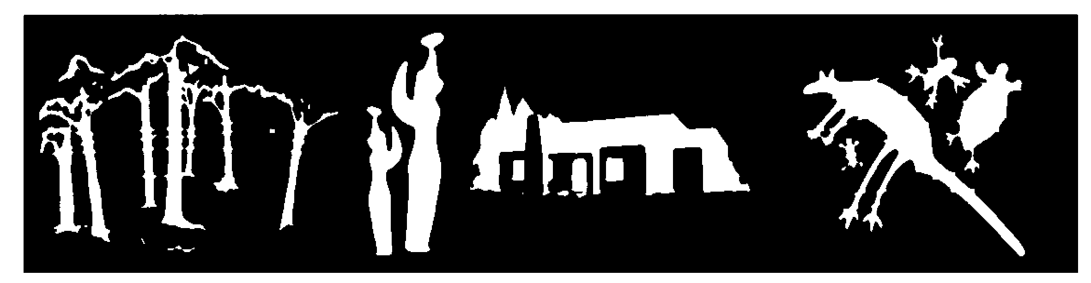
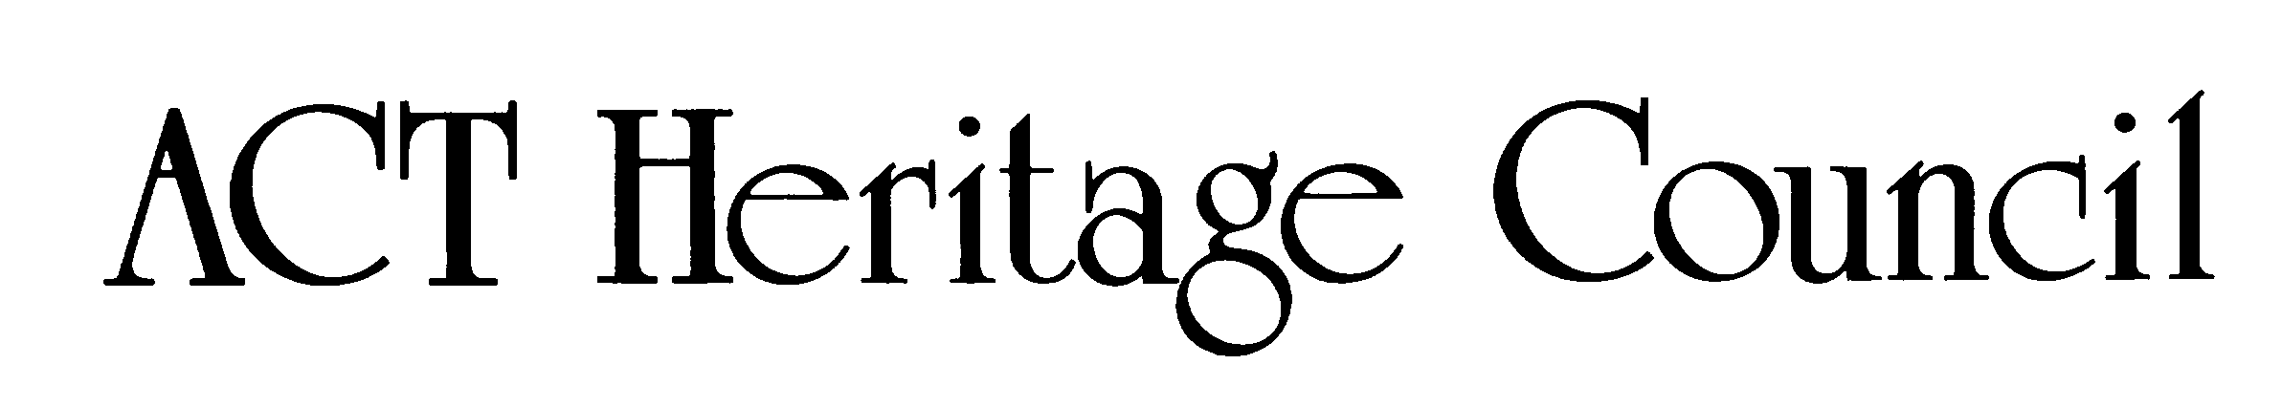
AUSTRALIAN CAPITAL TERRITORY
HERITAGE REGISTER
Provisional registration
For the purposes of s33 of the Heritage Act 2004 (the Act), a provisional entry to the heritage register has been prepared by the ACT Heritage Council for the following place/object:

PATERSON HOUSE
BLOCK 10 AND SECTION 43, ARANDA
DATE OF DECISION
10 June 2026 – same day as HCM meeting date
DATE OF PROVISIONAL REGISTRATION
11 June 2026 (being the day after the Heritage Council entered into the heritage register the registration details for the place together with an indication that the registration is provisional)
Notifiable Instrument: 2026–
PERIOD OF EFFECT OF PROVISIONAL REGISTRATION
5 months commencing on 11 June 2026 being until 10 November 2026.
Extended Period (if applicable) Start Date ________ End Date ________
Copies of the Register Entry are available for inspection at ACT Heritage. For further information please contact:
The Secretary
ACT Heritage Council
GPO Box 158
CANBERRA ACT 2601
Telephone 13 22 81

Statement of heritage significance
Paterson House at 7 Juad Place in Aranda was designed by architect Dr Enrico Taglietti AO and completed in 1968. The house demonstrates many of the principal characteristics of the late 20th-century sculptural organic style of architecture as practiced by Taglietti, characterised by an integrated relationship with its surroundings, sculptural features, and expressed building materials.
The house is embedded in the hillside and emerges from the craggy landscape as an imposing fortress-like structure with a façade made of exposed concrete brick. The house interfaces with the surrounding bushland through the careful positioning of timber framed windows and by blending in with the environment through the colour of its exposed concrete bricks and natural timber elements.
Paterson House features Taglietti’s signature prominent timber fascia, overhanging eaves, horizontal roof, wedge shaped windows, dedication to privacy through a sheltered courtyard and enclosed balcony, interlocking spatial volumes, open plan areas, as well as prominent rainwater spouts.
The house is of high integrity and has remained substantively unaltered. It was a complete commission with Taglietti also designing the interior fixtures. Taglietti considered it one of his most important residential designs in the ACT.

Location of the place
This statement refers to the name and location of the place as required in s12(a) and s12(b) of the Act.
Paterson House, Block 10, Section 43, 7 Juad Place, Aranda.

Description of the place
This statement refers to the description of the place as required in s12(c) of the Act. The attributes described in this section form part of the heritage significance of the place. For the purposes of s12(c) of the Act, the registration boundary of the place is at Figure 1.

Paterson House at 7 Juad Place, Aranda is located on a triangular, east-facing, steep 1,244m2 suburban block at the end of a cul-de-sac abutting a nature reserve.

Situated among bushland vegetation, the house is a 4-level home, located centrally on the block with views of the nature reserve to the west.

On approach, it is notable for its fortress-like appearance with a battered concrete brick front and three prominent, protruding rainwater spouts.

It features a horizontal roof, wide, overhanging eaves, as well as deep, splayed timber fascias and timber soffits.

The house is made of 2 interlocking cubes and a cylinder. The use of concrete brick, natural wood fascias, and timber window frames reflect the colours and textures of the surrounding bushland, reinforcing the building’s integration with its bush setting. The relationship between the house and its bush context is an important element the place.

The house has a protected inner courtyard with walls of varying heights.

The living, dining, and kitchen areas are all combined in an open plan, which open onto the wide front terrace to intentionally frame views of surrounding trees and Black Mountain. The terrace is enclosed by a brick balustrade, concealing it from the street.

The house is a fine example of late 20th-century organic style of architecture. It is notable for its asymmetrical massing, complex, angular geometry, natural setting, interface with the exterior, expressed timber, horizontal roof, geometric highlight windows, and sculptural elements such as the 3 prominent rainwater spouts on the front façade of the house.

The internal space was designed to maximise panoramic views of hills and surrounding trees from every room, eliminate close views of surrounding houses, enhance privacy, reduce external noise, and encourage social interaction on the inside.

Paterson House has the following attributes of significance:
Exterior features that are demonstrative of organic style architecture:
  - Embedded in the hillside
  - Three rainwater spouts on the front wall
  - Steep and massive battered walls of bare concrete brick
  - Wide, overhanging eaves consisting of prominent timber fascia and timber soffits
  - Long horizontal flat roofs
  - Timber window frames, framing views
  - Deep and fully enclosed bare concrete brick terrace to the front
  - Circular walled courtyard to rear

Interior elements that are demonstrative of organic style architecture:
  - Consideration of sound and its flow through interior spaces through sound dampening materials in the ceiling
  - Open connection between spaces (living/dining/kitchen)
  - Framed view from the living area and balcony that include nearby hills and surrounding treetops
  - Expressed timber skirting throughout
  - Johnstone River wood floorboards
  - Built-in timber sideboard in dining area
  - Built-in timber cupboards throughout
  - Feature curved cantilevered timber staircase
  - Timber kitchen benchtop.

Conservation objective
The guiding conservation objective is that Paterson House shall be conserved and appropriately managed in a manner respecting its heritage significance.
The ACT Heritage Council may make heritage guidelines applicable to the place under s25 of the Act.
For further information on managing the place, or for advice on proposed works or development, please contact ACT Heritage via email at heritage@act.gov.au or via 13 22 81.

Reason for provisional registration
This statement refers to the heritage significance of the place as required in s12(d) of the Act.
The Council has assessed the Paterson House against the heritage significance criteria and is reasonably satisfied that the place/object is likely to have heritage significance when assessed against criterion (d) under s10 of the Act. A place is considered to have heritage significance if it meets one or more of the criteria.
Table 1 Criteria that the Council consider have been met.
Criterion | (a) | (b) | (c) | (d) | (e) | (f) | (g) | (h)
Met | No | No | No | Yes | No | No | No | No

Assessment against the heritage significance criteria
In assessing the heritage significance of Paterson House, the Council considered:
- the original nomination and documentary evidence supplied by the nominator
- the Council’s Heritage Assessment Policy (March 2018)
- interviews of the Paterson family conducted in 2004 and in 2020 by ACT Heritage,
- papers provided to ACT Heritage by the Paterson family
- information provided by a site inspection on 8 April 2021 by ACT Heritage and the Council
- information provided by a second site inspection on 18 February 2026 by ACT Heritage and members of the ACT Heritage Council
- the report by ACT Heritage titled, Background Information Paterson House, containing information on history, description, condition and integrity
According to s10 of the Act, a place or object has heritage significance if it meets one or more of the following criteria. Future research may alter the findings of this assessment.

(a) importance to the course or pattern of the ACT’s cultural or natural history
Does not meet criterion.
The Council is not satisfied on reasonable grounds that the place is likely to meet this criterion.
Built in 1968, Paterson House has a clear association with Canberra’s early development, driven by National Capital Development Commission (NCDC). The NCDC engaged modernist architects of national and international renown to design buildings throughout the capital. A thematic heritage study of modernist houses in the ACT details the role of the NCDC in shaping Canberra’s urban landscape. Taglietti was part of a larger cohort of architects drawn to the capital by the possibilities of this era of planning and development.
Paterson House reflects the shift at the time from government designed and built housing driven by the NCDC to private development where the individual owner commissioned an architect. The house is one of several modernist buildings connected with leading Australian scientists of the mid-century and reflects the growth and cultural importance of Australian science as well as modernist architecture in the 1960s and 1970s.
Although Paterson House has a clear association with this shift in Canberra’s early development, and this association is evident in the physical fabric of the place, many other buildings in Canberra exhibit this link. Canberra is home to many privately commissioned mid-century modernist residential buildings designed by well-known architects. Indeed, Canberra is home to a disproportionate stock of modernist housing when compared to other Australian capital cities. Prior to designing Paterson House, Taglietti had already completed the Gibson House in Red Hill (1965), the McKeown House in Watson (1965), Souillac House in Griffith (1967), and the Dingle House in Hughes (1968).
The Council believes that Paterson House provides evidence of a historical quality that is relatively common in the ACT. Paterson House does not meet the threshold indicator of exceptionality and rarity in this regard.

(b) has uncommon, rare or endangered aspects of the ACT’s cultural or natural history
Does not meet criterion.
Does not meet criterion.

The Council is not satisfied on reasonable grounds that the place is likely to meet this criterion.
While Paterson House features unique design elements of Taglietti, it is not sufficiently uncommon as a mid-century modernist house.
Canberra is home to a disproportionate number of modernist residential housing when compared to other Australian capital cities. At a residential scale, Enrico Taglietti had already completed the Gibson House in Red Hill (1965), the McKeown House in Watson (1965), Souillac House in Griffith (1967), and the Dingle House in Hughes (1968) when he was commissioned by the Patersons in 1967.

The table below provides more detail on other Taglietti-designed residential houses in the ACT and their registration as well as nomination status:
Year | Dwelling | Heritage Listed? | Nominated?
1965 | Gibson House | No | No
1965 | McKeown House | Yes - 2026 | No
1967 | Souillac House | No | No
1968 | Dingle House | Yes - 2008 | No
1968 | Paterson House | No | Yes - 2011
1970 | Glenlyle Killen House | No | No
1971 | Evans House | No | Yes - 2011
1973 | Wood House | No | Yes - 2011
1975 | Green House | No | No
1977 | Gentle House | No | No
1983 | Mijuscovic House | No | Yes - 2022
1997 | Lo Hu Min House addition (Canberra) | No | No
2001 | House at Flinders Way | No | No
The table below compares the features of Paterson House to the significant features of McKeown House and Dingle House (the 2 residential houses by Taglietti on the ACT Heritage register):
Dwelling | Common features | Unique features
McKeown House | - Minimum pitch / flat roof  - Deep, horizontal timber fascia  - Concrete gutter (large)  - White-painted, rendered brick walls  - Built-in timber cabinetry  - Open plan design  - Tapered garden walls  - Copper box lights  - Johnstone River wood parquetry  - Expressed timber beams and rafters in the ceiling  - Geometric highlight windows with timber frames  - Tapered garden walls  - Rendered brick | - Concrete pond water feature in the front garden  - Oil tank above the pond in the front garden  - Large projecting external timber beams  - An addition, also designed by Taglietti, built 30 years later that contrasts & complements the main house, showing how Taglietti’s design evolved to suit the ACT climate  - Connecting cabinet between kitchen pantry and exterior  - Timber enclosed balcony (part of the addition)
Dingle House | - Horizontal roof  - Asymmetrical massing  - Courtyard walls  - Exposed timber roof beams  - Timber fascia  - Highlight windows  - Open plan design  - Copper box lights  - Rendered brick | - An open veranda with timber and steel balustrade
Paterson House | - Wide, overhanding eaves consisting of prominent timber fascias  - Long, horizontal flat roof  - Prominent rainwater spouts  - Exposed timber beams  - Timber window frames  - Open floor design (living/dining/kitchen)  - Johnstone River parquetry  - Built-in timber fixtures | - Embedded within uniquely steep site  - Prominent ‘fortress’-like appearance  - Deep and fully enclosed brick front terrace  - Feature curved cantilevered staircase  - Taglietti’s first open-plan kitchen  - Consideration of sound through sound dampening materials  - Circular walled courtyard to rear  - Exposed brick
While Paterson House features unique design elements by Taglietti not present in his other designs that are recognised on the ACT Heritage Register, it does not meet the threshold indicator of rarity. There are many other mid-century modern houses and many other Taglietti-designed places in the ACT.

(c) potential to yield important information that will contribute to an understanding of the ACT’s cultural or natural history
Does not meet criterion.
The Council is not satisfied on reasonable grounds that the place is likely to meet this criterion.
Due to its prominence in Australian architectural circles and a broader examination of Taglietti’s contribution to the built environment of Canberra, Paterson House has been well documented and studied. Several architectural publications, including popular news articles as well as architectural journal articles and books, examine the house. Many of these publications are cited in the background research document for this assessment.
The Council believes that Paterson House provides a further example of a type which is already well studied and documented. It is unlikely to provide any further, better understanding of mid-century Modernism and organic style architecture beyond what it already has.

(d) importance in demonstrating the principal characteristics of a class of cultural or natural places or objects
MEETS CRITERION.
The Council is satisfied on reasonable grounds that the place is likely to meet this criterion.
Paterson House demonstrates the principal characteristics of mid-century Modernism (i.e. focus on functionality, use of materials like concrete and glass, and rejection of traditional ornamentation in favour of clean lines) and sculptural organic style architecture (i.e. integration with nature, use of natural materials, flow and continuity between spaces, geometric forms, sculptural features).
Modernism is expressed at Paterson House through big glass windows and the characteristically horizontal roof of the house. Exposed concrete features prominently on the exterior of the house. Modernism is also expressed through the overall functional layout and design of the house, especially the open plan kitchen, dining and living areas. The simplicity and modern look of the Taglietti-designed fixtures are another aspect of this design.
Sculptural organic style architecture is expressed at Paterson House through the way it is built into the steep site and emerges from it as an imposing fortress.
Further examples are the 3 highly visible rainwater spouts and large geometric windows that are carefully placed to provide intentionally framed views of the surrounding environment. The natural tones of the exposed concrete bricks and the external timber elements interface with the surrounding bushland environment. The courtyard and enclosed balcony create links between the interior and exterior.
Organic style architecture is also expressed through the extensive use of timber. The house has wide, overhanging eaves consisting of prominent timber fascias and timber soffits. On the inside timber is visible through exposed timber beams and Taglietti-designed timber fixtures. These include the sideboard in the dining room, timber cupboards throughout, timber kitchen bench tops, timber parquetry, and a curved cantilevered timber staircase.
Paterson House is one of four houses Taglietti considered to be of notable importance in his Canberra work (the others being McKeown House, Dingle House, and Mijuscovic House).
Paterson House meets the threshold indicator of distinctiveness, intactness/integrity, and representativeness.

(e) importance in exhibiting particular aesthetic characteristics valued by the ACT community or a cultural group in the ACT
Does not meet criterion.
The Council is not satisfied on reasonable grounds that the place is likely to meet this criterion.
While Paterson House exhibits the aesthetic characteristics of organic style architecture, it is doubtful that these characteristics are valued by the ACT community, let alone a particular cultural group.
The threshold indicator of ‘valued by the ACT community’ must be objectively tested and/or clearly demonstrated. While Paterson House is clearly valued among architects and those passionate about architecture and ACT heritage, this does not qualify as the broader ACT community nor a cultural group. Simply being the work of a highly regarded architect is not sufficient to meet the assessment threshold of wider recognition in the broader ACT community.
While the work of Taglietti is becoming increasingly popular in the ACT, Paterson House has not been shown to be valued by the ACT community for exhibiting particular aesthetic characteristics.

(f) importance in demonstrating a high degree of creative or technical achievement for a particular period
Does not meet criterion.
The Council is not satisfied on reasonable grounds that the place is likely to meet this criterion.
While Paterson House exhibits a high degree of creative achievement in the context of residential architectural design, this achievement is not sufficiently beyond the ordinary within the context of the ACT. Due to the substantial development that took place after the NCDC was established, Canberra is home to many mid-century modernist buildings, including residential buildings.

(g) has a strong or special association with the ACT community, or a cultural group in the ACT for social, cultural or spiritual reasons
Does not meet criterion.
The Council is not satisfied on reasonable grounds that the place is likely to meet this criterion.
There is insufficient evidence to demonstrate that Paterson House has strong or special associations with the ACT community, or a cultural group in the ACT for social, cultural or spiritual reasons. As a private residence, it is not expected to have a broad appeal to the community, and it has not been associated with a cultural group within the ACT.
Professional groups and special interest groups do not qualify as ‘the ACT community’ nor ‘a cultural group’. Community or cultural group concern for Paterson House is not clearly demonstrated.

(h) has a special association with the life or work of a person, or people, important to the history of the ACT
Does not meet criterion.
The Council is not satisfied on reasonable grounds that the place is likely to meet this criterion.
While Paterson House has a clear association with the work of architect Dr Enrico Taglietti AO, there is insufficient evidence to suggest that it has a special association when compared to his other works.
Although Paterson House was a complete commission from start to finish, with Taglietti designing the fixtures, by the time Taglietti designed it in 1965 he had already been commissioned for a range of residential and commercial buildings.
Prior to designing Paterson House, Taglietti had already completed the Gibson House in Red Hill (1965), the McKeown House in Watson (1965), Souillac House Griffith (1967), and the Dingle House in Hughes (1968).
He had also already been commissioned to design the Town House Motel in Canberra (1961), Noah’s restaurant (1961), and the Cinema Centre (1964). The commercial venues arguably created significantly more visibility and occupied a more prominent role in his career as an architect than Paterson House.
Although the association of Paterson House with Taglietti is a close one, it is not an exceptional one. Paterson House does not meet the threshold indicator of exceptionality.

Provisional registration boundary
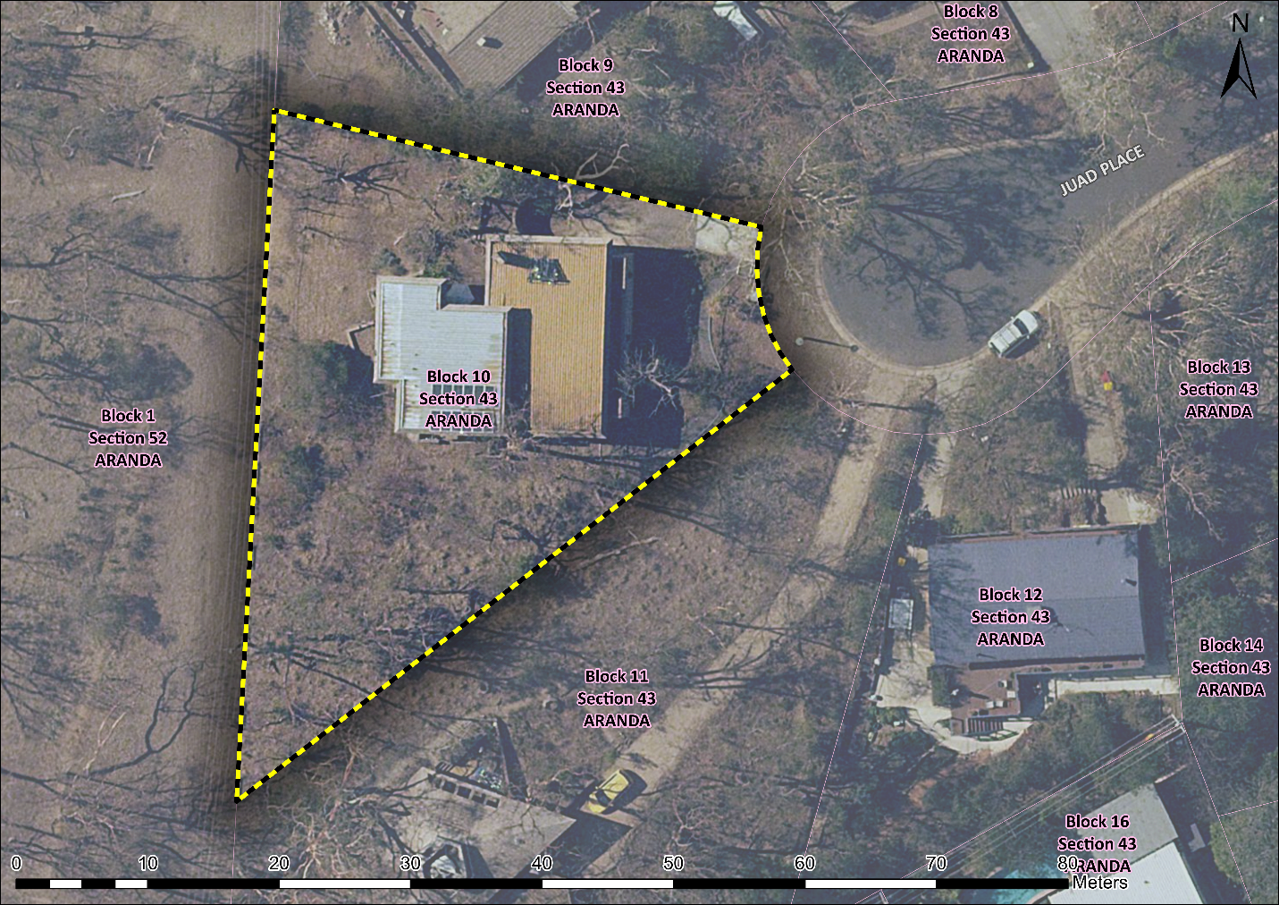
Figure 1 – Provisional registration boundary for Paterson House

GML Heritage. 2024. Modernist Houses in the Australian Capital Territory: Thematic Heritage Study. Canberra. pp. 28ff. Retrieved from https://gml.com.au/projects/thematic-heritage-study-act-modernist-houses/
Ibid.
Drawn from: Charlton, Favaro, & Jones. 2007. The Contribution of Enrico Taglietti to Canberra’s Architecture. Royal Australian Institute of Architects (RAIA), ACT Chapter. Canberra. pp. 122-126.
No longer existent

