Australian Capital Territory
Planning (Molonglo Valley) Minor Plan Amendment 2026 (No 1)
Notifiable instrument NI2026–360
made under the
Planning Act 2023, s 85 (Making minor plan amendments)

1 Name of instrument
This instrument is the Planning (Molonglo Valley) Minor Plan Amendment 2026 (No 1).
2 Commencement
This instrument commences on the day after its notification day.
3 Minor plan amendment
I make Minor Plan Amendment 2026-08 as contained in schedule 1.

James Bennett
Delegate of the territory planning authority
16 July 2026

Schedule 1
(see s3)
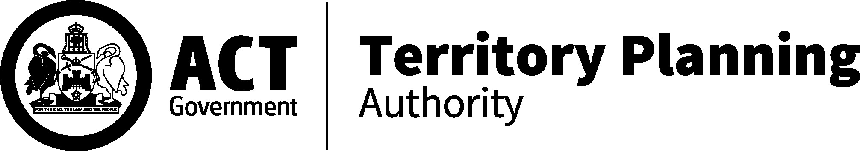

MINOR AMENDMENT
TO THE TERRITORY PLAN
2026-08

Amendments to the Molonglo Valley District Policy and rezoning under future urban area in the division of Molonglo

This minor plan amendment was prepared
under part 5.3 of the Planning Act 2023
Contents
1.0 INTRODUCTION 1
1.1 Outline of the process 1
1.2 Summary of the amendments 2
1.3 Summary of changes to technical specifications 2
2.0 CONSULTATION WITH THE PUBLIC 4
2.1 Consultation period 4
2.2 Comments from the public 4
2.3 Changes made following consultation 5
3.0 TERRITORY PLAN CHANGES 6
3.1 Molonglo Valley District Policy 6
3.2 Territory Plan Map 7
3.3 Changes to Molonglo Valley District Specifications 11
4.0 TERRITORY PLAN AMENDMENT INSTRUCTIONS 13
4.1 Part D: D05 – Molonglo Valley District Policy 13
4.2 Part B – Territory Plan Map 14
INTERPRETATION SERVICE 15

- INTRODUCTION
  - Outline of the process
Minor plan amendment 2026-08 (MA2026-08) to the Territory Plan is a minor plan amendment (MA) prepared under section 84 (2) (d) and (e) and section 89(1) of the Planning Act 2023 (the Act).

Section 84 of the Act outlines the different types of MAs, some which require limited consultation to be undertaken and some which require no consultation to be undertaken.

Under Section 85 of the Act an MA can only be made where:
- any required limited consultation has taken place and the authority is satisfied that the content of the MA meets the requirements of the Act
- if the MA is not inconsistent with the planning strategy or any relevant district strategy
- any comments received during the consultation period and from the National Capital Authority have been considered.

This MA requires limited consultation to be undertaken and was released for public consultation in accordance with the Act.

The MA is not inconsistent with the planning strategy and the Molonglo Valley District Strategy.

The National Capital Authority has received a copy of this MA.

For more information on the content of the Territory Plan and minor plan amendment processes please refer to the Planning website: The Territory Plan - City and Environment Directorate - Planning

  - Summary of the amendments
MA2026–08 makes the following changes:

Molonglo Valley District Policy

Area specific assessment outcomes:

- amend assessment outcome 3 to clarify the intentions around place making and built form for the Molonglo town centre and surrounds reflective of the ACT Government’s most recent master planning for the district

- clarify that assessment outcome 9 regarding views only applies to assessment of subdivision proposals while the land remains within a future urban area

Assessment requirements

- amend Assessment Requirement 36 to specify that the part of the provision referencing assessment outcomes for building heights does not include Assessment Outcome 9

Territory Plan Map

- Change the indicative land use zone of the parcel of land shown as the ‘subject site’ on the Territory Plan Map at figures 2 and 3 from Residential RZ3 Urban Residential Zone to RZ5 High Density Zone

  - Summary of changes to technical specifications

Technical specifications may be used as guidance in how to meet the relevant assessment outcomes in the Territory Plan in the preparation and assessment of a development application. Technical Specifications may not be met if a development can demonstrate it can meet all the relevant provisions of the Territory Plan.

The technical specifications are not part of the Territory Plan. They are being amended to take effect separately but concurrently when this MA commences.

An explanation of the changes to the Molonglo Valley District Specifications is provided along with the Territory Plan changes (changes to the relevant district policy) being made via this minor amendment, as they provide the benchmark guidance for consideration of appropriate building heights within the Molonglo Town Centre and surrounds.

To give effect to the intended development subject to the area specific assessment outcomes in the Molonglo Valley District Policy, the following amendments to the Molonglo Valley District Specifications are made:

- Revised to align with the amendments to the area specific assessment outcomes in the Molonglo Valley District Policy

- Figure 26A replaced to reflect the revised heights for the various areas within the Molonglo Town Centre and Surrounds.

- The current specification 3.3 deleted as it is no longer applicable.

- A new Specification introduced that permits increased building heights where a greater proportion of family friendly units are provided along with certain design outcomes.

- A new Specification introduced that permits landmark buildings in areas D and E in Figure 26A.

- CONSULTATION WITH THE PUBLIC
  - Consultation period
Under section 84 (2) of the Planning Act 2023, this minor amendment was subject to limited public consultation of at least 20 working days. Written comments on MA2026-08 were invited from the public from 11 May 2026 until 26 June 2026.
  - Comments from the public
Four written comments were received during the consultation period. One was from a community group (Molonglo Valley Community Forum) and three were from individuals.

Support was expressed for increased height, density, and environmental protections.

The following table provides a summary of the issues raised in public comments:
Key theme | Main issues raised in consultation comments
Employment and economic development | No mandated employment floorspace within the Town Centre; concern the centre will function as a residential satellite or dormitory suburb rather than a mixed-use centre.
Commercial core delivery | Commercial and retail development is proposed to occur after substantial residential development, with no guarantee of early delivery.
Balance of housing vs jobs | Perception that the amendment prioritises housing supply over employment, services and economic activity. Approximately 7,000 dwellings are enabled without corresponding employment requirements.
Infrastructure sequencing | Historical concerns that infrastructure has lagged behind population growth in Molonglo, including roads, services and community facilities.
Transport and connectivity | Requests for early delivery of public transport infrastructure, bus priority along John Gorton Drive, and improved road connections including links to Tuggeranong Parkway.
Community facilities and services | Requests for civic infrastructure such as a library, police station and other community services to be delivered in the first stage of development.
Town Centre function | Concern that changing the centre classification from ‘Group Centre’ to ’Town Centre’ has not been accompanied by stronger commercial or employment requirements.
Land release and staging | Concern that residential land release is being prioritised while commercial development is deferred to later stages. Suggestions that employment outcomes should trigger further residential development.
Planning processes and community confidence | Community members cited previous planning issues in Molonglo, including underestimated population growth, changing plans, delayed infrastructure, and uncertainty regarding earlier centres. This has reduced confidence in planning processes.
Commercial model | Concern that the proposed commercial model relies heavily on big-box retail and a shopping-centre format, with insufficient fine-grain retail and employment-generating uses
Evidence base | Concern that planning has been informed primarily by retail analysis rather than broader employment or economic studies.
Urban outcomes and liveability | Concern that without employment, services and infrastructure being delivered alongside housing, residents will continue to commute outside Molonglo for jobs and services, reducing liveability.

The concerns raised during consultation regarding the above issues are acknowledged and recognised as important matters for the long-term growth and liveability of the district. The Territory Planning Authority notes that these issues reflect broader community aspirations for a well-serviced, employment-generating town centre supported by timely infrastructure and services.

While these matters are not directly related to the scope of this minor amendment, which is limited to facilitating the delivery of residential development in Stage 1 and revisions to the Molonglo Valley District Policy regarding building heights, the ACT Government remains committed to the orderly development of the Molonglo Valley, including the delivery of housing, employment opportunities, transport connections, community facilities and supporting infrastructure. Strategic planning, land release and infrastructure investment will continue to be coordinated across government to support the evolution of Molonglo Valley as a sustainable and thriving community.
  - Changes made following consultation

No changes were made following consultation on MA2026-08.

.
- TERRITORY PLAN CHANGES
  - Molonglo Valley District Policy
The changes to the Molonglo Valley District Policy are required as there is a need for increasing the building heights to deliver the Government’s housing supply targets within the town centre and surrounds to balance increased open space requirements due to the tree retention requirements in accordance with the Urban Forest Act 2023. The increased open space requirements have reduced the developable area available, which has prompted a demand for greater building heights to compensate.

There is also an increased demand across the Territory for family friendly apartments comprising 3 or more bedrooms which development within Molonglo Town Centre will need to reflect and, which has been identified during the most recent master planning work for the area. The demand for larger dwellings for more family friendly urban living opportunities may require additional floorspace and corresponding increase in building heights to achieve the target of 7,000 dwellings to be provided within the Molonglo Town Centre and surrounds.

To provide greater flexibility in facilitating a larger proportion of family friendly apartments containing 3 or more bedrooms, an incentive has been included to allow extra storeys where a greater proportion of family friendly dwellings with 3 or more bedrooms is provided.

Amendments to assessment outcomes

- Amend assessment outcome 3 to clarify the requirements in certain locations and also to provide opportunities for increased building height where development provides a greater proportion of family friendly dwellings consisting of 3 or more bedrooms, in anticipation of the increased floor space requirements for larger apartments.

- Amend assessment outcome 9 to clarify that the consideration for views from the town centre to significant landscape features to be retained is addressed during the subdivision design development application phase only (whilst land is within a future urban area) and not for development applications for individual buildings.

The additional wording / clarification is provided in the underlined text below:
Locality | Assessment outcome
Molonglo Town Centre and surrounds  (Figure 5) | - Varied building heights, with taller buildings having slender footprints, encourages built form that responds to existing topography and the natural environment, and generally provides a gradual transition in height and scale. Lower buildings are located in the suburban areas, with the tallest buildings in the commercial centre and along major transport corridors. A variety of heights are provided across the Town Centre and surrounds to create architecturally interesting streetscapes and provide views to the river corridor and broader landscape, with additional height considered for buildings that incorporate a greater proportion of apartments that incorporate 3 or more bedrooms and functional, generous environments for family living.
Molonglo Town Centre and Surrounds – Future Urban Areas (Figure 5) | - Views from the town centre to significant landscape features, such as Black Mountain are retained, to assist people to easily navigate the town centre and promote a sense of place.

Amendments to assessment requirements

Assessment requirement 36 is revised to reflect that the consideration of the range of building heights and locations within the town centre and surrounds is controlled by Assessment Outcomes 3-8.

The additional wording clarification is provided in the underlined / strikethrough text below:
Locality | Assessment requirement
Building Height | - Residential development to a maximum of 6 storeys is permitted at group and local centres. This does not apply to the Molonglo Town Centre and surrounds (Figure 5) as building heights in this area are controlled by Assessment Outcomes 3-89.

To remove any doubt, Assessment Requirement 36 and the corresponding Assessment Outcomes 3-8 (specifically Assessment Outcome 3 pertaining to building heights) in the Molonglo Valley District Policy over-ride the building height limits in the Residential Zones Policy. This is articulated in Part A Administration and Governance in the Territory Plan to the effect that assessment requirements in district policies will prevail where inconsistencies occur (ref. section A.4. How to use the Territory Plan).
  - Territory Plan Map
The Territory Plan map is amended by rezoning the subject site as indicated in figures 1, 2 and 3 from Residential RZ3 – Urban Residential Zone to RZ5 - High Density Residential Zone. This amendment brings the indicative zoning under future urban area (FUA) into line with the future development intentions of this parcel of land for high density residential development.

The rezoning under FUA is not inconsistent with the Molonglo Valley District Strategy as the subject site is within the Category 1 change area and is in close proximity to the Molonglo Town Centre and therefore can support the objectives of achieving higher densities close to services, recreational and community facilities, public transport and employment. The rezoning to permit higher density residential development will also contribute towards meeting the 700 dwelling target for this location.

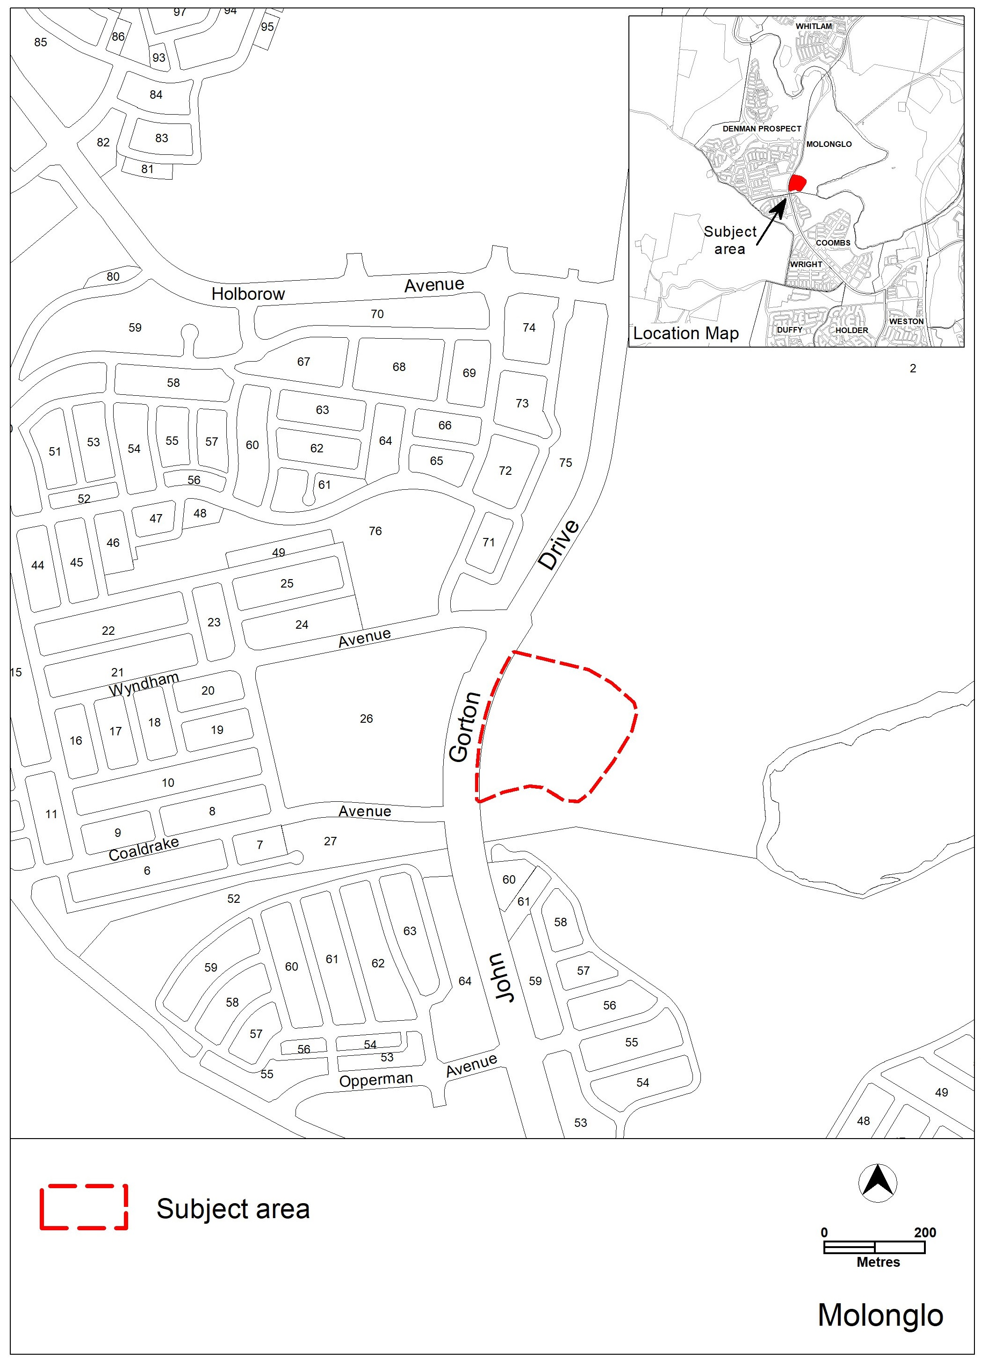
Figure 1 – Location map for rezoning of subject site
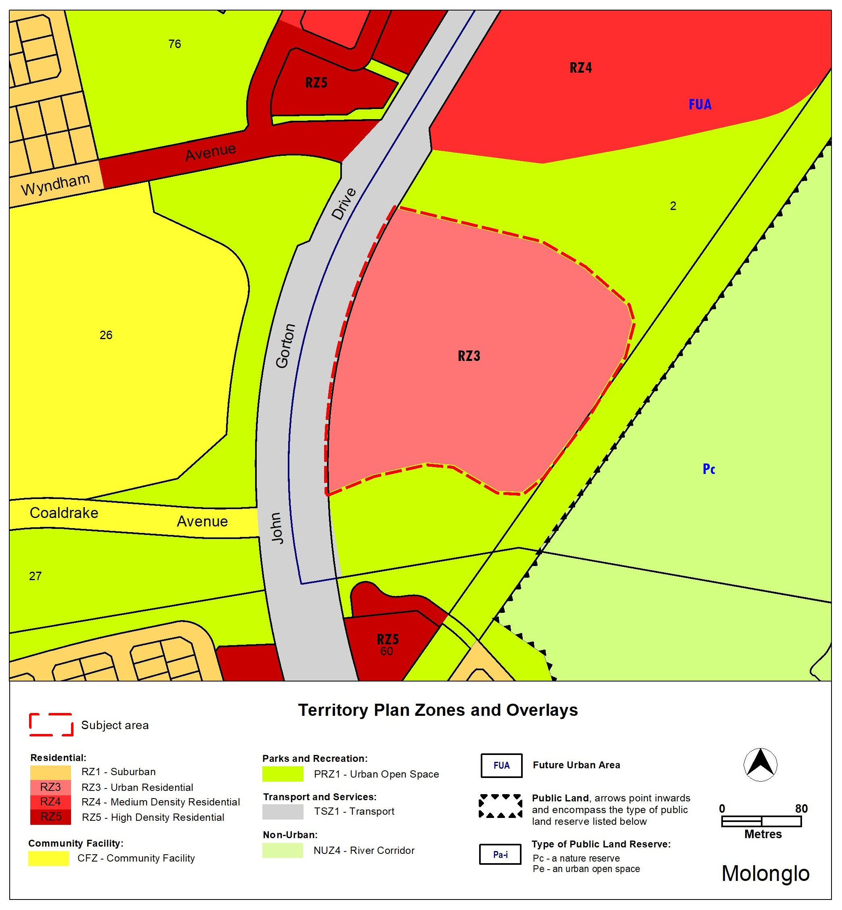
Figure 2: Existing Territory Plan Map – Molonglo Town Centre and surrounds

The Territory Plan Map is proposed to be amended as follows:

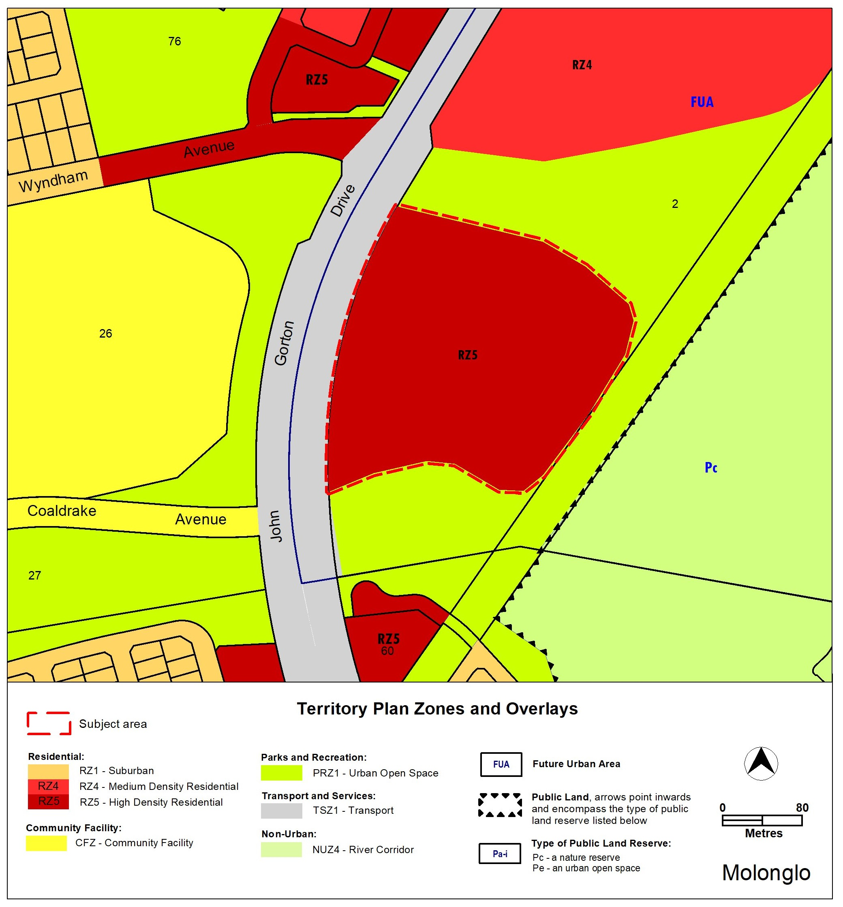
Figure 3: Proposed Territory Plan Map – Molonglo Town Centre and surrounds

  - Changes to Molonglo Valley District Specifications
The changes to the Molonglo Valley District Specifications are provided in strike-through and underlined text below:
Assessment Outcome 3 | Varied building heights, with taller buildings having slender footprints, encourages built form that responds to existing topography and the natural environment, and generally provides a gradual transition in height and scale. Lower buildings are located in the suburban areas with the tallest buildings in the commercial centre and along major transport corridors. A variety of heights are provided across the Town Centre and surrounds to create architecturally interesting streetscapes and provide views to the river corridor and broader landscape, with additional height considered for buildings that incorporate a greater proportion of apartments that incorporate 3 or more bedrooms and functional, generous environments for family living.
Specification
Building Heights | - A range of building heights, including maximum building heights are indicated in Figures 26A and 26B.  - In the area shown on Figure 26A as hatched, one building up to 29 metres (approximately 8 storeys) is permitted where building design contributes to a safe and interesting streetscape  - Taller buildings are to be carefully distributed at key locations which may include corners and sites adjacent to park or plaza frontages.  - For the areas shown in Figure 26A where residential development is proposed, the maximum height of a building may be increased by an additional 3 storeys, where the building achieves all of the following:  - the dwelling mix of the units in the building seeking the additional height is a:  - maximum 25% 1 bedroom units;  - maximum 40% 2 bedroom units; and  - minimum 35% 3 or more bedroom units,  - there is a clear difference in height between buildings within a block so that building height is not the same across the buildings in the precinct; and  - the proposal demonstrates a positive contribution to the streetscape.  - In areas D and E shown in Figure 26A one landmark building up to the height indicated is permitted per hectare of development footprint.  Note: Plant room that is set back a minimum of 3m from the building façade of the floor immediately below, and screening and other non-gross floor area rooftop architectural features are excluded from the building height.

The revised Figure 26A:
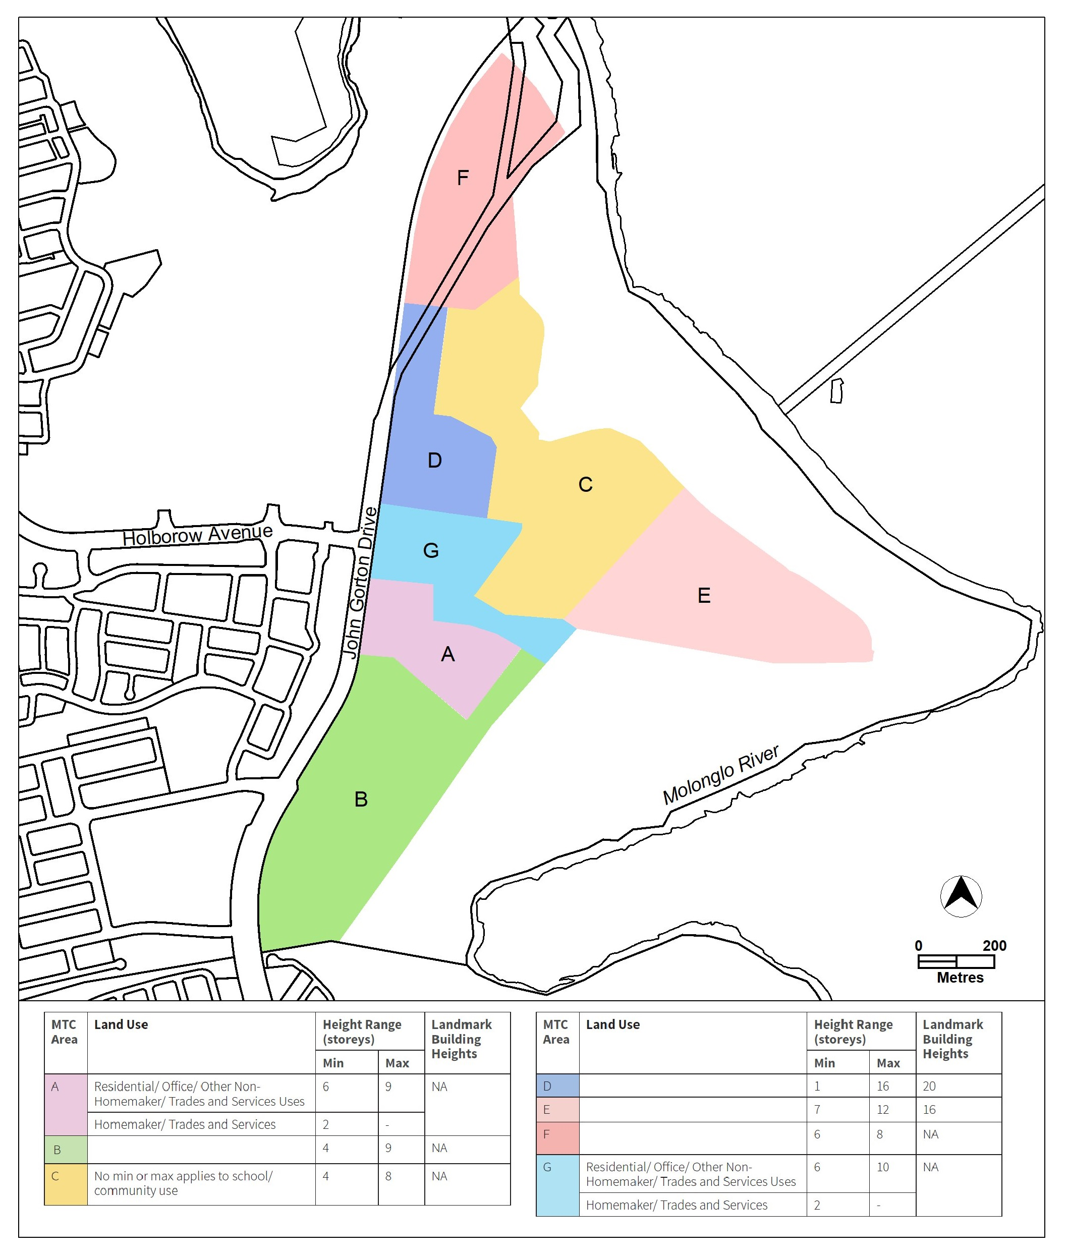

The Molonglo Valley District Specifications are available on the CED Planning website here.

- TERRITORY PLAN AMENDMENT INSTRUCTIONS
This section provides the legal instructions for how MA2026-08 amends the Territory Plan.
  - Part D: D05 – Molonglo Valley District Policy

Area specific assessment outcomes

Assessment Outcome 3:

Substitute

Locality | Assessment outcome
Molonglo Town Centre and surrounds  (Figure 5) | - Varied building heights, with taller buildings having slender footprints, encourages built form that responds to existing topography and the natural environment, and generally provides a gradual transition in height and scale. Lower buildings are located in the suburban areas, with the tallest buildings in the commercial centre and along major transport corridors. A variety of heights are provided across the Town Centre and surrounds to create architecturally interesting streetscapes and provide views to the river corridor and broader landscape, with additional height considered for buildings that incorporate a greater proportion of apartments that incorporate 3 or more bedrooms and functional, generous environments for family living.

Hyperlink text referring to Figure 5 to the corresponding Figure 5.

Assessment Outcome 9

Substitute

Locality | Assessment outcome
Molonglo Town Centre and Surrounds – Future Urban Areas (Figure 5) | - Views from the town centre to significant landscape features, such as Black Mountain are retained, to assist people to easily navigate the town centre and promote a sense of place.

Hyperlink text referring to Figure 5 to the corresponding Figure 5.

Assessment Requirement 36

Substitute

Locality | Assessment requirement
Building Height | - Residential development to a maximum of 6 storeys is permitted at group and local centres. This does not apply to the Molonglo Town Centre and surrounds (Figure 5) as building heights in this area are controlled by Assessment Outcomes 3-8.

Hyperlink text referring to Figure 5 to the corresponding Figure 5.

  - Part B – Territory Plan Map
The relevant part of the Territory Plan map is varied as indicated below.

Molonglo Town Centre and surrounds

INTERPRETATION SERVICE
To speak to someone in a language other than English please telephone the Telephone Interpreter Service (TIS) 13 14 50
LANGUAGE | DETAILS
English | If you need an interpreter please call: 13 14 50
Mandarin (Simplified Chinese) / 简体中文 | 如果您需要翻译，请致电：13 14 50
Arabic / العربية | إذا كنت بحاجة إلى مترجم شفهي اتصل بالرقم: 50 14 13
Cantonese (Traditional Chinese) / 繁體中文 | 如果你需要傳譯員，請致電：13 14 50
Vietnamese /  Tiếng Việt | Nếu bạn cần thông dịch viên, xin gọi: 13 14 50
Korean / 한국어 | 통역사가 필요할 경우 다음 번호로 전화하시기 바랍니다: 13 14 50
Spanish / Español | Si necesita un intérprete, llame al 13 14 50
Persian (Farsi) / فارسی | اگر به مترجم نیاز دارید، لطفاً به این شماره تلفن کنید: 50 14 13
Dari / دری | اگر به یک ترجمان شفاهی نیاز دارید لطفاً به شمارۀ 131450 زنگ بزنید.
Punjabi / ਪੰਜਾਬੀ | ਜੇਕਰ ਤੁਹਾਨੂੰ ਕਿਸੇ ਦੁਭਾਸ਼ੀਏ ਦੀ ਲੋੜ ਹੈ ਤਾਂ ਕਿਰਪਾ ਕਰਕੇ ਫੋਨ ਕਰੋ: 13 14 50
Tamil / தமிழ் | உங்களுக்கு மொழிபெயர்த்துரைப்பாளர் ஒருவர் தேவைப்பட்டால் 13 14 50 என்ற எண்ணை அழைக்கவும்
Greek / Ελληνικά | Αν χρειάζεστε διερμηνέα, τηλεφωνήστε: 13 14 50
Italian / Italiano | Se hai bisogno di un interprete, chiama: 13 14 50
Hazaragi / هزاره گی | اگه ده ترجمان ضرورت ده رید، لطفاً ده شماره 50 14 13 تماس بگیرید.
Thai / ภาษาไทย | หากคุณต้องการล่าม กรุณาโทรไปที่ 13 14 50
Karen / ကညီကျိၥ် | ဖဲနမ့ၢ်လိၣ်ဘၣ်ပှၤကတိၤကျိးထံတၢ်တဂၤအခါ၀ံသးစူၤကိးဘၣ်-၁၃၁ ၄၅၀ တက့ၢ်.

Telephone and Interpreter Service 13 14 50 - Canberra and District - 24 hours a day, seven days a week

