Australian Capital Territory
Planning (Jacka FUA Uplift) Minor Plan Amendment 2026 (No 1)
Notifiable instrument NI2026-373
made under the
Planning Act 2023, s 85 (Making minor plan amendments)

1 Name of instrument
This instrument is the Planning (Jacka FUA Uplift) Minor Plan Amendment 2026 (No.1).
2 Commencement
This instrument commences on the day after its notification day.
3 Minor plan amendment
I make Minor Plan Amendment 2026-10 as contained in schedule 1.

James Bennett
Delegate of the territory planning authority
21 July 2026

Schedule 1
(see s3)


MINOR PLAN AMENDMENT
TO THE TERRITORY PLAN
2026-10
Jacka FUA uplift

This minor plan amendment was prepared
under part 5.3 of the Planning Act 2023
Contents
1.0 INTRODUCTION 1
1.1 Outline of the process 1
1.2 Summary of the proposal 1
2.0 TERRITORY PLAN CHANGES 2
2.1 Part B – Territory Plan Map 2
3.0 TERRITORY PLAN AMENDMENT 5
3.1 Amendment to the Territory Plan Maps (Part B) 5
INTERPRETATION SERVICE 6

- INTRODUCTION
  - Outline of the process
Minor plan amendment 2026-10 (MA2026-10) to the Territory Plan is a minor plan amendment (MA) prepared under section 84 (1) (c) of the Planning Act 2023 (the Act).

Section 84 of the Act outlines the different types of MAs, some which require limited consultation to be undertaken and some which do not require consultation to be undertaken. This MA is consistent with the provisions under section 84 (1) (c) of the Act and therefore no consultation is needed.

Under Section 85 of the Act a MA can only be made if the MA is not inconsistent with the planning strategy or any relevant district strategy.

The MA is not inconsistent with the planning strategy or the Gungahlin district strategy.

The National Capital Authority will be advised of this MA.

For more information on the content of the Territory Plan and minor plan amendment processes please refer to the planning website www.planning.act.gov.au/professionals/our-planning-system/the-territory-plan/amendments-to-the-territory-plan.

  - Summary of the proposal
MA2026-10 proposes to:
- remove part of the future urban area overlay from land in the division of Jacka and add ongoing provisions consistent with the approved subdivision design application (related to DA201936527 and DA202544262).

- TERRITORY PLAN CHANGES
MA2026-10 makes changes to parts of the following Territory Plan documents:
- Part B – Territory Plan Map

  - Part B – Territory Plan Map
The Territory Plan map is varied to identify the zones and overlays that apply to land ceasing to be in a future urban area.

Jacka - Location map

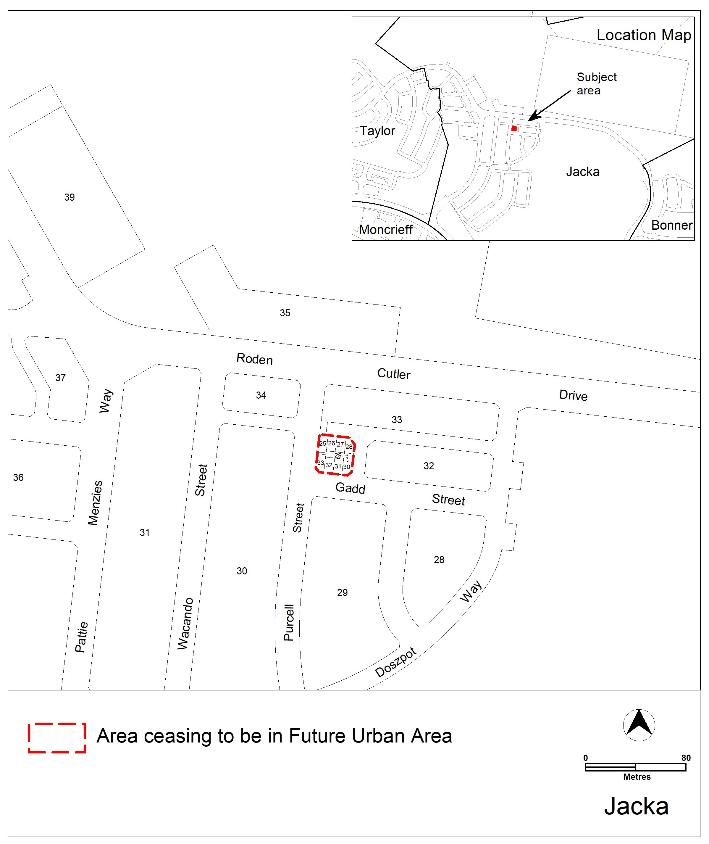

Jacka – Existing Territory Plan map

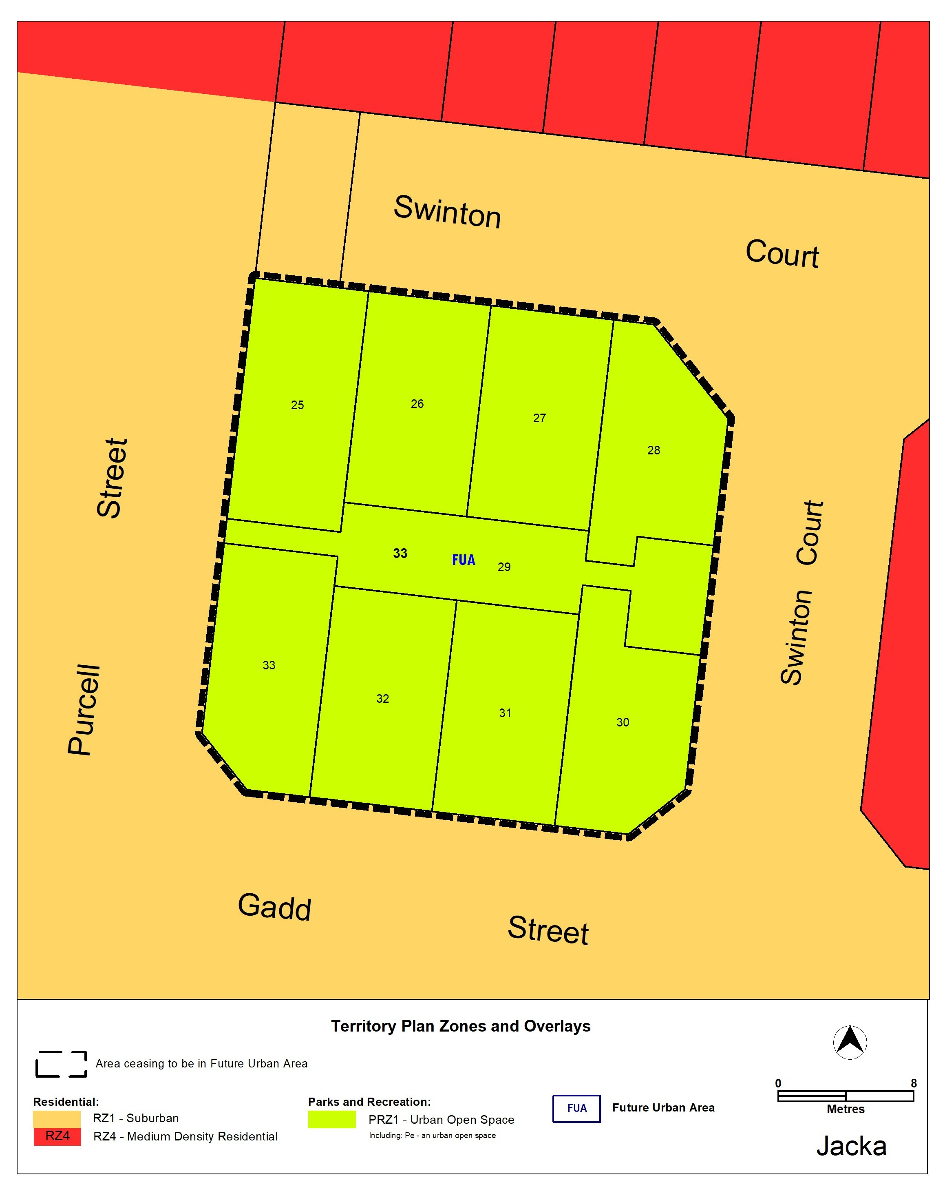

Jacka – updated Territory Plan map

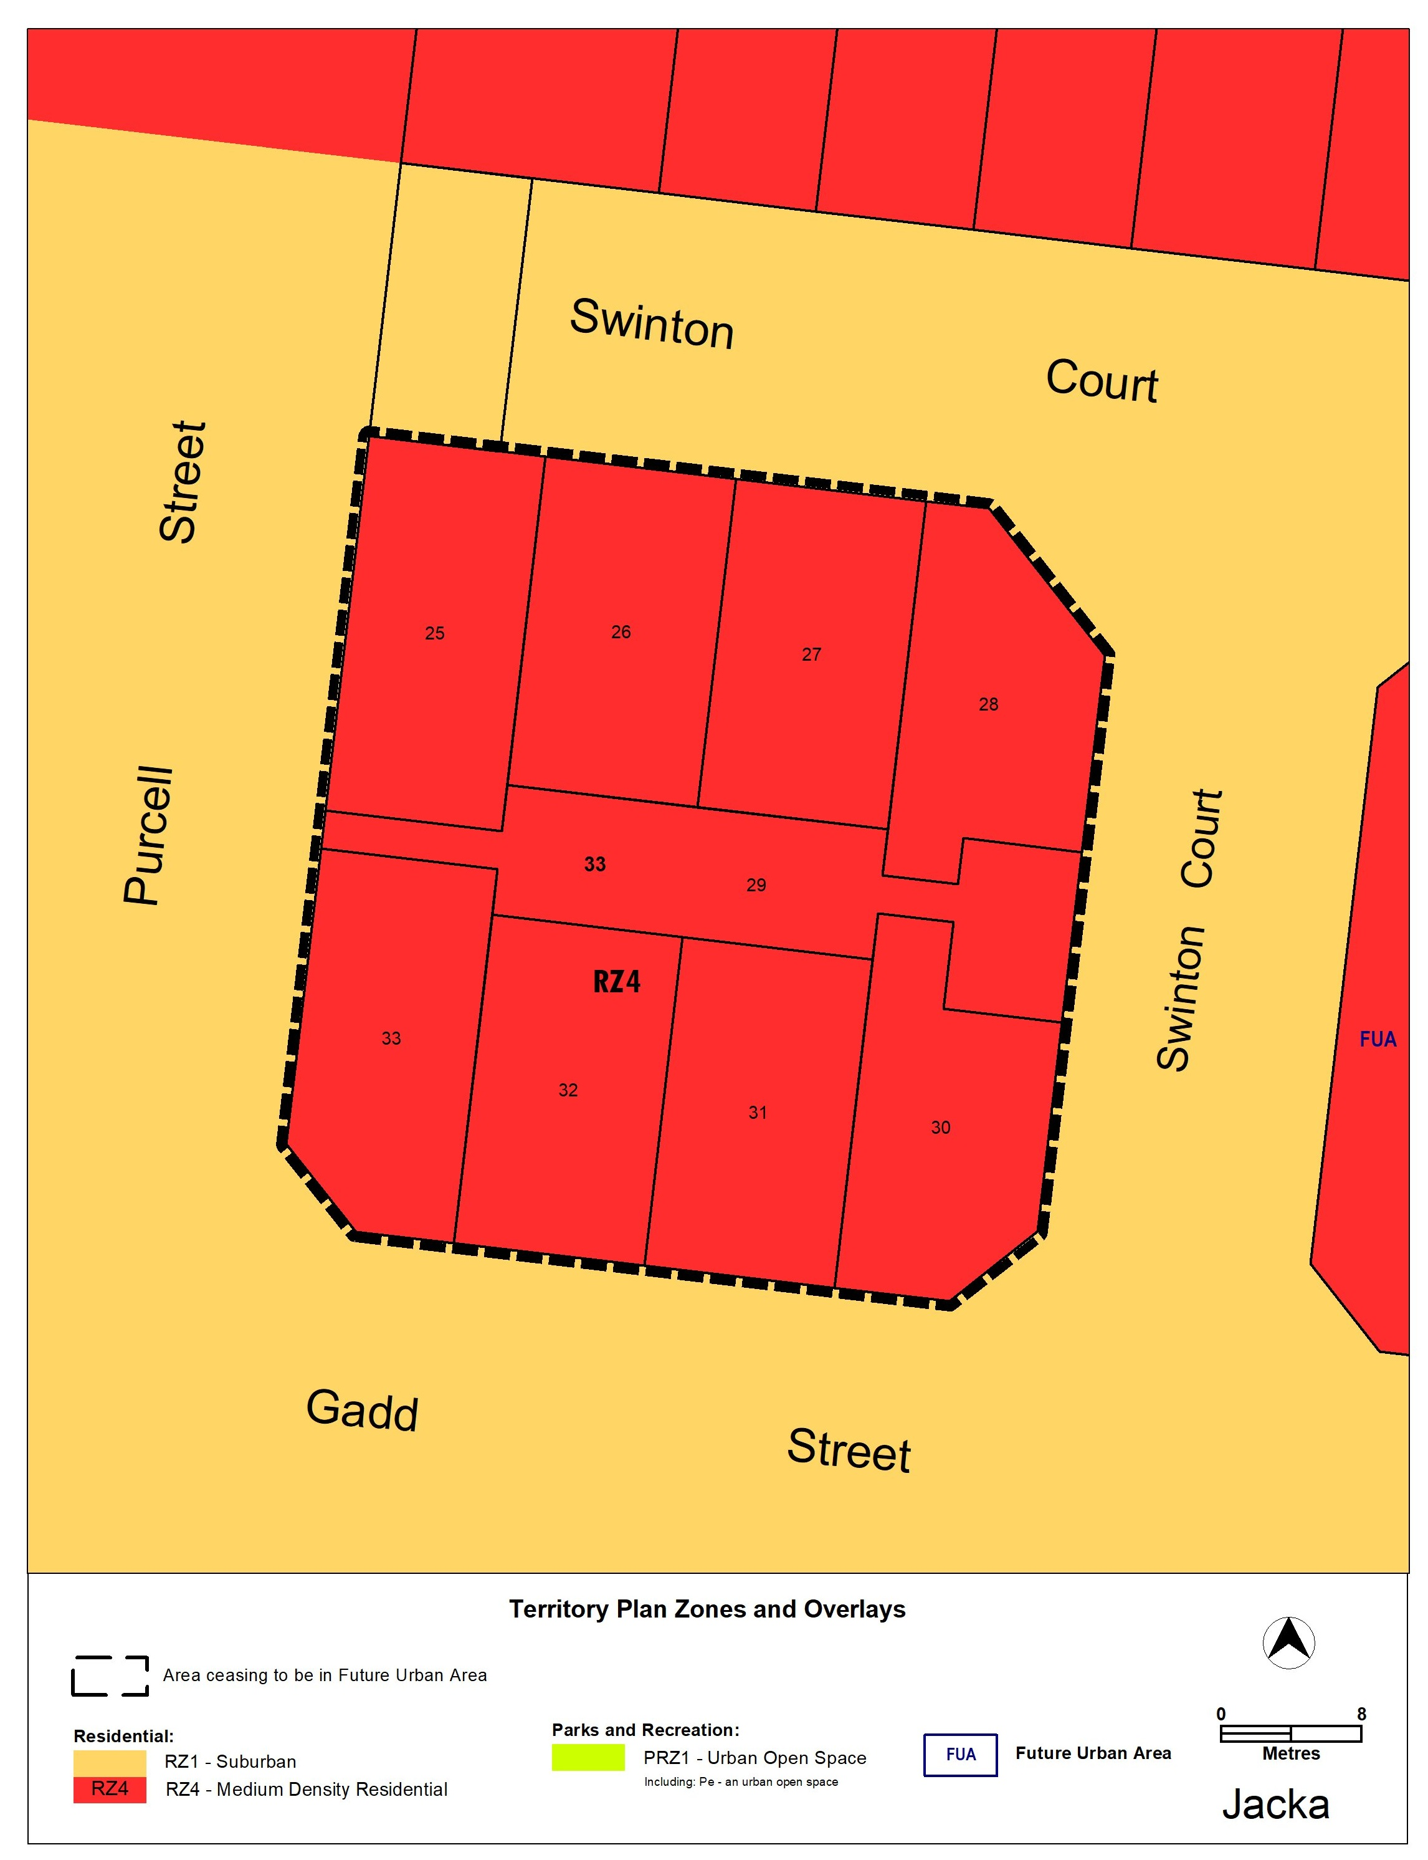

- TERRITORY PLAN AMENDMENT
  - Amendment to the Territory Plan Maps (Part B)
- Territory Plan map

The relevant part of the Territory Plan map is varied as indicated below.

INTERPRETATION SERVICE
To speak to someone in a language other than English please telephone the Telephone Interpreter Service (TIS) 13 14 50
LANGUAGE | DETAILS
English | If you need an interpreter please call: 13 14 50
Mandarin (Simplified Chinese) / 简体中文 | 如果您需要翻译，请致电：13 14 50
Arabic / العربية | إذا كنت بحاجة إلى مترجم شفهي اتصل بالرقم: 50 14 13
Cantonese (Traditional Chinese) / 繁體中文 | 如果你需要傳譯員，請致電：13 14 50
Vietnamese /  Tiếng Việt | Nếu bạn cần thông dịch viên, xin gọi: 13 14 50
Korean / 한국어 | 통역사가 필요할 경우 다음 번호로 전화하시기 바랍니다: 13 14 50
Spanish / Español | Si necesita un intérprete, llame al 13 14 50
Persian (Farsi) / فارسی | اگر به مترجم نیاز دارید، لطفاً به این شماره تلفن کنید: 50 14 13
Dari / دری | اگر به یک ترجمان شفاهی نیاز دارید لطفاً به شمارۀ 131450 زنگ بزنید.
Punjabi / ਪੰਜਾਬੀ | ਜੇਕਰ ਤੁਹਾਨੂੰ ਕਿਸੇ ਦੁਭਾਸ਼ੀਏ ਦੀ ਲੋੜ ਹੈ ਤਾਂ ਕਿਰਪਾ ਕਰਕੇ ਫੋਨ ਕਰੋ: 13 14 50
Tamil / தமிழ் | உங்களுக்கு மொழிபெயர்த்துரைப்பாளர் ஒருவர் தேவைப்பட்டால் 13 14 50 என்ற எண்ணை அழைக்கவும்
Greek / Ελληνικά | Αν χρειάζεστε διερμηνέα, τηλεφωνήστε: 13 14 50
Italian / Italiano | Se hai bisogno di un interprete, chiama: 13 14 50
Hazaragi / هزاره گی | اگه ده ترجمان ضرورت ده رید، لطفاً ده شماره 50 14 13 تماس بگیرید.
Thai / ภาษาไทย | หากคุณต้องการล่าม กรุณาโทรไปที่ 13 14 50
Karen / ကညီကျိၥ် | ဖဲနမ့ၢ်လိၣ်ဘၣ်ပှၤကတိၤကျိးထံတၢ်တဂၤအခါ၀ံသးစူၤကိးဘၣ်-၁၃၁ ၄၅၀ တက့ၢ်.

Telephone and Interpreter Service 13 14 50 - Canberra and District - 24 hours a day, seven days a week

