Australian Capital Territory
Planning (Telopea Park School) Major Plan Amendment 2026
Notifiable instrument NI2026–409
made under the
Planning Act 2023, s 75 (Minister’s powers in relation to draft plan amendments)

1 Name of instrument
This instrument is the Planning (Telopea Park School) Major Plan Amendment 2026.
2 Major plan amendment
(1) I approve under section 75 (2) (a) of the Planning Act 2023 (the Act) the Major Plan Amendment 10 to the Territory Plan.
(2) In accordance with the Act, section 75 (5) (c), a major plan amendment must be presented to the Legislative Assembly and may only commence by commencement notice under section 80 (2).
3 Dictionary
In this instrument:
Major Plan Amendment 10 to the Territory Plan means the Major Plan Amendment in schedule 1.
Chris Steel MLA
Minister for Planning and Sustainable Development
10 September 2026

Schedule 1
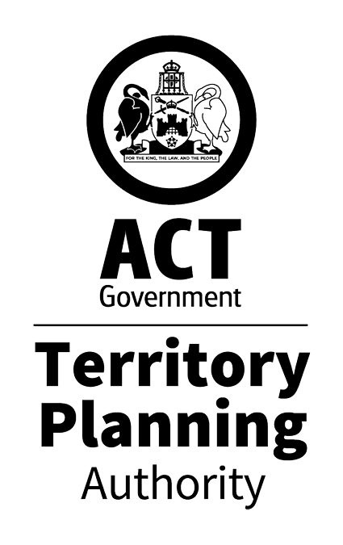
MAJOR PLAN AMENDMENT to the
TERRITORY PLAN 10
Expansion of Telopea Park School facilities
Rezoning from PRZ2 Restricted Access Recreation Zone to CFZ Community Facility Zone
Forrest Section 36 Blocks 4 and 5 and adjoining road reserve
September 2026
This major plan amendment was prepared
under division 5.2.7 of the Planning Act 2023
Contents
1.0 Introduction 1
1.1 Purpose 1
1.2 Outline of the process 1
2.0 SUMMARY OF MAJOR PLAN AMENDMENT 10 2
2.1 Site description 2
2.2 Summary of amendments to the Territory Plan 4
2.3 Amendment to Territory Plan policies, design guides and specifications 4
3.0 Need for the MAJOR Plan Amendment 7
4.0 Consultation 8
4.1 Consultation with entities 8
4.2 Consultation with the public 8
5.0 Major Plan Amendment 10 9
5.1 Amendments to the Territory Plan map 9
5.2 Amendments to the Inner South District Policy 10
INTERPRETATION SERVICE 11

- Introduction
  - Purpose
This document is Draft Major Plan Amendment 10 - Expansion of Telopea Park School facilities (DPA-10) to the Territory Plan.

Under section 67 of the Planning Act 2023 (the Planning Act) the Territory Planning Authority (the Authority) is giving DPA-10 to the Minister for Planning and Sustainable Development (the Minister) for referral to the relevant Legislative Assembly Standing Committee (the Standing Committee) and, where relevant, action under section 75 of the Planning Act.

Key parts of this document are:
- section 2 – summarises the proposal, including amendments this DPA proposes to make to the Territory Plan
- section 3 – discussion on the need for the draft major plan amendment
- section 4 – summary of entity and public consultation
- section 5 – detailed amendment instructions to the Territory Plan proposed by this DPA
- section 6 – details about interim effect
  - Outline of the process
A major plan amendment (MPA) is a statutory process under the Planning Act that enables the Territory Plan to be amended. The three types of MPAs are:
- Proponent-initiated
- Authority-initiated
- Minister-initiated

DPA-10 is an Authority-initiated MPA.

Under section 63 of the Planning Act, the Authority made DPA-10 available for public comment from 13 February 2026 to 30 March 2026. 44 public comments were received during the consultation period, with one late comment received on 14 April 2026. Following consultation, the Authority considered whether to revise or withdraw the DPA.

The Authority gave the DPA to the Minister who then referred the recommended DPA to the relevant Standing Committee. The Standing Committee chose not to inquire and report on the DPA. The Minister cannot take action on the DPA until the committee provides its report, or decides it will not provide a report.

Following this, the Minister may take action in relation to the DPA. Should the DPA be approved, the DPA becomes a Major Plan Amendment and the Minister must present it to the Legislative Assembly. If it is not rejected by the Legislative Assembly, the MPA will commence and become part of the Territory Plan.

For more information about the content of the Territory Plan and the major plan amendment processes please refer to the ACT Planning website.
- SUMMARY OF MAJOR PLAN AMENDMENT 10
  - Site description
The subject site, as shown in Figure 1, consists of Forrest Section 36 Blocks 4 and 5 and parts of the road reserve for New South Wales Crescent and Manuka Circle.

The subject site, as shown in Figure 2, is currently zoned PRZ2. Block 5 currently accommodates a range of informal community uses, functioning as open space for outdoor recreation, providing occasional parking, and containing tennis courts. These facilities are used intermittently by local residents, Telopea Park School, and workers associated with certain Manuka Oval events.

Block 4 is a pedestrian path, located along the north-western boundary of Block 5 and separates Block 5 from a Commercial CZ5 – Mixed Use zoned area consisting of offices and multi-unit residential development.

Directly to the north of the site is the Telopea Park School, which is zoned CFZ. To the south-west is Fitzroy Street and more CZ5 zoned land which includes a mix of professional offices, physiotherapy services, multi-unit residential developments and the Fire Brigade Historical Society. To the south of the site is the Corroboree Group Oval (Manuka Oval) zoned PRZ2, separated from the subject site by Manuka Circle.

Block 5 is currently utilised as open space with a cluster of four tennis courts located in the eastern corner, available for use by the public. These tennis courts are proposed to be retained within the site.

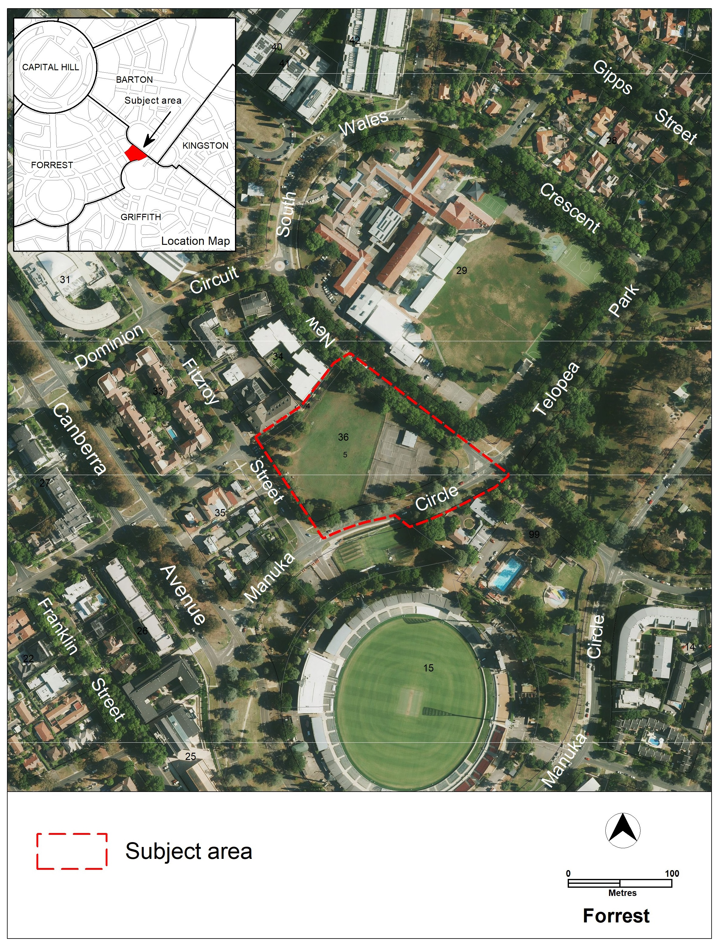
Figure 1 – Locality Map

  - Summary of amendments to the Territory Plan
Telopea Park School is a binational French Australian school and is one of the few schools within the ACT public education system which offers continuous education from Kindergarten through Year 10. The school’s study catchment area includes the suburbs of Kingston, Red Hill, Griffith, Forrest, Barton, Narrabundah, Fyshwick, Beard, Symonston and Oaks Estate. Within this catchment, the school is the designated public high school provider for Years 7 to 10. Expansion of the school is necessary to accommodate the growing school‑aged population in the Inner South district.

DPA-10 proposes to amend the Territory Plan map to rezone Blocks 4 and 5 Section 36 Forrest and parts of the road reserve for New South Wales Crescent and Manuka Circle adjoining Blocks 4 and 5 from PRZ2 Restricted Access Recreation Zone (Figure 2) to Community Facility Zone (CFZ) (Figure 3).

Block 5 Section 36 Forrest
A rezoning to CFZ is required for Block 5 Section 36 Forrest to permit educational establishment uses (as defined in the Territory Plan) and other similar uses on the block. This will allow the future expansion of Telopea Park School’s educational facilities. Educational establishment is not a permitted use on PRZ2 zoned land.

Initial expansion plans for the Telopea Park School are to provide improved facilities, including proposed indoor and outdoor spaces for performing arts, sporting activities and recreational uses. Concept plans highlight the intention to retain the existing tennis courts on site.

This expansion is required to accommodate growing enrolment demand driven by the increasing population in the Inner South community. These new facilities will also be available for public use outside school hours, providing valuable community amenities for the Inner South district.

Block 4 Section 36 Forrest and adjacent road reserves
Block 4 Section 36 is a pedestrian path that provides cross-section pedestrian access, including to the school and its grounds. Block 4 is under the custodianship of City Presentation and is managed to provide pedestrian access. There is no immediate intention to change or develop this block.

The rezoning of parts of the road reserve for New South Wales Crescent and Manuka Circle is proposed to ensure consistency with the standard practice for the zoning road reserves (where not zoned TSZ1 Transport Zone) to align with the zoning of adjoining parcels of land.

Rezoning Block 4 and the road reserves will avoid leaving residual slivers of unusable PRZ2 land.
  - Amendment to Territory Plan policies, design guides and specifications
No changes are made to the Territory Plan policies, design guides and specifications following public and entity consultation.

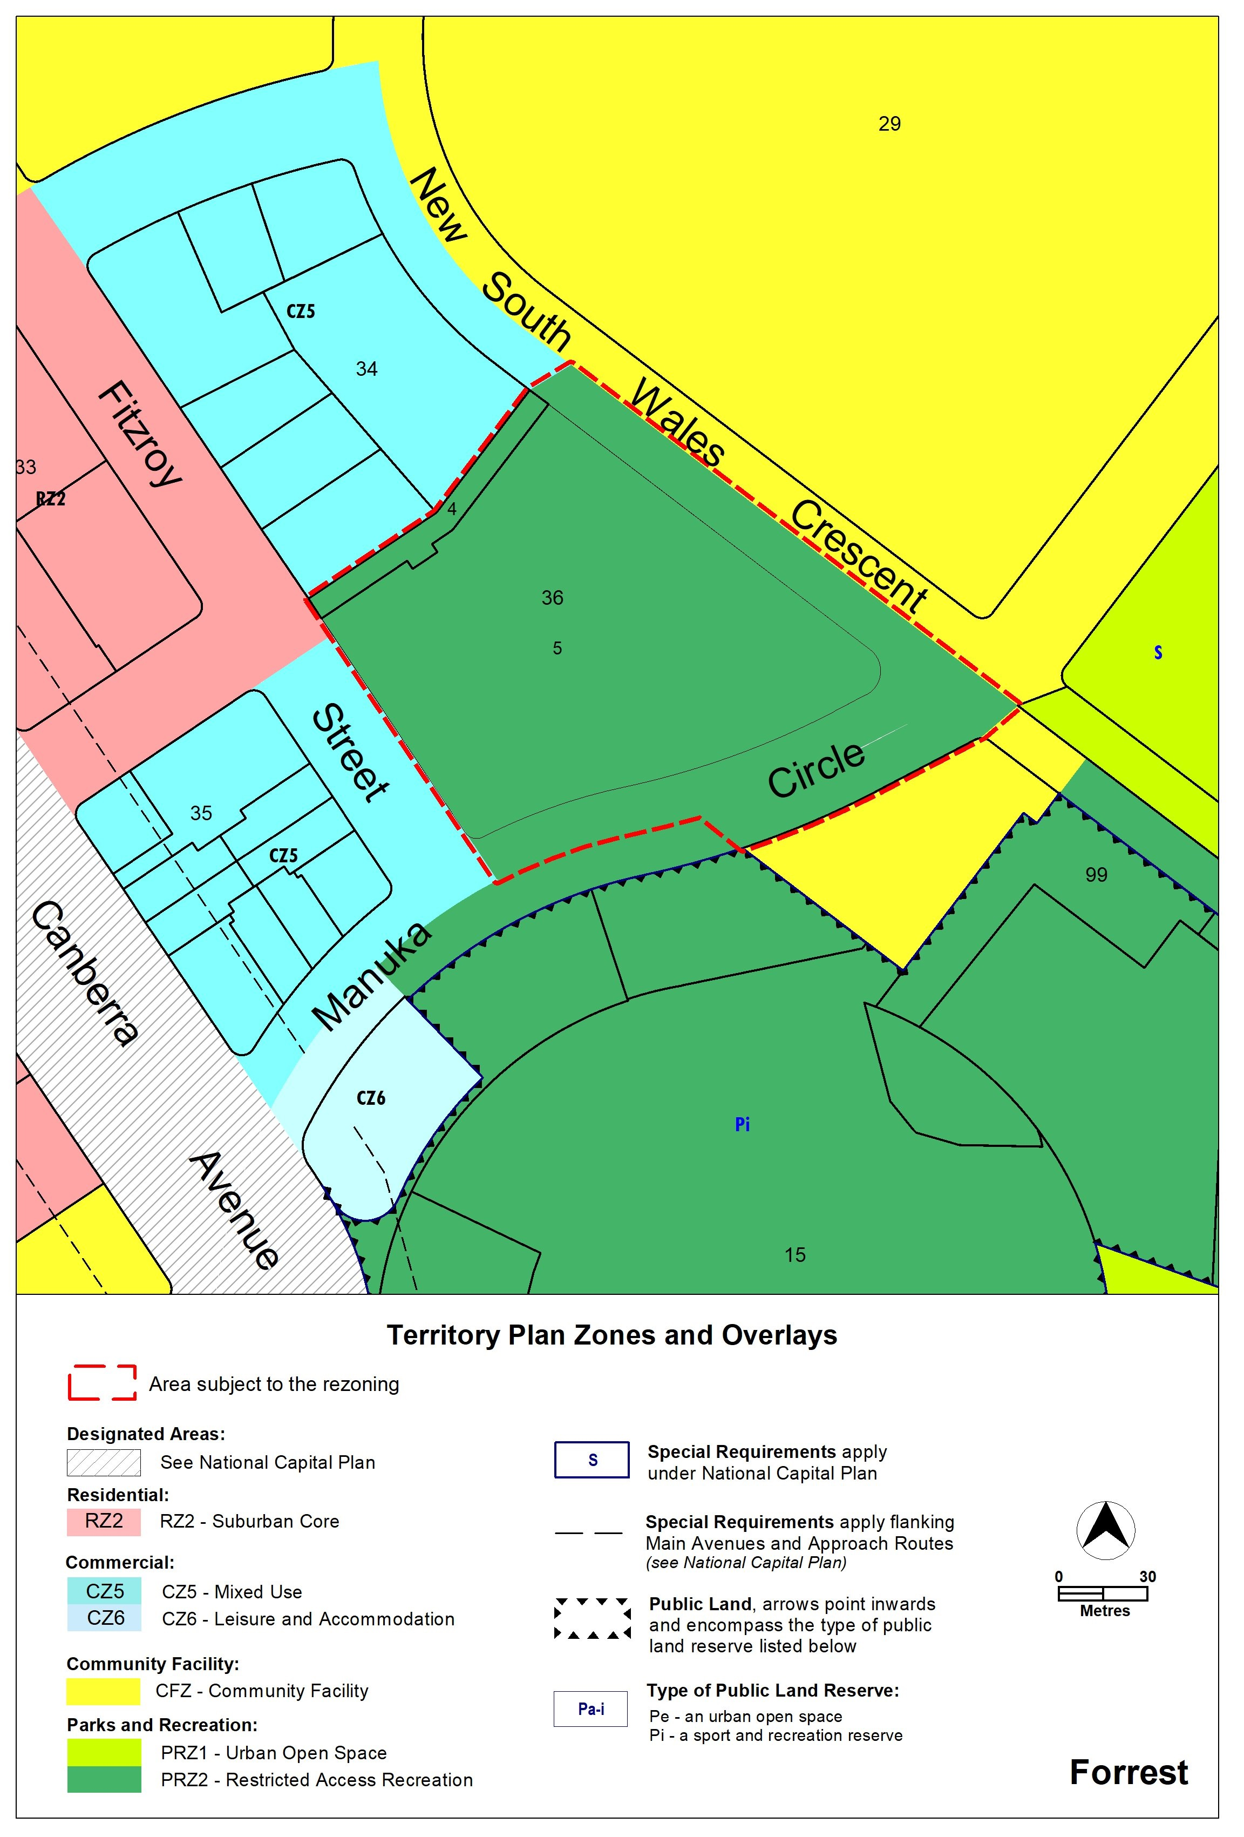
Figure 2 – Existing Territory Plan Map zoning

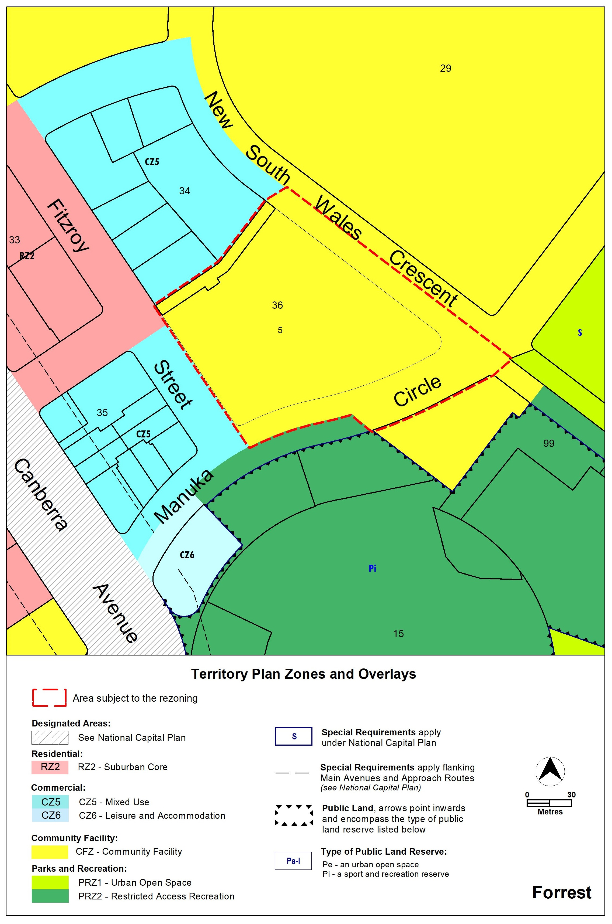
Figure 3 – Proposed Territory Plan Map zoning

- Need for the MAJOR Plan Amendment
A supporting report was prepared for DPA-10 and provided details on:
- the need for the proposed amendment.
- the positive and negative impacts of the proposed amendment.
- how the proposed amendment would give effect to the planning strategy and any relevant district strategy.
- how the proposed amendment would be consistent or inconsistent with relevant planning outcomes contained in other government strategies and policies.
- any consultation undertaken including with required entities who may have an interest in the proposed amendment.

- Consultation
  - Consultation with entities
In accordance with section 62 of the Planning Act the Authority consulted with each of the following in relation to this MPA:
- the National Capital Authority
- the Conservator of Flora and Fauna
- the Environment Protection Authority
- the Heritage Council
- each referral entity
- if unleased or leased public land, each custodian of the land likely to be affected.

Comments received from these and other entities were considered in the preparation of and by the Minister in approving this MPA.
  - Consultation with the public
Written comments were invited from the public on DPA-10 from 13 February 2026 to 30 March 2026.

Forty-four (44) comments were received during the public consultation period, and one late comment was received after the close of the public consultation period on 14 April 2026.

The majority of the comments indicated strong support for the proposed amendment. However, the following concerns were also raised in some of the comments:
- Loss of green open space
- Use of the oval for recreation and dog exercising
- Traffic and parking issues
- Loss of amenity, privacy, and sunlight to nearby residents
- Zoning expectations at the time of purchasing properties on adjoining land.

One change was made to DPA-10 following public and entity consultation. An assessment requirement was included in the Inner South District Policy for Block 5 Section 36 Forrest requiring an environmental assessment report for the development to be endorsed by the Environment Protection Authority (EPA).

- Major Plan Amendment 10
  - Amendments to the Territory Plan map
The relevant part of the Territory Plan map is varied in accordance with Figure 4.

Figure 4 – Proposed Territory Plan Map
  - Amendments to the Inner South District Policy
Under ‘Assessment Requirements’, insert the following under ‘Assessment requirement’ for Forrest:

Control | Assessment requirement
Forrest
Environmental assessment | 10A. For Block 5 Section 36 Forrest, an environmental assessment report for the development is endorsed by the Environment Protection Authority. Alternatively written advice from the Environmental Protection Authority that the site has been assessed for contamination to its satisfaction is provided.  Note: A condition of development approval may be imposed to ensure compliance with the endorsed environmental assessment report

INTERPRETATION SERVICE
To speak to someone in a language other than English please telephone the Telephone Interpreter Service (TIS) 13 14 50
LANGUAGE | DETAILS
English | If you need an interpreter please call: 13 14 50
Mandarin (Simplified Chinese) / 简体中文 | 如果您需要翻译，请致电：13 14 50
Arabic / العربية | إذا كنت بحاجة إلى مترجم شفهي اتصل بالرقم: 50 14 13
Cantonese (Traditional Chinese) / 繁體中文 | 如果你需要傳譯員，請致電：13 14 50
Vietnamese /  Tiếng Việt | Nếu bạn cần thông dịch viên, xin gọi: 13 14 50
Korean / 한국어 | 통역사가 필요할 경우 다음 번호로 전화하시기 바랍니다: 13 14 50
Spanish / Español | Si necesita un intérprete, llame al 13 14 50
Persian (Farsi) / فارسی | اگر به مترجم نیاز دارید، لطفاً به این شماره تلفن کنید: 50 14 13
Dari / دری | اگر به یک ترجمان شفاهی نیاز دارید لطفاً به شمارۀ 131450 زنگ بزنید.
Punjabi / ਪੰਜਾਬੀ | ਜੇਕਰ ਤੁਹਾਨੂੰ ਕਿਸੇ ਦੁਭਾਸ਼ੀਏ ਦੀ ਲੋੜ ਹੈ ਤਾਂ ਕਿਰਪਾ ਕਰਕੇ ਫੋਨ ਕਰੋ: 13 14 50
Tamil / தமிழ் | உங்களுக்கு மொழிபெயர்த்துரைப்பாளர் ஒருவர் தேவைப்பட்டால் 13 14 50 என்ற எண்ணை அழைக்கவும்
Greek / Ελληνικά | Αν χρειάζεστε διερμηνέα, τηλεφωνήστε: 13 14 50
Italian / Italiano | Se hai bisogno di un interprete, chiama: 13 14 50
Hazaragi / هزاره گی | اگه ده ترجمان ضرورت ده رید، لطفاً ده شماره 50 14 13 تماس بگیرید.
Thai / ภาษาไทย | หากคุณต้องการล่าม กรุณาโทรไปที่ 13 14 50
Karen / ကညီကျိၥ် | ဖဲနမ့ၢ်လိၣ်ဘၣ်ပှၤကတိၤကျိးထံတၢ်တဂၤအခါ၀ံသးစူၤကိးဘၣ်-၁၃၁ ၄၅၀ တက့ၢ်.

Telephone and Interpreter Service 13 14 50 - Canberra and District - 24 hours a day, seven days a week

