Australian Capital Territory
Public Roads (Macnamara) Declaration 2026
R6/26
Notifiable instrument NI2026–427
made under the
Public Roads Act 1902, s 18 (Lands reserved as roads may be declared public roads)

1 Name of instrument
This instrument is the Public Roads (Macnamara) Declaration 2026.
2 Commencement
This instrument commences on the day after its notification day.
3 Opening of road
I declare the areas identified in the schedule by grey shading to be public roads.
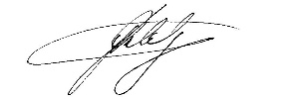
Greg Ledwidge
Delegate of the Minister for Planning and Sustainable Development
20 September 2026

