Australian Capital Territory
Heritage (Decision about Provisional Registration of Cameron Offices, wings 3, 4 and 5, link and bridge, Belconnen) Notice 2026
Notifiable instrument NI2026-436
made under the
Heritage Act 2004, s 34 (Notice of decision about provisional registration)

1 Name of instrument
This instrument is the Heritage (Decision about Provisional Registration of Cameron Offices, wings 3, 4 and 5, link and bridge, Belconnen) Notice 2026.
2 Commencement
This instrument commences on the day after its notification day.
3 Decision about provisional registration
On 23 September 2026, the ACT Heritage Council (the council) decided to provisionally register Cameron Offices, wings 3, 4 and 5, link and bridge, Block 8, Section 49, Blocks 7, 13, 15, 17, and 19, Section 44, and Block 1, Sections 193, 194, and 195, Belconnen (the place).
4 Description of the place
The provisional registration details of the place are in schedule 1.
5 Reasons for the decision
The council decided to provisionally register the place as it is satisfied on reasonable grounds that the place is likely to have heritage significance as defined by section 10 of the Heritage Act 2004 (the Act). A detailed statement of reasons, including an assessment against the heritage significance criteria, is provided in schedule 1.
6 Date provisional registration takes effect
The provisional registration of the place takes effect on the day the council enters into the register the details of the place, and an indication that the registration is provisional.
7 Indication of the council’s intention
The council intends to decide whether to register the place under the Act, division 6.2 during the period of provisional registration.
8 Invitation to make written comments during public consultation period
(1) The council invites written comments about the registration of the place. Any written comments must be made within 4 weeks after the day this notice is notified.
(2) Written comments can be provided to the council by the following methods:
(a) mail to
The Secretary
ACT Heritage Council
480 Northbourne Avenue
DICKSON ACT 2602
(b) email to heritage.registrations@act.gov.au

Dr Mary Clare Swete Kelly
Secretary (as delegate for)
ACT Heritage Council
24 September 2026

Schedule 1

(See sections 4 and 5)


AUSTRALIAN CAPITAL TERRITORY
HERITAGE REGISTER
Provisional registration
For the purposes of s 33 of the Heritage Act 2004, a provisional entry to the heritage register has been prepared by the ACT Heritage Council for the following place:
CAMERON OFFICES WING 3 AND BRIDGE, WINGS 4 AND 5 AND LINK
BLOCK 7, 13, 15, 17 AND 19, SECTION 44; BLOCK 8, SECTION 49; BLOCK 1, SECTION 193; BLOCK 1, SECTION 194; AND BLOCK 1, SECTION 195, BELCONNEN
DATE OF DECISION
23 September 2026
DATE OF PROVISIONAL REGISTRATION
The day after the notice is notified on the Legislation Register.
PERIOD OF EFFECT OF PROVISIONAL REGISTRATION
5 months commencing on the day after the notice is notified.
Extended Period (if applicable) Start Date ________ End Date ________
Copies of the Register Entry are available for inspection at ACT Heritage. For further information please contact:
The Secretary
ACT Heritage Council
GPO Box 158
CANBERRA ACT 2601
Telephone 13 22 81

Preamble
Cameron Offices was listed in 2004 on the Commonwealth Heritage List. On 16 December 2025, the Commonwealth status was revoked. Under the terms of the land transfer, the property was nominated to the ACT Heritage Register.

Statement of heritage significance
This statement refers to the heritage significance of the place as required by s 12(d) of the Heritage Act 2004 (the Heritage Act).
The Cameron Offices (consisting of the remaining Wings 3, 4, 5, the Bridge and Link) is a notable example of late 20th-century brutalist architecture and was Australia’s largest office development at the time of construction. Designed by architect John Andrews AO, it also demonstrates a high level of creative and technical achievement through its innovative structural systems and expressive architectural form.
The surviving parts of the office complex exemplify the complex’s terraced form, which follows the natural ridge of the landscape, thus creating a distinctive skyline for Belconnen. The project was among the earliest Australian office complexes to architecturally express the landform through stepped massing. Its structural system, combining post tensioned precast concrete, innovative ‘gallows’ beams, and column-free floor plates, was technically advanced and influential in later government office developments. The now-rare use of post-tensioned precast concrete ‘T’ beams underscores the site’s engineering significance.
The remaining sections of the offices embody the project’s original design philosophy: to create a pedestrian-oriented precinct with integrated courtyards, off-form concrete finishes, landscape elements, and a strong relationship between structure, services and circulation. Their bold concrete forms, cubic massing and continuous terraces represent outstanding examples of late 20th-century brutalist and International Style architecture.
Cameron Offices retain high integrity in their external form, materials, and structural systems. They remain a rare and instructive example of structuralist planning and continue to demonstrate the architectural, technical and urban ambitions of this nationally significant project.

Location of the place
This statement refers to the name and location of the place as required by ss 12 (a) and (b) of the Heritage Act.
Cameron Offices Wing 3 and Bridge, Wings 4 and 5 and Link, also known as Cameron Offices or Belconnen Offices, Block 8 Section 49, Block 7 Section 44, Blocks 13, 15, 17 and 19 Section 44, Block 1 Section 193, Block 1 Section 194 and Block 1 Section 195, Belconnen, Chandler Street, Belconnen.

Description of the place
This statement refers to the description of the place as required by s 12(c) of the Heritage Act. The attributes described in this section form part of the heritage significance of the place. For the purposes of s 12(c) of the Heritage Act, the provisional registration boundary of the place is at Figure 1.
Cameron Offices is located in Chandler Street in the Belconnen Town Centre and today comprises 3 buildings (wings), a pedestrian bridge between Wing 3 and Wing 4 (the Bridge), and a linking structure between Wings 4 and 5 (the Link). The complex is bounded by Benjamin Way to the west and Chandler Street to the east.
When constructed, Cameron Offices comprised 9 parallel office wings running east-west, of which only Wings 3, 4, and 5 remain. Wing 3 is to the north of Cameron Avenue and Wing 4 and 5 to the south. Wings 3 and 4 are connected by a pedestrian bridge over Cameron Avenue, while Wings 4 and 5 are linked at the eastern end by a north-south pedestrian spine known as the 'mall'.
Each mall contains three levels of offices, toilets and kitchens with walkways, lifts and stairs. The mall provides the principal circulation routes, connecting offices vertically and horizontally, north-south and east-west. To the west of each mall are the main office areas, comprising three levels of offices over a basement. The offices are divided into two modules, B and C, with floor levels in module C offset by half a storey from module B.
The wings follow the slope of the land along Cameron Avenue and present a strong horizontal form through their low rise and the expression of the floor levels on the exterior. All external concrete retains off-form concrete finishes.
A landscaped courtyard separates Wings 4 and 5. The basic layout was retained and still exists, but the plant species were changed in the mid-80s and possibly since. A watercourse has also been realigned and is no longer used. Former rooftop tennis courts and planted terraces have also been sheeted over with metal roofing.
Wing 3 is currently vacant, while Wings 4 and 5 have been adaptively reused as student residences for the University of Canberra.
Cameron Offices Wing 3 and Bridge, Wings 4 and 5 and Link (‘Cameron Offices’), has the following attributes of significance:
- Integration of a large-scale office, pedestrian, and landscaped environment into a cohesive urban form
- Rare and technically innovative structural system: expressed structural frame comprising the gallows beam configuration and integrated exposed concrete beam structure, interior and exterior (T-beam services)
- Visible exposed interior service ducts
- Strong shapes and cubiform rectangular built form
- Large sheets of glass forming Corbusian ribbon windows
- Expressed reinforced concrete and large areas of off-form concrete and smooth walls, exposed concrete finishes visible internally and externally
- Reinforced concrete balustrades as seen externally and reflected as metal balustrades internally in stairwells
- Integrated design elements comprising square hollow section handrails set on the diagonal, externally and internally
- Precast concrete non-load-bearing walls
- Open plan office spaces, landscaped courtyard, bridge and pedestrian walks and their fabric and finishes
- Design following fall of land and split levels
- Original internal aluminium light fittings
- Original tiling in bathrooms

Conservation objective
The guiding conservation objective is that Cameron Offices Wing 3 and Bridge, Wings 4 and 5 and Link (Cameron Offices) shall be conserved and appropriately managed in a manner respecting its heritage significance.
The ACT Heritage Council may make heritage guidelines applicable to the place under s 25 of the Heritage Act.
For further information on managing the place, or for advice on proposed works or development, please contact ACT Heritage via email at heritage@act.gov.au or via 13 22 81.

Reason for provisional registration
This statement refers to the heritage significance of the place as required by s 12(d) of the Heritage Act.
The Council has assessed the Cameron Offices against the heritage significance criteria and is reasonably satisfied that the place is likely to have heritage significance when assessed against criteria (a), (b), (d), (f) and (h) under s 10 of the Heritage Act. A place is considered to have heritage significance if it meets one or more of the criteria.
Table 1 Criteria that the Council consider have been met.
Criterion | (a) | (b) | (c) | (d) | (e) | (f) | (g) | (h)
Met | Yes | Yes | No | Yes | No | Yes | No | Yes

Assessment against the heritage significance criteria
This statement refers to the heritage significance of the place as required by s 12(d) of the Heritage Act.
In assessing the heritage significance of Cameron Offices, the Council considered:
- the original nomination and documentary evidence supplied by the nominator
- the Council’s Heritage Assessment Policy (March 2018)
- the report by ACT Heritage titled, Background Information Cameron Offices Wing 3 and Bridge, Wings 4 and 5 and Link, containing photographs and information on history, description, condition and integrity
According to s 10 of the Heritage Act, a place or object has heritage significance if it meets one or more of the following criteria. Future research may alter the findings of this assessment.

(a) importance to the course or pattern of the ACT’s cultural or natural history
MEETS CRITERION.
The Council is satisfied on reasonable grounds that the place is likely to meet this criterion.
The Cameron Office complex is significant for its role in the early formation and planned development of the Belconnen Town Centre. It was the first major building constructed as part of the National Capital Development Commission’s (NCDC) vision for a pedestrian-oriented, integrated town centre. The complex demonstrates a major phase in Canberra’s urban development during the 1970s and represents a milestone in the evolution of large-scale Commonwealth office buildings.
The construction of the Cameron Office complex between 1970 and 1977 marks the transition toward medium rise, campus-style government complexes. The project directly influenced subsequent NCDC office designs across Canberra in the 1970s and 1980s. The Cameron Offices reflect the vision of the National Capital Development Commission during the late 1960s under the leadership of Sir John Overall, marking an important phase in Canberra’s architectural and town planning evolution.
Although there have been changes internally, externally there has been little change. While only 3 of the 9 original buildings remain, they have a high level of integrity in their built fabric and represent an outstanding example of a unique and rare style of building development.
Representing a pioneering attempt to integrate large-scale office, pedestrian, and landscaped environments into a cohesive urban form, the place demonstrates a major chapter in the evolution of Canberra’s architectural and town planning identity during the 1970s. Its uniqueness, distinctiveness and pivotal influence on Canberra makes a strong contribution to the understanding of the ACT’s planned urban history. Cameron Offices meet the threshold indicator for influence under this criterion.

(b) has uncommon, rare or endangered aspects of the ACT’s cultural or natural history
MEETS CRITERION.
The Council is satisfied on reasonable grounds that the place is likely to meet this criterion.
Wings 3, 4, 5 and the Bridge of the Cameron Offices are significant as a rare surviving example of an ambitious, large-scale office complex that once represented the most technically and architecturally innovative government workplace in Australia. They retain evidence of a building technology no longer practised, including the use of post-tensioned precast concrete systems and a suspended “gallows beam” structural method, both now uncommon in contemporary office construction.
The surviving wings are also a rare example of an office complex planned around a stepped, horizontally linked circulation system, rather than the vertical circulation patterns typical of high-rise buildings. This pedestrian-oriented planning approach, expressed through elevated walkways, terraces and interconnected courtyards, remains unusual in Australian office design.
Architecturally, Wings 3, 4, 5 and the Bridge represent a rare free-form, pedestrian-linked office complex in the late 20th century brutalist style, distinguished by its terraced massing, exposed concrete forms and integration with the sloping landform. The remaining structures are the last intact components of what was once a nationally significant example of structuralist planning and are consequently rare as the principal surviving works of internationally acclaimed Australian architect John Andrews AO within the ACT.
Together with their associated landscape spaces and streetscape setting, these surviving elements retain a high degree of integrity and provide important evidence of a once extensive architectural and planning vision that is now rare within both the ACT and Australia. Cameron Offices meets the threshold indicators of integrity, uniqueness, and distinctiveness for this criterion.

(c) potential to yield important information that will contribute to an understanding of the ACT’s cultural or natural history
Does not meet criterion.
The Council is not satisfied on reasonable grounds that the place is likely to meet this criterion.
There is no evidence to suggest that Cameron Offices will yield substantial new information about the ACT’s cultural or natural history beyond what is currently known through historical documentation, or visible in the built fabric of the place.

(d) importance in demonstrating the principal characteristics of a class of cultural or natural places or objects
MEETS CRITERION.
The Council is satisfied on reasonable grounds that the place is likely to meet this criterion.
The remaining sections of the Cameron Offices are an excellent and highly intact example of a major late 20th-century brutalist office complex and clearly demonstrate the defining characteristics of the style. These characteristics include cubiform and rectilinear building forms, an expressed structural frame, large sheets of north-facing glazing, horizontal ribbon windows, plain smooth wall surfaces, boldly composed reinforced concrete elements, extensive off-form concrete, as well as precast concrete balustrades and wall panels. The building’s east–west orientation reflects early energy efficient design principles, maximising northern light in a low-rise format not possible in high-rise office towers.
The surviving wings also exhibit the defining qualities of late 20th-century international style architecture through their strong geometric composition, extensive glazing, and integration of structure and façade expression. Their terraced, stepped floorplates, which were designed to follow and articulate the natural landform ridge, demonstrate an innovative approach to siting that contributed to the early Belconnen skyline and introduced a distinctive terraced architectural presence to the district.
The complex is a highly representative example of a planning and design philosophy that integrated office accommodation with housing, commercial uses, and landscaped courtyards. The low-rise rectangular wings arranged around intervening courtyard spaces illustrate a broader mid-century move toward pedestrian-linked, human-scaled office environments. The high public visibility of the building reinforces its strong stylistic presence within the urban landscape.
Cameron Offices is among the finest surviving Australian demonstrations of structuralism, exemplifying an architectural and urban design approach in which buildings operate as interconnected components within a larger organisational system. Few Australian complexes combine brutalist, international style, and structuralist principles at this scale or level of resolution, making the surviving elements rare and representative.
Cameron Offices clearly demonstrate a pivotal example of the principal characteristics of this important class of late 20th-century office architecture. They meet the threshold indicators of rarity, representativeness, distinctiveness, exceptionality, extensiveness, and integrity in regard to this criterion.

(e) importance in exhibiting particular aesthetic characteristics valued by the ACT community or a cultural group in the ACT
Does not meet criterion.
The Council is not satisfied on reasonable grounds that the place is likely to meet this criterion.
Aesthetically, Cameron Offices exhibit a strong and distinctive brutalist expression, characterised by stepped and terraced profiles, repetitive volumetric forms, sculptural concrete surfaces, and landscaped courtyards framed by pedestrian routes. The monumental rectilinear forms and voids along Chandler Street and Cameron Avenue create a powerful urban composition that continues to define the Belconnen townscape. The Cameron Offices’ cohesive, visually dramatic presence has made it a landmark within the district, even as only a small section remains.
Despite this strong presence, Cameron Offices does not meet the threshold indicator of ‘valued by the ACT community or a cultural group in the ACT’, as this has not been objectively tested and/or clearly demonstrated.

(f) importance in demonstrating a high degree of creative or technical achievement for a particular period
MEETS CRITERION.
The Council is satisfied on reasonable grounds that the place is likely to meet this criterion.
The blending of structural engineering, environmental design, and architectural form represents an exceptional level of creative and technical innovation, providing a unified architectural engineering solution across the entire complex. Cameron Offices demonstrates a high level of creative and technical achievement through its innovative structural systems, expressive architectural form and pioneering integration of building, landscape and urban design.
The complex represents Australia’s first and arguably only true realisation of structuralism, an architectural approach in which buildings function as interdependent components of a broader urban order rather than isolated structures. Although elements of the Belconnen Town Plan changed during construction, the surviving wings continue to display this structuralist design intent.
The complex is also regarded as the first office building in Australia to give architectural expression to its topography. Wings 3, 4 and 5 step down the natural ridge to create a striking terraced profile, enhancing the then-emerging Belconnen skyline and reinforcing views along the ridge. This sensitivity to landform, combined with the strong sculptural massing of the concrete forms, contributes to the complex’s enduring visual prominence.
Technically, the surviving wings illustrate an ingenious and economical use of materials, achieving large column-free office spaces with clear spans of 17 metres. This was made possible using long precast post-tensioned concrete ‘T’ beams, staggered hanging columns and substantial ‘gallows’ beams supported by full-height structural columns. The extensive use of post tensioned precast concrete ‘T’ beams integrated mechanical and electrical services whilst the ‘gallows’ beam structural system enabled large column-free office spaces.
The extensive use of post-tensioned onsite precast concrete was an advanced and relatively new construction method at the time, later adopted in other office buildings but now rare in Australia. Overhanging floorplates provided passive solar control. These innovations were rare and pioneering in Australia at the time and influenced subsequent government building projects.
Other innovative features include the pedestrian street concept with horizontally linked walk-up circulation, and the seamless integration of structure, landscape and services into a unified architectural composition. These elements established a new design philosophy for office environments that influenced subsequent planning approaches in Canberra.
The off-form concrete structures, office spaces, courtyards, bridge, pedestrian walkways, and their material finishes and setting exemplify the intent of this criterion. The surviving complex is widely recognised in architectural scholarship as among Australia’s most important brutalist works which has had a groundbreaking influence nationally. It meets the threshold indicators for rarity, distinctiveness, exceptionality, and integrity for this criterion.

(g) has a strong or special association with the ACT community, or a cultural group in the ACT for social, cultural or spiritual reasons
Does not meet criterion.
The Council is not satisfied on reasonable grounds that the place is likely to meet this criterion.
While Cameron Offices remains embedded in the collective memory of local residents and some public servants of the time, there is no evidence that there is a strong or special association with the wider ACT community for social, cultural or spiritual reasons. Cameron Offices does not meet the threshold indicator of community association as this has not been objectively tested and/or clearly demonstrated.

(h) has a special association with the life or work of a person, or people, important to the history of the ACT
MEETS CRITERION.
The Council is satisfied on reasonable grounds that the place is likely to meet this criterion.
Cameron Offices is significant for its strong associations with the distinguished careers of Architect John Andrews AO and Structural Engineer Peter Owen Miller, both nationally and internationally recognised for their contributions to Australian modern architecture and engineering.
The place has strong associations with John Andrews AO, one of Australia’s most internationally recognised architects. Cameron Offices is considered one of his two major works in Australia and a defining project of his career. John Andrews AO was a leading Australian architect and received the Royal Australian Institute of Architects Gold Medal in 1980 in recognition of his influential body of work. The Cameron Offices was his first and largest Australian project, representing one of his most significant works together with Callam Offices in Woden.
The complex is also associated with innovative post-war engineer in the structural use of reinforced concrete in buildings, Peter Owen Miller, whose engineering solutions form a key part of the site’s significance. Miller’s structural expertise and innovative engineering solutions were further demonstrated in major national institutions such as the National Gallery of Australia and the High Court of Australia, following his work with Andrews on the Cameron Offices.
The intangible heritage value of the place lies in the intellectual creativity and design thinking expressed in the surviving elements of the Cameron Offices, where the architectural ambition of Andrews and the structural innovation of Miller are inseparable. These elements exemplify the collaborative excellence and degree of an enduring association of two leading practitioners whose work shaped the architectural and urban character of Canberra.
Cameron Offices’ relationship with John Andrews AO and Peter Miller meets the threshold indicators of influence and degree of association for this criterion.

Provisional registration boundary
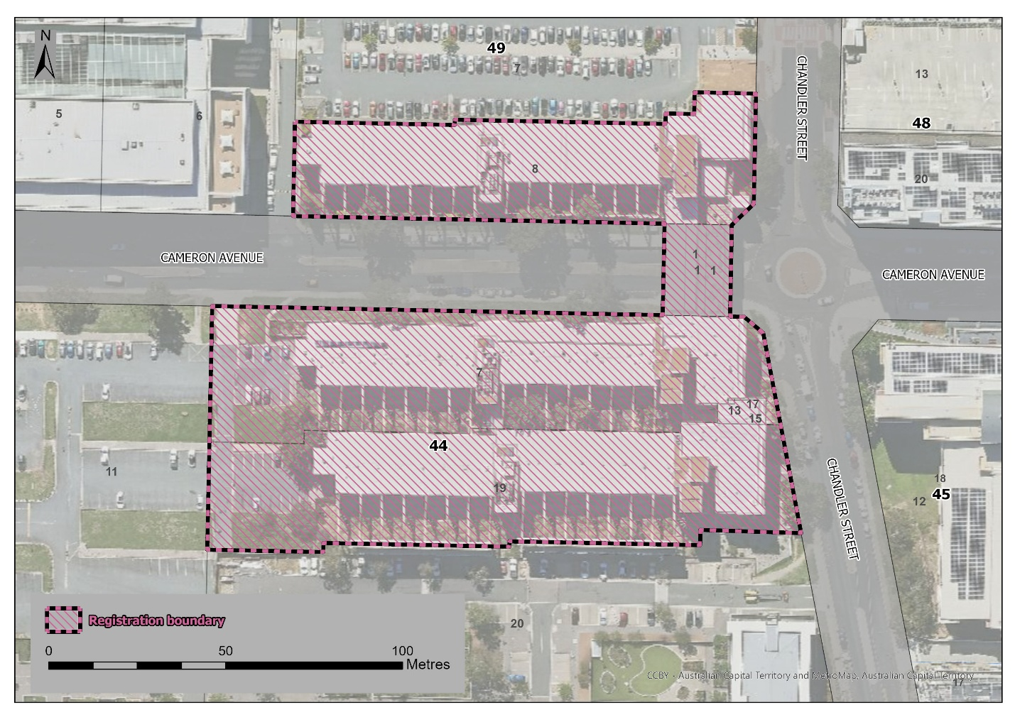
Figure 1: Provisional registration boundary for Cameron Offices Wing 3 and Bridge, Wings 4 and 5 and link.

