Australian Capital Territory
Heritage (Decision about Provisional Registration of Westridge House, Yarralumla) Notice 2026
Notifiable instrument NI2026-437
made under the
Heritage Act 2004, s 34 (Notice of decision about provisional registration)

1 Name of instrument
This instrument is the Heritage (Decision about Provisional Registration of Westridge House, Yarralumla) Notice 2026.
2 Commencement
This instrument commences on the day after its notification day.
3 Decision about provisional registration
On 23 September 2026, the ACT Heritage Council (the council) decided to provisionally register Westridge House, Block 6, Section 4, Yarralumla (the place).
4 Description of the place
The provisional registration details of the place are in schedule 1.
5 Reasons for the decision
The council decided to provisionally register the place as it is satisfied on reasonable grounds that the place is likely to have heritage significance as defined by section 10 of the Heritage Act 2004 (the Act). A detailed statement of reasons, including an assessment against the heritage significance criteria, is provided in schedule 1.
6 Date provisional registration takes effect
The provisional registration of the place takes effect on the day the council enters into the register the details of the place, and an indication that the registration is provisional.
7 Indication of the council’s intention
The council intends to decide whether to register the place under the Act, division 6.2 during the period of provisional registration.
8 Invitation to make written comments during public consultation period
(1) The council invites written comments about the registration of the place. Any written comments must be made within 4 weeks after the day this notice is notified.
(2) Written comments can be provided to the council by the following methods:
(a) mail to
The Secretary
ACT Heritage Council
480 Northbourne Avenue
DICKSON ACT 2602
(b) email to heritage.registrations@act.gov.au

Dr Mary Clare Swete Kelly
Secretary (as delegate for)
ACT Heritage Council
24 September 2026

Schedule 1

(See sections 4 and 5)


AUSTRALIAN CAPITAL TERRITORY
HERITAGE REGISTER
Provisional registration
For the purposes of s 33 of the Heritage Act 2004, a provisional entry to the heritage register has been prepared by the ACT Heritage Council for the following place:

WESTRIDGE HOUSE
BLOCK 6 SECTION 4, YARRALUMLA
DATE OF DECISION
23 September 2026
DATE OF PROVISIONAL REGISTRATION
The day after the notice is notified on the Legislation Register.
PERIOD OF EFFECT OF PROVISIONAL REGISTRATION
5 months commencing on the day after the notice is notified.
Extended Period (if applicable) Start Date ________ End Date ________
Copies of the Register Entry are available for inspection at ACT Heritage. For further information please contact:
The Secretary
ACT Heritage Council
GPO Box 158
CANBERRA ACT 2601
Telephone 13 22 81

Preamble
Westridge House (also known as Tudor House) is located on lands that the Ngunnawal and other First Nations peoples have had connections to for many thousands of years.
It was built during the Federation and early Commonwealth phase of Canberra’s development, when the Commonwealth Government relocated key national institutions and senior public officers to the new capital, including the Australian Forestry School.
It was acquired in 1975 by the CSIRO when the former Australian Forestry School precinct became the new CSIRO Division of Forest Research.
Westridge House was listed in 2004 on the Commonwealth Heritage List. On 16 December 2025, the Commonwealth status was revoked. Under the terms of the land transfer, the property was nominated to the ACT Heritage Register.

Statement of heritage significance
This statement refers to the heritage significance of the place as required by s 12(d) of the Heritage Act 2004 (the Heritage Act).
Westridge House is of heritage significance to the ACT for its association with the establishment of Canberra’s historic forestry precinct in the 1920s, and for creative achievement in early 20th century domestic architecture.
Designed by architect Harold Desbrowe Annear, the house demonstrates a distinctive architectural style, reflecting ideals of the Arts and Crafts movement, interpreted in a simplified and restrained manner in Tudor Revival style. The house is characterised by careful proportions and high‑quality architectural detailing and craftsmanship, including innovative window designs that slide into wall cavities.
Constructed in 1927 as the official residence of the Principal of the Australian Forestry School, Westridge House has a strong historical association with the development of forestry administration and education in the early federal capital.
Westridge House occupies a prominent block within Canberra’s historic forestry precinct, which includes the former Australian Forestry School and Westbourne Woods. Together, these elements illustrate the early institutional development of Canberra, particularly during the Federation and early Commonwealth phases when departments and educational institutions were first established in the national capital.
The house’s architectural character, combined with its landscaped setting and backdrop of Westbourne Woods, create a distinctive and picturesque feature within a historically significant area of Yarralumla (formerly Westridge). Westridge House retains a high degree of integrity and contributes meaningfully to an understanding of Canberra’s early residential, institutional and cultural history.

Location of the place
This statement refers to the name and location of the place as required by ss 12 (a) and (b) of the Heritage Act.
Westridge House, also known as Tudor House, Block 6, Section 4, 55 Banks Street, Yarralumla.

Description of the place
This statement refers to the description of the place as required by s 12(c) of the Heritage Act. The attributes described in this section form part of the heritage significance of the place. For the purposes of s 12(c) of the Heritage Act, the provisional registration boundary of the place is at Figure 1.
Westridge House is located on Banks Street, Yarralumla, in an area historically known as Westridge, approximately 100 metres north of the former Australian Forestry School (AFS). The place occupies a large, landscaped allotment bounded by Banks Street to the east, the former CSIRO Australian Forestry School precinct to the south, and the Royal Canberra Golf Club and Westbourne Woods to the west and north. The house was designed and constructed for the use of the Principal of the Australian Forestry School and his family.
The setting places Westridge House within Canberra’s historic forestry precinct and establishes a close physical and visual relationship between the residence, the former AFS, the Yarralumla Nursery and the surrounding arboretum and experimental plantings.
Banks Street is a wide, tree-lined avenue characterised by large residential properties and open grassed verges, allowing the house to be viewed within a semi open landscape context that reinforces its institutional origins and longstanding connection to the adjoining woodland setting. The site for the residence was selected in 1926, during the construction of the AFS.
Westridge House is a two-storey half-timbered and masonry residence with an asymmetric hipped and gabled Marseille tile roof sloping steeply on one side. The half-timbered first floor is jettied over a white rendered masonry ground floor with battered corner buttresses. Parallel horizontal bands of windows lie within the timber strapwork above and punctuate the plain rendered masonry walls below, while the area above the porch projects and rests on timber brackets.
The design incorporates details characteristic of Harold Desbrowe Annear’s domestic architecture, including flush doors; vertically sliding windows concealed within wall cavities; flyscreens that automatically cover window openings; chimney ventilation stacks flanking a central flue; and stepped forms to assist ventilation.
A central hall divides the ground floor into living and dining/kitchen zones connected by sliding doors, while the upper floor accommodates bedrooms and bathrooms. Circulation spaces are minimised to increase living areas, with the living room occupying one side of the house and opening to the dining room across the rear. Several smaller rooms are attached to the kitchen and utility area in the southeast corner.
Notable features include a false wall and concealed room in an upstairs bedroom, an element found in other Annear designs, and an unusual bow in the outer wall of the living room that draws attention to the chimney — a motif also used at the Ince House in Melbourne, the architect’s final residential design.
Westridge House has the following attributes of significance:
- Overall form, scale and massing of the two‑storey residence, including its domestic proportions and institutional siting in relation to the AFS.
- Asymmetric hipped and gabled Marseille tile roof, including roof form, pitch and dominant chimneys.
- Tudor Revival Style, half‑timbered upper storey and white rendered masonry ground floor, including battered corner buttresses and jettied upper floor.
- Fenestration pattern, and the relationship between window groupings and timber strapwork.
- Original windows, including vertically sliding sash windows designed to retract into wall cavities.
- Central hall plan form, including the spatial relationship between hall, living room, dining room and kitchen.
- Sliding internal doors that articulate the relationship between principal living spaces.
- Chimney forms, including ventilation stacks and stepped detailing, that assist passive ventilation.
- Distinctive living room bow that focuses attention on the chimney and expresses a motif used in other Desbrowe Annear houses.
- External details characteristic of Harold Desbrowe Annear’s domestic work, including restrained ornamentation and functional detailing.
Garden:
- Informal treescape and picturesque garden that frames the house.
- Curved entry driveway and approach sequence from Banks Street.
- Open lawn areas surrounding the house, reinforcing its prominence and domestic setting.
- Informal landscape design intent, set among trees that visually connect the site to Westbourne Woods, distinct from suburban garden layouts and reflective of the forestry precinct context.
- V-shaped planting to the west of the house, contributing to the historic setting.
- Visual and physical relationships between the house, garden, Westbourne Woods and the former Australian Forestry School.
- The garden’s role as a transitional landscape between a private residence and institutional forestry land.

Conservation objective
The guiding conservation objective is that Westridge House shall be conserved and appropriately managed in a manner respecting its heritage significance.
The ACT Heritage Council may make heritage guidelines applicable to the place under s 25 of the Heritage Act.
For further information on managing the place, or for advice on proposed works or development, please contact ACT Heritage via email at heritage@act.gov.au or via 13 22 81.

Reason for provisional registration
This statement refers to the heritage significance of the place as required by s 12(d) of the Heritage Act.
The Council has assessed Westridge House against the heritage significance criteria and is reasonably satisfied that the place is likely to have heritage significance when assessed against criteria (a) and (f) under s 10 of the Heritage Act. A place is considered to have heritage significance if it meets one or more of the criteria.
Table 1 Criteria that the Council consider have been met.
Criterion | (a) | (b) | (c) | (d) | (e) | (f) | (g) | (h)
Met | Yes | No | No | No | No | Yes | No | No

Assessment against the heritage significance criteria
This statement refers to the heritage significance of the place as required by s 12(d) of the Heritage Act.
In assessing the heritage significance of Westridge House, the Council considered:
- the original nomination and documentary evidence supplied by the nominator with the name Westridge House, Garden and Garage
- the Council’s Heritage Assessment Policy (March 2018)
- the report by ACT Heritage titled, Background Information Westridge House, containing photographs and information on history, description, condition and integrity
According to s 10 of the Heritage Act, a place or object has heritage significance if it meets one or more of the following criteria. Future research may alter the findings of this assessment.

(a) importance to the course or pattern of the ACT’s cultural or natural history
MEETS CRITERION.
The Council is satisfied on reasonable grounds that the place is likely to meet this criterion.
Westridge House is important to the course of the ACT’s cultural history through its direct and substantiated association with the establishment and early consolidation of national forestry administration and education in Canberra during the early Commonwealth period.
Constructed in 1927–1928 as the residence of the Principal of the Australian Forestry School (AFS), the place forms part of a deliberate and coordinated Commonwealth Government program to relocate key national institutions and senior officers to the national capital during its formative decades. Its location adjacent to the AFS, Westbourne Woods and the Yarralumla Nursery situate the house within a cohesive forestry precinct that illustrates the early institutional development of Canberra beyond parliamentary and administrative functions. The place clearly illustrates the expansion of Canberra’s role to include scientific research, professional education and national policy development.
The original house, its curtilage, garden and garage, and its relationship to the surrounding forestry landscape, together demonstrate how domestic accommodation was intentionally integrated into institutional planning for the early federal capital.
These attributes collectively provide clear, convincing and tangible evidence of an important pattern in Canberra’s cultural history, specifically the establishment and consolidation of specialist national institutions within a planned capital city during its formative decades. The place retains sufficient physical fabric and integrity to clearly convey this.

(b) has uncommon, rare or endangered aspects of the ACT’s cultural or natural history
Does not meet criterion.
The Council is not satisfied on reasonable grounds that the place is likely to meet this criterion.
Westridge House does not demonstrate rarity or uniqueness within the context of the ACT’s cultural history. While the place is demonstrative of Canberra’s institutional development, showing the capital’s growth beyond parliamentary and administrative institutions to include scientific research and professional education, there are many places in Canberra that illustrate this growth.
Westridge House does not meet the threshold requirement of containing rare, uncommon, or endangered aspects of the ACT’s heritage.

(c) potential to yield important information that will contribute to an understanding of the ACT’s cultural or natural history
Does not meet criterion.
The Council is not satisfied on reasonable grounds that the place is likely to meet this criterion.
Westridge House does not have the potential to yield new and important information that would contribute to an understanding of the ACT’s cultural history. The garden and garage occupy areas that have been subject to substantial ground disturbance associated with the original construction of the house and later modifications. This has significantly reduced or removed the likelihood of intact subsurface archaeological deposits being present.
Any archaeological evidence relating to domestic use of the site during the interwar period would be limited, redundant, or already documented, and is unlikely to provide information beyond what is already known about Commonwealth officer residences of the period.

(d) importance in demonstrating the principal characteristics of a class of cultural or natural places or objects
Does not meet criterion.
The Council is not satisfied on reasonable grounds that the place is likely to meet this criterion.
Westridge House does not satisfy the threshold required. It does not demonstrate the principal characteristics of a class of cultural places to a degree that is representative, instructive, or exemplary within the ACT context.

(e) importance in exhibiting particular aesthetic characteristics valued by the ACT community or a cultural group in the ACT
Does not meet criterion.
The Council is not satisfied on reasonable grounds that the place is likely to meet this criterion.
While Westridge House exhibits aesthetic characteristics that are clearly identifiable, distinct, and exceptional, they are not demonstrably valued by the wider ACT community or a cultural group.
Westridge House does not meet the threshold indicator of ‘valued by the ACT community or a cultural group in the ACT’, as this has not been objectively tested and/or clearly demonstrated.

(f) importance in demonstrating a high degree of creative or technical achievement for a particular period
MEETS CRITERION.
The Council is satisfied on reasonable grounds that the place is likely to meet this criterion.
Westridge House demonstrates a high degree of creative achievement in early 20th‑century domestic architecture through the design by Harold Desbrowe Annear, a leading architect associated with the Arts and Crafts movement and proto‑modern domestic architecture in Australia. The house exhibits an accomplished and cohesive integration of architectural form, planning and detailing that reflects creative innovation rather than routine residential design of its period.
This creative achievement is expressed through its distinctive architectural composition and advanced domestic detailing, including the asymmetric massing, half‑timbered upper storey over rendered masonry base, and the sophisticated manipulation of roof forms.
Of particular significance are the innovative interior and functional design features, vertically sliding windows designed to retract into wall cavities, as well as chimney and ventilation detailing that respond to comfort, climate and function. These elements demonstrate Annear’s deliberate and considered approach to modern domestic living and represent an advanced application of Arts and Crafts principles adapted to Australian conditions. The design led to the house being labelled ‘The Tudor House’ by Forestry and CSIRO occupants.
Westridge House is the only known work by Harold Desbrowe Annear in Canberra, and one of a small group of late domestic designs that illustrate the culmination of his architectural ideas. The survival and legibility of these creative attributes allow the place to clearly demonstrate a high level of architectural accomplishment for its time.

(g) has a strong or special association with the ACT community, or a cultural group in the ACT for social, cultural or spiritual reasons
Does not meet criterion.
The Council is not satisfied on reasonable grounds that the place is likely to meet this criterion.
While the place has historical associations to forestry administration and the CSIRO, there is no evidence that the place has meaning for a recognisable community or cultural group. The place does not meet the threshold requiring demonstrable, enduring and widely recognised social value.

(h) has a special association with the life or work of a person, or people, important to the history of the ACT
Does not meet criterion.
The Council is not satisfied on reasonable grounds that the place is likely to meet this criterion.
The house was established in 1927 as the official residence of the Principal of the AFS and is associated with its early occupants Charles Lane Poole and Dr Max Jacobs, both of whom played pivotal roles in the establishment, leadership and consolidation of the AFS and the Federal Forestry Bureau. Their occupancy of Westridge House corresponds with formative periods in Canberra’s early Commonwealth development when national institutions and senior officials were deliberately located in the capital.
The place is also associated with Ruth Lane Poole, an accomplished interior designer and influential figure in the early federal capital. Her residence at Westridge House coincided with her significant professional work in Canberra, including interior design commissions for The Lodge and Government House.
While these associations are notable in the context of forestry education, research and administration, they do not meet the threshold of being important to the ACT’s wider history.
Whilst Harold Desbrowe Annear is an accomplished Australian architect of the Arts and Crafts movement, in order to meet this criterion, the association between the person and the place must be enduring, beyond the ordinary, and differentiated from other similar places associated with the person.
There is no evidence that Harold Desbrowe Annear had an association with Westridge House beyond the ordinary in his line of work as an architect, or that this association is significant to the history of the ACT.

Provisional registration boundary
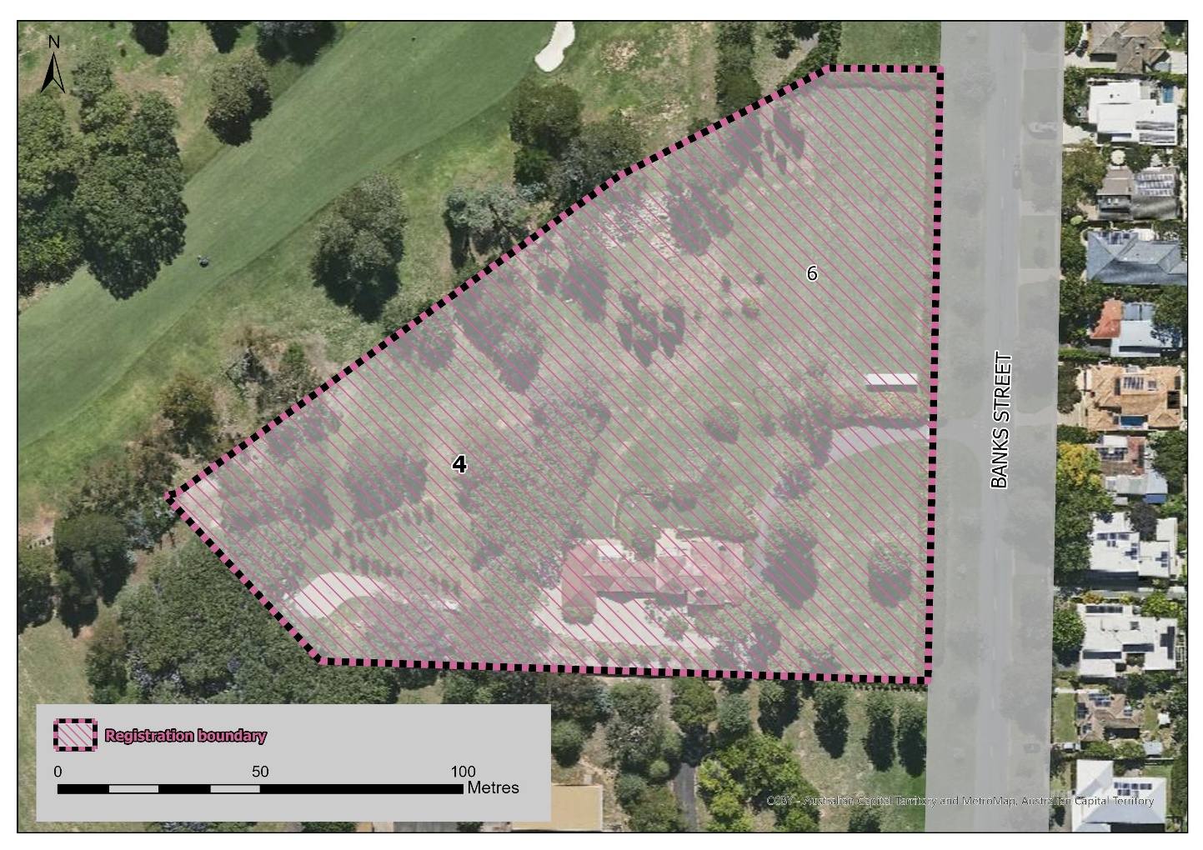
Figure 1: Provisional registration boundary

