Australian Capital Territory
Building (Obligations on Owners of Premises with a Regulated Swimming Pool) Guidance Material 2026
Notifiable instrument NI2026–444
made under the
Building Act 2004, s 83H (Guidance about obligations on owners)

1 Name of instrument
This instrument is the Building (Obligations on Owners of Premises with a Regulated Swimming Pool) Guidance Material 2026.

2 Commencement
This instrument commences on the day after its notification day.

3 Guidance material
I make the guidance material, about the obligations of owners of premises on which a regulated swimming pool is located, in the schedule.

4 Expiry
This instrument expires on 30 April 2028.

5 Revocation
This instrument revokes the Building (Obligations on Owners of Premises with a Regulated Swimming Pool) Guidance Material 2024 (NI2024-215).
Chris Steel MLA
Minister for Planning and Sustainable Development
29 September 2026

Schedule
(see s 3)

Pool owner guidance material

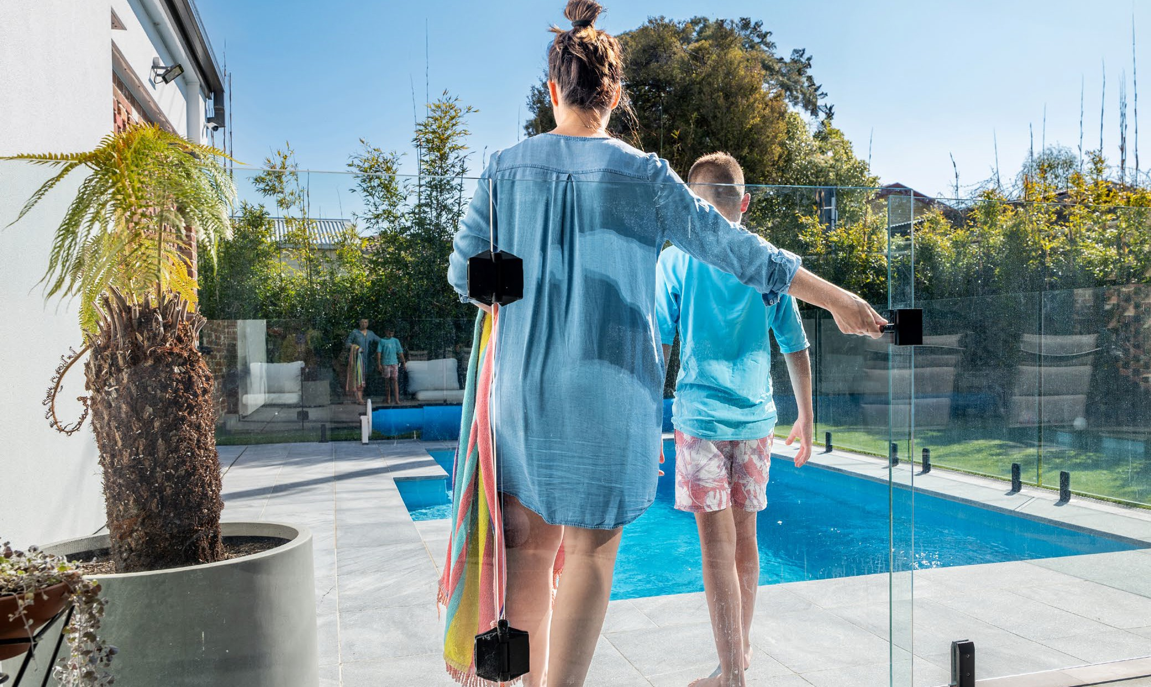




Pool Owner Guidance Material
The ACT Government is committed to avoiding preventable deaths and serious injuries from fatal and non-fatal drownings in home swimming pools and spas in the ACT.
New rules aim to protect the public by making sure that home swimming pools and spas in the ACT have a safety barrier that is compliant with modern safety standards and that they are maintained.

This document outlines the obligations for people who own a property with a regulated swimming pool for the period 1 May 2024 to 30 April 2028.

Regulated swimming pools
The new rules apply to regulated swimming pools, which are home swimming pools or spas that are:
- capable of containing water to a depth greater than 30cm; and
- associated with a residential building such as a house, unit, townhouse or block of apartments.
This includes in-ground and above-ground pools, temporary and permanent pools, wading pools, demountable pools, portable pools, kids’ pools and spas.
If your inflatable pool can be deflated and inflated and does not have a filtration system, you are not covered by the scheme. If any part of the pool requires assembly other than inflation (i.e. has a frame), or if the pool uses or comes with a filtration system, it is a demountable pool and therefore covered by the scheme.

Scheme commencement and transition period
The scheme commenced on 1 May 2024, with a four-year transition period for homeowners to have a compliant safety barrier for their regulated swimming pool or to obtain an exemption.

Compliant safety barrier
From 1 May 2028, it will be an offence to have a regulated swimming pool that does not have a safety barrier which meets the prescribed safety standards unless an exemption applies.
For pools built, altered or installed before 1 May 2023, the safety standards are:
- the current version of the Building Code of Australia (NCC 2022); and
- two Australian Standards which are Part 1 and Part 2 of Australian Standards for Swimming pool safety.
  - Part 1 (AS 1926.1 – 2012) relates to safety barriers for swimming pools
  - Part 2 (AS 1926.2 – 2007) is about the location of safety barriers
The changes that need to be made to swimming pool and spa safety barriers to make them compliant with the prescribed safety standards will depend on the type of safety barrier that is currently in place and the location of the swimming pool or spa in relation to other buildings, structures and boundary fences on the property. Information about what changes you may need to make can be found in the factsheets on the Home Swimming Pool Safety Reforms webpage on the ACT Government planning website.
Pools built, altered or installed on or after 1 May 2023 must meet:
- the Building Code of Australia as adopted in the ACT at the time the swimming pool or spa is built or altered; and
- the Australian Standards called up by the Building Code at the time the swimming pool or spa is built or altered.

Exemptions
Under the scheme, there are some circumstances where a pool is not required to comply with the prescribed safety standards and the owner of the premises does not need to apply for an exemption.

Date of pool construction | Before 1 May 2023 | On or after 1 May 2023
A demountable pool that will not be in place for more than three consecutive days  A spa which is covered and secured by a lockable child-resistant structure (such as a door, lid, grille or mesh) that meets the prescribed requirements  A spa that is located on the balcony of an apartment where self-closing and self-latching doors and/or windows restricts access | Exempt | Exempt
 | Exempt | Exempt
 | Exempt | A spa located on a balcony must comply with the prescribed safety standard or be covered and secured by a lockable child-resistant structure that meets the prescribed requirements

There are also circumstances where homeowners or owners’ corporations can apply for an exemption from compliance if the pool is unable to have a safety barrier compliant with the prescribed safety standards.

Date of pool construction | Before 1 May 2013 | Between 1 May 2013 and  30 April 2023 | On or after 1 May 2023
Compliance with the prescribed safety standard is impracticable  Compliance would be reasonably likely to require approval to remove a protected tree  Compliance would have a significant adverse effect on the heritage significance of a place or object registered under the Heritage Act 2005  Compliance would prevent a person with a disability from accessing the swimming pool  Documented plans to remove and not replace the swimming pool within 24 months | Exemption available | No | No
 | Exemption available | No | No
 | Exemption available | No | No
 | Exemption available | Exemption available | No
 | Exemption available | Exemption available | No

Offences and penalties apply for failing to notify of a change of circumstances that affects a ground on which an exemption was granted, and for failing to comply with a condition of an exemption.

Compliance status certificates
Pools built, altered or installed before 1 May 2013 will need to obtain a compliance status certificate before 1 May 2028 and lodge it with Government within 30 days of issue. Compliance status certificates obtained during the transition period will be valid until 1 May 2032.
Pools built, altered or installed on or after 1 May 2013 are not required to obtain a compliance status certificate by 1 May 2028 or lodge it with Government. This does not prevent a compliance status certificate being obtained before then.
Offences and penalties may apply for failing to meet these obligations.

Maintaining safety around home swimming pools and spas
From 1 May 2024, all owners of a property with a swimming pool or spa are required to maintain their swimming pool or spa safety barriers as an effective and safe child-resistant barrier. All residents of a property with a swimming pool or spa must ensure that all doors, gates and covers providing access to the swimming pool or spa are kept securely closed when not in use. Offences and penalties may apply for failing to meet these obligations.

More information
For more information on the reforms and what they mean for you and your pool, including disclosure obligations on sale or lease of your property, visit the Home Swimming Pool Safety Reforms webpage on the ACT Government planning website: https://www.planning.act.gov.au/planning-projects/building-regulatory-system/home-swimming-pool-safety-reforms

