Australian Capital Territory

Nature Conservation (Murunung Naruwi) Conservation Advice 2026

Notifiable instrument NI2026–457
made under the
Nature Conservation Act 2014, s 90C (Conservation advice)

1 Name of instrument
This instrument is the Nature Conservation (Murunung Naruwi) Conservation Advice 2026.

2 Commencement
This instrument commences on the day after its notification day.

3 Conservation advice for Murunung Naruwi
Schedule 1 sets out the conservation advice for Murunung Naruwi (Euastacus crassus).

Simon Clulow
Chair, Scientific Committee
7 October 2026
Schedule 1
(see s 3)

Conservation Advice
MURUNUNG NARUWI – Euastacus crassus

Conservation Status
The Murunung Naruwi – Euastacus crassus (Riek, 1951) – is recognised as threatened in the following jurisdictions:
International Endangered, International Union for Conservation of Nature (IUCN) Red List
National Under assessment, Environment Protection and Biodiversity Conservation Act 1999 (EPBC Act)
ACT Endangered, Nature Conservation Act 2014

ELIGIBILITY
The Murunung Naruwi is eligible to be listed as Endangered in the ACT Threatened Native Species List under IUCN Criterion B: B1ab(iii,v)+2ab(iii,v) at the national level (Attachment A). The main contributing factors are a restricted distribution (extent of occurrence (EOO) of 177 km² and area of occupancy (AOO) of 48 km²) and number of locations (not greater than five (5)) with continuing decline inferred in area, extent and/or quality of habitat, and number of mature individuals due to climate change (increasing temperature and increasing bushfire frequency) and other threats including predation by foxes (particularly after fire) and habitat degradation by horses (Attachment A).

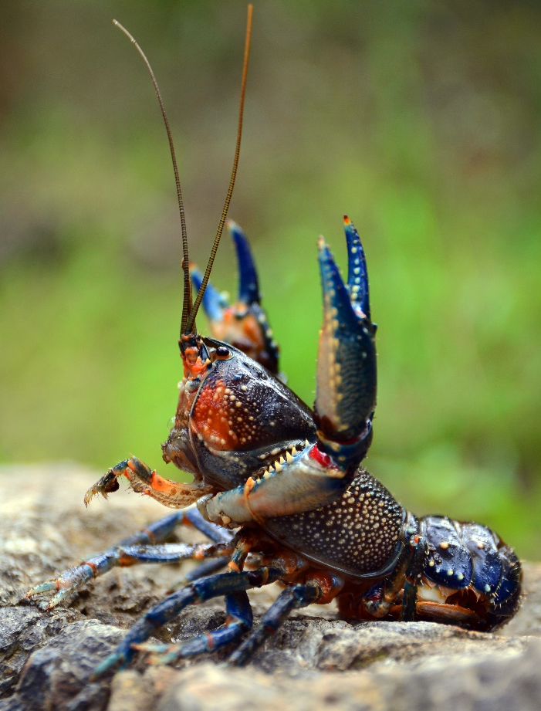
DESCRIPTION AND ECOLOGY
The Murunung Naruwi (translated as cold crayfish – Winanggaay Ngunnawal Language Aboriginal Corporation) and previously known as the Alpine Spiny Crayfish, is a small and spiny crayfish (Coughran 2008), recorded as reaching 58 mm occipital carapace length (OCL (‘head length’)) (Morgan 1997). The body is usually blue-green with abdominal segments reddish across the front half of body tending to blue-green toward the back and blue laterally with bright blue claws being white underneath (Riek 1951; Morgan 1997; McCormack 2012). Internal features are generally required to distinguish this species.
Knowledge on the biology and ecology of the Murunung Naruwi is limited particularly given that much of the information may now relate to separate species. However, it is recognised that Euastacus species have a suite of common biological characteristics as summarised in Furse and Coughran (2011a), which also apply to the Murunung Naruwi. Various studies have established that Euastacus are very slow growing (growth increments of a few millimetres OCL per year) and very long-lived, (Honan and Mitchell 1995a, 1995b; Turvey and Merrick 1997; Morey 1998; Furse and Wild 2004; Coughran 2013).
Murunung Naruwi (Mark Jekabsons – ACT Government)
Reproductive studies show that Euastacus species are typically late-maturing with females only reaching reproductive maturity at 5‒10 years (e.g., Honan & Mitchell 1995a, b; Turvey & Merrick 1997; Borsboom 1998; Furse & Wild 2004; Coughran 2013). There are limited studies published or information on reproduction in the Murunung Naruwi. They are considered winter breeders with females thought to approach maturity around 40‒50 mm OCL (Morgan 1997; McCormack 2012, ACT gov unpublished data). Berried females carrying around up to 200 eggs have been observed in Autumn, with the release of juveniles thought to occur between January to April based on water temperature (ACT Gov. observation; Morgan 1997; McCormack 2012). Eggs are pale to dark orange in colour (ACT Gov. observation; Morgan 1997; McCormack 2012). The longevity, fecundity, and age of sexual maturity in females is presently unknown for this species. In addition, there is little information available from other Euastacus species.
Like most of the medium sized Euastacus the Murunung Naruwi is predominantly nocturnal (McCormack 2012). It eats mostly vegetation/detritus, but it will eat meat opportunistically. Little is also known about its general biological characteristics, although given its high-altitude distribution and its close association with cool conditions und undisturbed vegetation it is anticipated to be intolerant of high temperatures like other Euastacus species (Bone et al. 2014).

Distribution and Habitat
The Murunung Naruwi is likely endemic to the high country (>600 m above sea level (ASL) with records up to 1544 m ASL) in the western extent of the Australian Capital Territory (ACT) (Morgan 1997; Coughran & Furse 2010; Hammer & Beitzel 2019; Austin et al. 2022) (Map 1).
The refinement of the range of E. crassus sensu stricto to only occur in the ACT is based on the molecular genetic analyses of Austin et al. (2022) and sampling by the ACT Government. It was formerly considered to occur more widely in southern NSW as well as north-eastern Victoria, but the molecular genetic analyses of Austin et al. (2022) identified specimens from those regions as belonging to different lineages. These divergent lineages do not overlap in distribution with E. crassus sensu stricto, namely with E. cf. crassus observed in Machine Creek, Bull Flat Creek and a tributary of Micalong Creek in the upper Murrumbidgee River Catchment in NSW. It is acknowledged that Murunung Naruwi could occur in headwater streams (e.g. upper Goodradigbee River Catchment) of adjacent areas of NSW, but this habitat is anticipated to be extremely limited given the known nearby (non-overlapping) range of different lineages identified by Austin et al. (2022) (Map 1).
In the ACT, the Murunung Naruwi is recorded from the tributaries and bogs and fens of the Cotter River (Gibraltar, Lees, Ginini, Bushrangers, Condor and Kangaroo creeks and upper Tidbinbilla River) in the upper Murrumbidgee catchment. It is commonly found in the high country of northern Namadgi National Park, Tidbinbilla Nature Reserve, Lower Cotter Catchment and Woods Reserve.
Part of the range of this species is afforded a degree of protection by being contained within the EPBC listed Endangered Ecological Community Alpine Sphagnum Bogs and Associated Fens that also occurs in protected areas and reserves (Namadgi National Park, Tidbinbilla Nature Reserve and Woods Reserve), but these areas are not actively managed for conservation of the Murunung Naruwi.
The Murunung Naruwi inhabits extensive burrow systems that generally start at the water level mark of small, high streams that have relatively undisturbed vegetation (Morgan 1997; McCormack 2012). It preferentially inhabits permanent, cold-water streams but can also be found in ephemeral streams. Permanent water in the burrows is a requirement of the species (McCormack 2012). It can travel up and down streams using temporary shelter (McCormack 2012).
Map 1: Recorded Distribution of the Murunung Naruwi (E. crassus) and other Euastacus species (ACT Wildlife Atlas)
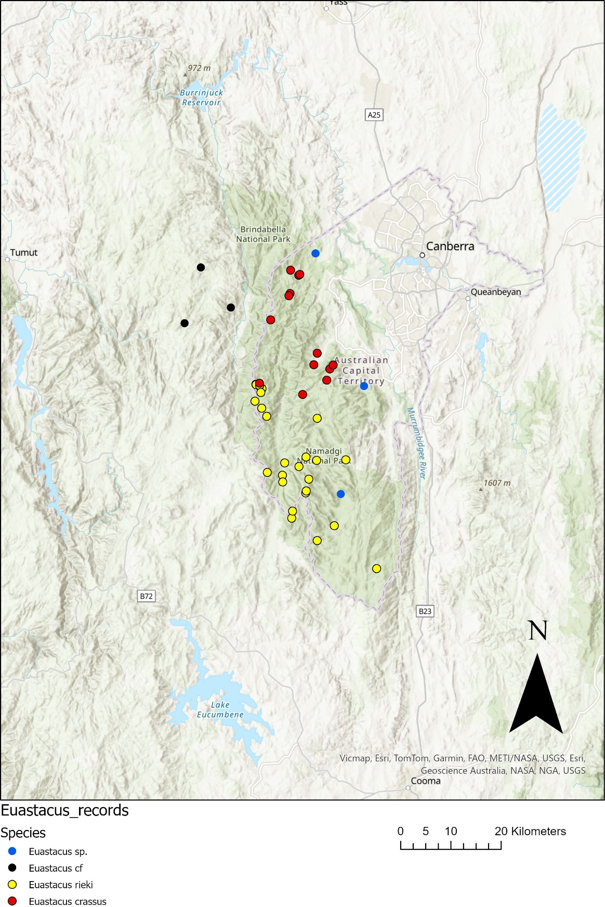

Threats

Established threats (habitat destruction, invasive and translocated native species, human exploitation, climate change and related changes to fire and flooding events) and potential threats (disease such as Crayfish Plague (Aphanomyces astaci) (Panteleit et al. 2017; DAWE 2019) may put nearly all species of Euastacus at serious risk of population declines, or extinction, over sub-decadal timeframes (Wells et al. 1983; Coughran 2007; Furse & Coughran 2011b; Furse 2014; Richman et al. 2015).

Climate change is a key threat to most Euastacus species (Hossain 2018), including the Murunung Naruwi, with the species having limited capacity to relocate to higher, cooler altitudes, or overland to other nearby suitably cool and wet habitat.

The species is likely to be impacted by invasive species, such as Rainbow Trout (Oncorhynchus mykiss), Brown Trout (Salmo trutta), feral pigs (Sus scrofa), European foxes (Vulpes vulpes). Competition with Common Yabbies (Cherax destructor) is also a threat to the species. This, along with being attracted to baited traps making illegal fishing a concern (McCormack 2012). Dramatic increases in predated crayfish remains have been observed following fires (Carey et al. 2003) and recent evidence from the 2019–20 fires documented > 90 % of predator scats collected around upland bogs in the ACT contained crayfish remains (ACT Government 2021).

Major Conservation Objective
The priority management objective should be to increase in the long term, viable, wild populations of the species as a component of the indigenous biological resources of the ACT. This includes the need to maintain natural evolutionary processes and resilience to major impact.

Conservation Priorities
Conservation and management priorities for the Murunung Naruwi are detailed in the listing assessment (ACT Scientific Committee 2025) for the Murunung Naruwi including to:
- protect the species from harvest
- protect sites in the ACT where the species occurs
- identify and include the species and habitat location and requirements specifically in the ACT Ecological Guidelines (ACT Government 2026) and on-ground management applications
- manage habitat to conserve populations by implementing post fire recovery actions and protecting waterways from tracks and road runoff
- actively control foxes around known habitats, especially immediately following fire
- enhance the long-term viability of populations
- improve understanding of the species’ ecology, habitat and functional role in its ecosystem
- identify options for management of threats including drought, fire and pest species improve community awareness and support for the species and freshwater fish conservation
- actively seek opportunities to involve members of local indigenous communities in on ground management and research activities.

Conservation Issues
It is recommended that quantitative targets and resourcing requirements are clearly identified in any Action Plan or other related projects/programs relevant to this species. Broader conservation issues need to be considered in developing and implementing actions arising from this advice and the listing assessment.

Critical Habitat
Critical habitat has not been formally defined for the Murunung Naruwi but as it is restricted to high country streams and bogs and requires permanent water in the burrows and relatively undisturbed vegetation, these features are critical to the survival of the species.
Generally, under the EPBC Act habitat critical to the survival of a species should not be cleared, fragmented or degraded. Any known or likely habitat (Map 1) should be considered as habitat critical to the survival of the species. It is essential that the highest level of protection is provided to these areas, and that enhancement and protection measures target these productive sites.

Climate Change
Climate change impacts are inevitable and will affect the likelihood of persistence, within the ACT, of many species. Most vulnerable in this regard are those species that occupy highly fragmented habitat with highly restricted distributions, such as the Murunung Naruwi. Capacity must be developed to model the impact on the Murunung Naruwi and its habitat under likely climate change scenarios if we are to anticipate and manage the impacts of climate change. This will require a combination of research and the development of in-house capacity for the collection of relevant data and its application in climate change modelling.

Disease Risk
The potential catastrophic impacts of the crayfish plague (Panteleit et al. 2017) entering Australia on the population viability of freshwater crayfish will require rapid management responses (DAWE 2019) to prevent extinction and a reassessment of priorities if biosecurity barriers are breached as the control of the crayfish plague is considered exceptionally challenging (Koivu-Jolma et al. 2023). Any biosecurity issues should be progressed to the Australian Chief Biosecurity Officer in the Commonwealth Department of Agriculture, Fisheries and Forestry. The EPBC Act regulates the import of live ornamental ‘fish’ into Australia, ensuring that only species on the Live Import List can be imported. There are no crayfish on the live import list and the approval for importation requires a risk assessment, jurisdictional consultation, permit and the species must be disease free.
Similar to the human-assisted dispersal of alien freshwater fish in Australia (Lintermans 2004), illegal wildlife/aquarium trade is the greatest risk of entry to Australia. While there are no known early detection systems outside commercial disease screening, aquarium inspection surveillance, training scenarios and pathway identification would be beneficial if able to be prioritised for resourcing.
Despite no crayfish being permitted to be imported into Australia, additional measures, such as listing potential high-risk taxa as prohibited, could reduce the risk of the crayfish plague and the threat to Australian native crayfish species, especially as illegal crayfish trade through the internet is not easily enforced. In the ACT, the crayfish plague (Aphanomyces astaci) is included on the Biosecurity (Notifiable and Prohibited Biosecurity Matter) Declaration 2025. Potential carriers of the crayfish plague should also be included as prohibited and notifiable on this instrument Biosecurity (Pests) Declaration under the ACT Biosecurity Act 2023.

Population Viability
With a threatened species, such as the Murunung Naruwi, the question often raised is whether the remaining population is viable into the future. That is, have the populations declined in abundance and become fragmented to such an extent, and has the genetic diversity of the species declined to such an extent, that the species no longer has the capacity to rebound should conditions improve or to respond to management intervention. Such an assessment may need to be undertaken in the case of the Murunung Naruwi, and if it is determined that the species population is not viable, to explore more intensive options for bringing the species to a position where it has the potential to recover, such as genetic rescue.

Ngunnawal Community Engagement
The ACT Government should actively facilitate, the inclusion of the Ngunnawal people in the conservation of this species and its habitat as part of Ngunnawal Country. Reference to the draft Cultural Resource Management Plan (ACT Government in prep.) would be useful to inform culturally appropriate resource management including of native species that aligns with achieving conservation outcomes for the species.

Other Relevant Advice, plans or Prescriptions
- ACT Aquatic and Riparian Conservation Strategy (ACT Government 2018)
- ACT Conservation Advice – High Country Bogs and Associated Fens (ACT Government 2019)
- ACT High Country Bogs and Associated Fens Ecological Community – Draft Action Plan (ACT Government 2023)
- Commonwealth Conservation Advice – Riek’s Crayfish (DCCEEW 2023)
- Namadgi National Park Plan of Management (ACT Government 2010)

Listing Background
The Murunung Naruwi was assessed under the Nature Conservation Act 2014, for the first time, by the ACT Scientific Committee in 2025. The national scale assessment concluded that the species is eligible to be included in the Endangered category on the Threatened Native Species List under IUCN Criterion B — B1ab(iii,v)+2ab(iii,v). The species was added to the EPBC Act Final Priority Assessment List (FPAL) in 2025 for assessment by October 2026.

Action Plan Decision
The ACT Scientific Committee does recommend that the Minister for the Environment should make the decision to have an action plan for the species in the ACT under the Nature Conservation Act 2014. The key habitat areas of the species in the ACT are in Namadgi National Park (most commonly above 1000 m asl) and its habitat is protected there but has not been actively managed for the conservation of Riek’s Crayfish. The Listing Assessment (ACT Scientific Committee 2025) and this Conservation Advice should be used to inform and support the priorities identified above. This especially includes the need for monitoring, and identifying and including the species and its habitat’s needs in ecological guidelines for on-ground management.

References
ACT Government in prep. Draft Cultural Resource Management Plan. Environment, Planning and Sustainable Development Directorate, ACT Government, Canberra.
ACT Government 2010. Namadgi National Park Plan of Management. Environment, Planning and Sustainable Development Directorate, Canberra. Accessed 14 August 2023 from: https://www.legislation.act.gov.au/di/2010-192/
ACT Government 2018. ACT Aquatic and Riparian Conservation Strategy and Action Plans. Environment, Planning and Sustainable Development Directorate, Canberra. Accessed 14 August 2023 from: https://www.legislation.act.gov.au/di/2018-240/

ACT Government 2019. ACT Conservation Advice – High Country Bogs and Associated Fens. Accessed 14 August 2023 from: https://www.legislation.act.gov.au/View/ni/2019-66/current/html/2019-66.html.
ACT Government 2021. Bushfire Ecosystem Recovery – Orroral Valley bushfire one year on: our ecosystem recovery programs. Environment, Planning and Sustainable Development Directorate – Environment, Heritage and Water – ACT Government. Accessed 23 August 2024 from: https://storymaps.arcgis.com/collections/4849e685478d48d6a6b37e84d144b176?item=2.
ACT Government 2023. ACT High Country Bogs and Associated Fens Ecological Community – Draft Action Plan. Accessed 14 August 2023 from: https://yoursayconversations.act.gov.au/draft-action-plan-high-country-bogs-and-fens.
ACT Government 2026. Ecological Guidelines for Fire, Fuel and Access Management Operations. Office of Nature Conservation, City and Environment Directorate. ACT Government, Canberra. https://www.act.gov.au/open/bushfire-management-plans
Austin C, Whiterod NS, McCormack R, Raadik TA, Ahyong ST, Lintermans M, Furse JM and Grandjean F 2022. Molecular taxonomy of Australia’s endemic freshwater crayfish genus Euastacus (Parastacidae), with reference to priority 2019–20 bushfire-impacted species – 2022 update. A report supported by the Australian Government’s Bushfire Recovery for Wildlife and their Habitats. Deakin University and Aquasave–Nature Glenelg Trust, Victor Harbor.
Bachman S, Moat J, Hill A, de la Torre J & Scott B 2011. Supporting Red List threat assessments with GeoCAT: geospatial conservation assessment tool. In. Smith V, Penev L (Eds) e-Infrastructures for data publishing in biodiversity science. Zookeys 150: 117-126. doi: 110.3897/zookeys.3150.2109.
Bone JWP, Renshaw GMC, Furse JM & Wild CH 2015. Using biochemical markers to assess the effects of imposed temperature stress on freshwater decapod crustaceans: Cherax quadricarinatus as a test case. Journal of Comparative Physiology B: Biochemical, Systems, and Environmental Physiology 185(3), 291–301.
Bone JWP, Renshaw GMC & Wild CH 2017. Physiological and biochemical responses to elevated temperature in a threatened freshwater crayfish, Euastacus sulcatus (Decapoda: Parastacidae). Marine and Freshwater Research 68(10): 1845–1854. doi.org/1810.1071/MF16232.
Bone JWP, Wild CH and Furse JM 2014. Thermal limit of Euastacus sulcatus (Decapoda: Parastacidae), a freshwater crayfish from the highlands of central eastern Australia. Marine and Freshwater Research 65: 645–651.
Borsboom A 1998. Aspects of the biology and ecology of the Australian freshwater crayfish, Euastacus urospinosus (Decapoda: Parastacidae). Proceedings of The Linnean Society of New South Wales 119, 87–100.
Carey A, Evans, M, Hann P, Lintermans M, MacDonald T, Ormay P, Sharp S, Shorthouse D and Webb N 2003. Wildfires in the ACT 2003: Report on Initial Impacts on Natural Ecosystems. Technical Report No. 17, Environment ACT, Canberra.
Coughran J 2008. Distinct groups in the genus Euastacus? Freshwater Crayfish 16: 125–132.
Coughran J 2013. Biology of the Mountain Crayfish Euastacus sulcatus Riek, 1951 (Crustacea: Parastacidae), in New South Wales, Australia. Journal of Threatened Taxa 5: 4840–4853.
Coughran J and Furse JM 2010. An assessment of genus Euastacus (49 species) versus IUCN Red List criteria. A report prepared for the global species conservation assessment of crayfishes for the IUCN Red List of Threatened Species. The International Association of Astacology. ISBN: 978-0-9805452-1-0. Auburn, Alabama, USA.
DAWE 2019. Australian aquatic veterinary emergency plan (AQUAVETPLAN) for crayfish plague (version 2.0). Department of Agriculture Water and the Environment, Australian Government, Canberra.
https://www.agriculture.gov.au/sites/default/files/documents/aquavetplan-crayfish-plague.pdf
Furse JM 2014. The freshwater crayfish fauna of Australia: update on conservation status and threats, in Yeo DCJ, Cumberlidge N, and Klaus S (eds.) Advances in Freshwater Decapod Systematics and Biology (Crustaceana Monographs, Vol. 19), 273–296. Brill, Leiden.
Furse JM & Coughran J 2011a. An assessment of the distribution, biology, threatening processes and conservation status of the freshwater crayfish, genus Euastacus (Decapoda: Parastacidae), in Continental Australia. I. Biological Background and Current Status. Crustaceana Monographs 15 (Special edition: New Frontiers in Crustacean Biology): 241-252.
Furse JM & Coughran J 2011b. An assessment of the distribution, biology, threatening processes and conservation status of the freshwater crayfish, genus Euastacus (Decapoda: Parastacidae), in Continental Australia. II. Threats, Conservation Assessments and Key Findings. Crustaceana Monographs 15 (Special edition: New Frontiers in Crustacean Biology): 253-263.
Furse JM and Coughran J 2012. An assessment of the distribution, biology, threatening processes and conservation status of the freshwater crayfish, genus Euastacus (Decapoda: Parastacidae), in Continental Australia. I. Biological Background and Current Status. Crustaceana Monographs 15 (Special edition: New Frontiers in Crustacean Biology): 241–252.
Furse J, Coughran J and Lawler S. 2010. Euastacus crassus. The IUCN Red List of Threatened Species 2010: e.T8148A12892235. https://dx.doi.org/10.2305/IUCN.UK.2010-3.RLTS.T8148A12892235.en.
Furse JM and Wild CH 2004. Laboratory moult increment, frequency, and growth in Euastacus sulcatus. Freshwater Crayfish 14: 205–211.
Hammer M and Beitzel M 2019. Australian Capital Territory region Bush Blitz: fishes and crayfish. Report submitted to Director of National Parks.
Honan JA and Mitchell BD 1995a. Growth of the large freshwater crayfish Euastacus bispinosus Clark (Decapoda: Parastacidae). Freshwater Crayfish 10: 118–131.
Honan JA and Mitchell BD 1995b. Reproduction of Euastacus bispinosus Clark (Decapoda: Parastacidae), and trends in the reproductive characteristics of freshwater crayfish. Marine and Freshwater Research 46: 485–499.
Lintermans M 2021. Unpublished post-bushfire survey data for Euastacus crassus and Euastacus rieki in the High Country of NSW. Report to Aquasave–NGT for Project: 100086 Saving the spinys: urgent actions to conserve the Euastacus freshwater crayfish. Centre for Applied Water Science, University of Canberra.
Koivu‑Jolma M, Kortet R, Vainikka A, and Kaitala V 2023. Crayfish population size under different routes of pathogen transmission. Ecology and Evolution 13(1): e9647. https://doi.org/10.1002/ece3.9647
Lowe S, Browne M, Boudjelas S and De-Poorter M 2000. 100 of the world’s worst invasive alien species. A selection from the global invasive species database. Aliens 12: 1–12.
McCormack RB 2012. A Guide to Australia's Spiny Freshwater Crayfish. CSIRO Publishing. Collingwood, Victoria.
Morey JL 1998. Growth, catch rates and notes on the biology of the Gippsland Spiny Freshwater Crayfish, Euastacus kershawi (Decapoda: Parastacidae), in West Gippsland, Victoria. Proceedings of the Linnean Society of New South Wales 119: 55–69.
Morgan GJ 1997. Freshwater crayfish of the genus Euastacus Clark (Decapoda: Parastacidae) from New South Wales, with a key to all species of the genus. Records of the Australian Museum Supplement 23: 1–110.
Panteleit J, Keller N, Kokko H, Jussila J, Makkonen J, Theissinger K and Schrimpf A 2017. Investigation of ornamental crayfish reveals new carrier species of the crayfish plague pathogen (Aphanomyces astaci). Aquatic Invasions 12(1): 77–83.
http://www.aquaticinvasions.net/2017/AI_2017_Panteleit_etal.pdf
Ponniah M & Hughes JM 2004. The evolution of Queensland spiny mountain crayfish of the genus Euastacus. I. Testing vicariance and dispersal with intraspecific mitochondrial DNA. Evolution 58(5): 1073–1085.
Riek EF 1951. The freshwater crayfish (family Parastacidae) of Queensland. Records of the Australian Museum 22.
Threatened Species Scientific Committee (TSSC) 2008. Commonwealth Conservation Advice on Alpine Sphagnum Bogs and Associated Fens. Department of the Environment, Water, Heritage and the Arts. Canberra, ACT, Australia.
Turvey P and Merrick JR 1997. Growth with age in the freshwater crayfish, Euastacus spinifer (Decapoda: Parastacidae), from the Sydney region, Australia. Proceedings of the Linnean Society of New South Wales 118: 205–215.
Unestam T 1975. Defence reactions in and susceptibility of Australian and New Guinean freshwater crayfish to European-crayfish-plague fungus. Australian Journal of Experimental Biology and Medical Science 53: 349–359.
Wells SM, Pyle RM and Collins NM 1983. The IUCN Invertebrate Red Data Book. 1st edition, The IUCN. Gland, Switzerland.

Further Information
Further information on related action plans or other threatened species and ecological communities can be obtained from: Environment, Planning and Sustainable Development Directorate (EPSDD).
Phone: (02) 132281, EPSDD – Environment Website: https://www.act.gov.au/environment.

Attachment A: Listing Assessment
This assessment only considers the Euastacus crassus sensu stricto (i.e., defined in the strict sense) records. Euastacus crassus sensu stricto is defined as the genetic lineage that is present at the type location (Bendora, Australian Capital Territory). The other divergent lineages are not included as they are considered to be distinct taxa.
The species was described by Riek (1951, 1969) without a common name given. Since that time, various common names have been used, including alpine crayfish, alpine spiny crayfish and thick crayfish. Following consultation with the Winanggaay Ngunnawal Language Aboriginal Corporation, the Ngunnawal name of Murunung Naruwi (which translates as cold crayfish) was chosen as a preferred common name for Euastacus crassus sensu stricto, to reflect its regional presence given its refined distribution.

Reason for assessment
The species was prioritised due to its IUCN conservation status, the reduction in distribution resulting from molecular taxonomic analyses and threats posed to the species.

Assessment of eligibility for listing
This assessment uses the criteria set out in the Nature Conservation (Threatened Native Species Eligibility) Criteria 2016. The thresholds used correspond with those in the IUCN Red List criteria. The IUCN criteria are used by Australian jurisdictions to achieve consistent listing assessments through the Common Assessment Method (CAM).

Key assessment parameters
Table 3 includes the key assessment parameters used in the assessment of eligibility for listing against the criteria. The definition of each of the parameters follows the Guidelines for Using the IUCN Red List Categories and Criteria.
Table 3 Key assessment parameters
Metric | Estimate used in the assessment | Minimum plausible value | Maximum plausible value | Justification
Number of mature individuals | Unknown | Unknown | Unknown | Not known for this species.
Trend | Continuing decline – inferred. |  |  | There are no long-term repeat monitoring data for Murunung Naruwi. However, due to the widespread threats from climate change, drought, and two severe wildfires since 2000, the number of mature individuals is inferred to be declining.
Generation time (years) | Unknown | Unknown | Unknown | The longevity, fecundity, and age of sexual maturity in females is presently unknown for this species. In addition, there is little information available from other species of Euastacus.
Extent of occurrence | 177km² | 177km² | <5000km² | Minimum value (which is estimate used in the assessment) is based on published, and/or known survey and collection records (McCormack 2012; Hammer and Beitzel 2019; ACT Government 2021; Austin et al. 2022) assigned to Murunung Naruwi through the genetic analyses of Austin et al. (2022). Calculated using GeoCAT (Bachman et al. 2011). Maximum EOO value is unknown due to limited sampling beyond the ACT border. Some individuals may occur in nearby areas of NSW, but given the known occupied areas, the availability of suitable habitat and the known nearby areas occupied by other Euastacus, it is extremely unlikely to exceed 5000 km².
Trend | Contracting |  |  | No long-term population data available, but given widespread threats from climate change, drought, and two severe wildfires since 2000, the range is assumed to be contracting.
Area of Occupancy | 48km² | 48km² | <500km² | Based on published, and/or known survey and collection records (McCormack 2012; Hammer and Beitzel 2019; ACT Government 2021; Austin et al. 2022) assigned to Murunung Naruwi through the genetic analyses of Austin et al. (2022). Calculated using GeoCAT (Bachman et al. 2011). Maximum AOO value is unknown due to limited sampling beyond the ACT border. Some individuals may occur in nearby areas of NSW, but given the known occupied areas, the availability of suitable habitat and the known nearby areas occupied by other Euastacus, it is extremely unlikely to exceed 500 km².
AOO is a standardised spatial measure of the risk of extinction, that represents the area of suitable habitat known, inferred or projected to be currently occupied by the taxon. It is estimated using a 2 x 2 km grid to enable comparison with the criteria thresholds. The resolution (grid size) that maximizes the correlation between AOO and extinction risk is determined more by the spatial scale of threats than by the spatial scale at which AOO is estimated or shape of the taxon's distribution. It is not a fine-scale estimate of the actual area occupied. In some cases, AOO is the smallest area essential at any stage to the survival of existing populations of a taxon (e.g. breeding sites for migratory species).
Trend | Unknown |  |  | No long-term population data available.
Number of subpopulations | <10 |  |  | Species has a restricted range across the high country with subpopulations separated by lower altitude valleys and forests (from which the species is largely absent). Low vagility means that substantial areas of unsuitable habitat prevent inter-population dispersal.
Trend | Declining |  |  | No long-term population data available, but given widespread threats from climate change, drought, and two severe wildfires since 2000, the subpopulations are inferred to be contracting.
Basis of assessment of subpopulation number | Species is restricted to small isolated upland tributaries of the Cotter and Tidbinbilla valleys separated by a larger river ranges and forests (from which the species is largely absent).
No. locations | 1 | 1 | 1 | Increased temperatures, increased frequency of drought and more frequent severe bushfires (coupled with subsequent predation by foxes) associated with climate change have the capacity to impact the entire range of the species simultaneously. Any of these events could result in a rapid reduction of the population.
Trend | Stable |  |  | Broad spatial range is thought to be contracting but number of locations is stable.
Basis of assessment of location number | Increased temperatures, frequency of drought and more severe bushfires associated with climate change have the capacity to impact the entire range of the species simultaneously.
Fragmentation | It is not known if the subpopulations can be considered to be severely fragmented.
Fluctuations | Not subject to extreme fluctuations in EOO, AOO, number of subpopulations, locations or mature individuals.

Criterion 1 Population size reduction
Reduction in total numbers (measured over the longer of 10 years or 3 generations) based on any of A1 to A4
– | Critically Endangered  Very severe reduction | Endangered  Severe reduction |  |  | Vulnerable  Substantial reduction
A1 | ≥ 90% | ≥ 70% |  |  | ≥ 50%
A2, A3, A4 | ≥ 80% | ≥ 50% |  |  | ≥ 30%
A1 Population reduction observed, estimated, inferred or suspected in the past and the causes of the reduction are clearly reversible AND understood AND ceased.  A2 Population reduction observed, estimated, inferred or suspected in the past where the causes of the reduction may not have ceased OR may not be understood OR may not be reversible.  A3 Population reduction, projected or suspected to be met in the future (up to a maximum of 100 years) [(a) cannot be used for A3]  A4 An observed, estimated, inferred, projected or suspected population reduction where the time period must include both the past and the future (up to a max. of 100 years in future), and where the causes of reduction may not have ceased OR may not be understood OR may not be reversible. |  |  | Based on any of the following | (a) direct observation [except A3]  (b) an index of abundance appropriate to the taxon  (c) a decline in area of occupancy, extent of occurrence and/or quality of habitat  (d) actual or potential levels of exploitation  (e) the effects of introduced taxa, hybridization, pathogens, pollutants, competitors or parasites

Criterion 1 evidence
Insufficient data to determine eligibility
The generation length of Murunung Naruwi is unknown and there are insufficient data to determine eligibility for listing under Criterion 1. However, it is projected that there will be a future reduction in population size of Murunung Naruwi due to the impacts of climate change. This species, and other likely cool-adapted species of crayfish, do not have the capacity to adapt to the current or projected rates of warming (see Threats Table 1 above). A decline in Area of Occupancy (AOO), Extent of Occupancy (EOO) and quality of habitat is anticipated due to climate change, as increasing temperatures and reduced moisture availability displaces flora and fauna upslope, including the alpine habitat of this species.
The Committee considers that there is insufficient information to determine the eligibility of the species for listing in any category under this criterion.
Criterion 2 Geographic distribution as indicators for either extent of occurrence AND/OR area of occupancy
– | Critically Endangered  Very restricted | Endangered  Restricted | Vulnerable  Limited
B1. Extent of occurrence (EOO) | < 100 km² | < 5,000 km² | < 20,000 km²
B2. Area of occupancy (AOO) | < 10 km² | < 500 km² | < 2,000 km²
AND at least 2 of the following 3 conditions:
(a) Severely fragmented OR Number of locations | = 1 | ≤ 5 | ≤ 10
(b) Continuing decline observed, estimated, inferred or projected in any of: (i) extent of occurrence; (ii) area of occupancy; (iii) area, extent and/or quality of habitat; (iv) number of locations or subpopulations; (v) number of mature individuals
(c) Extreme fluctuations in any of: (i) extent of occurrence; (ii) area of occupancy; (iii) number of locations or subpopulations; (iv) number of mature individuals

Criterion 2 evidence
Eligible under Criterion 2 B1ab(iii,v)+2ab(iii,v) for listing as Endangered
The distribution of Murunung Naruwi is restricted to the high country of the western extent of the ACT and nearby highland areas of southern NSW (Morgan 1997; Coughran & Furse 2010; Hammer & Beitzel 2019; Austin et al. 2022). Whilst the species can occur as low as ~600 m elevation, it is generally found in sub-alpine and alpine environments above 1000 m above sea level (Morgan 1997). Historical records and recent survey (Hammer and Beitzel 2019; ACT Government 2021) along with molecular analysis (Austin et al. 2022) helped to resolve the range of the species. The species has a restricted distribution: EOO of 177 km² and AOO of 48 km². Both the EOO and AOO are below the threshold (EOO: <5000 km²; AOO <500 km²) for listing as Endangered under B1 and B2.
While Murunung Naruwi is known from numerous sites, it is assessed to be restricted to one threat-defined location (IUCN Standards and Petitions Committee 2022), meeting the threshold for listing as Critically Endangered under subcriterion (a). The small range of this species is an important consideration as sites that are close experience similar conditions over time (e.g., weather, temperature, fire) compared to sites that are at greater distance from each other. Therefore, major threats associated with climate change and fire are likely to be experienced in a relatively uniform fashion across all sites.
It is projected that there will be a decline in area, extent and/or quality of habitat due to impacts of climate change (principally increasing temperature, reduced moisture availability and extreme weather events) and bushfires (and post-fire impacts of invasive ungulates) satisfying subcriterion (b)(iii). The mean annual temperature is expected to increase in the ACT by 0.7°C in the near future (2020–39) and 2°C longer term (2060–79) (OEH 2014). Murunung Naruwi likely lack the capacity to physiologically adapt or relocate to cooler areas as temperatures increase (Lowe et al. 2010; Bone et al. 2015, 2017). This will probably lead to altitudinal compression of habitat as there is limited scope for up-slope migration of this species and overland dispersal to other suitably cool environments is blocked by the warm lowlands (Ponniah & Hughes 2004; Furse et al. 2011a; Bone et al. 2014).
The above data indicate Murunung Naruwi is eligible for listing as Endangered B1ab(iii,v)+2ab(iii,v) under this criterion.
Criterion 3 Population size and decline
– |  | Critically Endangered  Very low | Endangered  Low | Vulnerable  Limited
Estimated number of mature individuals |  | < 250 | < 2,500 | < 10,000
AND either (C1) or (C2) is true
C1. An observed, estimated or projected continuing decline of at least (up to a max. of 100 years in future) |  | Very high rate  25% in 3 years or 1 generation  (whichever is longer) | High rate  20% in 5 years or 2 generation  (whichever is longer) | Substantial rate  10% in 10 years or 3 generations  (whichever is longer)
C2. An observed, estimated, projected or inferred continuing decline AND its geographic distribution is precarious for its survival based on at least 1 of the following 3 conditions:
(a) | (i) Number of mature individuals in each subpopulation | ≤ 50 | ≤ 250 | ≤ 1,000
(a) | (ii) % of mature individuals in one subpopulation = | 90 – 100% | 95 – 100% | 100%
(b) Extreme fluctuations in the number of mature individuals

Criterion 3 evidence
Insufficient data to determine eligibility

The estimated total number of mature individuals of this species is unknown, and the number and proportion of individuals in each population or subpopulation is also unknown. The data presented suggest that there are insufficient data to demonstrate if the species is eligible for listing under this criterion.

Criterion 4 Number of mature individuals
– | Critically Endangered  Extremely low | Endangered  Very Low | Vulnerable  Low
D. Number of mature individuals | < 50 | < 250 | < 1,000
D2.¹ Only applies to the Vulnerable category  Restricted area of occupancy or number of locations with a plausible future threat that could drive the species to Critically Endangered or Extinct in a very short time | - | - | D2. Typically: area of occupancy < 20 km² or number of locations ≤ 5
¹ The IUCN Red List Criterion D allows for species to be listed as Vulnerable under Criterion D2. The corresponding Criterion 4 in the EPBC Regulations does not currently include the provision for listing a species under D2. As such, a species cannot currently be listed under the EPBC Act under Criterion D2 only. However, assessments may include information relevant to D2. This information will not be considered by the Committee in making its recommendation of the species’ eligibility for listing under the EPBC Act, but may assist other jurisdictions to adopt the assessment outcome under the common assessment method.

Criterion 4 evidence
Eligible under Criterion D2
The estimated total number of mature individuals of Murunung Naruwi is unknown. However, ≤ 5 locations are identified (see Criterion 2), and plausible threats exist (see Threats Table 1 above) that could drive the species to Critically Endangered or Extinct in a very short time, demonstrating that the species is eligible for listing as Vulnerable under sub-criterion D2.
Criterion 5 Quantitative analysis
– | Critically Endangered  Immediate future | Endangered  Near future | Vulnerable  Medium-term future
Indicating the probability of extinction in the wild to be: | ≥ 50% in 10 years or 3 generations, whichever is longer (100 years max.) | ≥ 20% in 20 years or 5 generations, whichever is longer (100 years max.) | ≥ 10% in 100 years

Criterion 5 evidence
Insufficient data to determine eligibility
Population viability analysis has not been undertaken for Murunung Naruwi. Therefore, there is insufficient information to determine the eligibility of the species for listing in any category under this criterion.

Adequacy of survey
The survey effort has been considered adequate and there is sufficient scientific evidence to support the assessment.

Public consultation
Under the Nature Conservation Act 2014 (ACT), notice of the nomination and consultation document was made available for public comment for at least six weeks between 14 January 2025 and 26 February 2025. Any comments received that were relevant to the survival of the species were considered by the Scientific Committee as part of the assessment process and informed the Scientific Committee’s advice to the Minister for the Environment (ACT).

