Australian Capital Territory
Nature Conservation (Baeuerlen’s Gentian) Conservation Advice 2026
Notifiable instrument NI2026–460
made under the
Nature Conservation Act 2014, s 90C (Conservation advice)

1 Name of instrument
This instrument is the Nature Conservation (Baeuerlen’s Gentian) Conservation Advice 2026.

2 Commencement
This instrument commences on the day after its notification day.

3 Conservation advice for Baeuerlen’s Gentian
Schedule 1 sets out the conservation advice for the Baeuerlen’s Gentian (Gentiana baeuerlenii).

4 Revocation
This instrument revokes the Nature Conservation (Baeuerlen’s Gentian) Conservation Advice 2019 (NI2019-708).

Simon Clulow
Chair, Scientific Committee
7 October 2026
Schedule 1
(see s 3)

Conservation Advice
Baeuerlen’s Gentian
Gentiana baeuerlenii

Conservation Status
Baeuerlen’s Gentian Gentiana baeuerlenii L.G.Adams, is recognised as threatened in the following jurisdictions:
National Critically Endangered, Environment Protection and Biodiversity Conservation Act 1999
ACT Critically Endangered, Nature Conservation Act 2014
NSW Endangered, Biodiversity Conservation Act 2016

ELIGIBILITY
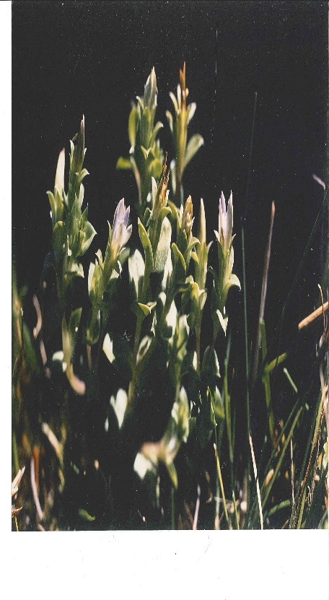
Baeuerlen’s Gentian is listed as Critically Endangered in the ACT Threatened Native Species List under IUCN Criterion B – B1ab(i,ii,iii,iv,v)+B2ab(i,ii,iii,iv,v), Criterion C – C2a(i) and Criterion D – D1. The factors that make the Baeuerlen’s Gentian eligible for listing are: the species’ geographic distribution and number of locations are very restricted, the species is severely fragmented and continuing decline is observed and inferred in Extent of Occurrence (EOO), Area of Occupancy (AOO), area, extent and quality of habitat, number of locations and populations, and number of mature individuals (0-20) (DCCEEW 2026). Baeuerlen’s Gentian is not currently known to be extant at any sites where the species was previously recorded. Although there are no known surviving individuals, the limited detectability of the species suggests it may be premature to infer extinction (Wilkins & Keith 2019) and further survey effort is needed to determine if the species is still extant.

DESCRIPTION AND ECOLOGY
Baeuerlen’s Gentian is a small annual herb, standing 2–4 cm high. Each plant has 1–3 bell-shaped flowers that are greenish outside and blue-white inside (Flora and Fauna Committee 1996).
The ACT population has been recorded as flowering between autumn and early winter (March–June) and it appears to be an annual, dependent on seed regeneration (Act Government 2017).
Baeuerlen’s Gentian (ACT Government)

Distribution and Habitat
Baeuerlen’s Gentian was described from specimens found near Bombala (NSW) in 1887 where it is no longer extant. It was not observed again until 1991 when 20 pants were accidently discovered in a moist grassland in the Orroral Valley (Namadgi National Park) reducing to less than 10 plants in 1994 (Flora and Fauna Committee 1996). This reduced to four plants in 1998, with annual surveys unsuccessful in locating any plants since then. This site was burnt in the bushfires in 2003 and the fire was severe in parts of the habitat and penetrated into the peat, which may have impacted any seeds in the soil seed bank (ACT Government 2017). The site was also burnt in the bushfires in 2019–20 and surveys in May 2020 found no plants even though there was initial recovery of much of the ground cover (J Seddon 2022. pers comm 19 July). Comparable sites with similar habitat nearby were also searched at this time, along with other swamps in the Southern Tablelands, but no plants were found (D Keith 2022. pers comm 15 July). Annual surveys from 2021 and 2024 also found no plants (F Grant 2022. pers comm 15 July 2022; E. Cook 2026. per comm 2 March), so the species has not been seen since 1998 (28 years). The known areas of historic habitat for the species are shown in Map 1.
Map 1: Modelled distribution of Gentiana baeuerlenii
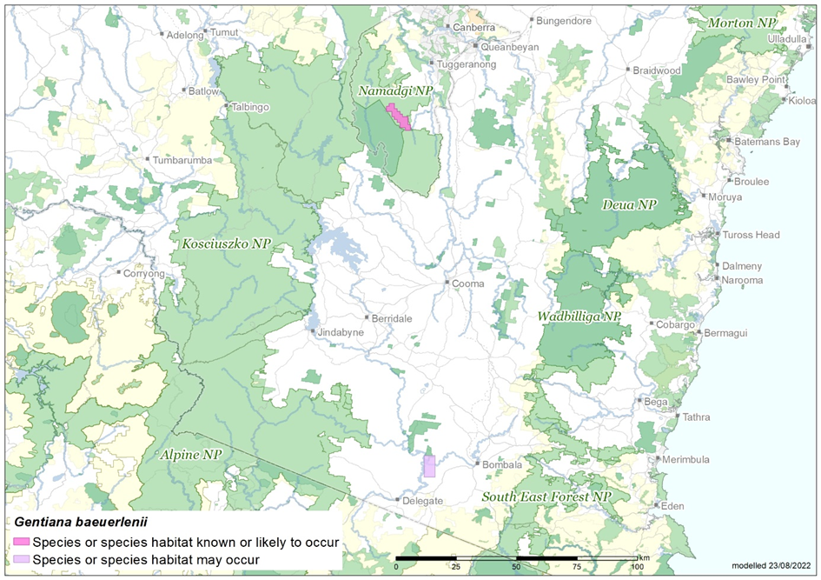
Source: Base map Geoscience Australia; species distribution data Species of National Environmental Significance database.
The species occurs in the inter-tussock space of moist tussock grassland and sedgeland (Poa labillardieri and Carex gaudichaudii), possibly spring-fed. The site is on the lower slopes of a broad valley above a river and it is very unlikely the species exists anywhere else in the ACT (ACT Government 2017).

Threats
The main identified threats in the ACT action plan (ACT Government 2017) include:
- unintended park management actions
- feral pig rooting
- insufficient understanding of species competition, grazing, trampling and fire.
Climate change and the resulting decreased rainfall in recent years, particularly in autumn and winter, may adversely impact this species as it is dependent on seepage areas remaining moist (OEH 2019). Also, increased frequency of extreme temperatures, droughts and fire danger weather, and changes in precipitation may have catastrophic consequences (DCCEEW 2026).

Major Conservation Objectives
The overall objective of the action plan (ACT Government 2017) is to preserve Baeuerlen’s Gentian in perpetuity in the wild across its natural geographic range in the ACT including the need to maintain natural evolutionary processes.

Conservation PRIORITIES
The ACT is likely to contain the only remaining site of Baeuerlen’s Gentian and its conservation is critical to the survival of the species. Due to the cryptic nature of this species and the small size of the site, management actions are directed towards maintaining existing conditions and ensuring activities located nearby do not adversely affect the site. Conservation actions identified in the ACT action plan (ACT Government 2017) include:
- protect the site in Namadgi National Park
- manage habitat to maintain suitability for the species (e.g., exclude disturbance by pigs)
- monitor site and effects of management actions
- manage adjacent grassland to facilitate expansion of populations.
- develop an ex-situ seed bank and/or tissue culture if the species can be found and germination occurs at suitable numbers
- research ecology, habitat and threats.
Future priorities identified in the 5-year report on the Action Plan (ACT Government 2024), in collaboration with the NSW NPWS and in the Commonwealth Conservation Advice (DCCEEW 2026) include to:
- develop a landscape-scale potential habitat map for the southern tablelands between ACT and the NSW “Quidong” property based on the habitat description (species composition, soils, topography, elevation, climatic features (Keith et al. 2018) and the location of springs) to identify areas suitable for further field search and surveys
- continue to undertake targeted surveys during flowering season in the Orroral Valley and potentially in the areas identified as suitable habitat for this species including Scabby Range Nature Reserve and Tantangara Reservoir as candidate locations (DCCEEW 2026)
- improve understanding of its population dynamics, ecology and specific habitat requirements to support management for conservation, if the species is rediscovered (Keith et al. 2018)
- continue to control feral pigs in Namadgi National Park
- undertake ecological restoration at the Orroral Valley site with the specific objectives to improve habitat quality and provide opportunities for G. baeuerlenii recruitment from seed (assuming a viable soil seedbank exists), building on past experience of land managers and ecologists at these sites (restoration should involve the development of a detailed project plan that includes monitoring and evaluation with key considerations for treatments such as erosion control and measures to improve local hydrology to maintain key structural dominants, weed and herbivore management)
- support research on the relationship between G. baeuerlenii and G. bredboensis to resolve taxonomic uncertainty
- collect seed and propagation of G. bredboensis if genetic studies show no genetic differentiation between G. baeuerlenii and G. bredboensis, conduct research into the life history and ecology of the species, if plants are found, including understanding the role of mycorrhiza as possible agents for germination/plant development, including determining seed bank longevity, factors controlling seed germination, pollinators, recruitment and seed dispersal.

Conservation Issues
It is recommended that quantitative targets and resourcing requirements are clearly identified in any Action Plan or other related projects/programs relevant to this species. Broader conservation issues need to be considered in developing and implementing actions arising from this advice and the listing assessment (DCCEEW 2026).

Critical Habitat
The Commonwealth Conservation Advice (DCCEEW 2026) identifies that Gentiana baeuerlenii has historically been found in the Namadgi National Park, ACT and the Quidong area near Bombala, NSW. Due to the small geographic distribution, habitat critical to the survival of the species includes the area of occupancy of the species including any areas where the species was previously known to occur or is found to occur in the future, areas of similar habitat surrounding these populations (as these areas provide potential habitat for pollinators or biota essential to the continued existence of the species and enables the movement of pollinators between localities), and the local catchment for the surface/groundwater that maintains the habitat of the taxon and any areas of similar habitat (defined as moist tussock grassland and sedgeland) in areas where the species is likely to occur or may occur (pink areas in Map 1) may be habitat critical to the survival of the species, and surveys should be conducted to determine if the species is present. Any surveys for the species should be conducted in autumn and take into account the likelihood of detecting the species given its cryptic nature.
No Critical Habitat as defined under section 207A of the EPBC Act has been identified or included in the Register of Critical Habitat under the EPBC Act.

Climate Change
Climate change impacts are inevitable and will affect the likelihood of persistence, within the ACT, of many species. Amongst the most vulnerable in this regard are those species that occupy highly fragmented habitat with highly restricted distributions, such as the Baeuerlen’s Gentian. Capacity must be developed to model the impact on the Baeuerlen’s Gentian and its habitat under likely climate change scenarios if we are to anticipate and manage the impacts of climate change. This will require a combination of research and the development of in-house capacity for the collection of relevant data and its application in climate change modelling.

Population Viability
With a threatened species, such as the Baeuerlen’s Gentian, the question often raised is whether the species is viable into the future. That is, have the populations declined in abundance and become fragmented to such an extent and has the genetic diversity of the species declined to such an extent that the species no longer has the capacity to rebound should conditions improve or to respond to management intervention. Such an assessment may need to be made in the case of the Baeuerlen’s Gentian if it is found, and if it is determined that the species is not viable, to explore more intensive options for bringing the species to a position where it has the potential to recover.

Jurisdictional Collaboration
The location of the species habitat in Namadgi National Park and in south-eastern NSW requires the development of any policies and action/recovery plans to be discussed between relevant jurisdictional entities.

Ngunnawal Community Engagement
The ACT Government should actively facilitate, the inclusion of the Ngunnawal people in the conservation of this species and its habitat as part of Ngunnawal Country. Reference to the draft Cultural Resource Management Plan (ACT Government in prep.) would be useful to inform culturally appropriate resource management including of native species that aligns with achieving conservation outcomes for the species.

Other Relevant Advice, plans or Prescriptions
- ACT Native Grassland Conservation Strategy (ACT Government 2017)
- Commonwealth Conservation Advice — Baeuerlen’s Gentian (DCCEEW 2026)
- Conservator Translocation Guidelines (ACT Government 2018)

Listing Background
The Baeuerlen’s Gentian was listed in the ACT as an Endangered species on 15 April 1996 in accordance with section 21 of the Nature Conservation Act 1980. At that time, the Flora and Fauna Committee (now the Scientific Committee) concluded that the assessment satisfied the following criteria:
1.1 Species is known or suspected to occur in the ACT region and is already recognised as endangered or presumed extinct in an authoritative international or national listing.
1.2 Species is observed, estimated, inferred or suspected to be at risk of premature extinction in the ACT region in the near future, as demonstrated by:
1.2.6 Extremely small population.
Baeuerlen’s Gentian is eligible for listing as Endangered under the Environment Protection and Biodiversity Conservation Act 1999 (EPBC Act) as, prior to the commencement of the EPBC Act, it was listed as Endangered under the Endangered Species Protection Act 1992 (Cwlth).
The species was reassessed and listed as Critically Endangered under the EPBC Act on 6 February 2026. In response, the ACT Scientific Committee recommended the Baeuerlen’s Gentian be transferred to the Critically Endangered category in the ACT Threatened Native Species List under the Nature Conservation Act 2014, to align with the EPBC Act listing.

Action Plan Decision
The ACT Scientific Committee recommends that the Minister for the Environment should make the decision to continue the current action plan (ACT Government 2017a) for the species in the ACT under the Nature Conservation Act 2014.
All known habitat on ACT-owned land is within Namadgi National Park. A national recovery plan is not required for the species as the Commonwealth Conservation Advice for the species will guide priority conservation actions, mitigate against key threats, enable potential recovery and provide a foundation for further planning (DCCEEW 2026) through well-established existing mechanisms between the NSW and the ACT governments.

References
ACT Government 2017. ACT Native Grassland Conservation Strategy and Action Plans. ACT Government, Canberra. https://www.legislation.act.gov.au/View/di/2017-288/current/PDF/2017-288.PDF
ACT Government 2018. Nature Conservation (Translocation of Native Flora and Fauna) Conservator Guidelines. Department of Environment, Planning and Sustainable Development, Canberra. https://www.legislation.act.gov.au/ni/2017-650/
ACT Government 2024. 5-year effectiveness report on the Baeuerlen’s Gentian Action Plan – unpublished draft Conservator report to the ACT Minister for the Environment, Canberra.
Canberra.naturemapr.org (CNM) 2019. Canberra Nature Map. Accessed 14 August 2019 from: https://canberra.naturemapr.org/Community/Species/Sightings/3294?ViewMode=Detail
Office of Environment and Heritage (OEH) 2019. Baeuerlen's Gentian – profile. OEH NSW, Sydney. Accessed 14 August 2019 from: https://www.environment.nsw.gov.au/threatenedSpeciesApp/profile.aspx?id=10345
Environment ACT 2004. Recovery Plan for a sub-alpine herb (Gentiana baeuerlenii). Environment ACT, Canberra.
Flora and Fauna Committee 1996. Recommendation for Declaration of an Endangered Species – Gentiana baeuerlenii. ACT Government, Canberra.
Keith D. Stephens R, Doyle C and Pellow B 2018. Priority Research Action Outcomes Report – Baeuerlen’s Gentian. Unpublished report as part of the Data deficient Species Research Grants Program. NSW Environmental Trust and NSW Government, Sydney.
Department of Climate Change, Energy, the Environment and Water (DCCEEW) 2026. Conservation Advice for Gentiana baeuerlenii (Baeuerlen's Gentian). Department of Climate Change, Energy, the Environment and Water, Canberra. http://www.environment.gov.au/biodiversity/threatened/species/pubs/12001-conservation-advice-06022026.pdf
Wilkins K and Keith DA 2019. SOS Data Deficient Species: Targeted survey results and management recommendations for Gentiana baeuerlenii L.G.Adams. Centre for Ecosystem Science, University of New South Wales, Sydney.

Further Information
Further information on the species or other threatened species and ecological communities can be obtained from the Environment, Planning and Sustainable Development Directorate (EPSDD).
Phone: (02) 132281, EPSDD Website: https://www.environment.act.gov.au/nature-conservation

Attachment A: Listing Assessment (DCCEEW 2026)
