Australian Capital Territory
Planning (Various) Minor Plan Amendment 2026 (No 1)
Notifiable instrument NI2026–85
made under the
Planning Act 2023, s 85 (Making minor plan amendments)

1 Name of instrument
This instrument is the Planning (Various) Minor Plan Amendment 2026 (No 1).
2 Commencement
This instrument commences on the day after its notification day.
3 Minor plan amendment
I am satisfied under the Planning Act 2023, section 85 (1) that Minor Plan Amendment 2025-13 is a minor plan amendment to the territory plan.
4 Dictionary
In this section:
Minor Plan Amendment 2025-13 means the minor plan amendment to the territory plan in schedule 1.

James Bennett
Delegate of the territory planning authority
12 February 2026

Schedule 1


MINOR AMENDMENT
TO THE TERRITORY PLAN
2025-13

Rezoning under future urban area, changes to future urban
area overlay boundary for part John Gorton Drive, Molonglo Valley and clarification amendments to the Inner North and City District Policy and Dictionary

This minor plan amendment was prepared
under part 5.3 of the Planning Act 2023
Contents
1.0 INTRODUCTION 4
1.1 Outline of the process 4
1.2 Summary of the proposed amendment 5
2.0 CONSULTATION WITH THE PUBLIC 5
2.1 Consultation period 5
2.2 Comments from the public 5
2.3 Changes made after public consultation 5
3.0 TERRITORY PLAN CHANGES 6
3.1 Territory Plan Map 6
3.2 Inner North and City District Policy 8
3.3 Dictionary 8
4.0 TERRITORY PLAN AMENDMENT INSTRUCTIONS 9
4.1 Part B - Territory Plan Maps 9
4.2 Part D: D03 – Inner North and City District Policy 10
4.3 Part G - Dictionary 10
INTERPRETATION SERVICE 11

- INTRODUCTION
  - Outline of the process
Minor plan amendment 2025-13 (MA2025-13) to the Territory Plan is a minor plan amendment (MA) prepared under section 84(2)(d) and (e) and section 89(1)(2) and (3) of the Planning Act 2023 (the Act).

Section 84 of the Act outlines the different types of MAs, some which require limited consultation to be undertaken and some which require no consultation to be undertaken.

Under Section 85 of the Act a MA can only be made where:
- any required limited consultation has taken place and the authority is satisfied that the content of the MA meets the requirements of the Act
- if the MA is not inconsistent with the planning strategy or any relevant district strategy
- any comments received during the consultation period and from the National Capital Authority have been considered.

This MA required limited consultation to be undertaken and was released for public consultation in accordance with the Act.

The MA is not inconsistent with the planning strategy or any relevant district strategies.

The National Capital Authority has received a copy of this MA.

For more information on the content of the Territory Plan and minor plan amendment processes please refer to the Planning website: The Territory Plan - City and Environment Directorate - Planning
  - Summary of the proposed amendment
MA2025-13 proposes to make the following changes:

Territory Plan Map
- rezone the land under future urban area from Residential RZ1-Suburban to Transport and Services TSZ1-Transport and amend the boundary of the future urban area overlay on part John Gorton Drive in the Molonglo Valley.

Inner North and City District Policy
- Clarify Assessment Requirement 2 by removing part of the requirement to improve design outcomes and enable sufficient rear setbacks to promote deep root planting zones.

Dictionary
- Expand the definition of agriculture to cover all types of horticulture and remove horticulture from the Dictionary in the Territory Plan.

- CONSULTATION WITH THE PUBLIC
  - Consultation period
Under section 84 (2) of the Planning Act 2023, this minor amendment was subject to limited public consultation of at least 20 working days. Written comments on MA2025-13 were invited from the public from 24 November 2025 and closed on 19 December 2025.

  - Comments from the public
No public comments were received during consultation.

  - Changes made after public consultation
No changes were made following public consultation as no comments were received.

- TERRITORY PLAN CHANGES
  - Territory Plan Map
Pursuant to section 84 (2) (e) of the Act, the Territory Plan map is amended by rezoning part of John Gorton Drive in Molonglo Valley to TSZ1 Transport and changing the boundary of the future urban area overlay, as outlined in Figure 1.

This change rezones part of John Gorton Drive from a RZ1 Suburban Zone with a future urban area overlay (Figure 2) to TSZ1 Transport Zone and changes part of the future urban area overlay in the Molonglo Valley (Figure 3). This amendment applies an appropriate long-term zone to an existing arterial road reserve and facilitates infrastructure consistent with its transport function. This will enable the future lodgement of a development application (DA) for telecommunications infrastructure in the existing road reserve.

This amendment is consistent with the Molonglo Valley District Strategy.

Figure 1 – Location map – John Gorton Drive, Molonglo Valley

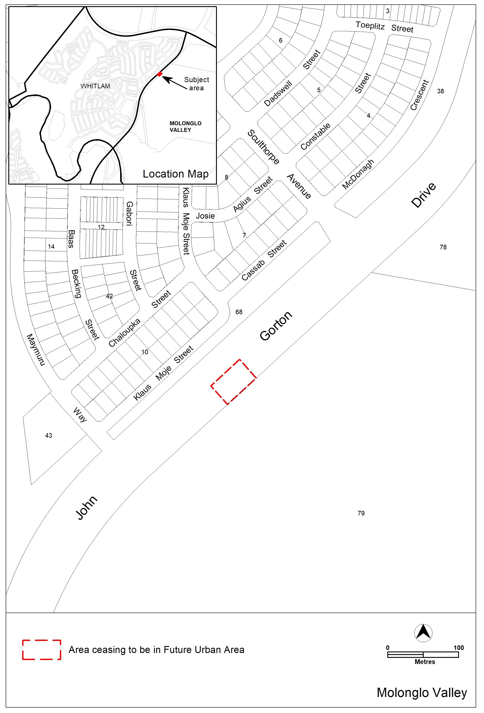

Figure 2 - Existing Territory Plan Map – John Gorton Drive
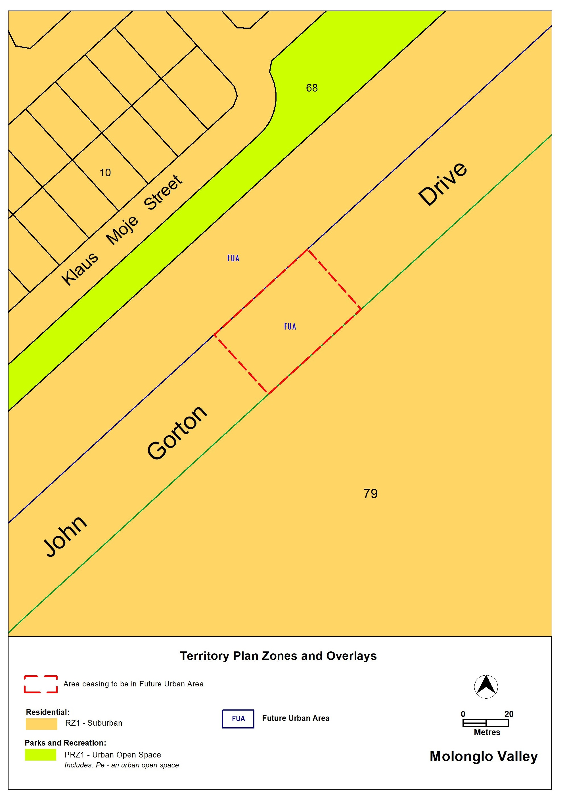

Figure 3 – Amended Territory Plan Map – John Gorton Drive
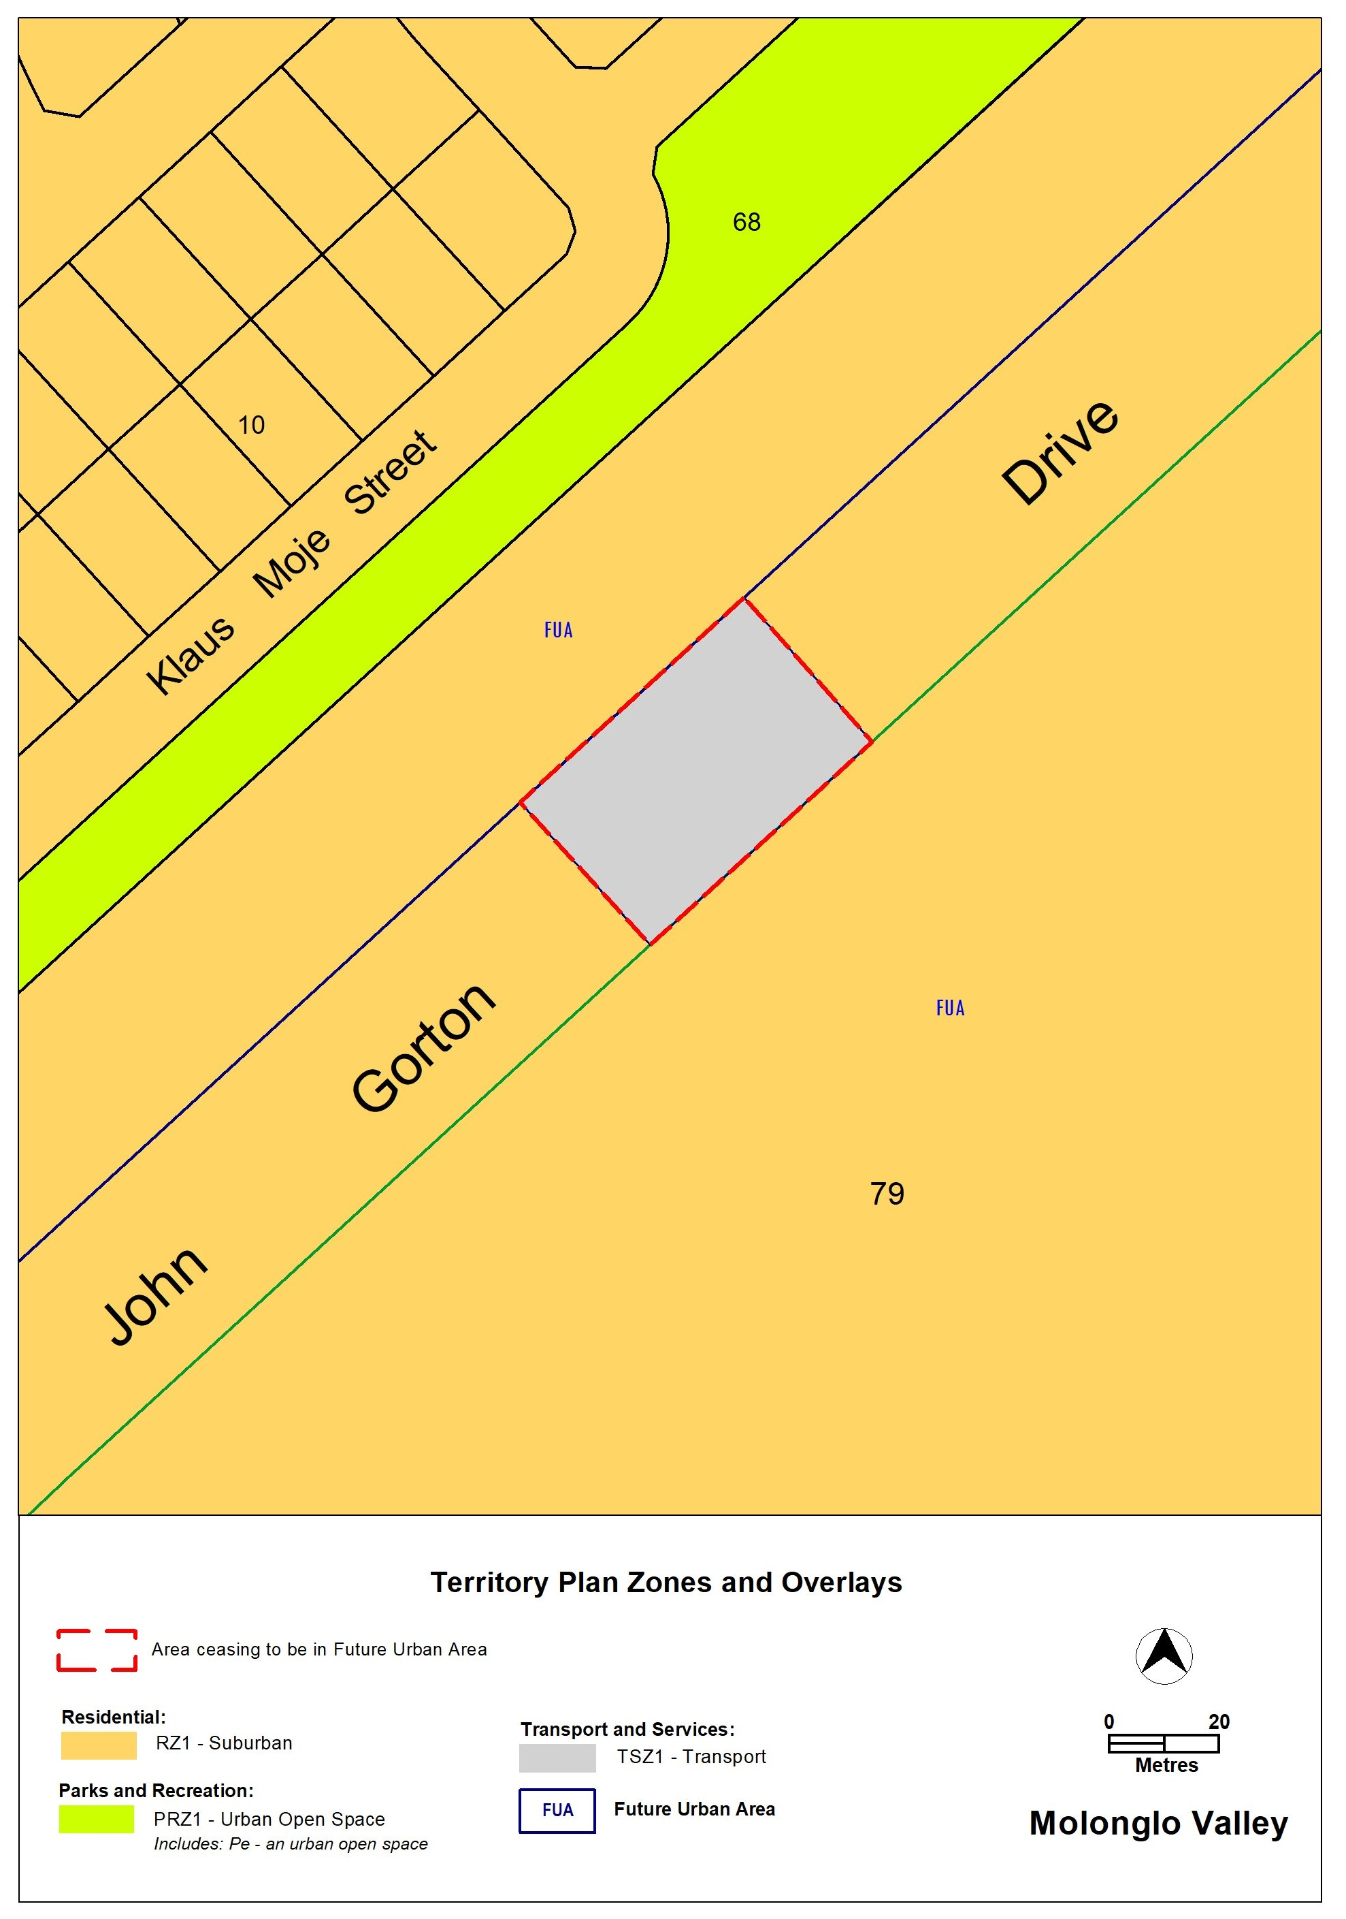
  - Inner North and City District Policy
This minor amendment clarifies Assessment Requirement 2 which currently outlines that perimeter development is required to, primarily, maximise large rear zones for privacy and open space.

The amendment specifically removes reference to ‘building primarily across the site frontage (and not down the length of the site)’ which is limiting built form opportunities and the ability to meet the outcomes of the RZ4 zone and the Inner North and City District Policy.

This change is made pursuant to section 84 (2) (d), as it’s considered not to change the substance of the plan and is consistent with the policy intent.
  - Dictionary

This minor amendment addresses inconsistencies in the definitions of ‘agriculture’ and ‘horticulture’, including associated example uses.

In the Territory Plan 2023, ‘horticulture’ is currently a standalone land use defined as “the use of land for intensive plant production such as fruit, vegetable, or flower production (including berries and vines)”. Despite this, it does not appear in any land use tables contained in zone policies. This has the unanticipated effect of prohibiting horticulture as a land use in all zones.

The current definition of ‘agriculture’ also outlines that horticulture as a subset of that land use. Agriculture currently means “broadacre animal farming, crop and pasture production, and horticulture for commercial wholesale production…”.

This amendment rectifies this inconsistency by removing the definition of horticulture and revising the definition for agriculture so it adequately captures horticulture uses.
- TERRITORY PLAN AMENDMENT INSTRUCTIONS
This section provides the legal instructions for how MA2025-13 proposes to amend the Territory Plan.
  - Part B - Territory Plan Maps

The relevant part of the Territory Plan map is varied as indicated below.

John Gorton Drive, Molonglo Valley
  - Part D: D03 – Inner North and City District Policy

Assessment Requirement 2

Substitute:

In areas identified in Figure 1, building design promotes perimeter block development to:
a) Provide space to the rear of the block to retain or introduce large-canopy trees and create a treed backdrop to development.
b) Maximise street address as well as physical and visual access to the rear garden.
c) Minimise privacy impacts between adjacent sites.
d) Optimise possibilities for private and communal open spaces.

Hyperlink: ‘Figure 1’ in Assessment Requirement 2 to the respective figure
  - Part G - Dictionary

Table 1 land use definitions:

Substitute:
Definition | Example uses
agriculture means broadacre animal farming, crop and pasture production and horticulture for intensive and broadacre plant production. Agriculture does not include intensive animal farming or farming carried out primarily for the personal enjoyment of, or consumption by, the owner or occupant of land. | horse agistment livestock grazing broadacre farming hydroponics market garden orchard  plant nursery (excluding retail plant nursery)

Omit:
horticulture means the use of land for intensive plant production such as fruit, vegetable, or flower production (including berries and vines). | hydroponics market garden orchard  plant nursery (excluding  retail plant nursery)

INTERPRETATION SERVICE
To speak to someone in a language other than English please telephone the Telephone Interpreter Service (TIS) 13 14 50
LANGUAGE | DETAILS
English | If you need an interpreter please call: 13 14 50
Mandarin (Simplified Chinese) / 简体中文 | 如果您需要翻译，请致电：13 14 50
Arabic / العربية | إذا كنت بحاجة إلى مترجم شفهي اتصل بالرقم: 50 14 13
Cantonese (Traditional Chinese) / 繁體中文 | 如果你需要傳譯員，請致電：13 14 50
Vietnamese /  Tiếng Việt | Nếu bạn cần thông dịch viên, xin gọi: 13 14 50
Korean / 한국어 | 통역사가 필요할 경우 다음 번호로 전화하시기 바랍니다: 13 14 50
Spanish / Español | Si necesita un intérprete, llame al 13 14 50
Persian (Farsi) / فارسی | اگر به مترجم نیاز دارید، لطفاً به این شماره تلفن کنید: 50 14 13
Dari / دری | اگر به یک ترجمان شفاهی نیاز دارید لطفاً به شمارۀ 131450 زنگ بزنید.
Punjabi / ਪੰਜਾਬੀ | ਜੇਕਰ ਤੁਹਾਨੂੰ ਕਿਸੇ ਦੁਭਾਸ਼ੀਏ ਦੀ ਲੋੜ ਹੈ ਤਾਂ ਕਿਰਪਾ ਕਰਕੇ ਫੋਨ ਕਰੋ: 13 14 50
Tamil / தமிழ் | உங்களுக்கு மொழிபெயர்த்துரைப்பாளர் ஒருவர் தேவைப்பட்டால் 13 14 50 என்ற எண்ணை அழைக்கவும்
Greek / Ελληνικά | Αν χρειάζεστε διερμηνέα, τηλεφωνήστε: 13 14 50
Italian / Italiano | Se hai bisogno di un interprete, chiama: 13 14 50
Hazaragi / هزاره گی | اگه ده ترجمان ضرورت ده رید، لطفاً ده شماره 50 14 13 تماس بگیرید.
Thai / ภาษาไทย | หากคุณต้องการล่าม กรุณาโทรไปที่ 13 14 50
Karen / ကညီကျိၥ် | ဖဲနမ့ၢ်လိၣ်ဘၣ်ပှၤကတိၤကျိးထံတၢ်တဂၤအခါ၀ံသးစူၤကိးဘၣ်-၁၃၁ ၄၅၀ တက့ၢ်.

Telephone and Interpreter Service 13 14 50 - Canberra and District - 24 hours a day, seven days a week

