Australian Capital Territory

Heritage (Decision about Registration of McKeown House, Watson) Notice 2026
Notifiable instrument NI2026—86
made under the
Heritage Act 2004, s 40 (Decision about registration)

1 Name of instrument
This instrument is the Heritage (Decision about Registration of McKeown House, Watson) Notice 2026.
2 Commencement
This instrument commences on the day after its notification day.
3 Decision about registration
On 18 February 2026, the ACT Heritage Council (the Heritage Council) decided to register McKeown House, Block 30, Section 47, Watson (the place).
4 Registration details of the place
The registration details of the place are in the schedule.
5 Reasons for the decision
The Heritage Council is satisfied on reasonable grounds that the place has heritage significance as it meets one or more of the heritage significance criteria in section 10 of the Heritage Act 2004. A detailed statement of reasons including an assessment against the heritage significance criteria is provided in the schedule.
6 Date registration takes effect
The registration of the place takes effect on the day after this notice is notified.
7 Revocation
The Heritage (Decision about Provisional Registration of McKeown House, Watson) Notice 2025 (NI2015—523) is revoked.

Dr. Mary Clare Swete Kelly
Secretary (as delegate for)
ACT Heritage Council
19 February 2026
Schedule
(See sections 4 and 5)


AUSTRALIAN CAPITAL TERRITORY
HERITAGE REGISTER
Final Registration
For the purposes of s40 of the Heritage Act 2004, an entry to the heritage register has been prepared by the ACT Heritage Council for the following place:

McKeown House (109 Irvine Street)
BLOCK 30 SECTION 47, WATSON
DATE OF DECISION
18 February 2026
Notifiable Instrument: 2026–
Copies of the Register Entry are available online at https://www.act.gov.au/environment/heritage/act-heritage-register and at ACT Heritage.
For further information please contact:
The Secretary
ACT Heritage Council
Email heritage@act.gov.au Post GPO Box 158 CANBERRA ACT 2601 Telephone 13 22 81

Statement of heritage significance
This statement refers to the heritage significance of the place as required in s12(d) of the Heritage Act 2004.
McKeown House was built in 1965 and the connected rear addition in 1995. The main house is an excellent example of modernist sculptural organic style architecture — characterised by an integrated relationship with the landscape, complex angular geometry, and expressed building materials. The addition is an evolved, yet sympathetic interpretation of the architectural style of the main house.
The main house with the addition were designed by the architect Dr Enrico Taglietti AO. Taglietti was an Italian-born Australian architect who played a significant role in shaping the built environment of the Australian Capital Territory (ACT). He was a leading practitioner of the sculptural organic style of architecture, designing several notable buildings in the ACT, many listed on the heritage register. His architectural work is highly celebrated and awarded.
The main house features Taglietti’s distinctive timber-framed, wedge-shaped corner windows as well as a striking cantilevered concrete gutter, marking the beginning of his use of prominent rainwater spouts as key sculptural elements of his designs. His expressive use of materials is visible in the extensive use of timber, which is juxtaposed against concrete and rendered brick walls. Timber is expressed in the form of timber window frames, expressed timber beams, and prominent timber fascias.
The addition connected to the main house appears to grow from the site, expressing its synthesis with nature through its large, north-facing windows and several geometric windows throughout. Timber is expressed in the window frames and in a horizontal timber balcony. The addition contrasts with the horizontal emphasis of the main house through a steeply pitched corrugated steel roof. It is overall lighter and brighter than the more encased main house, while at the same time remaining sympathetic to the original house through its geometric form and use of similar materials.
Both parts of McKeown House feature internal fixtures and fittings custom designed by Taglietti.
The main house is notable for being one of Taglietti's earliest residential works, while the addition, designed 30 years later, is one of his later works. Together, these residences form a unique and remarkably intact representation of Taglietti’s evolving domestic architectural style, bookending his career in a single location. They demonstrate the principal characteristics of organic style architecture and Taglietti’s progressively sophisticated manipulation of natural light and increasing responsiveness to Canberra’s climatic conditions.

Location of the place
This statement refers to the name and location of the place as required in s12(a) and s12(b) of the Heritage Act 2004.
McKeown House, Block 30, Section 47, 109 Irvine Street, Watson.

Description of the place
This statement refers to the description of the place as required in s12(c) of the Heritage Act 2004. The attributes described in this section form part of the heritage significance of the place. For the purposes of s12(c) of the Heritage Act 2004, the registration boundary of the place is at Figure 1.
McKeown House sits on a north-facing, slightly sloped 1,106m2 suburban block in Watson and consists of a residential house with a connected addition.
The main house is a single-storey home, featuring white-painted rendered brick walls and a flat galvanised-iron roof with wide eaves and timber fascias. The house is notable for its asymmetrical massing, sculptural forms, and complex geometry. Timber beams project beyond the fascias and a large concrete gutter is cantilevered from the front of the house, spilling rainwater from the roof into a concrete pond. This front garden pond and the oil tank above it contribute to the sculptural form of the house. The blank wall facing the street is extended as a sloping garden wall to give the house a sculptural form and to screen the approach to the front door and garage. Two other sloping garden walls project into the back garden. A steel carport over the driveway and steel posts for roof support were added in 1994.
The main house consists of two staggered square zones—one for living and entertaining featuring an open-plan lounge, kitchen, and dining area, and a private zone with two bedrooms, a bathroom, laundry, and garage. Timber beams are expressed internally and externally, and project externally beyond the roofline. The two front corners of the house have splayed, wedge-shaped, sloped corner windows with planting boxes, lighting the dining space and the second bedroom. The garage was designed to be converted into a third bedroom. The rear walls of the main bedroom and the open plan living/dining area have large, glazed openings, allowing the back garden to be appreciated from the interior. The prospect from the interior to the front garden and the street is more subtle, reflecting the need for privacy.
On the interior, both parts of McKeown House have built-in fixtures and fittings custom designed by Taglietti. The main house features sloping kitchen cupboards, copper box lights, and a custom-built wooden cabinet that divides the living room and kitchen.
The addition is a freestanding structure in the rear garden, connected to the main house by a passage aligned with the main house’s central axis. It consists of a two-storey, self-contained unit. Its geometry complements the main house, while at the same time contrasting it. Like the main house, it features white-painted brick walls and sloping garden walls that are used to shelter and discretely reveal. Timber is expressed in the form of a horizontal timber balcony. At the same time, the addition’s vertical emphasis and a steeply pitched corrugated steel roof contrasts with the horizontal massing of the main house. Its extensive use of smaller, geometric windows throughout, as well as north-facing large, glazed openings, points to a greater acknowledgement of Canberra climate and increasingly sophisticated use of natural light by Taglietti. Unusually, the addition was designed without gutters.
On the inside, the layout of the addition is flexible: it can be a two-bedroom dwelling or a one-bedroom flat with an upstairs study/library. It was designed with flexibility in mind. The upper floor functions as a study and features angular ceilings, highlight windows, and a light tower illuminating a desk/study area. The second-floor area also features a built-in bed frame, allowing for the space to be converted into a second bedroom. There is built-in book shelving throughout.
The main house, built in 1965 and designed according to sculptural organic style principles, has the following significant features:
Exterior features that are demonstrative of the sculptural organic style:
- Minimum pitch galvanised iron butterfly roof with deep horizontal timber fascia
- Flat panel soffit linings, painted white and large projecting timber beams
- White-painted, rendered brick walls
- Large concrete gutter at the front of the house, spilling water from two sections of the roof into a concrete pond
- Wedge-shaped corner windows with timber frames
- Large, glazed openings in the main bedroom and the open plan living/dining area
Landscape elements that are demonstrative of the sculptural organic style:
- Tapered garden walls
- Concrete pond water feature in the front garden
- Oil tank above the pond in the front garden
Interior elements that are demonstrative of the sculptural organic style:
- Layout with two staggered square zones, distinct functionally, one for living and entertaining (open-plan lounge, kitchen, dining) and one private zone with two bedrooms, a bathroom, laundry, and convertible garage
- Copper box lights
- Angled kitchen cabinets
- Modern, light-filled design of the bathroom
- Expressed timber beams and rafters in the ceiling
- Johnston River wood parquetry flooring in living and dining area.
- Custom wood cabinet in living room
- Connecting cabinet between kitchen pantry and exterior
The 1995 addition, designed in the late 20th-century organic style, has the following significant features:
Exterior features that are demonstrative of the sculptural organic style:
- Selective areas of timber cladding and soffit linings externally
- Timber balcony
- Geometric highlight windows with timber frames
- Light tower
- White rendered brick walls, matching the main house
- Steeply pitched corrugated steel roof
Landscape elements that are demonstrative of the sculptural organic style:
- Courtyard wall for privacy
- Tapered garden walls
Interior elements that are demonstrative of the sculptural organic style:
- Timber lining at the upper floor ceiling, and around the loft bed
- Built-in upstairs bed frame with timber panelling
- Angular ceilings throughout
- Light tower
- Flexible design, fully self-contained, with option to be converted into two bedroom or one bedroom

Conservation objective
The guiding conservation objective is that McKeown House shall be conserved and appropriately managed in a manner respecting its heritage significance.
The ACT Heritage Council may make heritage guidelines applicable to the place under s25 of the Heritage Act 2004.
For further information on guidelines applicable to the place, or for advice on proposed works or development, please contact ACT Heritage via email at heritage@act.gov.au or via 13 22 81.

Reason for provisional registration
This statement refers to the heritage significance of the place as required in s12(d) of the Heritage Act 2004.
The Council has assessed McKeown House against the heritage significance criteria and reasonably believes that the place has heritage significance when assessed against criteria (b) and (d) under s10 of the Heritage Act 2004. A place is considered to have heritage significance if it meets one or more of the criteria.
Table 1 Criteria that the Council consider have been met.
Criterion | (a) | (b) | (c) | (d) | (e) | (f) | (g) | (h)
Met | No | Yes | No | Yes | No | No | No | No

Assessment against the heritage significance criteria
This statement refers to the heritage significance of the place as required in s12(d) of the Heritage Act 2004.
In assessing the heritage significance of McKeown House, the Council considered:
- the original nomination and documentary evidence supplied by the nominator
- the Council’s Heritage Assessment Policy (March 2018)
- information provided by a site inspection on 04 August 2025 by ACT Heritage
- the report by ACT Heritage titled, Background Information McKeown house (109 Irvine Street), WATSON, August 2025, containing photographs and information on history, description, condition and integrity.
According to s10 of the Heritage Act 2004, a place or object has heritage significance if it meets one or more of the following criteria. Future research may alter the findings of this assessment.

(a) importance to the course or pattern of the ACT’s cultural or natural history
Does not meet criterion.
The Council reasonably believes that the place does not meet this criterion.
Although McKeown House has a clear association with Canberra’s early development driven by the National Capital Development Commission (NCDC), and this association is evident in the physical fabric of the place, many other buildings in Canberra exhibit this link. A thematic heritage study of modernist houses in the ACT details the role of the NCDC in shaping this development. Because of the NCDC-driven development during this time, Canberra is home to many mid-century modernist buildings, including residential buildings. Indeed, due to only one previous significant wave of residential construction, Canberra is home to a disproportionate stock of modernist housing when compared to other Australian capital cities.
The Council believes that McKeown House provides evidence of a historical quality that is relatively common in the ACT. McKeown house does not meet the threshold indicator of exceptionality and rarity in this regard.

(b) has uncommon, rare or endangered aspects of the ACT’s cultural or natural history
MEETS CRITERION.
The Council reasonably believes the place meets this criterion.
McKeown House is a unique example of a place that documents the evolution of Taglietti’s organic style of architecture. Built 30 years apart, the main house and addition bookend Taglietti’s career in one site. This is unique among residential houses designed by Taglietti.
The main house and rear addition complement and contrast each other. They share many features, including materials (rendered brick, stained timber) and design elements (tapered garden walls, geometric windows). At the same time, they contrast each other: while the main house features Taglietti’s first use of a prominent concrete gutter, a signature modernist flat roof, and large wedge-shaped windows, the addition does not have prominent gutters, has a steeply pitched roof and several smaller, geometric windows. Together, they showcase a unique composition of features, which respond to the specific site context.
Read in context, McKeown House illustrates Taglietti’s evolution in style, from a very private main house consisting of a massive, north-facing brick wall, signature prominent concrete gutter, and two large wedge-shaped windows, to an addition that is northwards oriented for more sunlight, as well as overall lighter and brighter through its use of smaller geometric windows throughout. The addition demonstrates Taglietti’s increased awareness of the Canberra climate and sophistication of natural light use.
Together, the main house and addition uniquely showcase in one place Taglietti’s change in style and evolution of ideas after a 30-year career. When judged in the context of Taglietti’s other designs in the ACT, this bookending feature of McKeown House is unique and thus exceptionally rare. It meets the key threshold criteria of rarity.
An analysis of comparable residential dwellings reveals that none of Taglietti’s other designs have this bookending quality. Taglietti designed a total of twelve residential buildings in the ACT.
The table below provides more detail on comparable places:
Year | Dwelling | Addition? | Notes
1965 | Gibson House | No
1965 | McKeown House | Yes | Addition designed by Taglietti and built in 1995
1967 | Souillac House | Yes | Later addition not designed by Taglietti, house substantially altered throughout
1968 | Dingle House | Yes | Addition built in 1981 but not designed by Taglietti (Trevor Gibson Architects instead), included on the ACT Heritage Register
1968 | Paterson House | No
1970 | Glenlyle Killen House | No | No longer existent
1971 | Evans House | No
1973 | Wood House | No
1975 | Green House | No
1977 | Gentle House | No
1983 | Mijuscovic House | No
1997 | Lo Hu Min House (Canberra) | Yes | House is an addition to an older house not designed by Taglietti
2001 | House at Flinders Way | No

(c) potential to yield important information that will contribute to an understanding of the ACT’s cultural or natural history
Does not meet criterion.
The Council reasonably believes that the place does not meet this criterion.
Due to its prominence in Australian architectural circles and a broader examination of Taglietti’s contribution to the built environment of Canberra, McKeown House has been well documented and studied. Several architectural publications, including popular news articles as well as architectural journal articles and books, examine the house. Many of these publications are cited in the background research document for this assessment. Moreover, the owner has been very forthcoming regarding the heritage value of the house and has previously shared plans and other relevant materials with various researchers as well as the ACT Government’s Galleries, Museums and Heritage section.
The Council believes that McKeown House provides a further example of a type which is already well studied and documented. It is unlikely to provide any further, better understanding of mid-century modernism and organic style architecture beyond what it already has.

(d) importance in demonstrating the principal characteristics of a class of cultural or natural places or objects
MEETS CRITERION.
The Council reasonably believes that the place meets this criterion.
McKeown House is a fine example of modernist sculptural organic style architecture in the ACT. It demonstrates the principal characteristics of mid-century modernism (i.e. focus on functionality, use of materials like concrete and glass, and rejection of traditional ornamentation in favour of clean lines) and sculptural organic style architecture (i.e. integration with nature, use of natural materials, flow and continuity between spaces, geometric forms, sculptural features). It showcases the evolution of modernist sculptural organic style architecture from 1965 – 1995 in one site, as practiced by Enrico Taglietti.
Modernism is expressed at McKeown House through big glass windows and the characteristically horizontal roof of the main house. It is also expressed through the overall functional layout and design of the house, especially the open plan living and entertaining area, as well as the flexibility of the addition. The simplicity and modern look of the Taglietti-designed interior copper light boxes are another aspect of this design.
Sculptural organic style architecture is expressed at McKeown House through the highly visible, large concrete gutter and pond at the front, the large windows that open the main house and addition up to the garden, the playful sloping garden walls that acknowledge the gentle slope of the site and which shelter and discreetly reveal the surrounding environment, and the connecting cabinet between kitchen pantry and exterior.
The addition takes this commitment to organic design further than the main house through its northward orientation, its many, smaller geometric windows, and light tower that illuminates the upstairs area. It is experienced as if rising out of the landscape.
Timber is another key organic design feature. In the main house it is expressed in the form of projecting and expressed timber beams that are visible on the exterior and interior of the main house, the custom wood cabinet in the living room, and the Johnston River wood parquetry. The addition, in turn, features a timber balcony, as well as a built-in upstairs bed frame with timber panelling. Both parts of the house feature timber window frames for all windows.
McKeown House displays high integrity, with most of the original fixtures and fittings of both the main house and addition intact.
McKeown House meets the threshold indicator of distinctiveness, intactness/integrity, and representativeness.

(e) importance in exhibiting particular aesthetic characteristics valued by the ACT community or a cultural group in the ACT
Does not meet criterion.
The Council reasonably believes that the place does not meet this criterion.
While McKeown House exhibits the aesthetic characteristics of organic style architecture, it is doubtful that these characteristics are valued by the ACT community, let alone a particular cultural group.
The threshold indicator of ‘valued by the ACT community’ must be objectively tested and/or clearly demonstrated. While McKeown House is clearly valued among architects and those passionate about architecture and ACT heritage, this does not qualify as the broader ACT community nor a cultural group. Simply being the work of a highly regarded architect is not sufficient to meet the assessment threshold of wider recognition in the broader ACT community.
While the work of Taglietti is becoming increasingly popular in the ACT, McKeown House has not been shown to be valued by the ACT community for exhibiting particular aesthetic characteristics.

(f) importance in demonstrating a high degree of creative or technical achievement for a particular period
Does not meet criterion.
The Council reasonably believes that the place does not meet this criterion.
While McKeown House exhibits a high degree of creative achievement in the context of residential architectural design, this achievement is not sufficiently beyond the ordinary within the context of the ACT. Due to the substantial development that took place after the NCDC was established, Canberra is home to many mid-century modernist buildings, including residential buildings.
McKeown House does not meet the threshold indicators of exceptionality and rarity.

(g) has a strong or special association with the ACT community, or a cultural group in the ACT for social, cultural or spiritual reasons
Does not meet criterion.
The Council reasonably believes that the place does not meet this criterion.
Professional groups and special interest groups do not qualify as ‘the ACT community’ nor ‘a cultural group’. Community or cultural group concern for McKeown house is not clearly demonstrated. The house does not have a strong or special association with the broader ACT community or a cultural group.

(h) has a special association with the life or work of a person, or people, important to the history of the ACT
Does not meet criterion.
The Council reasonably believes that the place does not meet this criterion.
While McKeown House has a clear association with the work of architect Dr Enrico Taglietti AO, there is insufficient evidence to suggest that it has a special association when compared to his other works.
Although McKeown House is one of Taglietti’s first residential designs (alongside Gibson House), by the time Taglietti designed it in 1965 he had already been commissioned for a range of commercial buildings. These include the Town House Motel in Canberra (1961), Noah’s restaurant (1961), and the Cinema Centre (1964). All these arguably created significantly more visibility and occupied a more prominent role in his career as an architect than McKeown House.
Although the association of McKeown House with Taglietti is a close one, with Taglietti remaining connected with the McKeowns for many decades and designing fixtures and furnishings for them as well as the addition in 1995, length of association is only one threshold indicator.
McKeown House does not meet the threshold indicator of exceptionality.

Registration boundary
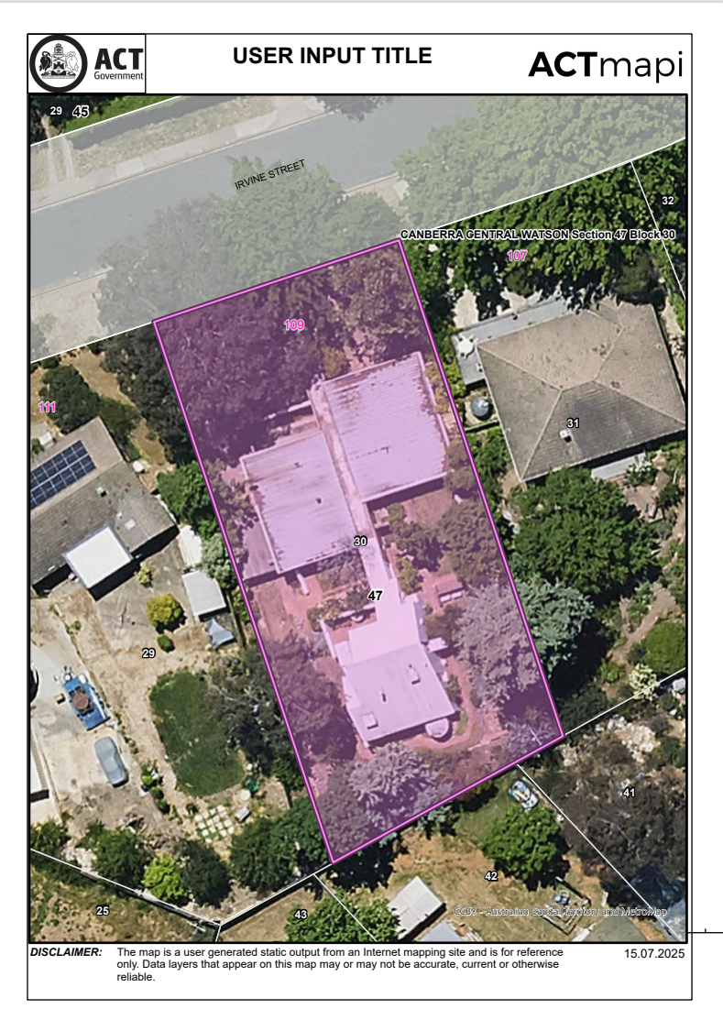
Figure 1: Registration boundary – block boundary

GML Heritage. 2024. Modernist Houses in the Australian Capital Territory: Thematic Heritage Study. Canberra. pp. 28ff. Retrieved from https://gml.com.au/projects/thematic-heritage-study-act-modernist-houses/
The analysis excluded commercial, government, and religious commissions.
Drawn from: Charlton, Favaro, & Jones. 2007. The Contribution of Enrico Taglietti to Canberra’s Architecture. Royal Australian Institute of Architects (RAIA), ACT Chapter. Canberra. pp. 122-126.

