Australian Capital Territory
Heritage (Decision about Provisional Registration of Later Kingston Shops, Kingston) Notice 2026
Notifiable instrument NI2026–87
made under the
Heritage Act 2004, s 34 (Notice of decision about provisional registration)

1 Name of instrument
This instrument is the Heritage (Decision about Provisional Registration of Later Kingston Shops, Kingston) Notice 2026.
2 Commencement
This instrument commences on the day after its notification day.
3 Decision about provisional registration
On 18 February 2026, the ACT Heritage Council (the council) decided not to provisionally register the Later Kingston Shops, Section 22 Blocks 25-32; and Section 21, Blocks 11-16, 19-22, and 25-27, Kingston (the place).
4 Description of the place
The description of the place is in the schedule.
5 Reasons for the decision
The council is not satisfied on reasonable grounds that the place is likely to have heritage significance as defined by the Heritage Act 2004, section 10. A detailed statement of reasons, including an assessment against the heritage significance criteria, is provided in the schedule.
6 Date decision takes effect
The decision not to provisionally register the place takes effect on 19 February 2026 (being the day after the council made its decision in writing as set out in the schedule).

Dr Mary Clare Swete Kelly
Secretary (as delegate for)
ACT Heritage Council
19 February 2026

THIS PAGE IS LEFT INTENTIONALLY BLANK

Schedule

(See sections 3 and 4)


Statement of Reasons
Decision Not to Provisionally Register
Later Kingston Shops
Section 22 Blocks 25-32; and Section 21, Blocks 11-16, 19-22, and 25-27, Kingston
on the ACT Heritage Register
In accordance with s 32 of the Heritage Act 2004, the ACT Heritage Council has decided not to provisionally register the Later Kingston Shops. This Statement of Reasons provides an assessment of the Later Kingston Shops and finds that the place does not meet any of the criteria under s10 of the Heritage Act 2004.

Preamble
This decision is being made to clear up any confusion about the different nominations for parts of the Kingston shopping area that are not included in the Early Kingston Shops register entry.
There were 3 separate nominations for different sections of Kingston shopping area: the Kingston Shops, the Jardine Street Banking and Commercial Row, and the site of A J Ryan's Radio and Electrical Store.
After looking at these nominations, the Council decided to only add part of the original Kingston Shops to the ACT Heritage Register, called the Early Kingston Shops.
The rest of the Kingston shopping area won't be registered because the newer shops are only important at a local level, which is not enough for the ACT Heritage Register which requires significance at the Territory level.
This includes the Jardine Street Banking and Commercial Row, and parts of the Kingston shops that are outside the Early Kingston Shops boundary. Although A J Ryan's Radio and Electrical Store is inside the registered area, it isn't being added because its connection to early radio broadcasting in Canberra isn't shown in the remaining material. These will be combined in this decision not to register under the heading “Later Kingston Shops”.

Reasons for decision
The Council is not satisfied on reasonable grounds that the place is likely to have heritage significance as defined by s 10 of the Heritage Act 2004.
This statement refers to the Council’s reasons for its decision as required by s 34(5)(b)(iv) of the Heritage Act 2004.

Location of the place
Later Kingston Shops – also known as the Kingston Shops [part], the Jardine Street Banking and Commercial Row, and the Site of A J Ryan's Radio and Electrical Store – Section 22 Blocks 25-32; and Section 21, Blocks 11-16, 19-22, and 25-27, surrounding streetscapes and Green Square, Kingston.
This statement refers to the location of the place as required by s 34(5)(b)(ii) of the Heritage Act 2004.

Description of the place
The Later Kingston Shops consists of commercial buildings from the second half of the 20th century that were built to expand on the Early Kingston Shops. They exhibit an eclectic mix of commercial modernist designs that have been added to and expanded over time. They are built with adjoining walls and have generally consistent façade heights and in Section 21 a continuous awning. The streetscapes have been designed for pedestrian amenity and small scale vehicular parking and access.

This section refers to the description of the place as required by s 34(5)(b)(iii) of the Heritage Act 2004. The boundary of the place and extent of features listed below is illustrated at Figure 1.

Assessment against the heritage significance criteria
This statement refers to the Council’s assessment of the place against the heritage significance criteria as a part of its reasons for its decision as required by s 34(5)(b)(iv) of the Heritage Act 2004.
In assessing the heritage significance of Later Kingston Shops, the Council considered:
- the original nomination and documentary evidence supplied by the nominator
- the Council’s Heritage Assessment Policy (March 2018)
- information provided by a site inspection on 10 and 11 September 2019, 27 July 2020 by ACT Heritage and 5 and 16 February 2024 by the Heritage Council
- the report by ACT Heritage titled, Background Information Early Kingston Shops and heritage considerations for the broader Kingston Shopping Precinct May 2024, containing photographs and information on history, description, condition and integrity
- the previous Council assessment, public consultation and register entry for the Early Kingston Shops.
Under s 10 of the Heritage Act 2004, a place or object has heritage significance if it satisfies one or more of the following criteria. Future research may alter the findings of this assessment.

(a) importance to the course or pattern of the ACT’s cultural or natural history
Does not meet criterion.
The Council is not satisfied that the place meets this criterion.
While Early Kingston Shops were important in Canberra’s first decades, their importance declined after the NCDC took over planning in 1958.
The Later Kingston Shops are a continuation of the retail and commercial functions of the Early Kingston Shops, they are not a part of the important role it had on the development of the ACT, rather they are part of the standard growth of a local centre that was not as important to the growth of the ACT as a whole.
The 2CA and A.J. Ryan buildings cannot be included because the originals were demolished and replaced in the 1980s, leaving no meaningful historic material.
The decision not to provisionally register also includes the nomination for 2CA and A. J. Ryan’s Electrical Store, as the entirety of the original building has been demolished and replaced in the 1980s, and a lack of significant material to represent its history precludes its registration.

(b) has uncommon, rare or endangered aspects of the ACT’s cultural or natural history
Does not meet criterion.
The Council is not satisfied that the place meets this criterion.
The Later Kingston Shops does not have uncommon, rare or endangered aspects of the ACT’s cultural history. Neighbourhood or local-level shopping centres are a common feature across the ACT and that it had different planning controls to other examples is not considered to be enough of a difference to meet threshold under this criterion.
The commercial modernist style architecture is representative of the time, but none of it is of a particularly high level and cannot be considered a strong enough example of the style.

(c) potential to yield important information that will contribute to an understanding of the ACT’s cultural or natural history
Does not meet criterion.
The Council is not satisfied that the place meets this criterion.
As a well-documented built place, with all significant changes recorded in the ACT Buildings files and Development Applications, it is unlikely that any new information will be garnered from the material fabric of the place that would be considered a significant contribution to our existing knowledge.

(d) importance in demonstrating the principal characteristics of a class of cultural or natural places or objects
Does not meet criterion.
The Council is not satisfied that the place meets this criterion.
The Later Kingston Shops may demonstrate the main characteristics of a shopping precinct as a class of cultural places, but there is no evidence it is important for demonstrating those traits.
Although the precinct includes typical traits of a shopping area—closely spaced shopfronts, pedestrian-friendly paths, awnings and service lanes—these features are not shown in a way that makes the area important or exemplary.
The Jardine Street Commercial and Banking Row as well as Green Square are modernist designs that have densified and expanded upwards, but this is not enough to convince the Council any part of the Kingston Shops has the potential to meet this criterion.

(e) importance in exhibiting particular aesthetic characteristics valued by the ACT community or a cultural group in the ACT
Does not meet criterion.
The Council is not satisfied that the place meets this criterion.

Many locals appreciate the mid-century, small-scale look and the comfortable pedestrian environment. However, there is no evidence that the wider ACT community or a recognised cultural group places special value on its aesthetic.

(f) importance in demonstrating a high degree of creative or technical achievement for a particular period
Does not meet criterion.
The Council is not satisfied that the place meets this criterion.
The Later Kingston Shops were built by various developers or owners who purchased the various blocks and then developed them in a standard method of construction in a very short time. This resulted in a mix of building types and aesthetics with several common attributes, such as building to the side boundaries and the continuous awning, set by the planning restrictions of the time.
Although the finished result has a pleasant mix of styles the construction or design patterns do not demonstrate a high level of technical skill or creative innovation for the period.

(g) has a strong or special association with the ACT community, or a cultural group in the ACT for social, cultural or spiritual reasons
Does not meet criterion.
The Council is not satisfied that the place meets this criterion.
Initial planning for the Later Kingston Shops was based on the Early Kingston Shops’ importance to the ACT community as the premier shopping destination.
Over time, the area shifted from a prominent shopping destination to a neighbourhood centre. Community action around Green Square’s landscaping in 2010 shows local attachment, but this does not extend to the wider ACT community. The fond memories shared by individuals do not demonstrate a strong or special connection for the broader community or a cultural group.

(h) has a special association with the life or work of a person, or people, important to the history of the ACT
Does not meet criterion.
The Council is not satisfied that the place meets this criterion.
Although several well-known Canberrans and businesses operated here, their involvement formed part of ordinary commercial activity. These connections do not show a strong or special relationship with the precinct, nor do they demonstrate importance to ACT cultural history as required under the criterion.

Decision boundary
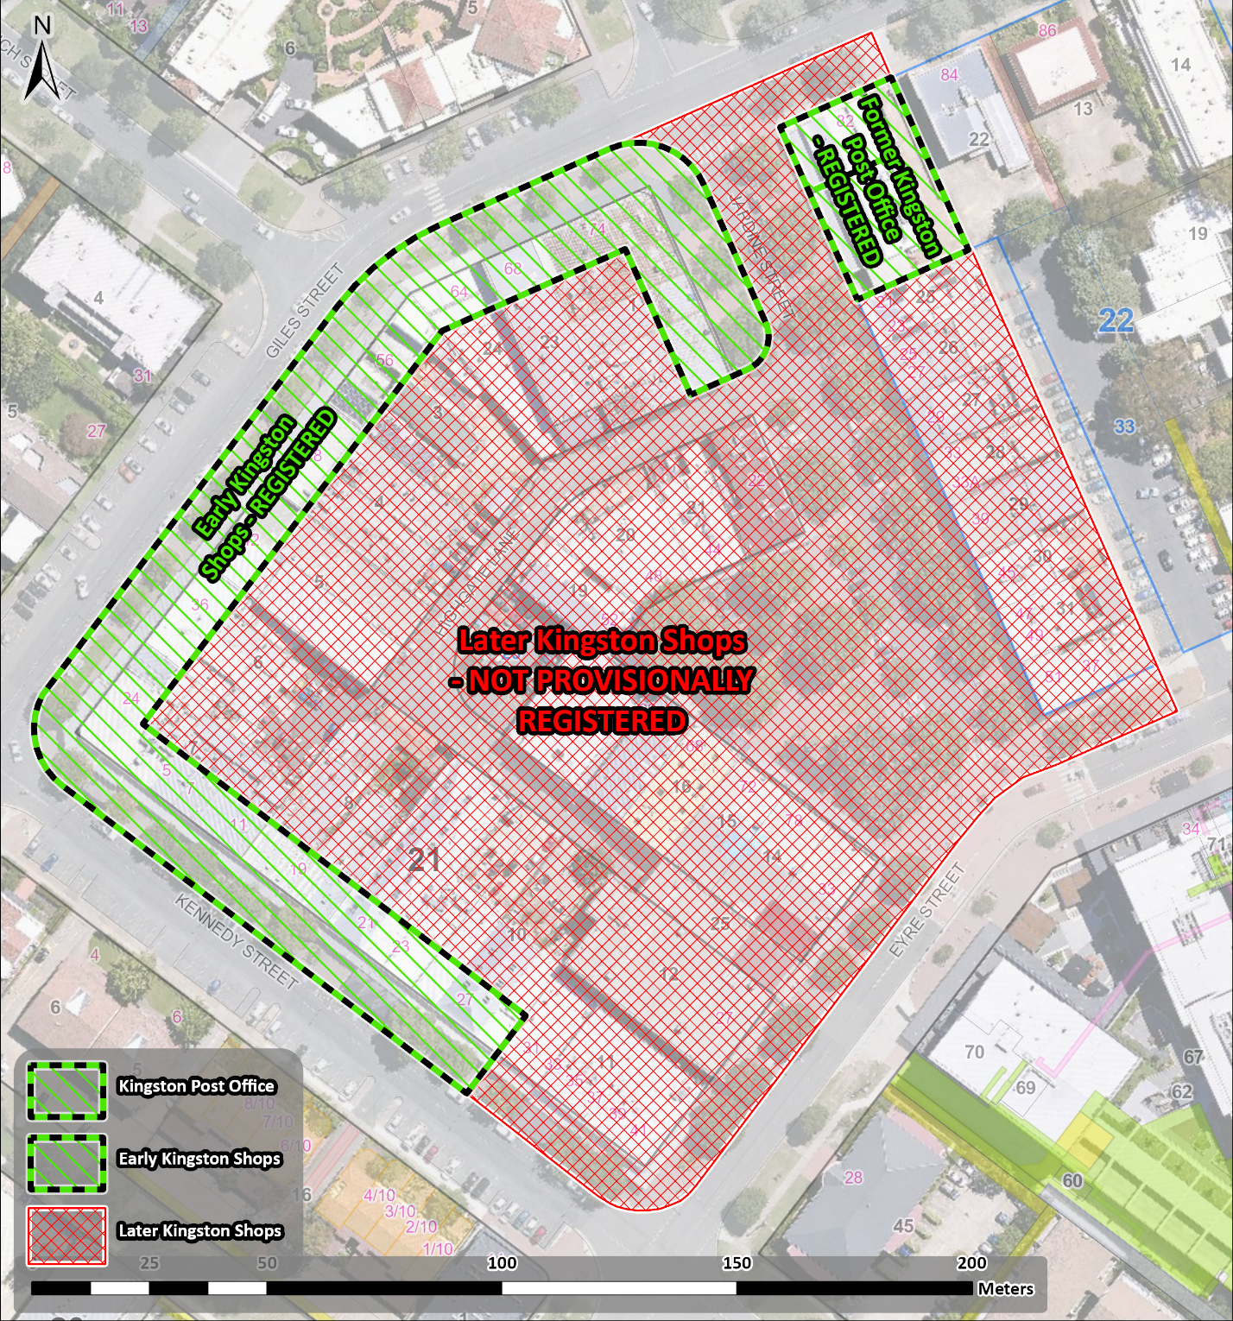
Figure 1 Later Kingston Shops boundary next to the existing registration boundaries for the Early Kingston Shops and the Former Kingston Post Office.

