Australian Capital Territory
Planning (Miscellaneous) Minor Plan Amendment 2026 (No 1)
Notifiable instrument NI2026–99
made under the
Planning Act 2023, s 85 (Making minor plan amendments)

1 Name of instrument
This instrument is the Planning (Miscellaneous) Minor Plan Amendment 2026 (No 1).
2 Commencement
This instrument commences on the day after its notification day.
3 Minor plan amendment
I am satisfied under the Planning Act 2023, section 85 (1) (a) that Minor Plan Amendment 2026-04 is a minor plan amendment to the territory plan.
4 Dictionary
In this section:
Minor Plan Amendment 2026-04 means the minor plan amendment to the territory plan in schedule 1.

Amy Kingham
Delegate of the territory planning authority
27 February 2026

Schedule 1


MINOR PLAN AMENDMENT TO THE TERRITORY PLAN
2026–04

Miscellaneous amendments to the Woden District Policy, Belconnen District Policy, East Canberra District Policy and the Inner South District Policy

This minor plan amendment was prepared
under part 5.3 of the Planning Act 2023
Contents
1.0 INTRODUCTION 1
1.1 Outline of the process 1
1.2 Summary of the amendments 2
2.0 Territory Plan changes 3
2.1 Woden District Policy 3
2.2 Belconnen District Policy 3
2.3 East Canberra District Policy 3
2.4 Inner South District Policy 3
3.0 TERRITORY PLAN AMENDMENT INSTRUCTIONS 4
3.1 Part D: D07– Woden District Policy 4
3.2 Part D: D02– Belconnen District Policy 4
3.3 Part D: D09 – East Canberra District Policy 5
3.4 Part D: D04 – Inner South District Policy 6
INTERPRETATION SERVICE 7

- INTRODUCTION
  - Outline of the process
Minor plan amendment 2026-04 (MA 2026-04) to the Territory Plan is a minor plan amendment (MA) prepared under section 84 (1) (a) of the Planning Act 2023 (the Act).

Section 84 of the Act outlines the different types of MAs, some which require limited consultation to be undertaken and some which do not require consultation. This MA is consistent with the provisions under section 84 (1) (a) of the Act and therefore no consultation is needed.

Under Section 85 of the Act this type of MA can only be made if the MA is not inconsistent with the planning strategy or any relevant district strategy.

The MA is not inconsistent with the Planning Strategy and the relevant district strategies.

For more information on the content of the Territory Plan and minor plan amendment processes please refer to the planning website: www.planning.act.gov.au/professionals/our-planning-system/the-territory-plan/amendments-to-the-territory-plan

  - Summary of the amendments

This MA makes the following changes:

Woden District Policy

- Rectifies the block number for Garran in the Land Use Table from Block 1 to Block 11.

Belconnen District Policy

- Updates Figure 25 Hawker to include omitted PD1 areas.

East Canberra District Policy

- Updates Figure 1 to include omitted RC1 and RC3 area labels, changes the Canberra Central label to Inner South and removes the inset and the previous unlabelled RC2 area which no longer applies in the policy.

Inner South District Policy

- Rectifies the wording in Assessment Requirement 8 to refer to Figure 2 and Area ‘d’ instead of Figure 1 and Area ‘a’.

- Territory Plan changes
This section contains details of the changes to be made to the Territory Plan.
  - Woden District Policy

Changes have been made to the ACT Cadastral Database which has resulted in Block 1 Section 33 Garran becoming a retired block and a new block, Block 11 Section 33 Garran being created. This change has resulted in the Land Use Table referencing a retired block number. This minor amendment reflects the change in block number in the Land Use Table by replacing ‘Block 1’ with ‘Block 11’.
  - Belconnen District Policy

When introducing the Territory Plan 2023, the area previously shown as PD1 in the Territory Plan 2008 Precinct Map and Code for Hawker was inadvertently omitted from Figure 25. Figure 25 is referenced in the Land use Table for Hawker and prohibits retirement village and supportive housing. This minor amendment rectifies this omission by including the PD1 areas on Figure 25.
  - East Canberra District Policy

When introducing the Territory Plan 2023, the labels for RC1 and RC3 areas were not translated from the Territory Plan 2008 for Figure 1. This minor amendment rectifies this omission by reinstating the labels RC1 and RC3 onto Figure 1.

The District labelled Canberra Central is now referred to as Inner South in the Territory Plan 2023. This minor amendment rectifies this, so the correct district policy area is referenced on Figure 1.

The area shown as Inset A previously referred to an RC2 area in the Territory Plan 2008. When introducing the Territory Plan 2023, the label RC2 was omitted, and this area is no longer referred to in the policy. This minor amendment removes the area shown as Inset A to make it clear that it no longer applies to the policy.
  - Inner South District Policy

When introducing the Territory Plan 2023, Figure 2 and area ‘d’ were not correctly translated into Assessment Requirement 8 from the Territory Plan 2008. Inadvertently, Figure 1 and area ‘a’ were translated into Assessment Requirement 8. This has resulted in the incorrect Figure and area being referenced. This minor amendment rectifies this by amending Assessment Requirement 8 to refer to Figure 2 and area ‘d’.

- TERRITORY PLAN AMENDMENT INSTRUCTIONS
  - Part D: D07– Woden District Policy

Land Use Table

Substitute:

In the Land Use Table in the row for Garran, substitute ‘block 1’ with ’block 11’ in the ‘Relevant parcel or figure’ column.

  - Part D: D02– Belconnen District Policy

Figure 25

Substitute:

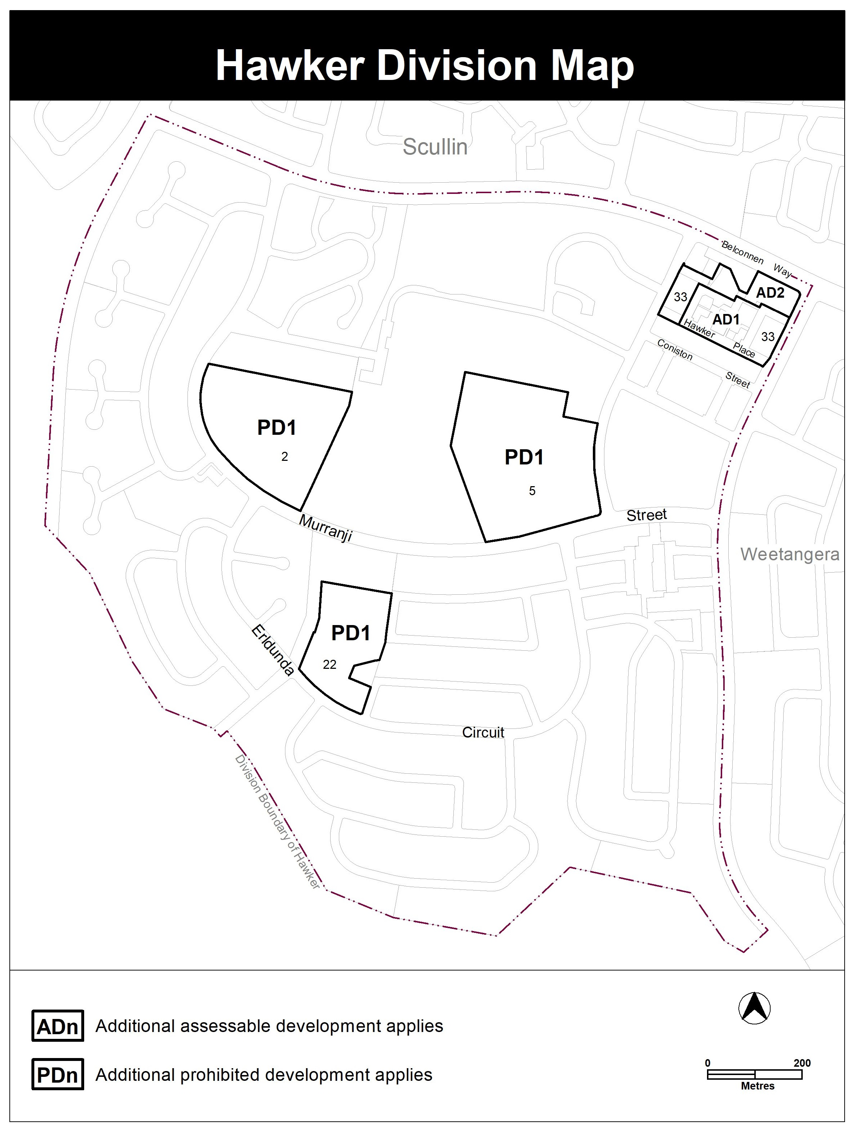

  - Part D: D09 – East Canberra District Policy

Figure 1

Substitute:

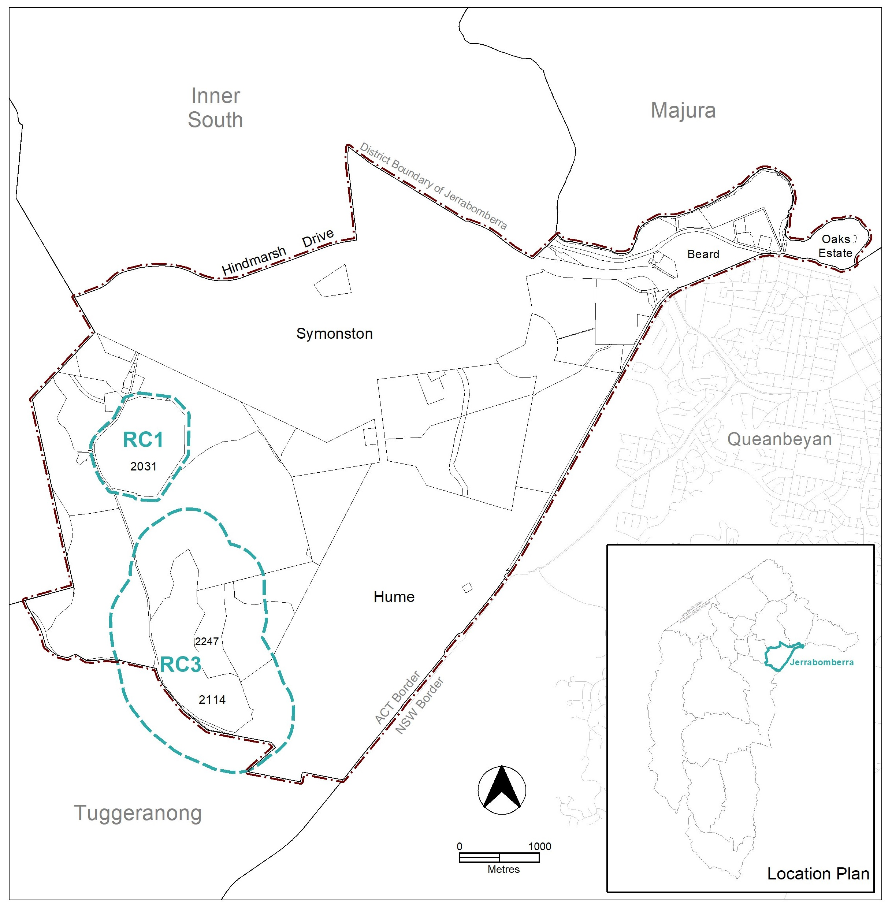

  - Part D: D04 – Inner South District Policy

Assessment Requirement 8

Substitute:

In Area ‘d’ identified in Figure 2, an environmental assessment report for the development is endorsed by the Environment Protection Authority.

Hyperlink: ‘Figure 2’ in Assessment Requirement 8 to the respective figure

INTERPRETATION SERVICE
To speak to someone in a language other than English please telephone the Telephone Interpreter Service (TIS) 13 14 50
LANGUAGE | DETAILS
English | If you need an interpreter please call: 13 14 50
Mandarin (Simplified Chinese) / 简体中文 | 如果您需要翻译，请致电：13 14 50
Arabic / العربية | إذا كنت بحاجة إلى مترجم شفهي اتصل بالرقم: 50 14 13
Cantonese (Traditional Chinese) / 繁體中文 | 如果你需要傳譯員，請致電：13 14 50
Vietnamese /  Tiếng Việt | Nếu bạn cần thông dịch viên, xin gọi: 13 14 50
Korean / 한국어 | 통역사가 필요할 경우 다음 번호로 전화하시기 바랍니다: 13 14 50
Spanish / Español | Si necesita un intérprete, llame al 13 14 50
Persian (Farsi) / فارسی | اگر به مترجم نیاز دارید، لطفاً به این شماره تلفن کنید: 50 14 13
Dari / دری | اگر به یک ترجمان شفاهی نیاز دارید لطفاً به شمارۀ 131450 زنگ بزنید.
Punjabi / ਪੰਜਾਬੀ | ਜੇਕਰ ਤੁਹਾਨੂੰ ਕਿਸੇ ਦੁਭਾਸ਼ੀਏ ਦੀ ਲੋੜ ਹੈ ਤਾਂ ਕਿਰਪਾ ਕਰਕੇ ਫੋਨ ਕਰੋ: 13 14 50
Tamil / தமிழ் | உங்களுக்கு மொழிபெயர்த்துரைப்பாளர் ஒருவர் தேவைப்பட்டால் 13 14 50 என்ற எண்ணை அழைக்கவும்
Greek / Ελληνικά | Αν χρειάζεστε διερμηνέα, τηλεφωνήστε: 13 14 50
Italian / Italiano | Se hai bisogno di un interprete, chiama: 13 14 50
Hazaragi / هزاره گی | اگه ده ترجمان ضرورت ده رید، لطفاً ده شماره 50 14 13 تماس بگیرید.
Thai / ภาษาไทย | หากคุณต้องการล่าม กรุณาโทรไปที่ 13 14 50
Karen / ကညီကျိၥ် | ဖဲနမ့ၢ်လိၣ်ဘၣ်ပှၤကတိၤကျိးထံတၢ်တဂၤအခါ၀ံသးစူၤကိးဘၣ်-၁၃၁ ၄၅၀ တက့ၢ်.

Telephone and Interpreter Service 13 14 50 - Canberra and District - 24 hours a day, seven days a week

