Regulatory Impact Statement

Energy Efficiency (Cost of Living) Improvement (Priority Household Target)
Determination 2018

Disallowable Instrument DI2018-243
Prepared in accordance with Chapter 5 of the Legislation Act 2001

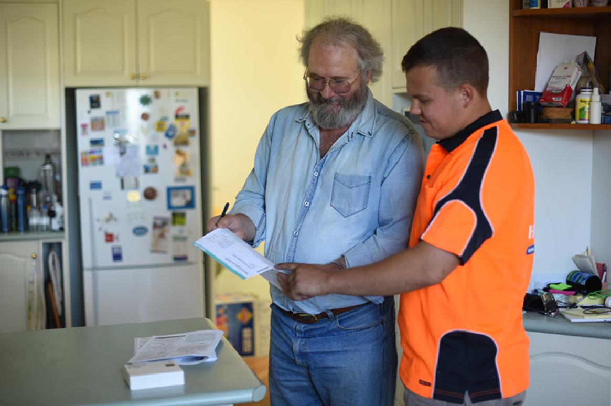

Contents
1. Executive Summary 3
2. The authorising law 3
3. Policy objectives of the disallowable instrument and the reasons for them 4
3.1 Impacts of rising energy prices on low income households 8
4. Achieving the policy objectives 10
5. Consultation 12
5.1. Increasing opportunities for priority households 14
5.2. Barriers to participation 14
5.3. EEIS Review findings 15
5.4. Complementary measures 16
6. Consistency of the disallowable instrument with the authorising law 17
7. The disallowable instrument is not inconsistent with the policy objectives of another Territory law 18
8. Reasonable alternatives to the disallowable instrument 18
9. Assessment of benefits and costs of the disallowable instrument 19
10. Human Rights 19
11. Assessment of the consistency of the proposed law with Scrutiny of Bills Committee principles 19
12. Conclusion 20

List of tables
Table 1 Gini coefficients for inequality of income and wealth 7
Table 2 Achievement of the Priority Household Target 11

List of Figures
Figure 1 Share of net worth and equivalised income, Australia, 2015-16 6
Figure 2 Energy expenditure as a proportion of gross household weekly income 8
Figure 3 Modelled average delivered mass market prices at major demand centres, Neutral case, 2016 in AUD/GJ 9

Executive Summary
The Energy Efficiency (Cost of Living) Improvement Act 2012 (the Act) establishes the Energy Efficiency Improvement Scheme (EEIS) which aims to encourage the efficient use of energy, reduce greenhouse gas emissions, reduce household and business energy use and costs, and increase opportunities for priority households to reduce energy use and costs. Priority households are Canberra’s lower income households, defined as households in which at least one resident holds an eligible concession card, are experiencing financial hardship or are residents of priority dwellings. These households are most affected by energy price rises, but least able to invest in efficient items and thus reduce their energy demand. The Priority Household Target (PHT) ensures that a proportion of EEIS savings are delivered in these priority households.
The PHT has been reviewed and set annually for previous compliance periods until 2018. This Regulatory Impact Statement is prepared in accordance with Part 5.2 of the Legislation Act 2001 for establishing the PHT for 2019 and 2020, as a disallowable instrument made under section 8 of the Act.

The authorising law
The Act was passed by the Legislative Assembly on 3 May 2012. EEIS is a retailer energy efficiency obligation scheme currently legislated to run until 31 December 2020.
The Act establishes a Territory-wide Energy Savings Target (EST) which correlates to mandatory greenhouse gas emission reduction obligations for individual electricity retailers based on their electricity sales in the ACT. The specific level of the EST, and other EEIS targets, are set by disallowable instruments for each compliance period, defined as a calendar year.
Section 8 of the Act requires tier 1 retailers to achieve a PHT for the total reduction in greenhouse gas emissions achieved in priority households for each compliance period. The PHT is expressed as a percentage of the Retailer Energy Savings Obligation (RESO) and tier 1 retailers are obliged to achieve a proportion of their energy savings obligation in low-income households. Section 8 provides for the determination of the PHT by disallowable instrument.
Section 15 establishes the PHT as a proportion of the total Retailer Energy Savings Obligation as follows:
Priority Household Obligation = Retailer Energy Savings Obligation x PHT
The Act requires tier 1 retailers to achieve their EST by delivering eligible activities. Eligible activities are determined by the Minister and include installing energy efficient light globes, draught seals, efficient space heating and cooling systems, water heaters and other items that save energy bills and greenhouse gas emissions while maintaining quality of life. Smaller, tier 2 retailers can either deliver eligible activities or pay an Energy Savings Contribution. ActewAGL Retail (ActewAGL) is currently the only tier 1 retailer in the ACT.
This document outlines the costs and benefits associated with determining the PHT at 20 per cent for 2019 and 2020 through the disallowable instrument Energy Efficiency (Cost of Living) Improvement (Priority Household Target) Determination 2018.

Policy objectives of the disallowable instrument and the reasons for them
The policy objective of the disallowable instrument is to achieve one of the objects of the Act relating to priority households. The objects of the Act are established in section 6. Object (d) is to “increase opportunities for priority households to reduce energy use and cost”. This is consistent with the ACT Government’s strategic objective of helping households, businesses and schools to reduce emissions, energy and costs.
Priority households are intended to be those lower income households who can benefit most from energy efficiency, but are least able to make improvements without additional assistance. Priority households are defined in the Act’s dictionary as a residential premises in which one person who lives at the premises –
- is a recipient of an ACT Government energy concession; or
- holds a Commonwealth pensioner concession card or health care card; or
- holds a Department of Veterans Affairs pensioner concession card, TPI gold repatriation health care card, war widows repatriation health care card or gold repatriation health care card.
The Energy Efficiency (Cost of Living) Improvement Regulation 2017 added the following priority household classes:
- Three additional commonwealth concessions:
  - Commonwealth Seniors Health Card;
  - Low Income Health Care Card;
  - Disability Support Pension Card;
- Households accessing an approved financial hardship scheme of an energy retailer,
- Households experiencing financial hardship and referred by a specified community organisation or the Australian Capital Territory Civil and Administrative Tribunal (ACAT); and
- Priority dwellings including:
- Public housing properties managed by Housing ACT;
- Not-for-profit community housing facilities;
- Not-for-profit aged care housing facilities; and
- Not-for-profit disability housing facilities.
The policy objective of providing benefits for low income households remains a key government priority. The PHT delivers on:
- ACT government priorities;
  - Helping reduce peak electricity and gas demand,
  - Improving social housing and affordability,
  - Achieve net zero greenhouse gas emissions by 2045 at the latest,
  - Helping households to reduce emissions, energy and costs,
  - Healthy and smart, and
  - Climate change mitigation and adaptation.
- Current 9th Labor-Greens Parliamentary Agreement;
  - 4.8, grow and diversify the not for profit community housing sector, through a combination of capital investment, land transfer and other means, and
  - 6.7 Implementing measures to improve energy efficiency of rental properties.
The recent independent Review of the EEIS confirmed that the priority household target is highly valued by scheme stakeholders. One of the recommendations from the Review is that an extended scheme be focused on a single, primary objective. One of the potential primary objectives is targeted bill savings, which would likely lead to an even higher ambition for priority energy users.
The PHT was determined at 25 per cent each year from 2013 to 2015. This level was above the estimated 20 per cent of households receiving energy concessions and/or holding a concession card in the ACT.
The EEIS Extension Regulatory Impact Statement (the EEIS Extension RIS) recommended the PHT be decreased in 2016 to 20 per cent. This was based on modelling results and consultation reported in the EEIS Review and aimed to balance the costs that are passed through to consumers while ensuring that priority households in the ACT continue to benefit from the EEIS (EEIS extension RIS p.20). For the purposes of modelling, all household costs and savings assume a 20 per cent PHT for the period 2016 to 2020. From 2016 to 2018, the PHT was reviewed and set annually at 20% for each compliance period.
The decision to set the PHT at 20% for 2019 and 2020 was based on favourable conditions that set a promising scenario for delivering the EEIS in the next two years:
- Consultation confirmed a consensus view that the PHT remains a valuable EEIS element and stakeholders supported retaining a PHT of at least 20%;
- The only Tier 1 retailer has met the PHT in every compliance period since the EEIS started in 2013 and has announced the intention to deliver new heating and hot water activities;
- Several strategies have been implemented to enhance opportunities to achieve the PHT:
  - A regulation to expand the classes of priority households eligible for EEIS;
  - Collaboration with stakeholders to enhance referral pathways between the community sector, Actsmart, ActewAGL, Housing ACT, ACAT and EEIS;
  - Trialled a partnership with ActewAGL and Housing ACT to replace around 240 inefficient gas heaters with high efficient models in public housing properties through EEIS.
Additionally, over the next three years, the ACT Government will invest a further $7.0 million to improve energy efficiency in public housing. This funding will be used to provide approximately 2,200 highly efficient heaters and hot water units through the EEIS, energy audits and education programs to tenants to help them better manage energy consumption and costs.
Submissions received during consultation confirm the ongoing importance of the PHT policy objective. Low income customers are the most likely to be living in housing that has poor energy efficiency and are either unable (as renters) or incapable (as low income home owners) to make capital investments in their housing to reduce energy usage.
The National Centre for Social and Economic Modelling analysed data from the 2016 census and estimated the extent of poverty in the ACT. This research found that there were 34,543 people living in poverty (defined as less than $500/week income) in the ACT in 2015-16 (representing 9.2% of the total ACT population). There were 8,897 children (representing 12.7% of the 0-14 age group) included in these figures. Older people, people living with disabilities, single parent families and Aboriginal and/or Torres Strait Islander people were over-represented in these figures.
Data available from the Australian Bureau of Statistics (ABS) confirm the ongoing importance of the PHT policy objective. Figure 1 is from a 2017 ABS article on Income and Wealth Distribution and shows that households with the lowest 20 per cent of wealth own less than one per cent of all Australian household wealth. The graph also shows the strong correlations between households with low income and those with low wealth, and the relative disadvantage of Australia’s poorest 20 per cent.
Figure 1 Share of net worth and equivalised income, Australia, 2015-16
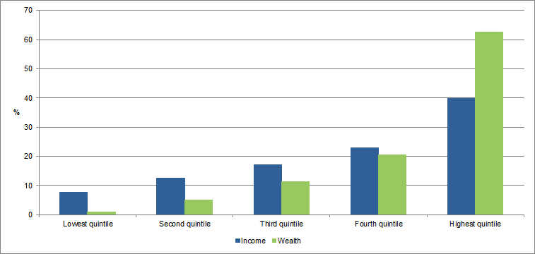
The relative poverty of Australia’s poorest people deteriorated during 2013-2014 and showed a slight improvement in 2015-2016, going back to 2011-2012 levels. This is measured by the Gini coefficient whose range is between zero and one, with zero meaning perfect equality and one complete inequality. It is worth noting the difference between the income and wealth coefficients, which shows even greater inequality in the distribution of wealth.
Table 1 Gini coefficients for inequality of income and wealth
 | Income | Wealth
2011-2012 | 0.320 | 0.605
2013-2014 | 0.333 | 0.666
2015-2016 | 0.323 | 0.605
Source: http://www.abs.gov.au/ausstats/abs@.nsf/Lookup/by%20Subject/6523.0~2015-16~Main%20Features~Household%20Income%20and%20Wealth%20Distribution~6

Many of the ACT priority households are reliant on base-rate government benefits such as pensions as their only source of income. There has arguably been a small easing of cost of living pressures on these people in recent years due to low inflation, and modest increases in the consumer price index. However some housing costs and health costs have also increased over recent years, exerting additional pressure on households relying entirely on income support. These rising costs are compounded by rising energy prices.

3.1 Impacts of rising energy prices on low income households
The price of energy supply also affects the achievement of the policy objective since rising energy prices affect low income households the most. This is because the cost of electricity represents a much larger proportion of low income household's income than for the general population and energy costs have more impact on the economic wellbeing of lower economic resource groups. Figure 2 shows that low income households spend on average almost 10% of their gross household weekly income on total household energy costs, almost four times that of high income households.
Figure 2 Energy expenditure as a proportion of gross household weekly income
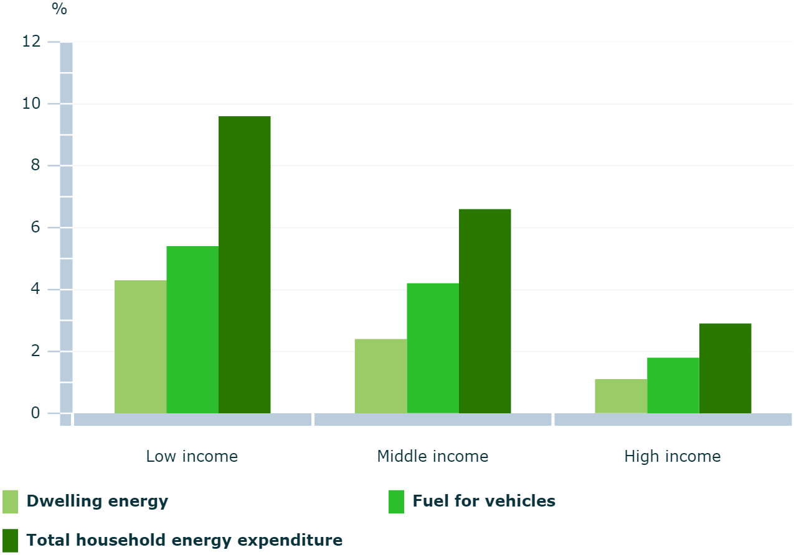
Even though ACT consumers enjoy some of the lowest electricity prices in Australia, energy prices in Australia have risen sharply over the last decade. In response, many households have reduced energy costs by investing in measures to reduce energy consumption, such as purchase of energy efficient appliances, installing rooftop solar panels and home upgrades. Priority households have not had access to the funds required to undertake these measures. Instead, these households have taken other measures such as rationing energy use, seeking emergency assistance to pay for energy costs, or not paying accounts.
Electricity and gas prices are predicted to continue to rise in the coming years, putting further pressure on low income households. A Retail electricity price recalibration for 2018-2019 that was released by ICRC in June 2018 indicates an increase of up to 14.29% in regulated retail prices, which is estimated to have an impact of $299 in the annual bill of a residential household consuming about 8,000kWh per year. This is on top of an 18.95% price rise in 2017-18.
Meanwhile, Figure 3 shows that gas prices in the ACT are predicted to rise at even faster rates than electricity from 2017 until 2023 as a result of changes to global oil prices, exchange rates and ongoing effects of the linking of the Eastern Australian gas market with international gas markets and prices.
Figure 3 Modelled average delivered mass market prices at major demand centres, Neutral case, 2016 in AUD/GJ
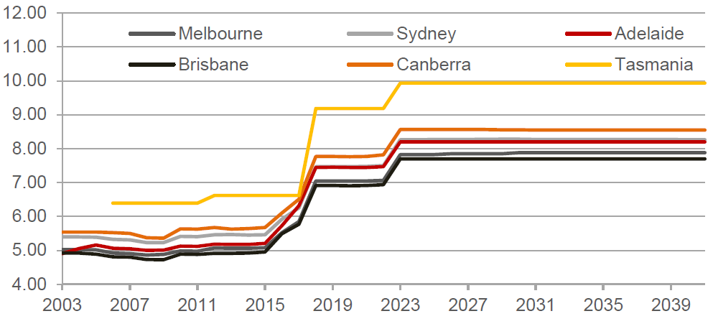
These cumulative price rises have put significant pressure on low income household budgets, including households whose primary source of income is a Centrelink payment, who are on a fixed retirement income and households reliant on minimum wage jobs.
The pressures caused by energy price rises need to be understood in the wider context on costs of living in the ACT. Costs of living are relatively high compared with other capital cities. Over the past year the Consumer Price Index in Canberra rose 2.2% – the second highest rate of rise in the country, along with Sydney and Melbourne, behind only Adelaide (2.3%). This was above the national rise of 1.9%.
The ABS data for the ACT states housing (which includes utilities) rose by 5.3%, above the national rise (+3.4%). Rents rose by 2.3%, above the national rise (+0.7%).
The ACT has one of the highest costs of private rental accommodation in the nation, so if you are in a low income household you are spending a disproportionate amount of your income on housing, which does not leave sufficient funds in a monthly budget to cover other essential costs of living, including energy.
Many low-income households have difficulty paying their energy bills, and there is strong evidence of the inability of low-income households to become more energy efficient without assistance.
Households that are struggling to pay their bills will often pay late and/or enter into debt if they do not have money available when their bills fall due. The AER monitors figures on the energy-related debt that results from customers not paying their bills on time. The AER reported that in December 2017, in the ACT, there were 5,909 households with electricity debt, with the average amount of debt being $807.00. Households with gas debt came in at 6,258 with an average debt of $598.00.
Should electricity and gas prices increase as predicted, we can expect greater demand for emergency relief, community services, affordable housing and schemes like the EEIS.

Achieving the policy objectives
There is good evidence that EEIS activities deliver significant savings to participating households, which to date have included a proportion of priority households.
The effectiveness of the EEIS in reducing household and business emissions and energy costs was confirmed by an independent review undertaken in 2018, which also found that the scheme has been cost-efficiently delivered, with an overall positive benefit-cost-ratio.
According to the review, the EEIS has fulfilled its four objectives: encouraging efficient use of energy, reducing emissions, reducing energy use and costs for households, businesses and priority households. It has delivered lifetime bill savings of $180M to households and an average weekly savings of $5.65 for participating households.
The EEIS has delivered approximately 800,000 GJ of lifetime energy savings in priority households, or 22% of total scheme residential lifetime energy savings. It has saved over $15M off the energy bills of 17,900 Canberra’s low income households that participated in the scheme since 2013. Savings from EEIS have been four times greater than the costs of running the scheme.
The PHT has been consistently achieved since the life of the scheme. Table 2 shows how ActewAGL has tracked on the PHT over the life of the scheme. Column one shows the PHT setting for each year of the scheme which was 25% from 2013-2015 and 20% thereafter. Column 2 shows the proportion of total abatement that ActewAGL delivered in priority households each year. This was well above the PHT in the first two years, and has dropped off steeply since then with previous year surpluses being carried over into subsequent years. Column 3 shows that as a result of the carry-over surplus from the first two years, the proportion of the total abatement that ActewAGL needed to deliver in priority households was less than the statutory target in each subsequent year.
Column 4 shows the total number of priority households in which abatement was delivered each year. This peaked in 2014 and has reduced since then.
Table 2 Achievement of the Priority Household Target
Year | PHT as a proportion of the RESO | Priority household abatement as a  % of total abatement | % of total abatement required in priority houses to meet PHT, after carry-over surplus | Number of priority households visited | Lifetime energy savings in priority households (GJ)
2013 | 25% | 31% | 25% | 5,123 | 168,682
2014 | 25% | 32% | 18% | 8,216 | 250,028
2015 | 25% | 16% | 9% | 4,393 | 158,427
2016 | 20% | 9% | -26%* | 1,972 | 73,366
2017 | 20% | 13% | 12% | 356 | 142,014
2018 | 20% | Not available | 12% | Not available | Not available
*no abatement required in this compliance period due to carried over surplus above PHT.
EEIS opportunities have shifted over the life of the scheme, and these changes are reflected in the types of activities that have been delivered by ActewAGL. From 2013 until 2016, most of the priority household abatement was delivered through a small set of activities including standby power controller, compact fluorescent light globe, draught sealing and refrigerator removal activities. These activities are widely considered the ‘low hanging fruit’ of energy efficiency schemes and have been delivered free of charge in the ACT, consistent with other schemes.
In 2017, more heating and cooling activities were delivered which has led to higher energy bill and emission savings and improvements in thermal comfort for participating households. However, a smaller number of households have benefited from these types of activities, which explains the reduced number of priority households visited in 2017.
A total of 17,900 priority households received EEIS activities from 2013 to 2017. Commentary in advance of the ACT Budget 2016-17 states that “concessions play an important role in supporting around 30,000 Canberra households, and the need for support is increasing”. ABS estimates that there are approximately 156,000 households in ACT in 2017, meaning that over 19 per cent of all Canberra houses fit the definition of EEIS priority households. This suggests that about two-thirds of ACT priority households have received EEIS benefits to date.
The ACT government is maintaining complementary programs to assist low income households with energy efficient upgrades. These include the Actsmart Household Energy Efficiency Program, No Interest Loan Scheme, and the Solar for Low Income Program. These Actsmart Energy programs are funded by, and operate complementary to, the Energy Efficiency Improvement Scheme (EEIS) to maximise opportunities for businesses and households to reduce emissions and energy costs by offering energy efficient opportunities beyond those being delivered through EEIS.
Together, these examples show that the PHT policy objectives are being consistently met and that new opportunities exist for continuing to deliver these objectives through the PHT.

Consultation
Consultation on the Priority Household Target (PHT) was carried out in June and July 2018.

Stakeholders were asked to provide feedback on the following questions:
What is the best setting for the EEIS Priority Household Target in 2019?
- 20%, the same as for 2016, 2017 and 2018?
- If you think it should change, what level do you suggest?
- Why do you think it should be set at this level?

The following stakeholders provided written feedback:
- ACAT Energy and Water (ACAT
- ACT Council of Social Services (ACTCOSS)
- ActewAGL Retail
- Care Financial Counselling Services (CARE)
- Community Services Directorate
- Council of the Aging (COTA)
- Office of the Commissioner for Sustainability and the Environment.
- Salvation Army

Consultation confirmed a consensus view that the PHT remains valuable and all stakeholders supported retaining a PHT of 20%.
All of the submissions commented favourably on the value of having a statutory target to ensure that savings are directed to low income households.
Three stakeholders noted that cost of living impacts need management with climate change, and most stakeholders noted that energy affordability problems are increasing. Some comments made on these subjects during consultation were:
- This initiative is critical in ensuring the cost of living impacts of climate change are managed, particularly for the low income demographic in the ACT, and
- Low income customers are the most likely to be living in housing that has poor energy efficiency and are either unable (as renters) or incapable (as low income home owners) to make capital investments in their housing to reduce energy usage.
- There are many more households in need of assistance that are not benefitting from the EEIS.
- Energy affordability is critical, as research shows the cost of housing largely determines how much is left in household budgets to pay energy bills. With the continuing housing affordability crisis many people are going without energy or in some cases having their utilities disconnected.
A PHT is especially needed at a time of falling solar system and solar battery prices when it is necessary to ensure that the social equity divide is bridged, otherwise this gap will only grow larger.
- Low income households are limited in the choices they can make, they rarely have discretionary income in their budgets, have income levels and costs of living that mean they are unable to save and are living in housing that has poor energy efficiency and are either unable (as renters) or incapable (as low income home owners) to make capital investments in their housing to reduce energy usage and are forced to live pay to pay.
- Priority households generally face financial and other barriers to improving their energy efficiency and reducing energy use. It is therefore important that they are provided access to the EEIS to support them to become more energy efficient.

Increasing opportunities for priority households
Most stakeholders acknowledged that several strategies had been implemented to enhance opportunities to achieve the PHT within the last 12 months:
  - Five stakeholders appreciated the Government introducing a regulation to expand the classes of eligible priority households in 2017. They said that expanding the classes increases access for people who might not have a concession card, but who are in difficult financial situations.
  - Four stakeholders were pleased the EEIS had extended opportunities in the public housing sector which is a critical step to addressing the significant number of public housing requiring energy efficiency upgrades. All stakeholders supported ongoing investment in public housing, however one stakeholder requested more resources be directed into the public housing energy efficiency program, as the trial program seemed to fill up very quickly, with a number of clients on the waiting list. An agreement between Housing ACT and ActewAGL is essential to ensure EEIS services reach those that need it most.

Barriers to participation
Some barriers identified through consultation included the upfront costs of appliances, split incentives and communication barriers. Stakeholders noted that because of these barriers, achieving the PHT requires ongoing concerted effort from the Tier 1 retailer. Some of the comments about barriers were:
Specific rebate schemes where a co-payment is required will likely have a smaller uptake amongst this group given their limited capacity to make any upfront contribution.
The particular problems for renters in the private market were highlighted in a report released by Better Renting in July 2018 that calculated the impact of inefficient housing on energy costs. The report found that: “For an average-sized property with an EER of 0, it would cost $2,800 to produce the same amount of heat that would be free in a property with an EER of 5. To put it another way, renters in such a property are being frozen out of free heat equivalent to running two 2000W electric heaters 24/7 from mid-May to September. We estimate that the ACT has roughly 24,000 rental properties that would attain an EER lower than 5. With an average household burden of just over $1,600, the total burden borne by all ACT renters living in energy-deficient properties is equivalent to over $39,000,000.”
In addition to the financial costs incurred from what Better Renting call “energy deficient” housing, people living in under-heated housing carry a health cost, in the form of increased risk of respiratory illnesses and increased costs to deal with exacerbations of existing health conditions caused by exposure to cold living environments.
These households are unable to participate in many of the Energy Efficiency Improvement Schemes because they either do not have permission from their landlord to modify their housing and/or have no capacity to co-contribute to the costs of government or industry assistance programs.
Maintaining the target at 20% remains a challenging target to achieve considering the recent transition to activities that require a contribution from the customer. There also remains impediments in delivering activities when there are split incentive barriers for renters.
The commercial lighting activity offered by ActewAGL currently contributes around 30% of ActewAGL’s total abatement. Maintaining the PHT at 20% may impact on the extent to which the business community will be able to access energy efficiency activities.

EEIS Review findings
- An independent review of the EEIS was undertaken in early 2018, which found the scheme has increased opportunities for priority low income households to participate in energy reductions (and associated cost savings). The Tier 1 retailer’s Priority Household Target (PHT) is an effective way to ensure that a proportion of the activities and hence benefits flows on to low income households.
- In total the EEIS has delivered over 800,000 GJ of lifetime energy savings in over 17,900 priority households, or 22% of total scheme residential lifetime energy savings.
- There is, however, an ongoing concern from stakeholders that some low income households might still be excluded from the scheme, while still bearing associated cost, especially as activities become “deeper”, deliver a large amount of abatement, but require co-contributions and are concentrated on fewer beneficiaries. Therefore, some financial barriers remain, where co-contributions are required from low income households.
- Analysis of co-contributions paid by households showed that priority households were offered a larger rebate ($3,000 vs $2,000) than non-priority households. This should help to address the barrier of lack of capital available to priority householders. However, this may not be enough to fully remove this barrier.
- As it currently stands, the PHT has resulted in the delivery of energy saving activities in nearly half of all priority households, however the majority of these households (>85%) were targeted in the first three years of the scheme, when the activities delivered did not provide deep energy savings. Therefore, the PHT may not constitute a strong safeguard that a significant number of priority households will benefit from the most impactful EEIS activities.
- Overall, stakeholders were supportive of the need to focus on improving energy efficiency in low income households.

Complementary measures
- The EEIS funds complementary activities that align with the objectives of the Energy Efficiency (Cost of Living) Improvement Act 2012, such as the Actsmart Home Energy Advice program, Actsmart Low Income Home Energy Efficiency Program, Actsmart Business Energy and Water Program and the Solar for low income program. Stakeholders provided the following comments on complementary programs currently in place and ideas for additional measures:
- Replacing inefficient appliances/heaters and accessing an energy audit through the Actsmart low income energy efficiency program will provide valuable assistance to people in priority households.
- Three stakeholders raised the challenge of stimulating energy efficiency improvements in the private rental market, particularly those premises geared towards lower socio-economic tenants. This issue has been highlighted in a recent report by Better Renting.
- In December 2017 AER reported the ACT had 817 (.44 per 100 customers) electricity customers receiving hardship assistance and 736 gas customers (.46 per 100 customers) receiving hardship assistance – the rate of hardship assistance for electricity is the lowest in the NEM. The hardship programs being referred to in these statistics are delivered by the 3 energy retail suppliers in the ACT: ACTEWAGL, Energy Australia and Origin Energy.
- The most extreme impacts of energy price rises are eligibility for hardship and energy debt relief programs, and disconnections. Demand for hardship and debt relief programs have been rising over the past year, and growth is accelerated as more people become aware of their entitlement to access these programs.
- The most recent figures from the Australian Energy Regulator (AER) indicate the number of disconnections is steady, even with significant efforts by financial counsellors, emergency relief services, ACAT, retailers and the distributor to prevent customer disconnection.
- The Tier 1 retailer, ACTEWAGL should continue its efforts to meet its PHT through addressing the barriers facing low income households; such as the upfront cost of energy efficient appliances by offering affordable and reasonable repayment plans, improved communication, ensuring all concession holders receive concessions and rebates and ensuring they are delivering energy savings activities along with the offers provided through the EEIS.
- ACT Government could initiate a review of complementary policy and innovative finance options to supplement future supplier-led PH energy efficiency outcomes.
- The ACTCOSS submission recommended the following complementary measures in addition to retaining the EEIS Priority Household Target at 20%:
  - Low income households need assistance to understand the support they are eligible to access (financial and practical) to reduce their energy bills and accumulated debts, get assistance to interpret their energy bills, engage with the EEIS and to build capacity to adapt their building fabric and their energy usage patterns.
  - The EEIS should resource targeted information and support to low income households around behaviour change to improve comfort in homes and reduce energy costs. This support should be funded through a partnership between government and industry and should be provided by an existing NGO working with low income households that can offer both in home coaching and financial counselling services.

These consultation results strongly support the continuation of an EEIS Priority Household Target at 20%.

Consistency of the disallowable instrument with the authorising law
The disallowable instrument is consistent with the object of the Act to increase opportunities for priority households to reduce energy use and cost.
The authorising law requires the Minister to set a PHT at least three months before the start of the compliance period to which the priority household target relates. The requirement is for the PHT to be established six-months before the start of the compliance period if the PHT is to be increased. Compliance periods are calendar years.
As the proposal is to retain, rather than to increase the PHT, the authorising law requires the PHT to be set at least three months before the end of 2018 for the 2019 compliance period and at least three months before the end of 2019 for the 2020 compliance period.
Setting the PHT for two subsequent compliance periods is consistent with the authorising law, as the PHT is being maintained at 20% for 2019 and 2020 and set at least three months before the compliance period to which the priority household target relates. There is no impediment for the 2020 PHT to be reviewed and set at a different level if circumstances change, as long as a new determination is made in accordance with section 8 of the Act.

The disallowable instrument is not inconsistent with the policy objectives of another Territory law
The proposed law is not inconsistent with the policy objectives of another Territory law.

Reasonable alternatives to the disallowable instrument
Section 8 of the authorising law is explicit in its requirement for a PHT to be determined by the Minister and provides for no alternative. Alternatives to the disallowable instrument are therefore restricted to either a lower or a higher setting, or other pathways that provide for an achievable PHT.
The disallowable instrument sets the PHT at 20% for 2019 and 2020. An alternative to this option would be for the disallowable instrument to set the PHT for 2019 only, a PHT review process to take place in 2019 and a new determination made to set the PHT for the 2020 compliance period.
As mentioned previously, several strategies have been implemented to enhance opportunities to achieve the PHT. Referral pathways have been established between the EEIS and community sector, negotiations are underway between ActewAGL and Housing ACT to continue delivering EEIS activities to public housing tenants and the pool of eligible households was expanded by a Regulation in 2017. These strategies were described and assessed in the Regulatory Impact Statement (RIS) for the Energy Efficiency (Cost of Living) Improvement (Priority Household Target) Determination 2017.
These strategies, along with new EEIS activities being phased in by ActewAGL set a favourable scenario for reaching more priority households in the future, which justifies a continuation of the 20% target for two subsequent compliance periods.

Assessment of benefits and costs of the disallowable instrument
An independent review of the EEIS was undertaken in 2018, which showed it had been effective in reducing household and business emissions, energy bills and been cost-efficiently delivered, with an overall positive benefit-cost-ratio.
Key results of the Review included
- total lifetime bill savings of $240M including $180M to households and $60M to small and medium businesses.
- Average weekly savings are $5.65 for participating households and $57 for participating businesses.
- The EEIS imposes a small pass-through costs onto all ACT energy users. The review calculated these pass-through costs as averaging $30 per year for average ACT households in 2017. Average weekly savings for participating households were estimated at $294 per year in 2017.
- EEIS saved over $15M off the energy bills of Canberra’s low income households.
- Without the disallowable instrument, there will be no requirement for the Tier 1 retailer to continue delivering EEIS savings to low income households, which would very likely result in fewer savings being delivered in those households. In this case, low income households would continue to pay an average of $30 per year towards EEIS, but be much less likely to achieve savings averaging $294 per year.
- Lifetime savings from EEIS have been four times greater than the costs of running the scheme.

Human Rights
The determination does not affect any human right set out in the Human Rights Act 2004.

Assessment of the consistency of the proposed law with Scrutiny of Bills Committee principles
The terms of reference of the Standing Committee on Justice and Community Safety (Legislative Scrutiny Role) require it to consider whether (among other things):
- any instrument of a legislative nature made under an Act which is subject to disallowance and/or disapproval by the Assembly (including a regulation, rule or by-law):
- is in accord with the general objects of the Act under which it is made,
- unduly trespasses on rights previously established by law,
- makes rights, liberties and/or obligations unduly dependent upon non reviewable decisions, or
- contains matter which in the opinion of the Committee should properly be dealt with in an Act of the Legislative Assembly.

The position in relation to each term of reference is as follows.
- is in accord with the general objects of the Act under which it is made
As noted above, the disallowable instrument is in accordance with the general objects of the Act.
- unduly trespasses on rights previously established by law
The disallowable instrument does not unduly trespass on rights previously established under law.
- makes rights, liberties and/or obligations unduly dependent upon non reviewable decisions
The disallowable instrument does not make rights, liberties and/or obligations unduly dependent upon non reviewable decisions.
- contains matter which in the opinion of the Committee should properly be dealt with in an Act of the Legislative Assembly
The disallowable instrument and the process of setting a priority household target is a requirement of the Act. The Act requires that a PHT be established by disallowable instrument and that is the sole purpose of this instrument.

Conclusion
The disallowable instrument sets the EEIS Priority Household Target (PHT) at 20% for 2019 and 2020. The 20% EEIS PHT maintains opportunities for low income households to reduce energy use and cost by requiring obligated retailers deliver a proportion of total EEIS abatement in priority households. The PHT was set at 25 per cent between 2013 and 2015 and 20 per cent since 2016. The PHT has been consistently achieved throughout the life of the EEIS. With inequality increasing and some increasing and uncertain energy prices, the need for priority household support remains as pressing as ever. Consultation indicated a consensus view that the PHT remains a valuable EEIS element and great support to retain a PHT of at least 20%.
The government has implemented several strategies to minimise the risk of missing the PHT in 2019 and 2020:
- Supporting the delivery of EEIS activities to Housing ACT tenants through a successful trial pilot program and a further $7.0 million investment to improve energy efficiency in public housing;
- Expanding the classes of priority households eligible for EEIS and therefore increasing the scope of the PHT;
- Introducing new EEIS heating and hot water activities;
- Collaborating with stakeholders to enhance referral pathways between the community sector, Actsmart, ActewAGL, Housing ACT, ACAT and EEIS.
Maintaining the PHT target at 20% in 2019 and 2020 will ensure the EEIS increases opportunities for priority households to reduce energy use and costs while encouraging the efficient use of energy and reducing greenhouse gas emissions. This setting is considered to be the best outcome for achieving the EEIS policy goals.

http://www.legislation.act.gov.au/a/2012-17/default.asp
http://www.legislation.act.gov.au/sl/2017-41/default.asp
https://www.environment.act.gov.au/energy/smarter-use-of-energy/energy_efficiency_improvement_scheme_eeis/publications
ACT Government Environment and Planning Directorate (2015) Energy Efficiency Improvement Scheme: Setting Key Parameters to 2020. Regulatory Impact Statement. Available at http://www.environment.act.gov.au/__data/assets/pdf_file/0006/735990/Attachment-C-Regulatory-Impact-Satement-EEIS-Parameters-to-2020-FINAL.pdf .
Australian Bureau of Statistics (2017) Income and Wealth Distribution. Available at http://www.abs.gov.au/ausstats/abs@.nsf/Lookup/by%20Subject/6523.0~2015-16~Main%20Features~Household%20Income%20and%20Wealth%20Distribution~6
Australian Council of Social Services (ACOSS) (2018) ACT Cost of Living Report. Available at https://www.actcoss.org.au/publications/advocacy-publications/act-cost-living-report-2018
Australian Bureau of Statistics (ABS) 4670.0 - Household Energy Consumption Survey, Australia: Summary of Results (2012) Available at http://www.abs.gov.au/ausstats/abs@.nsf/Lookup/4670.0main+features100032012
Australian Council of Social Service (ACOSS) (2013). Energy Efficiency & People on Low Incomes: policy to improve affordability and extreme weather adaptation, ACOSS, Strawberry Hills, NSW, Australia, August 2013. Available at www.acoss.org.au/images/uploads/ACOSS_ENERGY_EFFICIENCY_PAPER_FINAL.pdf
Independent Competition and Regulatory Commission (2018) Retail electricity price recalibration 2018−19. Available at http://www.icrc.act.gov.au/wp-content/uploads/2017/03/Report-3-of-2018-Retail-electricity-price-recalibration-2018–19.pdf
Australian Energy Market Commission (2017) Residential electricity price trends report. Available at https://www.aemc.gov.au/markets-reviews-advice/2017-residential-electricity-price-trends
Core Energy Group (2016) National Gas Forecasting Report. Available at http://www.aemo.com.au/-/media/Files/Gas/National_Planning_and_Forecasting/NGFR/2016/NGFR-Gas-Price-Review-Final-Report-October-2016.pdf
ACT Government (2016). ACT Budget 2016-17. Available at http://apps.treasury.act.gov.au/budget/budget-2016-2017/fact-sheets/concessions
Actsmart (2018) Low income households. Available at http://www.actsmart.act.gov.au/what-can-i-do/homes/Actsmart-household-energy-efficiency-program. Accessed July 2018.
Good Shepherd Microfinance (2018) The No Interest Loan Scheme. Available at http://nils.com.au/?gclid=CjwKEAiArbrFBRDL4Oiz97GP2nISJAAmJMFa3MbPIsjmV8YkIDFL6o7vxMq8COyJwvjSW9vRgMyCDBoCxIvw_wcB Accessed July 2018.
Actsmart (2018) Solar for Low income households. Available at https://www.actsmart.act.gov.au/what-can-i-do/homes/Actsmart-household-solar-for-low-income. Accessed July 2018.
Better Renting (2018). Frozen Out: The Burden of Energy Deficiency on People who rent. Available at https://d3n8a8pro7vhmx.cloudfront.net/betterrenting/pages/112/attachments/original/1530085206/Frozen_out_The_Burden_of_Energy_Deficiency_on_People_who_Rent_Better_Renting.pdf?1530085206. Accessed July 2018.
Point Advisory (2018) Review of the Energy Efficiency Improvement Scheme. Available at http://www.environment.act.gov.au/energy/smarter-use-of-energy/energy_efficiency_improvement_scheme_eeis/publications.
Better Renting (2018). Frozen Out: The Burden of Energy Deficiency on People who rent. Available at https://d3n8a8pro7vhmx.cloudfront.net/betterrenting/pages/112/attachments/original/1530085206/Frozen_out_The_Burden_of_Energy_Deficiency_on_People_who_Rent_Better_Renting.pdf?1530085206. Accessed July 2018.
EEIS RIS PHT Determination 2017. Available at http://www.legislation.act.gov.au/ri/db_56930/current/pdf/db_56930.pdf

