Regulatory Impact Statement

Energy Efficiency (Cost of Living) Improvement (Priority Household Target)
Determination 2019

Disallowable Instrument DI2019 -75
Prepared in accordance with Chapter 5 of the Legislation Act 2001

Contents
1. Executive Summary 3
2. The authorising law 3
3. Policy objectives of the disallowable instrument and the reasons for them 4
3.1 Impacts of rising energy prices on low income households 8
4. Achieving the policy objectives 11
5. Consultation 13
5.1. Barriers to participation 15
5.2. Increasing opportunities for priority households 16
6. Consistency of the disallowable instrument with the authorising law 18
7. The disallowable instrument is not inconsistent with the policy objectives of another Territory law 18
8. Reasonable alternatives to the disallowable instrument 18
9. Assessment of benefits and costs of the disallowable instrument 19
10. Human Rights 19
11. Conclusion 19

List of tables
Table 1 Gini coefficients for inequality of income and wealth 8
Table 2 Achievement of the Priority Household Target 12
Table 3 Proposals for expanding the scope of eligible priority households beyond 2020 17

List of Figures
Figure 1 Share of net worth and equivalised income, Australia, 2015-16 7
Figure 2 Energy expenditure as a proportion of gross household weekly income 9
Figure 3 Modelled average delivered mass market prices at major demand centres, Neutral case, 2016 in AUD/GJ 10

Executive Summary
The Energy Efficiency (Cost of Living) Improvement Act 2012 (the Act) establishes the Energy Efficiency Improvement Scheme (EEIS) which aims to encourage the efficient use of energy, reduce greenhouse gas emissions, reduce household and business energy use and costs, and increase opportunities for priority households to reduce energy use and costs. Priority households are Canberra’s lower income households, defined as households in which at least one resident holds an eligible concession card, are experiencing financial hardship or are residents of priority dwellings. These households are most affected by energy price rises, but least able to invest in efficient items and thus reduce their energy demand. The Priority Household Target (PHT) ensures that a proportion of EEIS savings are delivered in these priority households.
The PHT has been reviewed and set annually for previous compliance periods until 2019. This Regulatory Impact Statement is prepared in accordance with Part 5.2 of the Legislation Act 2001 for establishing the PHT for 2020, as a disallowable instrument made under Section 8 of the Act.
The disallowable instrument sets the EEIS Priority Household Target (PHT) at 30 per cent for 2020.

The authorising law
The Act was passed by the Legislative Assembly on 3 May 2012. EEIS is a retailer energy efficiency obligation scheme currently legislated to run until 31 December 2020. In 2018, the ACT Government decided to extend the Scheme from 1 January 2021 until 31 December 2030.
The Act establishes a Territory-wide Energy Savings Target (EST) which correlates to mandatory greenhouse gas emission reduction obligations for individual electricity retailers based on their electricity sales in the ACT. The specific level of the EST, and other EEIS targets, are set by disallowable instruments for each compliance period, defined as a calendar year.
Section 8 of the Act requires tier 1 retailers to achieve a PHT for the total reduction in greenhouse gas emissions achieved in priority households for each compliance period. The PHT is expressed as a percentage of the Retailer Energy Savings Obligation (RESO) and tier 1 retailers are obliged to achieve a proportion of their energy savings obligation in low income households. Section 8 provides for the determination of the PHT by disallowable instrument.
Section 15 establishes the PHT as a proportion of the total Retailer Energy Savings Obligation as follows:
Priority Household Obligation = Retailer Energy Savings Obligation x PHT
The Act requires tier 1 retailers to achieve their EST by delivering eligible activities. Eligible activities are determined by the Minister and include installing energy efficient light globes, draught seals, efficient space heating and cooling systems, water heaters and other items that save energy bills and greenhouse gas emissions while maintaining quality of life. Smaller, tier 2 retailers can either deliver eligible activities or pay an Energy Savings Contribution. ActewAGL Retail (ActewAGL) is currently the only tier 1 retailer in the ACT.
This document outlines the costs and benefits associated with determining the PHT at 30 per cent for 2020 through the disallowable instrument Energy Efficiency (Cost of Living) Improvement (Priority Household Target) Determination 2019.

Policy objectives of the disallowable instrument and the reasons for them
The policy objective of the disallowable instrument is to achieve one of the objects of the Act relating to priority households. The objects of the Act are established in section 6. Object (d) is to “increase opportunities for priority households to reduce energy use and cost”. This is consistent with the ACT Government’s strategic objective of helping households, businesses and schools to reduce emissions, energy and costs.
Priority households are intended to be those lower income households who can benefit most from energy efficiency, but are least able to make improvements without additional assistance. Priority households are defined in the Act’s dictionary as a residential premises in which one person who lives at the premises –
- is a recipient of an ACT Government energy concession; or
- holds a Commonwealth pensioner concession card or health care card; or
- holds a Department of Veterans Affairs pensioner concession card, TPI gold repatriation health care card, war widows repatriation health care card or gold repatriation health care card; or
- is within a class of people prescribed by regulation.
The Energy Efficiency (Cost of Living) Improvement Regulation 2017 added the following priority household classes:
- Three additional Commonwealth concessions:
  - Seniors Health Card;
  - Low Income Health Care Card;
  - Disability Support Pension Card;
- Households accessing an approved financial hardship scheme of an energy retailer,
- Households experiencing financial hardship and referred by a specified community organisation or the Australian Capital Territory Civil and Administrative Tribunal (ACAT); and
- Priority dwellings including:
- Public housing properties managed by Housing ACT;
- Not-for-profit community housing facilities;
- Not-for-profit aged care housing facilities; and
- Not-for-profit disability housing facilities.
The policy objective of providing benefits for low income households remains a key government priority. The PHT delivers on:
- ACT government priorities;
  - Helping reduce peak electricity and gas demand,
  - Improving social housing and affordability,
  - Achieve net zero greenhouse gas emissions by 2045 at the latest,
  - Helping households to reduce emissions, energy and costs,
  - Healthy and smart, and
  - Climate change mitigation and adaptation.
- Current 9th Labor-Greens Parliamentary Agreement;
  - 4.8, grow and diversify the not for profit community housing sector, through a combination of capital investment, land transfer and other means, and
  - 6.7 Implementing measures to improve energy efficiency of rental properties.
The 2018 independent Review of the EEIS confirmed that the priority household target is highly valued by scheme stakeholders. One of the recommendations from the review is that an extended scheme be focused on a single, primary objective. One of the potential primary objectives is targeted bill savings, which would likely lead to an even higher ambition for priority energy users.
The PHT was determined at 25 per cent each year from 2013 to 2015. This level was above the estimated 20 per cent of households receiving energy concessions and/or holding a concession card in the ACT.
The EEIS Extension Regulatory Impact Statement (the EEIS Extension RIS) recommended the PHT be decreased in 2016 to 20 per cent. This was based on modelling results and consultation reported in the EEIS Review and aimed to balance the costs that are passed through to consumers while ensuring that priority households in the ACT continue to benefit from the EEIS (EEIS extension RIS p.20). For the purposes of modelling, all household costs and savings assume a 20 per cent PHT for the period 2016 to 2020. From 2016 to 2019, the PHT was reviewed and set annually at 20 per cent for each compliance period.
After consultation with stakeholders, the decision was made to increase the PHT for 2020 to 30 per cent. This decision was based on favourable conditions that set a promising scenario for delivering the EEIS in the next year:
- Consultation confirmed a consensus view that the PHT remains a valuable EEIS element and the majority of stakeholders supported increasing the PHT;
- The only tier 1 retailer has met the PHT in every compliance period since the EEIS started in 2013 and is currently delivering heating and hot water activities;
- Several strategies have been implemented to enhance opportunities to achieve the PHT:
  - A regulation to expand the classes of priority households eligible for EEIS;
  - PHT delivery from 2018 until 2020 will be assisted by the ACT Government investing a further $7.0 million to improve energy efficiency in public housing which will be used to provide approximately 2,200 highly efficient heaters and hot water units through the EEIS; and
  - Collaboration with stakeholders to enhance referral pathways between the community sector, Actsmart, ActewAGL, Housing ACT, ACAT and EEIS;
  - The forecast abatement from priority households for 2019 and 2020 is higher than 25 per cent (see Table 2).
Based on the forecast abatement from the ACT Government investment of funds into public housing, there are several impacts of not increasing the PHT in 2020. This includes:
- The risk that all priority households in 2020 will be from Housing ACT properties and that other priority households will not be assisted through the EEIS; and
- The surplus abatement reducing the total abatement required from priority households in subsequent years. The EEIS allows for surplus abatement from priority households to be carried into future years. As seen in Table 2, as a result of the carry-over surplus in 2013 and 2014, the proportion of the total abatement from priority households was less than the statutory target in each subsequent year.

Responses received during consultation confirm the ongoing importance of the PHT policy objective. Low income customers are the most likely to be living in housing that has poor energy efficiency and are either unable (as renters) or incapable (as low-income home owners) to make capital investments in their housing to reduce energy usage.
The National Centre for Social and Economic Modelling analysed data from the 2016 census and estimated the extent of poverty in the ACT. This research found that there were 34,543 people living in poverty (defined as less than $500/week income) in the ACT in 2015-16 (representing 9.2% of the total ACT population). There were 8,897 children (representing 12.7% of the 0-14 age group) included in these figures. Older people, people living with disabilities, single parent families and Aboriginal and/or Torres Strait Islander people were over-represented in these figures.
Data available from the Australian Bureau of Statistics (ABS) confirm the ongoing importance of the PHT policy objective. Figure 1 is from a 2017 ABS article on Income and Wealth Distribution and shows that households with the lowest 20 per cent of wealth own less than one per cent of all Australian household wealth. The graph also shows the strong correlations between households with low income and those with low wealth, and the relative disadvantage of Australia’s poorest 20 per cent.
Figure 1 Share of net worth and equivalised income, Australia, 2015-165
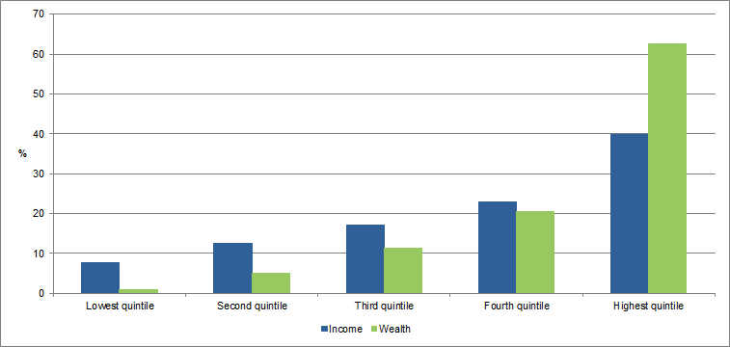
The relative poverty of Australia’s poorest people deteriorated during 2013-2014 and showed a slight improvement in 2015-2016, going back to 2011-2012 levels (Table 1). This is measured by the Gini coefficient whose range is between zero and one, with zero meaning perfect equality and one complete inequality. It is worth noting the difference between the income and wealth coefficients, which shows greater inequality in the distribution of wealth.
Table 1 Gini coefficients for inequality of income and wealth5
 | Income | Wealth
2011-2012 | 0.320 | 0.605
2013-2014 | 0.333 | 0.666
2015-2016 | 0.323 | 0.605

Many of the ACT priority households are reliant on base-rate government benefits such as pensions as their only source of income. Some housing costs and health costs have increased higher than Australia’s consumer price index over recent years, exerting additional pressure on households relying entirely on income support. These rising costs are compounded by rising energy prices.

3.1 Impacts of rising energy prices on low income households
The price of energy supply also affects the achievement of the policy objective since rising energy prices affect low income households the most. This is because the cost of electricity represents a much larger proportion of low-income household's income than for the general population and energy costs have more impact on the economic wellbeing of lower economic resource groups. Figure 2 shows that low income households spend on average almost 10% of their gross household weekly income on total household energy costs, almost four times that of high-income households.
Even though ACT consumers enjoy some of the lowest electricity prices in Australia, energy prices in Australia have risen sharply over the last decade. In response, many households have reduced energy costs by investing in measures to reduce energy consumption, such as purchase of energy efficient appliances, installing rooftop solar panels and home upgrades. Priority households have not had access to the funds required to undertake these measures. Instead, these households have taken other measures such as rationing energy use, seeking emergency assistance to pay for energy costs, or not paying accounts.
Figure 2 Energy expenditure as a proportion of gross household weekly income
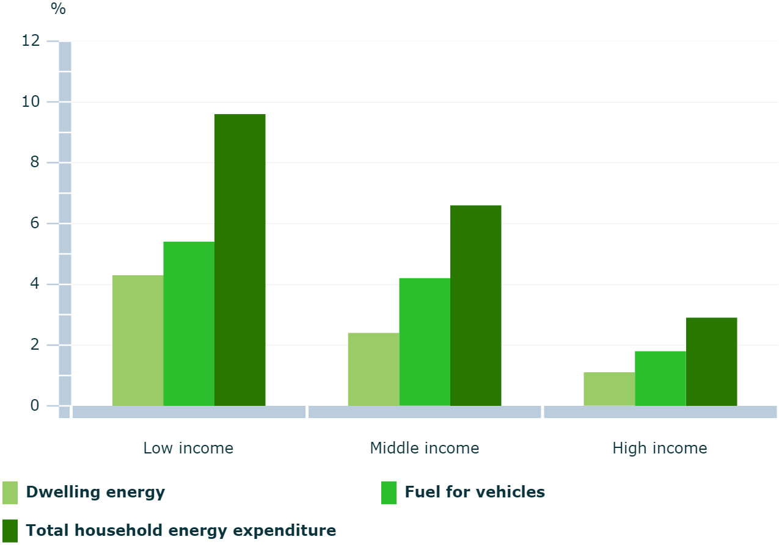
Electricity and gas prices are predicted to continue to rise in the coming years, putting further pressure on low income households. A Retail electricity price recalibration for 2018-2019 that was released by ICRC in June 2018 indicates an increase of up to 14.29% in regulated retail prices, which is estimated to have an impact of $299 in the annual bill of a residential household consuming about 8,000kWh per year. This is on top of an 18.95% price rise in 2017-18.
Meanwhile, Figure 3 shows that gas prices in the ACT are predicted to rise at even faster rates than electricity from 2017 until 2023 as a result of changes to global oil prices, exchange rates and ongoing effects of the linking of the Eastern Australian gas market with international gas markets and prices.
Figure 3 Modelled average delivered mass market prices at major demand centres, Neutral case, 2016 in AUD/GJ
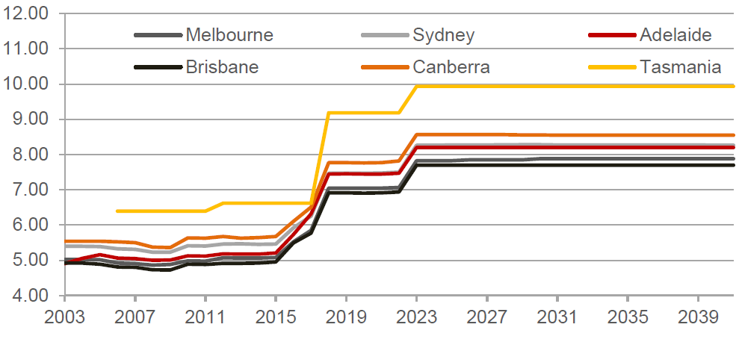
These cumulative price rises have put significant pressure on low income household budgets, including households whose primary source of income is a Centrelink payment, who are on a fixed retirement income and households reliant on minimum wage jobs.
The pressures caused by energy price rises need to be understood in the wider context on costs of living in the ACT. Costs of living are relatively high compared with other capital cities. The ACT Cost of Living Report (2018) prepared by ACTCOSS indicates the rising cost of living hits Canberra’s low income households the hardest, Canberra’s CPI rose higher than the national rate, and that Housing costs (which includes utilities) rose by 5.3%, above the national rise of 3.4%.
The ACT has one of the highest costs of private rental accommodation in the nation, so if you are in a low-income household you are spending a disproportionate amount of your income on housing, which does not leave sufficient funds in a monthly budget to cover other essential costs of living, including energy.
Many low-income households have difficulty paying their energy bills, and there is strong evidence of the inability of low-income households to become more energy efficient without assistance.
Households that are struggling to pay their bills will often pay late and/or enter into debt if they do not have money available when their bills fall due. The Australian Energy Regulator (AER) monitors figures on the energy-related debt that results from customers not paying their bills on time. The AER reported that in June 2018 the ACT had the highest percentage of customers in debt for both electricity (3.8%) and gas (6.1%) compared to other states and territories.
Should electricity and gas prices continue to rise, we can expect greater demand for emergency relief, community services, affordable housing and schemes like the EEIS.

Achieving the policy objectives
There is good evidence that EEIS activities deliver significant savings to participating households, which to date have included a proportion of priority households.
The effectiveness of the EEIS in reducing household and business emissions and energy costs was confirmed by an independent review undertaken in 2018, which also found that the scheme has been cost-efficiently delivered, with an overall positive benefit-cost-ratio.
According to the review, the EEIS has fulfilled its four objectives: encouraging efficient use of energy, reducing emissions, reducing energy use and costs for households, businesses and priority households. It has delivered lifetime bill savings of $180M to households and an average weekly savings of $5.65 for participating households.
The EEIS has delivered over 1M GJ of lifetime energy savings in priority households, or 24% of total scheme residential lifetime energy savings. It has saved $49M off the energy bills of over 18,000 Canberra’s low-income households that participated in the scheme since 2013. Savings from EEIS have been four times greater than the costs of running the scheme.
The PHT has been consistently achieved since the life of the scheme. Table 2 shows how ActewAGL has tracked on the PHT over the life of the scheme. Column one shows the PHT setting for each year of the scheme which was 25 per cent from 2013-2015 and 20 per cent thereafter. Column 2 shows the proportion of total abatement that ActewAGL delivered in priority households each year. This was well above the PHT in the first two years and has dropped off steeply since then with previous year surpluses being carried over into subsequent years. There was an increase again in 2018. Table 2 shows that as a result of the carry-over surplus from the first two years, the proportion of the total abatement that ActewAGL needed to deliver in priority households was less than the statutory target in each subsequent year. The total number of priority households in which abatement was delivered each year peaked in 2014, reduced until 2017 and is forecasted to increase again in 2019 and 2020.
Table 2 Achievement of the Priority Household Target
Year | PHT |  | % of total (achieved) abatement delivered in priority households | Priority household surplus for the given year (tCO₂ e) | % of total RESO required to be delivered in priority households less surplus | Number of priority households visited
2013 |  | 25% | 31% | 26,961 | 25% | 5,123
2014 |  | 25% | 31% | 20,648 | 18% | 8,216
2015 |  | 25% | 16% | -27,709 | 9% | 4,393
2016 |  | 20% | 9% | -11,599 | -25%* | 1,972
2017 |  | 20% | 13% | -6,141 | 12% | 356
2018 |  | 20% | 26% | 5,283 | 16% | 775
2019  Forecast** |  | 20% | 31% | 10,802 | 17% | 1,066
2020  Forecast** |  | 30% | 25% | -2,083 | 11% | 1,019

*no abatement required in this compliance period due to carried over surplus above PHT.
**forecast PHT values are based on ACT Government investment in Housing ACT properties.
Notes Columns 3 and 4 do not account for any carry over surplus from the previous year and relate to abatement delivered, not the abatement obligation (RESO).
Column 5 accounts for the carry over surplus from the previous year.

The forecast figures for 2019 and 2020 are based on the abatement the EEIS is likely to achieve in priority households with the $7million investment from the ACT Government. Approximately 2,200 highly efficient heaters and hot water units will be installed into public housing.
This ACT government Energy Efficiency Improvements in Public Housing initiative is estimated to provide around 48,000 tCO₂e of abatement. At the 20 per cent level, total priority household abatement required for the 2019 and 2020 periods would be approximately 31,500 tCO₂e, meaning that ActewAGL would achieve a significant surplus of around 16,500 tCO₂e if the current 20 per cent target is retained. Raising the target to 30 per cent would increase the expected priority household abatement to 39,000 tCO₂e, reducing the surplus to approximately 9,000 tCO₂e going into 2021. It is expected that barriers such as co-payments and split incentives will make achieving the Priority Household Target more difficult beyond 2021.
Therefore a 30 per cent setting is considered optimal to ensure ActewAGL is able to meet the target, but continues investing in abatement programs to priority households beyond the public housing group.
EEIS opportunities have shifted over the life of the scheme, and these changes are reflected in the types of activities that have been delivered by ActewAGL. From 2013 until 2016, most of the priority household abatement was delivered through a small set of activities including standby power controller, compact fluorescent light globe, draught sealing and refrigerator removal activities. These activities are widely considered the ‘low hanging fruit’ of energy efficiency schemes and have been delivered free of charge in the ACT, consistent with other schemes.
In 2017, more heating and cooling activities were delivered which has led to higher energy bill and emission savings and improvements in thermal comfort for participating households. However, a smaller number of households have benefited from these activities, which explains the reduced number of priority households visited in 2017 and 2018.
Over 18,000 priority households received EEIS activities from 2013 to 2018. Commentary in advance of the ACT Budget 2016-17 states that “concessions play an important role in supporting around 30,000 Canberra households, and the need for support is increasing”. ABS estimates that there are approximately 156,000 households in ACT in 2017, meaning that over 19 per cent of all Canberra houses fit the definition of EEIS priority households. This suggests that about two-thirds of ACT priority households have received EEIS benefits.
The ACT Government is maintaining complementary programs to assist low income households with energy efficient upgrades. These include the Actsmart Household Energy Efficiency Program, No Interest Loan Scheme, and the Solar for Low Income Program. These Actsmart Energy programs are funded by, and operate complementary to, the Energy Efficiency Improvement Scheme (EEIS) to maximise opportunities for businesses and households to reduce emissions and energy costs by offering energy efficient opportunities beyond those being delivered through EEIS.
Together, these examples show that the PHT policy objectives are being consistently met and that new opportunities exist for continuing to deliver these objectives through the PHT.

Consultation
Consultation on the Priority Household Target (PHT) was carried out at an EEIS Stakeholder Forum in February 2019.
Stakeholders were asked to provide feedback on the following questions:
The ACT Government is consulting stakeholders on the setting of the 2020 Priority Household Target.
- What do you think the EEIS Priority Household Target should be set at in 2020?
- Why do you think it should be set at this level?

The following stakeholders provided input at the forum:
- ACAT Energy and Water (ACAT)
- ACT Council of Social Services (ACTCOSS)
- ActewAGL
- Origin
- Better Renting
- Canberra Multicultural Community Forum
- Care Financial Counselling Services (CARE)
- Housing ACT
- St Vincent de Paul

- Chief Minister, Treasury and Economic Development Directorate (CMTEDD)
- Tuggeranong and Inner South Community Councils
- Alexander Watson Home Insulation Company
- Office of the Commissioner for Sustainability and the Environment
- Wildlife Carers Group
- EvoEnergy
- Knauf Insulation

Consultation confirmed that the PHT remains valuable. The general consensus was to keep the PHT at a minimum of 20 per cent, while the majority of participants supported an increase in the PHT, with suggestions as high as 30 per cent.
Comments on potential PHT settings were received at the workshop, and through an online survey. These include:
- The target could be increased to ensure the scheme still assists private renters and home owners. If the target is not increased in 2020 there is a risk that only Housing ACT tenants will make up the PHT.
- Increasing the target encourages the retailers to adopt new activities that could benefit priority households, for example insulation.
- Meeting the 20% target is already getting harder due to the removal of gas-to-gas activities from the scheme. Changing from ducted gas to ducted efficient electric is expensive and is unlikely to be taken up by priority households, making it harder to reach the PHT.
- Keep the PHT at 20% because it is currently working. It’s hard to provide further comments without the cost/benefit being available.
- Increase to 30% because the target is currently being met and is forecast to exceed the 20% level in both 2020 and 2021 as a result of the government’s public housing energy efficiency upgrade program.
- Have the target at 20% or below because having a lower target could potentially create higher rebates for each priority household.
- Priority households can re-access the program so it’s still feasible for a higher PHT to be met with new activities coming online.
- If the ACT Government is very keen to help the priority households perhaps they can fund the co-payment for capital works from the contribution they receive from Tier 2 retailers. Strict eligibility criteria would need to apply.
- Home energy audits lead to other activities being taken up.
- Expand the classes of priority households and increase the Priority Household Target.
- Barriers to increasing the PHT include priority households are less able to afford a co-contribution, renters make a significant proportion of priority households and will continue to be affected by split incentives, and removing gas activities from the scheme will reduce the subset of priority households that are able to access the scheme. Alternative policy options could be used to counteract these barriers, for example mandating energy efficient heating in rental properties, the provision of loans to owner occupiers and mandating disclosure of a property’s energy rating when entering into a new lease.

Additional consultation occurred for the proposal to increase the PHT to 25 per cent. An email was circulated to relevant stakeholders requesting any final comments. No comments were made relating to the increase in the PHT.

The consultation results support the increase of an EEIS priority household target to at least 25 per cent for 2020.

Barriers to participation
On completion of the Energy Efficiency Improvements in Public Housing initiative in 2020, it is expected that achieving the PHT will become more difficult. This is due to a range of factors, including gas to gas activities being removed from the scheme, higher cost activities requiring co-payments from priority households and split incentives in rental properties.

A significant message that was evident at the forum was the importance of ensuring access to the EEIS for priority households. As the EEIS has moved from free items to items that require a co-contribution, many of the most vulnerable households will not be able to pay the up-front fee and may not be able to access EEIS activities. Panel members and forum participants highlighted the need for mechanisms to assist priority households with the co-contribution. Such mechanisms may include no interest loans, additional Government subsidies, or alternative programs such as the Actsmart Home Energy Efficiency Program.
The particular problems for renters in the private market were also discussed at the forum. These households are unable to participate in many of the Energy Efficiency Improvement Scheme activities because they either do not have permission from their landlord to modify their housing and/or have no capacity to co-contribute to the costs of government or industry assistance programs.
Increasing the target to 30 per cent is an achievable target for 2020 due to the investment of funds from the ACT Government. The installation of 2,200 efficient heaters and hot water systems in Housing ACT properties is forecast to meet over 25 per cent of the total abatement in both 2019 and 2020, supporting an increase in the PHT to 30 per cent for 2020.
Options such as expanding the priority household definition are being explored to ensure more priority households, especially those in the second quintile, benefit from the scheme in the future. Any future priority household targets will need to take into account all of these factors.

Increasing opportunities for priority households
In 2018 the Minister for Climate Change and Sustainability made a regulation to expand the classes of priority households beyond the original scope as defined in the Act. This expansion will assist in meeting the PHT in 2019 and 2020.
Consultation occurred at the forum on ways to increase opportunities for low income households for the extension of the EEIS from 1 January 2021 until 31 December 2030. There was strong support to expand the scope of eligible priority households. The majority of workshop participants supported the expansion into private rentals, Family Tax Benefit B recipients, ACT Services Access Card and expanding referral organisations. Comments received at the forum can be seen in Table 3. This expansion of eligible households would not occur until the EEIS is extended beyond 2020 but would help to reduce some of the barriers to participation.
Table 3 Proposals for expanding the scope of eligible priority households beyond 2020
Proposed new class | Comments | Potential number of households
All renters | - This was considered a good umbrella group as many rental households would qualify under different criteria (such as student share houses, new migrants and bottom two income quintiles). This criterion requires significantly less administration to verify their financial situation.  - A major concern was to include restrictions on rent increases if landlords upgraded rental accommodation. The ACT Residential Tenancies Act 1997 may already offer this protection. This will be investigated further by EPSDD.  - Well-off renters in efficient accommodation would not likely access the scheme due to the nature of eligible activities offered.  - The EEIS activities generally support upgrades of the older housing stock in Canberra, which is more likely to be rented by people on lower incomes.  - Making renters eligible keeps the administration simple and puts the responsibility onto the landlord rather than the tenant. | 45,000 (includes Housing ACT and Community Housing organisations).
Family Tax Benefit B (FTBB) | - This was considered to be a good umbrella group that would be easier to administer than income dependent criteria such as the lowest two income quintiles.  - Maximum household incomes for FTBB is $127,772 and the financial limit does not increase based on the number of children in the household (unlike Family Tax Benefit A).  - This group could include homeowners. | 13,759
ACT Services Access Card | - This card was well supported and is limited to ACT residents with a Visa Protection. | Not known
Increasing referral organisations | - Increasing the number of referral organisations was well supported.  - No consensus was reached about which organisations would be included and research would need to be conducted on each additional organisation.  - Suggested organisations included:  - Migrant and Refugee Resettlement Services (MARRS) and other migrant groups  - Legal Aid  - Carers ACT  - The Public Trustee and Guardian  - Council of the Aging  - Emergency relief agencies  - Indigenous organisations | Not applicable

Consistency of the disallowable instrument with the authorising law
The disallowable instrument is consistent with the object of the Act to increase opportunities for priority households to reduce energy use and cost.
The authorising law requires the Minister to set a PHT at least three months before the start of the compliance period to which the priority household target relates. The requirement is for the PHT to be established six-months before the start of the compliance period if the PHT is to be increased. Compliance periods are calendar years.
As the proposal is to increase, rather than to retain the PHT, the authorising law requires the PHT to be set at least six months before the end of 2019 for the 2020 compliance period.

The disallowable instrument is not inconsistent with the policy objectives of another Territory law
The proposed law is not inconsistent with the policy objectives of another Territory law.

Reasonable alternatives to the disallowable instrument
Section 8 of the authorising law is explicit in its requirement for a PHT to be determined by the Minister and provides for no alternative. Alternatives to the disallowable instrument are therefore restricted to either a lower or a higher setting, or other pathways that provide for an achievable PHT.
The disallowable instrument sets the PHT at 30 per cent for 2020.
As mentioned previously, several strategies have been implemented to enhance opportunities to achieve the PHT. Referral pathways have been established between the EEIS and community sector, ActewAGL and Housing ACT are continuing to deliver the EEIS activities to public housing tenants and the pool of eligible households was expanded by a Regulation in 2017. These strategies were described and assessed in the Regulatory Impact Statement (RIS) for the Energy Efficiency (Cost of Living) Improvement (Priority Household Target) Determination 2017.
These strategies, along with new EEIS activities being phased in by ActewAGL set a favourable scenario for reaching more priority households in the future, which justifies an increase to the PHT of 30 per cent for 2020.

Assessment of benefits and costs of the disallowable instrument
An independent review of the EEIS was undertaken in 2018, which showed it had been effective in reducing household and business emissions, energy bills and been cost-efficiently delivered, with an overall positive benefit-cost-ratio.
Key results of the Review included:
- total lifetime bill savings of $240M including $180M to households and $60M to small and medium businesses.
- Average weekly savings are $5.65 for participating households and $57 for participating businesses.
- The EEIS imposes a small pass-through cost onto all ACT energy users. The review calculated these pass-through costs as averaging $30 per year for average ACT households in 2017. Average weekly savings for participating households were estimated at $294 per year in 2017.
- EEIS saved over $15M off the energy bills of Canberra’s low-income households.
- Without the disallowable instrument, there will be no requirement for the Tier 1 retailer to continue delivering EEIS savings to low income households, which would very likely result in fewer savings being delivered in those households. In this case, low income households would continue to pay an average of $30 per year towards EEIS, but be much less likely to achieve savings averaging $294 per year.
- Lifetime savings from EEIS have been four times greater than the costs of running the scheme.

Human Rights
The determination does not affect any human right set out in the Human Rights Act 2004.

Conclusion
The disallowable instrument sets the EEIS Priority Household Target (PHT) at 30 per cent for 2020. The 30 per cent EEIS PHT maintains opportunities for low income households to reduce energy use and cost by requiring obligated retailers deliver a proportion of total EEIS abatement in priority households. The PHT was set at 25 per cent between 2013 and 2015 and 20 per cent since 2016. The PHT has been consistently achieved throughout the life of the EEIS. With inequality and energy prices increasing, the need for priority household support remains as pressing as ever. Consultation indicated a consensus view that the PHT remains a valuable EEIS element and most stakeholders supported an increase to the PHT.
The government has implemented several strategies to minimise the risk of missing the PHT in 2020:
- Supporting the delivery of EEIS activities to Housing ACT tenants through a successful trial pilot program and a further $7.0 million investment to improve energy efficiency in public housing;
- Expanding the classes of priority households eligible for EEIS and therefore increasing the scope of the PHT;
- Introducing new EEIS heating and hot water activities;
- Collaborating with stakeholders to enhance referral pathways between the community sector, Actsmart, ActewAGL, Housing ACT, ACAT and EEIS.
Not increasing the PHT for 2020 could have the following impacts:
- The risk that all priority households in 2020 will be from Housing ACT properties and that other priority households will not be assisted through the EEIS; and
- Surplus abatement will reduce the total abatement required from priority households in subsequent years.
Increasing the PHT target to 30 per cent in 2020 will ensure the EEIS increases opportunities for priority households to reduce energy use and costs while encouraging the efficient use of energy and reducing greenhouse gas emissions. This setting is considered to be the best outcome for achieving the EEIS policy goals.

http://www.legislation.act.gov.au/a/2012-17/default.asp
http://www.legislation.act.gov.au/sl/2017-41/default.asp
https://www.environment.act.gov.au/energy/smarter-use-of-energy/energy_efficiency_improvement_scheme/publications
ACT Government Environment and Planning Directorate (2015) Energy Efficiency Improvement Scheme: Setting Key Parameters to 2020. Regulatory Impact Statement. Available at http://www.environment.act.gov.au/__data/assets/pdf_file/0006/735990/Attachment-C-Regulatory-Impact-Satement-EEIS-Parameters-to-2020-FINAL.pdf .
Australian Bureau of Statistics (2017) Income and Wealth Distribution. Available at http://www.abs.gov.au/ausstats/abs@.nsf/Lookup/by%20Subject/6523.0~2015-16~Main%20Features~Household%20Income%20and%20Wealth%20Distribution~6
Australian Council of Social Services (ACOSS) (2018) ACT Cost of Living Report. Available at https://www.actcoss.org.au/publications/advocacy-publications/act-cost-living-report-2018
Australian Bureau of Statistics (ABS) 4670.0 - Household Energy Consumption Survey, Australia: Summary of Results (2012) Available at http://www.abs.gov.au/ausstats/abs@.nsf/Lookup/4670.0main+features100032012
Australian Council of Social Service (ACOSS) (2013). Energy Efficiency & People on Low Incomes: policy to improve affordability and extreme weather adaptation, ACOSS, Strawberry Hills, NSW, Australia, August 2013. Available at www.acoss.org.au/images/uploads/ACOSS_ENERGY_EFFICIENCY_PAPER_FINAL.pdf
Independent Competition and Regulatory Commission (2018) Retail electricity price recalibration 2018−19. Available at http://www.icrc.act.gov.au/wp-content/uploads/2017/03/Report-3-of-2018-Retail-electricity-price-recalibration-2018–19.pdf
Australian Energy Market Commission (2017) Residential electricity price trends report. Available at https://www.aemc.gov.au/markets-reviews-advice/2017-residential-electricity-price-trends
Core Energy Group (2016) National Gas Forecasting Report. Available at http://www.aemo.com.au/-/media/Files/Gas/National_Planning_and_Forecasting/NGFR/2016/NGFR-Gas-Price-Review-Final-Report-October-2016.pdf
ACTCOSS (2018) ACT Cost of Living Report, Available at https://www.actcoss.org.au/sites/default/files/public/publications/2018-report-act-cost-of-living-may2018.pdf
Australian Energy Regulator (2018) State of the Energy Market, Available At https://www.aer.gov.au/system/files/State%20of%20the%20Energy%20Market%202018%20-%20Full%20report%20A4_2.pdf
ACT Government (2016). ACT Budget 2016-17. Available at http://apps.treasury.act.gov.au/budget/budget-2016-2017/fact-sheets/concessions
Actsmart (2018) Low income households. Available at http://www.actsmart.act.gov.au/what-can-i-do/homes/Actsmart-household-energy-efficiency-program. Accessed July 2018.
Good Shepherd Microfinance (2018) The No Interest Loan Scheme. Available at http://nils.com.au/?gclid=CjwKEAiArbrFBRDL4Oiz97GP2nISJAAmJMFa3MbPIsjmV8YkIDFL6o7vxMq8COyJwvjSW9vRgMyCDBoCxIvw_wcB Accessed July 2018.
Actsmart (2018) Solar for Low income households. Available at https://www.actsmart.act.gov.au/what-can-i-do/homes/Actsmart-household-solar-for-low-income. Accessed July 2018.
http://quickstats.censusdata.abs.gov.au/census_services/getproduct/census/2016/quickstat/8ACTE?opendocument
https://www.actcoss.org.au/sites/default/files/public/publications/2018-factsheet-poverty-and-inequality-in-the-act.pdf
EEIS RIS PHT Determination 2017. Available at http://www.legislation.act.gov.au/ri/db_56930/current/pdf/db_56930.pdf

