Waste Management and Resource Recovery Amendment Regulation 2021 (No 1)
  - SL2021-24

Regulatory Impact Statement
Transport Canberra and City Services
  - Incorporating impacts associated with the following related legislation:
- Waste Management and Resource Recovery (compostable material collection) Declaration 2021 (new),
- Magistrate’s Court (Waste Management and Resource Recovery Infringement Notices) Regulation 2021 (amended),
- Waste Management and Resource Recovery (Waste Categories) Determination 2021 (new),
- Waste Management and Resource Recovery (Exemption) Declaration 2021 (amended).
August 2021

Contents
1. Executive summary 5
2. Need for a regulatory impact statement 5
3. Introduction 5
4. Policy framework for waste management in the ACT 6
4.1 The ACT Waste Management Strategy 2011-2025 7
4.2 The ACT Waste Feasibility Study 2018 7
5. The authorising law 8
5.1 Waste Management and Resource Recovery Act 2016 8
5.2 Waste Management and Resource Recovery Regulation 2017 9
6. Consideration of human rights – Human Rights Act 2004 9
6.1 Right to be presumed innocent until proven guilty 10
6.2 Right to privacy 10
7. Providing for a Food Organics and Green Organics waste service 10
7.1 ACT Government FOGO commitments 10
7.1a Accommodating a FOGO pilot 11
FOGO case studies across Australia 11
7.1b Specifying households for the FOGO pilot 12
7.1c Temporary and long-term infrastructure 13
7.1d Minimising contamination 13
7.1e Changing the frequency of waste collection services 14
7.2 Objectives 14
7.3 Approaches from other jurisdictions 15
7.4 Options 16
7.5 Summary of amendments 16
7.6 Consideration of human rights 17
7.7 Impact and cost-benefit analysis 18
8. Clarifying kerbside container management 19
8.1 Problem 19
8.1a Bin-diving 20
8.1b Health and safety incidents related to kerbside container management 21
8.2 Objectives 24
8.3 Approaches from other jurisdictions 24
8.4 Options 25
8.5 Summary of amendments 26
8.6 Consideration of human rights 28
8.7 Impact and cost-benefit analysis 28
9. Improving enforceability of appropriate uses of waste facilities 30
9.1 Problem 30
9.1a Health and safety issues from offences at waste facilities 30
9.1b Offences at unstaffed waste facilities 32
9.2 Objectives 34
9.3 Approaches from other jurisdictions 34
9.4 Options 35
9.5 Summary of amendments 36
9.5a Vehicle related offences 40
9.6 Consideration of human rights 41
9.7 Impact and cost-benefit analysis 42
10. Increasing flexibility for Container Deposit Scheme collection points 43
10.1 Problem 43
10.2 Objectives 44
10.3 Approaches from other jurisdictions 44
10.4 Options and summary of amendments 44
10.5 Consideration of human rights 45
10.6 Impact and cost-benefit analysis 45
11. Improving and modernising waste definitions and reporting 45
11.1 Problems and objectives 45
11.2 Approaches from other jurisdictions 46
11.3 Options 47
11.4 Summary of amendments 48
11.4a Batteries 49
11.5 Human rights 50
11.6 Impact and cost-benefit analysis 50
12. Consultation statement 50
13. Summary of options 51
14. Recommended option 52
15. Overall impact analysis 52
16. Conclusion and recommendation 53

List of tables
Table 1 FOGO case studies and issues 11
Table 2 FOGO summary of impacts 17
Table 3 Commentary on bin diving, from Canberra Noticeboard March 2021 19
Table 4 Excerpts from workplace health and safety incidents from likely kerbside container offences 21
Table 5 Offences related to kerbside waste container storage and collection 26
Table 6 Kerbside container management summary of impacts 28
Table 7 Excerpts from workplace health and safety incidents from offences at facilities 30
Table 8 Offences related to disposing of waste at a waste facility 36
Table 9 Enforceability of appropriate uses of waste facilities summary of impacts 41
Table 10 Container deposit scheme simplification summary of impacts 43
Table 11 Problems and objectives in waste definitions and reporting 44
Table 12 Waste activity definitions and reporting summary of impacts 48

List of figures
Figure 1 Options for replacement bins 17
Figure 2 Analysis of comments made in Canberra Noticeboard bin diving debate, March 2021 20
Figure 3 Analysis of workplace health and safety incidents caused by likely kerbside container offences, 2017-2021 23
Figure 4 Analysis of workplace health and safety incidents from offences at waste facilities, 2017-2021 31
Figure 5 Images of unauthorised use of waste facilities 32

Executive summary
This Regulatory Impact Statement (RIS) presents an analysis of the impacts of the proposed Waste Management and Resource Recovery Amendment Regulation 2021 (No 1) (the Amendment Regulation). The primary purpose of this regulation is to enable the introduction of a Food Organics and Garden Organics (FOGO) service to the Australian Capital Territory (the ACT, or Territory) by allowing food waste to be placed in Territory organic recycling containers. A group of regulatory amendments are proposed to enable FOGO delivery, including changes to several sections of the Amendment Regulation, and the introduction of a new Waste Management and Resource Recovery (compostable material collection) Declaration 2021. The RIS addresses all of these.
The RIS also analyses the impacts of additional groups of amendments which have been proposed to improve the operation of the Waste Management and Resource Recovery Regulation 2017. Those additional groups of amendments seek to:
- clarify kerbside container management arrangements,
- improve enforceability of the regulation at waste facilities,
- increase flexibility for the Container Deposit Scheme collection points; and
- improve and modernise waste definitions and reporting.

Need for a regulatory impact statement
ACT Government policy requires the preparation of a RIS for any new or amending legislation proposals that may impact on a stakeholder group, for example, government, community groups, the general public, industry or a business group.
Section 34 of the Legislation Act 2001 provides that if the proposed law is likely to impose appreciable costs on the community, or a part of the community, then, before the proposed law is made, the Minister administering the authorising law must arrange for a RIS to be prepared for the proposed law.
The amending regulation has some actual and potential impacts on government, business and the community, and therefore requires a cost-benefit analysis for each option likely to impose a cost.
The policy problems and potential impacts differ considerably for each of the proposed groups of regulatory amendments. Due to this, the regulatory impacts are presented separately for each of the proposed groups of amendments.

Introduction
Waste management is an essential service and is integral to Canberra’s operation as a jurisdiction. The Territory’s waste legislation outlines the requirements for managing waste activity consistent with the ACT Waste Management Strategy 2011-2025, in a way that encourages recycling and recovery, while discouraging the sending of waste to landfill. The Waste Management and Resource Recovery Act 2016 (the Act) provides a framework for managing waste in the ACT and establishes the statutory authority role of a waste manager.
The Act provides for a regulation to define types of waste that could be placed in kerbside containers, waste reporting and management of waste facilities. The Waste Management and Resource Recovery Regulation 2017 (the Regulation) provides the capacity for the waste manager to determine arrangements for these through declaration of notifiable instruments.
This RIS outlines the impacts of a proposal to amend the Regulation primarily for the purpose of introducing a FOGO service to the Territory. Currently, the Regulation makes it an offence to place food waste into Territory organics recycling containers (green bins). The RIS will explain that amendments are needed because the green bins are the food and other organic waste containers proposed for FOGO collections.
The RIS presents the regulatory impacts associated with extending the use of green bins for food waste collection. It does not provide detailed information regarding the FOGO proposal including budget implications, infrastructure requirements, consultation and educational elements or timing, as these elements of the FOGO initiative are far broader than the regulatory changes needed to enable it.
The detailed information regarding the FOGO initiative is addressed separately in other government documents including separate feasibility studies, infrastructure plans, budget bids, and communications plans.
The RIS also analyses the impacts of additional amendments proposed for the Regulation, that have been identified by waste regulators as being beneficial for its effective operation. The need to update the Regulation to support a FOGO service provided the opportunity to incorporate feedback from the regulators and make these amendments. The goals of the additional amendments are as follows:
- clarifying kerbside container management,
- improving enforcement at waste facilities,
- increasing flexibility for CDS collection points; and
- consolidate and modernise waste definitions and reporting.

Policy framework for waste management in the ACT
The Territory’s regulatory waste functions are the responsibility of Transport Canberra and City Services Directorate (TCCS) and are delivered and managed by ACT NoWaste. ACT NoWaste is responsible for managing the operational outcomes of the ACT's waste infrastructure and delivering essential household waste collection and management services. ACT NoWaste is also responsible for shaping the waste and resource recovery landscape in the ACT by driving progress towards waste minimisation and resource recovery outcomes through a combination of policy, regulation and direct government investment in waste infrastructure projects.
The policy framework for waste management is established by the ACT Waste Management Strategy 2011-2025, which was further developed through the ACT Waste Feasibility Study 2018.

4.1 The ACT Waste Management Strategy 2011-2025
The ACT Waste Management Strategy 2011-2025 (WMS) sets a clear direction for the management of waste in the ACT, with objectives focusing on sustainable resource management to:
- Reduce waste generation per capita,
- Increase recovery of valuable resources,
- Protect the environment and prevent pollution; and
- Reduce greenhouse gas emissions from the waste sector.
The WMS establishes a framework for the consideration of waste materials as potential resources and recognises the importance of community engagement, partnerships and education initiatives in achieving these attitudinal changes.

4.2 The ACT Waste Feasibility Study 2018
The ACT Waste Feasibility Study 2018 (WFS) focuses primarily on reducing waste, improving resource recovery outcomes and creating markets for recycled products. It establishes two group of recommendations that create a roadmap for waste and resource recovery initiatives to meet the Territory's waste targets. The first group are specific to achieving direct diversion from landfill and commensurate resource recovery outcomes, whilst the second group are focused on legislative, policy and system changes to facilitate complement ongoing change and improvements.
Most of the stage one projects recommended in the WFS have been commenced by ACT NoWaste, including the implementation of a pilot Love Food Hate Waste education program, site identification work for new FOGO processing capacity and the development of a position for the ACT on waste to energy.
The WMS and subsequent WFS establish a clear set of priorities and goals for improving waste management and resource recovery outcomes in the ACT. They have been successful in supporting a commitment to new organic waste services, including the current opt-in kerbside garden waste service and the new FOGO service to be introduced from 2023, and the introduction of a CDS.

The authorising law

5.1 Waste Management and Resource Recovery Act 2016
The Waste Management and Resource Recovery Act 2016 (the Act) supports the achievement of resource recovery objectives in the ACT Waste Management Strategy 2011-2025. The Strategy is the principal Government policy statement outlining resource recovery aspirations and future directions. The Act seeks to facilitate and reward good practice in waste collection, transportation, recovery and reuse, and to discourage the disposal of waste into landfill.
The purpose of the Act is to promote and reward responsible best-practice in waste management and resource recovery. The Act was developed following extensive industry and community consultation.
The objects in the Act align with the Government’s waste management policy objectives, including:
- managing waste according to the following hierarchy:
  - minimise the generation of waste,
  - maximise the recovery and re-use of resources,
  - minimise the amount of waste that goes to landfill.
- supporting innovation and investment in waste management;
- promoting responsibility for waste reduction; and
- promoting best-practice waste management.
Several sections of the Act provide for matters to be declared by regulation. Those of relevance to this RIS include following:
- Section 10 – provides for substances to be declared to be waste,
- Section 19(2)(b) – provides for information in licence applications to be prescribed by regulation,
- Section 64(1)(a) – provides for the establishment of a waste collection service,
- Section 64(2) – provides for a waste collection service,
- Various arrangements for the CDS scheme including:
  - Section 64E – the definition of a CDS container,
  - Section 64F – the refund amount for CDS containers,
  - Section 64I – determines matters to be included in CDS scheme administration agreements, including commencement, performance targets,
  - Section 64K – outlines approval of CDS network arrangements,
- Section 65(2)(a) – outlines information to be contained in waste activity reports, and
- Section 113 – outlines offences relating to taking prescribed waste to facilities.
Section 128 of the Act provides a general regulation-making power, specifically that a regulation may:
- make provision in relation to the exclusion people or activities from the application of the provisions of the Act; and
- create offences for contraventions of the regulations and fix penalties of not more than 40 penalty units for the offences; and
- make provisions in relation to the content of CDS scheme arrangements.

5.2 Waste Management and Resource Recovery Regulation 2017
The Waste Management and Resource Recovery Regulation 2017 (the Regulation) details the licensing, registration and reporting requirements for waste businesses, and contains offence provisions which strengthen the Government’s ability to penalise inappropriate and potentially dangerous waste management practices where compliance is not achieved through public education or the issuing of a rectification notice.
Amongst other things, the Regulation:
- declares substances to be within the meaning of ‘waste’,
- lists different types of wastes and how they are to be reported as part of facility licenses and transporter registrations,
- defines eligible containers for the ACT CDS; and
- identifies information to be included in instruments.

Consideration of human rights – Human Rights Act 2004
Directorates are obligated under the Human Rights Act 2004 (the HR Act) to act and to make decisions consistently with human rights.
This includes ensuring any amendments result in a law that is proportionate – that it limits rights in the least restrictive way possible to achieve the purpose of the legislation (section 28 of the HR Act). This includes considering if any amendment is going to have a disproportionate impact on low-income earners or other vulnerable people, engaging the right to equality under section 8 of the HR Act.
The following matters are considered from a human rights perspective. Specific provisions that engage human rights were developed with the Justice and Community Safety Directorate (JACS) and provided to the Human Rights Commission (HRC).

6.1 Right to be presumed innocent until proven guilty
Strict liability offences engage the presumption of innocence under section 22 (1) of the HR Act by removing the fault elements from an offence. This means an accused will be automatically presumed guilty unless they successfully raise the defence of reasonable and honest mistake.
The Amendment Regulation proposes to introduce some new strict liability offences related to kerbside waste container management and activities at waste facilities. The reason for this, and the potential impacts are addressed within the sections that deal with those matters, and specifically in Section 8.6.

6.2 Right to privacy
Section 12 (a) of the HR Act provides that everyone has the right to not have their privacy interfered with unlawfully or arbitrarily. The Amendment Regulation proposes to introduce a new capacity for regulators to identify owners of vehicles that are identified as being involved in non-compliance at waste facilities. The reasons for these proposed provisions and their impacts on human rights are addressed within section 8.2f, on improving enforceability of provisions at waste facilities.

Providing for a Food Organics and Green Organics waste service

ACT Government FOGO commitments
The Parliamentary and Governing Agreement for the 10th Legislative Assembly includes a commitment to roll out a household food waste collection service by 2023 (Appendix 3, 9.1). Work towards the implementation of this service is underway with the commencement of a pilot of a combined Food Organics and Garden Organics (FOGO) collection using ACT green bins, for selected households in Belconnen in November 2021.
The ACT Waste Management Strategy 2011-2025 set targets raising waste diversion from landfill from 70% to 90% by 2025 and achieving a carbon-neutral waste sector by 2020.
An opt-in kerbside garden organic collection service has already been rolled out across the ACT, commencing with trials in 2017 and becoming available to all households across the ACT from 2019. Food organics are the next key focus in the ACT journey towards a more sustainable and circular use of resources.
In 2018, the Waste Feasibility Study Roadmap recommended introducing a kerbside FOGO service as a critical component of the roadmap to meet the 90% diversion target, contributing an additional 5 percentage points to the ACT recycling rate.
The proposal to introduce a FOGO service is also consistent with commitments within the ACT Climate Change Strategy 2019-2025. Waste management in the ACT currently generates approximately 70,000 tonnes of carbon dioxide equivalent emissions (tCO2e) each year, accounting for approximately 4% of ACT’s greenhouse emissions in the 2019-20 financial year. These emissions are primarily in the form of methane, a potent greenhouse gas which is generated when organic waste breaks down in landfill. Whilst some methane is collected from existing landfills to produce energy, it is estimated that introducing a universal FOGO collection for 45,000 tonnes per year of FOGO waste, it would reduce ACT’s emissions from the waste sector by approximately 30%.
The FOGO proposal is also consistent with the overarching goal of the National Food Waste Strategy to halve Australia’s food waste by 2030. It will further deliver on the Territory’s commitments under the National Waste Policy Action Plan, to halve the amount of organic waste sent to landfill for disposal by 2030.
The Amendment Regulation is required because it is recognised that the current Regulation makes it an offence to place anything other than garden waste into the ‘green bins’. The Territory’s current green bin collection and recycling service was established for garden waste. Additional infrastructure and operational processing are required to processing food and other organic waste in addition to the currently accepted garden clippings. Further work will be completed to define the compostable wastes that may be placed in the green bins, and to identify the households that will be involved in the pilot.

7.1a Accommodating a FOGO pilot
The current proposal is for a FOGO pilot to be delivered to approximately 5,000 households in Belconnen, commencing in late 2021. The pilot will aim to test the proposed service delivery model, raise awareness, understand household experiences and barriers to participation, and gather sample data on waste feedstock and recycled products in parallel to the planning and infrastructure development required for a whole-of-ACT roll-out.

FOGO case studies across Australia
A FOGO feasibility study prepared in support of the ACT proposal reviewed relevant case studies from across Australia. As a point of reference, a snapshot of some of the populations targeted for FOGO services can be found in Table 1 below.

Table 1 FOGO case studies and issues
Case study area | Service provision per population | Summary of issues
Bunbury-Harvey Regional Council, WA | Service provided to a subset of 46,000 households across seven local governments. | 2.4% contamination rates which vary between the 7 participating councils. Councils required to pay a penalty if contamination exceeds 5%.
Tweed Shire Council, NSW | Service provided to 60,000 people out of 100,000 in the region. | MUDs can opt into FOGO for an additional fee. Contamination rate of 4%, focused in specific hotspots.
Bega Valley Shire Council, NSW | Service provided to 20,000 people out of a total population of around 35,000. | Very low contamination rates averaging 0.4% following highly effective education campaign.
Snowy-Monaro Regional Council NSW | Service provided to 3,600 people from a total population of around 20,000. | Compost shown as beneficial for week control and feedstock self-sufficiency.
City of Sydney | Trial of 88 actively participating MUDs buildings, the largest with 810 dwellings. Trial to be extended to all MUDs by 2030. | Opt-in rate of about 40% among residents in participating buildings.

7.1b Specifying households for the FOGO pilot
To support the design of a final, whole-of-Canberra FOGO service, the pilot will need to connect all different types of dwellings to the FOGO service. For simplicity and cost effectiveness, the trial participants need to be close together, and the proposed approach is for a partial opt-in arrangement for multi-unit developments within the target geographical areas.
The most complex group of households for the trial are the many different types of multi-unit developments (MUDs) which exist in the Canberra community. Waste facilities and collection services differ for high density apartment buildings which generally use large skips for waste collections, and for a range of medium density units. The variety of waste containers and collection services that apply to MUDs mean that work will be needed to trouble-shoot issues and support households to transition to the new service. The best outcomes are anticipated if a collaborative approach is taken, and MUDs within the target pilot area will be offered the chance to opt-in.
The opt-in arrangements mean that the best option for defining households that will be part of the trial is not to map whole suburbs, or list whole streets. This approach would lead to the inclusion of some MUDs whose residents are not ready to opt into a trial, and would prefer to receive the final service, once troubleshooting is complete. Some movement in and out of the pilot may also be called for prior to the whole-of-Canberra roll-out. For these reasons, the proposal is to allow pilot participants to be specified through the comparatively quick and streamlined option of a notifiable instrument, rather than by regulation.

7.1c Temporary and long-term infrastructure
The introduction of FOGO will require the construction of new commercial composting infrastructure. This new infrastructure will take several years to establish.
It is intended that temporary infrastructure to compost and process the feedstock will be utilised during the FOGO pilot. The range of new compostable materials that can be accepted into this temporary infrastructure will be limited compared with materials that the purpose-built facility service will be able to accept. Examples of materials that will not be accepted into the FOGO pilot, but are expected to be allowed in the long-run are animal excrement and other odorous substances. There is also an intention to expand the range of biodegradable packaging that may be allowed in the final facility, although the ability to do this will be determined through further testing.
The regulatory problem includes a requirement to adjust the definition of compostable material that can be placed in green bins in-between the trial, and the whole-of-Canberra roll-out which will make use of the new, fit-for-purpose infrastructure.

7.1d Minimising contamination
Minimising contamination of the FOGO feedstock is critical to the success of the initiative. If contamination is low, the resulting compost can be sold as a valuable soil enhancer with beneficial properties for landscape development and even food production; whereas if contamination is high, the quality and value of the compost will be low and profitable markets may not be found.
Two main options are available to the Territory for preventing contamination and both are included in the ACT FOGO proposal. The first option is to deliver an effective communication campaign as was used in Bega Valley Shire Council and other jurisdictions with successful FOGO rollouts, although contamination remains a problem even for these areas. This is proposed to be supported by the provision of suitable caddies for household kitchens and caddy bags for at least the first year. Some councils, including parts of neighbouring Queanbeyan-Palerang Regional Council have continued to supply caddy bags to participating households. The supply of these items is being considered for ACT FOGO collections.
Another option for minimising contamination is regulatory – to make it an offence to place non-compostable material in the green bins, through an extension of the existing offence placing anything other than garden waste into these bins. This is included in the proposed Amendment Regulation.
The ACT is considering options for a FOGO collection service using technology which is being successfully used in the Bega Valley Council area and other places. This approach involves FOGO collection vehicles being fitted with cameras, which drivers or regulators could use to inspect and photograph material emptied in the truck. This system does not prevent contamination being collected; however it provides the information needed to follow up contamination sources and prevent repeat events.

7.1e Changing the frequency of waste collection services
Changes to the frequency of existing domestic waste collection services are being considered as part of the FOGO initiative, with FOGO compostable bins (green bins) potentially to be collected weekly, and residual waste bins (red bins) collected fortnightly. This is the opposite of the existing collection rates for both services as currently, red bins are collected weekly and green bins are collected fortnightly.
Under this arrangement, the increased frequency of green bin collections would be required as the introduction of putrescible wastes means that if the bins are not collected weekly, they will have an increased potential to cause odour issues, and to attract vermin or other nuisance issues. The collection of the red bin service will be reduced from weekly to fortnightly due to several reasons including managing the financial impact of the FOGO service and as there will be reduced putrescible wastes in the red bins, their risks of odour and other issues will be lowered. A reduced red bin service frequency will support the proposed community education and engagement program to encourage the separation of food and garden waste from the residual waste.
No regulatory change is needed for adjusting service frequency, as the waste legislation does not specify service delivery timeframes.

7.2 Objectives
The core objective of the regulation update is to allow for green bins to be used for FOGO collections. To support both a pilot and whole-of-Canberra roll-out, provision is made for:
- Different definitions for the compostable waste that may be placed in green bins during the pilot and whole-of-Canberra roll-out,
- Specification of Canberra households to be allowed to place additional compostable materials within the green bin during the pilot phase and final phase, and
- Offence provisions to support a high quality and low contamination feedstock which produces a valuable end product.

7.3 Approaches from other jurisdictions
As outlined above, many other jurisdictions have introduced FOGO services, consistent with national commitments to reduce food and organic waste in landfills and to support local economies and priorities. The Commonwealth Government is progressing a funding program to support new FOGO services across Australia and the Territory may seek to participate in the program through its FOGO initiatives.
In other jurisdictions, waste legislation is enacted by state governments while waste services are delivered by local governments. Where needed, state governments have provided regulatory capacity for local governments to use green bins for FOGO services. For example, some jurisdictions have required regulatory changes to enable changes in service frequency for their collections so that red bins shift to fortnightly and green bins to weekly. This type of regulatory change is not needed for the ACT as service frequency is not regulated.
Most jurisdictions with successful FOGO services and low contamination have focused on quality communications and engagement to clarify requirements ahead of service introduction. Most have provided every participating household with a kitchen caddy and an annual supply of compostable caddy liners. Some jurisdictions have continued to provide an annual supply of caddy liners to householders to encourage and support the use compostable bin liners and minimise odour and other potential nuisance issues that may be associated with green bins.
The ACT FOGO proposal is consistent with these approaches in that marketing, communication and education activities are proposed for both the pilot and the whole-of-Canberra roll-out to maximise community understanding and appropriate behaviours.
In early 2021, the ACT raised the issue of offence provisions during a National Waste Working Group meeting to prevent contamination of FOGO services with other state government jurisdictions. Advice was sought on whether jurisdictions recommended that regulatory offences be available to prevent contamination. A clear consensus was that offence provisions are essential to preventing contamination and supporting a cost-effective FOGO roll-out.
Taking account of the considerations above, the offence provisions applying to the improper use of the green bins are included in the Amendment Regulation. The policy intention is not to make extensive use of these provisions, or to seek additional resources to undertake significant additional enforcement actions. The proposal is to make use of recording devices on FOGO collection trucks to identify any major, repeated instances of contamination and to follow these up with targeted communication and education materials. Other options include random inspections of FOGO bins presented at the kerbside for collection. Bin tagging has been used to good effect for green bins contributing to low contamination levels. Enforcement action would be intended as a last resort option in rare cases where other approaches were unsuccessful in preventing contamination.

7.4 Options
The recommended option for the Amendment Regulation is to enable the waste manager to define compostable waste, and to specify addresses within the ACT which may place those wastes in a green bin by notifiable instrument. This option also allows for the extension of existing contamination offences so that they may be used to respond to and prevent FOGO contamination. The proposed offences are a simple extension of existing strict liability offence provisions designed to prevent contamination of other recyclable waste streams.
An alternative option would be to specify compostable materials and FOGO pilot areas by regulation instead of by notifiable instrument. This is not recommended, as it would limit the flexibility for MUDs to opt in and out as the trial progresses and would also require further regulation changes to transition to the whole-of-Canberra roll-out.
Consideration was given to not extending the existing strict liability offences to FOGO contamination. This is not recommended as it would mean a reduction in the existing regulatory controls around the management of green waste, resulting in FOGO and compostable wastes offences being less enforceable than those applying to other domestic recycling services. This approach would likely constrain the success of the FOGO service which depends on low contamination rates. Having an enforcement option is considered an important backup mechanism to reinforce and support the proposed education and communication campaign.
Another option for preventing contamination is to use the Plastic Reduction Act 2021 to prevent the sale of non-compostable caddy bags within the ACT. This is expected to be achieved with the second tranche of items to be phased out by the Act. A ban on the sale of further products will occur from July 2022 including single use plastic fruit and vegetable ‘barrier bags’ and products made from degradable plastics which contain additives which enable plastics to be broken down into microplastics which don’t completely decompose.

7.5 Summary of amendments
In summary, the FOGO amendments to the Regulation are as follows:
- The waste manager is provided a new capacity to declare via a notifiable instrument that a stated compostable material to be an organic waste,
- That the declaration applies to a stated area for a stated period, and
- The existing offence for placing waste in a green container if it is not organic waste is extended to apply also to compostable material.
Regarding the reference to standards in the Notifiable Instrument, the proposal is to disapply the requirement to notify the Australian Standards on the register. The ACT community will not need to have access to the two standards which are listed in the Instrument because:
- Households will be provided with compliant, compostable plastic bags for at least the first year of the pilot, and
- The second tranche of the Plastic Reduction Act 2021 is intended to be in place by the time households need to buy their own caddy bags, meaning that they will be unable to purchase caddy bags that do not meet the standards.

7.6 Consideration of human rights
Although the issue of collection frequency is outside of the regulatory amendment proposal, it is worth mentioning here as it associated with the introduction of a FOGO service and may have some human rights implications. Some households may face difficulties due to the shift in red bin domestic waste services from a weekly to a fortnightly collection. If they have been affected by the changes, households can apply for an additional garbage bin to supplement the existing allocation of a 140-litre garbage (red lidded) bin. Options are shown in the screen shot below from the ACT government website and fees are lower than quoted here for concession card holders. A delivery fee also applies. The additional bin service also attracts a one-off fee of $220 plus an annual payment of $116.70 per year. These options will mitigate negative impact from changed service frequency for red bin services.
Figure 1 Options for replacement bins
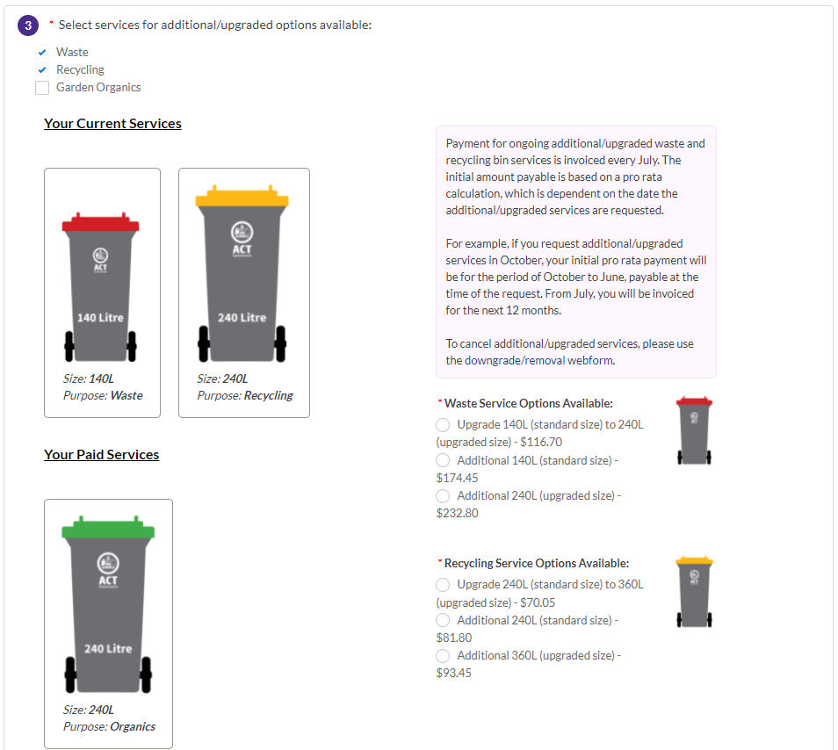

7.7 Impact and cost-benefit analysis
There will be some impacts from the implementation of the amendments, however the benefits of the proposed amendments are expected to outweigh both the costs of not making the amendments, and the costs associated with the amendments. The table below summarises this assessment.

Table 2 FOGO summary of impacts
Type of impact | Summary of impact
Benefits of amendments | - The amendments will allow ACT green bins to be used to collect compostable waste for the proposed ACT FOGO service. They will enable flexibility in the proposed pilot initiative to support a staged introduction of the FOGO service.  - Existing offences related to placing unsupported wastes into the green bins will be carried over into the compostable FOGO waste streams, providing the capacity to take enforcement action if communication and education actions fail to prevent repeated, significant contamination. The availability of offence provisions will provide the capacity to prevent contamination .
Impact of not making amendments | - Without the amendments, ACT green bins cannot be used for the proposed FOGO service. This would significantly impede the Territory’s capacity to deliver on its commitment to deliver the service to all ACT households.  - Implementing the changes without enforcement options will remove a viable and proportionate backup option for preventing contamination where education and communication efforts do not work.
Amendments which may impose some cost | - There are no costs associated with the amendments.  - Households which cannot cope with a reduced frequency of red bin collections may purchase larger sized, or additional red bins.
Amendments which will not impose any appreciable costs | - There is no change proposed to the range of organic material which may be placed into Territory waste containers, or the total set of waste collection servicers.  - The proposal to extend the existing infringements over to compostable wastes is consistent with, rather than additional to existing provisions.

Clarifying kerbside container management

8.1 Problem
The ACT government receives routine concerns from constituents about behaviour associated with the management of kerbside territory waste containers. Although Workplace Health and Safety (WHS) incidents associated with kerbside collections are also notified regularly. Part Four of the current Regulation deals with waste storage, collection etc and contains a range of offence provisions which could be used to respond to incidents. A review of existing provisions was undertaken to support the FOGO amendments and revealed that these provisions have not been used to achieve compliance outcomes to date, and that a number of issues are generating uncertainty around the Territory’s kerbside container management. These issues include:
- the Regulation does not establish responsibilities about kerbside container management but only provides offences for behaviours which are not allowed;
- the rules around ownership and access to waste containers, and the material within them are not clear and this creates uncertainty around the ACT Government’s right to inspect bins for audit and compliance purposes;
- the regulation does not provide clarity about whether other people may access bins left on the kerb, for example to remove CDS containers for redemption;
- related legislation, especially the Litter Act 2004 with established infringement notice schemes have been used to respond to some complaints related to kerbside container management and this has provided a regulatory presence at the kerbside. The Litter Act cannot be used to manage contamination issues, or health and safety issues associated with waste collection services and so is not a substitute for effective waste regulation. Evidence of genuine health and safety issues around kerbside container management is below;
- the Waste Act kerbside offence provisions have proven difficult to implement because it is frequently not possible to identify the person or household responsible for an offence; and
- the Regulation focuses on waste placed in containers and does not provide for waste to be left on the kerbside outside of containers for bulky waste collection services.
Evidence that these problems are manifesting in the ACT is presented below.

8.1a Bin-diving
Complaints are sometimes received about the behaviour of people ‘bin diving’ or going through yellow bins left out for kerbside collections, presumably seeking CDS containers for redemption.
A proxy straw poll on issues involved in this, and resident views about the behaviours was obtained through a text analysis of a Canberra Noticeboard post from 19 March 2021. A resident posted “People going through your recycling bins for cans and bottles. What are your thoughts? Invasion of privacy?” Numerous replies were made, and examples are included in Table 3.
Figure 2 below the table presents a semi-quantitative analysis of the number of comments that were made across five different topics related to the post and whether the comment was identifying the behaviour as problematic, not a problem or were neutral about it. Although these posts are not the result of a formal survey, and have no statistical validity, they do provide a sense of the range of concerns and the relative prevalence of different views. The results suggest those who commented on the post do not consider bin diving to be a significant problem.

Table 3 Commentary on bin diving, from Canberra Noticeboard March 2021
 | Not a problem | A problem | Neutral
The act of going through bins | - Please take and recycle them and thank you for recycling.  - Go for it. Money for them without a loss for me.  - I’d help him and give him an extra $10 to do it, and tell him not to give up on life. | - With all the talk about identity theft I would be concerned if I say this in my bins. But I don’t begrudge people making a dollar.  - Not OK if it is in the backyard. | - Perhaps put a sign on top of your bin whether or not there are collectable bottles/can inside.  - If it’s your recycling they can come into the house and clean up. That’s fair.
Privacy concerns | - Putting private documents in your yellow bin is not smart.  - If it’s your recycling is it really an invasion of privacy? Really it should just be bottles, cans and cardboard. If you’re concerned about privacy get a shredder. | - I am concerned about privacy concerns from confidential documents in the bin.  - Its actually a crime to go through private garbage bins because of the amount of identity theft. | - I didn’t realise that bins had privacy concerns.
Potential to cause a mess | - Perfectly fine so long as they don’t cause a mess. | - Dirty grubs. I’ve seen them in action leaving a mess. | - No comments
Concerns about trespassing | - It is on council land and they don’t make a mess | - Disgusting grubs and they are trespassing if bin is on your property | - No comments
Safety concerns | - Absolutely fine but go one step further and make a box for them. | - A bit worried they might find yucky nappies.  - The only iffy thing is what happens if they cut themselves while in your bin | - No comments

Figure 2 Analysis of comments made in Canberra Noticeboard bin diving debate, March 2021
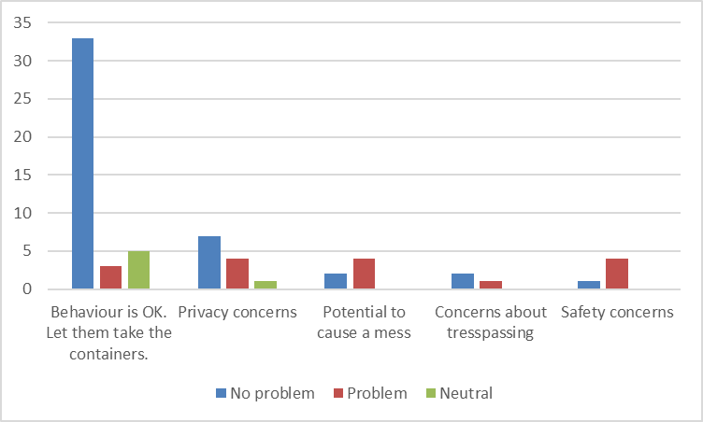

8.1b Health and safety incidents related to kerbside container management
ACT NoWaste records of Workplace Health and Safety (WHS) reports were analysed to establish whether these issues feature as policy problems for kerbside recycling. Table 4 below presents specific examples of WHS incidents which may have been caused by offences related to kerbside container management. It includes comments drawn from the records to show the types of problems being reported and the nature of the impacts involved.
The results suggest that multiple WHS incidents have likely resulted from the following three existing offences, as shown in Figure 3:
- Failure to ensure that a waste container is placed where a waste collection service has unobstructed access to the container on waste collection day (S2I(c)(ii)),
- Placing waste in a domestic waste container that is not domestic waste (S18(1)), and
- Placing waste that is not recyclable into a domestic recyclable waste container (S18(2)).
The data includes records of 40 apparent kerbside container offences having been reported over a five-year period, which is an average of about eight per year. The total number of offences is likely to have been higher as reporting is skewed towards more serious incidents involving actual harm.
The reasons for lack of enforcement action on these types of incidents differ. For incidents relating to placement of containers, a key issue is that ACT contractors cannot be authorised officers with capacity to issue infringements. They have also not been trained in gathering evidence for issuing infringements, and there are no systems in place to support them to initiate regulatory action. For offences relating to placing incorrect waste in containers, enforcement action is difficult as it is hard to identify which households are responsible for placing the wrong waste in the collections. This may be reduced in the case of future FOGO collections, as camera technology on collection vehicles could provide evidence of individual waste container composition.
Table 4 Excerpts from workplace health and safety incidents from likely kerbside container offences
Offence | Excerpt of reported incident
Obstructed location of a waste container | - Driver was reversing in a narrow area and collided with a brick wall. Damage to the brick wall was sustained.  - A driver collided with the resident’s bin and in the process of cleaning up, the resident approached the driver and started abusing him.  - Driver has tried reversing into the complex to service the RC bins onsite. Driver has not seen a low hanging awning and has damaged the sound insulation on the building.  - Collection Vehicle 726 Reversed into car on roadway during normal kerbside collections.  - Side Lift Collection Driver has attempted to service a non-presented bin. When attempting to close grab and pick bin up grab has damaged a tap.  - As driver picked up bin the bin collided with wall. Residents have previously been asked to place bins in specified areas.  - The kerbside recycling driver was collecting a waste container when two pedestrians that he had previously passed walked alongside the truck and underneath the lifter as the driver was lowering the bin. Both the pedestrian and driver required medical reviews.
Placing waste in a domestic waste container that is not domestic waste | - A small fire or 'hot-load' in a waste compartment of the domestic waste collection truck was discovered upon delivery to the landfill weighbridge. The fire was extinguished just off of the weighbridge. The load was then deposited under the spray of a water-cart in a clear and separate area of the working landfill. Plant machinery was used to rotate the waste load ensuring complete water coverage, before being covered with soil and left for 24 hours of observation. There were no further reports of re-ignition.  - Collection driver noticed smoke in his truck and found a hot load in rubbish.  - Whilst servicing residential kerbside bins, a bin was collected (address unknown) which contained Li-ion batteries. The batteries combusted inside the hopper resulting in a "hot load". Driver followed "hot load " procedure and emptied load in a suitable area.  - Something self-combusted in a 32m³ general waste bin which caused a fire to start.
Placing waste that is not recyclable into a domestic recyclable waste container | - Resident reported that someone had placed asbestos or some kind of contaminated material in her Territory provided recycling bin and when she opened it a lot of dust came out, which she breathed in and had to go to hospital due to respiratory shut down which she was quite distressed and upset about as she is pregnant.  - Syringes found in the recycling hopper that was collected.  - Driver noticed smoke coming from hopper of the recycling collection vehicle and closed blade to smoulder fire.  - Waste collection vehicle entered the Mugga Lane RMC with its load on fire contained in the back of the truck. The driver proceeded onto the main roundabout at the site entrance and unloaded the smouldering waste onto the ground. When the load was on the ground the load flared into a fire.  - Staff member was punctured by an unidentified syringe in the upper left forearm whilst moving a mattress onto the cutting table.

Figure 3 Analysis of workplace health and safety incidents caused by likely kerbside container offences, 2017-2021
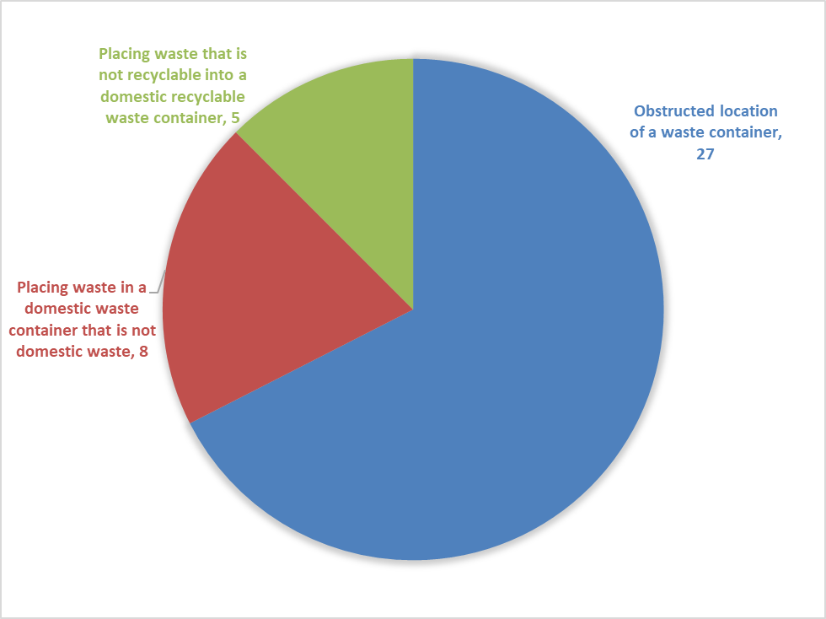

8.2 Objectives
Taking account of the above, the objectives of the amendments to Part 4 of the Regulation dealing with kerbside container management are required to:
- Clarify the responsibilities of both the Territory and occupiers, or persons living at premises so that the Regulation identifies appropriate behaviour before establishing offences,
- Support effective enforcement options to improve workplace, property and personal safety around waste collections, and
- Establish the legality of waste left on the kerb for a bulky waste collection service.

8.3 Approaches from other jurisdictions
Other jurisdictions have reported complaints about bin diving and the disturbance of containers left out for pickup. It is not uncommon for local governments to have, and to apply fines for messy bins and other issues around kerbside container management. Some examples of these include:
- In 2018, Queensland councils altered laws to introduce a potential $2,500 fine for leaving wheelie bins out on the kerb beyond 24 hours following a waste collection,
- The City of Gosnells in Western Australia passed laws in 2016 allowing on-the-spot fines for messy bins and other problems with kerbside container management, and
- Playford Council in South Australia has on-the-spot fines for illegal dumping.
There are also several posts on the internet stating and supporting that it is not illegal within Australia to place rubbish in other peoples’ bins, or to go through bins to pull out containers.

8.4 Options
The option to not make changes was considered in relation to the following proposed amendments, but rejected because of the reasons stated:
- the regulation could have remained silent on ACT government responsibilities for kerbside container management. Taking this option would have missed the opportunity to clarify that waste placed in a Territory waste container becomes the property of the Territory when placed out for a collection, and therefore that waste audits, compliance activities and other checks are authorised,
- the regulation could have remained silent on occupier responsibilities for kerbside container management. However this option would have limited the Government’s ability to emphasise the need for effective and safe operation of waste services in order to maximise waste reuse and recycling, and
- the regulation could have remained silent on waste placed on the kerbside outside of containers, for authorised waste collection services such as bulky waste pickups. However this option would have left occupiers at risk of complaints or litter offences resulting from authorised service arrangements.
Options were considered to make it illegal to go through other peoples’ bins, or to stop people from putting waste in bins left out on the kerbside. This appears to be inconsistent with the approach in other jurisdictions.

8.5 Summary of amendments
In summary, the amendments are as follows:
- the definitions of domestic and domestic recyclable waste are shifted to the Schedule, as detailed in S9.4,
- a new section has been inserted defining the Territory’s responsibilities in dealing with waste (Section 17A). This section clarifies that the waste container remains the property of the Territory and that waste placed in it for collection becomes the property of the Territory,
- a new section has been inserted defining the occupier’s responsibilities in dealing with waste (S17B). This clarifies that waste must be kept and stored safely and appropriately and disposed in a way that permits the effective and safe operation of waste re-use or collection services, and that territory waste containers must be used appropriately,
- new sections have been added clarifying that waste left out for authorised waste collection arrangements may be outside of Territory waste containers. This section allows for bulky waste collections, and
- there are multiple, minor amendments around Territory waste containers (supplied by the ACT Government), waste containers (provided by occupiers) and their lids. These allow occupiers to provide their own containers, but to manage odour and pests, it requires that such containers have lids and that the lids be kept closed. The amendments also clarify that if Territory waste containers are missing their lids, then it is not an offence for the container not be closed.
Table 5 provides a summary of the Regulation’s existing and proposed offence provisions around kerbside containers. This includes offences related to FOGO collections, as these are incorporated within the other kerbside offences. There are no new offences related to kerbside collection services, although there are two new exemptions, allowing for compostable waste to be placed in green bins to support FOGO collections, and for bulky waste to be left out for authorised waste collections.

Table 5 Offences related to kerbside waste container storage and collection
Existing offence | Max penalty units | Strict liability | Proposed offence | Max penalty (penalty units and $ amount) | Strict liability | Comment
18(1) places non-domestic waste in a domestic waste container | 5 | Yes | 14(1) places non-domestic waste in a domestic waste container | 5 ($150) | Yes
18(2) places non-domestic recyclable waste in a domestic recyclable waste container | 5 | Yes | 14(2) places non-domestic recyclable waste in a domestic recyclable waste container | 5 ($150) | Yes | Additional organic wastes are allowed to support FOGO collections, and the existing strict liability offence applies. The existing strict liability offence would support infringements for FOGO contamination.
18(3) places non garden waste in a green waste container | 5 | Yes | 14(3) places non-organic waste in a green waste container | 5 ($150) | Yes | The change allows organic non garden waste to be put into a green waste container to support the FOGO initiative.
19 Failure to keep waste in a container | 10 | Yes | 15 Failure to keep waste in a container | 10 ($150) | Yes | The proposed offence also includes an exception if the waste is left out in accordance with an authorised waste collection arrangement to enable bulky waste collections.
20 Unhygienic waste container | 10 | Yes | 16 Unhygienic waste container | 10 ($300) | Yes
21 Unsightly waste | 10 | Yes | 17 Unsightly waste | 10 ($300) | Yes
22 Waste container not closed | 10 | Yes | 18 Waste container not closed | 10 ($300) | Yes | The proposed offence contains a consequential amendment because of a change to the definition of ‘waste container’
23 Location of waste container | 10 | Yes | 19 Location of waste container | 10 ($300) | Yes | (Slight change because of definitions)

8.6 Consideration of human rights
There are no new human rights issues associated with changes to kerbside container arrangements. This is because there is a net reduction in the application of strict liability offences due to additional inclusion of compostable waste and bulky waste collections and no new offences are introduced.
The established human rights apply to this Amendment, with the right to be presumed innocent until proven guilty and the right to privacy, under section 22 (1) and section 12 of the Human Rights Act 2004 respectively.
The right to privacy is removed from kerbside container management in relation to data-gathering incidents, such as waste collection vehicles capturing contents of waste through cameras. This does not engage the right to privacy as all data captured is de-identified and captured purely for statistical purposes.
The existing strict liability offence was problematic because some elements were not completely irrefutable. For example, the existing S21 provision makes it an offence to keep unsightly waste on the premises, however, does not explain who decides whether waste is unsightly. The proposed amendments address this problem by defining the responsibilities of the Territory, and of occupiers of premises.
The amendments also provide a regulatory alternative to prosecution which is proportional to the nature of the offences, taking account of other existing, related offences for littering. Offences related to waste near residential dwellings may be regulated through either the WMRR legislation, or the Litter Act 2004 which establishes offences for depositing litter in a public place (including the kerb) which are $60 for small items and $200 for any other litter. The Litter Act also has $200 penalties for allowing litter to escape, or depositing litter in receptacles in public places that is not of size, shape, nature or volume to the receptable. The WMRR offences provide an adjunct to these litter offences as they can be applied to waste items on private land and also to waste placed inappropriately within territory waste containers. The Regulation’s penalties of $150 for failure to keep waste in Territory waste containers, and for using them incorrectly are in between the two offence amounts for littering, and therefore provide a proportional response.

8.7 Impact and cost-benefit analysis
There will be some impacts from the implementation of the amendments, however the benefits of the proposed amendments are expected to outweigh both the costs of not making amendments, and the costs associated with the amendments.
There is the potential for additional infringements to be issued due to the amendments. These would increase costs to infringed parties with resulting income to the Government.
Additional infringements are possible, for example resulting from contamination of FOGO collection services. It has been difficult to act on offences related to kerbside collections because there is no way to evidence which bin was the source of a particular contaminant, however the proposal for cameras on collection vehicles which can connect specific bin-lifts with contamination, introduce a capacity to apply infringements. While communication and education will be the first approach to dealing with contamination, infringements could follow if offences are repeated or significant.
The expected regulatory impact of the proposed changes can in part be measured in estimates of the number of infringement notices that may be expected to be issued in any given year. This is estimated at approximately 24, or two per month. It could be assumed that half may be at the five-penalty-unit rate ($150), and the other half at the 10-penalty unit rate ($300) suggesting that approximately $5,400 might be paid in infringements per year at the peak. The following factors have been considered in providing this estimate:
- issue of infringement notices would not be expected to be linear and consistent but instead to build up over the 2022-2023 and drop off afterwards. This is due to several factors including:
  - infringements would not commence immediately on regulation updates but would follow the establishment of administrative systems and an infringement notice scheme to support the work,
  - in early days, or in first instances, letters containing educational material about kerbside container offences would also be supplied prior to the issue of infringement notices and this could continue until the government is confident that people are aware of the offences, and
  - if successful in leading to greater awareness and compliance, it would be expected to drop off over time to less than the estimated amount.
- the WHS reporting includes an average of eight apparent offences per year over five years. It could be assumed that each incident of this magnitude may result in the issue of an infringement notice, and
- the proposal to photograph FOGO collections, which would enable identification of households supplying contaminated loads, combined with the importance of minimising contamination and the expected strong communication and education campaign.
Table 6 provides a summary of the expected impacts from proposed amendments to kerbside container collection services.
Table 6 Kerbside container management summary of impacts
Type of impact | Summary of impact
Benefits of amendments | - Will clarify the access rights for domestic waste containers left on the kerbside for servicing.  - Will also support effective regulation of waste segregation and access to waste containers.  - Could support later options for regulators to issue on-the-spot fines in relation to minor and clear infringements.
Impact of not making amendments | - Uncertainty will continue around responsibilities of the ACT government and occupiers of premises in relation to kerbside collection services.
Amendments which may impose some cost | - Costs associated with infringements are estimated at a potential total cost to community, and income to government peaking at $5,400 per year in about 2023 and reducing thereafter.
Amendments which will not impose any appreciable costs | - The clarification of responsibilities around kerbside collection services are not expected to result in appreciable costs.

Improving enforceability of appropriate uses of waste facilities

9.1 Problem
ACT waste facilities can be understood as a set of industrial sites in which waste is stored, sorted, processed and landfilled. Several of these sites provide for public access, and some are not staffed. In particular, the public waste facilities owned by the ACT Government and operated by contractors include two staffed Resource Management Centres (RMCs) at which householders and businesses can drop off materials for recycling, resource recovery and other sorting and waste management activities. They also include five Recycling Drop Off Centres (RDOCs) across the territory. These are unstaffed and provide options for households to drop off material which could otherwise go in yellow bins. These RMCs and RDOCs are the focus of a set of amendments intended to improve enforceability of regulations at waste facilities.
The problem is that currently there are no effective options available for enforcing appropriate behaviour by the public at these waste facilities.
The first problem is highlighted with the S13 offence for disposing of regulated waste at a waste facility and S14 offence for unauthorised conduct at a waste facility. Both offences require that a person undertaking unauthorised conduct must know that the licensee does not consent to the conduct. This is problematic, as it leaves open the option that a person dumping illegally could claim not to know that their conduct is unlawful, even if there are signs clearly displayed and other information informing them of proper conduct.
The second problem is that the Regulation does not provide the capacity for regulators to identify the ownership of vehicles through their registration numbers. This means that even if unauthorised conduct is observed through security footage, regulators have no way to respond. This is particularly problematic at the unstaffed RDOCs as there is not an opportunity for authorised officers to approach offenders and request their contact details.
These problems have apparent and obvious Workplace Health and Safety issues while placing people and property at risk at waste facilities. They also result in waste facilities being used counter to the objects of the Act, when waste that is not recyclable is placed in recycling bins, and when waste is otherwise deposited in inappropriate ways.
Evidence is presented below that these are genuine problems in relation to health, safety, reputation and loss of opportunities for waste reduction and resource recovery.

9.1a Health and safety issues from offences at waste facilities
ACT NoWaste records of WHS reports were analysed to establish whether incidents are associated with potential offences at waste facilities. Results are presented in Table 7 and Figure 4 below. The table includes comments drawn from the records to show the types of problems being reported and the nature of the impacts involved.
The results suggest that multiple WHS incidents have likely resulted from the following existing offences:
- disposal of regulated waste at a waste facility (S13),
- failure to comply with a requirement displayed on a sign at the facility (S15(c)(i)),
- interfering with waste at a waste facility (S14(b), and
- failure to comply with a reasonable direction given by the operator of a waste facility (S15(c)(iii)).
The data includes records of 32 apparent offences committed at waste facilities over a five-year period associated with WHS incidents, which is an average of about six per year. The total number of offences is likely to have been higher as reporting is skewed towards more serious incidents involving actual harm.
Table 7 Excerpts from workplace health and safety incidents from offences at facilities
Offence | Excerpt of reported incident
Disposal of regulated waste at facility | - Approximately 100 kilograms of bagged asbestos was dumped at the entrance / exit gates of the Mitchell RMC. As there are no CCTV's at the entrance/exit we were unable to ascertain who dropped the bags and at what time it occurred.  - Liquid waste placed in recycling hopper, including paint and oil. Deemed as Gros Contamination.
Failure to comply with a sign at a waste facility | - Customer entered the site after 5pm through the "out" gate coming in on the wrong side of the road. He drove onto the weighbridge and was advised that the site was closed and he would need to turn around and leave the site. He ignored this advice and drove to the push pit where he continued to dump his waste and then left without paying.  - Customer entered the site after 5pm through the "out" gate coming in on the wrong side of the road
Interfering with waste at a facility | - Batteries stolen from Site - from earthmoving equipment  - Unknown persons broke into ACT Recycling premises and stole approximately 400kg of copper
Failure to comply with a direction at a waste facility | - Customer at Weighbridge disputed costs and wanted to pay the lower fee. Staff advised customer of fees and showed signage which clearly stated the correct costs. Customer became abusive, and refused to leave. Staff called Police and Police advised customer to leave site and not attend Mugga RMC.  - Customer started abusing staff member regarding not wishing they inspect the load. The staff member told the customer it is operational procedure, so they can advise him on where to place his waste. The customer had metal in his load so he was instructed to place it in the metal pile, but the customer started unloading in the incorrect place. The customer was directed to stop and place it in the metal pile. The customer start yelling again.  - Customer refused to wait for loader to move material from the push wall. The customer then began to abuse staff member telling her to hang herself. The Contractor has sought approval to have the vehicle registration barred from site. This request has been approved.  - Customer came thought and started becoming hostile and aggressive towards the operator when she was told that she would have to pay for the excess rubbish over the 3 allowed bags designated by the government due to the strike.

Figure 4 Analysis of workplace health and safety incidents from offences at waste facilities, 2017-2021
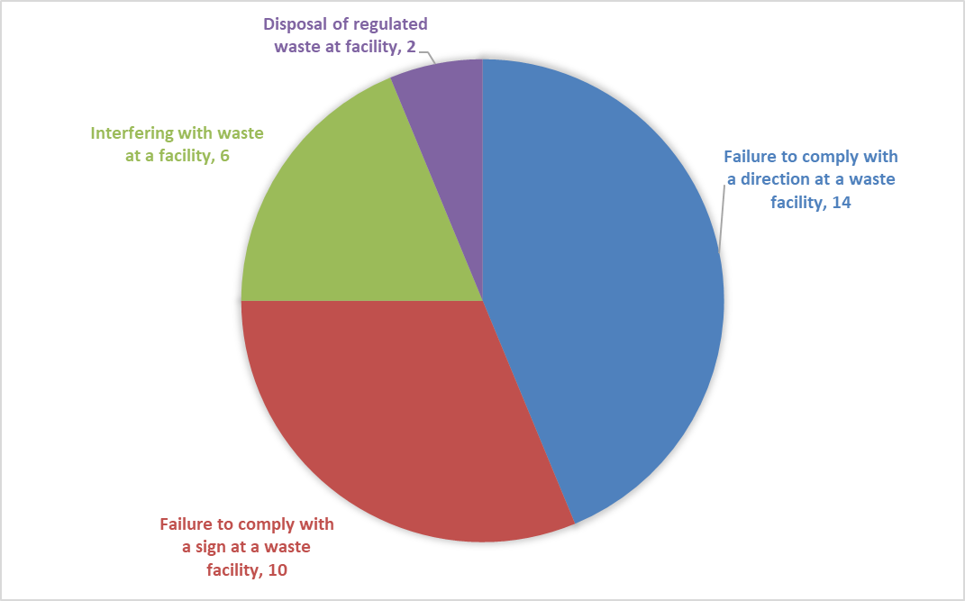

9.1b Offences at unstaffed waste facilities
An additional set of likely offences from the Regulation occur regularly at unstaffed RDOCs. These generally involve failure to comply with requirements displayed in signs, and result in contamination of recyclate and a reduced capacity for resource recovery and recycling outcomes consistent with the objects of the Act.
There are significant costs to Government associated with site clean-ups when these incidents occur, as well as reputational risks associated with Government’s provision of services which do not appear to be of a high quality. Additional impacts include litter generation and danger to people attending the sites.
The scale and frequency of these problems were investigated recently through a series of daily inspections of selected RDOCs. These were undertaken following an increase in complaints received by ACT NoWaste, which are also the subject of multiple news reports.
Inspections were undertaken daily during a four-week period and identified significant quantities of unauthorised waste, especially polystyrene, but also included stacks of regulated waste and bulky waste (furniture, bicycles and other items). Waste was also dumped outside of the recycling containers that are provided at the RDOCs. One of the RDOC sites was in a poor condition during 76% of inspections, with one or several piles of unapproved waste, and/or litter blown about. Confronted with such significant quantities of unauthorised wastes it appears that site users were encouraged to continue and to escalate unauthorised use of the site.
Some photographs showing the problem are in Figure 5 below.
Figure 5 Images of unauthorised use of waste facilities
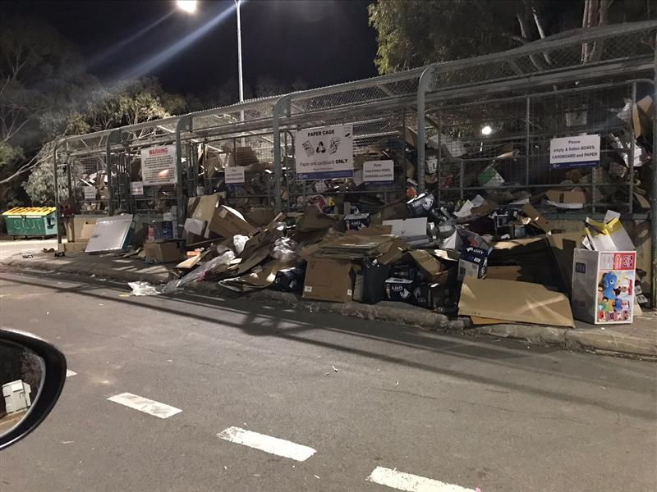 | 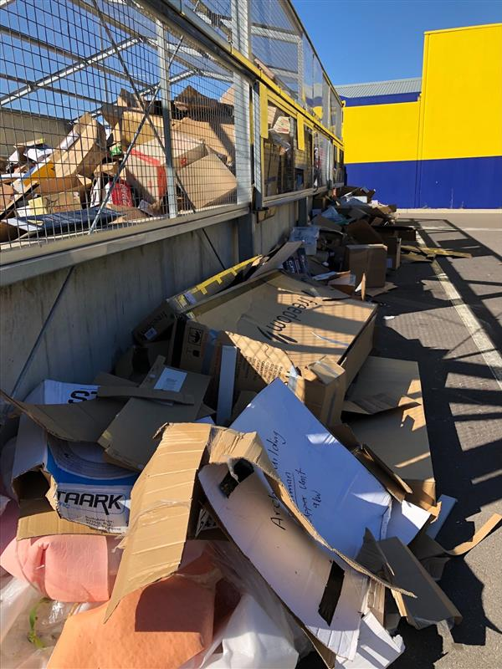
Photo 3a: Poor cardboard storage. Tuggeranong RDOC. | Photo 3b: Poor cardboard storage. Gungahlin RDOC.
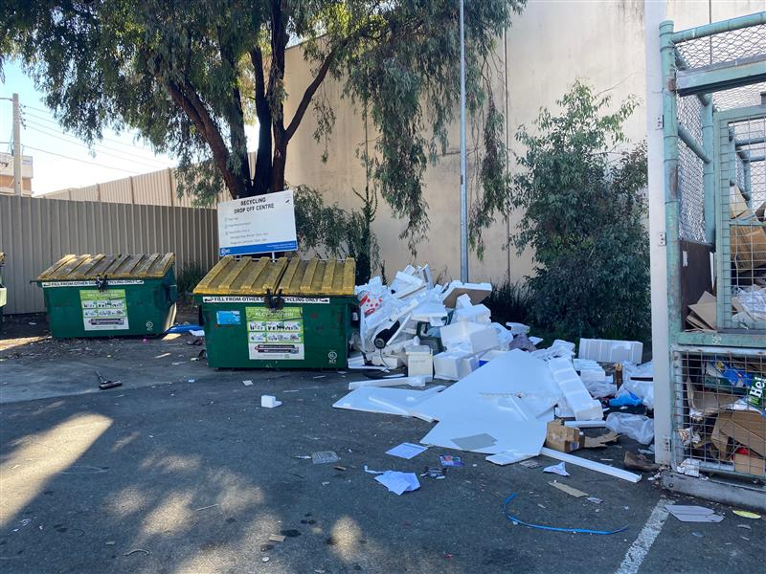 | 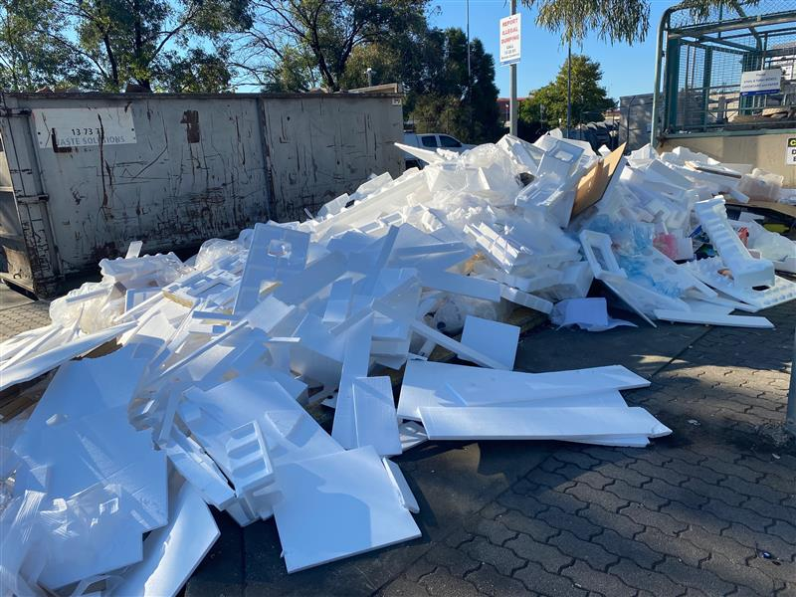
Photo 3c: Poor polystyrene pile.  Belconnen RDOC. | Photo 3d: Poor polystyrene pile.  Phillip RDOC.
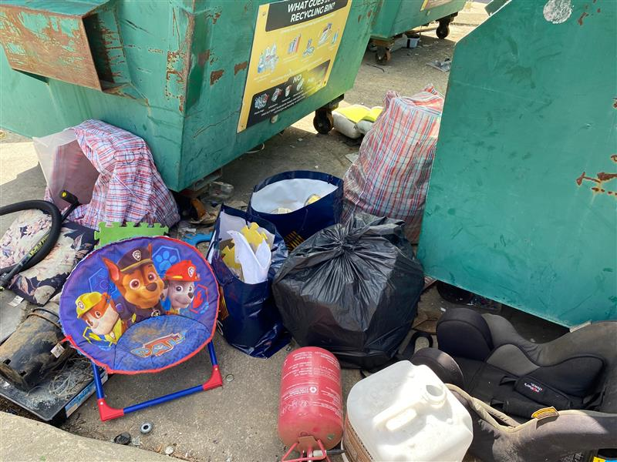 | 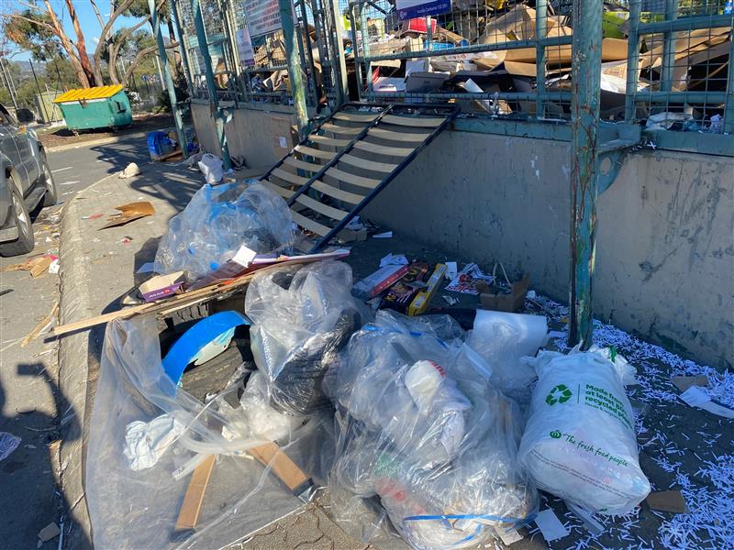
Photo 3e: Poor waste pile.  Mitchell RDOC. | Photo 3f: Poor waste pile.  Phillip RDOC.

9.2 Objectives
The objective of the amendments is to improve enforceability by:
- providing an alternative to the current and impractical requirement that regulators prove that alleged offenders know that site define appropriate use of facilities, and
- enable waste regulators to identify alleged offenders through Closed Circuit Television (CCTV) footage at unstaffed sites.

9.3 Approaches from other jurisdictions
Other jurisdictions also face difficulty enforcing appropriate behaviour at waste facilities and incur hefty clean-up costs. The Victorian Environmental Protection Authority (EPA) notes that many local governments have recorded costs of up to $100,000 per year to clean up waste that has been illegally dumped on council land, in charity bins and other public areas. The Victorian EPA provides a hotline and interactive portal to report illegal dumping .
A Victorian initiative investigating illegal dumping at charity drop-offs found that this type of illegal dumping could be reduced by introducing fending, improving signage, running public-facing information campaigns and emphasising the personal consequences, such as fines, that would result from illegal dumping. Results showed that the costs of installing these would on average be paid for by savings to waste disposal costs over about 17 months.
South Australian environmental protection legislation includes “disposal of a waste type to a council-provided bin not permitted by council for disposal” as a form of unlawful disposal. Penalties for individuals can be as high as $500,000 and for a corporate body the penalty can be as high as $2 million. Hotlines and email links are available to enable reporting of illegal dumping, however offences related to waste facilities are the responsibility of local governments, and penalties would generally be lower.
The NSW Government produced a handbook for local government for cracking down on illegal dumping in 2008. The handbook proposed a range of prevention techniques including steps for making access difficult through landscaping, lighting and barriers, increasing the risk of getting caught, through surveillance, compliance campaigns, partnerships and publicity and reducing financial rewards for illegal dumping, through fines and clean-up requirements.
The costliness of monitoring illegal waste and resulting diversion of resources from other important issues is being tackled through research into technology-driven solutions. These solutions focus on new technologies that leverage artificial intelligence, automation, internet-connected hardware and smartphones to create solutions for monitoring and enforcing illegal dumping.
All these responses are consistent with the approach being proposed for the ACT, with the focus on effective signage and greater use of surveillance technology backed up by enforceable waste legislation.

9.4 Options
The option to not make changes was considered in relation to the following proposed amendments, but rejected because of the reasons stated:
- the Regulation could have retained the S13 and 14 provisions requiring persons to know that a waste facility licence holder does not consent to disposal of waste. This was rejected because it limits the Government’s confidence in activating offence provisions and issuing infringement notices,
- alternative models for staffed RDOCs, or facilities with automated gates which close after hours have been considered as part of an ACT NoWaste Strategic Waste Infrastructure Planning Project. RDOCs are open 24 hours per day, seven days a week so the proposed options would be prohibitively expensive and/or require reduced opening hours. Staffing RDOCs is not a financially feasible option and automatic gates could result in a member of the public being locked inside. This means that unstaffed RDOCs will be a feature of the ACT for the immediate future. In this context, the proposed regulations are a much lower cost option and would only impact a minority of the community. No other options were available for enabling waste regulators to identify vehicle owners based on number plates,
- the offences could be maintained as general offences with no introduction of strict liability offences. The review of the evidence of health, safety and waste minimisation impacts of apparent offences suggests that the proposed offences pass the required tests for strict liability offences by way of the clarity around whether they are breached or not. There is also strong evidence of harm being caused due to the offences, and public outrage about problems such as illegal dumping at recycling facilities. These factors support the proposed approach of introducing strict liability offences,
- the scale of offences could have been maintained at current levels while being converted to strict liability offences. This was rejected in favour of retaining general offence provisions at the current levels, while introducing new strict liability offences at lower levels. This approach aims to ensure that the new strict liability offences do not increase the public’s level of legal risk consistent with the already established levels for maximum offences, and
- consideration was given to including a requirement for displayed signs to state that it is an offence for a person to contravene the sign. This was not included as it may not be practical for all signs at waste facilities to meet this requirement.

9.5 Summary of amendments
In summary, the proposed amendments are as follows:
- substitution of several existing offence provisions with new, tiered strict liability offences, set at lower levels to the existing offences and providing reasonable alternatives to the requirement that offenders know that the licensee objects to the offences,
- like-for-like replacement of the previous provisions requiring offenders to know that the licensee objects with alternative phrasing based on knowingly committing the offences. The scale of these offences is generally equivalent to the existing general offences, and
- one of the offences in the Regulation is proposed to be raised to a higher maximum penalty. That is the offence of knowingly disposing of regulated waste at a waste facility which does not accept regulated waste. This offence is proposed at this higher level because of the significant costs and risks that can be associated with inappropriate disposal of regulated waste.
Table 8 presents the full set of existing and proposed offences related to waste facilities.

Table 8 Division 4.4 Offences related to dealing with waste at waste facilities
Existing clause and offence | Max penalty units | Strict liability | Proposed offence | Max penalty | Strict liability | Comment
S13 Dispose of regulated waste knowing the licensee does not consent | 30 | No | 13, dispose of regulated waste at facility in contravention of a clearly visible sign | 10 ($300) | Yes | The current provision is considered un-enforceable as there is no way to prove that a the person disposing of the waste knows whether the licensee consents.  The proposed new provisions provide confidence to the Territory and clarity to people disposing of waste, that the rules of conduct at waste facilities apply so long as they are properly signposted.  Most of the proposed new offences are of lower penalty unit value than those in the current regulation, and so this does not increase exposure to regulatory risk.  The one offence which has a higher penalty unit The maximum penalty has been set at 40pu in line with the maximum allowed under the regulation-making power (Act, s 128 (2) (b)), as this is a more serious offence involving regulated waste. Please also note that this is not a strict liability offence and is therefore not suitable for an infringement notice.
 |  |  | S24AD, knowingly dispose of regulated waste at facility which doesn’t accept it | 40 (up to $6,400) | No
 |  |  | S24AE, 1-2 disposing of regulated waste in a container at a waste facility in contravention of a sign that states an offence | 20 ($600) | Yes
14 Unauthorised conduct at waste facility where the person knows the licensee doesn’t consent to the conduct |  |  | S24AE(3), remove, alter or cover a sign near a waste container without consent | 5 ($150) | Yes
 |  |  | 14(1), contaminates waste in a waste facility and makes the waste unsuitable for its intended waste processing | 10 ($300) | Yes
 |  |  | 14(2b), Removing waste from a container | 5 ($150) | Yes
 |  |  | 14(2c), Damage or alter waste container | 5 ($150) | Yes
 |  |  | 24AG, failure to comply with a direction at waste facility | 10 ($300) | Yes
15 Waste Transporter must comply with directions etc at waste facility | 10 | No | 15, Waste transporter must give information about waste being disposed of. | 10 ($300) | Yes | This new offence will ensure that waste facility operators can obtain information about material brought to them.
16 Waste escaping from a vehicle | 20 | No | 24A,I Vehicle related offences at waste facilities – certain listed offences are taken to involve a vehicle for the purpose of provision for vehicles related offences in the Magistrates Court Act |  |  | Offences relate to:  - 24AC(1) disposal of regulated waste,  - 24AE(1) or (3) Disposal of waste in contravention of a sign,  - 24AF(1), (2a), (2b) or (2c) Interfering with waste  - 24AG(1) Failure to comply with a direction.
 | 20 | No | 23G, Waste escaping from vehicle or equipment | 20 | No

9.5a Vehicle related offences
This section describes the proposed new provisions intended to enable waste regulators to connect vehicle registration numbers with their operators, to support the enforcement of offences at unstaffed waste facilities.
In accordance with S117 of the Magistrates Court Act 1930, a vehicle-related offence means an infringement notice offence that (a) involves a vehicle; and (b) is declared by regulation to be an offence to which division 3.8.3 applies.
In accordance with S131B of the Magistrates Court Act 1930, if an authorised person believes, on reasonable grounds, that a vehicle-related offence has been committed, the authorised person may serve an infringement notice for the offence on the responsible person for the vehicle at the time of the offence, or if there is more than one person responsible for the vehicle at that time, each or any of them.
In accordance with S10 of the Road Transport (General) Act 1999, a responsible person for a vehicle:
- for a registered vehicle a registered operator of the vehicle, unless the vehicle has been disposed of by the operator,
- for an unregistered vehicle to which a trader’s plate is attached, the person to whom the trader’s plate is issued under the Road Transport (Vehicle Registration) Act 1999,
- for an unregistered vehicle to which no trader’s plate is attached, a person who was last recorded as a registered operator of the vehicle, and
- for a light rail vehicle, the rail transport operator for the light rail vehicle.
The proposal in the Amendment Regulation is to use provisions for identifying the offender and issuing fines for a vehicle related offence under the Magistrates Court Act 1930. New clauses in the Amendment Regulation and the Magistrate’s Court (Waste Management and Resource Recovery Infringement Notices) Regulation 2021 will work together to introduce new vehicle related offences to apply where offences are committed in such close proximity to a vehicle that it is appropriate to use the vehicle to take enforcement action.
This includes an offence committed either near a vehicle, before entering a vehicle or after exiting a vehicle. An incidental vehicle offence is a type of vehicle related offence in which the vehicle is not actually used in the process of committing the offence, however it is in such close proximity to justify using the registration details of the vehicle to identify the offender and issue an infringement notice.
This offence is a vehicle related offence with respect to issuing an infringement notice and can only apply to strict liability offences. An example of this is where a person unloads material which is not domestic recycling material at an RDOC before entering a car and exiting the facility. In waste facilities where authorised persons are present, they would attempt to stop the person and inform them that an offence was committed. However, this provision can be used if there is no authorised officer present – such as at RDOCs, or at the RMCs, where contractors run facilities and cannot be authorised persons. In cases where a person refuses to give their name before driving off, or in these other situations where an authorised person cannot stop the offender or does not feel safe to do so.
Although dumping litter is included as an incidental vehicle offence it is intended that this is only for small items such as cigarettes that would normally be carried on a person. The situation where large items are carried in a car and then a person gets out to deposit/dump the litter would be classified as vehicle related offence and not an incidental offence because the vehicle is used to carry out an element of the offence.
The Magistrates Court Act 1930 allows infringement notices to be issued to the registered owner of a motor vehicle as determined by the registration details of the vehicle. When in control of a vehicle, a driver has responsibility for the passengers within the vehicle and their behaviour. This does not apply once the passengers are outside the vehicle. Safeguards have been introduced that only the driver of a vehicle can be issued an infringement notice under an incidental vehicle offence. This prevents a driver receiving a fine if a person drops/ deposits litter and then gets in the passenger seat before the vehicle is driven away.
While the proposed amendments will set up the capacity to act on these vehicle-related offences, it is noted that further work will be needed before the offence provisions can be applied. A separate and future process will need to be conducted to enable authorised persons under the WMRR Act to obtain access to RegoACT to conduct vehicle registration checks. This will require amendments to Memoranda of Understandings (MoU) that are in place with ACT Government Agencies and the Directorate which looks after RegoACT. There are also audits involved so arrangements will need to be made to ensure suitable processes are in place.

9.6 Consideration of human rights
It is arguable that the introduction of new strict liability offences to improve the Regulation’s enforceability at waste facilities may affect the right to equality. This is because people who cannot read signs, access the internet or otherwise become acquainted with restrictions at waste facilities may not be aware of rules before they break them. This would be particularly so if unapproved wastes are allowed to build up at waste facilities, and this is interpreted as meaning that such wastes are allowed.
- The Government has developed a strategy to counter most of these risks, making the amendments reasonable and justifiable, and therefore making it compatible with Human Rights. These include: examining options for best practice signage, including visual options to relay messages,
- many of the offences relate to instructions given by facility operators, which again do not rely on literacy but instead on listening and responding to face-to-face instructions, and
- introduction of technological solutions such as modern CCTV technology at waste facilities, combined with effective enforcement would reduce the build-up of unapproved waste in facilities, and minimise unintended messaging around which wastes were allowed.
That the proposed new vehicle offences may impinge on the HR Act’s S12 (a) provision that everyone has the right to not have their privacy interfered with unlawfully or arbitrability The Amendment Regulation proposes to introduce a new capacity for regulators to identify owners of vehicles that are identified as being involved in non-compliance at waste facilities, however the administrative arrangements required to put these provisions into action would ensure that they could only be used to obtain personal information in response to clear offences, and not for arbitrary purposes. Territory legislation including the Privacy Act 1988 and the Archives Act 1983 are applicable in regards to storing and archiving information. Policy development will provide strict requirements around what the information can be used for in-line with the offence provisions.

9.7 Impact and cost-benefit analysis
The regulatory impact of the proposed changes can in part be measured in estimates of the number of infringement notices that may be expected to be issued in any given year. This is estimated at approximately 48 per year. It could be assumed that half may be at the five-penalty-unit rate ($150), and the other half at the 10-penalty unit rate ($300) suggesting that approximately $10,800 might be paid in infringements per year at the peak. The following factors have been considered in providing this estimate:
- issue of infringement notices would not be expected to be linear and consistent but instead to build up over the 2022-2023 and drop off afterwards. This is because:
  - infringements would not commence immediately on regulation updates but would follow the establishment of administrative systems and an infringement notice scheme generally, and specific arrangements for vehicle-related offences to support the work,
  - confirmation would be needed that signage at all relevant facilities was clear and specific about expectations and offences prior to issuing any infringements, and
  - effective security camera systems would need to be installed before offences could readily be proven.
- the WHS reporting includes an average of six apparent offences per year over five years. We could assume that each incident of this magnitude may result in the issue of an infringement notice,
- inspections at RDOCs indicate that waste management offences are being committed very regularly at several facilities at present, sometimes at rates of more than one per day, and
- if successful in leading to greater awareness and compliance, the occurrence of offences and the need to issue infringements notices would be expected to drop off over time.

Table 9 Enforceability of appropriate uses of waste facilities summary of impacts
Type of impact | Summary of impact
Benefits of amendments | - The amendments establish clear waste management practices in line with expectations of members of public. This creates the ability to produce on-the-spot fines as necessary.
Impact of not making amendments | - Without the amendments, effective regulation of breaches at waste facilities is unlikely because it will be too difficult to show that offenders were aware that facility operators do not consent to inappropriate use of facilities.  - If vehicle offences are not introduced then it severely limits the government’s capacity to respond to offences committed at unstaffed facilities.
Amendments which may impose some cost | - Costs associated with infringements are estimated at a potential total cost to community, and income to government peaking at $10,800 per year in about 2023 and reducing thereafter.
Amendments which will not impose any appreciable costs | - There is no real change to the scope of the offence provisions, just additional clarity and enforceability.

Increasing flexibility for Container Deposit Scheme collection points

10.1 Problem
Division 4A of the Regulation provides for the administration of the ACT CDS. There are two clauses which currently limit the flexibility available for approving CDS collection points (locations that containers are taken for redemption of the 10c payment per container). The clauses were written prior to CDS commencement with the goal of initiating the Scheme. They reflect the start-up phase in which they were drafted rather than providing flexible options for the continuous improvement of the mature scheme. One of the clauses is inconsistent with the Act following some recent amendments.
Section 24P constrains flexibility in the mature Scheme by being overly prescriptive about the characteristics of all collection points. Its initial goal was to ensure the provision of a sufficient set of accessible collection points throughout the Territory, however now that such points have been made available, it is constraining the establishment of additional points which could meet other needs. For example, S24P(d)(i) requires that all collection points be open for at least seven hours, seven days of the week between the hours of 7am and 7pm, including on all but two public holidays. This excludes many potentially useful collection points such as those located at charity shops as their volunteer staff are not able to keep the stores open for such long hours. There are also overly prescriptive requirements for receipt of bulk deliveries, sizes of residential catchment areas, travel times from other collection points and so on.
Section 24Q implies that licences are required for all collection points which was an early expectation for the scheme but has proven to be unnecessary as many popular collection points are provided as additional services within shopping centres and charity shops. These sites are not waste facilities and do not hold waste facility licences. The Act was amended via the Planning and Environment Legislation Amendment Bill 2020 to make it explicit that collection points are not required to be licensed waste facilities. The Regulation was not amended in conjunction with the Bill and so an inconsistency has remained where the Regulation still requires evidence of a waste facility licence for collection point applications.

10.2 Objectives
The objectives of amendments are to increase flexibility in approvals for CDS collection points and remove an inconsistency between the Act and Regulation.

10.3 Approaches from other jurisdictions
Other jurisdictions have also adjusted statutory CDS provisions over time as Schemes move from start-up to mature phases.

10.4 Options and summary of amendments
The option of leaving CDS provisions as they are would continue to limit options for collection points to be established in safe and convenient locations which cannot meet the prescriptive S24P requirements for opening hours, access and other features. They would also maintain a legacy inconsistency between the Act and Regulation.
The selected option for improving S24P is to retain the full set of factors indicated there, but to express them as information to be provided to support a S24T decision about acceptance of the proposed collection point, rather than maintain each prescriptive requirement. An alternative was considered, which would have removed all detail from S24P and shift the collection point features out of the Regulation and into the contractual, Network Operator Agreement. This was rejected because waste regulators have found it helpful for the regulation to establish high expectations for access and quality of collection points.
To remove inconsistencies with the Act, the current requirement for each collection point application to provide a waste facility licence has been removed. The replacement clause requires that a waste facility licence be provided only if the collection point is required to hold one.

10.5 Consideration of human rights
The S24P requirements have been included in the Regulation to provide for good collection point access for all Canberrans. By retaining the government’s obligation to consider the full range of accessibility matters, the amendment will prevent a reduction of CDS collection point accessibility. It will also increase the potential for CDS Network Operators to continue opening small and convenient collection points which may not meet all the prescriptive requirements. In doing so, the changes will increase access to the scheme and its benefits.

10.6 Impact and cost-benefit analysis
There will be some impacts from the implementation of the amendments, however the benefits of the proposed amendments are expected to outweigh both the costs of not making amendments, and the costs associated with the amendments. Table 10 below provides the assessment.
Table 10 Container Deposit Scheme simplification summary of impacts
Type of impact | Summary of impact
Benefits of amendments | - Provides more flexibility in collection point approvals.  - Retains a focus on accessibility of collection points across the Territory.  - Removes a legacy inconsistency between the Regulation and the Act.
Impact of not making amendments | - Some convenient collection points would need to be rejected because they do not meet prescriptive requirements.  - An inconsistency would remain between the Act and Regulation.
Amendments which may impose some cost | - There are no costs associated with these amendments.
Amendments which will not impose any appreciable costs | - There are no costs associated with these amendments.

Improving and modernising waste definitions and reporting

11.1 Problems and objectives
There are several problems associated with definitions of waste which appear in the Regulation. An objective for proposed changes is associated with each of these problems as shown in Table 11 below.
Table 11 Problems and objectives in waste definitions and reporting
Problem | Objective of changes
Definitions of different types of wastes appear throughout the Regulation, making them difficult to find. | Consolidate all definitions of waste which appear in the Regulation into Schedules.
Waste categories require regular updating as technologies change in recycling facilities or reporting requirements are updated to meet the needs of the Territory or to harmonise with other jurisdictions. | Where feasible, shift waste categories into notifiable instruments to support easier updating as needed.
The list of domestic waste types is inconsistent with proposed FOGO definitions and is not clear on suitable disposal options for batteries. | Provide consistency between domestic waste definitions and the FOGO proposal. Clarify that batteries are not domestic waste, or domestic recyclable waste and should not be placed in kerbside waste containers.
The Regulation’s Schedule 1.2 Categories of waste are outdated and no longer support best practice reporting. | Update the current categories of waste to maximise its value for reporting outcomes.
The Regulation is overly prescriptive about the details needed in waste activity reports, especially in light of government plans to introduce a new on-line Waste Regulation Management System (WRMS) to streamline reporting. | Provide for the WRMS to be selected by waste reporters as an alternative to following the prescriptive reporting requirements.
Some waste reporting which is required under ACT waste legislation is unnecessary since the information already achieved through other arrangements. | Provide exemptions for waste activities that are fully achieved through other arrangements.

11.2 Approaches from other jurisdictions
Other jurisdictions generally have combined legislation for environmental protection and waste management and waste definitions at the state level reflect this. Waste definitions and reporting are generally aligned with national and international categories of hazardous, regulated and controlled wastes. The ACT Environmental Protection Act 1994 is aligned with other jurisdictions in referring directly to these waste categories for its environmental authorisations. Key sources of national waste definitions called up in environmental protection laws are include:
- Australian hazardous waste data and reporting standards, which supports Australia’s international reporting under the Basel Convention and periodic domestic reporting, and
- National Environment Protection (Movement of Controlled Waste between States and Territories) Measure 1998 which establishes a system for jurisdictions to authorise and report on cross-border movements of controlled wastes.
Between them, each jurisdiction’s environmental protection laws and these national reporting requirements provide an effective system for preventing harm and collecting information about hazardous waste movements in Australia.
In addition to these arrangements, the Commonwealth Government and all jurisdictions are actively working to improve reporting and in relation to other waste categories with a focus on waste avoidance and resource recovery. These efforts are formalised for instance in commitments within the National Waste Policy Action Plan, which has a target for making comprehensive, economy-wide and timely data publicly available to support better consumer, investment and policy decisions.
Other jurisdictions are working in parallel with the ACT to harmonise waste definitions and reporting arrangements in line with waste avoidance and resource recovery policy priorities. In particular, the new National standard for waste and resource recovery data and reporting is in draft form and contains a table of waste categories which are intended to support nationally consistent reporting of material flows, quantities, sources and management of wastes. This is aligned with the hazardous waste reporting systems already in place and with the ACT WMRR waste legislation’s objectives for waste minimisation, innovation and promotion of best practice waste management which underpin the reporting obligations. The review of waste categories completed to support this Regulation update identified the waste categories in the draft national standard as the most appropriate alternative to the current Schedule 1.1 Schedule of Waste Categories.
In relation to the WRMS, other jurisdictions are developing equivalent systems. For example, both South Australia and Victoria commenced new on-line reporting systems in July 2021 and amended their environmental protection regulations to require their use by specified waste facility operators and transporters. The ACT has been working with both of those jurisdictions in designing the WRMS and identifying appropriate reporting arrangements for local businesses.

11.3 Options
Different options were considered for the consolidation of waste categories and definitions into the Regulation’s Schedule and into separate Notifiable Instrument. An initial policy goal was to assemble all of the definitions and categories into a new Notifiable Instrument (NI) so that they would all be in one place and be easy to update as required. This was not possible because the Act specifies that CDS containers, domestic and recyclable wastes all be defined by regulation, meaning that they cannot be shifted into an NI.
Two definitions of waste categories could be shifted into NIs, including the definition of compostable material to support FOGO, and the categories of wastes to be used in reporting under the WMRR Act. The preferred option for defining compostable material is to incorporate it into a FOGO-specific NI so that there is a single instrument defining the terms of the FOGO trial, and its intended later transition into a whole-of-Canberra service. This outcome is achieved by the proposed new Waste Management and Resource Recovery (compostable material collection) Declaration 2021.
This leaves the categories of wastes that WMRR licensed facilities and registered transporters must report on as the only set of waste categories which could be shifted from the Regulation into a separate NI. This option is recommended instead of the alternative of leaving the reportable waste categories in the Regulation because there will almost certainly be an interest in updating the waste categories as the draft National standard for waste and resource recovery data is finalised, when the WRMS is introduced and as waste recovery technologies change.
The Regulation amendments could have removed the prescriptive reporting requirements which are currently provided; however this could be premature as the WRMS is not yet completed, user-tested or in use by facility operator. Retaining reporting functions which are providing some value at present provides a back-up option which will be useful in the transition to WRMS, while also encouraging the transition into WRMS once available.
No changes are required to the Regulation to provide exemptions for reporting in specific circumstances, as S67 of the Act already allows this. This regulatory package which updates the WMRR Regulation provides an opportune time to formalise the exemption applying to movements of controlled waste between jurisdictions that are completely covered by National Environment Protection (Movement of Controlled Waste between States and Territories) Measure 1998. This is achieved by the proposed updates to the existing Waste Management and Resource Recovery (Exemption) Declaration (Disallowable Instrument) (Exemption Declaration DI).
The impetus to amend the Exemption Declaration also presents an opportunity to commence another proposed amendment to that DI which exempts very small transporters who shift less than three tonnes of waste per year, other than to a landfill site. This amendment has been in draft form with the intention of exempting various community groups with CDS collections, and very small-scale composting arrangements and other similar activities which are closer to hobbies or community service than to waste management businesses.

11.4 Summary of amendments
In summary, the proposed amendments are as follows:
- Move several lists of waste categories from throughout the Regulation into the Schedule. The waste categories being shifted are those defining:
  - domestic recyclable waste,
  - domestic waste – excluded material,
  - container deposit scheme:
    - definition of beverages,
    - liquids that are not beverages,
    - definitions of containers, and
    - what is not a container.
- include a reference to FOGO waste categories in the list of domestic recyclable waste,
- include ‘batteries’ as a stand-alone item in the list of domestic waste – excluded material,
- shift the previous Schedule 1.2 categories of waste for reporting purposes into a separate, new Waste Management and Resource Recovery (Waste Categories) Determination 2021,
- update the existing Waste Management and Resource Recovery (Exemption). Declaration (Disallowable Instrument) to exempt from WMRR reporting, waste transporters whose entire waste management business operations between jurisdictions are subject to the National Environment Protection (Movement of Controlled Waste between States and Territories) Measure 1998,
- also update the Exemption Declaration DI to exempt very small waste transporters such as community groups transporting CDS material for redemption, from reporting requirements; and
- introduce a new option for waste reporting by way of the new Waste Regulation Management System, which is currently under development.
Additional commentary is needed on the proposal to list batteries specifically as a material that is excluded from domestic waste.

11.4a Batteries
Waste batteries are currently not allowed to be placed in either ACT municipal waste containers (red bins) or domestic recyclable waste containers (yellow bins). The mechanism for that ‘regulated wastes’ are excluded from both of those waste types in the Waste Management and Resource Recovery Regulation 2017 (WMRR Regulation). The current statutory pathway confirming batteries as being excluded from territory waste containers is complex and unclear.
Lithium-ion batteries and other domestic waste batteries would be excluded as ‘substances liable to spontaneous combustion’ in Table 4e of ACT’s Assessment & Classification of Liquid & Non-liquid Wastes. Because of this they are classified as hazardous wastes, which are a type of regulated waste under Schedule 1.1A of the Environmental Protection Act 1997, therefore they are already excluded as domestic waste under the Regulation.
There are significant risks of health and safety incidents associated with batteries placed in waste containers. This was shown clearly in the review of kerbside container incidents (see Table 4).
Taking this into account, the addition of ‘batteries’ to the list of excluded domestic waste aims to improve safety by clarifying an arrangement that is already in place. This addition is consistent with advice already available on the ACT Recyclopaedia, which states that batteries do not go in recycling or rubbish bins.

11.5 Human rights
There are no human rights impacts from these proposed amendments. They apply only to activities which already have obligations for waste reporting, and do not involve any additional disclosure of information.

11.6 Impact and cost-benefit analysis
There will be some impacts from the implementation of the amendments, however the benefits of the proposed amendments are expected to outweigh both the costs of not making amendments, and the costs associated with the amendments. The table below provides the assessment
Table 12 Waste activity definitions and reporting summary of impacts
Type of impact | Summary of impact
Benefits of amendments | - The proposed amendments will improve and modernise waste definitions and reporting by consolidating them into areas of legislation where they can easily be located, and updating lists to current best practice.
Impact of not making amendments | - If amendments are not made then it will inhibit a transition to reporting under the WRMS once it is developed.  - It will also generate inconsistencies between definitions of domestic recyclable waste and waste that will be allowed into the FOGO collections.  - Not making amendments will retain uncertainty the exclusion of batteries from domestic waste collections.
Amendments which may impose some cost | - There may be costs involved in businesses shifting their reporting to the new WRMS system. However by retaining existing reporting options, this transition will be allowed to be gradual, to ensure that the needs of local businesses are met.
Amendments which will not impose any appreciable costs | - Shifts in the locations of waste definitions will not impose any costs.  - Businesses will benefit from exemptions for WMRR Regulation reporting when they already report under existing arrangements focused on hazardous and controlled wastes.

Consultation statement
In late-2019, the ACT Government announced its intention to introduce a food organics and garden organics waste collection service for all ACT households by 2023, starting with a pilot program in 2021. This well publicised initiative is enabled by these amendments, but consultation on FOGO generally is outside of the scope of these regulatory changes and will be managed through separate communications activities.
Key stakeholder consultation has been undertaken with potentially impacted parties including relevant internal ACT government agencies such as:
- The Environmental Protection Authority,
- TCCS Licensing and Compliance,
- Chief Minister, Treasury, Economic Development Directorate (CMTEDD) in relation to human rights, economic and other impacts,
- Justice and Community Services in relation to human rights and offence provisions,
- NoWaste contract managers and other teams.
External consultation has been with:
- the CDS Network Operator and Scheme Coordinator,
- waste business operators including waste facility operators and waste transporters, by way of discussions held on waste reporting arrangements during site inspections and while discussing current quarterly reporting arrangements and exemptions, and
- the Battery Stewardship Council, Australian Battery Recycling Initiative and other experts confirmed that waste batteries should be excluded from domestic waste streams, including with the support of other battery experts during a recent workshop aiming to characterise battery waste.
The proposed changes to offence provisions around kerbside containers and waste facilities have not been widely promoted to the community. Communications initiatives are proposed to ensure effective public communication and education around the use of waste facilities. Additional signage at waste facilities, social media awareness campaigns and a monthly ABC radio chat are all recommended.

Summary of options
Detailed options associated with each of the groups of changes included in this package have been described above. This section presents three broad options which are presented to decision makers.
The options are:
- support,
- do nothing – retain the existing legislation as is, or
- support with amendments.
Option 1 – support
This option means that the proposed amendments are supported, and the Regulation will be introduced by November 2021, in time to support the FOGO pilot and to improve other regulatory conditions to support effective waste regulation.
Option 2 – do nothing
This option will retain the existing Regulation.
If Option 2 is pursued, the status quo will be retained and food waste will not be able to be put into green bins, constraining the government’s proposals to introduce a FOGO system. Other improvements proposed for the Regulation will not be made.
Option 3 – support with amendments
This option means that support is given to the Regulation, with amendments. This has the potential to impact the FOGO pilot or not give full effect to the other recommended changes proposed to improve capacity for effective waste regulation.

Recommended option
Option 1 is recommended and would give effect to the commitments made in FOGO election commitment, as well as improving regulatory outcomes in relation to kerbside container collections, enforceability of offences at waste facilities, increased flexibility in establishing CDS collection points, and improving and modernising waste definitions and reporting.

Overall impact analysis
Specific impacts from the implementation of the Regulation have been described for each group of amendments above. This analysis confirms that the overall costs to government and the community should the Regulation not be progressed would outweigh the costs imposed from the Regulation.
The expected regulatory impact of the proposed changes has in part been estimated through expected numbers and scales of infringement notices for offences that may be expected to be issued in any given year, related to kerbside collection services and behaviour at waste facilities. These are expected to peak at around $16,200 during the 2022-23 financial year, then reducing due to improved compliance.
There will be savings associated with an expected reduction in clean-up costs at waste facilities, and especially the Recycling Drop-off Centres.
No additional resources are being sought to support the amendments. The proposal is to use existing staffing resource allocations to establish an infringement notice scheme in the coming years. This timeline would enable the scheme’s rollout to be supported by communications campaigns which can be absorbed using existing resource, including effective public communication and education around the use of waste facilities. Updates to signage, social media awareness campaigns and a monthly ABC radio chat. Other communication will be delivered through projects for which funding is being sought separately – including FOGO educational initiatives and the Wayfinding Project.

Conclusion and recommendation
The proposed amendments to the Waste Management and Resource Recovery Regulation 2017 will provide for the introduction of a FOGO collection service, improve health and safety around kerbside collection services and waste facilities, support an increase in CDS container collection points and improve waste definitions and reporting. The amendments will improve the framework for waste regulation in the ACT and are recommended for adoption.

https://www.environment.act.gov.au/__data/assets/pdf_file/0007/576916/ACT-Waste-Strategy-Policy_access.pdf
https://s3.ap-southeast-2.amazonaws.com/hdp.au.prod.app.act-yoursay.files/8615/2575/8129/WFS_roadmap.pdf
https://www.environment.act.gov.au/__data/assets/pdf_file/0003/1414641/ACT-Climate-Change-Strategy-2019-2025.pdf/_recache
https://www.environment.gov.au/system/files/resources/4683826b-5d9f-4e65-9344-a900060915b1/files/national-food-waste-strategy.pdf
https://www.wasteauthority.wa.gov.au/images/resources/files/FOGO_session_4_presentation__Taryn_Davis.pdf
https://www.epa.nsw.gov.au/-/media/epa/corporate-site/resources/wastestrategy/20p2373-appendix-waste-resource-recovery-report-2108-19.xlsx?la=en&hash=FDCE65DFA69AA7BD854471429BB39E09F9FCFA72
https://www.epa.nsw.gov.au/-/media/epa/corporate-site/resources/wastestrategy/20p2373-appendix-waste-resource-recovery-report-2108-19.xlsx?la=en&hash=FDCE65DFA69AA7BD854471429BB39E09F9FCFA72
https://www.epa.nsw.gov.au/-/media/epa/corporate-site/resources/wastestrategy/20p2373-appendix-waste-resource-recovery-report-2108-19.xlsx?la=en&hash=FDCE65DFA69AA7BD854471429BB39E09F9FCFA72
https://www.qprc.nsw.gov.au/Waste-Environment/Waste/Resource-Recovery-and-Recycling-Programs#section-4
https://www.cityservices.act.gov.au/recycling-and-waste/single-use-plastics
https://www.wsms.act.gov.au/bins/s/request-additional-bins?addressId=a0J5m000000Rz28EAC&concession=No
https://www.facebook.com/groups/951618864874073/permalink/3903712529664677
https://www.news.com.au/lifestyle/real-life/news-life/queensland-councils-alter-law-and-potential-fine-for-residents-who-leave-their-wheelie-bins-out/news-story/43a6b44f4123a20d58efb18791272f28
https://www.perthnow.com.au/community-news/comment-news/city-of-gosnells-passes-law-allowing-fines-for-messy-bins-c-782323
https://www.playford.sa.gov.au/live/environment-and-waste/waste-management
https://www.paulsrubbish.com.au/is-it-illegal-throw-someone-elses-trash-can/#:~:text=Unfortunately%20for%20bin%20owners%2C%20stuffing,is%20generally%20considered%20super%20shady; https://www.bhg.com.au/is-it-illegal-to-go-through-rubbish-in-australia; https://www.domain.com.au/living/is-it-ever-ok-to-put-your-rubbish-in-a-neighbours-bin-20180829-h14lle-760721/.
See for example https://the-riotact.com/illegal-unsafe-dumping-at-gungahlin-recycling-centre-shocks-locals/470433.
https://www.epa.vic.gov.au/report-pollution/illegal-waste-disposal/household-information
https://www.behaviourworksaustralia.org/portfolios/tackling-the-problem-charity-dumping/
https://www.epa.sa.gov.au/environmental_info/waste_recycling/waste-management
https://www.epa.nsw.gov.au/~/media/EPA/Corporate%20Site/resources/illegaldumping/080045-illegal-dumping.ashx
https://www.insidewaste.com.au/index.php/2019/06/21/opinion-australias-80m-illegal-rubbish-dumping-issue-tackled-through-tech/
https://designawards.core77.com/Strategy-Research/107773/Behavioural-Wayfinding-Design-for-Sustainable-Resource-Recovery
https://www.environment.gov.au/system/files/resources/3b8179ea-c9ce-4b51-939c-deca12abd6a7/files/aus-hazwaste-data-reporting-standard-2019.pdf
https://www.legislation.gov.au/Details/F2012C00858
https://www.environment.gov.au/system/files/resources/5b86c9f8-074e-4d66-ab11-08bbc69da240/files/national-waste-policy-action-plan-2019.pdf
https://www.epa.sa.gov.au/environmental_info/waste_recycling/mass-balance-reporting
https://www.epa.vic.gov.au/for-business/business-forms-permits-online-tools/waste-tracker/features-of-waste-tracker
ACT’s Assessment & Classification of Liquid & Non-liquid Wastes
https://www.cityservices.act.gov.au/recyclopaedia/home
Workshop hosted on-line on 28 July 2021 by Australian Battery Recycling Initiative and Commonwealth Scientific and Industrial Research Organisation.

