

CHANGES TO OPERATING TIMES OF ELECTRONIC GAMING MACHINES
  - Regulatory Impact Assessment
Gambling and Racing Control (Code of Practice) Amendment Regulation 2026 (No 1)
SL2026-15
JUSTICE AND COMMUNITY SAFETY DIRECTORATE
July 2026

Table of Contents
CHANGES TO OPERATING TIMES OF ELECTRONIC GAMING MACHINES 1
Assessment of the consistency of the proposed law with Scrutiny of Bills Committee principles 3
Background 3
The Authorising Law 3
The problem 4
Objectives of the regulation 6
Feasible options 6
Option 1: No change – retain existing Regulation and shutdown period 7
Option 2: Encourage self-regulation by licensees to increase the shutdown period 7
Option 3: Expand the existing shutdown period so that licensees must not operate gaming machines during certain times, with shorter hours of operation permitted during the week while permitting longer hours on Friday and Saturday and into Sunday morning 8
Recommended option (option 3) 8
Impact analysis 9
Post implementation review of regulation 13

Assessment of the consistency of the proposed law with Scrutiny of Bills Committee principles
This Regulatory Impact Assessment was prepared with consideration to Part 5.2 of the Legislation Act 2001 and provides an analysis of the regulatory impact of amendments to the Gambling and Racing Control (Code of Practice) Regulation 2002 to (the Regulation), proposed through the Gambling and Racing Control (Code of Practice) Amendment Regulation 2026 (No 1) (the Amendment Regulation).
The objective of the Amendment Regulation is to extend the mandatory shutdown period of electronic gaming machines (EGMs) to address gambling harm experienced by individuals using EGMs through a harm minimisation approach which restricts EGM availability to address gambling harm from EGM usage.
This Regulatory Impact Assessment outlines the policy issue, considers the need for action, provides options to achieve the policy intent and indicates how the impact of the regulation would be measured. The assessment provides alternative options for addressing the policy problem and considers the impacts and benefits of each option.
This Regulatory Impact Assessment was prepared in accordance with Part 5.2 of the Legislation Act 2001. The Regulation will include a 12-month transition period to enable licensees to prepare for and adjust operations to comply with the extended EGM shutdown requirements.

Background
The ACT government is committed to reducing harm caused by gambling and supporting a sustainable and thriving community clubs sector in the Australian Capital Territory (ACT).
At the 2024 election, ACT Labor committed to addressing harm caused by EGMs by reducing the number of gaming machines available, alongside the introduction of mandatory harm reduction measures in licensed venues with EGMs.

The Authorising Law
The Amendment Regulation is made under the Gambling and Racing Control Act 1999.
The Amendment Regulation extends EGM shutdown periods, so that there will be shorter hours of operation permitted during the week while retaining longer hours on Friday into Sunday morning. The revised EGM shutdown periods will be:
i. 2am to 10am from Monday to Thursday (3 hours additional shutdown per day, totalling 12 hours);
ii. 2am to 9am Friday (2 hours additional shutdown);
iii. 4am to 9am Saturday (nil change); and
iv. 4am to 10am Sunday (1 hour additional shutdown).
The purpose of restricting EGM operating hours is to reduce the availability of EGMs and to provide a break from possible 24-hour gaming. The Amendment Regulation extends the shutdown period of EGMs by an additional 15 hours per week, which provides for longer breaks in play than the current shutdown of 5 hours per day. Restricting EGM operating hours is part of the Government’s harm minimisation approach to reducing gambling harm through reducing availability of EGMs and in turn, the cost and impacts of gambling for people experiencing gambling harm and those who are experiencing harm from other people’s use of EGMs such as family, friends, and the broader community.

The problem
The evidence-base supports the need for an extended shutdown period to address gambling harm experienced by individuals who use EGMs in club venues. Gambling harm and problem gambling is known to be more prevalent in the early hours of the morning. An extended shutdown period will address this prevalence of harm by reducing the hours EGMs can operate in the early hours of the morning in the ACT by providing longer breaks in EGM play.
The 2024 ACT Gambling Survey found that limiting the availability and convenience of higher-risk gambling products such as EGMs may be one of the most effective ways to reduce harm at the population level. Recent research which supports this contention found that gambling problems in Western Australia – where EGMs are restricted to a single casino – were approximately one-third lower than in other jurisdictions, largely due to reduced EGM accessibility.
The ACT currently has one of the shortest EGM shutdown periods in Australia (a 5-hour shutdown period). New South Wales, Victoria and the Northern Territory have a 6-hour shutdown period from 4am to 10am. In Tasmania, gaming and wagering must not be available in each approved venue or approved outlet for at least four continuous hours within a 24-hour period.
A 2023 study commissioned by the NSW Government’s Responsible Gambling Fund to investigate the impact of late-night EGM playing on gambling behaviour, found late-night EGM gambling was strongly linked to problematic gambling behaviour. Problematic gambling behaviours as defined in the study are those such as chasing losses, needing to gamble with larger amounts for the same feeling and those experiencing problem gambling or moderate risk of problem gambling (according to the Problem Gambling Severity Index, or PGSI).
The NSW study concluded that:
- Limiting access to venues late at night would likely reduce problem gambling risk. People who used EGMs late at night (12am-8am) made up 11.6% of all people who used EGMs, had more intense gambling participation and behaviours and were significantly more likely to be experiencing problem gambling. The later into the early hours of the morning (i.e., after 2am, and after 4am), the higher the problem gambling risk became.
- Venue closures would limit access and reduce harm for people who used EGMs late at night and people at risk of problem gambling, particularly for those experiencing problem gambling, through having a break, allowing them to reassess their spending and time gambling on EGMs.
There is a group of people who use EGMs who demonstrate more intense gambling behaviours and participation – that is, they gamble at more types of venues, gamble on EGMs more frequently, spend more money in a session, gamble more days of the week, are members of loyalty schemes across two or three venue types, and are more likely to gamble alone, and consequently, have significantly higher levels of problem gambling risk. People who have more intense gambling behaviours would benefit most from venue closures.
Figure 1: Usual EGM gambling time by problem gambling risk (PGSI)
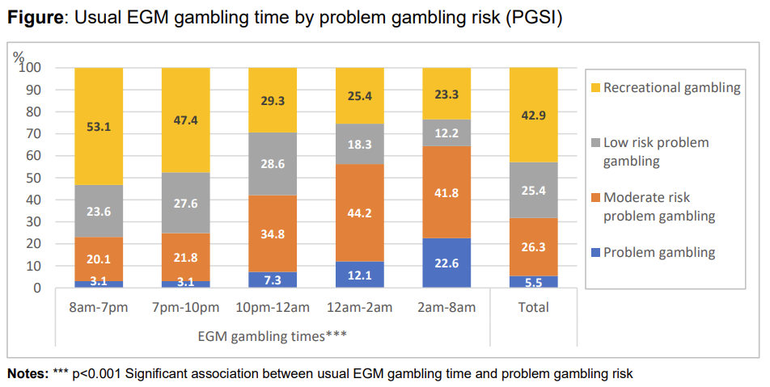
The study found that problem gambling increased significantly from later in the day, into the evening and early morning hours when people who used EGMs usually gambled. People who played EGMs after midnight were significantly more likely to be experiencing gambling harm; with over 64% of those who gambled between 2am and 8am classified as moderate risk or problem gambling.
The study also examined links between late night workers and late-night gambling. It showed that late-night EGM players were more likely to be late-night workers compared to non-late-night workers, however most late-night workers (76%) do not gamble on EGMs. There was no evidence late-night workers experienced different rates of gambling harm compared to non-late-night workers.
A 2024 review of NSW’s gaming machine hours framework cited research indicating that people gambling on EGMs after midnight (and particularly after 2am) are disproportionately at risk of problem gambling and concluded that a 6-hour shutdown period, commencing no later than 4am is effective at minimising gambling harm.

Objectives of the regulation
What is the objective of the regulation considered in this report?
The proposed regulation will address harm caused by late night gambling on EGMs in the ACT by extending the current EGM shutdown period during certain times, so that there will be shorter hours of operation permitted during weekdays while retaining longer hours on Friday and Saturday and into Sunday morning. This will limit the availability of EGMs on weekdays and provide longer breaks in play, while not disproportionately impacting licensees during weekend periods. In particular, this regulation will reduce harm for people who have more intense gambling behaviours and late-night workers who use EGMs, and more broadly, people who are affected by EGM harm such as family and friends.
How will the impact of the regulation be measured?
It is proposed that the impact of this regulation could be measured by two primary methods:
- Comparison of gambling harm prevalence relating to EGM use at the population level through the ACT Gambling Survey (a survey conducted approximately every 5 years to assist in monitoring the social and economic impacts of gambling in the ACT);
- Comparison of clubs’ reported EGM revenue to assess impacts to overall EGM usage and turnover.

Feasible options
The following feasible options have been considered:
- Option 1: No change to the Regulation – retain the existing regulation and shutdown period;
- Option 2: No change to the Regulation but encourage self-regulation by licensees to increase the shutdown period; and
- Option 3: Change the Regulation to extend the existing shutdown period so that licensees must not operate EGMs during certain times, with shorter hours of operation permitted during weekdays while retaining longer hours on Friday and Saturday and into Sunday morning.

Option 1: No change – retain existing Regulation and shutdown period
Option 1 is the base case for the proposed change as it would result in maintaining the status quo by retaining the current regulation. This would mean no change to the hours in which licensees are currently allowed to operate EGMs – i.e., an EGM shutdown period of between 4am to 9am (a five-hour shutdown period every day).
However, there are several issues raised by the continued operation of the current shutdown period. In summary, no change, would result in:
- A continued disproportionate risk of gambling harm and problem gambling for those who gamble late at night, particularly after 2am;
- A short break in EGM play (i.e. 5 hours) which limits the time for people to reassess their spending, financial losses and length of time spent gambling on EGMs.
- The ACT continuing to have one of the shortest EGM shutdown periods in Australia, along with Tasmania which has a 4-hour shutdown period.
- Additional compliance monitoring measures of the current shutdown period by Access Canberra would not achieve the policy objective of addressing gambling harm through a harm minimisation approach as more compliance oversight would not result in reduced availability of EGM use.
This option would mean:
- The continuation of the current licensee operating conditions, including the current shutdown period;
- No change in addressing gambling harm by way of a measure which extends the shutdown period to ensure a longer break in play and reduced availability of EGMs.

Option 2: Encourage self-regulation by licensees to increase the shutdown period
Option 2 would involve licensees self-regulating additional shutdown outside the current mandated EGM shutdown periods. This option would be likely to lead to inconsistent or unknown application and impact, and compliance challenges.
This option would result in:
- Inconsistent EGM shutdown periods and EGM operating times due to industry self-regulation, with no change to mandated operating times and a lack of ability to enforce non-compliance;
- Inconsistent operating hours between different licensees and club venues. For example, licensees which chose to self-regulate would have an extended shutdown period compared to licensees which did not self-regulate. Additionally, there would be no guarantee licensees would sustain self-regulation with an extended shutdown period over the long-term. There would be limited ability to monitor impact and compliance due to the voluntary nature of this option.
- The intended impact of reducing gambling harm from EGMs through an extended shutdown period would not be achieved.

Option 3: Expand the existing shutdown period so that licensees must not operate gaming machines during certain times, with shorter hours of operation permitted during the week while permitting longer hours on Friday and Saturday and into Sunday morning
Option 3 involves increasing the hours licensees must not operate EGMs during certain times. Shorter hours of operation would be permitted during weekdays while longer operating hours on Friday and Saturday and into Sunday morning would be retained. This option would result in:
- Reduced availability of EGMs through an extended shutdown period which would reduce operating hours and risk of gambling harm, in line with the Government’s harm minimisation approach. Reduced EGM operating hours during the early hours of the morning, particularly on week days, is anticipated to decrease the risk of EGM gambling harm because the later into the early hours of the morning (i.e., after 2am, and after 4am), the higher the risk of gambling harm; and
- An EGM shutdown period which matches or exceeds those in other Australian jurisdictions and demonstrates the ACT Government’s commitment to reducing the availability of EGMs which is consistent with the Government’s approach to reducing gambling harm in the Territory.
This option will mean:
- A reduction in harm associated with late night EGM gambling in line with evidence which shows there is a greater risk of gambling harm late at night, i.e. after 12am and after 2am;
- An anticipated small reduction in gaming machine tax revenue received by the Territory (Government modelling estimates the tax revenue cost to the Territory at $454k per annum, indexed and ongoing);
- Anticipated financial impacts to clubs/licensees due to a reduction in weekday EGM operating hours (Government modelling estimates the revenue cost to EGM licensees at $2.04m per annum, indexed and ongoing);
- Potential impacts to the ‘shoulder period’ in relation to EGM usage and turnover either side of the shutdown period. While these impacts are unknown, evidence shows that additional breaks in play due to longer EGM shutdown periods is likely to reduce gambling harm, particularly for those experiencing problem gambling.

Recommended option (option 3)
Option 3 is the recommended option. Changing the current regulation to extend the EGM shutdown period will deliver the intended reduction in the availability of EGMs in the Territory, and in turn, is anticipated to reduce gambling harm faced by individuals, their family, and the community. The change in regulation as proposed by Option 3 will ensure the hours EGMs are able to be used are reduced whereas Options 1 and 2 do not.
Option 3 is the most effective way to reduce operating hours of EGMs in line with the Government’s approach to harm minimisation of gambling harm as the amendment to the Regulation ensures the ACT government proactively addresses the availability of EGMs in the ACT by restricting operating hours by extending the current shutdown period.
The benefits associated with regulatory reform in line with Option 3 outweigh the anticipated financial impact from the change. Option 3 ensures licensees and the ACT club industry are appropriately supported to comply with the extended shutdown period through a 12-month transition period which has been considered through industry stakeholder consultation. The change proposed by Option 3 is similar to regulations adopted in other Australian jurisdictions by restricting availability of EGMs by mandating operating hours, and responds to evidence of the need for a more consistent approach to minimising gambling harm through restricting EGM availability.

Impact analysis
Option 3 is expected to achieve the policy objective of using a harm minimisation approach to address gambling harm experienced by people, their families and the community. It is anticipated to achieve a primary impact to the Health domain and have a secondary impact to the Economy domain. It is however noted that Option 3 is anticipated to have a higher financial impact to the Territory than other options due to an expected reduction in gambling tax revenue due to increased EGM shutdown hours, however this impact would likely be offset by a reduction in health and social costs due a reduction in gambling harm. This option is also expected to have a higher financial impact to licensees due to the possibility that EGM turnover and revenue may be reduced.
Option 2 would be expected to have a minimal or low impact in reducing gambling harm as licensee participation would be voluntary and therefore additional shutdown would be inconsistent or likely to be minimal, reducing the likelihood of achieving the intended effect of reducing gambling harm through longer EGM shutdown periods.
Option 1 would be expected to have nil impact to gambling harm and nil financial impact to the Territory or club licensees.
Overall, Option 3 is the recommended option as it will achieve the intended policy objective which is to reduce gambling harm from EGM use through restricting availability of EGMs through an extended mandatory shutdown period.
An evaluation of the expected benefits of each option against the expected costs, is summarised below:
Table 1: Overview of options analysis
Option | Expected benefit | Expected cost | Overall assessment
1 | Nil reduction in gambling harm. | Nil additional cost to the Territory or industry. | Nil cost and nil benefit.  Not recommended as no outcome would be pursued.
2 | Some reduction in gambling harm is possible, however this is expected to be unpredictable and inconsistent across venues. | Some cost to the Territory in terms of reduced EGM tax revenue expected, however extent of this impact is likely to be unpredictable. There may be some cost to industry, however, industry is expected to be unlikely to engage in this if it significantly disrupts business operations and revenue. | Unpredictable cost and benefit are expected, however, both are unlikely to be high.  Not recommended as outcomes are unpredictable and likely to be inconsistent across the ACT.
3 | Significant reduction in gambling harm is expected, noting the shutdown will limit gambling participation consistently across the ACT at a time which evidence demonstrates entails high risk of harm. | There will be some cost to the Territory in terms of lost tax revenue and some cost to industry in terms of lost revenue. These costs can be predicted, although with some uncertainties around possible downstream offsets in support service expenditure and around business operational responses to the regulation. Cost is expected to be $454k to the Territory and $2.04m across all EGM licensees annually. | Low cost to Government and industry expected, and high benefit in terms of reduction in gambling harm.  Recommended option as most likely to achieve an effective balance of cost and benefit.
Gambling harm impact evidence base Gambling harm can include financial harm and extend to psychological, emotional, and social harm, both for consumers of gambling products, the people around them, and the broader community. Major harms to individuals using EGMs may include relationship and family breakdown, financial losses and emotional and psychological suffering which also extends beyond the person who gambles.
Impacts such as psychosocial impacts can be challenging to quantify as they generally extend beyond the individual who gambles, including to their families and the wider community. A 2016 study on the types of gambling harms and their prevalence in Australia found that harms to relationships (25%), health (21%), and emotional/psychological wellbeing (19%) accounted for the greatest share of gambling-related harm. Additionally, gambling harm occurs on a spectrum and is not always proportionate to the amount of gambling participation or spending losses.
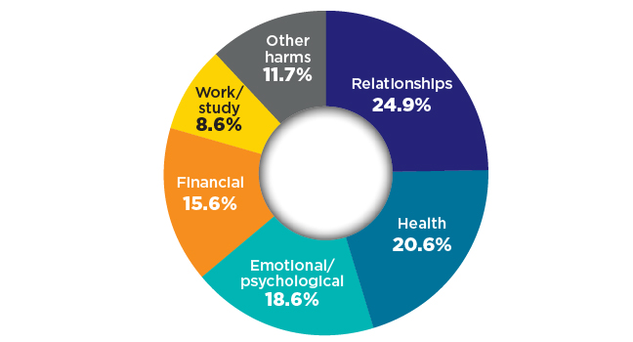
Figure 2: A breakdown of the types of gambling harms and an estimate of their prevalence in Australia

Screening for gambling harm using questions and scales can help identify if someone is experiencing or is at risk of experiencing gambling harm. Such qualitative methods are considered an acceptable strategy for health and community practitioners to determine if harms are in fact gambling related. The Problem Gambling Severity Index (PGSI) is one commonly utilised assessment tool for measuring at-risk gambling behaviours. The PGSI includes 9 questions asking respondents to rate their experiences related to gambling on a scale ranging from never (0), sometimes (1), most of the time (2) and almost always (3). Scores are then summed for a total of between 0 and 27 and respondents are grouped into the following categories:
- Non-problem gambling (0)
- Low-risk gambling (1–2)
- Moderate-risk gambling (3–7)
- Problem gambling (8+).
Research shows that people gambling on EGMs after midnight (and particularly after 2am) are disproportionately at risk of harm from gambling. One indicator of problem gambling is spending more money in a session. The ACT government has determined that an extended shutdown period of EGMs in the ACT will likely lead to a decrease in spending for players by risk level and a decrease in gross gaming machine revenue for licensees, and in turn, a decrease in gaming machine tax received by the Territory. The National Gambling Trends Study conducted in 2022 observed that participants considered at risk of gambling harm spent considerably more money on electronic gaming machines per month, $500, when compared to participants not at risk, who spent $125.
An ACT study confirmed the national findings referred to above and found that the mean net expenditure on EGMs increased across levels of problem gambling from non-problem (mean $94) to problem ($4,406). The table below demonstrates that 63.1% of money lost on EGMs came from individuals who had at least some problem gambling behaviours (i.e., scored at least +1 on the PGSI).

Table 2: Capped net expenditure on EGMs in the last 12 months by level of problem gambling
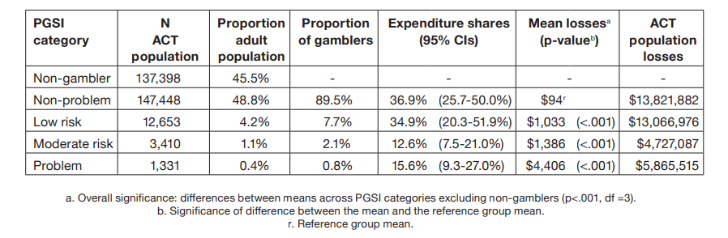
A 2024 review of the NSW shutdown hours framework analysed gambling turnover for venues with a shutdown variation (i.e., venues that remained open during the standard shutdown of 4am to 10am). The analysis found that 97% of gambling turnover was generated outside of the standard shutdown hours. More specifically, only 2.6% of gambling turnover was generated between the hours of 4am and 10am. This evidence provides important context in relation to the financial implications club venues in the ACT may experience due to the proposed extension of the EGM shutdown period, and the likely reduction in harm it may achieve. Based on the NSW evidence it is likely that in the ACT there will be a minor reduction to gross gaming machine revenue, and in turn, a minor reduction in gaming machine tax received by the Territory. Gaming machine tax is payable in relation to the gross revenue from the operation of EGMs.
The Review of the ACT Government’s Harm Minimisation Measures considered the effects of a mandated 3-hour shutdown of EGMs each day. This initial shutdown period in the ACT was reviewed in 2005 following its implementation 4 years prior. The report highlighted that the majority of shutdown clubs reported impacted their gaming revenue and total revenue, with losses estimated to be ranging from 3-10%. The below table summarises data captured from interviews with club managers from 13 different club venues affected by the shutdown. Impacts related to gaming and non-gaming revenue, staffing and other costs and gaming patrons and non-gaming patrons were assessed. The biggest impacts seen by club managers were a decrease of gaming revenue, gaming patrons and non-gaming patrons equally.
Table 3: Impacts of the 3-hour shutdown
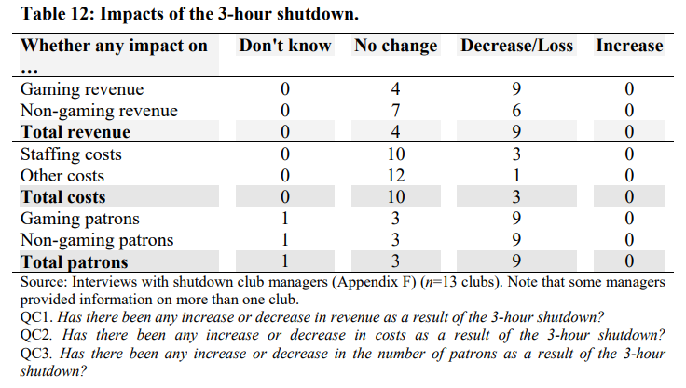
The evidence presented above provides a clear indicator of the likely impacts to club licensees from the proposed change to extend the shutdown period of EGMs.

Post implementation review of regulation
The proposed change to clubs’ EGM operating hours will be monitored by Access Canberra’s compliance monitoring program. Additional compliance activities by Access Canberra such as monitoring licensee implementation of and adherence to the extended shutdown is not expected to have a resourcing impact to Access Canberra.
JACS will work with Access Canberra on the timing of implementation of the extended shutdown period. The ACT Government will develop a compliance review framework to monitor compliance. The compliance review framework may involve enforcement activities, long-term monitoring strategies and evaluation of licensee compliance with the reform.
Financial impacts will be monitored through EGM gross gaming machine revenue reported by clubs. The regulation change should be classified as a contributing factor rather than a causal factor of any difference in gross gaming machine revenue and gaming machine tax.
As mentioned in this impact assessment, the full health and social impact of this regulation is difficult to quantify due to the complex nature and effects of gambling harm, however there is substantial evidence indicating that limiting access to EGMs reduces problem gambling risk. Impacts in reduction of gambling harm could be measured through the ACT Gambling Survey. The survey provides data such as spending by risk level and other quantitative data relevant for analysis of impacts of EGM gambling harm. The survey is conducted approximately every 5 years, with the next survey anticipated in 2029. Additional data could also be sought through ACT gambling harm support services.
External factors such as licensee planning and development projects, surrender and trade of EGMs, and social attitudinal shifts towards gambling may also influence EGM use, revenue and changes in levels of gambling harm. Additionally, a number of gambling harm minimisation measures are expected to be introduced which may impact EGM usage and revenue, for example, mandatory reduction of the number of EGM authorisations in the Territory and the introduction of mandatory account-based gaming in all venues which operate EGMs.

Gambling and Racing Control (Code of Practice) Regulation 2002 (ACT) s 1.27B.
Explanatory Statement, Gaming Machine Regulations 2004 (ACT). <https://www.legislation.act.gov.au/View/GetHTMLFile/es/db_13774/20040730-15656/html/db_13774.html>.
Russell AMT, Browne M, Hing N, Rockloff M, Newall P, Dowling NA, Merkouris S, King DL, Stevens M, Salonen AH, Breen H, Greer N, Thorne HB, Visintin T, Rawat V, Woo L. Electronic gaming machine accessibility and gambling problems: A natural policy experiment. J Behav Addict. 2023 Aug 18;12(3):721-732. doi: 10.1556/2006.2023.00044. PMID: 37594879; PMCID: PMC10562817.
M Stevens and Roy Morgan Research, Impact of electronic gaming machine (EGM) late night play on EGM player behaviours (Report, Commissioned by the NSW Responsible Gambling Fund, February 2023) <https://www.liquorandgaming.nsw.gov.au/__data/assets/pdf_file/0016/1140037/impact-of-electronic-gaming-machine-late-night-play-on-egm-player-behaviours-may-2023.pdf>. The broad aims of the study were to investigate the impact of EGM late-night gambling on gambling behaviours, associations with problem gambling risk and harms, and characterise the profile of those engaging in late-night play to better inform decision making and policy development. The study surveyed 625 participants and carried out statistical analyses (weighted to the age, sex, late-night worker status and problem gambling profile of the population who use EGMs).
Ibid.
Ibid 17.
Ibid 17, 18.
Ibid 18.
Ibid 13.
Ibid 13.
Ibid 68, 69.
Liquor & Gaming NSW, Review of Gaming Machine Shutdown Hours Framework (Report, August 2024) 19. <https://www.liquorandgaming.nsw.gov.au/__data/assets/pdf_file/0008/1350647/review-of-gaming-machine-shutdown-hours-framework-report.pdf>.
M Browne et al, Assessing gambling-related harm in Victoria: A public health perspective (Report, Melbourne: Victorian Responsible Gambling Foundation, 2016) <https://responsiblegambling.vic.gov.au/resources/publications/assessing-gambling-related-harm-in-victoria-a-public-health-perspective-69/>.
Ibid 136.
L Blank et al, ‘Should screening for risk of gambling-related harm be undertaken in health, care and support settings? A systematic review of the international evidence’ (Research Paper 16:35/2021, Addiction Science and Clinical Practice) <doi:10.1186/s13722-021-00243-9>.
M Stevens and Roy Morgan Research, Impact of electronic gaming machine (EGM) late night play on EGM player behaviours (Report, Commissioned by the NSW Responsible Gambling Fund, February 2023) <https://www.liquorandgaming.nsw.gov.au/__data/assets/pdf_file/0016/1140037/impact-of-electronic-gaming-machine-late-night-play-on-egm-player-behaviours-may-2023.pdf>.
N Greer et al, Regular pokies gambling in Australia, 2022: National Gambling Trends Study (Report, Australian Gambling Research Centre, Australian Institute of Family Studies, 2023) <ISBN:978-1-76016-297-9>.
T Davidson et al, Gambling Expenditure in the ACT (2014): By level of problem gambling, type of activity, and socioeconomic and demographic characteristics, (Report, Commission by the ACT Gambling and Racing Commission, June 2026) 27-28 < https://www.gamblingandracing.act.gov.au/__data/assets/pdf_file/0010/982774/2014-Gambling-Expenditure.pdf>
Ibid 28.
Liquor & Gaming NSW, Review of Gaming Machine Shutdown Hours Framework (Report, August 2024) 15. <https://www.liquorandgaming.nsw.gov.au/__data/assets/pdf_file/0008/1350647/review-of-gaming-machine-shutdown-hours-framework-report.pdf>.
Ibid.
J McMillen and S Pitt, Review of the ACT’s Government’s Harm Minimisation Measures (Report, ANU Centre for Gambling Research, Commissioned by the ACT Gambling and Racing Commission, March 2005) <https://www.gamblingandracing.act.gov.au/__data/assets/pdf_file/0003/745059/Review-of-the-ACT-Governments-Harm-Minimisation-Measures.pdf>.
Ibid 82.

