
Australian Capital Territory
Nature Conservation Regulation 2015
SL2015-23
made under the
Nature Conservation Act 2014
Republication No 2
Effective: 23 February 2017 – 13 May 2021
Republication date: 23 February 2017
Last amendment made by A2017-3

About this republication
The republished law
This is a republication of the Nature Conservation Regulation 2015, made under the Nature Conservation Act 2014 (including any amendment made under the Legislation Act 2001, part 11.3 (Editorial changes)) as in force on 23 February 2017. It also includes any commencement, amendment, repeal or expiry affecting this republished law to 23 February 2017.
The legislation history and amendment history of the republished law are set out in endnotes 3 and 4.
Kinds of republications
The Parliamentary Counsel’s Office prepares 2 kinds of republications of ACT laws (see the ACT legislation register at www.legislation.act.gov.au):
- authorised republications to which the Legislation Act 2001 applies
- unauthorised republications.
The status of this republication appears on the bottom of each page.
Editorial changes
The Legislation Act 2001, part 11.3 authorises the Parliamentary Counsel to make editorial amendments and other changes of a formal nature when preparing a law for republication. Editorial changes do not change the effect of the law, but have effect as if they had been made by an Act commencing on the republication date (see Legislation Act 2001, s 115 and s 117). The changes are made if the Parliamentary Counsel considers they are desirable to bring the law into line, or more closely into line, with current legislative drafting practice.
This republication does not include amendments made under part 11.3 (see endnote 1).
Uncommenced provisions and amendments
If a provision of the republished law has not commenced, the symbol U appears immediately before the provision heading. Any uncommenced amendments that affect this republished law are accessible on the ACT legislation register (www.legislation.act.gov.au). For more information, see the home page for this law on the register.
Modifications
If a provision of the republished law is affected by a current modification, the symbol M appears immediately before the provision heading. The text of the modifying provision appears in the endnotes. For the legal status of modifications, see the Legislation Act 2001, section 95.
Penalties
At the republication date, the value of a penalty unit for an offence against this law is $150 for an individual and $750 for a corporation (see Legislation Act 2001, s 133).

Australian Capital Territory
Nature Conservation Regulation 2015
made under the
Nature Conservation Act 2014

Contents
Page
Part 1 Preliminary
1 Name of regulation 2
3 Dictionary 2
4 Notes 2
Part 2 Reserves—management planning
5 What is a reserve?—Act, s 169 (1), def reserve, par (b) (ii) 3
Part 3 Nature conservation licences
6 Suitability information about a person—Act, s 266, def suitability information, par (e) 4
7 Unsuitable activities for a licence—Act, s 268 (1), def suitable activity, par (b) 4
8 Suitability information about an activity—Act, s 269, def suitability information, par (e) 5
9 Conditions—clearing native vegetation in a reserve—Act, s 274 (a) 6
10 Conditions—damaging land in a reserve—Act, s 274 (a) 6
11 Conditions—keeping an animal for public display—Act, s 274 (a) 6
12 Records—licence to keep animals—Act, s 306 (1) (c) and (2) (c) 7
13 Records—licence to keep live fish—Act, s 306 (1) (c) and (2) (c) 8
14 Records—licence to sell or export native plant—Act, s 306 (1) (c) and (2) (c) 8
15 Records—licence to sell or export protected invertebrate—Act, s 306 (1) (c) and (2) (c) 9
Schedule 1 Reserves 10
Part 1.1 Special purpose reserves 10
Part 1.2 Special purpose reserve maps 12
Division 1.2.1 Birrigai 12
Division 1.2.2 Blue Ridge Special Purpose Reserve 13
Division 1.2.3 Bullen Range North Special Purpose Reserve 14
Division 1.2.4 Bullen Range South Special Purpose Reserve 15
Division 1.2.5 Bullen Range Special Purpose Reserve 16
Division 1.2.6 Cotter Reserve 17
Division 1.2.7 Gibraltar Special Purpose Reserve 18
Division 1.2.8 Kambah Pool Recreation Area 19
Division 1.2.9 Molonglo River Reserve 20
Division 1.2.10 Namadgi Special Purpose Reserve 21
Division 1.2.11 Pine Island and Point Hut to Tharwa Bridge 22
Division 1.2.12 Sherwood Forest Special Purpose Reserve 23
Division 1.2.13 Stony Creek Special Purpose Reserve 24
Division 1.2.14 Tidbinbilla Special Purpose Reserve and Jedbinbilla 25
Division 1.2.15 Uriarra Crossing Recreation Area 26
Division 1.2.16 Woodstock West Special Purpose Reserve 27
Dictionary 28
Endnotes
1 About the endnotes 29
2 Abbreviation key 29
3 Legislation history 30
4 Amendment history 30
5 Earlier republications 31

Australian Capital Territory
Nature Conservation Regulation 2015

made under the
Nature Conservation Act 2014

Part 1 Preliminary

1 Name of regulation
This regulation is the Nature Conservation Regulation 2015.

3 Dictionary
The dictionary at the end of this regulation is part of this regulation.

4 Notes
A note included in this regulation is explanatory and is not part of this regulation.
Note See the Legislation Act, s 127 (1), (4) and (5) for the legal status of notes.

Part 2 Reserves—management planning

5 What is a reserve?—Act, s 169 (1), def reserve, par (b) (ii)

(1) The special purpose reserves mentioned in schedule 1, part 1.1 and outlined in bold in schedule 1, part 1.2 are prescribed.

(2) In this section:
special purpose reserve means an area of public land reserved in the territory plan as a special purpose reserve under the Planning and Development Act 2007, section 315 (d).

Part 3 Nature conservation licences

6 Suitability information about a person—Act, s 266, def suitability information, par (e)
The following matters are prescribed:

(a) the person’s qualifications, training, knowledge and experience in carrying out the activity for the licence;

(b) if the activity for the licence involves a native species that has special protection status, or is a protected native species, and the purpose of the activity is—

(i) scientific research, education, or propagation of the species—the person’s association with relevant scientific research organisations; or

(ii) practice of Aboriginal tradition—the person’s membership of the Aboriginal community in the ACT or surrounding region.

7 Unsuitable activities for a licence—Act, s 268 (1), def suitable activity, par (b)
An activity that would constitute an offence under 1 or more of the following provisions of the Act is prescribed:

(a) section 144 (Offence—damage native tree—unleased land) if the tree is in a wilderness area;

(b) section 146 (Offence—damage or take fallen native timber) if the timber is in a wilderness area;

(c) section 149 (Offence—sell native plant without plant tag—protected or special protection status);

(d) section 152 (Offence—export plant without plant tag—protected or special protection status);

(e) section 223 (Offence—make road in wilderness area);

(f) section 224 (Offence—use motor vehicle off road in wilderness area);

(g) section 225 (Offence—excavate in wilderness area without licence) if the excavation is for a purpose other than archaeological investigation;

(h) section 364 (Offences—use or divulge protected information).

8 Suitability information about an activity—Act, s 269, def suitability information, par (e)
The following matters are prescribed:

(a) if the activity involves killing a native animal—

(i) how the animal is to be killed; and

(ii) how the carcass is to be disposed of;

(b) if the activity involves taking a native animal—how the animal is to be taken;

(c) if the activity involves keeping a native animal—the facilities and care procedures at the place where the animal is to be kept;
Note The conservator may inspect the place under the Act, s 272.

(d) if the activity involves selling a native animal—whether the animal was raised in captivity;

(e) if the activity involves importing or exporting an animal—how the animal is to be transported;

(f) if the activity involves releasing an animal from captivity—

(i) any genetic characteristics of the animal that indicate whether the animal was bred in captivity; and

(ii) whether the animal is free from disease;

(g) if the activity involves excavating in a wilderness area for archaeological investigation—

(i) the objectives of the investigation; and

(ii) the expected contribution of the investigation to the understanding of Aboriginal prehistory or Australian history in general;

(h) if the purpose of the activity is scientific research—details of the scientific research.

9 Conditions—clearing native vegetation in a reserve—Act, s 274 (a)
A licence authorising the clearing of native vegetation in a reserve is subject to the condition that the licensee must tell the conservator before starting to clear the native vegetation.

10 Conditions—damaging land in a reserve—Act, s 274 (a)
A licence authorising the damaging of land in a reserve is subject to the condition that the licensee must tell the conservator before starting to damage the land.

11 Conditions—keeping an animal for public display—Act, s 274 (a)
A licence authorising the keeping of an animal for public display is subject to the condition that the licensee must comply with a risk management plan approved by the conservator for the licence.

12 Records—licence to keep animals—Act, s 306 (1) (c) and (2) (c)

(1) This section applies to a licence to keep an animal that is not a live fish.

(2) The licensee must keep a record of—

(a) the total number of animals kept under the licence; and

(b) the species and sex of each animal kept under the licence.

(3) In addition, the licensee must also keep a record of—

(a) if an animal is acquired from another person—

(i) the name and address of the other person; and

(ii) the date of receipt of the acquired animal; and

(iii) the species and sex of the acquired animal; and

(b) for an animal that dies or escapes from captivity—

(i) the date of death or escape; and

(ii) the species and sex of the deceased or escaped animal; and

(c) for an animal that is transferred, whether because of a sale or otherwise, to another person—

(i) the name and address of the person receiving the animal; and

(ii) the date of transfer; and

(iii) the species and sex of the transferred animal.

(4) However, a person need not keep a record of the sex of an animal if it is not possible to ascertain without handling the animal.

13 Records—licence to keep live fish—Act, s 306 (1) (c) and (2) (c)

(1) A licensee who is authorised under the licence to keep live fish must keep a record of the species of each fish kept under the licence.

(2) In addition, the licensee must also keep a record of—

(a) for live fish acquired from another person—

(i) the name and address of the other person; and

(ii) the date of receipt of the acquired fish; and

(iii) the species of the acquired fish; and

(b) for live fish transferred, whether because of a sale or otherwise, to another person—

(i) the name and address of the person receiving the fish; and

(ii) the date of transfer; and

(iii) the species of the transferred fish; and

(c) for live fish exported from the ACT by the licensee—

(i) the name and address of the person receiving the fish; and

(ii) the date of export; and

(iii) the species of the exported fish.

14 Records—licence to sell or export native plant—Act, s 306 (1) (c) and (2) (c)

(1) This section applies to a licensee who is authorised under the licence to—

(a) sell a native plant; or
Note Sell includes offer for sale (see Act, s 126).

(b) export a native plant from the ACT.

(2) The licensee must keep a record of the following details for each plant sold, or exported, under the licence:

(a) the name and address of the person receiving the plant;

(b) the date when the plant was sold or exported;

(c) the species of the plant sold or exported.

(3) The licensee must also keep a record of the total number of plants sold, or exported, under the licence.

15 Records—licence to sell or export protected invertebrate—Act, s 306 (1) (c) and (2) (c)

(1) This section applies to a licensee who is authorised under the licence to—

(a) sell an invertebrate that—

(i) has special protection status; or

(ii) is a protected native species; or
Note Sell includes offer for sale (see Act, s 126).

(b) export from the ACT an invertebrate that—

(i) has special protection status; or

(ii) is a protected native species.

(2) The licensee must keep a record of the following details for each invertebrate sold, or exported, under the licence:

(a) the name and address of the person receiving the invertebrate;

(b) the date when the invertebrate was sold or exported;

(c) the species of invertebrate sold or exported.

(3) The licensee must also keep a record of the total number of invertebrates sold, or exported, under the licence.

Schedule 1 Reserves
(see s 5)

Part 1.1 Special purpose reserves

column 1  item | column 2  map and location | column 3  district
1 | map 1—Birrigai | Paddys River
2 | map 2—Blue Ridge Special Purpose Reserve | Coree
3 | map 3—Bullen Range North Special Purpose Reserve | Stromlo
4 | map 4—Bullen Range South Special Purpose Reserve | Tuggeranong
5 | map 5—Bullen Range Special Purpose Reserve | Stromlo
6 | map 6—Cotter Reserve | • Coree  • Paddys River  • Stromlo
7 | map 7—Gibraltar Special Purpose Reserve | Paddys River
8 | map 8—Kambah Pool Recreation Area | Paddys River
9 | map 9—Molonglo River Reserve | Molonglo Valley
10 | map 10—Namadgi Special Purpose Reserve | Tennent
11 | map 11—Pine Island and Point Hut to Tharwa Bridge | Tuggeranong
12 | map 12—Sherwood Forest Special Purpose Reserve | Coree
13 | map 13— Stony Creek Special Purpose Reserve | Stromlo
14 | map 14—Tidbinbilla Special Purpose Reserve and Jedbinbilla | Paddys River
15 | map 15—Uriarra Crossing Recreation Area | • Coree  • Stromlo
16 | map 16—Woodstock West Special Purpose Reserve | • Stromlo

Part 1.2 Special purpose reserve maps

Division 1.2.1 Birrigai

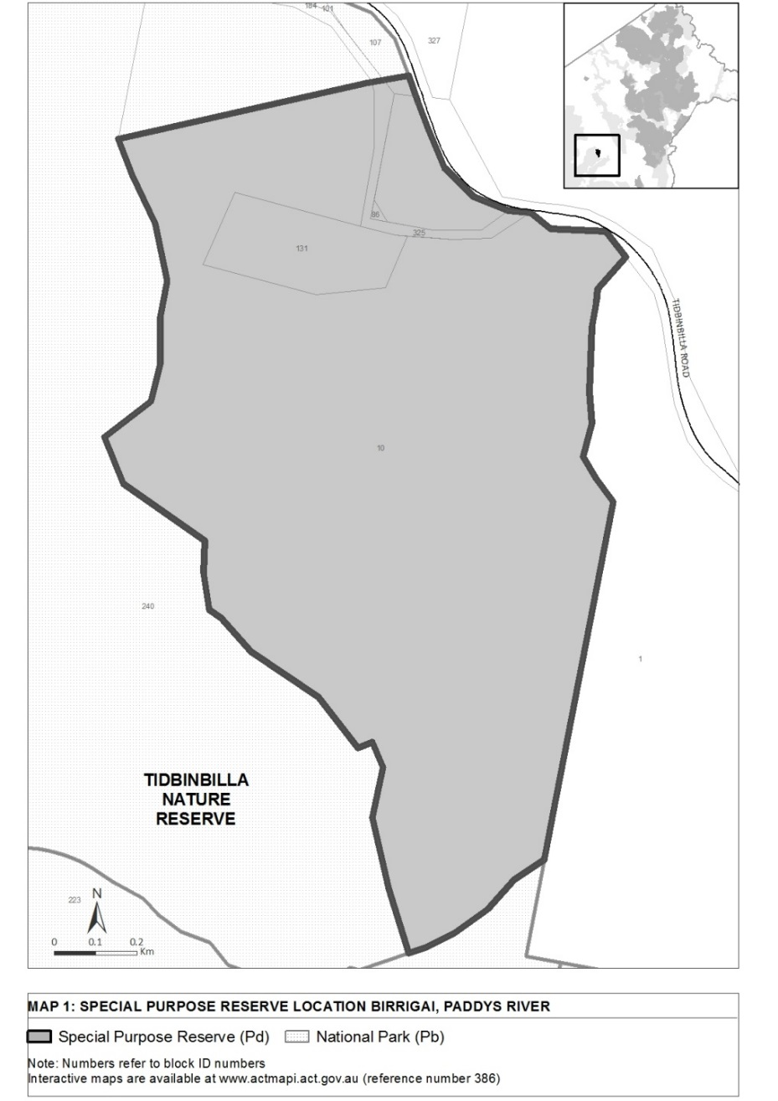

Division 1.2.2 Blue Ridge Special Purpose Reserve

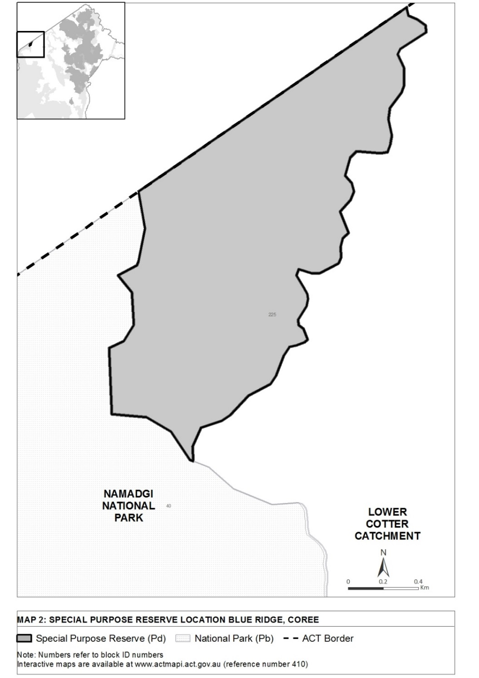

Division 1.2.3 Bullen Range North Special Purpose Reserve

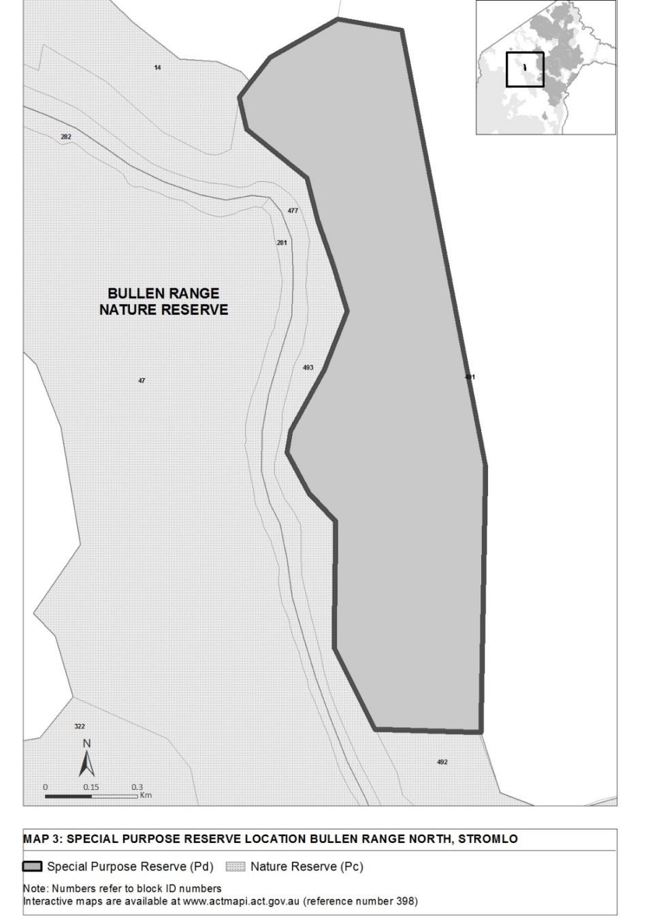

Division 1.2.4 Bullen Range South Special Purpose Reserve

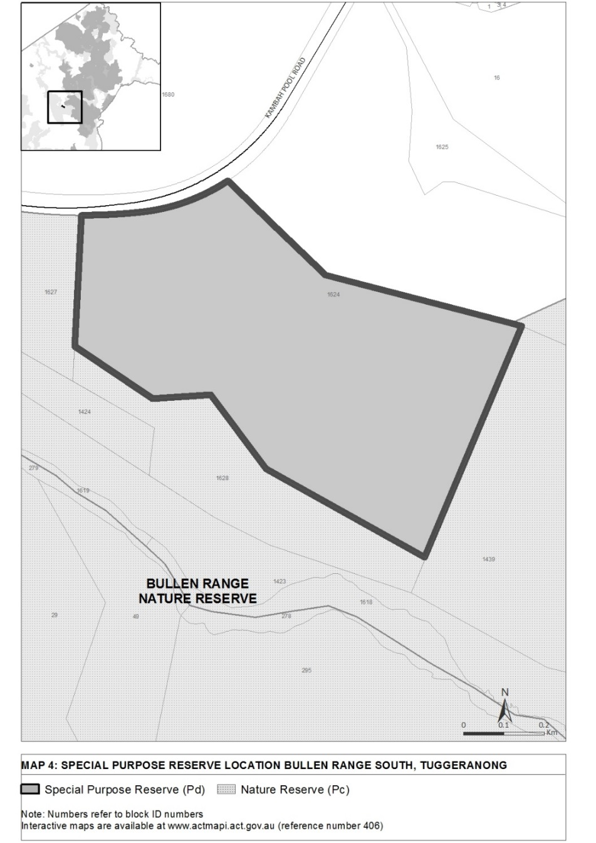

Division 1.2.5 Bullen Range Special Purpose Reserve

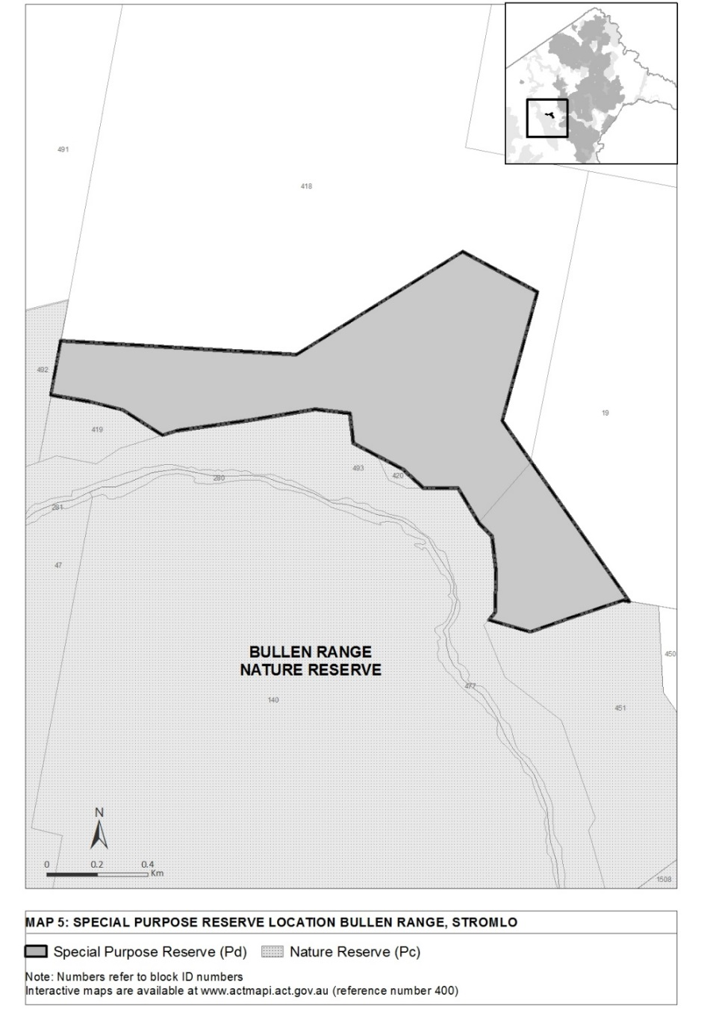

Division 1.2.6 Cotter Reserve

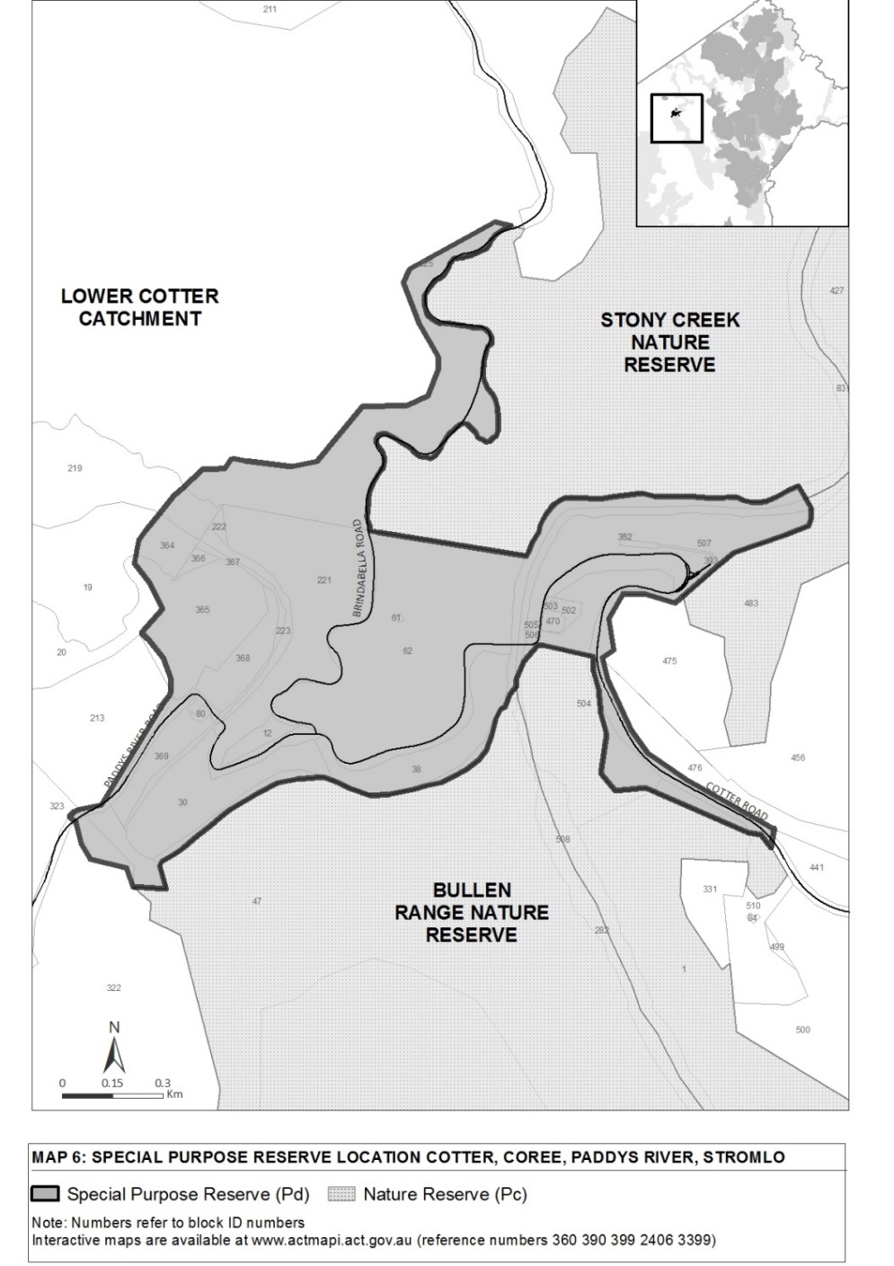

Division 1.2.7 Gibraltar Special Purpose Reserve

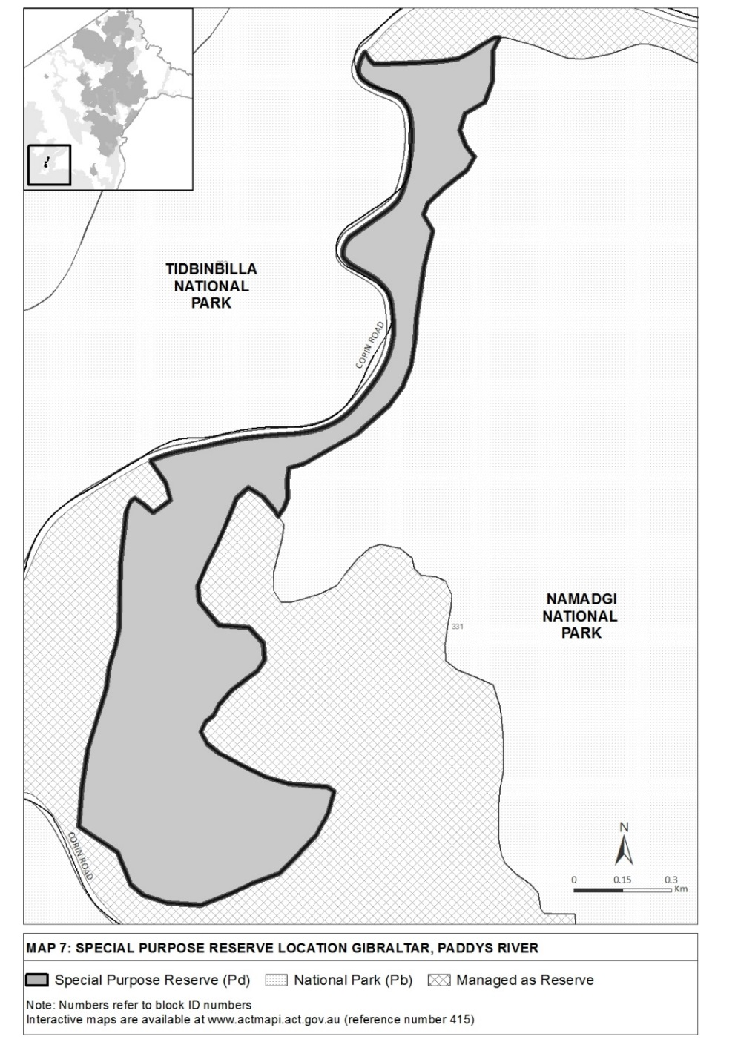

Division 1.2.8 Kambah Pool Recreation Area

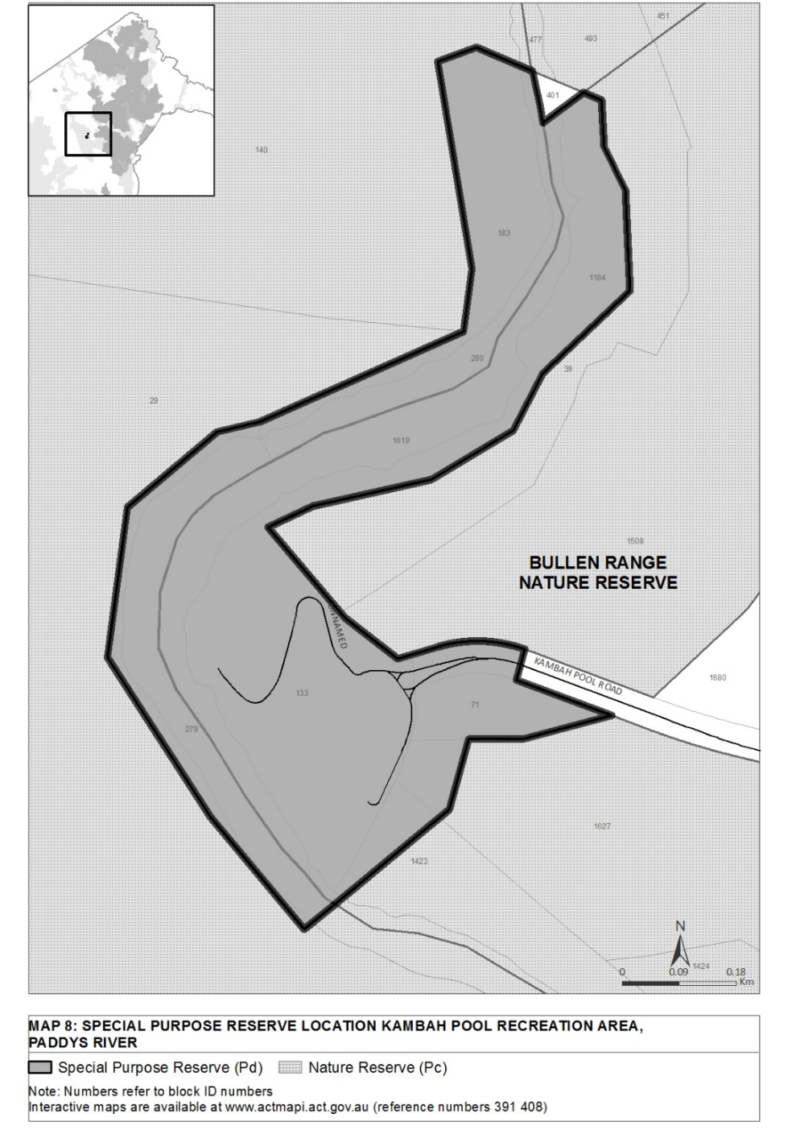

Division 1.2.9 Molonglo River Reserve

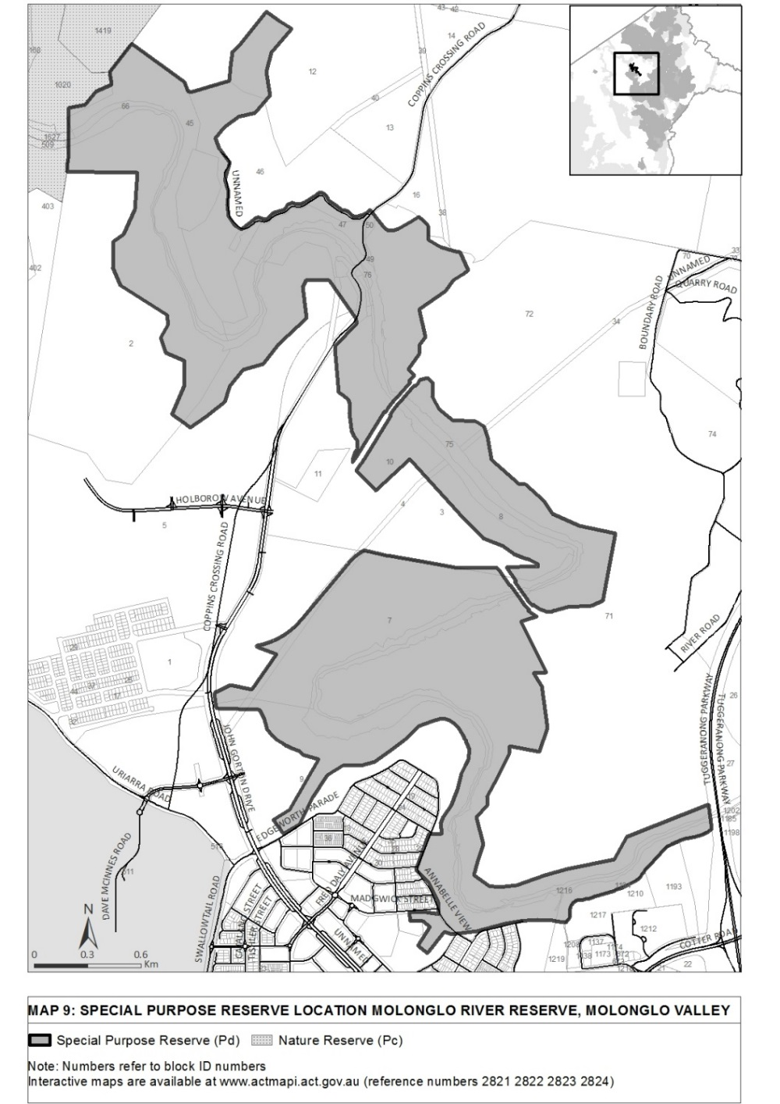

Division 1.2.10 Namadgi Special Purpose Reserve

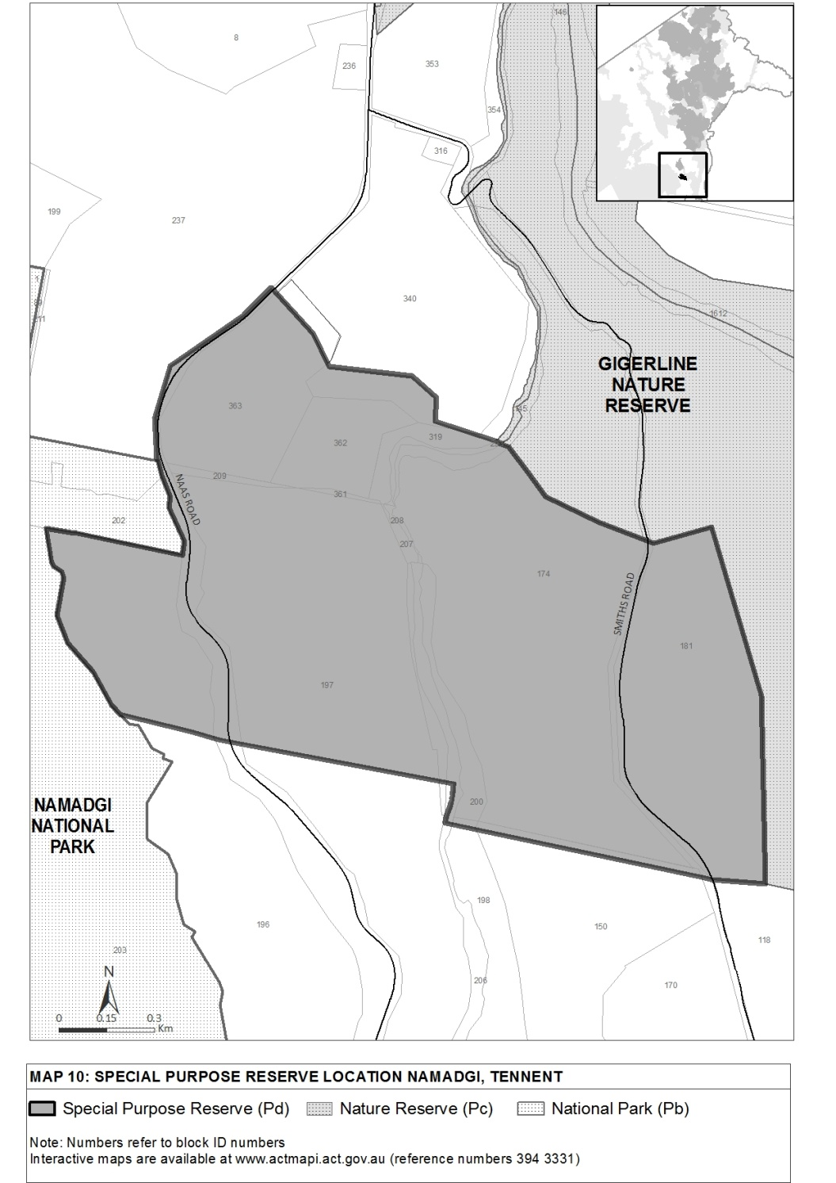

Division 1.2.11 Pine Island and Point Hut to Tharwa Bridge

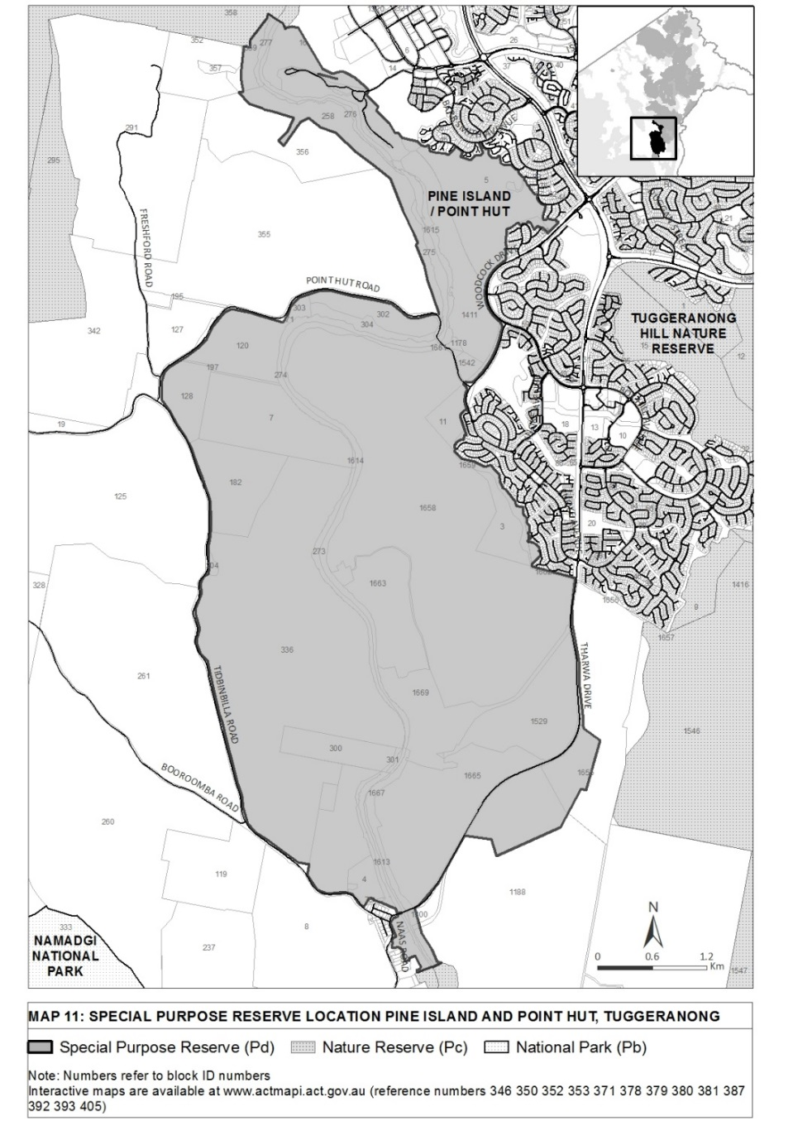

Division 1.2.12 Sherwood Forest Special Purpose Reserve

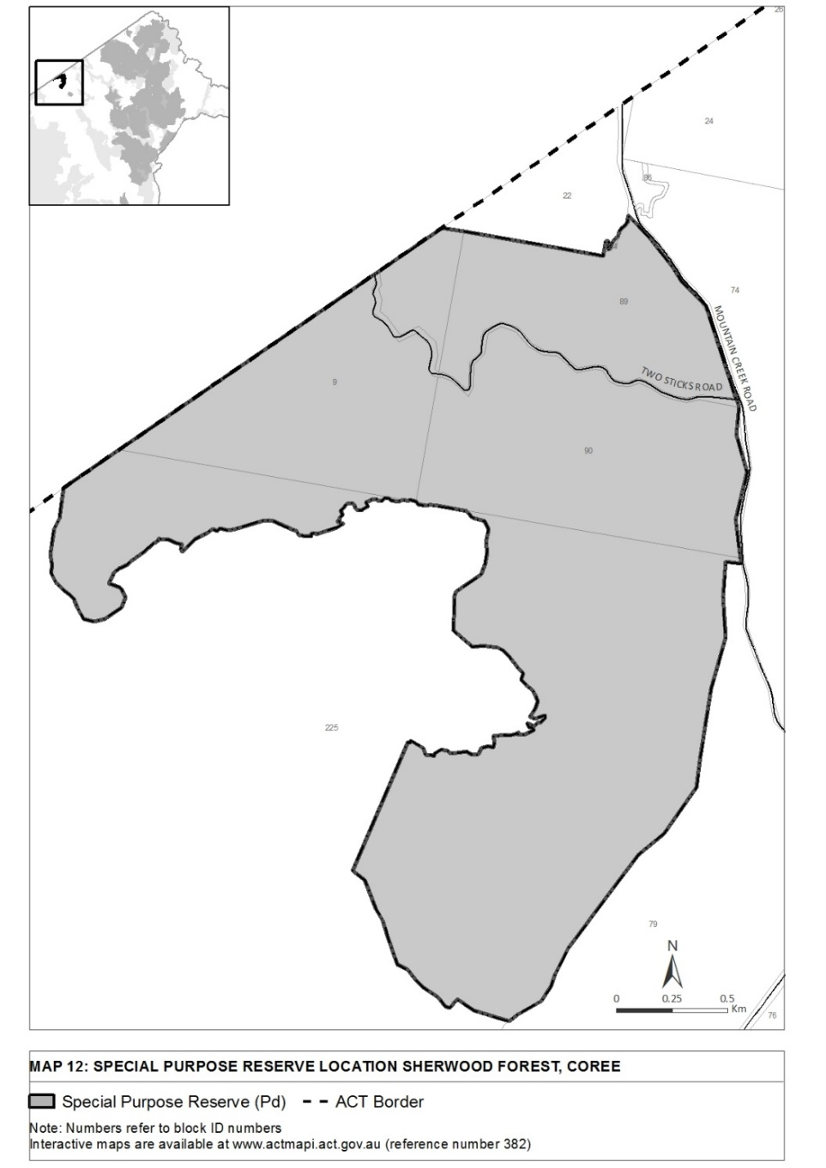

Division 1.2.13 Stony Creek Special Purpose Reserve

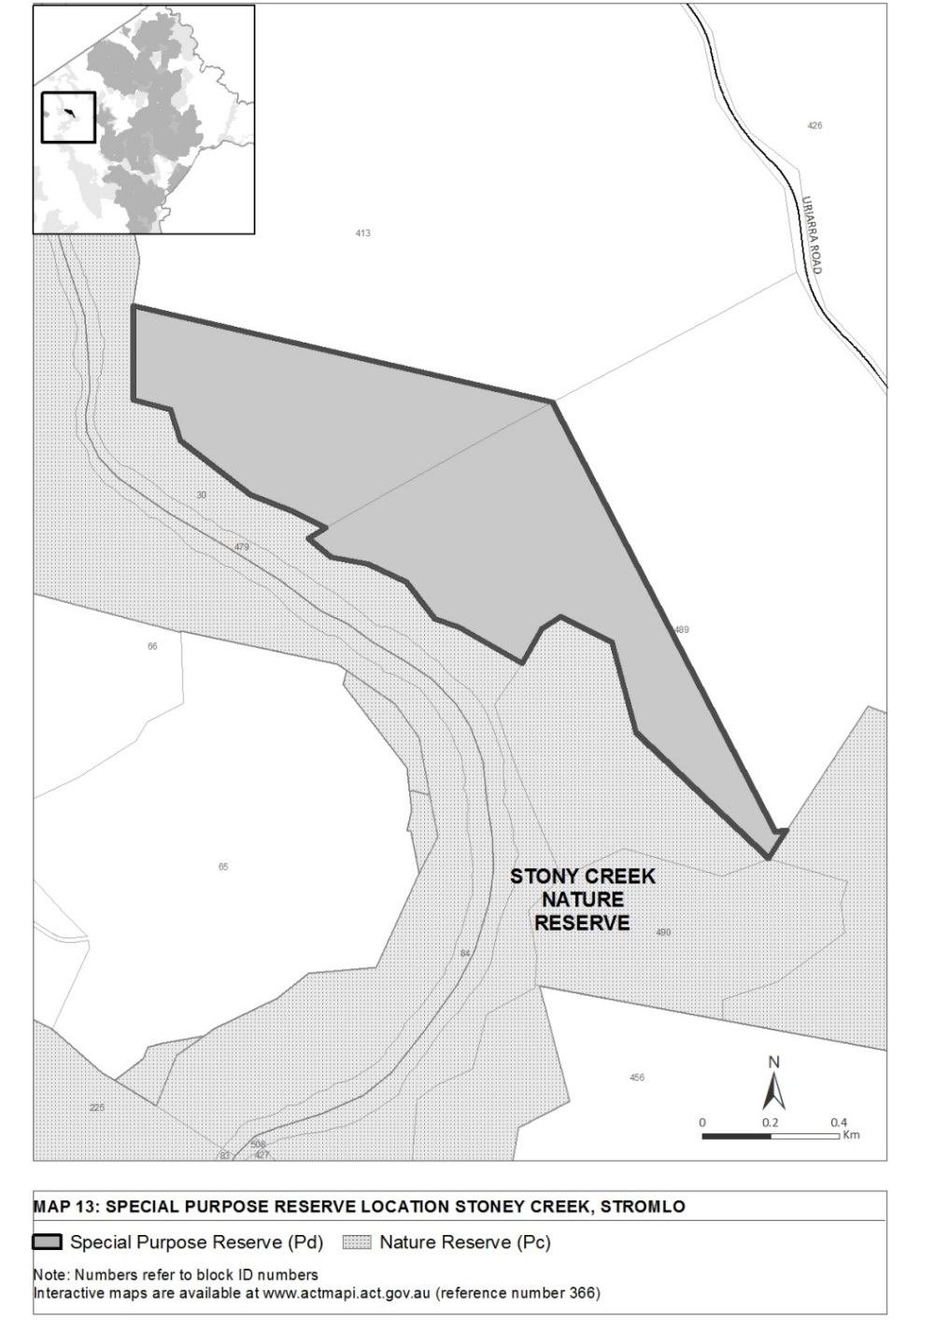

Division 1.2.14 Tidbinbilla Special Purpose Reserve and Jedbinbilla

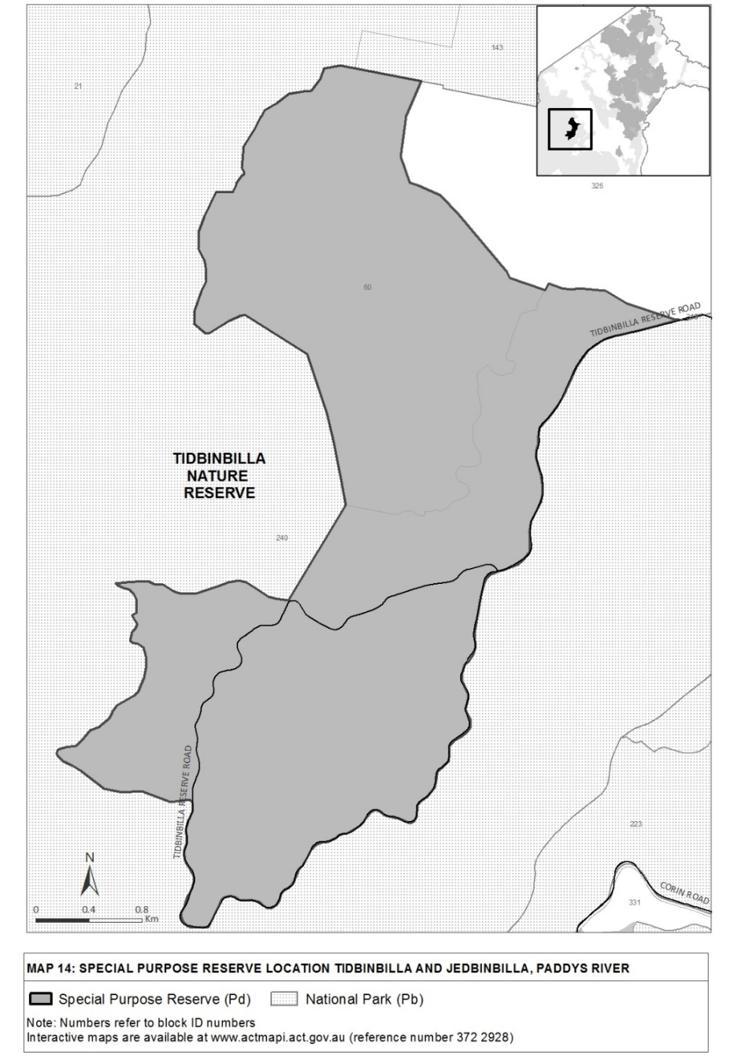

Division 1.2.15 Uriarra Crossing Recreation Area

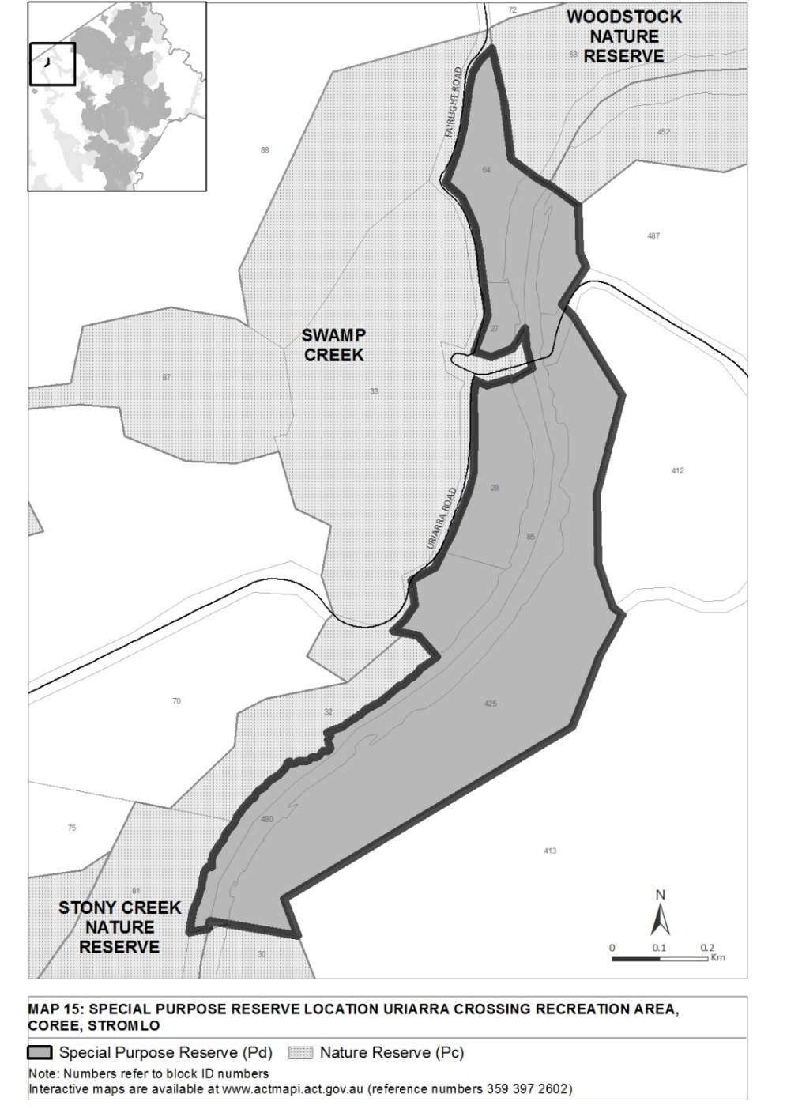

Division 1.2.16 Woodstock West Special Purpose Reserve

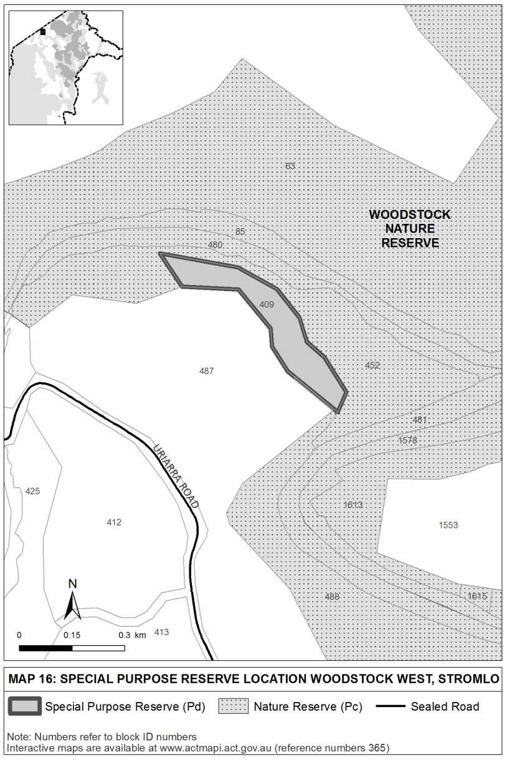

Dictionary
(see s 3)
Note 1 The Legislation Act contains definitions and other provisions relevant to this regulation.
Note 2 For example, the Legislation Act, dict, pt 1, defines the following terms:
• may (see s 146)
• must (see s 146).
Note 3 Terms used in this regulation have the same meaning that they have in the Nature Conservation Act 2014 (see Legislation Act, s 148). For example, the following terms are defined in the Nature Conservation Act 2014, dict:
• animal (see s 11)
• clearing
• conservator (see s 20)
• damage
• export
• keep
• licence
• native animal (see s 12)
• native plant (see s 14)
• native species (see s 16)
• native timber
• native vegetation
• plant (see s 13)
• plant reproductive material
• protected native species (see s 110)
• reserve (see s 169)
• sell
• special protection status
• take
• wilderness area (see s 170).

Endnotes
1 About the endnotes
Amending and modifying laws are annotated in the legislation history and the amendment history. Current modifications are not included in the republished law but are set out in the endnotes.
Not all editorial amendments made under the Legislation Act 2001, part 11.3 are annotated in the amendment history. Full details of any amendments can be obtained from the Parliamentary Counsel’s Office.
Uncommenced amending laws are not included in the republished law. The details of these laws are underlined in the legislation history. Uncommenced expiries are underlined in the legislation history and amendment history.
If all the provisions of the law have been renumbered, a table of renumbered provisions gives details of previous and current numbering.
The endnotes also include a table of earlier republications.
2 Abbreviation key

A = Act | NI = Notifiable instrument
AF = Approved form | o = order
am = amended | om = omitted/repealed
amdt = amendment | ord = ordinance
AR = Assembly resolution | orig = original
ch = chapter | par = paragraph/subparagraph
CN = Commencement notice | pres = present
def = definition | prev = previous
DI = Disallowable instrument | (prev...) = previously
dict = dictionary | pt = part
disallowed = disallowed by the Legislative | r = rule/subrule
Assembly | reloc = relocated
div = division | renum = renumbered
exp = expires/expired | R[X] = Republication No
Gaz = gazette | RI = reissue
hdg = heading | s = section/subsection
IA = Interpretation Act 1967 | sch = schedule
ins = inserted/added | sdiv = subdivision
LA = Legislation Act 2001 | SL = Subordinate law
LR = legislation register | sub = substituted
LRA = Legislation (Republication) Act 1996 | underlining = whole or part not commenced
mod = modified/modification | or to be expired

3 Legislation history
Nature Conservation Regulation 2015 SL2015-23
notified LR 2 July 2015
s 1, s 2 commenced 2 July 2015 (LA s 75 (1))
remainder commenced 3 July 2015 (s 2)
as amended by
Planning, Building and Environment Legislation Amendment Act 2017 A2017-3 pt 5
notified LR 22 February 2017
s 1, s 2 commenced 22 February 2017 (LA s 75 (1))
pt 5 commenced 23 February 2017 (s 2)
4 Amendment history
Commencement
s 2 om LA s 89 (4)
Special purpose reserves
sch 1 pt 1.1 am A2017-3 s 8
Woodstock West Special Purpose Reserve
sch 1 div 1.2.16 sub A2017-3 s 9

5 Earlier republications
Some earlier republications were not numbered. The number in column 1 refers to the publication order.
Since 12 September 2001 every authorised republication has been published in electronic pdf format on the ACT legislation register. A selection of authorised republications have also been published in printed format. These republications are marked with an asterisk (*) in column 1. Electronic and printed versions of an authorised republication are identical.

Republication No and date | Effective | Last amendment made by | Republication for
R1  3 July 2015 | 3 July 2015–  22 Feb 2017 | not amended | new regulation

© Australian Capital Territory 2017

