Australian Capital Territory
Nature Conservation Amendment Regulation 2021 (No 1)
Subordinate Law SL2021-8

The Australian Capital Territory Executive makes the following regulation under the Nature Conservation Act 2014.
Dated 7 May 2021.
Rebecca Vassarotti
Minister
Andrew Barr
Minister

Australian Capital Territory
Nature Conservation Amendment Regulation 2021 (No 1)
Subordinate Law SL2021-8
made under the
Nature Conservation Act 2014

1 Name of regulation
This regulation is the Nature Conservation Amendment Regulation 2021 (No 1).

2 Commencement
This regulation commences on the day after its notification day.
Note The naming and commencement provisions automatically commence on the notification day (see Legislation Act, s 75 (1)).

3 Legislation amended
This regulation amends the Nature Conservation Regulation 2015.

4 Schedule 1, division 1.2.9
substitute
Division 1.2.9 Molonglo River Reserve

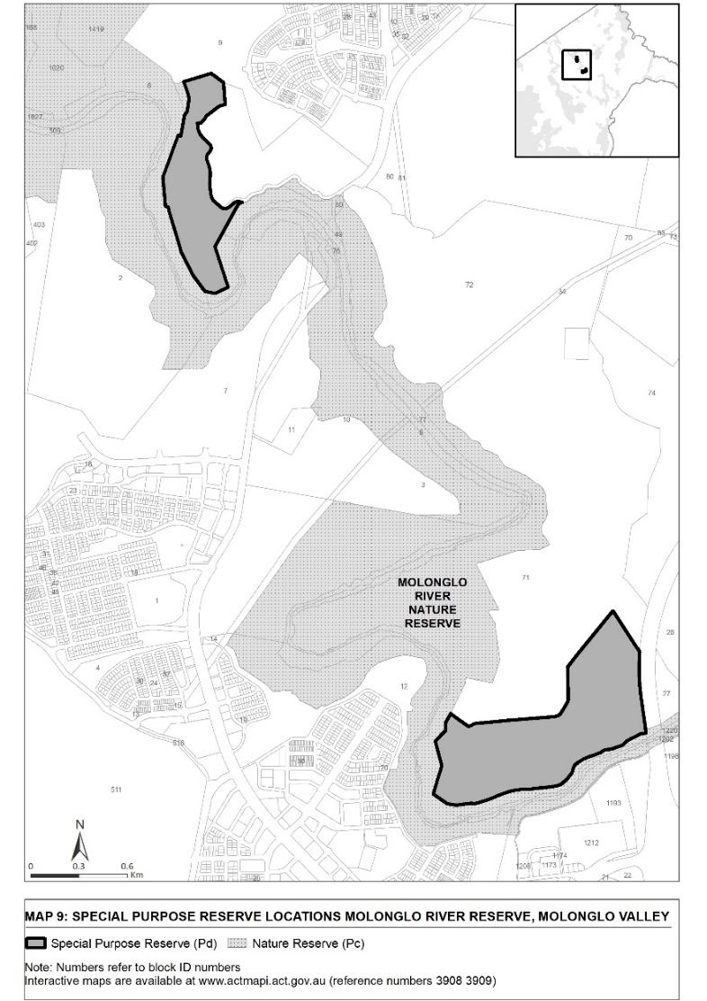

Endnotes
1 Notification
Notified under the Legislation Act on 13 May 2021.
2 Republications of amended laws
For the latest republication of amended laws, see www.legislation.act.gov.au.

© Australian Capital Territory 2021

