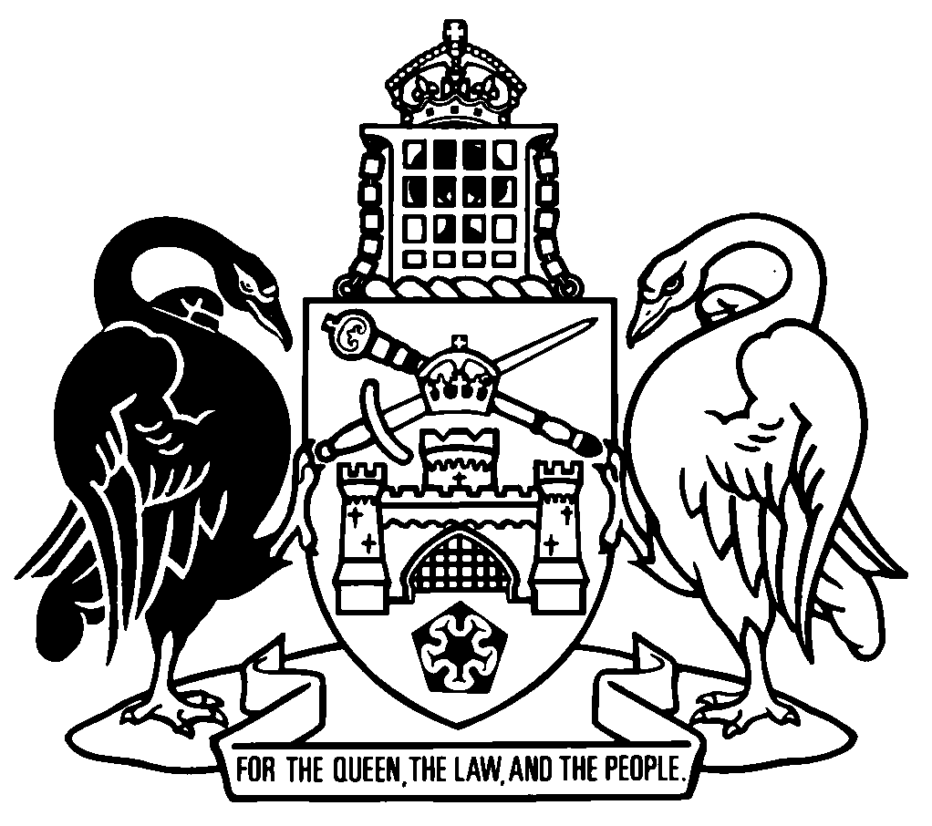
Australian Capital Territory
Magistrates Court (Fair Trading Australian Consumer Law Infringement Notices) Regulation 2024
Subordinate Law SL2024-12
made under the
Magistrates Court Act 1930

Contents
Page
1 Name of regulation 1
2 Dictionary 1
3 Notes 1
4 Purpose of regulation 1
5 Administering authority 1
6 Infringement notice offence 2
7 Infringement notice penalty 2
8 Contents of infringement notices—identifying authorised person 2
9 Contents of infringement notices—other information 2
10 Contents of reminder notices—identifying authorised person 3
11 Authorised person for infringement notice offences 3
12 Prescribed person—Act, s 135 (1) 3
Dictionary 4

1 Name of regulation
This regulation is the Magistrates Court (Fair Trading Australian Consumer Law Infringement Notices) Regulation 2024.

2 Dictionary
The dictionary at the end of this regulation is part of this regulation.
Note 1 The dictionary at the end of this regulation defines certain terms used in this regulation.
Note 2 A definition in the dictionary applies to the entire regulation unless the definition, or another provision of the regulation, provides otherwise or the contrary intention otherwise appears (see Legislation Act, s 155 and s 156 (1)).

3 Notes
A note included in this regulation is explanatory and is not part of this regulation.

4 Purpose of regulation
The purpose of this regulation is to provide for infringement notices under the Magistrates Court Act 1930, part 3.8 for an offence against the relevant provision.
Note The Magistrates Court Act 1930, pt 3.8 provides a system of infringement notices for offences against various territory laws. The infringement notice system is intended to provide an alternative to prosecution.

5 Administering authority
The administering authority for an infringement notice offence against the relevant provision is the commissioner for fair trading.

6 Infringement notice offence
The Magistrates Court Act 1930, part 3.8 applies to an offence against the relevant provision.

7 Infringement notice penalty

(1) The penalty payable by an individual for an offence against the relevant provision, under an infringement notice for the offence, is $960.

(2) The penalty payable by a corporation for an offence against the relevant provision, under an infringement notice for the offence, is $4 800.

(3) The cost of serving a reminder notice for an infringement notice offence against the relevant provision is $34.

8 Contents of infringement notices—identifying authorised person
An infringement notice served on a person by an authorised person for an infringement notice offence against the relevant provision must identify the authorised person by—

(a) the authorised person’s full name, or surname and initials; or

(b) any unique number given, for this regulation, to the authorised person by the administering authority.

9 Contents of infringement notices—other information

(1) An infringement notice served on a company by an authorised person for an infringement notice offence against the relevant provision must include the company’s ACN.
Note This requirement under this section is additional to the requirement under the Magistrates Court Act 1930, s 121 (1) (c).

(2) In this section:
company means a company registered under the Corporations Act.

10 Contents of reminder notices—identifying authorised person
A reminder notice served on a person by an authorised person for an infringement notice offence against the relevant provision must identify the authorised person by—

(a) the authorised person’s full name, or surname and initials; or

(b) any unique number given, for this regulation, to the authorised person by the administering authority.

11 Authorised person for infringement notice offences
An authorised person may serve the following:

(a) an infringement notice for an infringement notice offence against the relevant provision;

(b) a reminder notice for an infringement notice offence against the relevant provision.

12 Prescribed person—Act, s 135 (1)
A public servant is prescribed.

Dictionary
(see s 2)
Note 1 The Legislation Act contains definitions relevant to this regulation. For example:
• corporation
• Corporations Act
• individual
• public servant.
Note 2 Terms used in this regulation have the same meaning that they have in the Magistrates Court Act 1930. For example, the following terms are defined in that Act, dict:
• administering authority
• infringement notice
• infringement notice offence
• infringement notice penalty
• reminder notice.
authorised person means an investigator appointed under the Fair Trading (Australian Consumer Law) Act 1992, section 36.
relevant provision means the Fair Trading (Australian Consumer Law) Act 1992, section 34GA (1).

Endnotes
1 Making of regulation
This regulation was made as part of the Housing and Consumer Affairs Legislation Amendment Act 2024 (see A2024-29, sch 2) and is taken to have been made under the Magistrates Court Act 1930 A1930-21 (see A2024-29, s 5 (1)).
2 Republications of amended laws
For the latest republication of amended laws, see www.legislation.act.gov.au.

© Australian Capital Territory 2024

