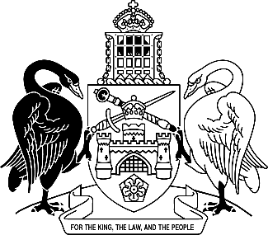
Australian Capital Territory
Work Health and Safety Amendment Regulation 2025 (No 1)
Subordinate Law SL2025-26

The Australian Capital Territory Executive makes the following regulation under the Work Health and Safety Act 2011.
Dated 28 November 2025.
Andrew Barr
Chief Minister
Michael Pettersson
Minister

Australian Capital Territory
Work Health and Safety Amendment Regulation 2025 (No 1)
Subordinate Law SL2025-26
made under the
Work Health and Safety Act 2011

1 Name of regulation
This regulation is the Work Health and Safety Amendment Regulation 2025 (No 1).

2 Commencement
This regulation commences on the day after its notification day.
Note The naming and commencement provisions automatically commence on the notification day (see Legislation Act, s 75 (1)).

3 Legislation amended
This regulation amends the Work Health and Safety Regulation 2011.

4 New section 419 (3A) and (3B)
insert

(3A) The Minister may declare work to be minor or routine maintenance work, or other minor work, for subsection (3) (k).

(3B) A declaration is a notifiable instrument.

5 Section 447 (2), definition of demolition or refurbishment
after
minor work
insert
as mentioned in section 419 (3) (k)
Note The Minister may declare work to be minor or routine maintenance work, or other minor work, under s 419 (3A).

Endnotes
1 Notification
Notified under the Legislation Act on 28 November 2025.
2 Republications of amended laws
For the latest republication of amended laws, see www.legislation.act.gov.au.

© Australian Capital Territory 2025

