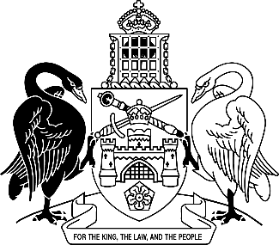
Australian Capital Territory
Water and Sewerage Amendment Regulation 2026 (No 1)
Subordinate Law SL2026-2

The Australian Capital Territory Executive makes the following regulation under the Water and Sewerage Act 2000.
Dated 16 April 2026.
Andrew Barr
Chief Minister
Chris Steel
Minister

Australian Capital Territory
Water and Sewerage Amendment Regulation 2026 (No 1)
Subordinate Law SL2026-2
made under the
Water and Sewerage Act 2000

1 Name of regulation
This regulation is the Water and Sewerage Amendment Regulation 2026 (No 1).

2 Commencement
This regulation commences on the day after its notification day.
Note The naming and commencement provisions automatically commence on the notification day (see Legislation Act, s 75 (1)).

3 Legislation amended
This regulation amends the Water and Sewerage Regulation 2001.

4 Section 5A, note 1, dot points
substitute
• s 16B (Preservation of separated sanitary drainage for grey water)
• s 16C (Overflow from grey water disposal system)
• s 16D (Retrofitting backflow prevention devices)
• s 24A (Building in separated rainwater supply device)
• s 24B (Installing rainwater supply service).

5 Section 16A
omit

Endnotes
1 Notification
Notified under the Legislation Act on 23 April 2026.
2 Republications of amended laws
For the latest republication of amended laws, see www.legislation.act.gov.au.

© Australian Capital Territory 2026

