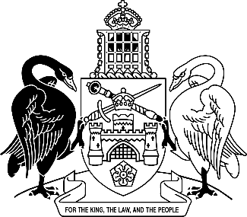
Australian Capital Territory
Leases (Commercial and Retail) Amendment Regulation 2026 (No 1)
Subordinate Law SL2026-5

The Australian Capital Territory Executive makes the following regulation under the Leases (Commercial and Retail) Act 2001.
Dated 18 May 2026.
Andrew Barr
Chief Minister
Tara Cheyne
Minister

Australian Capital Territory
Leases (Commercial and Retail) Amendment Regulation 2026 (No 1)
Subordinate Law SL2026-5
made under the
Leases (Commercial and Retail) Act 2001

1 Name of regulation
This regulation is the Leases (Commercial and Retail) Amendment Regulation 2026 (No 1).

2 Commencement
This regulation commences on the day after its notification day.
Note The naming and commencement provisions automatically commence on the notification day (see Legislation Act, s 75 (1)).

3 Legislation amended
This regulation amends the Leases (Commercial and Retail) Regulation 2002.

4 New section 4 (1) (l) to (n)
insert
(l) a lease of premises known as GIO Stadium and identified as ‘Bruce Stadium’ on sublease plan number 2986, block 26 section 8 division of Bruce, between the Australian Sports Commission (lessor) and the Territory (tenant);
(m) a licence granted by the Australian Sports Commission to the Territory to use any part of the following land identified in the licence as ‘car park’:
(i) part of block 26 section 8 division of Bruce;
(ii) block 36 section 8 division of Bruce;
(iii) block 2 section 30 division of Bruce;
(iv) block 6 section 46 division of Bruce;
(v) block 1 section 106 division of O’Connor;
(n) a lease between the Territory (lessor) and a tenant if the lease provides for the tenant to use any part of the following premises for the purpose of providing services to the Territory:
(i) premises known as Exhibition Park in Canberra at—

(A) block 6 section 72 division of Lyneham; and

(B) block 466 district of Gungahlin; and

(C) block 765 district of Gungahlin;
(ii) premises known as GIO Stadium and identified as ‘Bruce Stadium’ on sublease plan number 2986, block 26 section 8 division of Bruce;
(iii) premises known as Manuka Oval at blocks 2, 4, 10, 11, 14 and 15 section 15 division of Griffith.
Example
an agreement to use a kitchen at the premises to provide catering services

5 Section 4 (2), new definition of Australian Sports Commission
insert
Australian Sports Commission means the Australian Sports Commission established under the Australian Sports Commission Act 1989 (Cwlth).

Endnotes
1 Notification
Notified under the Legislation Act on 21 May 2026.
2 Republications of amended laws
For the latest republication of amended laws, see www.legislation.act.gov.au.

© Australian Capital Territory 2026

